## LLM-para

### 一 、 Moe

#### 1. 启用MoE

use_moe = False  
# 如果传入 moe 参数 则启用moe计算  
if num_experts_per_tok is not None:  
 use_moe = True

#### 2. Prefill MoE 参数计算

| 分解 | Input1 | Input2 | Output | 运算量 |
| --- | --- | --- | --- | --- |
| MoE_Router | (b,s,h) | (h,num_local_experts) | (b,s,num_local_experts) | 2bsh*num_local_experts |
| MoE_FFN1 | (b, s*num_experts_per_tok , h) | (num_local_experts,h, intermediate_size*2) | (b,s*num_experts_per_tok ,intermediate_size * 2) | 2bs* num_experts_per_tok * h * intermediate_size * 2 + bs * num_experts_per_tok * intermediate_size |
| MoE_FFN2 | (b,s*num_experts_per_tok, intermediate_size) | (num_local_experts, intermediate_size, h) | (b, s*num_experts_per_tok , h) | 2bs * num_experts_per_tok * intermediate_size * h |

##### 路由参数计算

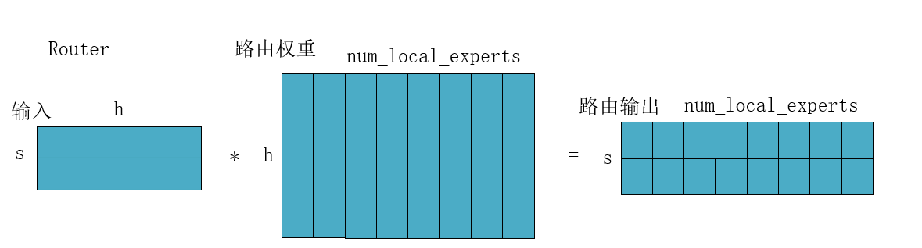

moe_router_flops = b * seq * h * num_local_experts * 2  
param_count = h * num_local_experts  
add_row(phase, "Router", "(b,s,h)", f"(h,{num_local_experts})", f"(b,s,{num_local_experts})",   
 moe_router_flops, param_count,   
 (b,seq,h), (h,num_local_experts), (b,seq,num_local_experts), a_bit, w_ffn)

##### FNN-1计算

**假设prefill输入seq足够大，大到能够使用到所有expert。**

输入形状为**(b,s*num_experts_per_tok,h)**: 对于每个token，需要送入num_experts_per_tok个MLP进行计算，则相当于将每个token复制了num_experts_per_tok次，即有seq*num_experts_per_tok个token。

输入权重形状为**(num_local_experts,h,intermediate_size*2)**: 使用到所有expert，且加载up和gate的权重。

所需参数量：num_experts_per_tok个 up+gate 权重矩阵

# FFN-1(up + gate)(with Moe)  
FFN_1_moe = b * seq * num_experts_per_tok * h * intermediate_size * 2 * 2 # * 两个矩阵乘法 * 每个token算num_experts_per_tok次  
# 额外的逐元素乘法  
FFN_1_moe += b * seq * num_experts_per_tok * intermediate_size # (W₁x) ⊙ SiLU(W_gate*x)  
  
param_count = h * intermediate_size * 2 * num_local_experts # 两个权重矩阵 * 假设 prefill 用到了所有expert  
add_row(phase, "FFN-1(with Moe)", f"(b,{s}*num_experts_per_tok,h)", f"(num_local_experts,h,{intermediate_size}*2)", f"(b,{s}*num_experts_per_tok,{intermediate_size}*2)",   
 FFN_1_moe, param_count,   
 (b, seq * num_experts_per_tok, h), (h, intermediate_size * 2 * num_local_experts), (b, seq * num_experts_per_tok, intermediate_size*2 ), a_bit, w_ffn)

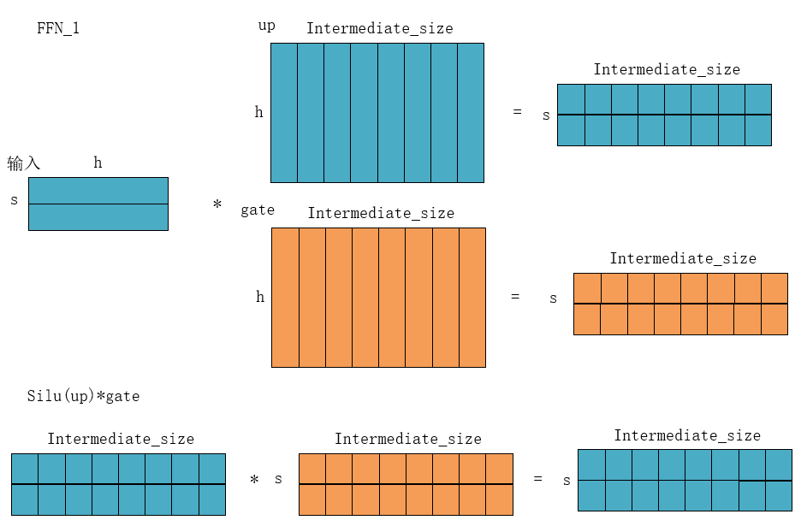

##### FFN-2 计算

# FFN-2(with Moe)  
FFN_2_moe = b * seq * intermediate_size * h * 2 * num_experts_per_tok  
param_count = intermediate_size * h * num_local_experts  
add_row(phase, "FFN-2(with Moe)", f"(b, {s}*num_experts_per_tok, {intermediate_size})", f"(num_local_experts, {intermediate_size}, h)", f"(b,{s}*num_experts_per_tok,h)",FFN_2_moe, param_count,  
(b, seq * num_experts_per_tok, intermediate_size), (intermediate_size, h, num_local_experts), (b, seq * num_experts_per_tok, h), a_bit, w_ffn)

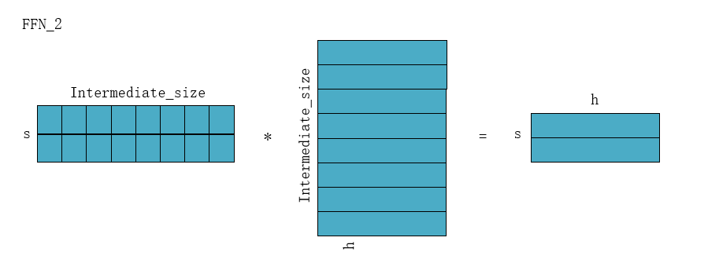

#### 3. Decode MoE参数计算

prefill 阶段的计算每次需要加载**num_local_experts**个MLP的参数。

decode 阶段的计算每次**只**需要加载**num_experts_per_tok**个MLP的参数。