parse_segments_data.py
Goal: create strava_segments.db from training.db
Working databse: training.db. table name: segments_data
New database: strava_segments.db

For a given activity_id, and the corresponding athlete_id, date, and tour_year there a segment data.
The segment column in training.db is a JSON BLOB which looks like

For example: for activity_id 6929407944 and athlete_id 4018952 the blob looks like

{"segment_name": ["Ploubezre-K\u00e9rauzern",… , "Sprint de cinq croix"],
"segment_time": ["9:20", "9:24", …, "51s"],
"segment_speed": ["27.6km/h", "25.1km/h", …, "31.4km/h"],
"watt": ["177W", "200W", …, "179W"],
"heart_rate": ["\u2014", "\u2014", …, "\u2014"],
"segment_distance": ["4.29km", "3.93km", …, "0.44km"],
"segment_vert": ["15m", "30m", …, "3m"],
"segment_grade": ["0.2%", "0.8%", …, "0.5%"],
"VAM": ["", "", …, ""]}

The goal is to parse the BLOB into columns with all athlete-dependent measured properties of an activity into a forming the table. Note that (activity_id, athlete_id, segment_name) can’t be not keys because they are not unique so we will add a row-counter (id) as a primary key

CREATE TABLE segment_activity (
id INTEGER PRIMARY KEY AUTOINCREMENT,
activity_id INTEGER,
athlete_id INTEGER,
segment_name TEXT,
segment_distance_km REAL,
segment_vert_m REAL,
segment_grade REAL,
segment_time_seconds INTEGER,
segment_speed_kph REAL,
power_watt INTEGER,
heart_rate_bpm INTEGER,
vertical_ascent_m REAL,
FOREIGN KEY (athlete_id) REFERENCES segments_data(athlete_id),
FOREIGN KEY (segment_name) REFERENCES segments_data(segment_name)
)

The table now looks like:

Challenges:
- A training activity is broken into an arbitrary number of segments chosen by the rider.
- A training activity could have repeated segments and circuits. Even if we get a unique segment_id, if a rider goes over that segment multiple times, then there is no way to distinguish one segment information from another. Thus, if a rider goes out and rides a circuit course, the (activity_id, athlete_id, segment_id) would all be the same

We can avoid this issue by getting the “Analysis” data of a given Strava activity.
For example, consider the for activity for athlete_id 3905720 and activity_id 9188311589.
Note: depending on location the units are either imperial or metric.

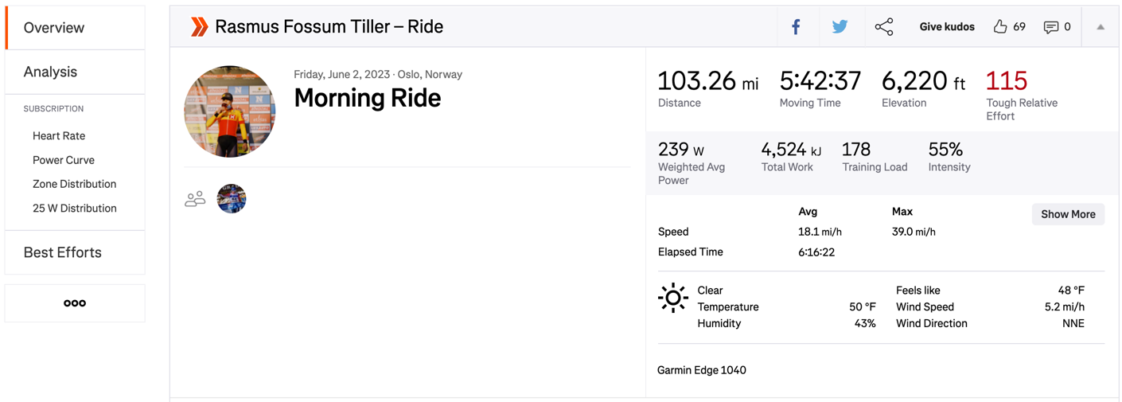

Clicking on the Analysis tab on the left we can see two types of data with a starting the zero-point. The first tab shows the distance data for that activity and the other tab shows time data. Is there a way to scrape this data?

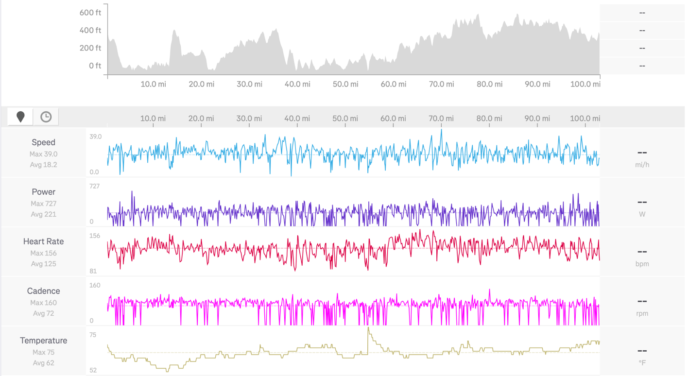

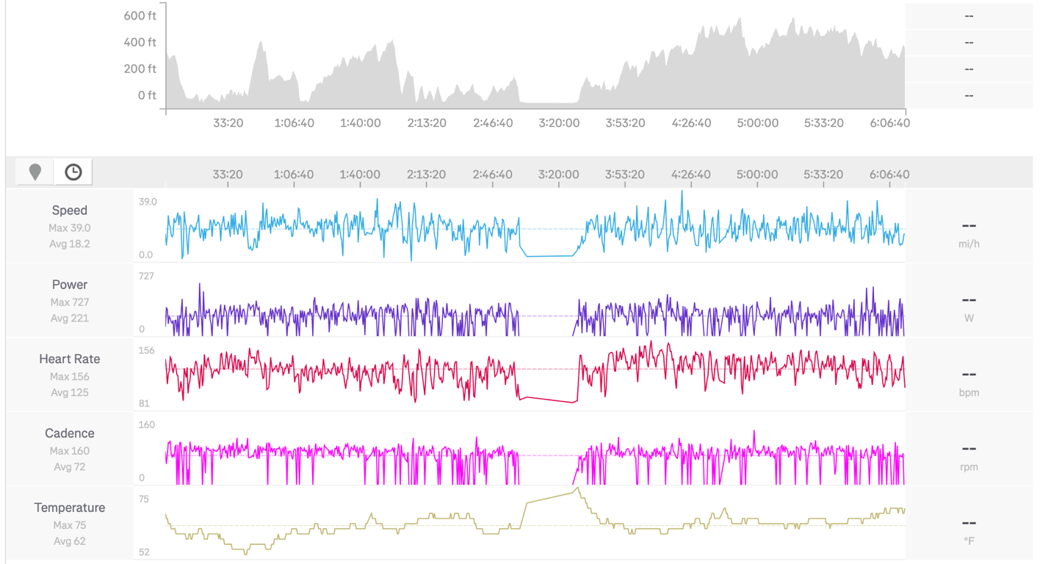

But all this depends on our goal. So here are some of our ideas for project goal
- Classify any segment of road (length above between 1 to 5 km say) based on difficulty. Either on a scale of 1-10 or simply an (easy, medium, hard) difficulty ranking. We know the elevation and grade (slope) the segments posted by Strava. We can then construct a “normalized” representative segment for different kinds of terrain (flat, hilly, mountainous). Thus, for the actual tour we can break up the course (stage) based on difficulty ranking
  - Problem: there is no natural break in a particular segment

- Classify a biker using the tour’s official classification (Climber, GC, Classic, Time-Trial Specialist, Hills, Sprint) . This might require us to scrape data of non-pro athletes to have a background. Create a profile of a rider on several different axes for example (speed, strength, endurance) and predict how they are going to do in a specific stage.
  - We can test our classification against the procyclingstats.com grouping.

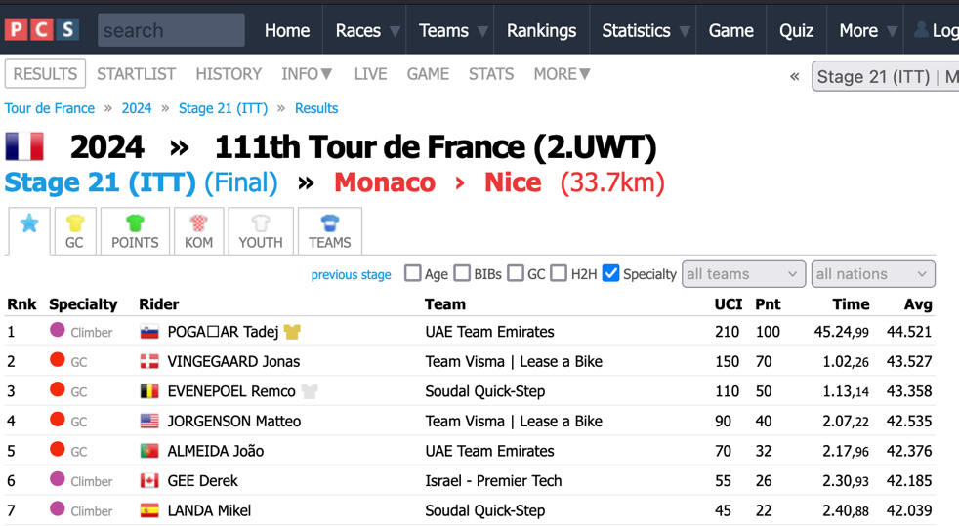

- Predict competition among elite riders. Use the split-time to rank the riders. As with most racing, if a rider is taking longer than their previous trial (or previous k trials) on a 'similar' segment, then we denote them as having a positive split time, say +0.8, and give them an indication of red. Conversely, we give them a negative split time, -1.2, and show them in green if they are taking less time to complete a 'similar' segment. I suspect for time-trial stages the units are in seconds and for regular stages the units are minutes.
  - Add interactive dashboard?
- Based on the finishing times can we say which of the three tours is the most competitive? In addition, are there any dominant teams/riders in the tours?

- Given the data from a certain training activity, is it possible to say how the activity would compare to a tdf activity?

Questions/remarks about data:
- Scrape segements_data and stats_data for Vuelta?
- Find missing segments or stats data and scrape it (if it is from the first 10 riders of a stage, can we find it somewhere else?)
- Figure out how much (percentage) of the top 100 finishers are represented in the Strava table
- Can we find the official tdf or giro segments (if it exists) for a given year (as gps coordinates of the start/stop locations of the stages?)
- Would scarping the ‘overview” tab of an activity tell us anything new?

