Tour de France (TDF) – Giro d'Italia (GRO) – Vuelta a España (LAV)
The modern format of each of these races involves cycling 3000+ km around the respective countries. The races are competed by 20 to 22 teams of 8 or 9 riders each in three weeks of racing with extra two days of rest between the racing days. The daily courses/routes of the race-days are called stages (hence the races have 21 stages). The routes may change from year-to-year but the format stays the same. An example of how the rest days are used to break up the race is shown below

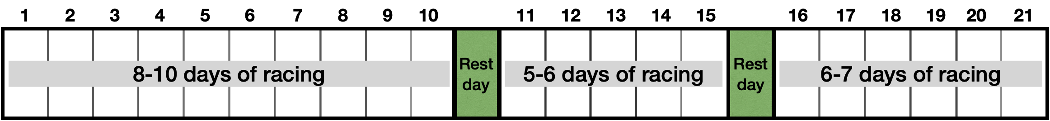
Every stage is a timed competition and each day there is an individual winner. Moreover, there is an overall winner which is the individual rider with the lowest cumulative time. In addition to the timed race, there are four secondary competitions/classifications.
- General Classification (GC) is a competition for overall best time. The rider with the lowest cumulative time is the winner (awarded yellow jersey in TDF). This is the objective of the race; hence it’s the primary classification.
- Points Classification is a secondary competition to get the highest points by winning time trials (awarded green jersey in TDF).
- Mountains Classification is a secondary competition to get the most points for reaching mountain summits first (awarded polka-dot jersey in TDF).
- Young Rider Classification is a secondary competition for riders 25 years or younger with the best time in the general classification (awarded white jersey in TDF).
- Team Classification is a secondary competition between teams which have more than three riders left in the race. The team with the lowest sum of the three best readers in the team is the winner.
The stages/courses are typically divided into three broad categories: ($∆h$ are my estimates)
- Flat stages (minimal change in altitude $∆h ≤1000m$). Usually have high speed.
- Hilly stage (change in altitude $∆h \sim 1000- 2000m$).
- Mountain stage (change in altitude $∆h \sim 3000-4000 m$).
Teams have specialized riders whose skills and physical traits make them an ideal fit for a specific type of course.
- Climbers for mountain stages.
- Sprinters for rapid accelerations over a short amount of time on flat stages.
- Time trial specialists for general races. They can sustain relatively high speeds over very long distances.
Details of how points are calculated, and how time bonuses and penalties are awarded can be found the rule book.
Sources
- https://olympic.ca/2023/05/17/everything-you-need-to-know-about-the-grand-tours-of-road-cycling/
- https://www.montaguebikes.com/folding-bikes-blog/2014/07/understanding-the-tour-de-france/
- https://www.cyclistshub.com/tour-de-france-statistics/
Tour de France (TDF)
Source: https://www.cyclistshub.com/tour-de-france-statistics/
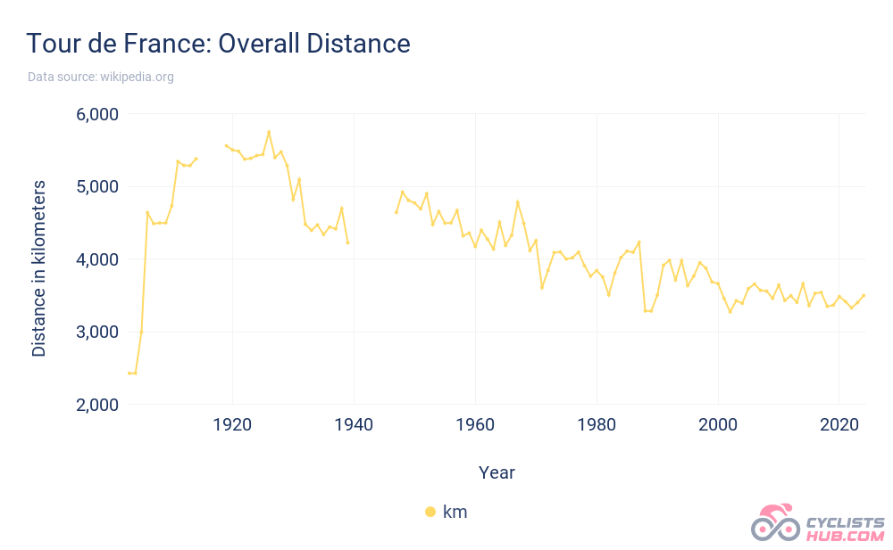
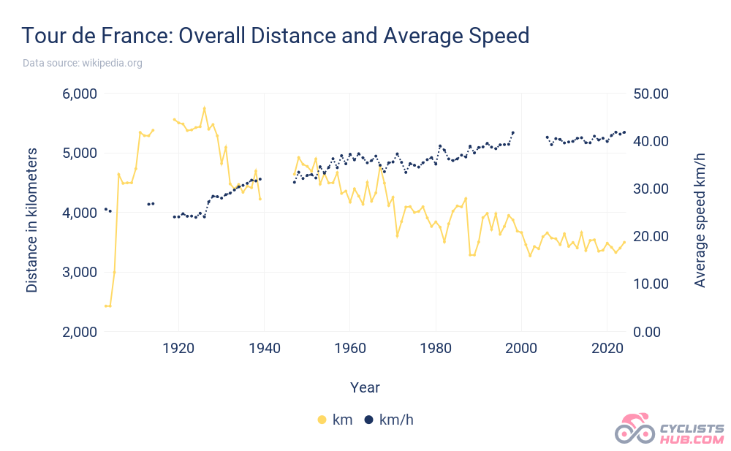
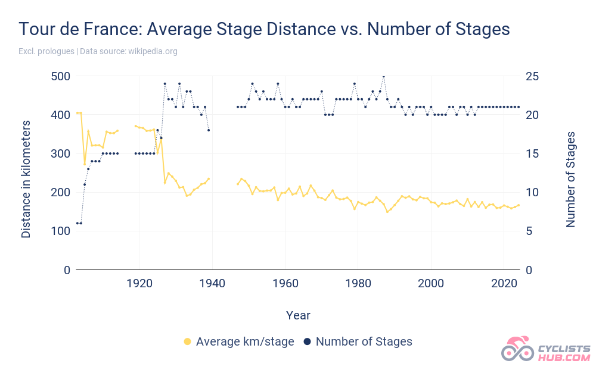

Giro d'Italia (GRO)
Source: https://www.cyclistshub.com/giro-d-italia-statistics/
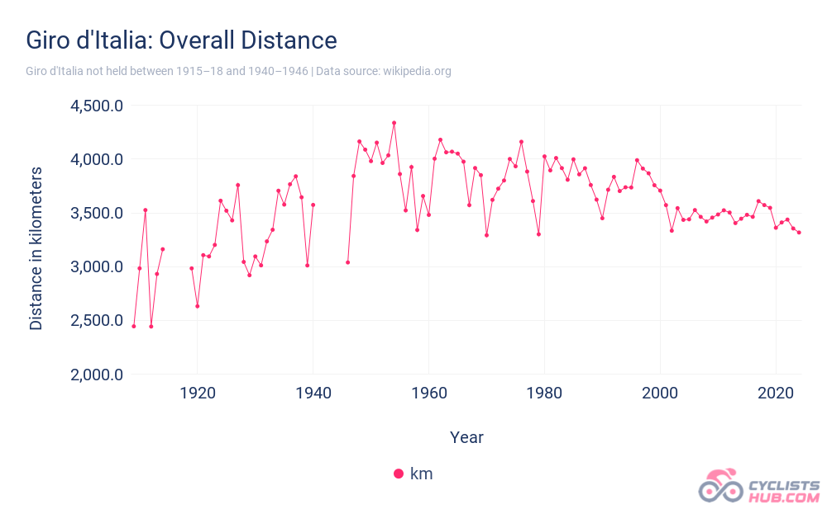
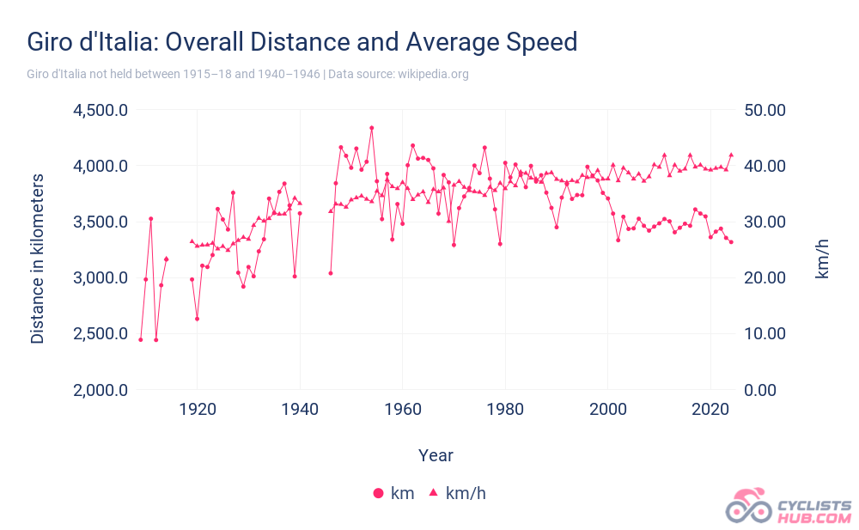

Vuelta a España (LAV)
Source: https://www.cyclistshub.com/vuelta-a-espana-statistics/
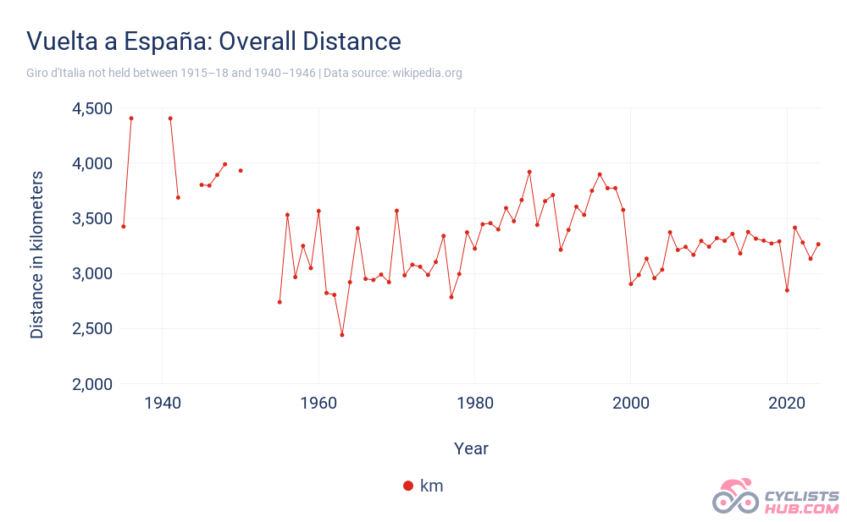
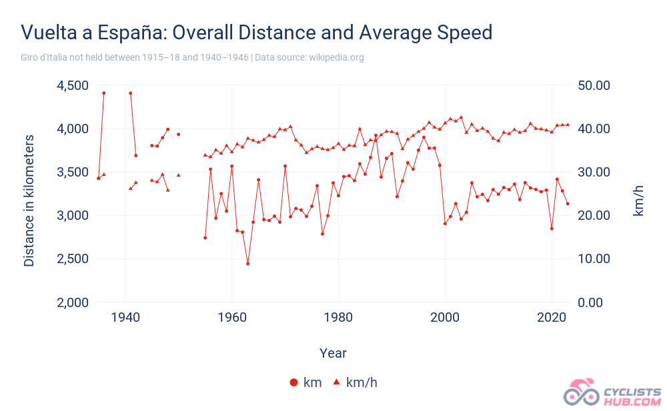

The Grand Tours
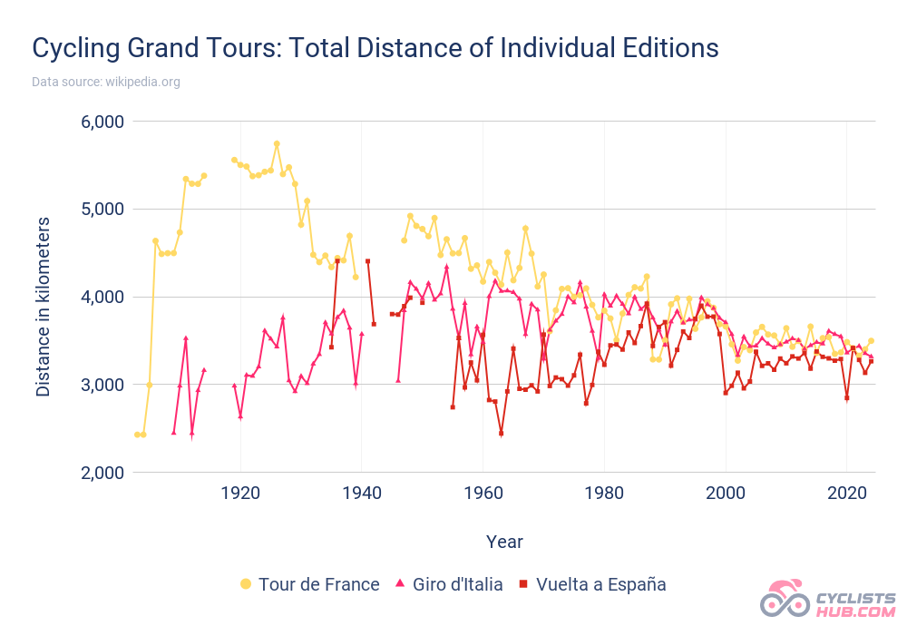
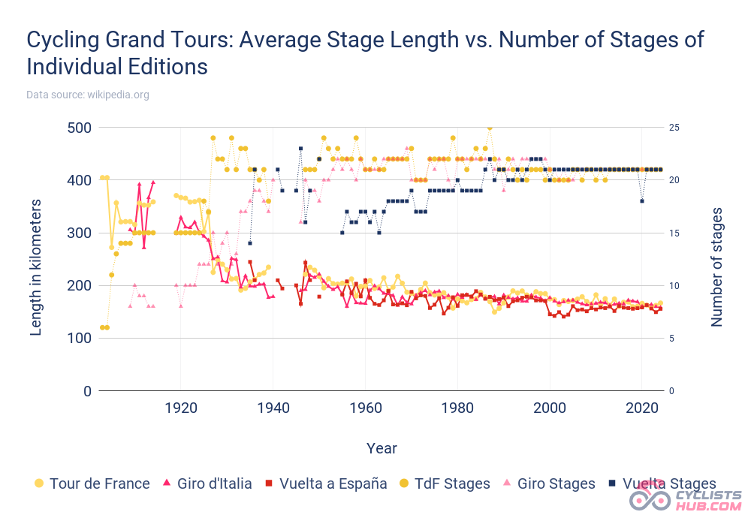
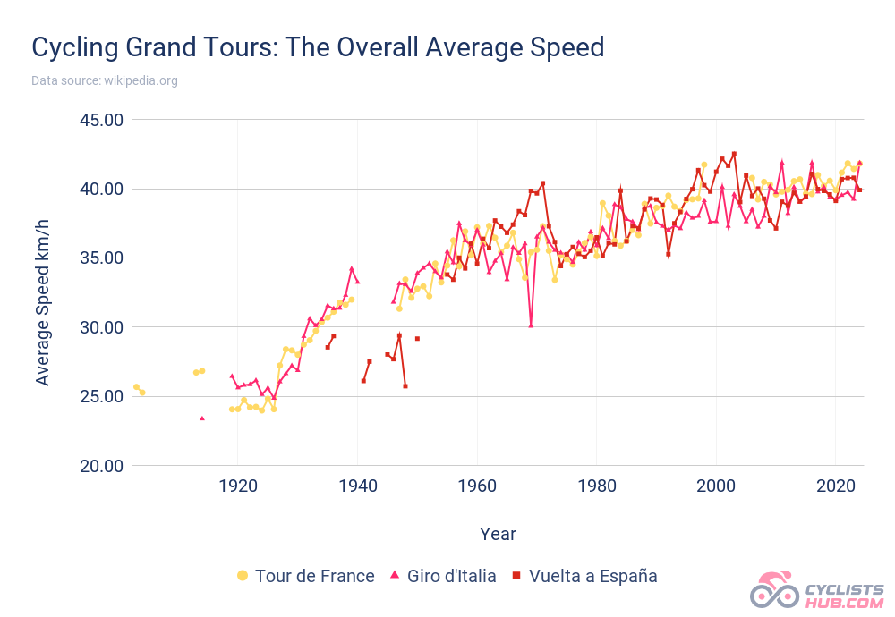

Summary of grand_tours.db
From the first two columns we can see how much yearly data we have
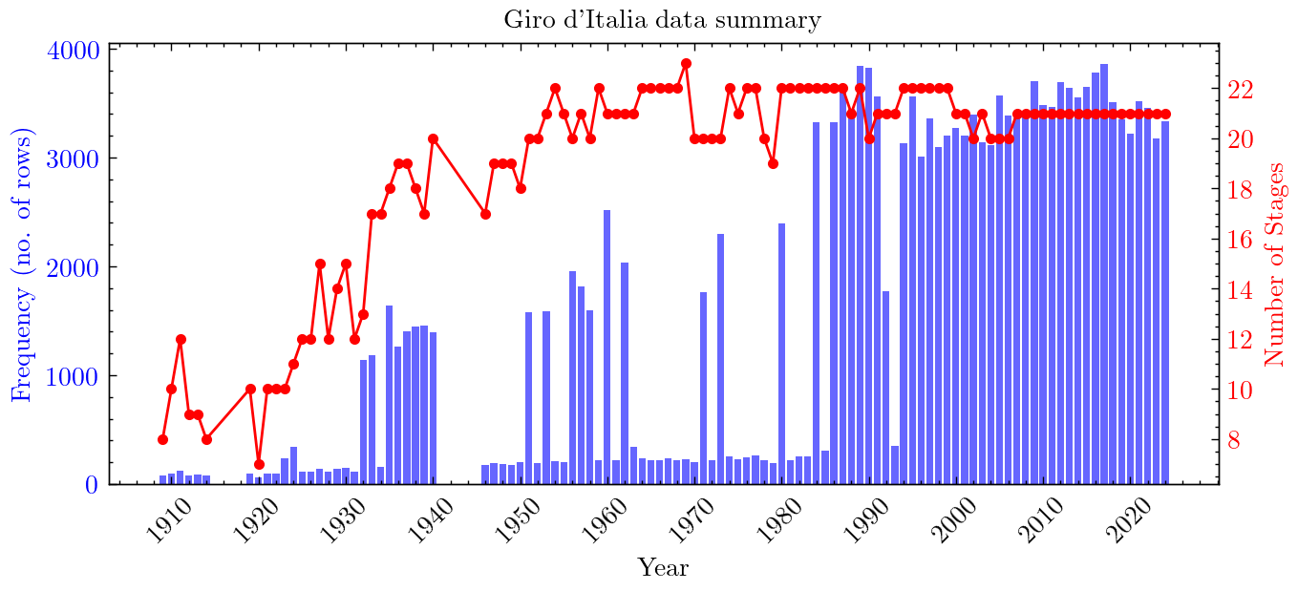
For a given year we can also see the number of riders each stage
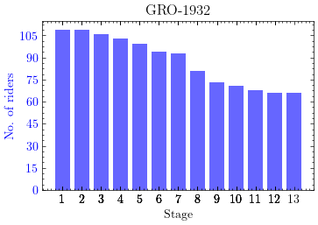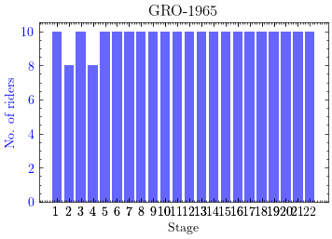
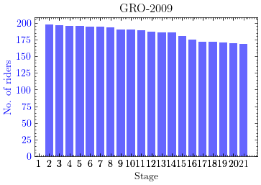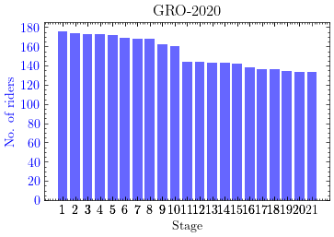

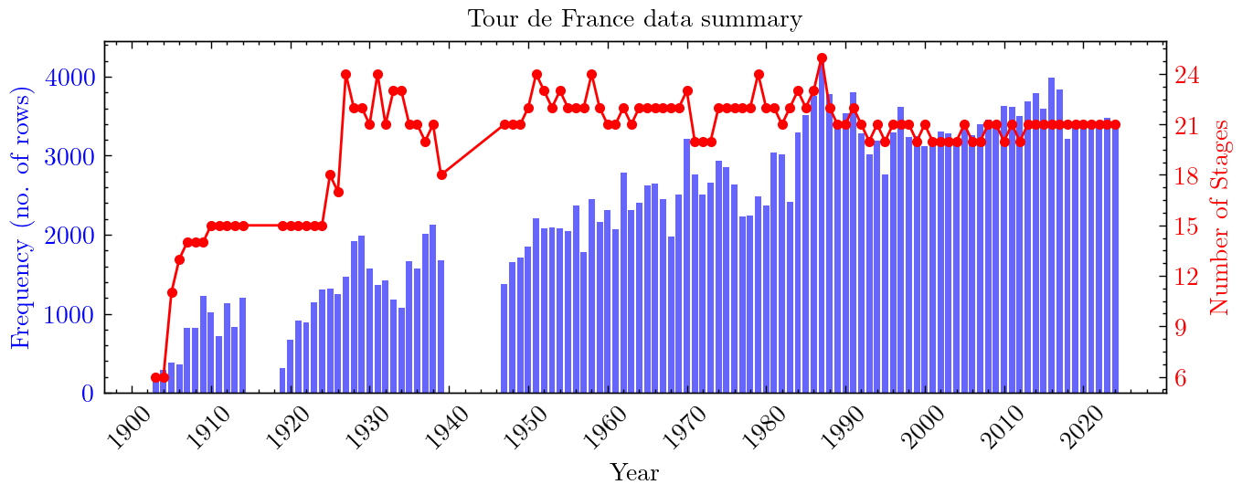
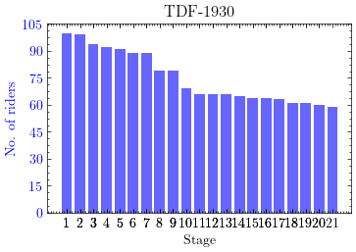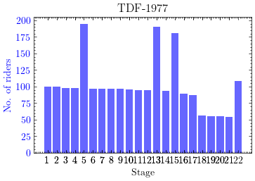
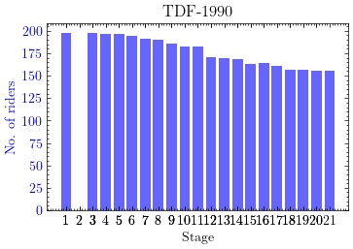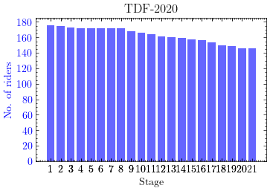

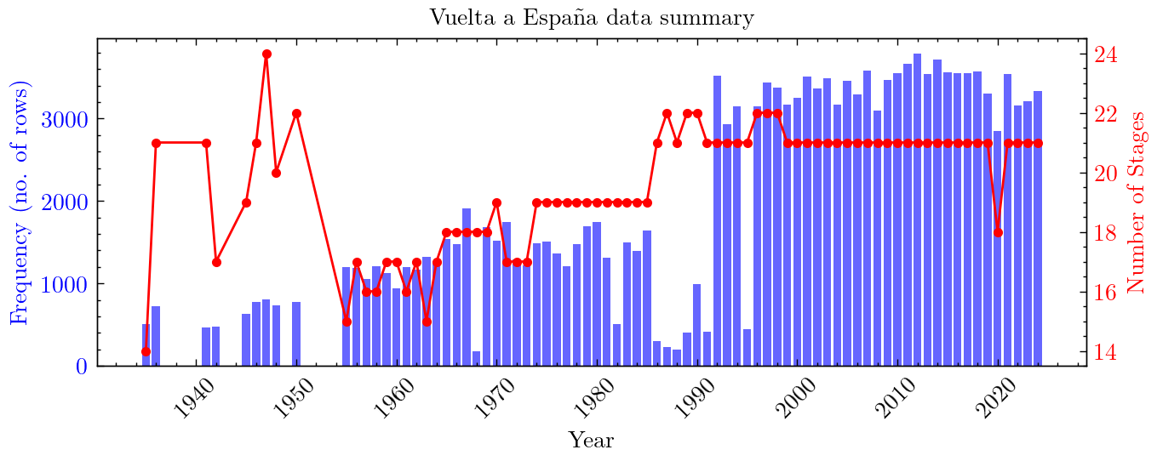
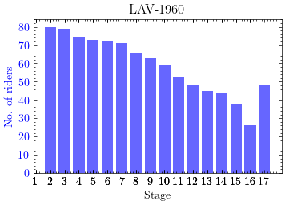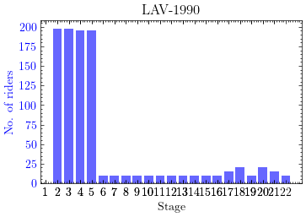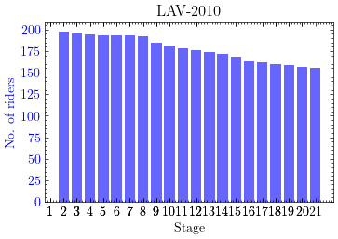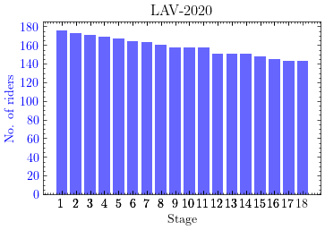

This project aims to analyze and predict performance trends in Grand Tours (Tour de France, Giro d’Italia, La Vuelta) using data from ProCyclingStats and Strava. We will
- scrape and integrate race and rider statistics,
- perform exploratory data analysis (EDA),
- classify stages based on terrain and difficulty, and
- build predictive models for race performance.
In addition to predicting race times, we will conduct statistical analyses on factors such as time gaps between riders, stage properties (like climbs, distance), and historical performance trends. Key research questions include identifying trends in rider speeds, distances, and climbing efforts, understanding factors influencing stage outcomes, and developing machine learning models to estimate race times. Expected outcomes include insights into performance trends, predictive models, and interactive visualizations. Challenges include data gaps, consistency issues.

