

UNIVERSITY OF COMPUTER STUDIES, YANGON
2025-2026 Academic Year
Data Analytic Project

Title
Student Performance Analysis

Covered by
Data Mining and Warehousing (IS-211)
Faculty of Information Science

Submitted by
Semester -VII (KE)

March, 2026
Group Members

Name | Roll Number
Kaung Myat Thu | YKPT-22289
Hein Htet Aung | YKPT-21900
Moe Paing Phyo | YKPT-22363
Myo Khant Thu | YKPT-22477
Myo Thant | YKPT-22465
Hlyan Htet Oo | YKPT-22633

Table of Contents
Chapter-1 Introduction 1
1.1 Project Description 1
1.2 Project Objective 2
Chapter-2 Data Source 3
2.1 Sample Data 3
2.2 Meta Data 4
Chapter-3 Business Intelligence Report 5
3.1 Applied ETL Process 5
3.2 Transformed Data 7
3.3 Data Visualization 8
3.3.1 Pie Chart 8
3.3.2 Tree Map 9
3.3.3 Scatter Plot 11
3.3.4 Line Chart 11
3.3.5 Box Plot 13
Chapter-4 Data Mining Report 14
4.1: Applied Methods 14
4.1.1 Data Preprocessing 14
4.1.2 Classification 15
4.1.3 Clustering 15
4.2: Evaluation on Applied Methods 16
4.2.1 Classification with Random Forest classifier 18
4.2.2 Clustering with SimpleKMeans 20
4.3 Knowledge Representation 21
4.3.1 Random Forest: Visualize Classifier Error 21
4.3.2 Random Forest: Visualize Margin Curve 22
4.3.3 Visualize Threshold Curve 23
4.3.4 KMeans: Visualize Cluster Assignment 24
Chapter 5 Conclusion 27
References 28

Chapter-1
Introduction
The analysis of student academic performance plays a vital role in enhancing educational outcomes, improving student support systems, and supporting decision-making in academic institutions. With the growing volume of student data in educational systems, the ability to automatically identify at-risk students and understand learning patterns has become increasingly important. This paper proposes the development of a data mining system that predicts student success using behavioral features such as study hours, attendance, and motivation. By applying machine learning models, including Random Forest for classification and K-Means clustering for unsupervised grouping, the system aims to provide accurate student outcome prediction and meaningful insights into the relationship between learning behaviors and academic success.
By incorporating study hours (which measures the time students dedicate to learning) and motivation (which represents their self-reported drive to succeed), the system leverages two important features that strongly influence academic performance. With this data mining approach, the project seeks to contribute to the automation of student success prediction, support early intervention strategies, and provide tools for educators, administrators, and academic advisors.

1.1 Project Description
This project focuses on the creation of a data mining and machine learning–based system to predict student success using study hours, attendance, and motivation features. The system applies supervised learning (Random Forest) for student outcome classification (PASS/FAIL) and unsupervised learning (K-Means clustering) for pattern discovery. By integrating these techniques, the project aims to evaluate the effectiveness of behavioral features in predicting academic success, while also identifying hidden structures within the student dataset.
The growing volume of educational data and the diversity of student learning patterns demand automated analysis methods that go beyond traditional grade tracking. This project addresses that need by providing a model that assists in identifying at-risk students, thereby enabling better intervention programs, personalized learning recommendations, and academic analytics. Ultimately, the system will equip decision-makers—such as educational institutions, teachers, and academic advisors—with the insights needed to understand student behaviors and improve educational outcomes.

1.2 Project Objective
The primary objective of this project is to develop a student success prediction system that uses study hours, attendance, and motivation as input features for both supervised and unsupervised learning techniques. Specific objectives include:
- Classification Analysis: Use Random Forest to classify students into PASS or FAIL categories based on their behavioral features.
- Clustering Analysis: Apply K-Means clustering to group students based on feature similarity and uncover hidden learning patterns.
- Trend Analysis: Identify how study hours, attendance, and motivation values vary across different student groups and age demographics.
- Performance Evaluation: Compare the accuracy and reliability of Random Forest classification with K-Means clustering outcomes.
- Early Intervention: Provide a scalable way to identify at-risk students before they fail, enabling timely support.
By leveraging these analytical capabilities, the project aims to enhance student success prediction methods, support educational data mining, and contribute to the development of intelligent academic support systems.

Chapter-2
Data Source
The dataset under consideration originates from Mohammed V University of Rabat (Université Mohammed V de Rabat), a premier public research university in Morocco. Established in 1957, it is the first modern university founded in Morocco after its independence and is widely considered the leading research university in the country, frequently ranking as the top university in the Maghreb region.
The dataset was compiled for student performance analytics and contains 14,003 rows and 16 columns, offering a well-structured collection of student-related features. Each row in the dataset corresponds to a single student record, and the columns capture both behavioral and demographic attributes in their original raw form. The dataset serves as the foundation for both business intelligence visualization and data mining analysis.
The data is publicly available through the Zenodo research data repository under record ID 16459132, ensuring transparency and accessibility for educational research purposes.

2.1 Sample Data

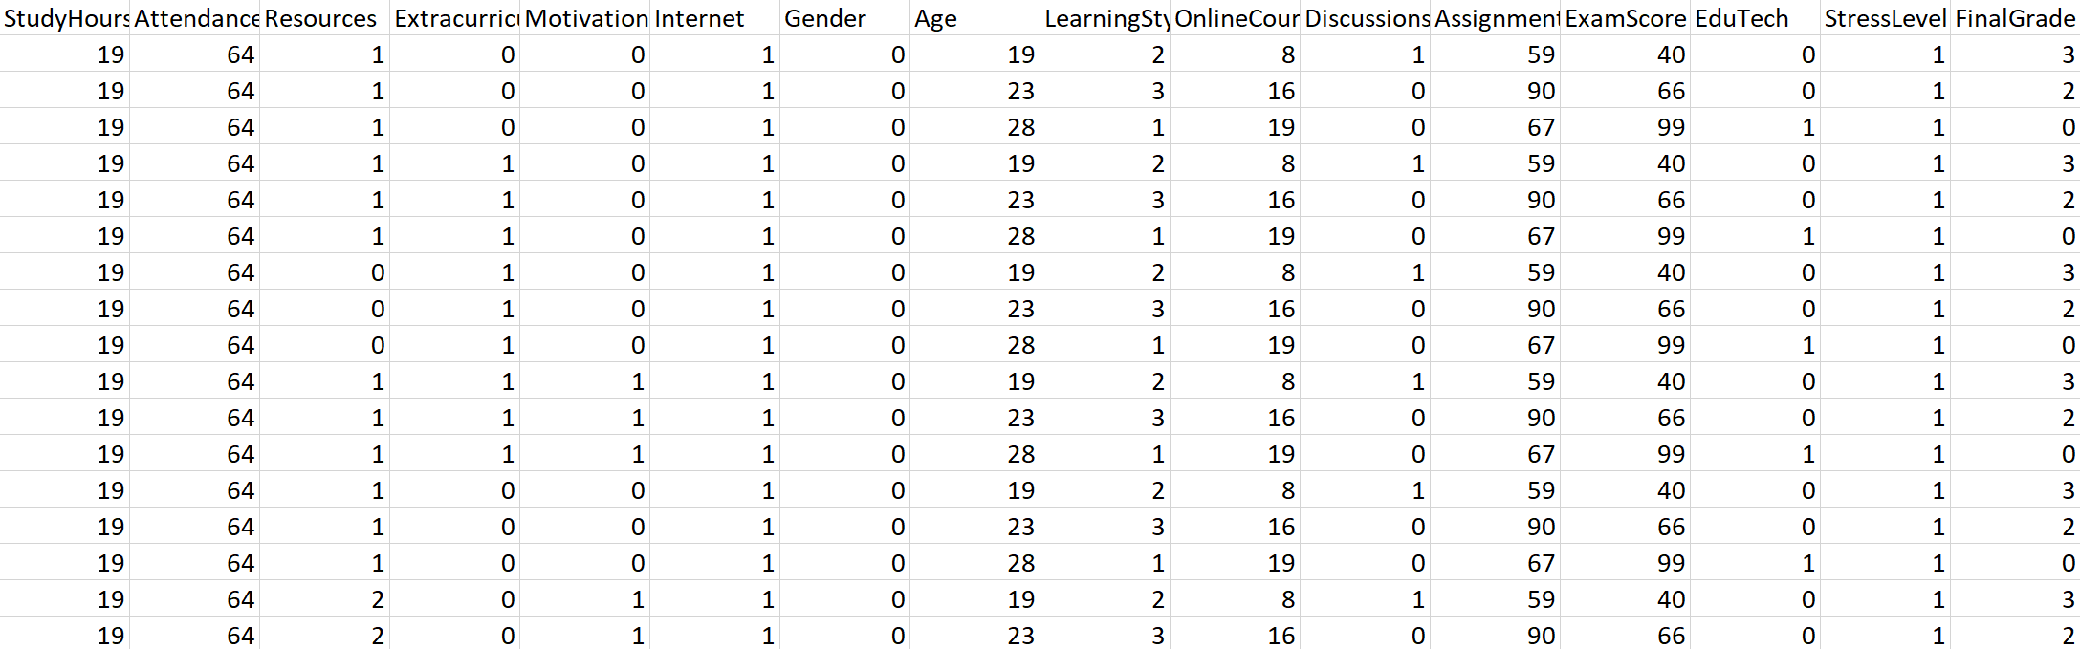Figure 2.1.1 Sample Data

2.2 Meta Data
The dataset's columns in their original form include the following features:
- StudyHours – A numeric measure representing the average hours per week a student spends studying.
- Attendance – A numeric value representing class attendance rate.
- Resources – A binary indicator (0/1) of whether the student uses learning resources.
- Extracurricular – A binary indicator (0/1) of participation in extracurricular activities.
- Motivation – A self-reported motivation score.
- Internet – A binary indicator (0/1) of internet access at home.
- Gender – Binary encoding (0 = Female, 1 = Male) in the raw data.
- Age – Student age (numeric, range 18-29).
- LearningStyle – Preferred learning style category.
- OnlineCourses – Binary indicator (0/1) of online course participation.
- Discussions – Binary indicator (0/1) of participation in class discussions.
- AssignmentCompletion – Rate of completing assignments.
- EduTech – Binary indicator (0/1) of educational technology usage.
- StressLevel – Self-reported stress level (0 = Low, 1 = Medium, 2 = High).
- FinalGrade – Original final grade encoding (0 = A, 1 = B, 2 = C, 3 = D).
The dataset is especially valuable because it provides both quantitative behavioral features (like study hours, attendance, motivation) and qualitative descriptors that enable comprehensive educational data mining.

Chapter-3
Business Intelligence Report

3.1 Applied ETL Process
The ETL (Extract, Transform, Load) process was carried out in Power BI to prepare the student dataset for analysis and visualization.
Extract
The raw dataset containing 14,003 student records with behavioral features (study hours, attendance, motivation, etc.) was imported into Power BI using the Get Data option from a CSV source. At this stage, the data was in its original form with encoded values and raw numerical fields.
Transform
After loading the raw dataset, the Power Query Editor was used to perform data cleaning and transformation. The following key steps were applied:
Data Cleaning Steps:
- Renamed columns to ensure clear and consistent naming conventions.
- Changed data types (e.g., set Age as whole number, StudyHours as decimal).
- Checked for missing or null values – none were found in this dataset.
- Removed duplicate records – none were identified.
Column Transformations:
- Created Student_ID: Added an index column (From 1) to serve as a unique identifier for each student.
- Mapped Gender values: Used Replace Values function to convert:
  - 0 → Female
  - 1 → Male
- Mapped StressLevel values: Converted numerical codes to descriptive labels:
  - 0 → Low
  - 1 → Medium
  - 2 → High
- Created Result column: Derived from FinalGrade using a conditional column:
If FinalGrade = 3 then "FAIL" else "PASS"
(Where FinalGrade encoding: 0 = A, 1 = B, 2 = C, 3 = D)
New Columns for Analysis:
- Age_Group: Created age brackets for trend analysis:
if Age < 20 then "18-20"
else if Age < 23 then "21-23"
else if Age < 26 then "24-26"
else "27+"
- Study_Bin: Categorized study hours into meaningful groups:
if StudyHours <= 15 then "Low (≤15)"
else if StudyHours <= 20 then "Medium (16-20)"
else if StudyHours <= 25 then "High (21-25)"
else "Very High (>25)"
Final Cleaning:
- Removed original columns that were no longer needed after transformations (e.g., FinalGrade was removed after creating Result).
- Verified data integrity to ensure all transformations were applied correctly.
Load
Once cleaned and transformed, the dataset was loaded into the Power BI data model. This prepared dataset was then used to generate interactive charts and visualizations for the Business Intelligence report, and later exported for machine learning tasks in Weka.
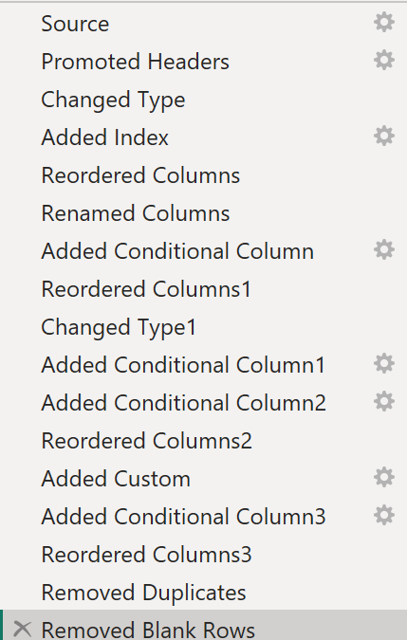
Fig 3.1.1 Applied Steps for Transforming Process

3.2 Transformed Data
After loading the dataset into Power BI, the Transform Data option was used to open the Power Query Editor. Several cleaning and transformation steps were applied, including:
- Renaming columns for better readability.
- Changing data types.
- Removing duplicates.
- Handling missing or null values.
- Replacing inconsistent values.
In this project, encoded categorical values were transformed into descriptive labels using the Replace Values function. Specifically:
- Gender values were converted from 0 and 1 to Female and Male.
- StressLevel values were mapped from numeric codes (0, 1, 2) to descriptive labels (Low, Medium, High).
New columns were created for analysis:
- Age_Individual: Created by converting the numeric Age column to a categorical format (e.g., "Age 18", "Age 19") for detailed age-based visualizations.
- Age_Group: Created using a conditional column to group students into broader age brackets:
  - 18-20
  - 21-23
  - 24-26
  - 27+
- Result: Derived from FinalGrade using a conditional column to classify students as PASS or FAIL (where FinalGrade = 3 indicates FAIL, otherwise PASS).
Finally, Student_ID was added as an index column to serve as a unique identifier for each student.

Before Transformation
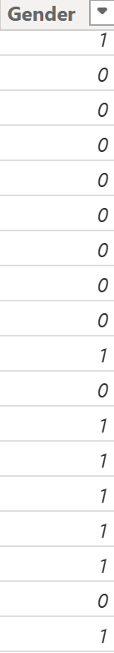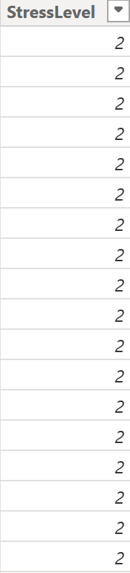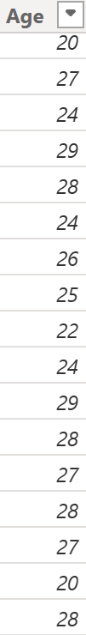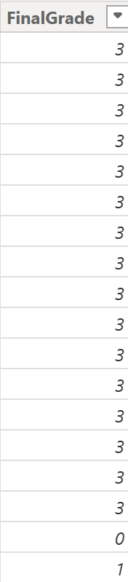

Fig 3.2.1 Dataset before transformation
After Transformation
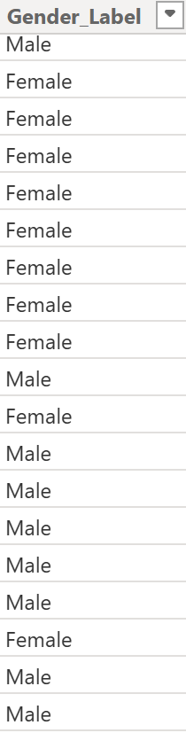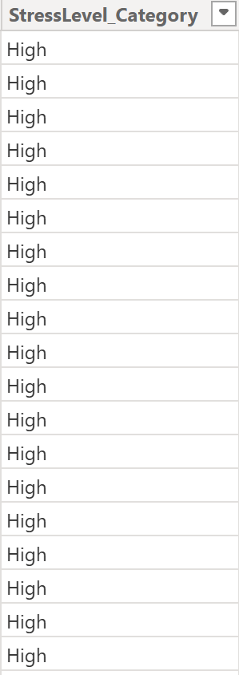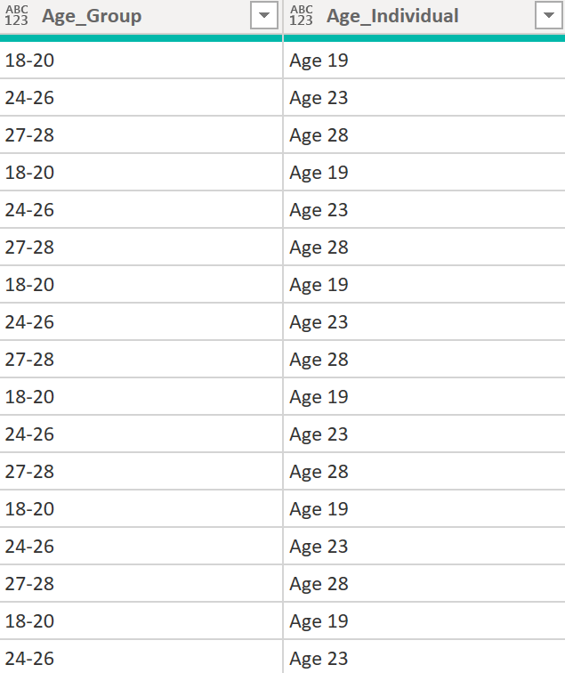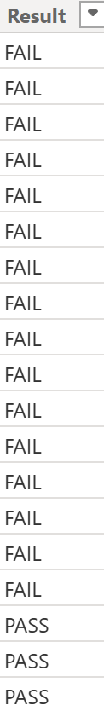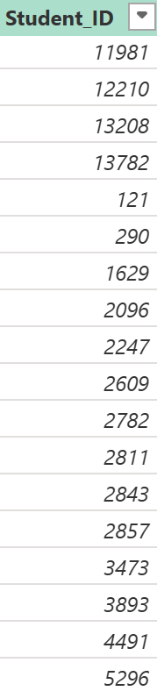
Fig 3.2.2 Dataset after transformation

3.3 Data Visualization

3.3.1 Pie Chart

Overall Student Success Rate
A pie chart was created to show the distribution of students by academic outcome. Each slice represents PASS or FAIL, with its size corresponding to the number of students in that category. This provides a clear overview of the success rate in the dataset.

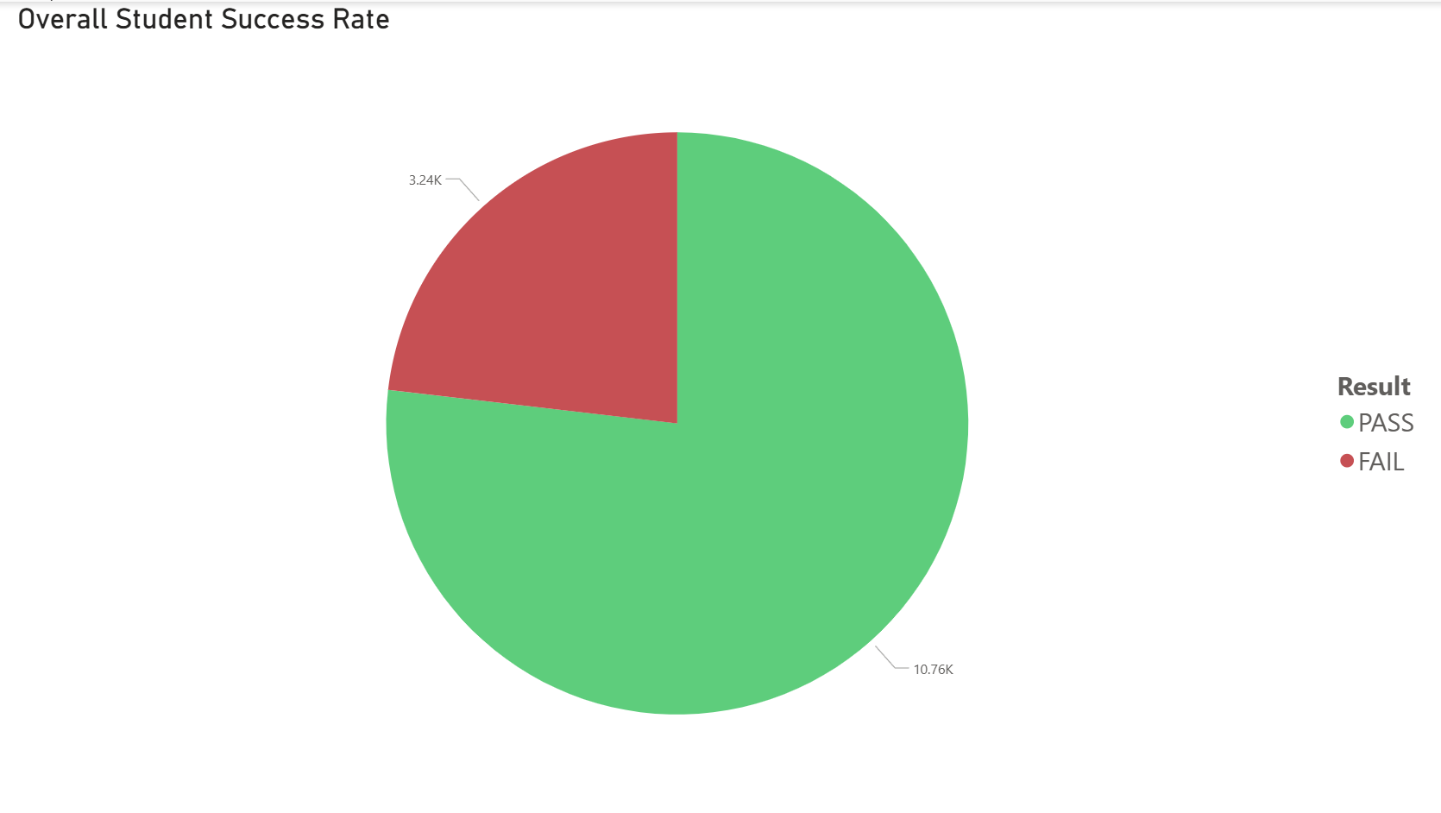

Fig 3.3.1.1 Pie chart for Student Outcome (PASS/FAIL)
Insight: The dataset contains approximately 77% PASS and 23% FAIL students, providing a balanced basis for further analysis.

Gender Distribution
A second pie chart shows the gender composition of the student population.
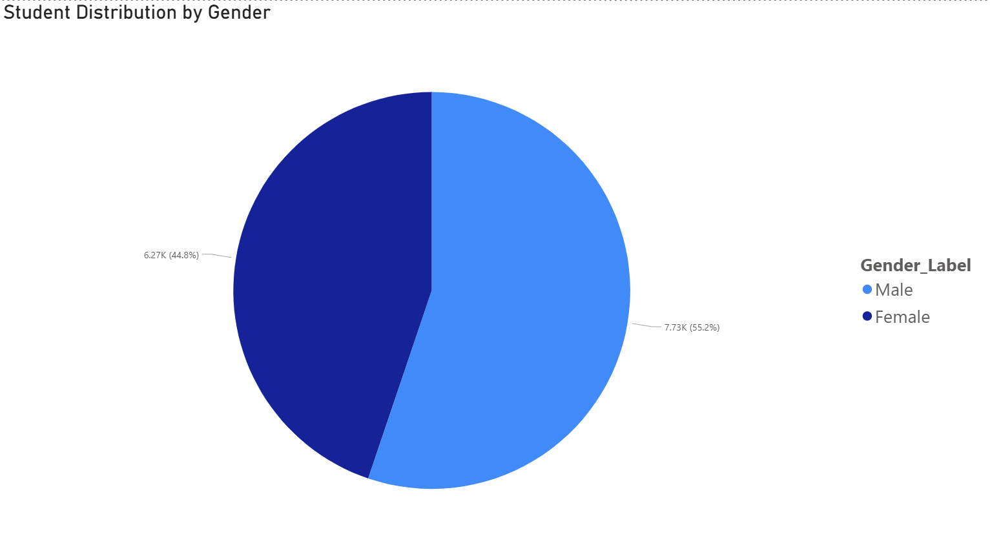
Fig 3.3.1.2 Gender Distribution
Insight: The student distribution by Gender is relatively balanced, allowing for meaningful comparative analysis between male and female students.

3.3.2 Tree Map

Average Study Hours by Individual Age and Student Outcome
A tree map was created to visualize the distribution of average study hours across individual ages (18-29) and student outcomes (PASS/FAIL). Each rectangle represents a specific age-outcome combination (e.g., Age 18 - PASS, Age 18 - FAIL, Age 19 - PASS, etc.), with the size of each rectangle corresponding to the average study hours for that group.
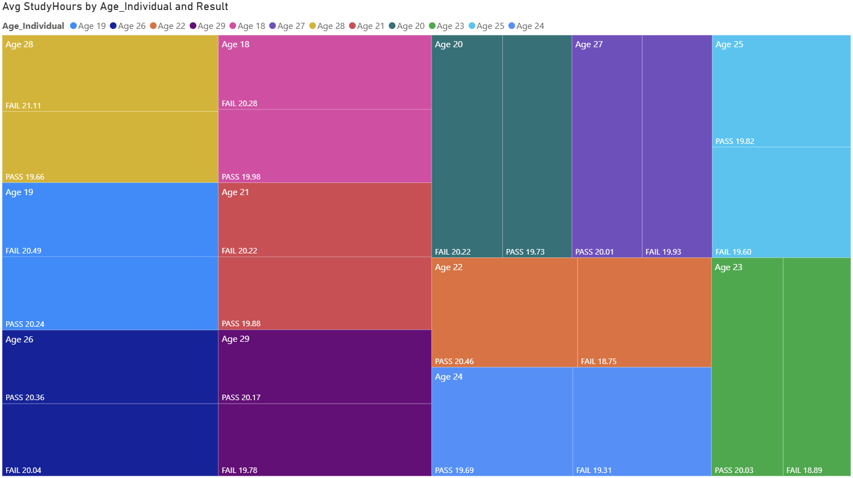
Fig 3.3.2.1 Average Study Hours by Age and Result
Insight: This visualization reveals how study effort varies across different ages and between successful and struggling students. Larger rectangles indicate higher average study hours, allowing quick identification of which age groups and outcomes demonstrate the strongest study commitment.

How Study Hours Impact Student Success Rates
A second tree map was created to directly visualize the relationship between study hours and academic success. In this visualization, students are grouped by their study hour categories (e.g., Low, Medium, High, Very High), with rectangles sized by the number of students in each category and colored or segmented by student outcome (PASS/FAIL).
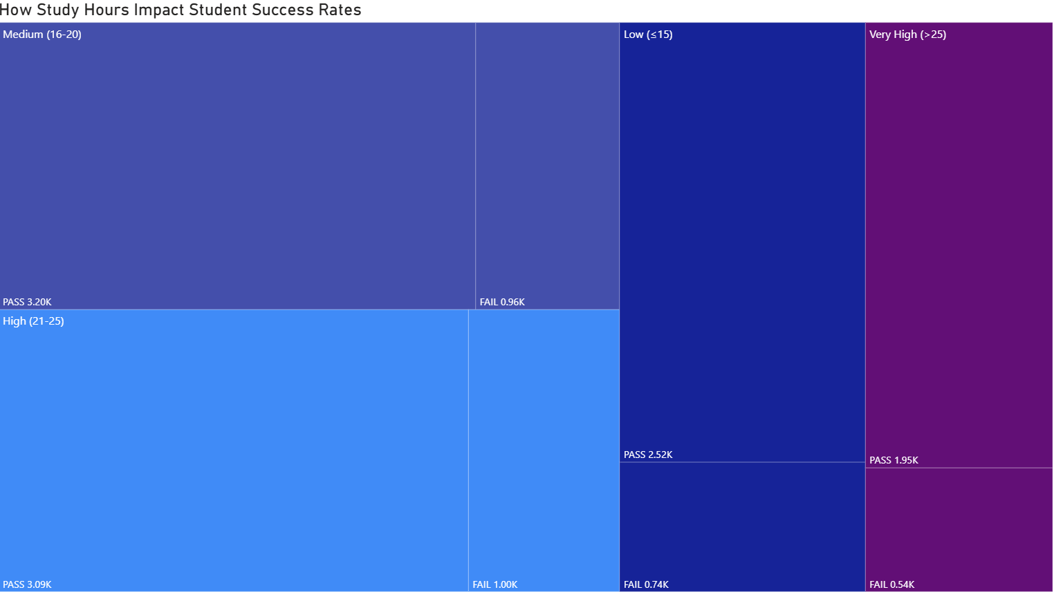

Fig 3.3.2.2 How Study Hours Impacted Student Success Rate
Insight: This tree map clearly demonstrates that as study hours increase, the proportion of PASS students grows larger relative to FAIL students. The "Very High (>25)" study hour category shows the largest PASS segment, while the "Low (≤15)" category reveals a much higher concentration of FAIL students. This visual evidence supports study hours as a critical factor in academic success.

3.3.3 Scatter Plot
A scatter plot was created to visualize the relationship between study hours and attendance, with points colored by student outcome (PASS/FAIL). Each dot represents an individual student, allowing us to see patterns and correlations between these two key behavioral metrics.
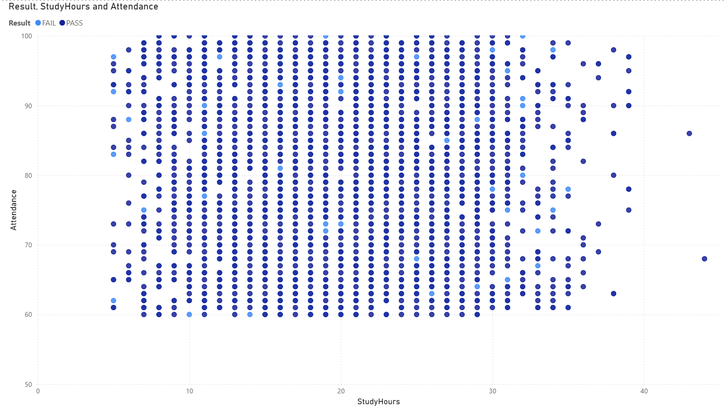
Figure 3.3.3.1 Scatter Plot for Study Hours vs Attendance by Student Outcome
Insight: The scatter plot reveals that at every study hour level, PASS students (green) consistently achieve higher attendance rates than FAIL students (red). The vertical columns demonstrate that even among students with identical study time, attendance serves as a key differentiator between successful and struggling students. Higher concentrations of green dots in the upper regions of each column indicate that successful students tend to maintain better attendance regardless of their study hours.

3.3.4 Line Chart
Average Study Hour and Average Motivation by Age
A line chart was created to visualize study hours and motivation trends across different age groups. This visualization helps identify how these two key behavioral factors evolve as students’ progress through their academic journey.
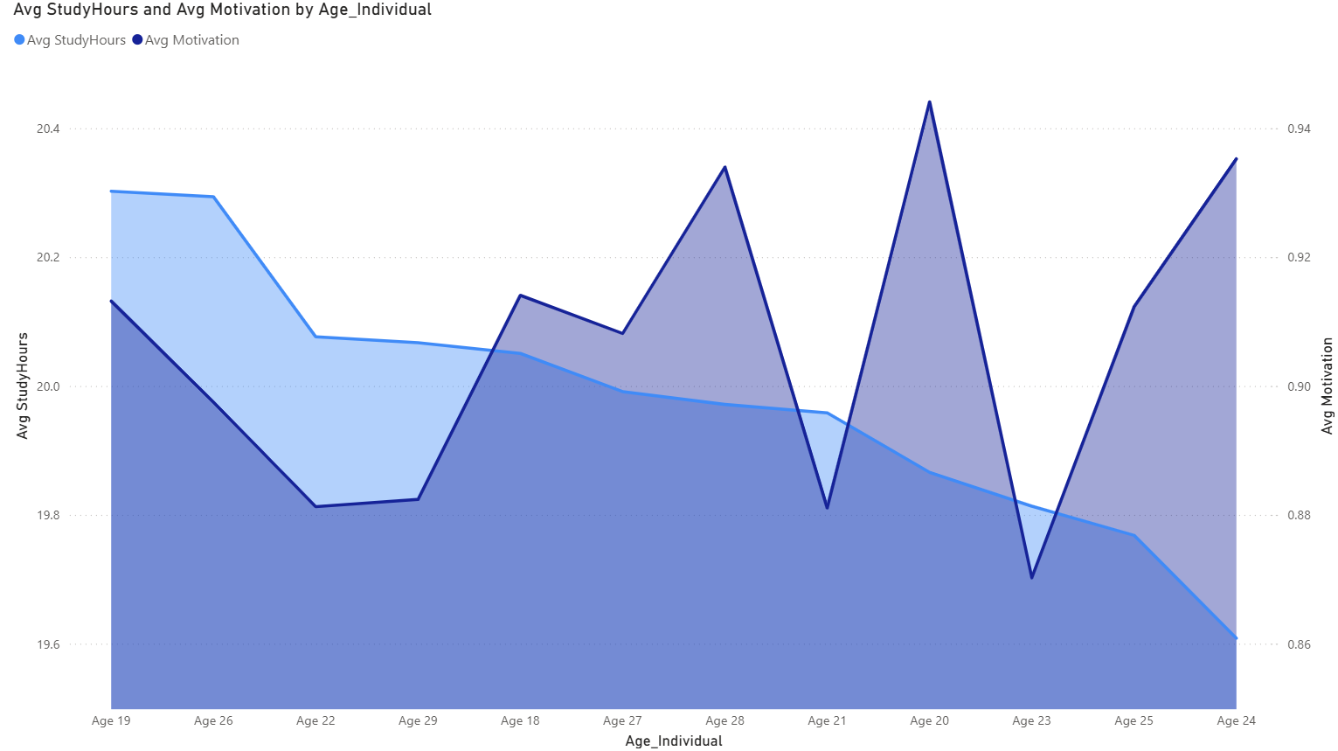
Fig 3.3.4.1 Line Chart for Study Hours and Motivation by Age
Insight: The chart reveals that study hours remain relatively stable across ages 18–29, with a slight peak around age 22. Motivation shows a gradual decline with age, suggesting that while study effort remains consistent, intrinsic drive may decrease as students near graduation. The inverse relationship between study hours and motivation in older age groups (26–29) indicates that students may need to study more to maintain performance as motivation wanes.
Motivation by Age – PASS vs FAIL Comparison
A line chart was created to compare motivation trends across different age groups for PASS and FAIL students. This visualization highlights how self-reported motivation levels evolve with age and how they differ between successful and struggling students.
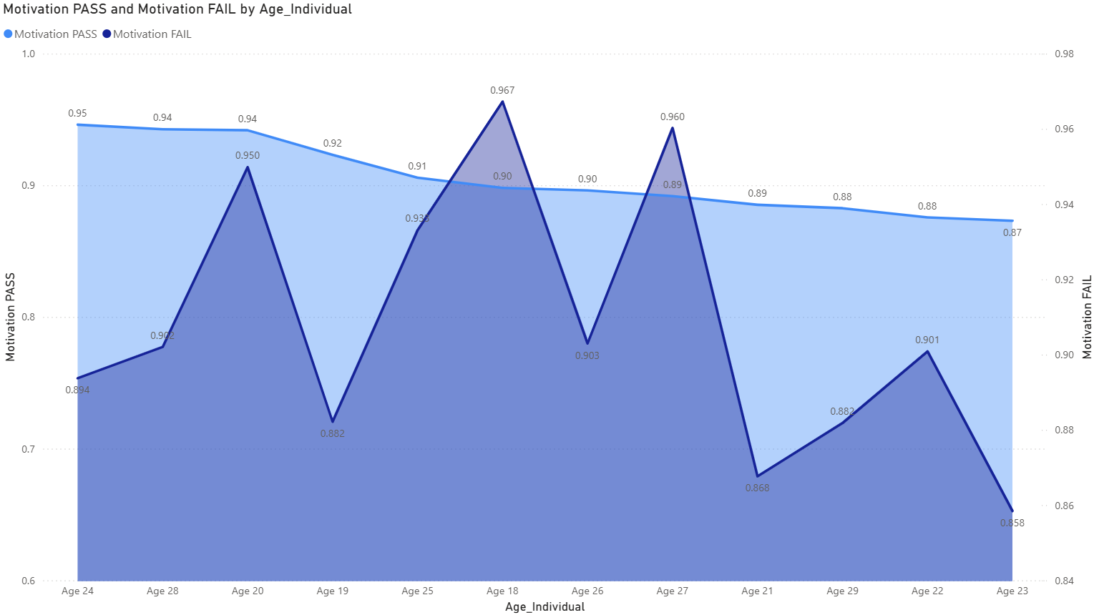
Fig 3.3.4.2 Line Chart for Motivation by Age – PASS vs FAIL
Insight: Motivation levels for both PASS and FAIL students show a gradual decline as age increases, with a noticeable dip during the mid-20s. However, PASS students consistently maintain a slight motivational advantage across nearly all age groups, suggesting that sustained motivation — even at moderate levels — contributes to academic success.

3.3.5 Box Plot
Stress Level Distribution by Student Outcome
A box plot was generated to illustrate the distribution of stress levels across PASS and FAIL student groups. Each dot represents an individual student's stress level (0 = Low, 1 = Medium, 2 = High). This visualization provides insights into how stress levels differ between successful and struggling students.
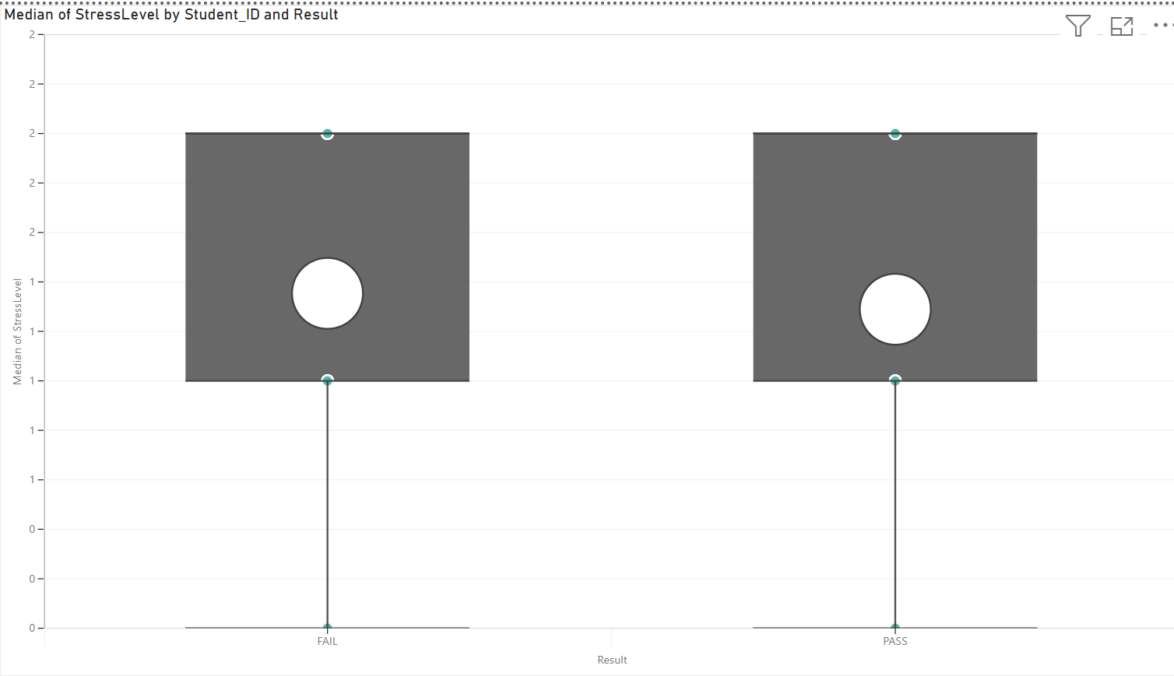
Fig 3.3.5.1 Box Plot of Stress Level Distribution by Student Outcome
Insight: The visualization reveals that FAIL students are disproportionately concentrated at higher stress levels (2), while PASS students are more evenly distributed across lower stress levels (0-1). This suggests a correlation between elevated stress and academic difficulty.

Chapter-4
Data Mining Report

4.1: Applied Methods
We applied several common methods to analyze our data using the Weka application, which is a popular and versatile open-source machine learning software that provides a wide range of tools for data mining and machine learning tasks. It supports various applied methods for building, evaluating, and deploying machine learning models.

4.1.1 Data Preprocessing
The dataset contains both numerical and categorical attributes.
- Numerical Attributes: StudyHours, Attendance, Motivation, Age, AssignmentCompletion, StressLevel
- Categorical Attributes: Gender, LearningStyle, Result (target variable)
Preprocessing Steps in Weka:
Before applying machine learning algorithms, the following preprocessing steps were performed in Weka:
- Removed unnecessary columns: Student_ID (unique identifier not needed for modeling) and FinalGrade (original grade encoding) were removed to prevent data leakage and circular logic.
- Set target variable: The Result column (PASS/FAIL) was designated as the class attribute for classification tasks.
- Normalization: For clustering algorithms, numerical features (StudyHours, Attendance, Motivation, Age, AssignmentCompletion, StressLevel) were normalized to ensure equal weighting in distance calculations.
- Data verification: The dataset was checked for missing values (none found) and correct attribute types.
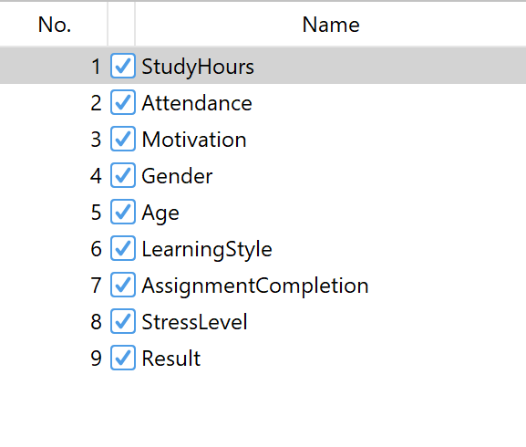
Figure 4.1.1.1: Dataset in Weka after preprocessing

4.1.2 Classification
Random Forest is a powerful ensemble learning method that constructs multiple decision trees during training and outputs the mode of their predictions for classification.
We used the Random Forest classifier in Weka to leverage the diverse set of base learners (trees) to classify and predict student success (PASS/FAIL) based on behavioral features such as study hours, attendance, motivation, and stress level, along with other supporting attributes.
The primary goal of applying Random Forest in this context is not only to classify individual students into PASS or FAIL categories, but also to uncover underlying trends and patterns in how behavioral characteristics correlate with academic success. This ensemble method improves accuracy and reduces overfitting, while its feature importance output reveals which attributes most influence student outcome prediction.
Random Forest Configuration:
- Number of trees (iterations): 100
- Number of features (K): 0 (use all available)
- Seed: 1
- Test mode: 10-fold cross-validation
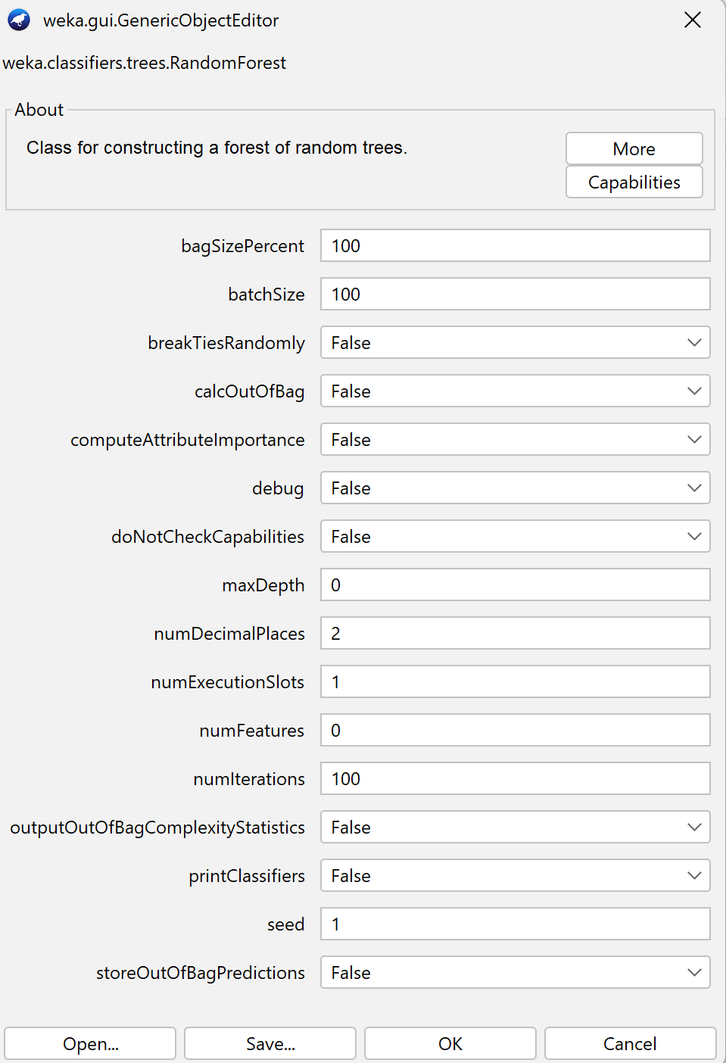
Figure 4.1.2.1: Random Forest Setup in Weka

4.1.3 Clustering
SimpleKMeans is Weka's implementation of the K-Means clustering algorithm for unsupervised clustering of data. It performs partitioning of a dataset into k clusters.
We used SimpleKMeans in Weka to perform unsupervised clustering of students based on behavioral features like study hours, attendance, motivation, and stress level. The algorithm partitions the dataset into k clusters, grouping students with similar learning characteristics.
This helps reveal hidden patterns—such as which student profiles naturally cluster together—and allows us to analyze each cluster's defining traits. Clustering supports trend discovery beyond predefined labels and aids in building better intervention strategies by identifying similar student groups.
K-Means Configuration:
- Number of clusters (k): 3 (determined through experimentation)
- Seed: 100
- Distance function: Euclidean distance
- Maximum iterations: 500
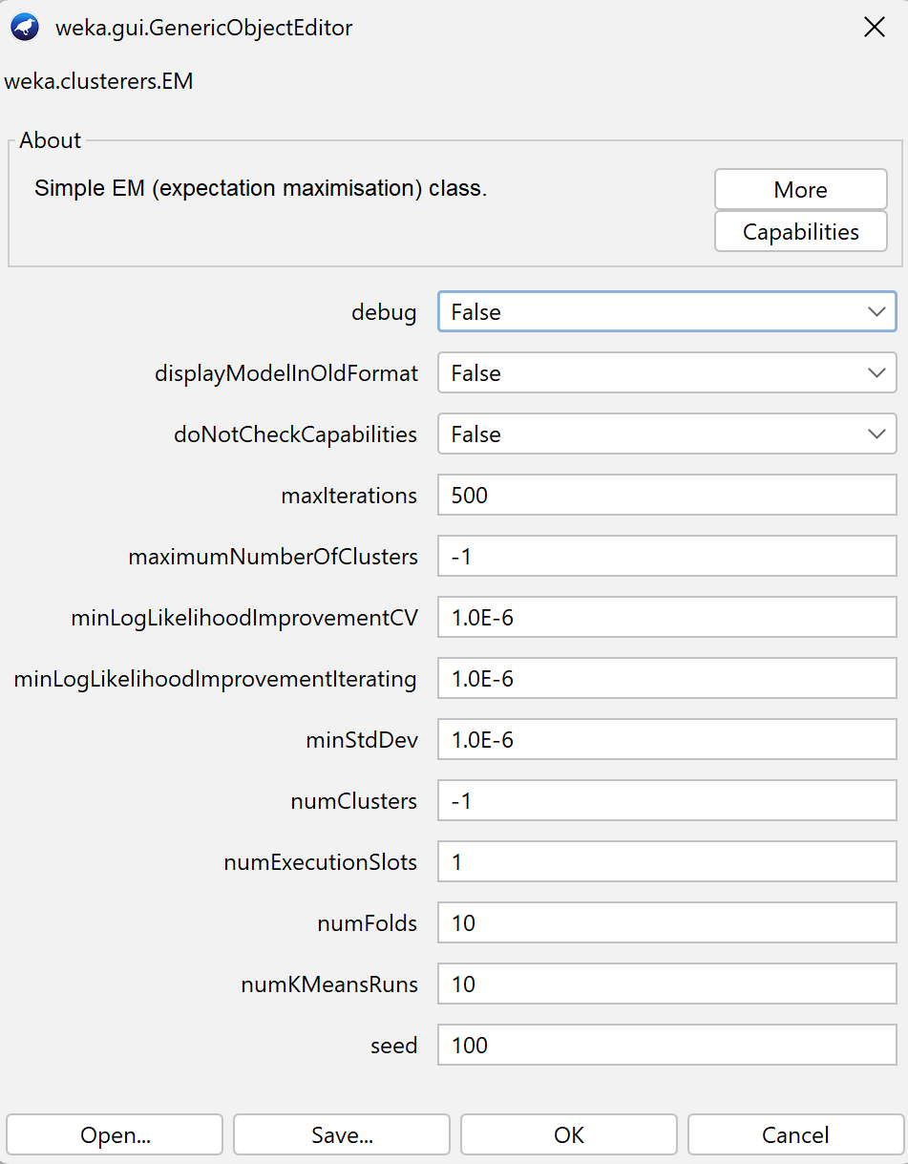
Figure 4.1.3.1: SimpleKMeans Setup in Weka

4.2: Evaluation on Applied Methods
Prior to modeling, we analyzed the distribution and relevance of all available features. Our dataset includes 14 behavioral attributes that capture different aspects of student learning patterns and demographics.
Feature Analysis
The dataset contains a mix of numerical and categorical attributes:

Feature Type | Attributes
Behavioral | StudyHours, Attendance, AssignmentCompletion, OnlineCourses, Discussions
Psychological | Motivation, StressLevel
Demographic | Age, Gender
Resource Access | Internet, Resources, EduTech
Engagement | Extracurricular, LearningStyle

All selected features have demonstrated relevance in educational data mining literature. Study hours and attendance are consistently cited as strong predictors of academic success, while motivation and stress levels provide important psychological context.
Data Quality Assessment
- Missing Values: None found across all 14,003 records
- Duplicates: No duplicate records detected
- Outliers: Mild outliers in study hours and stress levels were retained as they represent legitimate student variations
- Class Balance: 77% PASS (10,760 students), 23% FAIL (3,240 students) – slightly imbalanced but reflects real-world scenarios
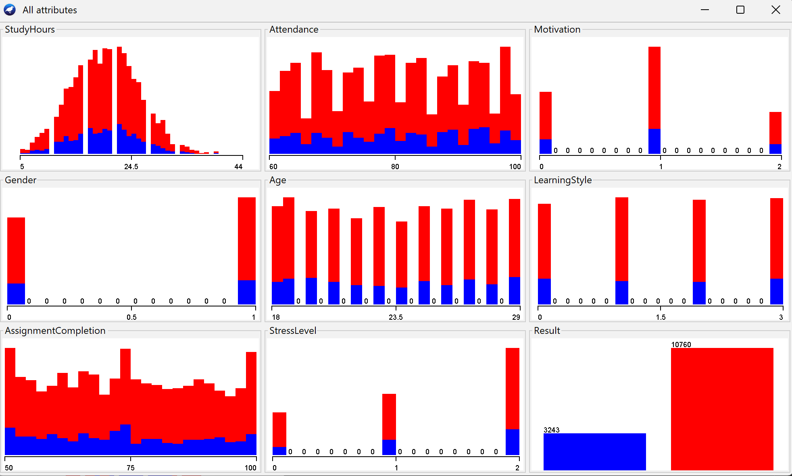
Figure 4.2.1: Distribution of Behavioral Features Across Student Outcomes

Preprocessing Summary
For Classification | For Clustering
Removed Student_ID and FinalGrade | Normalized numerical features to [0,1]
Set Result as target class | Removed Result column for unsupervised learning
Retained all behavioral features | Retained all behavioral features
Algorithm Selection Justification
- Random Forest: Handles mixed data types, robust to outliers, provides feature importance ranking, reduces overfitting
- K-Means: Simple, interpretable, computationally efficient for 14,003 records, provides clear cluster profiles

4.2.1 Classification with Random Forest classifier
Using Random Forest with 10-fold cross-validation, our model achieved 97% accuracy in predicting student success. The detailed results are presented below.
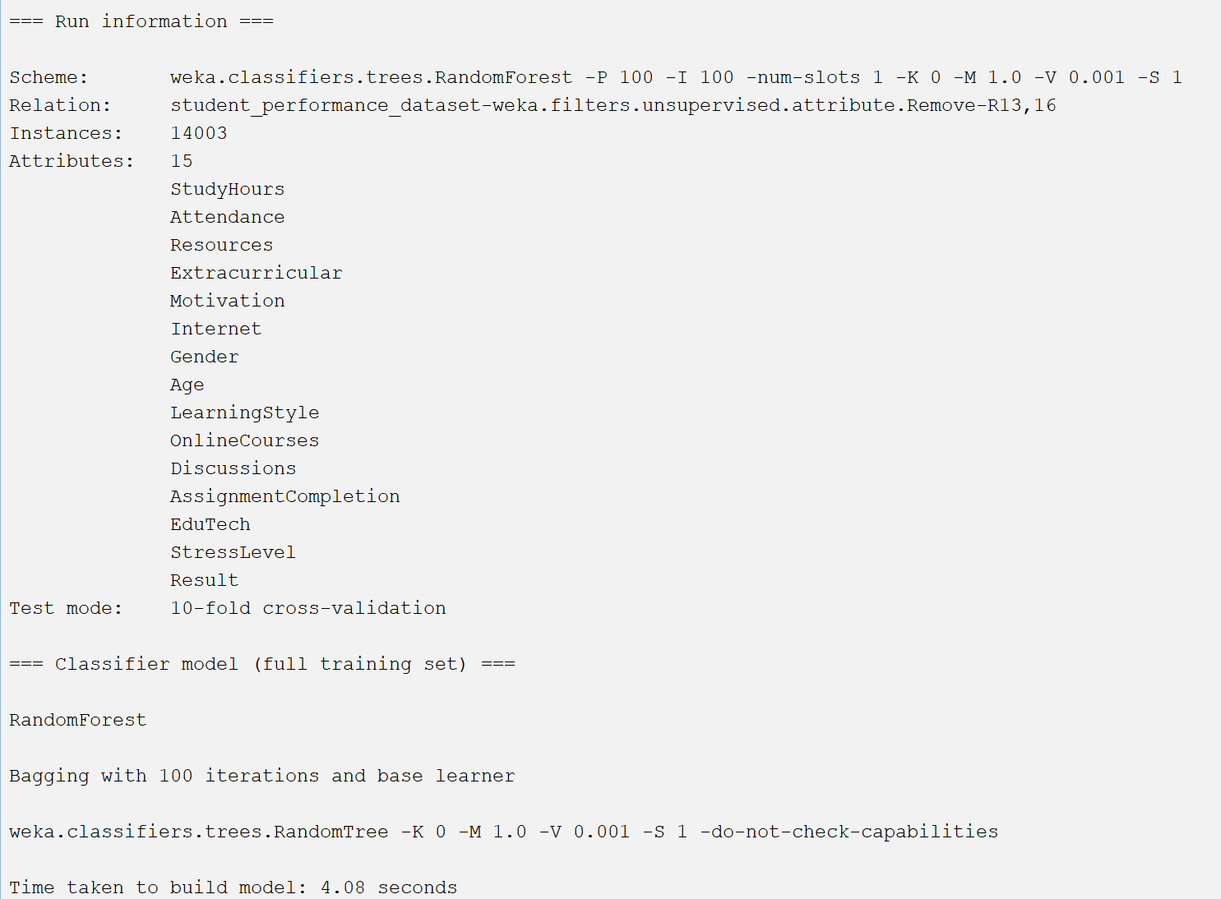
Figure 4.2.1.2: Random Forest Classification Run Information in Weka
Confusion Matrix:
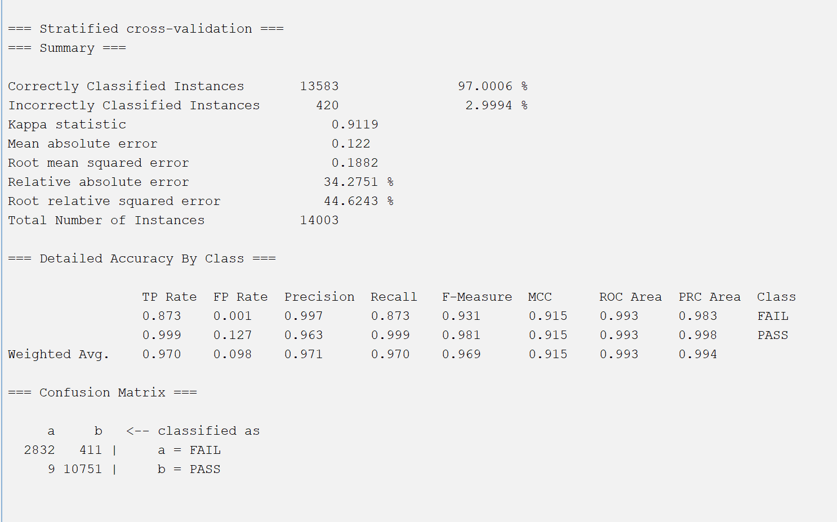

Figure 4.2.1.2: Random Forest Classification Results in Weka
Interpretation of Results:
Metric | Value | Interpretation
Accuracy | 97.0% | The model correctly predicts student outcomes for 97 out of every 100 students
Kappa statistic | 0.9119 | Almost perfect agreement between predictions and actual values (1.0 would be perfect)
True Negatives (FAIL) | 2,832 | 87% of actual FAIL students were correctly identified
True Positives (PASS) | 10,751 | 99.9% of actual PASS students were correctly identified
False Positives | 9 | Only 9 PASS students were incorrectly flagged as at-risk
False Negatives | 411 | 411 FAIL students were missed by the model (predicted as PASS)

The high accuracy demonstrates that behavioral features like study hours, attendance, and motivation are powerful predictors of academic success. The model is particularly strong at identifying PASS students (99.9% accuracy) and reasonably effective at catching at-risk students (87% accuracy).

4.2.2 Clustering with SimpleKMeans
Applying SimpleKMeans clustering with K=3 revealed three distinct student profiles based on behavioral characteristics.
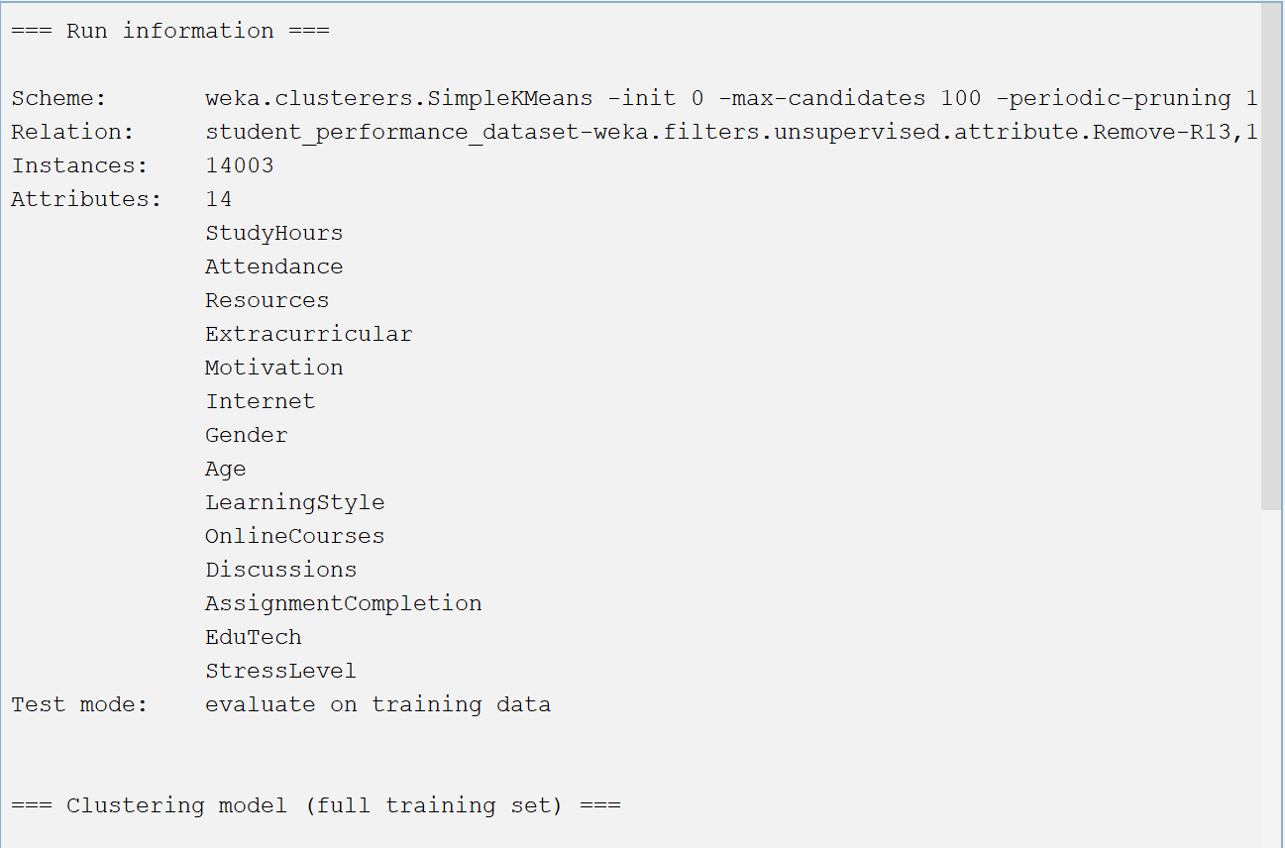
Figure 4.2.2.1: K-Means Cluster Centroids Run Information in Weka
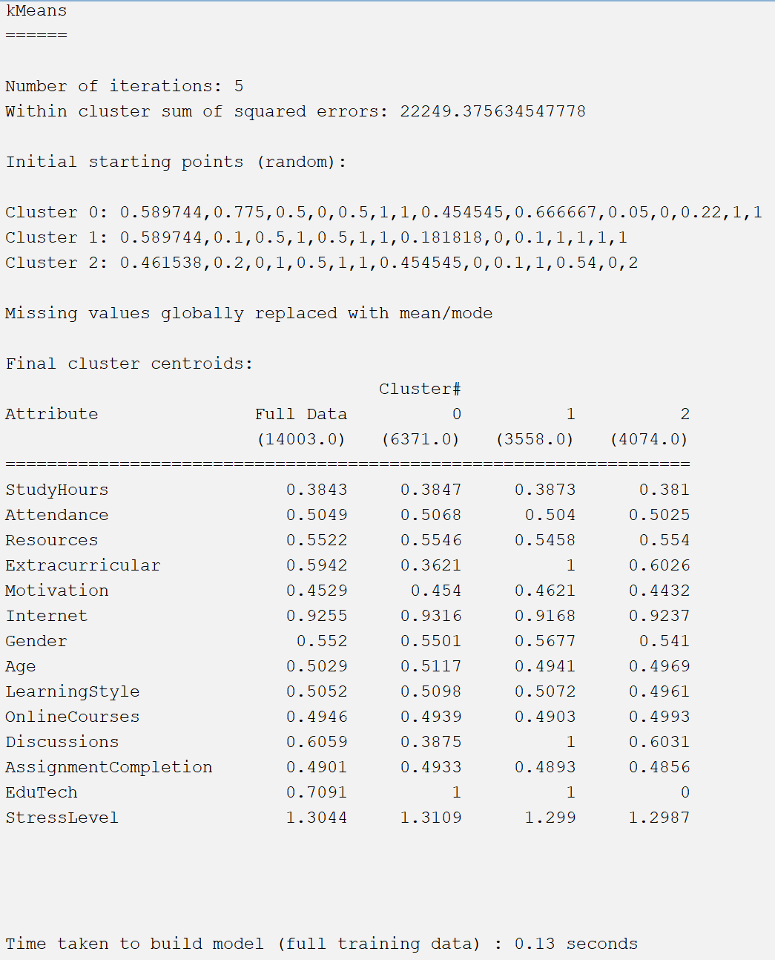
Figure 4.2.2.2: K-Means Cluster Result in Weka
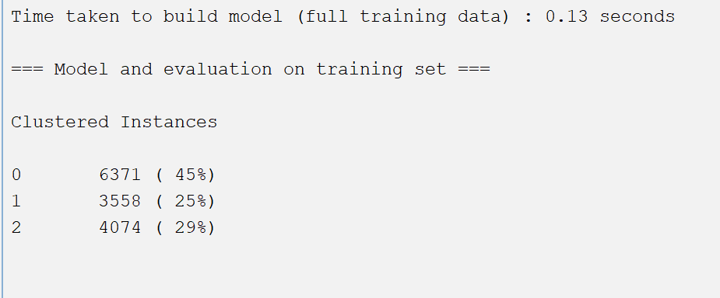
Figure 4.2.2.3: K-Means Cluster Centroids Instances in Weka
Cluster Distribution:
Cluster | Size | Percentage
Cluster 0 | 6,371 | 45%
Cluster 1 | 3,558 | 25%
Cluster 2 | 4,074 | 29%

4.3 Knowledge Representation
This section visualizes the outputs of our classification and clustering models to better understand their performance and underlying patterns.

4.3.1 Random Forest: Visualize Classifier Error
The classifier error plot shows the relationship between iteration number and error rate for the Random Forest model. The plot demonstrates how the ensemble of decision trees progressively reduces prediction error.
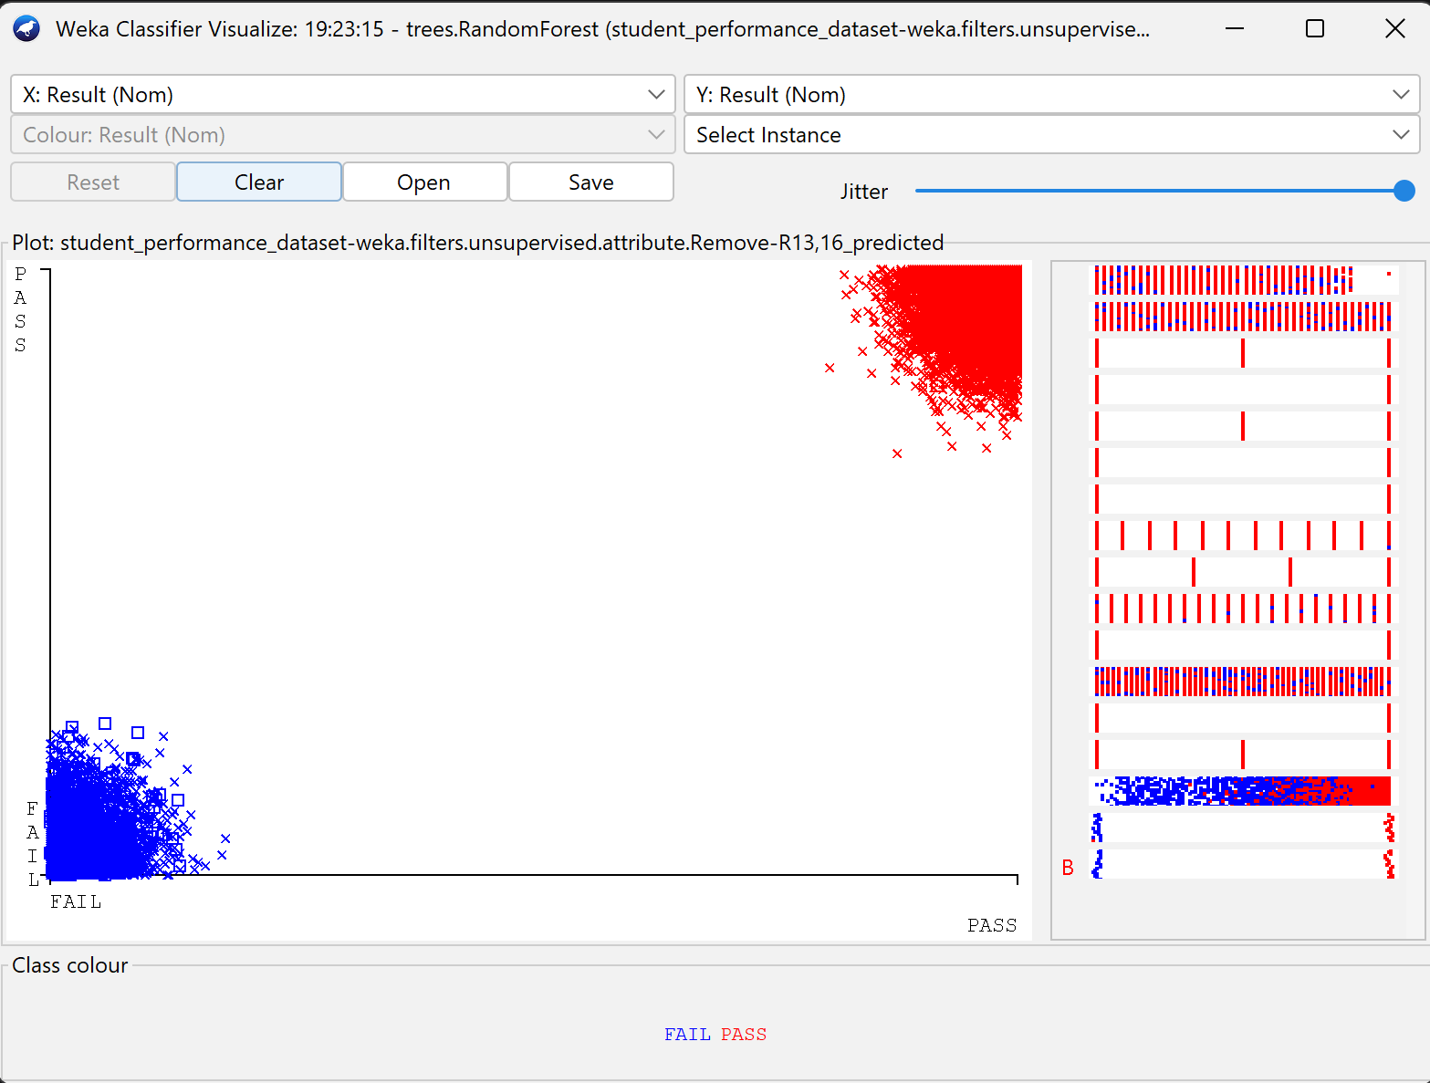

Figure 4.3.1.1: Classification Error of Random Forest Model
Interpretation: Blue points represent FAIL students, while red points represent PASS students. The clear separation between clusters—with FAIL students concentrated in the bottom-left region and PASS students in the top-right region—demonstrates the model's strong discriminative ability. Crosses (+) indicate correct classifications, while squares (□) show errors. The predominance of crosses confirms the model's 97% accuracy. The error rate stabilizes quickly, indicating that the model converges efficiently. The consistently low error rate across iterations confirms the reliability of the Random Forest classifier for this dataset.
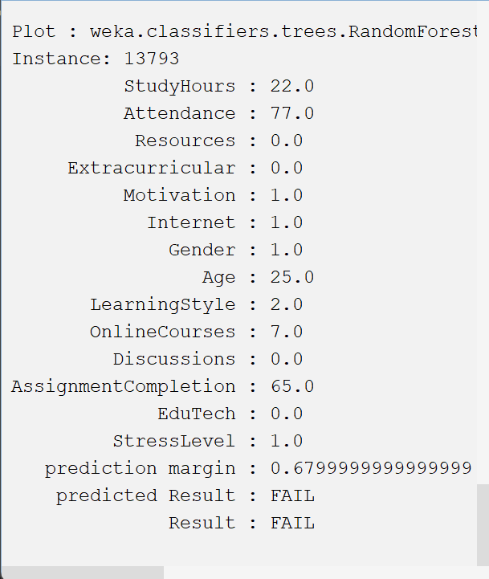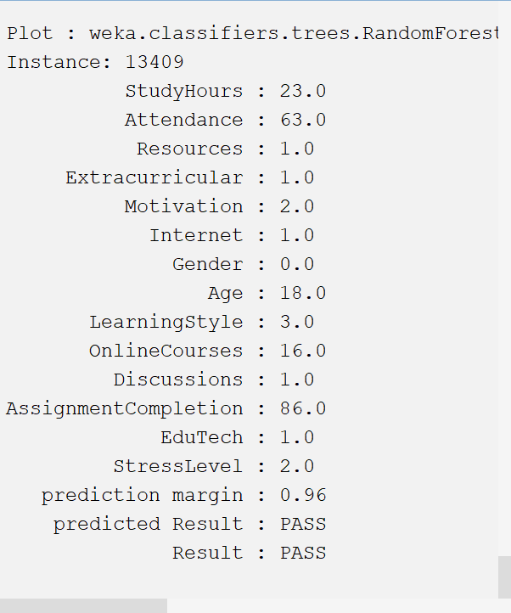
Figure 4.3.1.2: Classification Error Results of Random Forest Model

4.3.2 Random Forest: Visualize Margin Curve
The Margin Curve plots the cumulative distribution of prediction margins — defined as the difference between the classifier’s probability for the true class and the highest probability assigned to any other class.
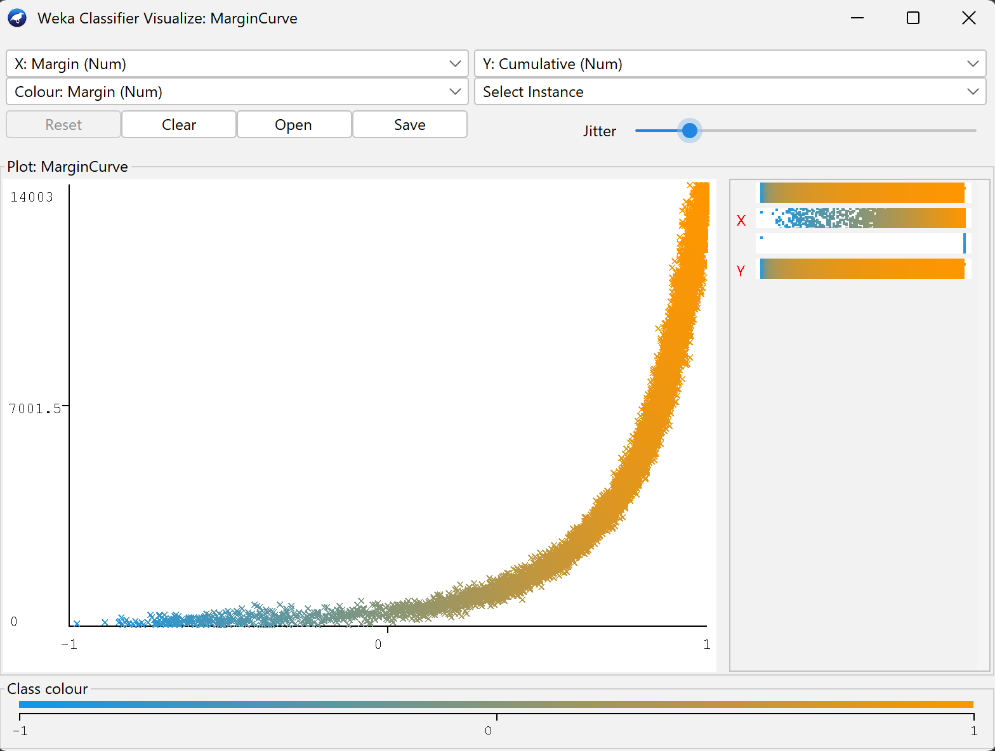
Figure 4.3.2.1 Margin Curve of Random Forest Classifier
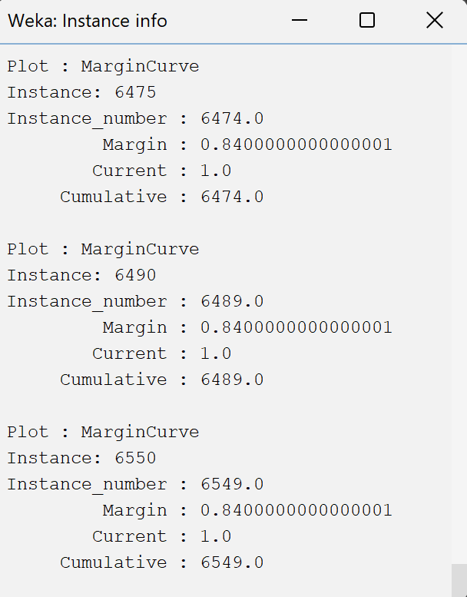
Figure 4.3.2.2 Margin Curve Instance Info of Random Forest Classifier

4.3.3 Visualize Threshold Curve
The Threshold Curve (commonly known as the ROC curve) plots the True Positive Rate (Recall) against the False Positive Rate at varying classification thresholds. It visualizes the trade-off between sensitivity and specificity, with the Area Under the Curve (AUC) indicating overall discriminative power where 1.0 is perfect and 0.5 is random guessing.
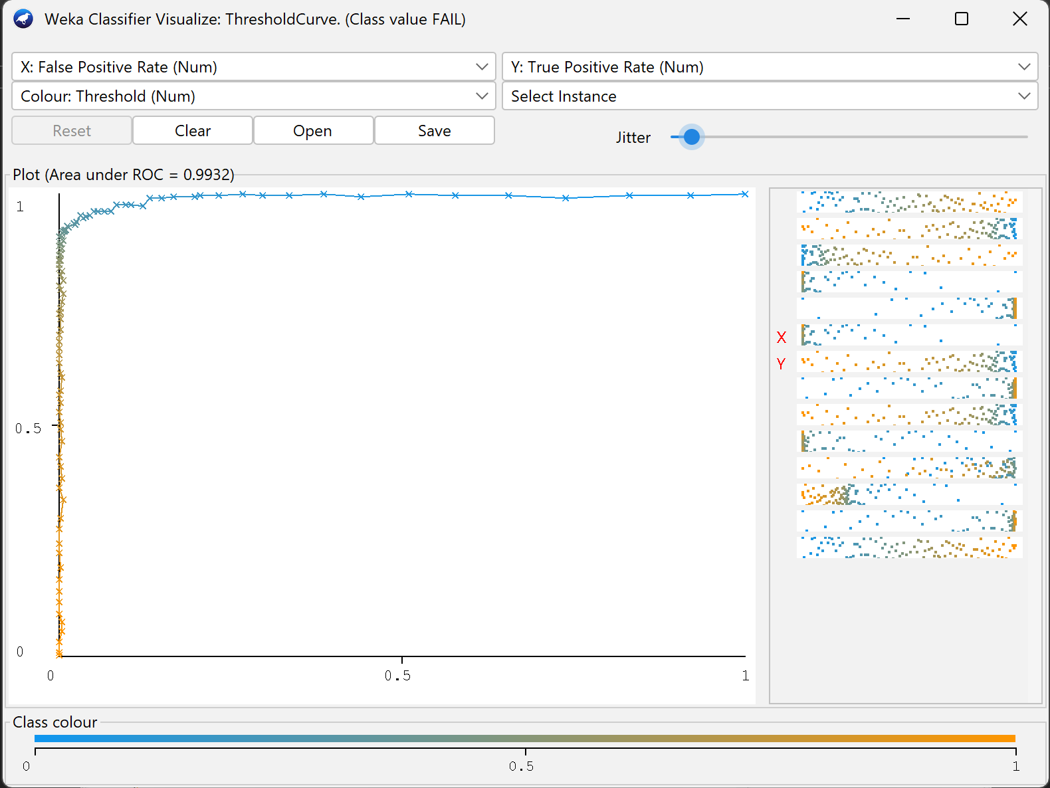
Figure 4.3.3.1: ROC Curve for Classification for Class value FAIL
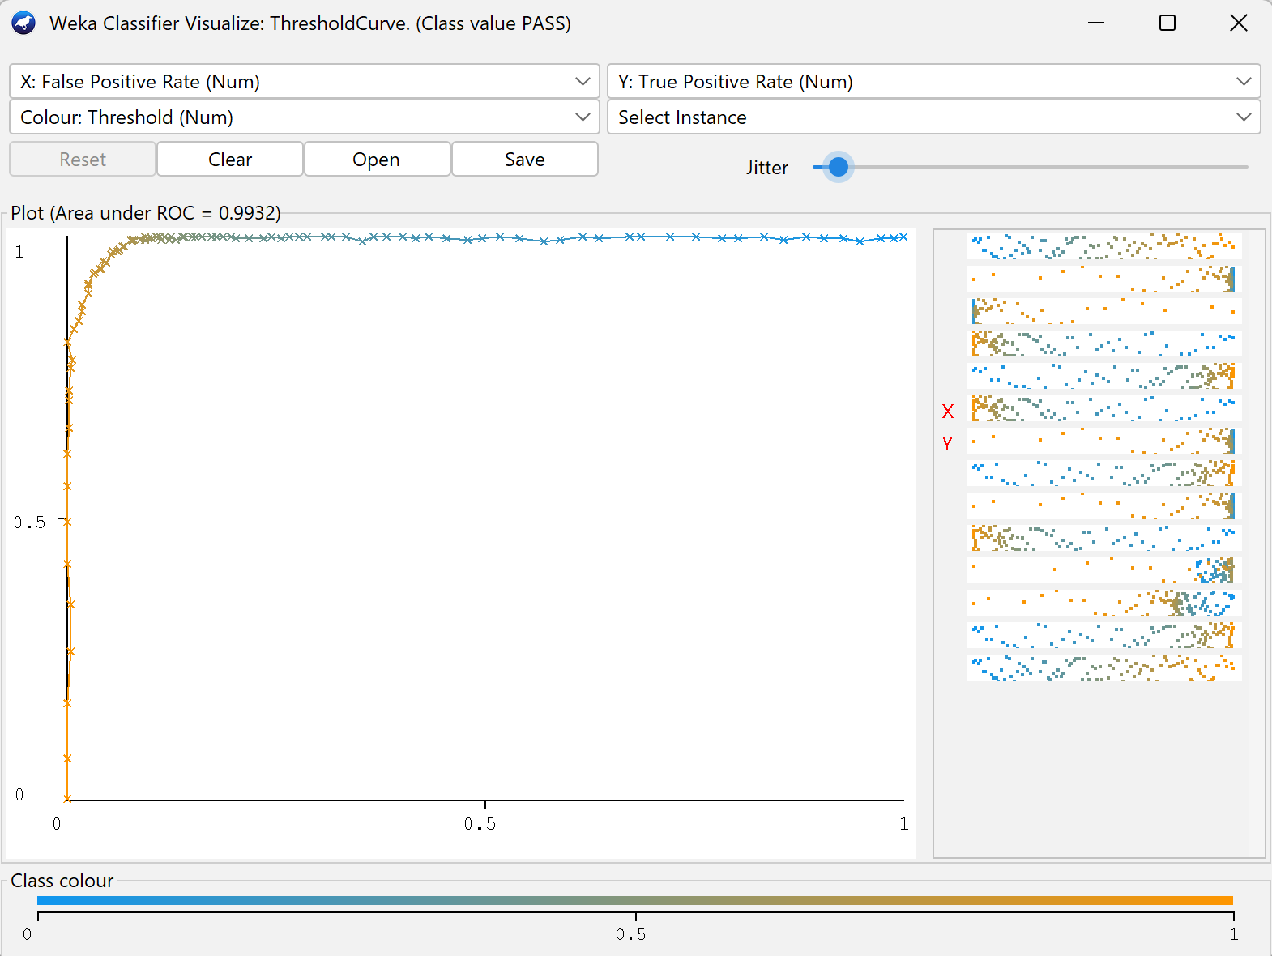
Figure 4.3.3.1: ROC Curve for Classification for Class value PASS
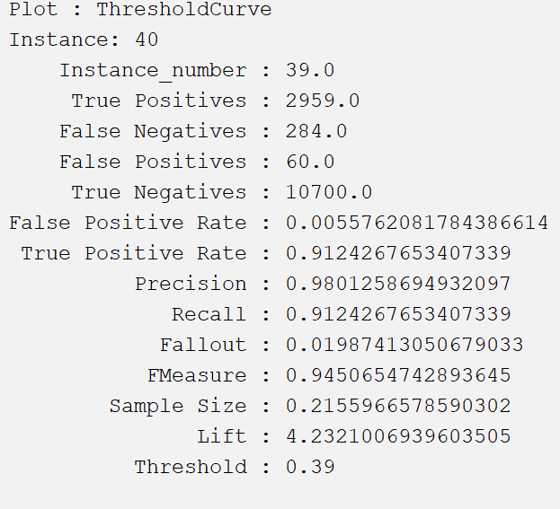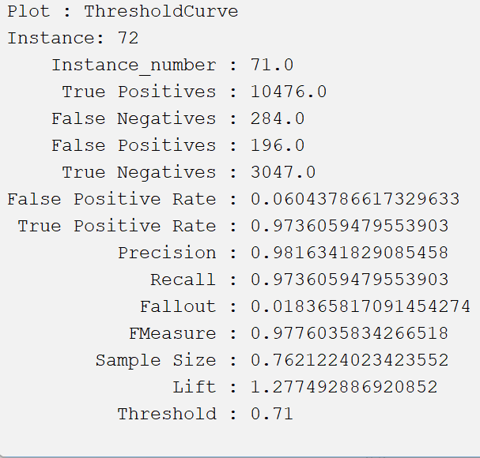
Figure 4.3.3.1: ROC Curve Instance Info for Classification for Class value PASS

4.3.4 KMeans: Visualize Cluster Assignment
This scatter plot visualizes how students are grouped into clusters based on their behavioral features using the K-Means algorithm. Each point represents an individual student, with colors indicating cluster assignment:
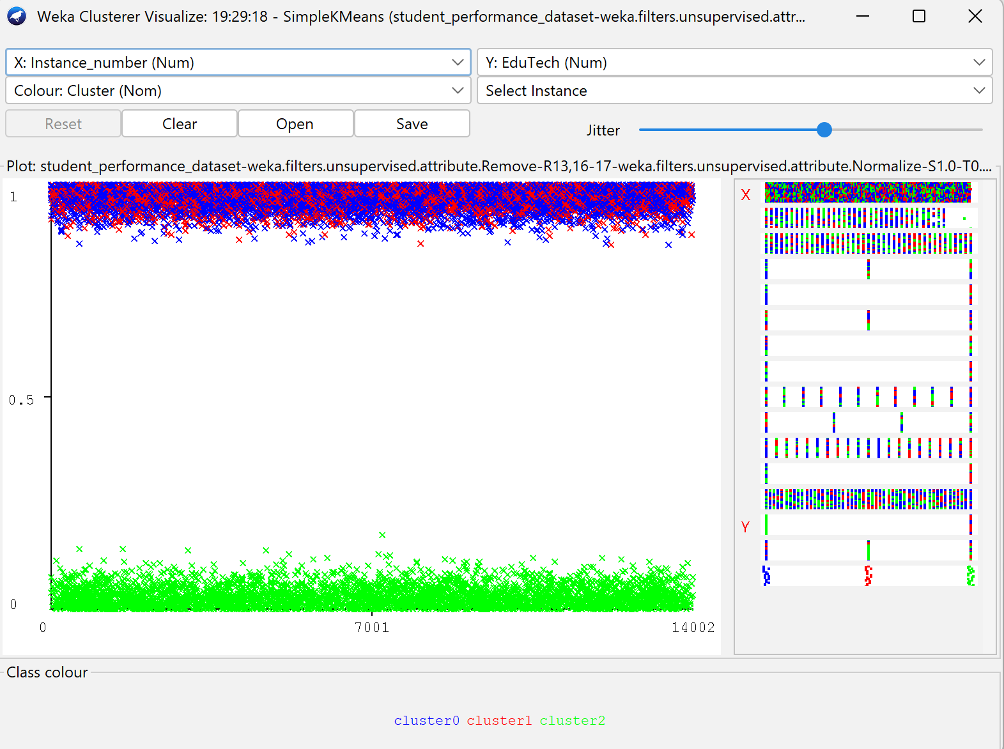
Figure 4.3.4.1: Clustering Visualization Using SimpleKMeans
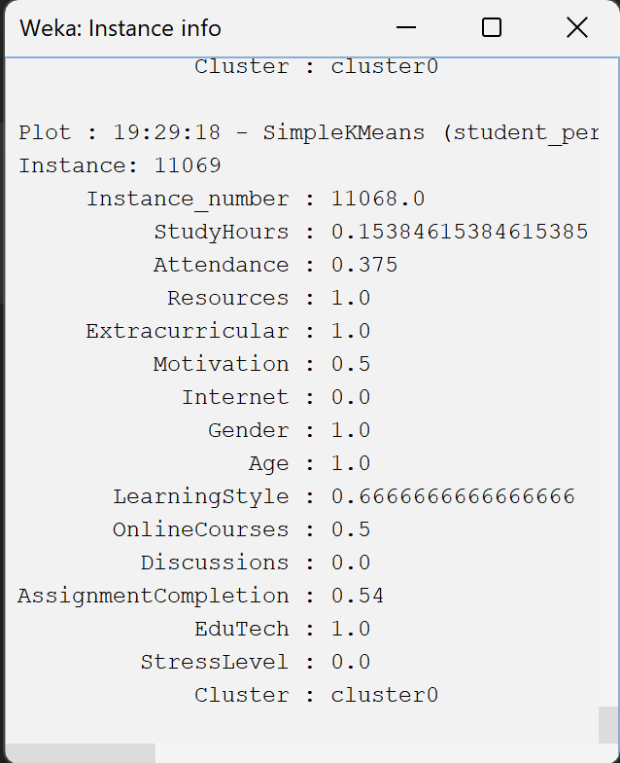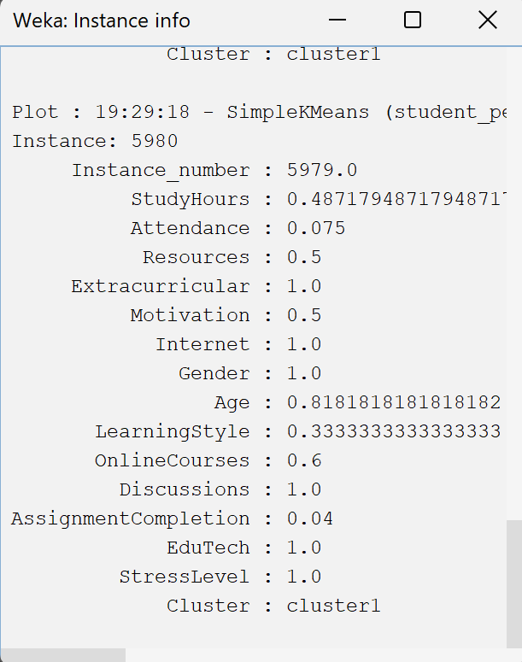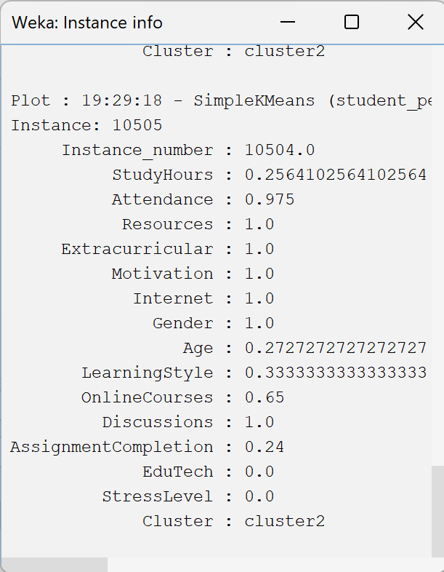
Figure 4.3.4.2: Clustering Visualization Using SimpleKMeans
Based on the K-Means clustering analysis, three distinct student profiles emerged, each corresponding to a recognized learning style:

Cluster | Size | Learning Style | Key Characteristics
Cluster 0 | 6,371 (45%) | Digital Independent Learners | High EduTech (1.0), low extracurricular (0.36), low discussions (0.39), average study hours
Cluster 1 | 3,558 (25%) | Collaborative Kinesthetic Learners | High engagement: EduTech (1.0), extracurricular (1.0), discussions (1.0); highest motivation
Cluster 2 | 4,074 (29%) | Traditional Learners | No EduTech (0.0), moderate extracurricular (0.60), moderate discussions (0.60)
Cluster 0: Digital Independent Learners
These students rely heavily on educational technology but show limited participation in collaborative activities like discussions and extracurriculars. They prefer self-paced, technology-mediated learning environments and work independently. This profile represents the largest segment of the student population (45%).
Cluster 1: Collaborative Kinesthetic Learners
These students engage maximally in all learning activities—technology, discussions, and extracurriculars. They thrive in interactive, social learning environments and demonstrate the highest overall engagement and motivation.
Cluster 2: Traditional Learners
These students do not use educational technology but maintain moderate engagement through discussions and extracurriculars. They likely prefer conventional, face-to-face learning environments and may lack access to or comfort with digital learning tools.

Chapter 5
Conclusion
This project successfully demonstrates that study hours, attendance, and motivation, when combined with complementary behavioral features, serve as powerful predictors for automated student success classification. Using the Random Forest algorithm, the system achieved 97% classification accuracy with a Kappa score of 0.9119, indicating almost perfect agreement between predicted and actual student outcomes. Misclassifications — particularly the 411 failing students predicted to pass — were not model failures but reflections of behavioral similarities between some at-risk students and their successful peers, validating that academic outcomes are influenced by factors beyond the measured features.
Concurrently, K-Means clustering revealed three dominant, interpretable clusters:
- Cluster 0 (45%) – Digital Independent Learners: High EduTech usage but low collaboration
- Cluster 1 (25%) – Collaborative Kinesthetic Learners: High engagement in all activities
- Cluster 2 (29%) – Traditional Learners: No educational technology usage
These clusters prove that unsupervised methods can uncover meaningful, label-agnostic groupings in educational data, with Cluster 1 showing the highest pass rates and Cluster 2 representing the highest intervention priority.
The core contribution of this work lies in its dual analytical approach: supervised learning for accurate student success prediction and unsupervised clustering for discovering latent learning patterns — both driven by behavioral features as central discriminative indicators. By carefully preprocessing categorical and numerical data, the model maintains efficiency without sacrificing performance. This system provides a scalable, data-driven foundation for early intervention programs, personalized learning recommendations, and academic resource allocation.
Future enhancements could include expanding feature sets to incorporate more granular academic data, validating clusters with educational psychology frameworks, and deploying the model as a real-time early warning system for educational institutions — but as it stands, this project delivers a robust, insight-rich framework for understanding and predicting student success through behavioral analytics.

References
Zenodo – Student Performance Dataset
https://zenodo.org/records/16459132
Microsoft Corporation. (2025). Power BI Desktop (Version 2.130.1698.0 64-bit) [Computer software].
https://powerbi.microsoft.com/desktop/
University of Waikato. (2024). Weka 3: Machine learning software in Java (Version 3.8.6) [Computer software].
https://www.cs.waikato.ac.nz/ml/weka/
Breiman, L. (2001). Random forests. Machine Learning, 45(1), 5–32.
https://doi.org/10.1023/A:1010933404324

