Baseline analysis supplement

Welcome to the LMI baseline supplement! This supplement will walk you through the paper and provides additional graphs.

# Measures used in the study

Clicking the “Code”-buttons on the right shows code for each chunk.

To start data analysis, we set up the basics to enable compiling the document:

source("baseline-datasetup.R")

# Means with CIs taking clustering into account

## Description

The code chunks create linear models for all variables. The results are used to estimate confidence intervals and intra-class correlations (ICC).

Browse throught the tabs above to see different information.

Code chunk below shows how the values are calculated.

# Create a vector with all names of the variables we want. Exclude T3 variables.  
names <- df %>% select(-id, -intervention, -group, -school, -girl, -track, -trackSchool, -contains("_T3"), -contains("_diff")) %>% names(.)  
  
# Create empty soon-to-be-filled objects  
m <- NA  
mean <- NA  
m_p <- NA  
ci_low <- NA  
ci_high <- NA  
ICC_group <- NA  
ICC_School <- NA  
nonmissings <- NA  
  
## Use this to test a single variable:  
# dftest <- df #%>% na.omit()  
# m <- lme4::lmer(sitLieAccelerometer_diff ~ (1|school) + (1|group), data=dftest)  
# mean <- lme4::fixef(m)  
# m_p <- profile(m, which = "beta_")  
# ci_low <- confint(m_p)[, 1]  
# ci_high <- confint(m_p)[, 2]  
# ICC_group <- icc(m)[1]  
# ICC_School <- icc(m)[2]  
# nonmissings <- length(m@resp$y)  
  
  
# Loop over each variable name, extract statistics:   
  
# all participants  
for (i in names){  
m <- lme4::lmer(paste0(i," ~ (1|school) + (1|group)"), data=df)  
mean[i] <- lme4::fixef(m)  
m_p <- profile(m, which = "beta_")  
ci_low[i] <- confint(m_p)[, 1]  
ci_high[i] <- confint(m_p)[, 2]  
ICC_group[i] <- sjstats::icc(m)[1]  
ICC_School[i] <- sjstats::icc(m)[2]  
nonmissings[i] <- length(m@resp$y)  
}  
## Warning in nextpar(mat, cc, i, delta, lowcut, upcut): unexpected decrease  
## in profile: using minstep  
## Warning in profile.merMod(m, which = "beta_"): non-monotonic profile for  
## (Intercept)  
## Warning in confint.thpr(m_p): bad spline fit for (Intercept): falling back  
## to linear interpolation  
  
## Warning in confint.thpr(m_p): bad spline fit for (Intercept): falling back  
## to linear interpolation  
## Warning in nextpar(mat, cc, i, delta, lowcut, upcut): unexpected decrease  
## in profile: using minstep  
## Warning in profile.merMod(m, which = "beta_"): non-monotonic profile for  
## (Intercept)  
## Warning in confint.thpr(m_p): bad spline fit for (Intercept): falling back  
## to linear interpolation  
  
## Warning in confint.thpr(m_p): bad spline fit for (Intercept): falling back  
## to linear interpolation  
  
  
vardatatable <- data_frame(  
 Variable = stringr::str_sub(names(mean), end = -4), #remove "_T1" from names  
 "Mean" = round(mean, 1),  
 "CI95" = paste(round(ci_low, 1), " - ", round(ci_high, 2)),   
 "ICC class" =ifelse(round(ICC_group, 3) == 0, "< 0.001", round(ICC_group, 3)),   
 "ICC school" = ifelse(round(ICC_School, 3) == 0, "< 0.001", round(ICC_School, 3)),  
 n = nonmissings) %>%   
 dplyr::arrange(Variable) %>%   
 filter(Variable != "") %>% #remove first row, which is empty  
 mutate(`ICC class` = as.numeric(`ICC class`)) %>%   
 as.data.frame()  
## Warning in evalq(as.numeric(`ICC class`), <environment>): NAs introduced by  
## coercion  
  
ci_total <- data_frame(  
 "ciLo" = ci_low,  
 "mean" = mean,  
 "ciHi" = ci_high,   
 "diamondlabels" = names(mean)) %>%   
 filter(diamondlabels != "") %>% #remove first row, which is empty  
 as.data.frame()

## Primary outcome variables

options(tibble.print_max = 1000)  
  
vardatatable2 <- vardatatable  
vardatatable2$Variable <- gsub("paAccelerometer", "PA minutes", vardatatable2$Variable)  
vardatatable2$Variable <- gsub("padaysLastweek", "Number of MVPA days last week (self-report)", vardatatable2$Variable)  
vardatatable2$Variable <- gsub("sitLieAccelerometer", "Minutes spent sitting or lying down", vardatatable2$Variable)  
vardatatable2$Variable <- gsub("sitBreaks", "Number of times sitting was interrupted", vardatatable2$Variable)  
  
vardatatable2 %>%   
 filter(Variable == "MVPA minutes" |   
 Variable == "Number of MVPA days last week (self-report)" |   
 Variable == "Daily minutes spent sitting or lying down" |   
 Variable == "Number of times sitting was interrupted daily" ) %>%   
 papaja::apa_table(  
 caption = "Primary outcome variables with their class and school ICCs",  
 escape = T,  
 format.args = list(digits = c(1, 3, 0), margin = 2))

(#tab:selected-total)

*Primary outcome variables with their class and school ICCs*

|  |  |  |  |  |  |
| --- | --- | --- | --- | --- | --- |
| Variable | Mean | CI95 | ICC class | ICC school | n |
| Number of MVPA days last week (self-report) | 2.8 | 2.6  -  2.95 | 0.047 | < 0.001 | 1,082 |

## All main variables, their means, CIs and ICCs.

options(tibble.print_max = 1000)  
   
vardatatable %>%  
 papaja::apa_table(  
 caption = "All variables with their class and school ICCs",  
 escape = T,  
 format.args = list(digits = c(1, 3, 0), margin = 2))

(#tab:allvars-total)

*All variables with their class and school ICCs*

|  |  |  |  |  |  |
| --- | --- | --- | --- | --- | --- |
| Variable | Mean | CI95 | ICC class | ICC school | n |
| b5agr | 5.3 | 5.2  -  5.5 | 0.033 | 0.012 | 1,068 |
| b5agr_01 | 5.5 | 5.4  -  5.66 | 0.045 | 0.002 | 1,061 |
| b5agrReverseCoded_02 | 5.2 | 5  -  5.37 | 0.005 | 0.01 | 1,064 |
| b5cons | 5.0 | 4.9  -  5.17 | NA | 0.007 | 1,067 |
| b5cons_01 | 5.4 | 5.2  -  5.65 | 0.014 | 0.015 | 1,059 |
| b5consReverseCoded_02 | 4.6 | 4.5  -  4.78 | NA | 0.002 | 1,065 |
| b5ext | 4.5 | 4.3  -  4.77 | 0.020 | 0.022 | 1,068 |
| b5ext_01 | 5.0 | 4.7  -  5.24 | 0.048 | 0.013 | 1,063 |
| b5extReverseCoded_02 | 4.1 | 3.8  -  4.32 | 0.002 | 0.012 | 1,062 |
| b5neur | 3.8 | 3.6  -  4 | 0.014 | 0.012 | 1,068 |
| b5neur_01 | 4.1 | 3.8  -  4.39 | 0.017 | 0.014 | 1,064 |
| b5neurReverseCoded_02 | 3.5 | 3.4  -  3.67 | 0.011 | 0.002 | 1,061 |
| b5open | 4.9 | 4.7  -  5.12 | 0.010 | 0.03 | 1,068 |
| b5open_01 | 5.4 | 5.1  -  5.59 | 0.025 | 0.016 | 1,062 |
| b5openReverseCoded_02 | 4.4 | 4.2  -  4.67 | NA | 0.016 | 1,066 |
| fatpct | 25.5 | 22.4  -  28.67 | 0.003 | 0.123 | 942 |
| PA_actCop | 2.6 | 2.6  -  2.69 | 0.035 | < 0.001 | 1,073 |
| PA_actionplan | 2.8 | 2.7  -  2.83 | 0.038 | < 0.001 | 1,073 |
| PA_actplan_01 | 2.6 | 2.5  -  2.68 | 0.032 | < 0.001 | 1,073 |
| PA_actplan_02 | 2.8 | 2.7  -  2.88 | 0.028 | < 0.001 | 1,073 |
| PA_actplan_03 | 2.9 | 2.8  -  2.93 | 0.037 | < 0.001 | 1,073 |
| PA_actplan_04 | 2.8 | 2.7  -  2.86 | 0.038 | < 0.001 | 1,073 |
| PA_agrbct | 3.1 | 3  -  3.23 | 0.052 | < 0.001 | 1,071 |
| PA_agrbct_01 | 3.7 | 3.5  -  3.85 | 0.061 | < 0.001 | 1,071 |
| PA_agrbct_02 | 3.2 | 3  -  3.33 | 0.025 | < 0.001 | 1,071 |
| PA_agrbct_03 | 2.4 | 2.3  -  2.57 | 0.009 | < 0.001 | 1,071 |
| PA_agrbct_04 | 2.5 | 2.4  -  2.67 | 0.035 | < 0.001 | 1,071 |
| PA_agrbct_05 | 2.6 | 2.5  -  2.78 | 0.055 | < 0.001 | 1,071 |
| PA_agrbct_06 | 3.2 | 3.1  -  3.38 | 0.028 | 0.001 | 1,071 |
| PA_agrbct_07 | 3.0 | 2.9  -  3.16 | 0.022 | < 0.001 | 1,071 |
| PA_agrbct_08 | 3.1 | 3  -  3.25 | 0.023 | < 0.001 | 1,071 |
| PA_agrbct_09 | 3.7 | 3.5  -  3.85 | 0.032 | 0.001 | 1,071 |
| PA_agrbct_10 | 3.6 | 3.5  -  3.79 | 0.044 | < 0.001 | 1,071 |
| PA_amotivation | 1.5 | 1.5  -  1.61 | 0.035 | 0.002 | 1,072 |
| PA_amotivation_01 | 1.5 | 1.4  -  1.59 | 0.031 | < 0.001 | 1,062 |
| PA_amotivation_02 | 1.5 | 1.4  -  1.63 | 0.026 | 0.005 | 1,057 |
| PA_amotivation_03 | 1.6 | 1.5  -  1.69 | 0.032 | < 0.001 | 1,067 |
| PA_amotivation_04 | 1.5 | 1.4  -  1.55 | 0.027 | < 0.001 | 1,066 |
| PA_autonomous | 3.4 | 3.3  -  3.52 | 0.073 | < 0.001 | 1,078 |
| PA_autonomous_01 | 3.1 | 3  -  3.29 | 0.002 | 0.012 | 1,063 |
| PA_autonomous_02 | 3.8 | 3.7  -  3.86 | 0.031 | < 0.001 | 1,063 |
| PA_autonomous_03 | 3.4 | 3.2  -  3.51 | 0.058 | < 0.001 | 1,070 |
| PA_autonomous_04 | 3.3 | 3.2  -  3.47 | 0.059 | 0.004 | 1,070 |
| PA_autonomous_05 | 3.3 | 3.1  -  3.39 | 0.048 | < 0.001 | 1,062 |
| PA_autonomous_06 | 3.1 | 3  -  3.22 | 0.072 | < 0.001 | 1,066 |
| PA_autonomous_07 | 3.7 | 3.6  -  3.88 | 0.072 | 0.005 | 1,070 |
| PA_autonomous_08 | 3.6 | 3.5  -  3.76 | 0.057 | < 0.001 | 1,066 |
| PA_autonomous_09 | 3.5 | 3.4  -  3.62 | 0.055 | < 0.001 | 1,057 |
| PA_controlled | 1.8 | 1.8  -  1.9 | 0.005 | < 0.001 | 1,073 |
| PA_controlled_01 | 1.7 | 1.6  -  1.73 | 0.010 | < 0.001 | 1,068 |
| PA_controlled_02 | 1.5 | 1.4  -  1.55 | 0.024 | < 0.001 | 1,069 |
| PA_controlled_03 | 1.5 | 1.5  -  1.61 | 0.011 | < 0.001 | 1,064 |
| PA_controlled_04 | 2.2 | 2.1  -  2.28 | NA | 0.001 | 1,068 |
| PA_controlled_05 | 2.3 | 2.2  -  2.4 | 0.006 | < 0.001 | 1,066 |
| PA_copingplan | 2.5 | 2.4  -  2.56 | 0.023 | < 0.001 | 1,073 |
| PA_copplan_01 | 2.4 | 2.3  -  2.47 | 0.007 | < 0.001 | 1,073 |
| PA_copplan_02 | 2.4 | 2.4  -  2.5 | 0.004 | < 0.001 | 1,073 |
| PA_copplan_03 | 2.5 | 2.4  -  2.54 | 0.035 | < 0.001 | 1,073 |
| PA_copplan_04 | 2.7 | 2.6  -  2.77 | 0.035 | < 0.001 | 1,073 |
| PA_dnorm | 4.4 | 4.2  -  4.58 | 0.050 | 0.003 | 1,073 |
| PA_dnorm_01 | 4.5 | 4.3  -  4.71 | 0.050 | 0.004 | 1,073 |
| PA_dnorm_02 | 4.3 | 4.1  -  4.52 | 0.027 | 0.004 | 1,073 |
| PA_extrinsic | 1.6 | 1.5  -  1.62 | 0.022 | < 0.001 | 1,069 |
| PA_extrinsic_01 | 1.7 | 1.6  -  1.73 | 0.010 | < 0.001 | 1,068 |
| PA_extrinsic_02 | 1.5 | 1.4  -  1.55 | 0.024 | < 0.001 | 1,069 |
| PA_extrinsic_03 | 1.5 | 1.5  -  1.61 | 0.011 | < 0.001 | 1,064 |
| PA_frqbct | 2.5 | 2.4  -  2.62 | 0.027 | < 0.001 | 1,070 |
| PA_frqbct_01 | 3.7 | 3.6  -  3.84 | 0.014 | < 0.001 | 1,070 |
| PA_frqbct_02 | 1.9 | 1.8  -  1.98 | 0.024 | < 0.001 | 1,070 |
| PA_frqbct_03 | 2.0 | 1.9  -  2.13 | 0.007 | < 0.001 | 1,070 |
| PA_frqbct_04 | 1.9 | 1.8  -  2.02 | 0.035 | < 0.001 | 1,070 |
| PA_frqbct_05 | 2.5 | 2.4  -  2.64 | 0.033 | < 0.001 | 1,070 |
| PA_frqbct_06 | 3.4 | 3.3  -  3.54 | 0.016 | < 0.001 | 1,070 |
| PA_frqbct_07 | 2.2 | 2.1  -  2.3 | 0.003 | < 0.001 | 1,070 |
| PA_frqbct_08 | 2.4 | 2.3  -  2.5 | 0.014 | < 0.001 | 1,070 |
| PA_frqbct_09 | 2.8 | 2.7  -  2.9 | 0.007 | < 0.001 | 1,070 |
| PA_goal | 0.6 | 0.5  -  0.59 | 0.046 | < 0.001 | 1,061 |
| PA_goal_01 | 0.6 | 0.5  -  0.59 | 0.046 | < 0.001 | 1,061 |
| PA_identified | 3.4 | 3.3  -  3.54 | 0.040 | 0.004 | 1,074 |
| PA_identified_01 | 3.1 | 3  -  3.29 | 0.002 | 0.012 | 1,063 |
| PA_identified_02 | 3.8 | 3.7  -  3.86 | 0.031 | < 0.001 | 1,063 |
| PA_identified_03 | 3.4 | 3.2  -  3.51 | 0.058 | < 0.001 | 1,070 |
| PA_inorm | 4.7 | 4.5  -  4.84 | 0.006 | 0.003 | 1,073 |
| PA_inorm_01 | 4.7 | 4.5  -  4.84 | 0.006 | 0.003 | 1,073 |
| PA_integrated | 3.2 | 3.1  -  3.34 | 0.071 | < 0.001 | 1,073 |
| PA_integrated_01 | 3.3 | 3.2  -  3.47 | 0.059 | 0.004 | 1,070 |
| PA_integrated_02 | 3.3 | 3.1  -  3.39 | 0.048 | < 0.001 | 1,062 |
| PA_integrated_03 | 3.1 | 3  -  3.22 | 0.072 | < 0.001 | 1,066 |
| PA_intention | 5.4 | 5.2  -  5.57 | 0.105 | < 0.001 | 1,073 |
| PA_intention_01 | 5.4 | 5.2  -  5.55 | 0.088 | < 0.001 | 1,073 |
| PA_intention_02 | 5.4 | 5.2  -  5.61 | 0.111 | < 0.001 | 1,073 |
| PA_intrinsic | 3.6 | 3.5  -  3.74 | 0.074 | < 0.001 | 1,074 |
| PA_intrinsic_01 | 3.7 | 3.6  -  3.88 | 0.072 | 0.005 | 1,070 |
| PA_intrinsic_02 | 3.6 | 3.5  -  3.76 | 0.057 | < 0.001 | 1,066 |
| PA_intrinsic_03 | 3.5 | 3.4  -  3.62 | 0.055 | < 0.001 | 1,057 |
| PA_introjected | 2.2 | 2.2  -  2.33 | NA | < 0.001 | 1,073 |
| PA_introjected_01 | 2.2 | 2.1  -  2.28 | NA | 0.001 | 1,068 |
| PA_introjected_02 | 2.3 | 2.2  -  2.4 | 0.006 | < 0.001 | 1,066 |
| PA_opportunities | 5.1 | 5.1  -  5.19 | 0.018 | < 0.001 | 1,075 |
| PA_opportunities_01 | 4.7 | 4.3  -  4.98 | 0.037 | 0.02 | 1,070 |
| PA_opportunities_02 | 5.5 | 5.4  -  5.62 | 0.018 | < 0.001 | 1,067 |
| PA_opportunities_04 | 5.6 | 5.4  -  5.75 | 0.021 | 0.008 | 1,070 |
| PA_opportunities_05 | 5.3 | 5.2  -  5.43 | NA | < 0.001 | 1,064 |
| PA_opportunities_07 | 4.6 | 4.5  -  4.77 | 0.009 | 0.001 | 1,068 |
| PA_opportunitiesReverseCoded_03 | 5.1 | 5  -  5.23 | NA | < 0.001 | 1,065 |
| PA_opportunitiesReverseCoded_06 | 3.6 | 3.3  -  3.95 | NA | 0.024 | 1,059 |
| PA_opportunitiesReverseCoded_08 | 6.6 | 6.5  -  6.68 | 0.020 | < 0.001 | 1,066 |
| PA_outcomeExpectations | 4.6 | 4.5  -  4.74 | 0.034 | 0.013 | 1,078 |
| PA_outcomeExpectations_01 | 5.5 | 5.3  -  5.7 | 0.042 | 0.011 | 1,071 |
| PA_outcomeExpectations_03 | 5.2 | 4.9  -  5.47 | 0.008 | 0.018 | 1,064 |
| PA_outcomeExpectations_04 | 5.5 | 5.3  -  5.65 | 0.009 | 0.007 | 1,071 |
| PA_outcomeExpectations_05 | 5.2 | 5  -  5.39 | 0.023 | 0.011 | 1,067 |
| PA_outcomeExpectations_06 | 5.4 | 5.2  -  5.63 | 0.030 | 0.016 | 1,071 |
| PA_outcomeExpectations_07 | 4.9 | 4.7  -  5.13 | 0.039 | 0.008 | 1,062 |
| PA_outcomeExpectations_10 | 5.4 | 5.2  -  5.54 | 0.019 | 0.006 | 1,069 |
| PA_outcomeExpectations_11 | 5.1 | 4.9  -  5.38 | 0.055 | 0.011 | 1,063 |
| PA_outcomeExpectations_12 | 5.2 | 4.9  -  5.45 | 0.042 | 0.014 | 1,070 |
| PA_outcomeExpectationsNegative_02 | 2.9 | 2.7  -  3.02 | 0.046 | < 0.001 | 1,066 |
| PA_outcomeExpectationsNegative_08 | 2.5 | 2.3  -  2.69 | 0.038 | 0.004 | 1,063 |
| PA_outcomeExpectationsNegative_09 | 2.6 | 2.5  -  2.68 | 0.023 | < 0.001 | 1,064 |
| PA_pbc | 5.3 | 5.2  -  5.45 | 0.028 | 0.004 | 1,071 |
| PA_pbc_01 | 5.9 | 5.7  -  5.98 | 0.032 | < 0.001 | 1,069 |
| PA_pbc_03 | 5.2 | 5  -  5.4 | 0.014 | 0.01 | 1,066 |
| PA_pbcReverseCoded_02 | 4.9 | 4.7  -  5.11 | 0.005 | 0.005 | 1,063 |
| PA_selfefficacy | 5.2 | 5.1  -  5.35 | 0.007 | 0.005 | 1,071 |
| PA_selfefficacy_01 | 5.9 | 5.8  -  5.96 | 0.009 | < 0.001 | 1,071 |
| PA_selfefficacyReverseCoded_02 | 4.6 | 4.4  -  4.77 | 0.002 | 0.005 | 1,071 |
| PA_sePbc | 5.3 | 5.1  -  5.4 | 0.028 | 0.007 | 1,071 |
| paAccelerometer | 183.1 | 166  -  200.45 | 0.072 | 0.096 | 706 |
| padaysLastweek | 2.8 | 2.6  -  2.95 | 0.047 | < 0.001 | 1,082 |
| pafreqUsually | 2.6 | 2.4  -  2.73 | 0.094 | 0.003 | 1,082 |
| pahrsLastweek | 5.4 | 4.7  -  6.16 | 0.024 | 0.007 | 1,082 |
| pahrsUsually | 3.1 | 2.9  -  3.36 | 0.085 | 0.005 | 1,082 |
| paLastweek | 339.7 | 296  -  382.07 | 0.024 | 0.006 | 1,082 |
| paminLastweek | 1.4 | 1.4  -  1.5 | NA | 0.01 | 1,082 |
| SB_dnorm | 3.2 | 3.1  -  3.41 | 0.003 | 0.007 | 1,062 |
| SB_dnorm_01 | 3.1 | 2.9  -  3.22 | NA | 0.004 | 1,059 |
| SB_dnorm_02 | 3.4 | 3.2  -  3.59 | 0.010 | 0.007 | 1,060 |
| SB_inorm | 4.0 | 3.9  -  4.14 | 0.012 | 0.004 | 1,064 |
| SB_inorm_01 | 3.9 | 3.8  -  4.11 | NA | 0.008 | 1,056 |
| SB_inorm_02 | 4.1 | 3.9  -  4.28 | 0.030 | 0.005 | 1,053 |
| SB_intention | 3.7 | 3.4  -  4.06 | 0.014 | 0.035 | 1,064 |
| SB_intention_01 | 3.3 | 3  -  3.64 | NA | 0.025 | 1,059 |
| SB_intention_02 | 3.5 | 3.2  -  3.81 | NA | 0.034 | 1,056 |
| SB_intention_03 | 4.0 | 3.7  -  4.37 | 0.023 | 0.027 | 1,054 |
| SB_intention_04 | 4.1 | 3.8  -  4.43 | 0.028 | 0.027 | 1,055 |
| SB_outcomeExpectations | 4.4 | 4.3  -  4.53 | 0.029 | 0.005 | 1,064 |
| SB_outcomeExpectations_02 | 4.8 | 4.6  -  5.06 | 0.017 | 0.014 | 1,056 |
| SB_outcomeExpectations_03 | 4.6 | 4.4  -  4.88 | 0.024 | 0.014 | 1,058 |
| SB_outcomeExpectations_04 | 4.9 | 4.7  -  5.12 | 0.038 | 0.005 | 1,063 |
| SB_outcomeExpectations_05 | 4.9 | 4.7  -  5.09 | 0.040 | 0.004 | 1,060 |
| SB_outcomeExpectations_06 | 4.9 | 4.7  -  5.11 | 0.047 | 0.011 | 1,058 |
| SB_outcomeExpectationsNegative_01 | 3.4 | 3.3  -  3.51 | 0.008 | < 0.001 | 1,063 |
| SB_outcomeExpectationsNegative_07 | 3.3 | 3.2  -  3.51 | 0.012 | 0.003 | 1,057 |
| SB_sePbc | 5.0 | 4.8  -  5.14 | 0.015 | 0.011 | 1,064 |
| SB_sePbc_01 | 4.4 | 4.1  -  4.6 | 0.010 | 0.014 | 1,062 |
| SB_sePbc_02 | 4.3 | 4.1  -  4.54 | 0.003 | 0.015 | 1,061 |
| SB_sePbc_03 | 5.7 | 5.6  -  5.87 | 0.026 | < 0.001 | 1,060 |
| SB_sePbc_04 | 5.7 | 5.6  -  5.88 | 0.034 | < 0.001 | 1,060 |
| SB_sePbc_05 | 4.7 | 4.5  -  4.91 | 0.005 | 0.012 | 1,054 |
| sitBreaks | 28.0 | 24.7  -  31.37 | 0.058 | 0.085 | 706 |
| sitLieAccelerometer | 573.9 | 535.5  -  611.8 | 0.086 | 0.145 | 706 |
| symptom | 2.0 | 1.8  -  2.11 | 0.023 | 0.039 | 1,084 |
| symptom_headAche | 2.0 | 1.8  -  2.16 | 0.007 | 0.027 | 1,055 |
| symptom_irritabilityAngerbursts | 1.9 | 1.8  -  2.04 | 0.026 | 0.01 | 1,039 |
| symptom_lowerBackPain | 1.8 | 1.7  -  1.85 | 0.004 | 0.005 | 1,053 |
| symptom_neckShoulderPain | 2.0 | 1.8  -  2.17 | 0.011 | 0.033 | 1,047 |
| symptom_sleepDifficulty | 2.1 | 1.9  -  2.27 | 0.010 | 0.023 | 1,052 |
| symptom_stomachAche | 1.7 | 1.6  -  1.86 | 0.015 | 0.023 | 1,026 |
| symptom_tensionNervousness | 1.9 | 1.8  -  2.08 | 0.007 | 0.024 | 1,051 |
| symptom_tirednessFaintness | 2.3 | 2.2  -  2.4 | 0.025 | 0.009 | 1,058 |

## ICC top 20 items, sorted by classroom ICC

vardatatable %>%   
 select(Variable, `ICC class`, `ICC school`, n) %>%   
 arrange(desc(`ICC class`)) %>% slice(1:20) %>%   
 as.tbl() %>%   
 papaja::apa_table(caption = "Intra-class correlations sorted by classroom ICC",  
 format.args = list(digits = c(3, 0), margin = 2))

(#tab:icc-school-class-sortbyclass)

*Intra-class correlations sorted by classroom ICC*

|  |  |  |  |
| --- | --- | --- | --- |
| Variable | ICC class | ICC school | n |
| PA_intention_02 | 0.111 | < 0.001 | 1,073 |
| PA_intention | 0.105 | < 0.001 | 1,073 |
| pafreqUsually | 0.094 | 0.003 | 1,082 |
| PA_intention_01 | 0.088 | < 0.001 | 1,073 |
| sitLieAccelerometer | 0.086 | 0.145 | 706 |
| pahrsUsually | 0.085 | 0.005 | 1,082 |
| PA_intrinsic | 0.074 | < 0.001 | 1,074 |
| PA_autonomous | 0.073 | < 0.001 | 1,078 |
| PA_autonomous_06 | 0.072 | < 0.001 | 1,066 |
| PA_autonomous_07 | 0.072 | 0.005 | 1,070 |
| PA_integrated_03 | 0.072 | < 0.001 | 1,066 |
| PA_intrinsic_01 | 0.072 | 0.005 | 1,070 |
| paAccelerometer | 0.072 | 0.096 | 706 |
| PA_integrated | 0.071 | < 0.001 | 1,073 |
| PA_agrbct_01 | 0.061 | < 0.001 | 1,071 |
| PA_autonomous_04 | 0.059 | 0.004 | 1,070 |
| PA_integrated_01 | 0.059 | 0.004 | 1,070 |
| PA_autonomous_03 | 0.058 | < 0.001 | 1,070 |
| PA_identified_03 | 0.058 | < 0.001 | 1,070 |
| sitBreaks | 0.058 | 0.085 | 706 |

## ICC top 20 items, sorted by school ICC

vardatatable %>% select(Variable, `ICC class`, `ICC school`, n) %>%   
 arrange(desc(`ICC school`)) %>%   
 slice(1:20) %>%   
 papaja::apa_table(caption = "Intra-class correlations sorted by school ICC",  
 format.args = list(digits = c(3, 0), margin = 2))

(#tab:icc-school-class-sortbyschool)

*Intra-class correlations sorted by school ICC*

|  |  |  |  |
| --- | --- | --- | --- |
| Variable | ICC class | ICC school | n |
| sitLieAccelerometer | 0.086 | 0.145 | 706 |
| fatpct | 0.003 | 0.123 | 942 |
| paAccelerometer | 0.072 | 0.096 | 706 |
| sitBreaks | 0.058 | 0.085 | 706 |
| symptom | 0.023 | 0.039 | 1,084 |
| SB_intention | 0.014 | 0.035 | 1,064 |
| SB_intention_02 | NA | 0.034 | 1,056 |
| symptom_neckShoulderPain | 0.011 | 0.033 | 1,047 |
| b5open | 0.010 | 0.03 | 1,068 |
| SB_intention_03 | 0.023 | 0.027 | 1,054 |
| SB_intention_04 | 0.028 | 0.027 | 1,055 |
| symptom_headAche | 0.007 | 0.027 | 1,055 |
| SB_intention_01 | NA | 0.025 | 1,059 |
| PA_opportunitiesReverseCoded_06 | NA | 0.024 | 1,059 |
| symptom_tensionNervousness | 0.007 | 0.024 | 1,051 |
| symptom_sleepDifficulty | 0.010 | 0.023 | 1,052 |
| symptom_stomachAche | 0.015 | 0.023 | 1,026 |
| b5ext | 0.020 | 0.022 | 1,068 |
| PA_opportunities_01 | 0.037 | 0.02 | 1,070 |
| PA_outcomeExpectations_03 | 0.008 | 0.018 | 1,064 |

## Model with educational track

The model below is the same as the one above, except it adds educational track.

As before, we create a table with all variables, their means, CIs and ICCs.

#library(sjstats)  
#library(lme4)  
  
names <- df %>% select(-id, -intervention, -group, -school, -girl, -track, -trackSchool, -contains("_T3"), -contains("_diff")) %>% names(.)  
  
# Create empty soon-to-be-filled objects  
m <- NA  
mean <- NA  
m_p <- NA  
ci_low <- NA  
ci_high <- NA  
ICC_group <- NA  
ICC_School <- NA  
nonmissings <- NA  
ICC_track <- NA  
  
  
## To test the code with a single variable:  
# dftest <- df #%>% na.omit()  
# m <- lmer(sitLieAccelerometer_T1 ~ (1|school) + (1|group) + (1|track), data=df)  
# mean <- fixef(m)  
# m_p <- profile(m)  
# ci_low <- confint(m_p)[5]  
# ci_high <- confint(m_p)[10]  
# ICC_group <- icc(m)[1]  
# ICC_School <- icc(m)[2]  
# nonmissings <- length(m@resp$y)  
  
# Loop over each variable name, extract statistics:   
  
# all participants   
for (i in names){  
m <- lme4::lmer(paste0(i," ~ (1|school) + (1|group) + (1|track)"), data=df)  
mean[i] <- lme4::fixef(m)  
m_p <- profile(m, which = "beta_")  
ci_low[i] <- confint(m_p)[5]  
ci_high[i] <- confint(m_p)[10]  
ICC_group[i] <- sjstats::icc(m)[1]  
ICC_School[i] <- sjstats::icc(m)[3]  
ICC_track[i] <- sjstats::icc(m)[2]  
nonmissings[i] <- length(m@resp$y)  
}  
## Warning in sqrt(fv - base): NaNs produced  
## Warning in nextpar(mat, cc, i, delta, lowcut, upcut): Last two rows have  
## identical or NA .zeta values: using minstep  
## Warning in sqrt(fv - base): NaNs produced  
## Warning in nextpar(mat, cc, i, delta, lowcut, upcut): Last two rows have  
## identical or NA .zeta values: using minstep  
## Warning in sqrt(fv - base): NaNs produced  
## Warning in nextpar(mat, cc, i, delta, lowcut, upcut): Last two rows have  
## identical or NA .zeta values: using minstep  
## Warning in sqrt(fv - base): NaNs produced  
## Warning in nextpar(mat, cc, i, delta, lowcut, upcut): Last two rows have  
## identical or NA .zeta values: using minstep  
## Warning in sqrt(fv - base): NaNs produced  
## Warning in nextpar(mat, cc, i, delta, lowcut, upcut): Last two rows have  
## identical or NA .zeta values: using minstep  
## Warning in sqrt(fv - base): NaNs produced  
## Warning in nextpar(mat, cc, i, delta, lowcut, upcut): Last two rows have  
## identical or NA .zeta values: using minstep  
## Warning in sqrt(fv - base): NaNs produced  
## Warning in nextpar(mat, cc, i, delta, lowcut, upcut): Last two rows have  
## identical or NA .zeta values: using minstep  
## Warning in sqrt(fv - base): NaNs produced  
## Warning in nextpar(mat, cc, i, delta, lowcut, upcut): Last two rows have  
## identical or NA .zeta values: using minstep  
## Warning in sqrt(fv - base): NaNs produced  
## Warning in nextpar(mat, cc, i, delta, lowcut, upcut): Last two rows have  
## identical or NA .zeta values: using minstep  
## Warning in sqrt(fv - base): NaNs produced  
## Warning in nextpar(mat, cc, i, delta, lowcut, upcut): Last two rows have  
## identical or NA .zeta values: using minstep  
## Warning in sqrt(fv - base): NaNs produced  
## Warning in nextpar(mat, cc, i, delta, lowcut, upcut): Last two rows have  
## identical or NA .zeta values: using minstep  
## Warning in sqrt(fv - base): NaNs produced  
## Warning in nextpar(mat, cc, i, delta, lowcut, upcut): Last two rows have  
## identical or NA .zeta values: using minstep  
## Warning in sqrt(fv - base): NaNs produced  
## Warning in nextpar(mat, cc, i, delta, lowcut, upcut): Last two rows have  
## identical or NA .zeta values: using minstep  
## Warning in sqrt(fv - base): NaNs produced  
## Warning in nextpar(mat, cc, i, delta, lowcut, upcut): Last two rows have  
## identical or NA .zeta values: using minstep  
## Warning in sqrt(fv - base): NaNs produced  
## Warning in nextpar(mat, cc, i, delta, lowcut, upcut): Last two rows have  
## identical or NA .zeta values: using minstep  
## Warning in sqrt(fv - base): NaNs produced  
## Warning in nextpar(mat, cc, i, delta, lowcut, upcut): Last two rows have  
## identical or NA .zeta values: using minstep  
## Warning in sqrt(fv - base): NaNs produced  
## Warning in nextpar(mat, cc, i, delta, lowcut, upcut): Last two rows have  
## identical or NA .zeta values: using minstep  
## Warning in sqrt(fv - base): NaNs produced  
## Warning in nextpar(mat, cc, i, delta, lowcut, upcut): Last two rows have  
## identical or NA .zeta values: using minstep  
## Warning in sqrt(fv - base): NaNs produced  
## Warning in nextpar(mat, cc, i, delta, lowcut, upcut): Last two rows have  
## identical or NA .zeta values: using minstep  
## Warning in sqrt(fv - base): NaNs produced  
## Warning in nextpar(mat, cc, i, delta, lowcut, upcut): Last two rows have  
## identical or NA .zeta values: using minstep  
## Warning in sqrt(fv - base): NaNs produced  
## Warning in nextpar(mat, cc, i, delta, lowcut, upcut): Last two rows have  
## identical or NA .zeta values: using minstep  
## Warning in sqrt(fv - base): NaNs produced  
## Warning in nextpar(mat, cc, i, delta, lowcut, upcut): Last two rows have  
## identical or NA .zeta values: using minstep  
## Warning in sqrt(fv - base): NaNs produced  
## Warning in nextpar(mat, cc, i, delta, lowcut, upcut): Last two rows have  
## identical or NA .zeta values: using minstep  
## Warning in sqrt(fv - base): NaNs produced  
## Warning in nextpar(mat, cc, i, delta, lowcut, upcut): Last two rows have  
## identical or NA .zeta values: using minstep  
## Warning in sqrt(fv - base): NaNs produced  
## Warning in nextpar(mat, cc, i, delta, lowcut, upcut): Last two rows have  
## identical or NA .zeta values: using minstep  
## Warning in sqrt(fv - base): NaNs produced  
## Warning in nextpar(mat, cc, i, delta, lowcut, upcut): Last two rows have  
## identical or NA .zeta values: using minstep  
## Warning in sqrt(fv - base): NaNs produced  
## Warning in nextpar(mat, cc, i, delta, lowcut, upcut): Last two rows have  
## identical or NA .zeta values: using minstep  
## Warning in sqrt(fv - base): NaNs produced  
## Warning in nextpar(mat, cc, i, delta, lowcut, upcut): Last two rows have  
## identical or NA .zeta values: using minstep  
## Warning in sqrt(fv - base): NaNs produced  
## Warning in nextpar(mat, cc, i, delta, lowcut, upcut): Last two rows have  
## identical or NA .zeta values: using minstep  
## Warning in sqrt(fv - base): NaNs produced  
## Warning in nextpar(mat, cc, i, delta, lowcut, upcut): Last two rows have  
## identical or NA .zeta values: using minstep  
## Warning in sqrt(fv - base): NaNs produced  
## Warning in nextpar(mat, cc, i, delta, lowcut, upcut): Last two rows have  
## identical or NA .zeta values: using minstep  
## Warning in sqrt(fv - base): NaNs produced  
## Warning in nextpar(mat, cc, i, delta, lowcut, upcut): Last two rows have  
## identical or NA .zeta values: using minstep  
## Warning in sqrt(fv - base): NaNs produced  
## Warning in nextpar(mat, cc, i, delta, lowcut, upcut): Last two rows have  
## identical or NA .zeta values: using minstep  
## Warning in sqrt(fv - base): NaNs produced  
## Warning in nextpar(mat, cc, i, delta, lowcut, upcut): Last two rows have  
## identical or NA .zeta values: using minstep  
## Warning in sqrt(fv - base): NaNs produced  
## Warning in nextpar(mat, cc, i, delta, lowcut, upcut): Last two rows have  
## identical or NA .zeta values: using minstep  
## Warning in sqrt(fv - base): NaNs produced  
## Warning in nextpar(mat, cc, i, delta, lowcut, upcut): Last two rows have  
## identical or NA .zeta values: using minstep  
## Warning in sqrt(fv - base): NaNs produced  
## Warning in nextpar(mat, cc, i, delta, lowcut, upcut): Last two rows have  
## identical or NA .zeta values: using minstep  
## Warning in sqrt(fv - base): NaNs produced  
## Warning in nextpar(mat, cc, i, delta, lowcut, upcut): Last two rows have  
## identical or NA .zeta values: using minstep  
## Warning in sqrt(fv - base): NaNs produced  
## Warning in nextpar(mat, cc, i, delta, lowcut, upcut): Last two rows have  
## identical or NA .zeta values: using minstep  
## Warning in sqrt(fv - base): NaNs produced  
## Warning in nextpar(mat, cc, i, delta, lowcut, upcut): Last two rows have  
## identical or NA .zeta values: using minstep  
## Warning in sqrt(fv - base): NaNs produced  
## Warning in nextpar(mat, cc, i, delta, lowcut, upcut): Last two rows have  
## identical or NA .zeta values: using minstep  
## Warning in sqrt(fv - base): NaNs produced  
## Warning in nextpar(mat, cc, i, delta, lowcut, upcut): Last two rows have  
## identical or NA .zeta values: using minstep  
## Warning in sqrt(fv - base): NaNs produced  
## Warning in nextpar(mat, cc, i, delta, lowcut, upcut): Last two rows have  
## identical or NA .zeta values: using minstep  
## Warning in sqrt(fv - base): NaNs produced  
## Warning in nextpar(mat, cc, i, delta, lowcut, upcut): Last two rows have  
## identical or NA .zeta values: using minstep  
## Warning in sqrt(fv - base): NaNs produced  
## Warning in nextpar(mat, cc, i, delta, lowcut, upcut): Last two rows have  
## identical or NA .zeta values: using minstep  
## Warning in sqrt(fv - base): NaNs produced  
## Warning in nextpar(mat, cc, i, delta, lowcut, upcut): Last two rows have  
## identical or NA .zeta values: using minstep  
## Warning in sqrt(fv - base): NaNs produced  
## Warning in nextpar(mat, cc, i, delta, lowcut, upcut): Last two rows have  
## identical or NA .zeta values: using minstep  
## Warning in sqrt(fv - base): NaNs produced  
## Warning in nextpar(mat, cc, i, delta, lowcut, upcut): Last two rows have  
## identical or NA .zeta values: using minstep  
## Warning in sqrt(fv - base): NaNs produced  
## Warning in nextpar(mat, cc, i, delta, lowcut, upcut): Last two rows have  
## identical or NA .zeta values: using minstep  
## Warning in sqrt(fv - base): NaNs produced  
## Warning in nextpar(mat, cc, i, delta, lowcut, upcut): Last two rows have  
## identical or NA .zeta values: using minstep  
## Warning in sqrt(fv - base): NaNs produced  
## Warning in nextpar(mat, cc, i, delta, lowcut, upcut): Last two rows have  
## identical or NA .zeta values: using minstep  
## Warning in sqrt(fv - base): NaNs produced  
## Warning in nextpar(mat, cc, i, delta, lowcut, upcut): Last two rows have  
## identical or NA .zeta values: using minstep  
## Warning in sqrt(fv - base): NaNs produced  
## Warning in nextpar(mat, cc, i, delta, lowcut, upcut): Last two rows have  
## identical or NA .zeta values: using minstep  
## Warning in sqrt(fv - base): NaNs produced  
## Warning in nextpar(mat, cc, i, delta, lowcut, upcut): Last two rows have  
## identical or NA .zeta values: using minstep  
## Warning in sqrt(fv - base): NaNs produced  
## Warning in nextpar(mat, cc, i, delta, lowcut, upcut): Last two rows have  
## identical or NA .zeta values: using minstep  
## Warning in sqrt(fv - base): NaNs produced  
## Warning in nextpar(mat, cc, i, delta, lowcut, upcut): Last two rows have  
## identical or NA .zeta values: using minstep  
## Warning in sqrt(fv - base): NaNs produced  
## Warning in nextpar(mat, cc, i, delta, lowcut, upcut): Last two rows have  
## identical or NA .zeta values: using minstep  
## Warning in sqrt(fv - base): NaNs produced  
## Warning in nextpar(mat, cc, i, delta, lowcut, upcut): Last two rows have  
## identical or NA .zeta values: using minstep  
## Warning in sqrt(fv - base): NaNs produced  
## Warning in nextpar(mat, cc, i, delta, lowcut, upcut): Last two rows have  
## identical or NA .zeta values: using minstep  
## Warning in sqrt(fv - base): NaNs produced  
## Warning in nextpar(mat, cc, i, delta, lowcut, upcut): Last two rows have  
## identical or NA .zeta values: using minstep  
## Warning in sqrt(fv - base): NaNs produced  
## Warning in nextpar(mat, cc, i, delta, lowcut, upcut): Last two rows have  
## identical or NA .zeta values: using minstep  
## Warning in sqrt(fv - base): NaNs produced  
## Warning in nextpar(mat, cc, i, delta, lowcut, upcut): Last two rows have  
## identical or NA .zeta values: using minstep  
## Warning in sqrt(fv - base): NaNs produced  
## Warning in nextpar(mat, cc, i, delta, lowcut, upcut): Last two rows have  
## identical or NA .zeta values: using minstep  
## Warning in sqrt(fv - base): NaNs produced  
## Warning in nextpar(mat, cc, i, delta, lowcut, upcut): Last two rows have  
## identical or NA .zeta values: using minstep  
## Warning in sqrt(fv - base): NaNs produced  
## Warning in nextpar(mat, cc, i, delta, lowcut, upcut): Last two rows have  
## identical or NA .zeta values: using minstep  
## Warning in sqrt(fv - base): NaNs produced  
## Warning in nextpar(mat, cc, i, delta, lowcut, upcut): Last two rows have  
## identical or NA .zeta values: using minstep  
## Warning in sqrt(fv - base): NaNs produced  
## Warning in nextpar(mat, cc, i, delta, lowcut, upcut): Last two rows have  
## identical or NA .zeta values: using minstep  
## Warning in sqrt(fv - base): NaNs produced  
## Warning in nextpar(mat, cc, i, delta, lowcut, upcut): Last two rows have  
## identical or NA .zeta values: using minstep  
## Warning in sqrt(fv - base): NaNs produced  
## Warning in nextpar(mat, cc, i, delta, lowcut, upcut): Last two rows have  
## identical or NA .zeta values: using minstep  
## Warning in sqrt(fv - base): NaNs produced  
## Warning in nextpar(mat, cc, i, delta, lowcut, upcut): Last two rows have  
## identical or NA .zeta values: using minstep  
## Warning in sqrt(fv - base): NaNs produced  
## Warning in nextpar(mat, cc, i, delta, lowcut, upcut): Last two rows have  
## identical or NA .zeta values: using minstep  
## Warning in sqrt(fv - base): NaNs produced  
## Warning in nextpar(mat, cc, i, delta, lowcut, upcut): Last two rows have  
## identical or NA .zeta values: using minstep  
## Warning in sqrt(fv - base): NaNs produced  
## Warning in nextpar(mat, cc, i, delta, lowcut, upcut): Last two rows have  
## identical or NA .zeta values: using minstep  
## Warning in sqrt(fv - base): NaNs produced  
## Warning in nextpar(mat, cc, i, delta, lowcut, upcut): Last two rows have  
## identical or NA .zeta values: using minstep  
## Warning in sqrt(fv - base): NaNs produced  
## Warning in nextpar(mat, cc, i, delta, lowcut, upcut): Last two rows have  
## identical or NA .zeta values: using minstep  
## Warning in sqrt(fv - base): NaNs produced  
## Warning in nextpar(mat, cc, i, delta, lowcut, upcut): Last two rows have  
## identical or NA .zeta values: using minstep  
## Warning in sqrt(fv - base): NaNs produced  
## Warning in nextpar(mat, cc, i, delta, lowcut, upcut): Last two rows have  
## identical or NA .zeta values: using minstep  
## Warning in sqrt(fv - base): NaNs produced  
## Warning in nextpar(mat, cc, i, delta, lowcut, upcut): Last two rows have  
## identical or NA .zeta values: using minstep  
## Warning in sqrt(fv - base): NaNs produced  
## Warning in nextpar(mat, cc, i, delta, lowcut, upcut): Last two rows have  
## identical or NA .zeta values: using minstep  
## Warning in sqrt(fv - base): NaNs produced  
## Warning in nextpar(mat, cc, i, delta, lowcut, upcut): Last two rows have  
## identical or NA .zeta values: using minstep  
## Warning in sqrt(fv - base): NaNs produced  
## Warning in nextpar(mat, cc, i, delta, lowcut, upcut): Last two rows have  
## identical or NA .zeta values: using minstep  
## Warning in sqrt(fv - base): NaNs produced  
## Warning in nextpar(mat, cc, i, delta, lowcut, upcut): Last two rows have  
## identical or NA .zeta values: using minstep  
## Warning in sqrt(fv - base): NaNs produced  
## Warning in nextpar(mat, cc, i, delta, lowcut, upcut): Last two rows have  
## identical or NA .zeta values: using minstep  
## Warning in sqrt(fv - base): NaNs produced  
## Warning in nextpar(mat, cc, i, delta, lowcut, upcut): Last two rows have  
## identical or NA .zeta values: using minstep  
## Warning in sqrt(fv - base): NaNs produced  
## Warning in nextpar(mat, cc, i, delta, lowcut, upcut): Last two rows have  
## identical or NA .zeta values: using minstep  
## Warning in sqrt(fv - base): NaNs produced  
## Warning in nextpar(mat, cc, i, delta, lowcut, upcut): Last two rows have  
## identical or NA .zeta values: using minstep  
## Warning in sqrt(fv - base): NaNs produced  
## Warning in nextpar(mat, cc, i, delta, lowcut, upcut): Last two rows have  
## identical or NA .zeta values: using minstep  
## Warning in sqrt(fv - base): NaNs produced  
## Warning in nextpar(mat, cc, i, delta, lowcut, upcut): Last two rows have  
## identical or NA .zeta values: using minstep  
## Warning in sqrt(fv - base): NaNs produced  
## Warning in nextpar(mat, cc, i, delta, lowcut, upcut): Last two rows have  
## identical or NA .zeta values: using minstep  
## Warning in sqrt(fv - base): NaNs produced  
## Warning in nextpar(mat, cc, i, delta, lowcut, upcut): Last two rows have  
## identical or NA .zeta values: using minstep  
## Warning in sqrt(fv - base): NaNs produced  
## Warning in nextpar(mat, cc, i, delta, lowcut, upcut): Last two rows have  
## identical or NA .zeta values: using minstep  
## Warning in sqrt(fv - base): NaNs produced  
## Warning in nextpar(mat, cc, i, delta, lowcut, upcut): Last two rows have  
## identical or NA .zeta values: using minstep  
## Warning in sqrt(fv - base): NaNs produced  
## Warning in nextpar(mat, cc, i, delta, lowcut, upcut): Last two rows have  
## identical or NA .zeta values: using minstep  
## Warning in sqrt(fv - base): NaNs produced  
## Warning in nextpar(mat, cc, i, delta, lowcut, upcut): Last two rows have  
## identical or NA .zeta values: using minstep  
## Warning in sqrt(fv - base): NaNs produced  
## Warning in nextpar(mat, cc, i, delta, lowcut, upcut): Last two rows have  
## identical or NA .zeta values: using minstep  
## Warning in sqrt(fv - base): NaNs produced  
## Warning in nextpar(mat, cc, i, delta, lowcut, upcut): Last two rows have  
## identical or NA .zeta values: using minstep  
## Warning in sqrt(fv - base): NaNs produced  
## Warning in nextpar(mat, cc, i, delta, lowcut, upcut): Last two rows have  
## identical or NA .zeta values: using minstep  
## Warning in sqrt(fv - base): NaNs produced  
## Warning in profile.merMod(m, which = "beta_"): non-monotonic profile for  
## (Intercept)  
## Warning in confint.thpr(m_p): bad spline fit for (Intercept): falling back  
## to linear interpolation  
  
## Warning in confint.thpr(m_p): bad spline fit for (Intercept): falling back  
## to linear interpolation  
## Warning in nextpar(mat, cc, i, delta, lowcut, upcut): unexpected decrease  
## in profile: using minstep  
## Warning in profile.merMod(m, which = "beta_"): non-monotonic profile for  
## (Intercept)  
## Warning in confint.thpr(m_p): bad spline fit for (Intercept): falling back  
## to linear interpolation  
  
## Warning in confint.thpr(m_p): bad spline fit for (Intercept): falling back  
## to linear interpolation  
  
vardatatable_containing_edutrack <- data_frame(  
 Variable = stringr::str_sub(names(mean), end = -4), #remove "_T1" from names  
 Mean = round(mean, 1),   
 CI95 = paste(round(ci_low, 2), "-", round(ci_high, 2)),   
 "ICC class" =ifelse(round(ICC_group, 3) == 0, "< 0.001", round(ICC_group, 3)),   
 "ICC school" = ifelse(round(ICC_School, 3) == 0, "< 0.001", round(ICC_School, 3)),  
 "ICC educational track" = ifelse(round(ICC_track, 3) == 0, "< 0.001", round(ICC_track, 3)),  
 n = nonmissings) %>%   
 dplyr::arrange(Variable) %>%   
 filter(Variable != "") #remove first row, which is empty  
  
options(tibble.print_max = 15)

### Top 20 items, sorted by school

vardatatable_containing_edutrack %>%   
 select(Variable, `ICC educational track`, `ICC class`, `ICC school`, n) %>%   
 arrange(desc(`ICC school`)) %>%   
 top_n(20) %>%   
 papaja::apa_table(caption = "Intra-class correlations sorted by school ICC",  
 format.args = list(digits = c(0), margin = 2))  
## Selecting by n

(#tab:icc-school-class-track-sortbyschool)

*Intra-class correlations sorted by school ICC*

|  |  |  |  |  |
| --- | --- | --- | --- | --- |
| Variable | ICC educational track | ICC class | ICC school | n |
| PA_dnorm_01 | 0.054 | < 0.001 | 0.012 | 1,073 |
| paminLastweek | 0.005 | < 0.001 | 0.011 | 1,082 |
| PA_integrated | 0.082 | < 0.001 | 0.008 | 1,073 |
| PA_autonomous | 0.073 | 0.005 | 0.006 | 1,078 |
| PA_intrinsic | 0.071 | 0.009 | 0.006 | 1,074 |
| pafreqUsually | 0.069 | 0.023 | 0.005 | 1,082 |
| PA_dnorm | 0.052 | 0.005 | 0.004 | 1,073 |
| pahrsUsually | 0.051 | 0.033 | 0.004 | 1,082 |
| PA_inorm | < 0.001 | 0.006 | 0.003 | 1,073 |
| PA_inorm_01 | < 0.001 | 0.006 | 0.003 | 1,073 |
| PA_outcomeExpectations | 0.024 | 0.029 | 0.003 | 1,078 |
| PA_actCop | 0.036 | 0.006 | < 0.001 | 1,073 |
| PA_actionplan | 0.031 | 0.013 | < 0.001 | 1,073 |
| PA_actplan_01 | 0.033 | 0.006 | < 0.001 | 1,073 |
| PA_actplan_02 | 0.018 | 0.015 | < 0.001 | 1,073 |
| PA_actplan_03 | 0.02 | 0.021 | < 0.001 | 1,073 |
| PA_actplan_04 | 0.038 | 0.008 | < 0.001 | 1,073 |
| PA_controlled | 0.051 | 0.004 | < 0.001 | 1,073 |
| PA_copingplan | 0.034 | < 0.001 | < 0.001 | 1,073 |
| PA_copplan_01 | 0.022 | < 0.001 | < 0.001 | 1,073 |
| PA_copplan_02 | 0.015 | < 0.001 | < 0.001 | 1,073 |
| PA_copplan_03 | 0.034 | 0.011 | < 0.001 | 1,073 |
| PA_copplan_04 | 0.033 | 0.01 | < 0.001 | 1,073 |
| PA_dnorm_02 | 0.023 | 0.013 | < 0.001 | 1,073 |
| PA_identified | 0.044 | 0.006 | < 0.001 | 1,074 |
| PA_intention | 0.064 | 0.039 | < 0.001 | 1,073 |
| PA_intention_01 | 0.061 | 0.027 | < 0.001 | 1,073 |
| PA_intention_02 | 0.064 | 0.044 | < 0.001 | 1,073 |
| PA_introjected | 0.001 | < 0.001 | < 0.001 | 1,073 |
| PA_opportunities | < 0.001 | 0.018 | < 0.001 | 1,075 |
| padaysLastweek | 0.04 | 0.006 | < 0.001 | 1,082 |
| pahrsLastweek | 0.036 | 0.004 | < 0.001 | 1,082 |
| paLastweek | 0.037 | 0.004 | < 0.001 | 1,082 |
| symptom | 0.066 | 0.013 | < 0.001 | 1,084 |

### Top 20 items, sorted by classroom

vardatatable_containing_edutrack %>% select(Variable, `ICC educational track`, `ICC class`, `ICC school`, n) %>% arrange(desc(`ICC class`)) %>% top_n(20) %>% papaja::apa_table(caption = "Intra-class correlations sorted by classroom ICC",  
 format.args = list(digits = c(0), margin = 2))  
## Selecting by n

(#tab:icc-school-class-track-sortbyclass)

*Intra-class correlations sorted by classroom ICC*

|  |  |  |  |  |
| --- | --- | --- | --- | --- |
| Variable | ICC educational track | ICC class | ICC school | n |
| PA_intention_02 | 0.064 | 0.044 | < 0.001 | 1,073 |
| PA_intention | 0.064 | 0.039 | < 0.001 | 1,073 |
| pahrsUsually | 0.051 | 0.033 | 0.004 | 1,082 |
| PA_outcomeExpectations | 0.024 | 0.029 | 0.003 | 1,078 |
| PA_intention_01 | 0.061 | 0.027 | < 0.001 | 1,073 |
| pafreqUsually | 0.069 | 0.023 | 0.005 | 1,082 |
| PA_actplan_03 | 0.02 | 0.021 | < 0.001 | 1,073 |
| PA_opportunities | < 0.001 | 0.018 | < 0.001 | 1,075 |
| PA_actplan_02 | 0.018 | 0.015 | < 0.001 | 1,073 |
| PA_actionplan | 0.031 | 0.013 | < 0.001 | 1,073 |
| PA_dnorm_02 | 0.023 | 0.013 | < 0.001 | 1,073 |
| symptom | 0.066 | 0.013 | < 0.001 | 1,084 |
| PA_copplan_03 | 0.034 | 0.011 | < 0.001 | 1,073 |
| PA_copplan_04 | 0.033 | 0.01 | < 0.001 | 1,073 |
| PA_intrinsic | 0.071 | 0.009 | 0.006 | 1,074 |
| PA_actplan_04 | 0.038 | 0.008 | < 0.001 | 1,073 |
| PA_actCop | 0.036 | 0.006 | < 0.001 | 1,073 |
| PA_actplan_01 | 0.033 | 0.006 | < 0.001 | 1,073 |
| PA_identified | 0.044 | 0.006 | < 0.001 | 1,074 |
| PA_inorm | < 0.001 | 0.006 | 0.003 | 1,073 |
| PA_inorm_01 | < 0.001 | 0.006 | 0.003 | 1,073 |
| padaysLastweek | 0.04 | 0.006 | < 0.001 | 1,082 |
| PA_autonomous | 0.073 | 0.005 | 0.006 | 1,078 |
| PA_dnorm | 0.052 | 0.005 | 0.004 | 1,073 |
| PA_controlled | 0.051 | 0.004 | < 0.001 | 1,073 |
| pahrsLastweek | 0.036 | 0.004 | < 0.001 | 1,082 |
| paLastweek | 0.037 | 0.004 | < 0.001 | 1,082 |
| PA_copingplan | 0.034 | < 0.001 | < 0.001 | 1,073 |
| PA_copplan_01 | 0.022 | < 0.001 | < 0.001 | 1,073 |
| PA_copplan_02 | 0.015 | < 0.001 | < 0.001 | 1,073 |
| PA_dnorm_01 | 0.054 | < 0.001 | 0.012 | 1,073 |
| PA_integrated | 0.082 | < 0.001 | 0.008 | 1,073 |
| PA_introjected | 0.001 | < 0.001 | < 0.001 | 1,073 |
| paminLastweek | 0.005 | < 0.001 | 0.011 | 1,082 |

### Top 20 items, sorted by educational track

vardatatable_containing_edutrack %>% select(Variable, `ICC educational track`, `ICC class`, `ICC school`, n) %>% arrange(desc(`ICC educational track`)) %>% top_n(20) %>% papaja::apa_table(caption = "Intra-class correlations sorted by educational track ICC",  
 format.args = list(digits = c(0), margin = 2))  
## Selecting by n

(#tab:icc-school-class-track-sortbytrack)

*Intra-class correlations sorted by educational track ICC*

|  |  |  |  |  |
| --- | --- | --- | --- | --- |
| Variable | ICC educational track | ICC class | ICC school | n |
| PA_integrated | 0.082 | < 0.001 | 0.008 | 1,073 |
| PA_autonomous | 0.073 | 0.005 | 0.006 | 1,078 |
| PA_intrinsic | 0.071 | 0.009 | 0.006 | 1,074 |
| pafreqUsually | 0.069 | 0.023 | 0.005 | 1,082 |
| symptom | 0.066 | 0.013 | < 0.001 | 1,084 |
| PA_intention | 0.064 | 0.039 | < 0.001 | 1,073 |
| PA_intention_02 | 0.064 | 0.044 | < 0.001 | 1,073 |
| PA_intention_01 | 0.061 | 0.027 | < 0.001 | 1,073 |
| PA_dnorm_01 | 0.054 | < 0.001 | 0.012 | 1,073 |
| PA_dnorm | 0.052 | 0.005 | 0.004 | 1,073 |
| PA_controlled | 0.051 | 0.004 | < 0.001 | 1,073 |
| pahrsUsually | 0.051 | 0.033 | 0.004 | 1,082 |
| PA_identified | 0.044 | 0.006 | < 0.001 | 1,074 |
| padaysLastweek | 0.04 | 0.006 | < 0.001 | 1,082 |
| PA_actplan_04 | 0.038 | 0.008 | < 0.001 | 1,073 |
| paLastweek | 0.037 | 0.004 | < 0.001 | 1,082 |
| PA_actCop | 0.036 | 0.006 | < 0.001 | 1,073 |
| pahrsLastweek | 0.036 | 0.004 | < 0.001 | 1,082 |
| PA_copingplan | 0.034 | < 0.001 | < 0.001 | 1,073 |
| PA_copplan_03 | 0.034 | 0.011 | < 0.001 | 1,073 |
| PA_actplan_01 | 0.033 | 0.006 | < 0.001 | 1,073 |
| PA_copplan_04 | 0.033 | 0.01 | < 0.001 | 1,073 |
| PA_actionplan | 0.031 | 0.013 | < 0.001 | 1,073 |
| PA_outcomeExpectations | 0.024 | 0.029 | 0.003 | 1,078 |
| PA_dnorm_02 | 0.023 | 0.013 | < 0.001 | 1,073 |
| PA_copplan_01 | 0.022 | < 0.001 | < 0.001 | 1,073 |
| PA_actplan_03 | 0.02 | 0.021 | < 0.001 | 1,073 |
| PA_actplan_02 | 0.018 | 0.015 | < 0.001 | 1,073 |
| PA_copplan_02 | 0.015 | < 0.001 | < 0.001 | 1,073 |
| paminLastweek | 0.005 | < 0.001 | 0.011 | 1,082 |
| PA_introjected | 0.001 | < 0.001 | < 0.001 | 1,073 |
| PA_inorm | < 0.001 | 0.006 | 0.003 | 1,073 |
| PA_inorm_01 | < 0.001 | 0.006 | 0.003 | 1,073 |
| PA_opportunities | < 0.001 | 0.018 | < 0.001 | 1,075 |

### Model with educational track only

#library(sjstats)  
#library(lme4)  
  
names <- df %>% select(-id, -intervention, -group, -school, -girl, -track, -trackSchool, -contains("_T3"), -contains("_diff")) %>% names(.)  
  
# Create empty soon-to-be-filled objects  
m <- NA  
mean <- NA  
m_p <- NA  
ci_low <- NA  
ci_high <- NA  
ICC_group <- NA  
ICC_School <- NA  
nonmissings <- NA  
ICC_track <- NA  
  
  
## To test the code with a single variable:  
# dftest <- df #%>% na.omit()  
# m <- lmer(sitLieAccelerometer_T1 ~ (1|school) + (1|group) + (1|track), data=df)  
# mean <- fixef(m)  
# m_p <- profile(m)  
# ci_low <- confint(m_p)[5]  
# ci_high <- confint(m_p)[10]  
# ICC_group <- icc(m)[1]  
# ICC_School <- icc(m)[2]  
# nonmissings <- length(m@resp$y)  
  
# Loop over each variable name, extract statistics:   
  
# all participants   
for (i in names){  
m <- lme4::lmer(paste0(i," ~ (1|school) + (1|group) + (1|track)"), data=df)  
mean[i] <- lme4::fixef(m)  
m_p <- profile(m, which = "beta_")  
ci_low[i] <- confint(m_p)[5]  
ci_high[i] <- confint(m_p)[10]  
ICC_group[i] <- sjstats::icc(m)[1]  
ICC_School[i] <- sjstats::icc(m)[3]  
ICC_track[i] <- sjstats::icc(m)[2]  
nonmissings[i] <- length(m@resp$y)  
}  
## Warning in sqrt(fv - base): NaNs produced  
## Warning in nextpar(mat, cc, i, delta, lowcut, upcut): Last two rows have  
## identical or NA .zeta values: using minstep  
## Warning in sqrt(fv - base): NaNs produced  
## Warning in nextpar(mat, cc, i, delta, lowcut, upcut): Last two rows have  
## identical or NA .zeta values: using minstep  
## Warning in sqrt(fv - base): NaNs produced  
## Warning in nextpar(mat, cc, i, delta, lowcut, upcut): Last two rows have  
## identical or NA .zeta values: using minstep  
## Warning in sqrt(fv - base): NaNs produced  
## Warning in nextpar(mat, cc, i, delta, lowcut, upcut): Last two rows have  
## identical or NA .zeta values: using minstep  
## Warning in sqrt(fv - base): NaNs produced  
## Warning in nextpar(mat, cc, i, delta, lowcut, upcut): Last two rows have  
## identical or NA .zeta values: using minstep  
## Warning in sqrt(fv - base): NaNs produced  
## Warning in nextpar(mat, cc, i, delta, lowcut, upcut): Last two rows have  
## identical or NA .zeta values: using minstep  
## Warning in sqrt(fv - base): NaNs produced  
## Warning in nextpar(mat, cc, i, delta, lowcut, upcut): Last two rows have  
## identical or NA .zeta values: using minstep  
## Warning in sqrt(fv - base): NaNs produced  
## Warning in nextpar(mat, cc, i, delta, lowcut, upcut): Last two rows have  
## identical or NA .zeta values: using minstep  
## Warning in sqrt(fv - base): NaNs produced  
## Warning in nextpar(mat, cc, i, delta, lowcut, upcut): Last two rows have  
## identical or NA .zeta values: using minstep  
## Warning in sqrt(fv - base): NaNs produced  
## Warning in nextpar(mat, cc, i, delta, lowcut, upcut): Last two rows have  
## identical or NA .zeta values: using minstep  
## Warning in sqrt(fv - base): NaNs produced  
## Warning in nextpar(mat, cc, i, delta, lowcut, upcut): Last two rows have  
## identical or NA .zeta values: using minstep  
## Warning in sqrt(fv - base): NaNs produced  
## Warning in nextpar(mat, cc, i, delta, lowcut, upcut): Last two rows have  
## identical or NA .zeta values: using minstep  
## Warning in sqrt(fv - base): NaNs produced  
## Warning in nextpar(mat, cc, i, delta, lowcut, upcut): Last two rows have  
## identical or NA .zeta values: using minstep  
## Warning in sqrt(fv - base): NaNs produced  
## Warning in nextpar(mat, cc, i, delta, lowcut, upcut): Last two rows have  
## identical or NA .zeta values: using minstep  
## Warning in sqrt(fv - base): NaNs produced  
## Warning in nextpar(mat, cc, i, delta, lowcut, upcut): Last two rows have  
## identical or NA .zeta values: using minstep  
## Warning in sqrt(fv - base): NaNs produced  
## Warning in nextpar(mat, cc, i, delta, lowcut, upcut): Last two rows have  
## identical or NA .zeta values: using minstep  
## Warning in sqrt(fv - base): NaNs produced  
## Warning in nextpar(mat, cc, i, delta, lowcut, upcut): Last two rows have  
## identical or NA .zeta values: using minstep  
## Warning in sqrt(fv - base): NaNs produced  
## Warning in nextpar(mat, cc, i, delta, lowcut, upcut): Last two rows have  
## identical or NA .zeta values: using minstep  
## Warning in sqrt(fv - base): NaNs produced  
## Warning in nextpar(mat, cc, i, delta, lowcut, upcut): Last two rows have  
## identical or NA .zeta values: using minstep  
## Warning in sqrt(fv - base): NaNs produced  
## Warning in nextpar(mat, cc, i, delta, lowcut, upcut): Last two rows have  
## identical or NA .zeta values: using minstep  
## Warning in sqrt(fv - base): NaNs produced  
## Warning in nextpar(mat, cc, i, delta, lowcut, upcut): Last two rows have  
## identical or NA .zeta values: using minstep  
## Warning in sqrt(fv - base): NaNs produced  
## Warning in nextpar(mat, cc, i, delta, lowcut, upcut): Last two rows have  
## identical or NA .zeta values: using minstep  
## Warning in sqrt(fv - base): NaNs produced  
## Warning in nextpar(mat, cc, i, delta, lowcut, upcut): Last two rows have  
## identical or NA .zeta values: using minstep  
## Warning in sqrt(fv - base): NaNs produced  
## Warning in nextpar(mat, cc, i, delta, lowcut, upcut): Last two rows have  
## identical or NA .zeta values: using minstep  
## Warning in sqrt(fv - base): NaNs produced  
## Warning in nextpar(mat, cc, i, delta, lowcut, upcut): Last two rows have  
## identical or NA .zeta values: using minstep  
## Warning in sqrt(fv - base): NaNs produced  
## Warning in nextpar(mat, cc, i, delta, lowcut, upcut): Last two rows have  
## identical or NA .zeta values: using minstep  
## Warning in sqrt(fv - base): NaNs produced  
## Warning in nextpar(mat, cc, i, delta, lowcut, upcut): Last two rows have  
## identical or NA .zeta values: using minstep  
## Warning in sqrt(fv - base): NaNs produced  
## Warning in nextpar(mat, cc, i, delta, lowcut, upcut): Last two rows have  
## identical or NA .zeta values: using minstep  
## Warning in sqrt(fv - base): NaNs produced  
## Warning in nextpar(mat, cc, i, delta, lowcut, upcut): Last two rows have  
## identical or NA .zeta values: using minstep  
## Warning in sqrt(fv - base): NaNs produced  
## Warning in nextpar(mat, cc, i, delta, lowcut, upcut): Last two rows have  
## identical or NA .zeta values: using minstep  
## Warning in sqrt(fv - base): NaNs produced  
## Warning in nextpar(mat, cc, i, delta, lowcut, upcut): Last two rows have  
## identical or NA .zeta values: using minstep  
## Warning in sqrt(fv - base): NaNs produced  
## Warning in nextpar(mat, cc, i, delta, lowcut, upcut): Last two rows have  
## identical or NA .zeta values: using minstep  
## Warning in sqrt(fv - base): NaNs produced  
## Warning in nextpar(mat, cc, i, delta, lowcut, upcut): Last two rows have  
## identical or NA .zeta values: using minstep  
## Warning in sqrt(fv - base): NaNs produced  
## Warning in nextpar(mat, cc, i, delta, lowcut, upcut): Last two rows have  
## identical or NA .zeta values: using minstep  
## Warning in sqrt(fv - base): NaNs produced  
## Warning in nextpar(mat, cc, i, delta, lowcut, upcut): Last two rows have  
## identical or NA .zeta values: using minstep  
## Warning in sqrt(fv - base): NaNs produced  
## Warning in nextpar(mat, cc, i, delta, lowcut, upcut): Last two rows have  
## identical or NA .zeta values: using minstep  
## Warning in sqrt(fv - base): NaNs produced  
## Warning in nextpar(mat, cc, i, delta, lowcut, upcut): Last two rows have  
## identical or NA .zeta values: using minstep  
## Warning in sqrt(fv - base): NaNs produced  
## Warning in nextpar(mat, cc, i, delta, lowcut, upcut): Last two rows have  
## identical or NA .zeta values: using minstep  
## Warning in sqrt(fv - base): NaNs produced  
## Warning in nextpar(mat, cc, i, delta, lowcut, upcut): Last two rows have  
## identical or NA .zeta values: using minstep  
## Warning in sqrt(fv - base): NaNs produced  
## Warning in nextpar(mat, cc, i, delta, lowcut, upcut): Last two rows have  
## identical or NA .zeta values: using minstep  
## Warning in sqrt(fv - base): NaNs produced  
## Warning in nextpar(mat, cc, i, delta, lowcut, upcut): Last two rows have  
## identical or NA .zeta values: using minstep  
## Warning in sqrt(fv - base): NaNs produced  
## Warning in nextpar(mat, cc, i, delta, lowcut, upcut): Last two rows have  
## identical or NA .zeta values: using minstep  
## Warning in sqrt(fv - base): NaNs produced  
## Warning in nextpar(mat, cc, i, delta, lowcut, upcut): Last two rows have  
## identical or NA .zeta values: using minstep  
## Warning in sqrt(fv - base): NaNs produced  
## Warning in nextpar(mat, cc, i, delta, lowcut, upcut): Last two rows have  
## identical or NA .zeta values: using minstep  
## Warning in sqrt(fv - base): NaNs produced  
## Warning in nextpar(mat, cc, i, delta, lowcut, upcut): Last two rows have  
## identical or NA .zeta values: using minstep  
## Warning in sqrt(fv - base): NaNs produced  
## Warning in nextpar(mat, cc, i, delta, lowcut, upcut): Last two rows have  
## identical or NA .zeta values: using minstep  
## Warning in sqrt(fv - base): NaNs produced  
## Warning in nextpar(mat, cc, i, delta, lowcut, upcut): Last two rows have  
## identical or NA .zeta values: using minstep  
## Warning in sqrt(fv - base): NaNs produced  
## Warning in nextpar(mat, cc, i, delta, lowcut, upcut): Last two rows have  
## identical or NA .zeta values: using minstep  
## Warning in sqrt(fv - base): NaNs produced  
## Warning in nextpar(mat, cc, i, delta, lowcut, upcut): Last two rows have  
## identical or NA .zeta values: using minstep  
## Warning in sqrt(fv - base): NaNs produced  
## Warning in nextpar(mat, cc, i, delta, lowcut, upcut): Last two rows have  
## identical or NA .zeta values: using minstep  
## Warning in sqrt(fv - base): NaNs produced  
## Warning in nextpar(mat, cc, i, delta, lowcut, upcut): Last two rows have  
## identical or NA .zeta values: using minstep  
## Warning in sqrt(fv - base): NaNs produced  
## Warning in nextpar(mat, cc, i, delta, lowcut, upcut): Last two rows have  
## identical or NA .zeta values: using minstep  
## Warning in sqrt(fv - base): NaNs produced  
## Warning in nextpar(mat, cc, i, delta, lowcut, upcut): Last two rows have  
## identical or NA .zeta values: using minstep  
## Warning in sqrt(fv - base): NaNs produced  
## Warning in nextpar(mat, cc, i, delta, lowcut, upcut): Last two rows have  
## identical or NA .zeta values: using minstep  
## Warning in sqrt(fv - base): NaNs produced  
## Warning in nextpar(mat, cc, i, delta, lowcut, upcut): Last two rows have  
## identical or NA .zeta values: using minstep  
## Warning in sqrt(fv - base): NaNs produced  
## Warning in nextpar(mat, cc, i, delta, lowcut, upcut): Last two rows have  
## identical or NA .zeta values: using minstep  
## Warning in sqrt(fv - base): NaNs produced  
## Warning in nextpar(mat, cc, i, delta, lowcut, upcut): Last two rows have  
## identical or NA .zeta values: using minstep  
## Warning in sqrt(fv - base): NaNs produced  
## Warning in nextpar(mat, cc, i, delta, lowcut, upcut): Last two rows have  
## identical or NA .zeta values: using minstep  
## Warning in sqrt(fv - base): NaNs produced  
## Warning in nextpar(mat, cc, i, delta, lowcut, upcut): Last two rows have  
## identical or NA .zeta values: using minstep  
## Warning in sqrt(fv - base): NaNs produced  
## Warning in nextpar(mat, cc, i, delta, lowcut, upcut): Last two rows have  
## identical or NA .zeta values: using minstep  
## Warning in sqrt(fv - base): NaNs produced  
## Warning in nextpar(mat, cc, i, delta, lowcut, upcut): Last two rows have  
## identical or NA .zeta values: using minstep  
## Warning in sqrt(fv - base): NaNs produced  
## Warning in nextpar(mat, cc, i, delta, lowcut, upcut): Last two rows have  
## identical or NA .zeta values: using minstep  
## Warning in sqrt(fv - base): NaNs produced  
## Warning in nextpar(mat, cc, i, delta, lowcut, upcut): Last two rows have  
## identical or NA .zeta values: using minstep  
## Warning in sqrt(fv - base): NaNs produced  
## Warning in nextpar(mat, cc, i, delta, lowcut, upcut): Last two rows have  
## identical or NA .zeta values: using minstep  
## Warning in sqrt(fv - base): NaNs produced  
## Warning in nextpar(mat, cc, i, delta, lowcut, upcut): Last two rows have  
## identical or NA .zeta values: using minstep  
## Warning in sqrt(fv - base): NaNs produced  
## Warning in nextpar(mat, cc, i, delta, lowcut, upcut): Last two rows have  
## identical or NA .zeta values: using minstep  
## Warning in sqrt(fv - base): NaNs produced  
## Warning in nextpar(mat, cc, i, delta, lowcut, upcut): Last two rows have  
## identical or NA .zeta values: using minstep  
## Warning in sqrt(fv - base): NaNs produced  
## Warning in nextpar(mat, cc, i, delta, lowcut, upcut): Last two rows have  
## identical or NA .zeta values: using minstep  
## Warning in sqrt(fv - base): NaNs produced  
## Warning in nextpar(mat, cc, i, delta, lowcut, upcut): Last two rows have  
## identical or NA .zeta values: using minstep  
## Warning in sqrt(fv - base): NaNs produced  
## Warning in nextpar(mat, cc, i, delta, lowcut, upcut): Last two rows have  
## identical or NA .zeta values: using minstep  
## Warning in sqrt(fv - base): NaNs produced  
## Warning in nextpar(mat, cc, i, delta, lowcut, upcut): Last two rows have  
## identical or NA .zeta values: using minstep  
## Warning in sqrt(fv - base): NaNs produced  
## Warning in nextpar(mat, cc, i, delta, lowcut, upcut): Last two rows have  
## identical or NA .zeta values: using minstep  
## Warning in sqrt(fv - base): NaNs produced  
## Warning in nextpar(mat, cc, i, delta, lowcut, upcut): Last two rows have  
## identical or NA .zeta values: using minstep  
## Warning in sqrt(fv - base): NaNs produced  
## Warning in nextpar(mat, cc, i, delta, lowcut, upcut): Last two rows have  
## identical or NA .zeta values: using minstep  
## Warning in sqrt(fv - base): NaNs produced  
## Warning in nextpar(mat, cc, i, delta, lowcut, upcut): Last two rows have  
## identical or NA .zeta values: using minstep  
## Warning in sqrt(fv - base): NaNs produced  
## Warning in nextpar(mat, cc, i, delta, lowcut, upcut): Last two rows have  
## identical or NA .zeta values: using minstep  
## Warning in sqrt(fv - base): NaNs produced  
## Warning in nextpar(mat, cc, i, delta, lowcut, upcut): Last two rows have  
## identical or NA .zeta values: using minstep  
## Warning in sqrt(fv - base): NaNs produced  
## Warning in nextpar(mat, cc, i, delta, lowcut, upcut): Last two rows have  
## identical or NA .zeta values: using minstep  
## Warning in sqrt(fv - base): NaNs produced  
## Warning in nextpar(mat, cc, i, delta, lowcut, upcut): Last two rows have  
## identical or NA .zeta values: using minstep  
## Warning in sqrt(fv - base): NaNs produced  
## Warning in nextpar(mat, cc, i, delta, lowcut, upcut): Last two rows have  
## identical or NA .zeta values: using minstep  
## Warning in sqrt(fv - base): NaNs produced  
## Warning in nextpar(mat, cc, i, delta, lowcut, upcut): Last two rows have  
## identical or NA .zeta values: using minstep  
## Warning in sqrt(fv - base): NaNs produced  
## Warning in nextpar(mat, cc, i, delta, lowcut, upcut): Last two rows have  
## identical or NA .zeta values: using minstep  
## Warning in sqrt(fv - base): NaNs produced  
## Warning in nextpar(mat, cc, i, delta, lowcut, upcut): Last two rows have  
## identical or NA .zeta values: using minstep  
## Warning in sqrt(fv - base): NaNs produced  
## Warning in nextpar(mat, cc, i, delta, lowcut, upcut): Last two rows have  
## identical or NA .zeta values: using minstep  
## Warning in sqrt(fv - base): NaNs produced  
## Warning in nextpar(mat, cc, i, delta, lowcut, upcut): Last two rows have  
## identical or NA .zeta values: using minstep  
## Warning in sqrt(fv - base): NaNs produced  
## Warning in nextpar(mat, cc, i, delta, lowcut, upcut): Last two rows have  
## identical or NA .zeta values: using minstep  
## Warning in sqrt(fv - base): NaNs produced  
## Warning in nextpar(mat, cc, i, delta, lowcut, upcut): Last two rows have  
## identical or NA .zeta values: using minstep  
## Warning in sqrt(fv - base): NaNs produced  
## Warning in nextpar(mat, cc, i, delta, lowcut, upcut): Last two rows have  
## identical or NA .zeta values: using minstep  
## Warning in sqrt(fv - base): NaNs produced  
## Warning in nextpar(mat, cc, i, delta, lowcut, upcut): Last two rows have  
## identical or NA .zeta values: using minstep  
## Warning in sqrt(fv - base): NaNs produced  
## Warning in nextpar(mat, cc, i, delta, lowcut, upcut): Last two rows have  
## identical or NA .zeta values: using minstep  
## Warning in sqrt(fv - base): NaNs produced  
## Warning in nextpar(mat, cc, i, delta, lowcut, upcut): Last two rows have  
## identical or NA .zeta values: using minstep  
## Warning in sqrt(fv - base): NaNs produced  
## Warning in nextpar(mat, cc, i, delta, lowcut, upcut): Last two rows have  
## identical or NA .zeta values: using minstep  
## Warning in sqrt(fv - base): NaNs produced  
## Warning in nextpar(mat, cc, i, delta, lowcut, upcut): Last two rows have  
## identical or NA .zeta values: using minstep  
## Warning in sqrt(fv - base): NaNs produced  
## Warning in nextpar(mat, cc, i, delta, lowcut, upcut): Last two rows have  
## identical or NA .zeta values: using minstep  
## Warning in sqrt(fv - base): NaNs produced  
## Warning in nextpar(mat, cc, i, delta, lowcut, upcut): Last two rows have  
## identical or NA .zeta values: using minstep  
## Warning in sqrt(fv - base): NaNs produced  
## Warning in nextpar(mat, cc, i, delta, lowcut, upcut): Last two rows have  
## identical or NA .zeta values: using minstep  
## Warning in sqrt(fv - base): NaNs produced  
## Warning in nextpar(mat, cc, i, delta, lowcut, upcut): Last two rows have  
## identical or NA .zeta values: using minstep  
## Warning in sqrt(fv - base): NaNs produced  
## Warning in profile.merMod(m, which = "beta_"): non-monotonic profile for  
## (Intercept)  
## Warning in confint.thpr(m_p): bad spline fit for (Intercept): falling back  
## to linear interpolation  
  
## Warning in confint.thpr(m_p): bad spline fit for (Intercept): falling back  
## to linear interpolation  
## Warning in nextpar(mat, cc, i, delta, lowcut, upcut): unexpected decrease  
## in profile: using minstep  
## Warning in profile.merMod(m, which = "beta_"): non-monotonic profile for  
## (Intercept)  
## Warning in confint.thpr(m_p): bad spline fit for (Intercept): falling back  
## to linear interpolation  
  
## Warning in confint.thpr(m_p): bad spline fit for (Intercept): falling back  
## to linear interpolation  
  
vardatatable_containing_edutrack <- data_frame(  
 Variable = stringr::str_sub(names(mean), end = -4), #remove "_T1" from names  
 Mean = round(mean, 1),   
 CI95 = paste(round(ci_low, 1), "-", round(ci_high, 1)),   
 "ICC class" =ifelse(round(ICC_group, 3) == 0, "< 0.001", round(ICC_group, 3)),   
 "ICC school" = ifelse(round(ICC_School, 3) == 0, "< 0.001", round(ICC_School, 3)),  
 "ICC educational track" = ifelse(round(ICC_track, 3) == 0, "< 0.001", round(ICC_track, 3)),  
 n = nonmissings) %>%   
 dplyr::arrange(Variable) %>%   
 filter(Variable != "") #remove first row, which is empty  
  
options(tibble.print_max = 15)

Top 20 items, sorted by ICC educational track

vardatatable_containing_edutrack %>%   
 select(Variable, `ICC educational track`, n) %>%   
 arrange(desc(`ICC educational track`)) %>%   
 top_n(20) %>%   
 papaja::apa_table(caption = "Intra-class correlations sorted by educational track ICC",  
 format.args = list(digits = c(0), margin = 2))  
## Selecting by n

(#tab:icc-edu-track-only)

*Intra-class correlations sorted by educational track ICC*

|  |  |  |
| --- | --- | --- |
| Variable | ICC educational track | n |
| PA_integrated | 0.082 | 1,073 |
| PA_autonomous | 0.073 | 1,078 |
| PA_intrinsic | 0.071 | 1,074 |
| pafreqUsually | 0.069 | 1,082 |
| symptom | 0.066 | 1,084 |
| PA_intention | 0.064 | 1,073 |
| PA_intention_02 | 0.064 | 1,073 |
| PA_intention_01 | 0.061 | 1,073 |
| PA_dnorm_01 | 0.054 | 1,073 |
| PA_dnorm | 0.052 | 1,073 |
| PA_controlled | 0.051 | 1,073 |
| pahrsUsually | 0.051 | 1,082 |
| PA_identified | 0.044 | 1,074 |
| padaysLastweek | 0.04 | 1,082 |
| PA_actplan_04 | 0.038 | 1,073 |
| paLastweek | 0.037 | 1,082 |
| PA_actCop | 0.036 | 1,073 |
| pahrsLastweek | 0.036 | 1,082 |
| PA_copingplan | 0.034 | 1,073 |
| PA_copplan_03 | 0.034 | 1,073 |
| PA_actplan_01 | 0.033 | 1,073 |
| PA_copplan_04 | 0.033 | 1,073 |
| PA_actionplan | 0.031 | 1,073 |
| PA_outcomeExpectations | 0.024 | 1,078 |
| PA_dnorm_02 | 0.023 | 1,073 |
| PA_copplan_01 | 0.022 | 1,073 |
| PA_actplan_03 | 0.02 | 1,073 |
| PA_actplan_02 | 0.018 | 1,073 |
| PA_copplan_02 | 0.015 | 1,073 |
| paminLastweek | 0.005 | 1,082 |
| PA_introjected | 0.001 | 1,073 |
| PA_inorm | < 0.001 | 1,073 |
| PA_inorm_01 | < 0.001 | 1,073 |
| PA_opportunities | < 0.001 | 1,075 |

## Create confidence bounds for all items by gender and intervention allocation

These numbers are visualised with diamond plots later.

names <- df %>% select(-id, -intervention, -group, -school, -girl, -track, -trackSchool, -contains("_T3"), -contains("_diff")) %>% names(.)  
  
# Intercepts for boys; when boy is 1, girl is 0, but boy is a factor, so intercept is for boys even though boy is 1 for boys and 0 for girls.  
m.boys <- NA  
mean.boys <- NA  
m_p.boys <- NA  
ci_low.boys <- NA  
ci_high.boys <- NA  
ICC_group.boys <- NA  
ICC_School.boys <- NA  
nonmissings.boys <- NA  
  
df.boys <- df %>% mutate(boy = factor(ifelse(girl == "girl", 0, 1), levels = c(1, 0)))  
  
for (i in names){  
m.boys <- lme4::lmer(paste0(i," ~ (1|school) + (1|group) + boy"), data=df.boys)  
mean.boys[i] <- lme4::fixef(m.boys)[1]  
m_p.boys <- profile(m.boys, which = "beta_")  
ci_low.boys[i] <- confint(m_p.boys)[1, 1]  
ci_high.boys[i] <- confint(m_p.boys)[1, 2]  
ICC_group.boys[i] <- sjstats::icc(m.boys)[1]  
ICC_School.boys[i] <- sjstats::icc(m.boys)[2]  
nonmissings.boys[i] <- length(m.boys@resp$y)  
}  
## Warning in optwrap(optimizer, par = thopt, fn = mkdevfun(rho, 0L), lower  
## = fitted@lower): convergence code 3 from bobyqa: bobyqa -- a trust region  
## step failed to reduce q  
  
## Warning in optwrap(optimizer, par = thopt, fn = mkdevfun(rho, 0L), lower  
## = fitted@lower): convergence code 3 from bobyqa: bobyqa -- a trust region  
## step failed to reduce q  
## Warning in nextpar(mat, cc, i, delta, lowcut, upcut): unexpected decrease  
## in profile: using minstep  
## Warning in profile.merMod(m.boys, which = "beta_"): non-monotonic profile  
## for (Intercept)  
## Warning in optwrap(optimizer, par = thopt, fn = mkdevfun(rho, 0L), lower  
## = fitted@lower): convergence code 3 from bobyqa: bobyqa -- a trust region  
## step failed to reduce q  
## Warning in confint.thpr(m_p.boys): bad spline fit for (Intercept): falling  
## back to linear interpolation  
  
## Warning in confint.thpr(m_p.boys): bad spline fit for (Intercept): falling  
## back to linear interpolation  
## Warning in optwrap(optimizer, par = thopt, fn = mkdevfun(rho, 0L), lower  
## = fitted@lower): convergence code 3 from bobyqa: bobyqa -- a trust region  
## step failed to reduce q  
  
## Warning in optwrap(optimizer, par = thopt, fn = mkdevfun(rho, 0L), lower  
## = fitted@lower): convergence code 3 from bobyqa: bobyqa -- a trust region  
## step failed to reduce q  
  
## Warning in optwrap(optimizer, par = thopt, fn = mkdevfun(rho, 0L), lower  
## = fitted@lower): convergence code 3 from bobyqa: bobyqa -- a trust region  
## step failed to reduce q  
  
## Warning in optwrap(optimizer, par = thopt, fn = mkdevfun(rho, 0L), lower  
## = fitted@lower): convergence code 3 from bobyqa: bobyqa -- a trust region  
## step failed to reduce q  
## Warning in doTryCatch(return(expr), name, parentenv, handler): restarting  
## interrupted promise evaluation  
## Warning in optwrap(optimizer, par = thopt, fn = mkdevfun(rho, 0L), lower  
## = fitted@lower): convergence code 3 from bobyqa: bobyqa -- a trust region  
## step failed to reduce q  
## Warning in optwrap(optimizer, par = thopt, fn = mkdevfun(rho, 0L), lower =  
## fitted@lower): convergence code 1 from bobyqa: bobyqa -- maximum number of  
## function evaluations exceeded  
## Warning in optwrap(optimizer, par = thopt, fn = mkdevfun(rho, 0L), lower  
## = fitted@lower): convergence code 3 from bobyqa: bobyqa -- a trust region  
## step failed to reduce q  
  
## Warning in optwrap(optimizer, par = thopt, fn = mkdevfun(rho, 0L), lower  
## = fitted@lower): convergence code 3 from bobyqa: bobyqa -- a trust region  
## step failed to reduce q  
  
## Warning in optwrap(optimizer, par = thopt, fn = mkdevfun(rho, 0L), lower  
## = fitted@lower): convergence code 3 from bobyqa: bobyqa -- a trust region  
## step failed to reduce q  
  
## Warning in optwrap(optimizer, par = thopt, fn = mkdevfun(rho, 0L), lower  
## = fitted@lower): convergence code 3 from bobyqa: bobyqa -- a trust region  
## step failed to reduce q  
  
## Warning in optwrap(optimizer, par = thopt, fn = mkdevfun(rho, 0L), lower  
## = fitted@lower): convergence code 3 from bobyqa: bobyqa -- a trust region  
## step failed to reduce q  
  
## Warning in optwrap(optimizer, par = thopt, fn = mkdevfun(rho, 0L), lower  
## = fitted@lower): convergence code 3 from bobyqa: bobyqa -- a trust region  
## step failed to reduce q  
  
cat("The labels are arranged such that intercept is not for girls:", labels(lme4::fixef(m.boys))[2] == "boy0")  
## The labels are arranged such that intercept is not for girls: TRUE  
  
ci_boys <- data.frame(ciLo = ci_low.boys, mean = mean.boys, ciHi = ci_high.boys)  
diamondlabels <- labels(ci_boys)[[1]]  
ci_boys <- data.frame(ci_boys, diamondlabels)  
  
# Intercepts for girls; when boy is 1, girl is 0, but boy is a factor, so intercept is for girls even though girl is 1 for girls and 0 for boys.  
m.girls <- NA  
mean.girls <- NA  
m_p.girls <- NA  
ci_low.girls <- NA  
ci_high.girls <- NA  
ICC_group.girls <- NA  
ICC_School.girls <- NA  
nonmissings.girls <- NA  
  
for (i in names){  
m.girls <- lme4::lmer(paste0(i," ~ (1|school) + (1|group) + girl"), data=df)  
mean.girls[i] <- lme4::fixef(m.girls)[1]  
m_p.girls <- profile(m.girls, which = "beta_")  
ci_low.girls[i] <- confint(m_p.girls)[1, 1]  
ci_high.girls[i] <- confint(m_p.girls)[1, 2]  
ICC_group.girls[i] <- sjstats::icc(m.girls)[1]  
ICC_School.girls[i] <- sjstats::icc(m.girls)[2]  
nonmissings.girls[i] <- length(m.girls@resp$y)  
}  
## Warning in optwrap(optimizer, par = thopt, fn = mkdevfun(rho, 0L), lower  
## = fitted@lower): convergence code 3 from bobyqa: bobyqa -- a trust region  
## step failed to reduce q  
  
## Warning in optwrap(optimizer, par = thopt, fn = mkdevfun(rho, 0L), lower  
## = fitted@lower): convergence code 3 from bobyqa: bobyqa -- a trust region  
## step failed to reduce q  
## Warning in optwrap(optimizer, devfun, x@theta, lower = x@lower, calc.derivs  
## = TRUE, : convergence code 3 from bobyqa: bobyqa -- a trust region step  
## failed to reduce q  
## Warning in nextpar(mat, cc, i, delta, lowcut, upcut): unexpected decrease  
## in profile: using minstep  
## Warning in profile.merMod(m.girls, which = "beta_"): non-monotonic profile  
## for (Intercept)  
## Warning in optwrap(optimizer, par = thopt, fn = mkdevfun(rho, 0L), lower  
## = fitted@lower): convergence code 3 from bobyqa: bobyqa -- a trust region  
## step failed to reduce q  
## Warning in confint.thpr(m_p.girls): bad spline fit for (Intercept): falling  
## back to linear interpolation  
  
## Warning in confint.thpr(m_p.girls): bad spline fit for (Intercept): falling  
## back to linear interpolation  
## Warning in optwrap(optimizer, par = thopt, fn = mkdevfun(rho, 0L), lower  
## = fitted@lower): convergence code 3 from bobyqa: bobyqa -- a trust region  
## step failed to reduce q  
  
## Warning in optwrap(optimizer, par = thopt, fn = mkdevfun(rho, 0L), lower  
## = fitted@lower): convergence code 3 from bobyqa: bobyqa -- a trust region  
## step failed to reduce q  
  
## Warning in optwrap(optimizer, par = thopt, fn = mkdevfun(rho, 0L), lower  
## = fitted@lower): convergence code 3 from bobyqa: bobyqa -- a trust region  
## step failed to reduce q  
## Warning in optwrap(optimizer, devfun, x@theta, lower = x@lower, calc.derivs  
## = TRUE, : convergence code 3 from bobyqa: bobyqa -- a trust region step  
## failed to reduce q  
## Warning in nextpar(mat, cc, i, delta, lowcut, upcut): unexpected decrease  
## in profile: using minstep  
## Warning in profile.merMod(m.girls, which = "beta_"): non-monotonic profile  
## for (Intercept)  
## Warning in optwrap(optimizer, par = thopt, fn = mkdevfun(rho, 0L), lower  
## = fitted@lower): convergence code 3 from bobyqa: bobyqa -- a trust region  
## step failed to reduce q  
## Warning in confint.thpr(m_p.girls): bad spline fit for (Intercept): falling  
## back to linear interpolation  
  
## Warning in confint.thpr(m_p.girls): bad spline fit for (Intercept): falling  
## back to linear interpolation  
  
cat("The labels are arranged such that intercept is not for boys:", labels(lme4::fixef(m.girls))[2] == "girl0")  
## The labels are arranged such that intercept is not for boys: FALSE  
  
ci_girls <- data.frame(ciLo = ci_low.girls, mean = mean.girls, ciHi = ci_high.girls)  
diamondlabels <- labels(ci_girls)[[1]]  
ci_girls <- data.frame(ci_girls, diamondlabels)  
  
  
# Intercepts for intervention  
m.intervention <- NA  
mean.intervention <- NA  
m_p.intervention <- NA  
ci_low.intervention <- NA  
ci_high.intervention <- NA  
ICC_group.intervention <- NA  
ICC_School.intervention <- NA  
nonmissings.intervention <- NA  
  
## change "intervention" to be consistent regarding level order with "girl".  
df.intervention <- df %>% mutate(intervention = factor(intervention, levels = c(1, 0)))  
  
for (i in names){  
m.intervention <- lme4::lmer(paste0(i," ~ (1|school) + (1|group) + intervention"), data=df.intervention)  
mean.intervention[i] <- lme4::fixef(m.intervention)[1]  
m_p.intervention <- profile(m.intervention, which = "beta_")  
ci_low.intervention[i] <- confint(m_p.intervention)[1, 1]  
ci_high.intervention[i] <- confint(m_p.intervention)[1, 2]  
ICC_group.intervention[i] <- sjstats::icc(m.intervention)[1]  
ICC_School.intervention[i] <- sjstats::icc(m.intervention)[2]  
nonmissings.intervention[i] <- length(m.intervention@resp$y)  
}  
## Warning in optwrap(optimizer, par = thopt, fn = mkdevfun(rho, 0L), lower  
## = fitted@lower): convergence code 3 from bobyqa: bobyqa -- a trust region  
## step failed to reduce q  
## Warning in optwrap(optimizer, par = thopt, fn = mkdevfun(rho, 0L), lower  
## = fitted@lower): convergence code 3 from bobyqa: bobyqa -- a trust region  
## step failed to reduce q  
## Warning in nextpar(mat, cc, i, delta, lowcut, upcut): unexpected decrease  
## in profile: using minstep  
## Warning in profile.merMod(m.intervention, which = "beta_"): non-monotonic  
## profile for (Intercept)  
## Warning in confint.thpr(m_p.intervention): bad spline fit for (Intercept):  
## falling back to linear interpolation  
  
## Warning in confint.thpr(m_p.intervention): bad spline fit for (Intercept):  
## falling back to linear interpolation  
## Warning in optwrap(optimizer, devfun, x@theta, lower = x@lower, calc.derivs  
## = TRUE, : convergence code 3 from bobyqa: bobyqa -- a trust region step  
## failed to reduce q  
## Warning in nextpar(mat, cc, i, delta, lowcut, upcut): unexpected decrease  
## in profile: using minstep  
## Warning in profile.merMod(m.intervention, which = "beta_"): non-monotonic  
## profile for (Intercept)  
## Warning in confint.thpr(m_p.intervention): bad spline fit for (Intercept):  
## falling back to linear interpolation  
  
## Warning in confint.thpr(m_p.intervention): bad spline fit for (Intercept):  
## falling back to linear interpolation  
## Warning in nextpar(mat, cc, i, delta, lowcut, upcut): unexpected decrease  
## in profile: using minstep  
## Warning in profile.merMod(m.intervention, which = "beta_"): non-monotonic  
## profile for (Intercept)  
## Warning in nextpar(mat, cc, i, delta, lowcut, upcut): unexpected decrease  
## in profile: using minstep  
## Warning in profile.merMod(m.intervention, which = "beta_"): non-monotonic  
## profile for intervention0  
## Warning in confint.thpr(m_p.intervention): bad spline fit for (Intercept):  
## falling back to linear interpolation  
## Warning in confint.thpr(m_p.intervention): bad spline fit for  
## intervention0: falling back to linear interpolation  
## Warning in confint.thpr(m_p.intervention): bad spline fit for (Intercept):  
## falling back to linear interpolation  
## Warning in confint.thpr(m_p.intervention): bad spline fit for  
## intervention0: falling back to linear interpolation  
## Warning in optwrap(optimizer, par = thopt, fn = mkdevfun(rho, 0L), lower  
## = fitted@lower): convergence code 3 from bobyqa: bobyqa -- a trust region  
## step failed to reduce q  
  
## Warning in optwrap(optimizer, par = thopt, fn = mkdevfun(rho, 0L), lower  
## = fitted@lower): convergence code 3 from bobyqa: bobyqa -- a trust region  
## step failed to reduce q  
## Warning in nextpar(mat, cc, i, delta, lowcut, upcut): unexpected decrease  
## in profile: using minstep  
## Warning in optwrap(optimizer, par = thopt, fn = mkdevfun(rho, 0L), lower  
## = fitted@lower): convergence code 3 from bobyqa: bobyqa -- a trust region  
## step failed to reduce q  
  
## Warning in optwrap(optimizer, par = thopt, fn = mkdevfun(rho, 0L), lower  
## = fitted@lower): convergence code 3 from bobyqa: bobyqa -- a trust region  
## step failed to reduce q  
## Warning in profile.merMod(m.intervention, which = "beta_"): non-monotonic  
## profile for (Intercept)  
## Warning in nextpar(mat, cc, i, delta, lowcut, upcut): unexpected decrease  
## in profile: using minstep  
## Warning in profile.merMod(m.intervention, which = "beta_"): non-monotonic  
## profile for intervention0  
## Warning in confint.thpr(m_p.intervention): bad spline fit for (Intercept):  
## falling back to linear interpolation  
## Warning in confint.thpr(m_p.intervention): bad spline fit for  
## intervention0: falling back to linear interpolation  
## Warning in confint.thpr(m_p.intervention): bad spline fit for (Intercept):  
## falling back to linear interpolation  
## Warning in confint.thpr(m_p.intervention): bad spline fit for  
## intervention0: falling back to linear interpolation  
## Warning in nextpar(mat, cc, i, delta, lowcut, upcut): unexpected decrease  
## in profile: using minstep  
## Warning in profile.merMod(m.intervention, which = "beta_"): non-monotonic  
## profile for (Intercept)  
## Warning in nextpar(mat, cc, i, delta, lowcut, upcut): unexpected decrease  
## in profile: using minstep  
## Warning in profile.merMod(m.intervention, which = "beta_"): non-monotonic  
## profile for intervention0  
## Warning in confint.thpr(m_p.intervention): bad spline fit for (Intercept):  
## falling back to linear interpolation  
## Warning in confint.thpr(m_p.intervention): bad spline fit for  
## intervention0: falling back to linear interpolation  
## Warning in confint.thpr(m_p.intervention): bad spline fit for (Intercept):  
## falling back to linear interpolation  
## Warning in confint.thpr(m_p.intervention): bad spline fit for  
## intervention0: falling back to linear interpolation  
  
cat("The labels are arranged such that intercept is not for control:", labels(lme4::fixef(m.intervention))[2] == "intervention0")  
## The labels are arranged such that intercept is not for control: TRUE  
  
ci_intervention <- data.frame(ciLo = ci_low.intervention, mean = mean.intervention, ciHi = ci_high.intervention)  
diamondlabels <- labels(ci_intervention)[[1]]  
ci_intervention <- data.frame(ci_intervention, diamondlabels)  
  
# Intercepts for control  
  
m.control <- NA  
mean.control <- NA  
m_p.control <- NA  
ci_low.control <- NA  
ci_high.control <- NA  
ICC_group.control <- NA  
ICC_School.control <- NA  
nonmissings.control <- NA  
  
df.control <- df %>% mutate(control = factor(ifelse(intervention == 1, 0, 1), levels = c(1, 0)))  
  
for (i in names){  
m.control <- lme4::lmer(paste0(i," ~ (1|school) + (1|group) + control"), data=df.control)  
mean.control[i] <- lme4::fixef(m.control)[1]  
m_p.control <- profile(m.control, which = "beta_")  
ci_low.control[i] <- confint(m_p.control)[1, 1]  
ci_high.control[i] <- confint(m_p.control)[1, 2]  
ICC_group.control[i] <- sjstats::icc(m.control)[1]  
ICC_School.control[i] <- sjstats::icc(m.control)[2]  
nonmissings.control[i] <- length(m.control@resp$y)  
}  
## Warning in nextpar(mat, cc, i, delta, lowcut, upcut): unexpected decrease  
## in profile: using minstep  
## Warning in optwrap(optimizer, par = thopt, fn = mkdevfun(rho, 0L), lower  
## = fitted@lower): convergence code 3 from bobyqa: bobyqa -- a trust region  
## step failed to reduce q  
## Warning in nextpar(mat, cc, i, delta, lowcut, upcut): unexpected decrease  
## in profile: using minstep  
## Warning in profile.merMod(m.control, which = "beta_"): non-monotonic  
## profile for (Intercept)  
## Warning in confint.thpr(m_p.control): bad spline fit for (Intercept):  
## falling back to linear interpolation  
  
## Warning in confint.thpr(m_p.control): bad spline fit for (Intercept):  
## falling back to linear interpolation  
## Warning in optwrap(optimizer, par = thopt, fn = mkdevfun(rho, 0L), lower  
## = fitted@lower): convergence code 3 from bobyqa: bobyqa -- a trust region  
## step failed to reduce q  
  
## Warning in optwrap(optimizer, par = thopt, fn = mkdevfun(rho, 0L), lower  
## = fitted@lower): convergence code 3 from bobyqa: bobyqa -- a trust region  
## step failed to reduce q  
## Warning in nextpar(mat, cc, i, delta, lowcut, upcut): unexpected decrease  
## in profile: using minstep  
## Warning in profile.merMod(m.control, which = "beta_"): non-monotonic  
## profile for control0  
## Warning in confint.thpr(m_p.control): bad spline fit for control0: falling  
## back to linear interpolation  
  
## Warning in confint.thpr(m_p.control): bad spline fit for control0: falling  
## back to linear interpolation  
## Warning in optwrap(optimizer, par = thopt, fn = mkdevfun(rho, 0L), lower  
## = fitted@lower): convergence code 3 from bobyqa: bobyqa -- a trust region  
## step failed to reduce q  
## Warning in nextpar(mat, cc, i, delta, lowcut, upcut): unexpected decrease  
## in profile: using minstep  
## Warning in optwrap(optimizer, par = thopt, fn = mkdevfun(rho, 0L), lower  
## = fitted@lower): convergence code 3 from bobyqa: bobyqa -- a trust region  
## step failed to reduce q  
## Warning in nextpar(mat, cc, i, delta, lowcut, upcut): unexpected decrease  
## in profile: using minstep  
## Warning in profile.merMod(m.control, which = "beta_"): non-monotonic  
## profile for (Intercept)  
## Warning in nextpar(mat, cc, i, delta, lowcut, upcut): unexpected decrease  
## in profile: using minstep  
## Warning in profile.merMod(m.control, which = "beta_"): non-monotonic  
## profile for control0  
## Warning in confint.thpr(m_p.control): bad spline fit for (Intercept):  
## falling back to linear interpolation  
## Warning in confint.thpr(m_p.control): bad spline fit for control0: falling  
## back to linear interpolation  
## Warning in confint.thpr(m_p.control): bad spline fit for (Intercept):  
## falling back to linear interpolation  
## Warning in confint.thpr(m_p.control): bad spline fit for control0: falling  
## back to linear interpolation  
## Warning in optwrap(optimizer, par = thopt, fn = mkdevfun(rho, 0L), lower  
## = fitted@lower): convergence code 3 from bobyqa: bobyqa -- a trust region  
## step failed to reduce q  
  
## Warning in optwrap(optimizer, par = thopt, fn = mkdevfun(rho, 0L), lower  
## = fitted@lower): convergence code 3 from bobyqa: bobyqa -- a trust region  
## step failed to reduce q  
  
## Warning in optwrap(optimizer, par = thopt, fn = mkdevfun(rho, 0L), lower  
## = fitted@lower): convergence code 3 from bobyqa: bobyqa -- a trust region  
## step failed to reduce q  
  
## Warning in optwrap(optimizer, par = thopt, fn = mkdevfun(rho, 0L), lower  
## = fitted@lower): convergence code 3 from bobyqa: bobyqa -- a trust region  
## step failed to reduce q  
## Warning in nextpar(mat, cc, i, delta, lowcut, upcut): unexpected decrease  
## in profile: using minstep  
## Warning in profile.merMod(m.control, which = "beta_"): non-monotonic  
## profile for control0  
## Warning in confint.thpr(m_p.control): bad spline fit for control0: falling  
## back to linear interpolation  
  
## Warning in confint.thpr(m_p.control): bad spline fit for control0: falling  
## back to linear interpolation  
## Warning in nextpar(mat, cc, i, delta, lowcut, upcut): unexpected decrease  
## in profile: using minstep  
## Warning in profile.merMod(m.control, which = "beta_"): non-monotonic  
## profile for (Intercept)  
## Warning in confint.thpr(m_p.control): bad spline fit for (Intercept):  
## falling back to linear interpolation  
  
## Warning in confint.thpr(m_p.control): bad spline fit for (Intercept):  
## falling back to linear interpolation  
  
cat("The labels are arranged such that intercept is not for intervention:", labels(lme4::fixef(m.control))[2] == "control0")  
## The labels are arranged such that intercept is not for intervention: TRUE  
  
ci_control <- data.frame(ciLo = ci_low.control, mean = mean.control, ciHi = ci_high.control)  
diamondlabels <- labels(ci_control)[[1]]  
ci_control <- data.frame(ci_control, diamondlabels)  
  
# Same ICC results you'd get with e.g.:  
# m1 <- as.data.frame(VarCorr(m))  
# m1$vcov[1] / (m1$vcov[1] + m1$vcov[3])  
  
# Or from broom:  
# tidy(m)$estimate[2]^2 / (tidy(m)$estimate[2]^2 + tidy(m)$estimate[4]^2)  
  
# Or from sjstats:  
# sum(get_re_var(m)) / (sum(get_re_var(m)) + get_re_var(m, "sigma_2"))

# Descriptive tables

## prepare data

demographics <- lmi %>% dplyr::select(id = ID,  
birthYear = Kys0004.1,  
intervention = ryhma,  
school = Aineisto.1,  
girl = Kys0013.1,  
ethnicity = Kys0005.1,  
studyYear = Kys0014.1) %>%   
 mutate(age = 2016 - birthYear,  
 intervention = ifelse(intervention == 1, 1, 0),  
 intervention = as.numeric(intervention),  
 girl = ifelse(girl == 2, 1, 0),  
 girl = as.numeric(girl, levels = c("1", "0")),  
 school = factor(school, levels = c("1", "2", "3", "4", "5")),  
 bornInFinland = as.numeric(ifelse(ethnicity == 1, 1, 0)),  
 studyYear = ifelse(studyYear == 0, NA, studyYear)) # Remove "other" from study year  
  
# Insert track variable with those who answered "other" with one of the actual category labels given the appropriate category:  
Track <- lmi %>% select(Kys0016.1, Kys0017.1) %>% mutate(  
 Kys0016.1 = ifelse(Kys0017.1 == "Merkonomi" | Kys0017.1 == "merkonomi", 3,  
 ifelse(Kys0017.1 == "Datanomi" | Kys0017.1 == "datanomi", 2, Kys0016.1)),  
 Track = factor(Kys0016.1, # Fix track labels first  
 levels = c(0, 1, 2, 3, 4),  
 labels = c("Other", "Business IT", "Business Admin", "HRC", "Nursing"))) %>%   
 select(-Kys0016.1, -Kys0017.1)  
  
demographics <- bind_cols(demographics, Track)

## Create demographic tables

### By educational track

demotable <- demographics %>%   
 group_by(Track) %>%   
 summarise("Mean age (range)" = paste0(round(mean(age, na.rm = T), 1)," (",   
 range(age, na.rm = T)[1], "-",  
 range(age, na.rm = T)[2], ")"),  
 "Mean study year (sd)" = paste0(round(mean(studyYear, na.rm = T), 1)," (",   
 round(sd(studyYear, na.rm = T), 1), ")"),  
 "% girl" = round(mean(girl, na.rm = T)*100, 1),  
 "% intervention" = round(mean(intervention, na.rm = T)*100, 1),  
 "% born in Finland" = round(mean(bornInFinland, na.rm = T)*100, 1),  
 n = n()) %>%   
 filter(complete.cases(.)) %>%   
 arrange(desc(Track))   
## Warning in min(x): no non-missing arguments to min; returning Inf  
## Warning in max(x): no non-missing arguments to max; returning -Inf  
## Warning in min(x): no non-missing arguments to min; returning Inf  
## Warning in max(x): no non-missing arguments to max; returning -Inf  
  
demotable_total <- demographics %>%   
 summarise("Track" = "Full sample",  
 "Mean age (range)" = paste0(round(mean(age, na.rm = T), 1)," (",   
 range(age, na.rm = T)[1], "-",  
 range(age, na.rm = T)[2], ")"),  
 "Mean study year (sd)" = paste0(round(mean(studyYear, na.rm = T), 1)," (",   
 round(sd(studyYear, na.rm = T), 1), ")"),  
 "% girl" = round(mean(girl, na.rm = T)*100, 1),  
 "% intervention" = round(mean(intervention, na.rm = T)*100, 1),  
 "% born in Finland" = round(mean(bornInFinland, na.rm = T)*100, 1),  
 n = n())  
  
demotable <- bind_rows(demotable, demotable_total)  
## Warning in bind_rows_(x, .id): binding factor and character vector,  
## coercing into character vector  
## Warning in bind_rows_(x, .id): binding character and factor vector,  
## coercing into character vector  
  
demotable <- demotable %>% tidyr::gather(Variable, val, 2:ncol(demotable)) %>% tidyr::spread(Track, val)  
  
# For some reason, sum of n's of all tracks is 1084.  
  
papaja::apa_table(demotable, caption = "Baseline demographics of educational tracks", digits = c(0, 1, 1, 1, 1, 1, 0))

(#tab:demographics-table-track)

*Baseline demographics of educational tracks*

|  |  |  |  |  |  |  |
| --- | --- | --- | --- | --- | --- | --- |
| Variable | Business Admin | Business IT | Full sample | HRC | Nursing | Other |
| % born in Finland | 87.1 | 87.9 | 83.1 | 88.2 | 80 | 54.2 |
| % girl | 39 | 16 | 56.5 | 60.6 | 82.3 | 70.8 |
| % intervention | 53.5 | 46.6 | 53.6 | 31.5 | 68.9 | 41.7 |
| Mean age (range) | 19 (17-36) | 19.5 (18-44) | 19.3 (17-50) | 18.5 (17-27) | 19.8 (17-50) | 21 (17-45) |
| Mean study year (sd) | 1.7 (0.9) | 1.7 (0.9) | 1.7 (0.9) | 1.9 (0.7) | 1.7 (0.9) | 2 (1.4) |
| n | 282 | 163 | 1165 | 213 | 402 | 24 |

### By gender

demographics$Girl <- factor(demographics$girl)  
  
demotable <- demographics %>%   
 group_by(Girl) %>%   
 summarise("Mean age (range)" = paste0(round(mean(age, na.rm = T), 1)," (",   
 range(age, na.rm = T)[1], "-",  
 range(age, na.rm = T)[2], ")"),  
 "Mean study year (sd)" = paste0(round(mean(studyYear, na.rm = T), 1)," (",   
 round(sd(studyYear, na.rm = T), 1), ")"),  
 "% intervention" = round(mean(intervention, na.rm = T)*100, 1),  
 "% born in Finland" = round(mean(bornInFinland, na.rm = T)*100, 1),  
 n = n()) %>%   
 filter(complete.cases(.)) %>%   
 arrange(desc(Girl))   
## Warning in min(x): no non-missing arguments to min; returning Inf  
## Warning in max(x): no non-missing arguments to max; returning -Inf  
## Warning in min(x): no non-missing arguments to min; returning Inf  
## Warning in max(x): no non-missing arguments to max; returning -Inf  
  
demotable_total <- demographics %>%   
 summarise("Girl" = "Full sample",  
 "Mean age (range)" = paste0(round(mean(age, na.rm = T), 1)," (",   
 range(age, na.rm = T)[1], "-",  
 range(age, na.rm = T)[2], ")"),  
 "Mean study year (sd)" = paste0(round(mean(studyYear, na.rm = T), 1)," (",   
 round(sd(studyYear, na.rm = T), 1), ")"),  
 "% intervention" = round(mean(intervention, na.rm = T)*100, 1),  
 "% born in Finland" = round(mean(bornInFinland, na.rm = T)*100, 1),  
 n = n())  
  
demotable <- bind_rows(demotable, demotable_total)  
## Warning in bind_rows_(x, .id): binding factor and character vector,  
## coercing into character vector  
## Warning in bind_rows_(x, .id): binding character and factor vector,  
## coercing into character vector  
  
demotable <- demotable %>% tidyr::gather(Variable, val, 2:ncol(demotable)) %>% tidyr::spread(Girl, val)  
  
names(demotable) <- c("", "Boy", "Girl", "Full sample")  
  
# For some reason, sum of n's of all tracks is 1084.  
  
papaja::apa_table(demotable, caption = "Baseline demographics of educational tracks", digits = c(0, 1, 1, 1, 1, 0))

(#tab:demographics-table-gender)

*Baseline demographics of educational tracks*

|  |  |  |  |
| --- | --- | --- | --- |
|  | Boy | Girl | Full sample |
| % born in Finland | 88.2 | 80.1 | 83.1 |
| % intervention | 50.5 | 56 | 53.6 |
| Mean age (range) | 19.1 (17-36) | 19.5 (17-50) | 19.3 (17-50) |
| Mean study year (sd) | 1.7 (0.9) | 1.7 (0.8) | 1.7 (0.9) |
| n | 471 | 613 | 1165 |

### By intervention participation

demographics$intervention <- factor(demographics$intervention)  
demographics$girl <- as.numeric(demographics$girl)  
  
demotable <- demographics %>%   
 group_by(intervention) %>%   
 summarise("Mean age (range)" = paste0(round(mean(age, na.rm = T), 1)," (",   
 range(age, na.rm = T)[1], "-",  
 range(age, na.rm = T)[2], ")"),  
 "Mean study year (sd)" = paste0(round(mean(studyYear, na.rm = T), 1)," (",   
 round(sd(studyYear, na.rm = T), 1), ")"),  
 "% girl" = round(mean(girl, na.rm = T)*100, 1),  
 "% born in Finland" = round(mean(bornInFinland, na.rm = T)*100, 1),  
 n = n()) %>%   
 filter(complete.cases(.)) %>%   
 arrange(desc(intervention))   
## Warning in min(x): no non-missing arguments to min; returning Inf  
## Warning in max(x): no non-missing arguments to max; returning -Inf  
## Warning in min(x): no non-missing arguments to min; returning Inf  
## Warning in max(x): no non-missing arguments to max; returning -Inf  
  
demotable_total <- demographics %>%   
 summarise("intervention" = "Full sample",  
 "Mean age (range)" = paste0(round(mean(age, na.rm = T), 1)," (",   
 range(age, na.rm = T)[1], "-",  
 range(age, na.rm = T)[2], ")"),  
 "Mean study year (sd)" = paste0(round(mean(studyYear, na.rm = T), 1)," (",   
 round(sd(studyYear, na.rm = T), 1), ")"),  
 "% girl" = round(mean(girl, na.rm = T)*100, 1),  
 "% born in Finland" = round(mean(bornInFinland, na.rm = T)*100, 1),  
 n = n())  
  
demotable <- bind_rows(demotable, demotable_total)  
## Warning in bind_rows_(x, .id): binding factor and character vector,  
## coercing into character vector  
## Warning in bind_rows_(x, .id): binding character and factor vector,  
## coercing into character vector  
  
demotable <- demotable %>% tidyr::gather(Variable, val, 2:ncol(demotable)) %>% tidyr::spread(intervention, val)  
  
names(demotable) <- c("", "Control", "Intervention", "Full sample")  
  
# For some reason, sum of n's of all tracks is 1084.  
  
papaja::apa_table(demotable, caption = "Baseline demographics of educational tracks", digits = c(0, 1, 1, 1, 1, 0))

(#tab:demographics-table-intervention)

*Baseline demographics of educational tracks*

|  |  |  |  |
| --- | --- | --- | --- |
|  | Control | Intervention | Full sample |
| % born in Finland | 87.5 | 79.6 | 83.1 |
| % girl | 53.7 | 59 | 56.5 |
| Mean age (range) | 19 (17-39) | 19.6 (17-50) | 19.3 (17-50) |
| Mean study year (sd) | 1.7 (0.9) | 1.7 (0.9) | 1.7 (0.9) |
| n | 503 | 581 | 1165 |

## Create outcome tables

outtable_track <- df %>%  
 select(paAccelerometer_T1, sitLieAccelerometer_T1, sitBreaks_T1, # Main outcomes   
 PA_actionplan_T1,  
 PA_copingplan_T1,  
 PA_agrbct_T1,  
 PA_frqbct_T1,  
 PA_amotivation_T1,  
 PA_autonomous_T1,  
 PA_controlled_T1,  
 PA_goal_T1,  
 PA_inorm_T1,  
 PA_dnorm_T1,  
 PA_intention_T1,  
 PA_outcomeExpectations_T1,  
 PA_opportunities_T1,  
 PA_pbc_T1,  
 PA_selfefficacy_T1,  
 SB_dnorm_T1,  
 SB_inorm_T1,  
 SB_intention_T1,  
 SB_outcomeExpectations_T1,  
 SB_sePbc_T1,  
 track, girl, intervention) %>%   
 group_by(track) %>%   
 summarise(  
 'PA action planning' = paste0(round(mean(PA_actionplan_T1, na.rm = TRUE), 1), " (", round(sd(PA_actionplan_T1, na.rm = T), 1), ")"),  
 'PA coping planning' = paste0(round(mean(PA_copingplan_T1, na.rm = TRUE), 1), ' (', round(sd(PA_copingplan_T1, na.rm = T), 1), ')'),  
 'PA agreement-BCTs' = paste0(round(mean(PA_agrbct_T1, na.rm = TRUE), 1), ' (', round(sd(PA_agrbct_T1, na.rm = T), 1), ')'),  
 'PA frequency-BCTs' = paste0(round(mean(PA_frqbct_T1, na.rm = TRUE), 1), ' (', round(sd(PA_frqbct_T1, na.rm = T), 1), ')'),  
 'PA amotivation' = paste0(round(mean(PA_amotivation_T1, na.rm = TRUE), 1), ' (', round(sd(PA_amotivation_T1, na.rm = T), 1), ')'),  
 'PA autonomous regulation' = paste0(round(mean(PA_autonomous_T1, na.rm = TRUE), 1), ' (', round(sd(PA_autonomous_T1, na.rm = T), 1), ')'),  
 'PA controlled regulation' = paste0(round(mean(PA_controlled_T1, na.rm = TRUE), 1), ' (', round(sd(PA_controlled_T1, na.rm = T), 1), ')'),  
 'PA injunctive norm' = paste0(round(mean(PA_inorm_T1, na.rm = TRUE), 1), ' (', round(sd(PA_inorm_T1, na.rm = T), 1), ')'),  
 'PA descriptive norm' = paste0(round(mean(PA_dnorm_T1, na.rm = TRUE), 1), ' (', round(sd(PA_dnorm_T1, na.rm = T), 1), ')'),  
 'PA intention' = paste0(round(mean(PA_intention_T1, na.rm = TRUE), 1), ' (', round(sd(PA_intention_T1, na.rm = T), 1), ')'),  
 'PA outcome expectations' = paste0(round(mean(PA_outcomeExpectations_T1, na.rm = TRUE), 1), ' (', round(sd(PA_outcomeExpectations_T1, na.rm = T), 1), ')'),  
 'PA opportunities' = paste0(round(mean(PA_opportunities_T1, na.rm = TRUE), 1), ' (', round(sd(PA_opportunities_T1, na.rm = T), 1), ')'),  
 'PA perceived behavioural control' = paste0(round(mean(PA_pbc_T1, na.rm = TRUE), 1), ' (', round(sd(PA_pbc_T1, na.rm = T), 1), ')'),  
 'PA self-efficacy' = paste0(round(mean(PA_selfefficacy_T1, na.rm = TRUE), 1), ' (', round(sd(PA_selfefficacy_T1, na.rm = T), 1), ')'),  
 'SB descriptive norm' = paste0(round(mean(SB_dnorm_T1, na.rm = TRUE), 1), ' (', round(sd(SB_dnorm_T1, na.rm = T), 1), ')'),  
 'SB injunctive norm' = paste0(round(mean(SB_inorm_T1, na.rm = TRUE), 1), ' (', round(sd(SB_inorm_T1, na.rm = T), 1), ')'),  
 'SB intention' = paste0(round(mean(SB_intention_T1, na.rm = TRUE), 1), ' (', round(sd(SB_intention_T1, na.rm = T), 1), ')'),  
 'SB outcome expectations' = paste0(round(mean(SB_outcomeExpectations_T1, na.rm = TRUE), 1), ' (', round(sd(SB_outcomeExpectations_T1, na.rm = T), 1), ')'),  
 'SB self-efficacy & perceived behavioural control' = paste0(round(mean(SB_sePbc_T1, na.rm = TRUE), 1), ' (', round(sd(SB_sePbc_T1, na.rm = T), 1), ')'),  
  
 "Mean daily MVPA minutes" = paste0(round(mean(paAccelerometer_T1, na.rm = T), 1)," (",   
 round(sd(paAccelerometer_T1, na.rm = T), 1), ")"),  
 "Mean daily minutes spent sitting or lying down" = paste0(round(mean(sitLieAccelerometer_T1, na.rm = T), 1)," (",   
 round(sd(sitLieAccelerometer_T1, na.rm = T), 1), ")"),  
 "Mean daily breaks in sitting" = paste0(round(mean(sitBreaks_T1, na.rm = T), 1)," (",   
 round(sd(sitBreaks_T1, na.rm = T), 1), ")"),  
 n = n()) %>%   
 filter(complete.cases(.)) %>%   
 arrange(desc(track)) %>%   
 filter(track != "Other")  
  
outtable_intervention <- df %>%  
 select(paAccelerometer_T1, sitLieAccelerometer_T1, sitBreaks_T1, # Main outcomes   
 PA_actionplan_T1,  
 PA_copingplan_T1,  
 PA_agrbct_T1,  
 PA_frqbct_T1,  
 PA_amotivation_T1,  
 PA_autonomous_T1,  
 PA_controlled_T1,  
 PA_goal_T1,  
 PA_inorm_T1,  
 PA_dnorm_T1,  
 PA_intention_T1,  
 PA_outcomeExpectations_T1,  
 PA_opportunities_T1,  
 PA_pbc_T1,  
 PA_selfefficacy_T1,  
 SB_dnorm_T1,  
 SB_inorm_T1,  
 SB_intention_T1,  
 SB_outcomeExpectations_T1,  
 SB_sePbc_T1,  
 track, girl, intervention) %>%   
 group_by(intervention) %>%   
 summarise(  
 'PA action planning' = paste0(round(mean(PA_actionplan_T1, na.rm = TRUE), 1), " (", round(sd(PA_actionplan_T1, na.rm = T), 1), ")"),  
 'PA coping planning' = paste0(round(mean(PA_copingplan_T1, na.rm = TRUE), 1), ' (', round(sd(PA_copingplan_T1, na.rm = T), 1), ')'),  
 'PA agreement-BCTs' = paste0(round(mean(PA_agrbct_T1, na.rm = TRUE), 1), ' (', round(sd(PA_agrbct_T1, na.rm = T), 1), ')'),  
 'PA frequency-BCTs' = paste0(round(mean(PA_frqbct_T1, na.rm = TRUE), 1), ' (', round(sd(PA_frqbct_T1, na.rm = T), 1), ')'),  
 'PA amotivation' = paste0(round(mean(PA_amotivation_T1, na.rm = TRUE), 1), ' (', round(sd(PA_amotivation_T1, na.rm = T), 1), ')'),  
 'PA autonomous regulation' = paste0(round(mean(PA_autonomous_T1, na.rm = TRUE), 1), ' (', round(sd(PA_autonomous_T1, na.rm = T), 1), ')'),  
 'PA controlled regulation' = paste0(round(mean(PA_controlled_T1, na.rm = TRUE), 1), ' (', round(sd(PA_controlled_T1, na.rm = T), 1), ')'),  
 'PA injunctive norm' = paste0(round(mean(PA_inorm_T1, na.rm = TRUE), 1), ' (', round(sd(PA_inorm_T1, na.rm = T), 1), ')'),  
 'PA descriptive norm' = paste0(round(mean(PA_dnorm_T1, na.rm = TRUE), 1), ' (', round(sd(PA_dnorm_T1, na.rm = T), 1), ')'),  
 'PA intention' = paste0(round(mean(PA_intention_T1, na.rm = TRUE), 1), ' (', round(sd(PA_intention_T1, na.rm = T), 1), ')'),  
 'PA outcome expectations' = paste0(round(mean(PA_outcomeExpectations_T1, na.rm = TRUE), 1), ' (', round(sd(PA_outcomeExpectations_T1, na.rm = T), 1), ')'),  
 'PA opportunities' = paste0(round(mean(PA_opportunities_T1, na.rm = TRUE), 1), ' (', round(sd(PA_opportunities_T1, na.rm = T), 1), ')'),  
 'PA perceived behavioural control' = paste0(round(mean(PA_pbc_T1, na.rm = TRUE), 1), ' (', round(sd(PA_pbc_T1, na.rm = T), 1), ')'),  
 'PA self-efficacy' = paste0(round(mean(PA_selfefficacy_T1, na.rm = TRUE), 1), ' (', round(sd(PA_selfefficacy_T1, na.rm = T), 1), ')'),  
 'SB descriptive norm' = paste0(round(mean(SB_dnorm_T1, na.rm = TRUE), 1), ' (', round(sd(SB_dnorm_T1, na.rm = T), 1), ')'),  
 'SB injunctive norm' = paste0(round(mean(SB_inorm_T1, na.rm = TRUE), 1), ' (', round(sd(SB_inorm_T1, na.rm = T), 1), ')'),  
 'SB intention' = paste0(round(mean(SB_intention_T1, na.rm = TRUE), 1), ' (', round(sd(SB_intention_T1, na.rm = T), 1), ')'),  
 'SB outcome expectations' = paste0(round(mean(SB_outcomeExpectations_T1, na.rm = TRUE), 1), ' (', round(sd(SB_outcomeExpectations_T1, na.rm = T), 1), ')'),  
 'SB self-efficacy & perceived behavioural control' = paste0(round(mean(SB_sePbc_T1, na.rm = TRUE), 1), ' (', round(sd(SB_sePbc_T1, na.rm = T), 1), ')'),  
  
 "Mean daily MVPA minutes" = paste0(round(mean(paAccelerometer_T1, na.rm = T), 1)," (",   
 round(sd(paAccelerometer_T1, na.rm = T), 1), ")"),  
 "Mean daily minutes spent sitting or lying down" = paste0(round(mean(sitLieAccelerometer_T1, na.rm = T), 1)," (",   
 round(sd(sitLieAccelerometer_T1, na.rm = T), 1), ")"),  
 "Mean daily breaks in sitting" = paste0(round(mean(sitBreaks_T1, na.rm = T), 1)," (",   
 round(sd(sitBreaks_T1, na.rm = T), 1), ")"),  
 n = n()) %>%   
 filter(complete.cases(.))  
  
outtable_girl <- df %>%  
 select(paAccelerometer_T1, sitLieAccelerometer_T1, sitBreaks_T1, # Main outcomes   
 PA_actionplan_T1,  
 PA_copingplan_T1,  
 PA_agrbct_T1,  
 PA_frqbct_T1,  
 PA_amotivation_T1,  
 PA_autonomous_T1,  
 PA_controlled_T1,  
 PA_goal_T1,  
 PA_inorm_T1,  
 PA_dnorm_T1,  
 PA_intention_T1,  
 PA_outcomeExpectations_T1,  
 PA_opportunities_T1,  
 PA_pbc_T1,  
 PA_selfefficacy_T1,  
 SB_dnorm_T1,  
 SB_inorm_T1,  
 SB_intention_T1,  
 SB_outcomeExpectations_T1,  
 SB_sePbc_T1,  
 track, girl, intervention) %>%   
 group_by(girl) %>%   
 summarise(  
 'PA action planning' = paste0(round(mean(PA_actionplan_T1, na.rm = TRUE), 1), " (", round(sd(PA_actionplan_T1, na.rm = T), 1), ")"),  
 'PA coping planning' = paste0(round(mean(PA_copingplan_T1, na.rm = TRUE), 1), ' (', round(sd(PA_copingplan_T1, na.rm = T), 1), ')'),  
 'PA agreement-BCTs' = paste0(round(mean(PA_agrbct_T1, na.rm = TRUE), 1), ' (', round(sd(PA_agrbct_T1, na.rm = T), 1), ')'),  
 'PA frequency-BCTs' = paste0(round(mean(PA_frqbct_T1, na.rm = TRUE), 1), ' (', round(sd(PA_frqbct_T1, na.rm = T), 1), ')'),  
 'PA amotivation' = paste0(round(mean(PA_amotivation_T1, na.rm = TRUE), 1), ' (', round(sd(PA_amotivation_T1, na.rm = T), 1), ')'),  
 'PA autonomous regulation' = paste0(round(mean(PA_autonomous_T1, na.rm = TRUE), 1), ' (', round(sd(PA_autonomous_T1, na.rm = T), 1), ')'),  
 'PA controlled regulation' = paste0(round(mean(PA_controlled_T1, na.rm = TRUE), 1), ' (', round(sd(PA_controlled_T1, na.rm = T), 1), ')'),  
 'PA injunctive norm' = paste0(round(mean(PA_inorm_T1, na.rm = TRUE), 1), ' (', round(sd(PA_inorm_T1, na.rm = T), 1), ')'),  
 'PA descriptive norm' = paste0(round(mean(PA_dnorm_T1, na.rm = TRUE), 1), ' (', round(sd(PA_dnorm_T1, na.rm = T), 1), ')'),  
 'PA intention' = paste0(round(mean(PA_intention_T1, na.rm = TRUE), 1), ' (', round(sd(PA_intention_T1, na.rm = T), 1), ')'),  
 'PA outcome expectations' = paste0(round(mean(PA_outcomeExpectations_T1, na.rm = TRUE), 1), ' (', round(sd(PA_outcomeExpectations_T1, na.rm = T), 1), ')'),  
 'PA opportunities' = paste0(round(mean(PA_opportunities_T1, na.rm = TRUE), 1), ' (', round(sd(PA_opportunities_T1, na.rm = T), 1), ')'),  
 'PA perceived behavioural control' = paste0(round(mean(PA_pbc_T1, na.rm = TRUE), 1), ' (', round(sd(PA_pbc_T1, na.rm = T), 1), ')'),  
 'PA self-efficacy' = paste0(round(mean(PA_selfefficacy_T1, na.rm = TRUE), 1), ' (', round(sd(PA_selfefficacy_T1, na.rm = T), 1), ')'),  
 'SB descriptive norm' = paste0(round(mean(SB_dnorm_T1, na.rm = TRUE), 1), ' (', round(sd(SB_dnorm_T1, na.rm = T), 1), ')'),  
 'SB injunctive norm' = paste0(round(mean(SB_inorm_T1, na.rm = TRUE), 1), ' (', round(sd(SB_inorm_T1, na.rm = T), 1), ')'),  
 'SB intention' = paste0(round(mean(SB_intention_T1, na.rm = TRUE), 1), ' (', round(sd(SB_intention_T1, na.rm = T), 1), ')'),  
 'SB outcome expectations' = paste0(round(mean(SB_outcomeExpectations_T1, na.rm = TRUE), 1), ' (', round(sd(SB_outcomeExpectations_T1, na.rm = T), 1), ')'),  
 'SB self-efficacy & perceived behavioural control' = paste0(round(mean(SB_sePbc_T1, na.rm = TRUE), 1), ' (', round(sd(SB_sePbc_T1, na.rm = T), 1), ')'),  
  
 "Mean daily MVPA minutes" = paste0(round(mean(paAccelerometer_T1, na.rm = T), 1)," (",   
 round(sd(paAccelerometer_T1, na.rm = T), 1), ")"),  
 "Mean daily minutes spent sitting or lying down" = paste0(round(mean(sitLieAccelerometer_T1, na.rm = T), 1)," (",   
 round(sd(sitLieAccelerometer_T1, na.rm = T), 1), ")"),  
 "Mean daily breaks in sitting" = paste0(round(mean(sitBreaks_T1, na.rm = T), 1)," (",   
 round(sd(sitBreaks_T1, na.rm = T), 1), ")"),  
 n = n()) %>%   
 filter(complete.cases(.))  
  
outtable_total <- df %>%   
 summarise('girl' = "Full sample",  
 'PA action planning' = paste0(round(mean(PA_actionplan_T1, na.rm = TRUE), 1), " (", round(sd(PA_actionplan_T1, na.rm = T), 1), ")"),  
 'PA coping planning' = paste0(round(mean(PA_copingplan_T1, na.rm = TRUE), 1), ' (', round(sd(PA_copingplan_T1, na.rm = T), 1), ')'),  
 'PA agreement-BCTs' = paste0(round(mean(PA_agrbct_T1, na.rm = TRUE), 1), ' (', round(sd(PA_agrbct_T1, na.rm = T), 1), ')'),  
 'PA frequency-BCTs' = paste0(round(mean(PA_frqbct_T1, na.rm = TRUE), 1), ' (', round(sd(PA_frqbct_T1, na.rm = T), 1), ')'),  
 'PA amotivation' = paste0(round(mean(PA_amotivation_T1, na.rm = TRUE), 1), ' (', round(sd(PA_amotivation_T1, na.rm = T), 1), ')'),  
 'PA autonomous regulation' = paste0(round(mean(PA_autonomous_T1, na.rm = TRUE), 1), ' (', round(sd(PA_autonomous_T1, na.rm = T), 1), ')'),  
 'PA controlled regulation' = paste0(round(mean(PA_controlled_T1, na.rm = TRUE), 1), ' (', round(sd(PA_controlled_T1, na.rm = T), 1), ')'),  
 'PA injunctive norm' = paste0(round(mean(PA_inorm_T1, na.rm = TRUE), 1), ' (', round(sd(PA_inorm_T1, na.rm = T), 1), ')'),  
 'PA descriptive norm' = paste0(round(mean(PA_dnorm_T1, na.rm = TRUE), 1), ' (', round(sd(PA_dnorm_T1, na.rm = T), 1), ')'),  
 'PA intention' = paste0(round(mean(PA_intention_T1, na.rm = TRUE), 1), ' (', round(sd(PA_intention_T1, na.rm = T), 1), ')'),  
 'PA outcome expectations' = paste0(round(mean(PA_outcomeExpectations_T1, na.rm = TRUE), 1), ' (', round(sd(PA_outcomeExpectations_T1, na.rm = T), 1), ')'),  
 'PA opportunities' = paste0(round(mean(PA_opportunities_T1, na.rm = TRUE), 1), ' (', round(sd(PA_opportunities_T1, na.rm = T), 1), ')'),  
 'PA perceived behavioural control' = paste0(round(mean(PA_pbc_T1, na.rm = TRUE), 1), ' (', round(sd(PA_pbc_T1, na.rm = T), 1), ')'),  
 'PA self-efficacy' = paste0(round(mean(PA_selfefficacy_T1, na.rm = TRUE), 1), ' (', round(sd(PA_selfefficacy_T1, na.rm = T), 1), ')'),  
 'SB descriptive norm' = paste0(round(mean(SB_dnorm_T1, na.rm = TRUE), 1), ' (', round(sd(SB_dnorm_T1, na.rm = T), 1), ')'),  
 'SB injunctive norm' = paste0(round(mean(SB_inorm_T1, na.rm = TRUE), 1), ' (', round(sd(SB_inorm_T1, na.rm = T), 1), ')'),  
 'SB intention' = paste0(round(mean(SB_intention_T1, na.rm = TRUE), 1), ' (', round(sd(SB_intention_T1, na.rm = T), 1), ')'),  
 'SB outcome expectations' = paste0(round(mean(SB_outcomeExpectations_T1, na.rm = TRUE), 1), ' (', round(sd(SB_outcomeExpectations_T1, na.rm = T), 1), ')'),  
 'SB self-efficacy & perceived behavioural control' = paste0(round(mean(SB_sePbc_T1, na.rm = TRUE), 1), ' (', round(sd(SB_sePbc_T1, na.rm = T), 1), ')'),  
  
 "Mean daily MVPA minutes" = paste0(round(mean(paAccelerometer_T1, na.rm = T), 1)," (",   
 round(sd(paAccelerometer_T1, na.rm = T), 1), ")"),  
 "Mean daily minutes spent sitting or lying down" = paste0(round(mean(sitLieAccelerometer_T1, na.rm = T), 1)," (",   
 round(sd(sitLieAccelerometer_T1, na.rm = T), 1), ")"),  
 "Mean daily breaks in sitting" = paste0(round(mean(sitBreaks_T1, na.rm = T), 1)," (",   
 round(sd(sitBreaks_T1, na.rm = T), 1), ")"),  
 n = n())  
  
  
  
# Transpose each table  
outtable_track <- outtable_track %>% tidyr::gather(Variable, val, 2:ncol(.)) %>% tidyr::spread(track, val)  
  
outtable_intervention <- outtable_intervention %>% tidyr::gather(Variable, val, 2:ncol(.)) %>% tidyr::spread(intervention, val)  
names(outtable_intervention) <- c("Variable", "Control", "Intervention")  
  
## In the last table, have a column for total before transposing  
outtable_girl <- bind_rows(outtable_girl, outtable_total)  
## Warning in bind_rows_(x, .id): binding factor and character vector,  
## coercing into character vector  
## Warning in bind_rows_(x, .id): binding character and factor vector,  
## coercing into character vector  
outtable_girl <- outtable_girl %>% tidyr::gather(Variable, val, 2:ncol(.)) %>% tidyr::spread(girl, val)  
names(outtable_girl) <- c("Variable", "Boy", "Girl", "Full sample")  
  
# Are all variables the same?  
identical(outtable_track$Variable, outtable_girl$Variable)

[1] TRUE

identical(outtable_track$Variable, outtable_intervention$Variable)

[1] TRUE

# Create large table with all variables  
outtable_mega <- bind_cols(outtable_track, outtable_intervention, outtable_girl) %>%   
 select(-Variable1, -Variable2)   
  
# Move n to be the first row  
out1 <- outtable_mega %>% filter(Variable == "n")  
out2 <- outtable_mega %>% filter(Variable != "n")  
outtable_mega <- bind_rows(out1, out2)  
  
# Fix names: leave first blank, have the rest as they were  
names(outtable_mega) <- c("", names(outtable_mega)[2:(length(names(outtable_mega)))])  
  
papaja::apa_table(outtable_mega, caption = "Baseline demographics of educational tracks")

(#tab:outcome-table)

*Baseline demographics of educational tracks*

|  |  |  |  |  |  |  |  |  |  |
| --- | --- | --- | --- | --- | --- | --- | --- | --- | --- |
|  | Business IT | Business Admin | HRC | Nursing | Control | Intervention | Boy | Girl | Full sample |
| n | 163 | 282 | 213 | 402 | 503 | 581 | 471 | 613 | 1165 |
| Mean daily breaks in sitting | 20 (9) | 27.5 (10) | 27.5 (9.6) | 31.7 (11.3) | 27.2 (10.4) | 29 (11.6) | 23.4 (9.5) | 31.3 (11) | 28.2 (11.1) |
| Mean daily minutes spent sitting or lying down | 652.8 (86.3) | 586.8 (93) | 557.8 (101.2) | 554.4 (82.1) | 568.5 (100.9) | 585.9 (92.7) | 612.5 (95.6) | 554.9 (90.9) | 578.2 (97.2) |
| Mean daily MVPA minutes | 141.3 (51.6) | 179.6 (48.4) | 183.1 (52.2) | 201.2 (49.2) | 179.5 (52) | 187.3 (55.1) | 173.5 (59.4) | 190.4 (48.6) | 183.8 (53.8) |
| PA action planning | 2.4 (1.1) | 2.9 (0.9) | 2.8 (0.9) | 2.8 (0.9) | 2.8 (1) | 2.7 (0.9) | 2.8 (1) | 2.7 (0.9) | 2.8 (0.9) |
| PA agreement-BCTs | 2.6 (1.3) | 3.5 (1.2) | 3.1 (1.3) | 3 (1.3) | 3.2 (1.3) | 3 (1.3) | 3.1 (1.4) | 3.1 (1.3) | 3.1 (1.3) |
| PA amotivation | 1.8 (1) | 1.5 (0.8) | 1.5 (0.8) | 1.4 (0.7) | 1.6 (0.8) | 1.5 (0.8) | 1.6 (0.9) | 1.5 (0.7) | 1.5 (0.8) |
| PA autonomous regulation | 2.9 (1.1) | 3.6 (1) | 3.4 (1.1) | 3.5 (1) | 3.5 (1) | 3.4 (1.1) | 3.5 (1.1) | 3.4 (1) | 3.4 (1.1) |
| PA controlled regulation | 1.9 (0.8) | 1.8 (0.8) | 1.8 (0.9) | 1.8 (0.8) | 1.9 (0.9) | 1.8 (0.8) | 1.8 (0.8) | 1.9 (0.8) | 1.8 (0.8) |
| PA coping planning | 2.2 (0.9) | 2.7 (0.8) | 2.5 (0.9) | 2.5 (0.9) | 2.5 (0.9) | 2.5 (0.9) | 2.6 (0.9) | 2.5 (0.8) | 2.5 (0.9) |
| PA descriptive norm | 3.8 (1.6) | 4.8 (1.5) | 4.5 (1.5) | 4.2 (1.6) | 4.5 (1.6) | 4.3 (1.6) | 4.5 (1.6) | 4.3 (1.6) | 4.4 (1.6) |
| PA frequency-BCTs | 2.2 (1.1) | 2.8 (1.2) | 2.5 (1.1) | 2.5 (1.1) | 2.6 (1.1) | 2.5 (1.1) | 2.6 (1.2) | 2.5 (1.1) | 2.5 (1.1) |
| PA injunctive norm | 4.7 (2) | 4.8 (2) | 4.7 (2) | 4.5 (2) | 4.8 (2) | 4.5 (2) | 4.8 (2) | 4.6 (2) | 4.6 (2) |
| PA intention | 4.3 (2.1) | 5.7 (1.7) | 5.5 (1.8) | 5.5 (1.7) | 5.4 (1.9) | 5.4 (1.8) | 5.3 (1.9) | 5.4 (1.8) | 5.4 (1.8) |
| PA opportunities | 5.1 (0.9) | 5.2 (1) | 5.1 (0.9) | 5.1 (1) | 5.2 (0.9) | 5.1 (1) | 5.2 (0.9) | 5.1 (1) | 5.1 (0.9) |
| PA outcome expectations | 4.3 (0.9) | 4.6 (0.9) | 4.6 (0.9) | 4.7 (0.9) | 4.6 (0.9) | 4.6 (0.9) | 4.5 (0.9) | 4.7 (0.9) | 4.6 (0.9) |
| PA perceived behavioural control | 5.3 (1.3) | 5.5 (1.2) | 5.2 (1.3) | 5.3 (1.3) | 5.3 (1.3) | 5.3 (1.3) | 5.5 (1.2) | 5.2 (1.3) | 5.3 (1.3) |
| PA self-efficacy | 5.2 (1.3) | 5.4 (1.4) | 5.1 (1.2) | 5.2 (1.3) | 5.3 (1.3) | 5.2 (1.3) | 5.3 (1.3) | 5.1 (1.3) | 5.2 (1.3) |
| SB descriptive norm | 2.8 (1.5) | 3.2 (1.4) | 3.4 (1.4) | 3.4 (1.5) | 3.3 (1.4) | 3.2 (1.5) | 3.3 (1.5) | 3.2 (1.4) | 3.2 (1.5) |
| SB injunctive norm | 4 (1.1) | 3.8 (1.3) | 4 (1.2) | 4.1 (1.3) | 4.1 (1.2) | 3.9 (1.3) | 4 (1.2) | 4 (1.3) | 4 (1.3) |
| SB intention | 3 (1.6) | 3.6 (1.5) | 3.7 (1.6) | 4 (1.6) | 3.7 (1.6) | 3.7 (1.6) | 3.5 (1.7) | 3.9 (1.6) | 3.7 (1.6) |
| SB outcome expectations | 4.1 (1.1) | 4.4 (1) | 4.4 (1) | 4.5 (1) | 4.4 (1) | 4.4 (1.1) | 4.3 (1.1) | 4.5 (1) | 4.4 (1) |
| SB self-efficacy & perceived behavioural control | 5 (1.3) | 4.9 (1.2) | 5.1 (1.2) | 4.9 (1.3) | 5.1 (1.2) | 4.9 (1.3) | 5 (1.3) | 4.9 (1.2) | 4.9 (1.3) |

## Mediator table with CIs

mediatortable_intervention <- ci_intervention %>%  
 dplyr::filter(grepl('PA_actionplan_T1|PA_copingplan_T1|PA_agrbct_T1|PA_frqbct_T1|PA_amotivation_T1|PA_autonomous_T1|PA_controlled_T1|PA_goal_T1|PA_inorm_T1|PA_dnorm_T1|PA_intention_T1|PA_outcomeExpectations_T1|PA_opportunities_T1|PA_pbc_T1|PA_selfefficacy_T1|SB_dnorm_T1|SB_inorm_T1|SB_intention_T1|SB_outcomeExpectations_T1', ci_intervention$diamondlabels)) %>%   
 filter(diamondlabels != "PA_goal_T1") %>%   
 mutate("CI95" = paste(round(ciLo, 1), "-", round(ciHi, 1)),  
 mean = round(mean, 1))  
  
mediatortable_intervention$diamondlabels <- gsub('PA_actionplan_T1', 'PA action planning', mediatortable_intervention$diamondlabels)  
mediatortable_intervention$diamondlabels <- gsub('PA_copingplan_T1', 'PA coping planning', mediatortable_intervention$diamondlabels)  
mediatortable_intervention$diamondlabels <- gsub('PA_agrbct_T1', 'PA agreement-BCTs', mediatortable_intervention$diamondlabels)  
mediatortable_intervention$diamondlabels <- gsub('PA_frqbct_T1', 'PA frequency-BCTs', mediatortable_intervention$diamondlabels)  
mediatortable_intervention$diamondlabels <- gsub('PA_amotivation_T1', 'PA amotivation', mediatortable_intervention$diamondlabels)  
mediatortable_intervention$diamondlabels <- gsub('PA_autonomous_T1', 'PA autonomous regulation', mediatortable_intervention$diamondlabels)  
mediatortable_intervention$diamondlabels <- gsub('PA_controlled_T1', 'PA controlled regulation', mediatortable_intervention$diamondlabels)  
mediatortable_intervention$diamondlabels <- gsub('PA_inorm_T1', 'PA injunctive norm', mediatortable_intervention$diamondlabels)  
mediatortable_intervention$diamondlabels <- gsub('PA_dnorm_T1', 'PA descriptive norm', mediatortable_intervention$diamondlabels)  
mediatortable_intervention$diamondlabels <- gsub('PA_intention_T1', 'PA intention', mediatortable_intervention$diamondlabels)  
mediatortable_intervention$diamondlabels <- gsub('PA_outcomeExpectations_T1', 'PA outcome expectations', mediatortable_intervention$diamondlabels)  
mediatortable_intervention$diamondlabels <- gsub('PA_opportunities_T1', 'PA opportunities', mediatortable_intervention$diamondlabels)  
mediatortable_intervention$diamondlabels <- gsub('PA_pbc_T1', 'PA perceived behavioural control', mediatortable_intervention$diamondlabels)  
mediatortable_intervention$diamondlabels <- gsub('PA_selfefficacy_T1', 'PA self-efficacy', mediatortable_intervention$diamondlabels)  
mediatortable_intervention$diamondlabels <- gsub('SB_dnorm_T1', 'SB descriptive norm', mediatortable_intervention$diamondlabels)  
mediatortable_intervention$diamondlabels <- gsub('SB_inorm_T1', 'SB injunctive norm', mediatortable_intervention$diamondlabels)  
mediatortable_intervention$diamondlabels <- gsub('SB_intention_T1', 'SB intention', mediatortable_intervention$diamondlabels)  
mediatortable_intervention$diamondlabels <- gsub('SB_outcomeExpectations_T1', 'SB outcome expectations', mediatortable_intervention$diamondlabels)  
  
mediatortable_control <- ci_control %>%  
 dplyr::filter(grepl('PA_actionplan_T1|PA_copingplan_T1|PA_agrbct_T1|PA_frqbct_T1|PA_amotivation_T1|PA_autonomous_T1|PA_controlled_T1|PA_goal_T1|PA_inorm_T1|PA_dnorm_T1|PA_intention_T1|PA_outcomeExpectations_T1|PA_opportunities_T1|PA_pbc_T1|PA_selfefficacy_T1|SB_dnorm_T1|SB_inorm_T1|SB_intention_T1|SB_outcomeExpectations_T1', ci_control$diamondlabels)) %>%   
 filter(diamondlabels != "PA_goal_T1") %>%   
 mutate("CI95" = paste(round(ciLo, 1), "-", round(ciHi, 1)),  
 mean = round(mean, 1))  
  
mediatortable_control$diamondlabels <- gsub('PA_actionplan_T1', 'PA action planning', mediatortable_control$diamondlabels)  
mediatortable_control$diamondlabels <- gsub('PA_copingplan_T1', 'PA coping planning', mediatortable_control$diamondlabels)  
mediatortable_control$diamondlabels <- gsub('PA_agrbct_T1', 'PA agreement-BCTs', mediatortable_control$diamondlabels)  
mediatortable_control$diamondlabels <- gsub('PA_frqbct_T1', 'PA frequency-BCTs', mediatortable_control$diamondlabels)  
mediatortable_control$diamondlabels <- gsub('PA_amotivation_T1', 'PA amotivation', mediatortable_control$diamondlabels)  
mediatortable_control$diamondlabels <- gsub('PA_autonomous_T1', 'PA autonomous regulation', mediatortable_control$diamondlabels)  
mediatortable_control$diamondlabels <- gsub('PA_controlled_T1', 'PA controlled regulation', mediatortable_control$diamondlabels)  
mediatortable_control$diamondlabels <- gsub('PA_inorm_T1', 'PA injunctive norm', mediatortable_control$diamondlabels)  
mediatortable_control$diamondlabels <- gsub('PA_dnorm_T1', 'PA descriptive norm', mediatortable_control$diamondlabels)  
mediatortable_control$diamondlabels <- gsub('PA_intention_T1', 'PA intention', mediatortable_control$diamondlabels)  
mediatortable_control$diamondlabels <- gsub('PA_outcomeExpectations_T1', 'PA outcome expectations', mediatortable_control$diamondlabels)  
mediatortable_control$diamondlabels <- gsub('PA_opportunities_T1', 'PA opportunities', mediatortable_control$diamondlabels)  
mediatortable_control$diamondlabels <- gsub('PA_pbc_T1', 'PA perceived behavioural control', mediatortable_control$diamondlabels)  
mediatortable_control$diamondlabels <- gsub('PA_selfefficacy_T1', 'PA self-efficacy', mediatortable_control$diamondlabels)  
mediatortable_control$diamondlabels <- gsub('SB_dnorm_T1', 'SB descriptive norm', mediatortable_control$diamondlabels)  
mediatortable_control$diamondlabels <- gsub('SB_inorm_T1', 'SB injunctive norm', mediatortable_control$diamondlabels)  
mediatortable_control$diamondlabels <- gsub('SB_intention_T1', 'SB intention', mediatortable_control$diamondlabels)  
mediatortable_control$diamondlabels <- gsub('SB_outcomeExpectations_T1', 'SB outcome expectations', mediatortable_control$diamondlabels)  
  
mediatortable_girls <- ci_girls %>%  
 dplyr::filter(grepl('PA_actionplan_T1|PA_copingplan_T1|PA_agrbct_T1|PA_frqbct_T1|PA_amotivation_T1|PA_autonomous_T1|PA_controlled_T1|PA_goal_T1|PA_inorm_T1|PA_dnorm_T1|PA_intention_T1|PA_outcomeExpectations_T1|PA_opportunities_T1|PA_pbc_T1|PA_selfefficacy_T1|SB_dnorm_T1|SB_inorm_T1|SB_intention_T1|SB_outcomeExpectations_T1', ci_girls$diamondlabels)) %>%   
 filter(diamondlabels != "PA_goal_T1") %>%   
 mutate("CI95" = paste(round(ciLo, 1), "-", round(ciHi, 1)),  
 mean = round(mean, 1))  
  
mediatortable_girls$diamondlabels <- gsub('PA_actionplan_T1', 'PA action planning', mediatortable_girls$diamondlabels)  
mediatortable_girls$diamondlabels <- gsub('PA_copingplan_T1', 'PA coping planning', mediatortable_girls$diamondlabels)  
mediatortable_girls$diamondlabels <- gsub('PA_agrbct_T1', 'PA agreement-BCTs', mediatortable_girls$diamondlabels)  
mediatortable_girls$diamondlabels <- gsub('PA_frqbct_T1', 'PA frequency-BCTs', mediatortable_girls$diamondlabels)  
mediatortable_girls$diamondlabels <- gsub('PA_amotivation_T1', 'PA amotivation', mediatortable_girls$diamondlabels)  
mediatortable_girls$diamondlabels <- gsub('PA_autonomous_T1', 'PA autonomous regulation', mediatortable_girls$diamondlabels)  
mediatortable_girls$diamondlabels <- gsub('PA_controlled_T1', 'PA controlled regulation', mediatortable_girls$diamondlabels)  
mediatortable_girls$diamondlabels <- gsub('PA_inorm_T1', 'PA injunctive norm', mediatortable_girls$diamondlabels)  
mediatortable_girls$diamondlabels <- gsub('PA_dnorm_T1', 'PA descriptive norm', mediatortable_girls$diamondlabels)  
mediatortable_girls$diamondlabels <- gsub('PA_intention_T1', 'PA intention', mediatortable_girls$diamondlabels)  
mediatortable_girls$diamondlabels <- gsub('PA_outcomeExpectations_T1', 'PA outcome expectations', mediatortable_girls$diamondlabels)  
mediatortable_girls$diamondlabels <- gsub('PA_opportunities_T1', 'PA opportunities', mediatortable_girls$diamondlabels)  
mediatortable_girls$diamondlabels <- gsub('PA_pbc_T1', 'PA perceived behavioural control', mediatortable_girls$diamondlabels)  
mediatortable_girls$diamondlabels <- gsub('PA_selfefficacy_T1', 'PA self-efficacy', mediatortable_girls$diamondlabels)  
mediatortable_girls$diamondlabels <- gsub('SB_dnorm_T1', 'SB descriptive norm', mediatortable_girls$diamondlabels)  
mediatortable_girls$diamondlabels <- gsub('SB_inorm_T1', 'SB injunctive norm', mediatortable_girls$diamondlabels)  
mediatortable_girls$diamondlabels <- gsub('SB_intention_T1', 'SB intention', mediatortable_girls$diamondlabels)  
mediatortable_girls$diamondlabels <- gsub('SB_outcomeExpectations_T1', 'SB outcome expectations', mediatortable_girls$diamondlabels)  
  
mediatortable_boys <- ci_boys %>%  
 dplyr::filter(grepl('PA_actionplan_T1|PA_copingplan_T1|PA_agrbct_T1|PA_frqbct_T1|PA_amotivation_T1|PA_autonomous_T1|PA_controlled_T1|PA_goal_T1|PA_inorm_T1|PA_dnorm_T1|PA_intention_T1|PA_outcomeExpectations_T1|PA_opportunities_T1|PA_pbc_T1|PA_selfefficacy_T1|SB_dnorm_T1|SB_inorm_T1|SB_intention_T1|SB_outcomeExpectations_T1', ci_boys$diamondlabels)) %>%   
 filter(diamondlabels != "PA_goal_T1") %>%   
 mutate("CI95" = paste(round(ciLo, 1), "-", round(ciHi, 1)),  
 mean = round(mean, 1))  
  
mediatortable_boys$diamondlabels <- gsub('PA_actionplan_T1', 'PA action planning', mediatortable_boys$diamondlabels)  
mediatortable_boys$diamondlabels <- gsub('PA_copingplan_T1', 'PA coping planning', mediatortable_boys$diamondlabels)  
mediatortable_boys$diamondlabels <- gsub('PA_agrbct_T1', 'PA agreement-BCTs', mediatortable_boys$diamondlabels)  
mediatortable_boys$diamondlabels <- gsub('PA_frqbct_T1', 'PA frequency-BCTs', mediatortable_boys$diamondlabels)  
mediatortable_boys$diamondlabels <- gsub('PA_amotivation_T1', 'PA amotivation', mediatortable_boys$diamondlabels)  
mediatortable_boys$diamondlabels <- gsub('PA_autonomous_T1', 'PA autonomous regulation', mediatortable_boys$diamondlabels)  
mediatortable_boys$diamondlabels <- gsub('PA_controlled_T1', 'PA controlled regulation', mediatortable_boys$diamondlabels)  
mediatortable_boys$diamondlabels <- gsub('PA_inorm_T1', 'PA injunctive norm', mediatortable_boys$diamondlabels)  
mediatortable_boys$diamondlabels <- gsub('PA_dnorm_T1', 'PA descriptive norm', mediatortable_boys$diamondlabels)  
mediatortable_boys$diamondlabels <- gsub('PA_intention_T1', 'PA intention', mediatortable_boys$diamondlabels)  
mediatortable_boys$diamondlabels <- gsub('PA_outcomeExpectations_T1', 'PA outcome expectations', mediatortable_boys$diamondlabels)  
mediatortable_boys$diamondlabels <- gsub('PA_opportunities_T1', 'PA opportunities', mediatortable_boys$diamondlabels)  
mediatortable_boys$diamondlabels <- gsub('PA_pbc_T1', 'PA perceived behavioural control', mediatortable_boys$diamondlabels)  
mediatortable_boys$diamondlabels <- gsub('PA_selfefficacy_T1', 'PA self-efficacy', mediatortable_boys$diamondlabels)  
mediatortable_boys$diamondlabels <- gsub('SB_dnorm_T1', 'SB descriptive norm', mediatortable_boys$diamondlabels)  
mediatortable_boys$diamondlabels <- gsub('SB_inorm_T1', 'SB injunctive norm', mediatortable_boys$diamondlabels)  
mediatortable_boys$diamondlabels <- gsub('SB_intention_T1', 'SB intention', mediatortable_boys$diamondlabels)  
mediatortable_boys$diamondlabels <- gsub('SB_outcomeExpectations_T1', 'SB outcome expectations', mediatortable_boys$diamondlabels)  
  
mediatortable_total <- ci_total %>%  
 dplyr::filter(grepl('PA_actionplan_T1|PA_copingplan_T1|PA_agrbct_T1|PA_frqbct_T1|PA_amotivation_T1|PA_autonomous_T1|PA_controlled_T1|PA_goal_T1|PA_inorm_T1|PA_dnorm_T1|PA_intention_T1|PA_outcomeExpectations_T1|PA_opportunities_T1|PA_pbc_T1|PA_selfefficacy_T1|SB_dnorm_T1|SB_inorm_T1|SB_intention_T1|SB_outcomeExpectations_T1', ci_total$diamondlabels)) %>%   
 filter(diamondlabels != "PA_goal_T1") %>%   
 mutate("CI95" = paste(round(ciLo, 1), "-", round(ciHi, 1)),  
 mean = round(mean, 1))  
  
mediatortable_total$diamondlabels <- gsub('PA_actionplan_T1', 'PA action planning', mediatortable_total$diamondlabels)  
mediatortable_total$diamondlabels <- gsub('PA_copingplan_T1', 'PA coping planning', mediatortable_total$diamondlabels)  
mediatortable_total$diamondlabels <- gsub('PA_agrbct_T1', 'PA agreement-BCTs', mediatortable_total$diamondlabels)  
mediatortable_total$diamondlabels <- gsub('PA_frqbct_T1', 'PA frequency-BCTs', mediatortable_total$diamondlabels)  
mediatortable_total$diamondlabels <- gsub('PA_amotivation_T1', 'PA amotivation', mediatortable_total$diamondlabels)  
mediatortable_total$diamondlabels <- gsub('PA_autonomous_T1', 'PA autonomous regulation', mediatortable_total$diamondlabels)  
mediatortable_total$diamondlabels <- gsub('PA_controlled_T1', 'PA controlled regulation', mediatortable_total$diamondlabels)  
mediatortable_total$diamondlabels <- gsub('PA_inorm_T1', 'PA injunctive norm', mediatortable_total$diamondlabels)  
mediatortable_total$diamondlabels <- gsub('PA_dnorm_T1', 'PA descriptive norm', mediatortable_total$diamondlabels)  
mediatortable_total$diamondlabels <- gsub('PA_intention_T1', 'PA intention', mediatortable_total$diamondlabels)  
mediatortable_total$diamondlabels <- gsub('PA_outcomeExpectations_T1', 'PA outcome expectations', mediatortable_total$diamondlabels)  
mediatortable_total$diamondlabels <- gsub('PA_opportunities_T1', 'PA opportunities', mediatortable_total$diamondlabels)  
mediatortable_total$diamondlabels <- gsub('PA_pbc_T1', 'PA perceived behavioural control', mediatortable_total$diamondlabels)  
mediatortable_total$diamondlabels <- gsub('PA_selfefficacy_T1', 'PA self-efficacy', mediatortable_total$diamondlabels)  
mediatortable_total$diamondlabels <- gsub('SB_dnorm_T1', 'SB descriptive norm', mediatortable_total$diamondlabels)  
mediatortable_total$diamondlabels <- gsub('SB_inorm_T1', 'SB injunctive norm', mediatortable_total$diamondlabels)  
mediatortable_total$diamondlabels <- gsub('SB_intention_T1', 'SB intention', mediatortable_total$diamondlabels)  
mediatortable_total$diamondlabels <- gsub('SB_outcomeExpectations_T1', 'SB outcome expectations', mediatortable_total$diamondlabels)  
  
mega_mediatortable <- data.frame(Variable = mediatortable_girls$diamondlabels,   
 "Girls" = paste0(round(mediatortable_girls$mean, 2), " (", mediatortable_girls$CI95, ")"),  
 "Boys" = paste0(round(mediatortable_boys$mean, 2), " (", mediatortable_boys$CI95, ")"),  
 "Intervention" = paste0(round(mediatortable_intervention$mean, 2), " (", mediatortable_intervention$CI95, ")"),  
 "Control" = paste0(round(mediatortable_control$mean, 2), " (", mediatortable_control$CI95, ")"),  
 "Total" = paste0(round(mediatortable_total$mean, 2), " (", mediatortable_total$CI95, ")")) %>%   
 arrange(Variable)  
  
papaja::apa_table(mega_mediatortable, caption = "Main mediating variables of PA and SB")

(#tab:outcome-table2)

*Main mediating variables of PA and SB*

|  |  |  |  |  |  |
| --- | --- | --- | --- | --- | --- |
| Variable | Girls | Boys | Intervention | Control | Total |
| PA action planning | 2.7 (2.6 - 2.8) | 2.8 (2.7 - 2.9) | 2.7 (2.6 - 2.8) | 2.8 (2.7 - 2.9) | 2.8 (2.7 - 2.8) |
| PA agreement-BCTs | 3.1 (2.9 - 3.2) | 3.1 (3 - 3.3) | 3 (2.9 - 3.2) | 3.2 (3 - 3.4) | 3.1 (3 - 3.2) |
| PA amotivation | 1.5 (1.4 - 1.5) | 1.6 (1.5 - 1.7) | 1.5 (1.4 - 1.6) | 1.5 (1.4 - 1.7) | 1.5 (1.5 - 1.6) |
| PA autonomous regulation | 3.3 (3.2 - 3.5) | 3.6 (3.4 - 3.7) | 3.3 (3.2 - 3.5) | 3.5 (3.3 - 3.6) | 3.4 (3.3 - 3.5) |
| PA controlled regulation | 1.9 (1.8 - 2) | 1.8 (1.7 - 1.8) | 1.8 (1.7 - 1.9) | 1.9 (1.8 - 1.9) | 1.8 (1.8 - 1.9) |
| PA coping planning | 2.4 (2.4 - 2.5) | 2.6 (2.5 - 2.7) | 2.5 (2.4 - 2.6) | 2.5 (2.4 - 2.6) | 2.5 (2.4 - 2.6) |
| PA descriptive norm | 4.3 (4.1 - 4.5) | 4.5 (4.4 - 4.7) | 4.3 (4.1 - 4.5) | 4.5 (4.3 - 4.7) | 4.4 (4.2 - 4.6) |
| PA frequency-BCTs | 2.5 (2.4 - 2.6) | 2.6 (2.5 - 2.7) | 2.5 (2.4 - 2.6) | 2.6 (2.4 - 2.7) | 2.5 (2.4 - 2.6) |
| PA injunctive norm | 4.6 (4.4 - 4.8) | 4.8 (4.5 - 5) | 4.5 (4.3 - 4.7) | 4.8 (4.6 - 5) | 4.7 (4.5 - 4.8) |
| PA intention | 5.3 (5.1 - 5.5) | 5.5 (5.2 - 5.7) | 5.4 (5.1 - 5.7) | 5.4 (5.1 - 5.7) | 5.4 (5.2 - 5.6) |
| PA opportunities | 5.1 (5 - 5.1) | 5.2 (5.1 - 5.3) | 5.1 (5 - 5.2) | 5.2 (5.1 - 5.3) | 5.1 (5.1 - 5.2) |
| PA outcome expectations | 4.7 (4.6 - 4.8) | 4.5 (4.4 - 4.6) | 4.6 (4.4 - 4.7) | 4.7 (4.5 - 4.8) | 4.6 (4.5 - 4.7) |
| PA perceived behavioural control | 5.2 (5.1 - 5.3) | 5.5 (5.4 - 5.6) | 5.3 (5.1 - 5.5) | 5.3 (5.1 - 5.5) | 5.3 (5.2 - 5.5) |
| PA self-efficacy | 5.1 (5 - 5.3) | 5.3 (5.2 - 5.5) | 5.2 (5 - 5.3) | 5.3 (5.1 - 5.4) | 5.2 (5.1 - 5.4) |
| SB descriptive norm | 3.2 (3 - 3.4) | 3.4 (3.1 - 3.6) | 3.2 (3 - 3.4) | 3.3 (3.1 - 3.5) | 3.2 (3.1 - 3.4) |
| SB injunctive norm | 4 (3.8 - 4.1) | 4.1 (3.9 - 4.3) | 3.9 (3.8 - 4.1) | 4.1 (4 - 4.2) | 4 (3.9 - 4.1) |
| SB intention | 3.8 (3.5 - 4.1) | 3.6 (3.3 - 3.9) | 3.7 (3.2 - 4.2) | 3.7 (3.3 - 4.2) | 3.7 (3.4 - 4.1) |
| SB outcome expectations | 4.5 (4.4 - 4.6) | 4.3 (4.2 - 4.4) | 4.4 (4.2 - 4.6) | 4.4 (4.3 - 4.6) | 4.4 (4.3 - 4.5) |

# PA psychosocial determinants: self report scales T1

PA_ci_girls <- ci_girls %>% filter(diamondlabels %in% names(scales_T1) & grepl("PA_", diamondlabels) & !grepl("bct", diamondlabels))  
  
PA_ci_boys <- ci_boys %>% filter(diamondlabels %in% names(scales_T1) & grepl("PA_", diamondlabels) & !grepl("bct", diamondlabels))  
  
PA_ci_intervention <- ci_intervention %>% filter(diamondlabels %in% names(scales_T1) & grepl("PA_", diamondlabels) & !grepl("bct", diamondlabels))  
  
PA_ci_control <- ci_control %>% filter(diamondlabels %in% names(scales_T1) & grepl("PA_", diamondlabels) & !grepl("bct", diamondlabels))  
  
ICClabels <- vardatatable_containing_edutrack %>% filter(Variable %in% PA_ci_control$diamondlabels)  
  
library(ggplot2)  
plot1 <- userfriendlyscience::diamondPlot(PA_ci_girls, color = 'green', alpha=.3, yLabels = PA_ci_girls$diamondlabels, fixedSize = 0.3, xlab = NULL) +  
 userfriendlyscience::diamondPlot(PA_ci_boys, returnLayerOnly = TRUE, color='blue', alpha=.3, fixedSize = 0.3) +  
 scale_x_continuous(limits = c(1, 7), breaks = 1:7)  
  
plot2 <- userfriendlyscience::diamondPlot(PA_ci_intervention, color = 'red', alpha=.3, yLabels = c(rep("", length(PA_ci_girls$diamondlabels))), fixedSize = 0.3, xlab = NULL, ylab = NULL) +  
 userfriendlyscience::diamondPlot(PA_ci_control, returnLayerOnly = TRUE, color='black', alpha=.3, fixedSize = 0.3) +  
 scale_x_continuous(limits = c(1, 7), breaks = 1:7)  
  
grid::grid.newpage()  
grid::grid.draw(cbind(ggplotGrob(plot1), ggplotGrob(plot2), size = "first"))

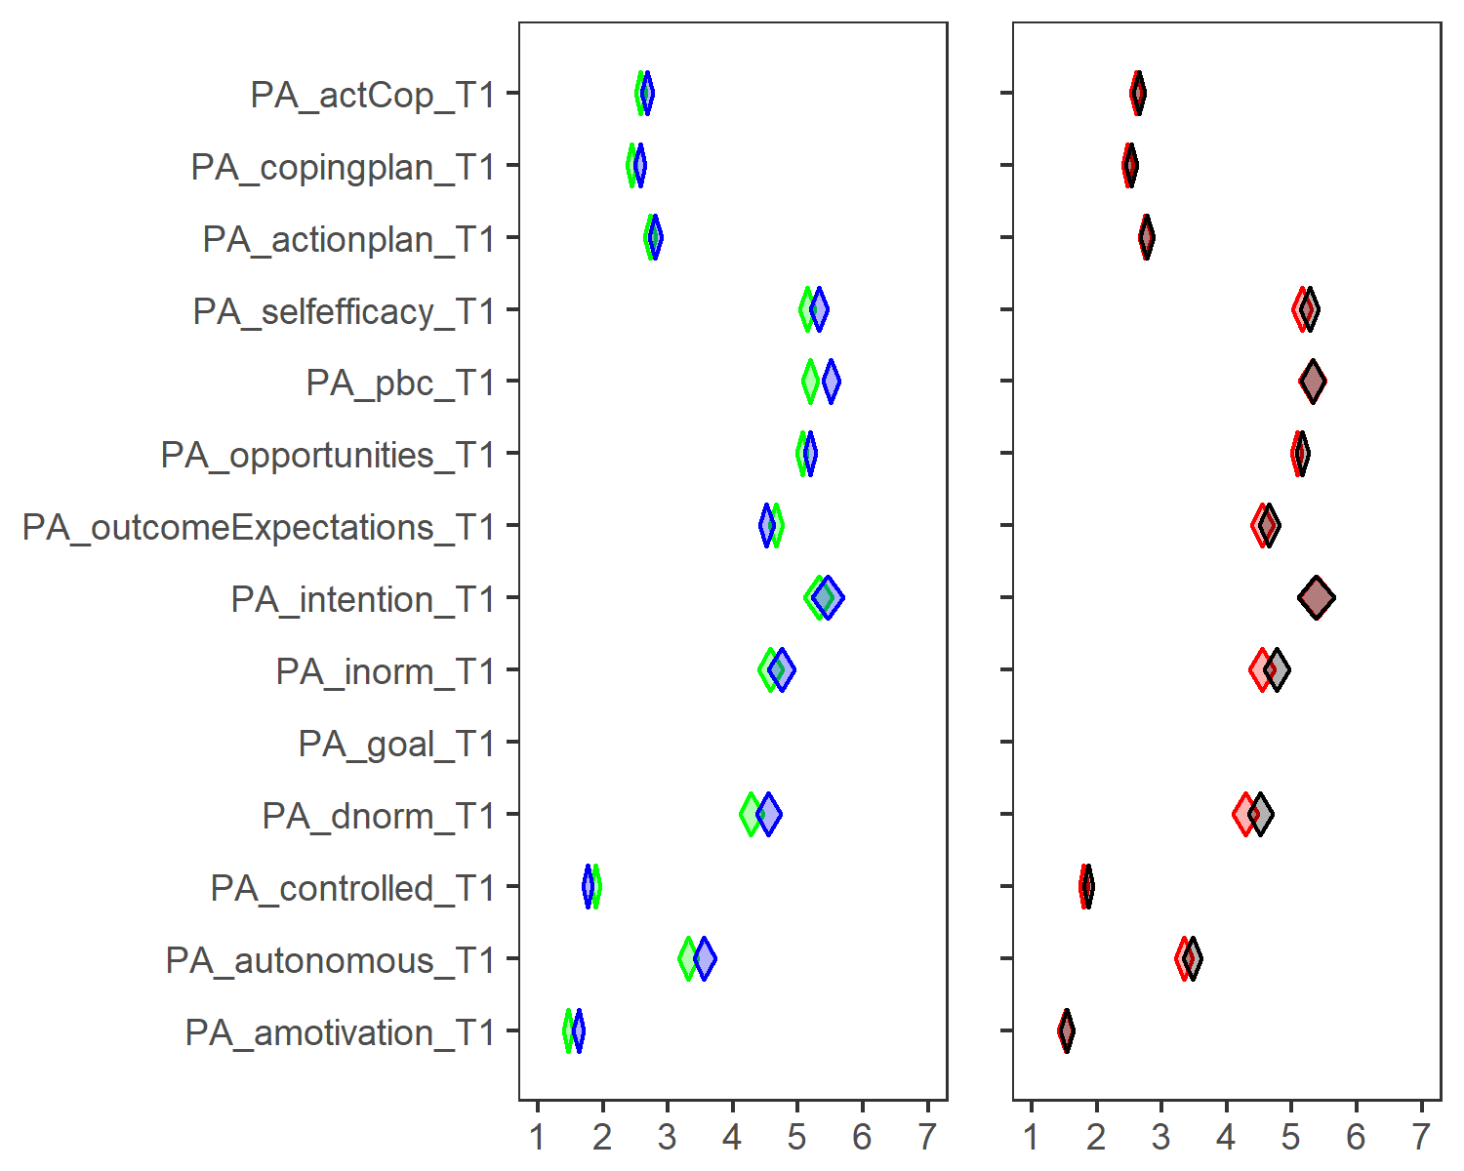

# dat2 <- data.frame(ciLo = c(3, 2), mean = c(4, 2.5), ciHi = c(6, 3));  
# userfriendlyscience::diamondPlot(dat1, color = 'blue', alpha=.3, yLabels = dat1$diamondlabels) +  
# userfriendlyscience::diamondPlot(dat2, returnLayerOnly = TRUE, color='red', alpha=.3)

Note: action and coping planning on a scale from 1 to 4.

# Visualising random effects using full posterior (UNDER CONSTRUCTION)

## Using rstanarm

Plot below shows credible intervals deviations

library(rstanarm)  
# grep("PA_", names(df), value = TRUE)  
  
# Centre the variable:  
df <- df %>% mutate(paAccelerometer_T1_centred = paAccelerometer_T1 - mean(paAccelerometer_T1, na.rm = TRUE))  
  
m_1 <- stan_glmer(paAccelerometer_T1_centred ~ (1 | group), data = df, chains = 2, iter = 2000)   
##   
## SAMPLING FOR MODEL 'continuous' NOW (CHAIN 1).  
##   
## Gradient evaluation took 0.001 seconds  
## 1000 transitions using 10 leapfrog steps per transition would take 10 seconds.  
## Adjust your expectations accordingly!  
##   
##   
## Iteration: 1 / 2000 [ 0%] (Warmup)  
## Iteration: 200 / 2000 [ 10%] (Warmup)  
## Iteration: 400 / 2000 [ 20%] (Warmup)  
## Iteration: 600 / 2000 [ 30%] (Warmup)  
## Iteration: 800 / 2000 [ 40%] (Warmup)  
## Iteration: 1000 / 2000 [ 50%] (Warmup)  
## Iteration: 1001 / 2000 [ 50%] (Sampling)  
## Iteration: 1200 / 2000 [ 60%] (Sampling)  
## Iteration: 1400 / 2000 [ 70%] (Sampling)  
## Iteration: 1600 / 2000 [ 80%] (Sampling)  
## Iteration: 1800 / 2000 [ 90%] (Sampling)  
## Iteration: 2000 / 2000 [100%] (Sampling)  
##   
## Elapsed Time: 1.902 seconds (Warm-up)  
## 1.001 seconds (Sampling)  
## 2.903 seconds (Total)  
##   
##   
## SAMPLING FOR MODEL 'continuous' NOW (CHAIN 2).  
##   
## Gradient evaluation took 0 seconds  
## 1000 transitions using 10 leapfrog steps per transition would take 0 seconds.  
## Adjust your expectations accordingly!  
##   
##   
## Iteration: 1 / 2000 [ 0%] (Warmup)  
## Iteration: 200 / 2000 [ 10%] (Warmup)  
## Iteration: 400 / 2000 [ 20%] (Warmup)  
## Iteration: 600 / 2000 [ 30%] (Warmup)  
## Iteration: 800 / 2000 [ 40%] (Warmup)  
## Iteration: 1000 / 2000 [ 50%] (Warmup)  
## Iteration: 1001 / 2000 [ 50%] (Sampling)  
## Iteration: 1200 / 2000 [ 60%] (Sampling)  
## Iteration: 1400 / 2000 [ 70%] (Sampling)  
## Iteration: 1600 / 2000 [ 80%] (Sampling)  
## Iteration: 1800 / 2000 [ 90%] (Sampling)  
## Iteration: 2000 / 2000 [100%] (Sampling)  
##   
## Elapsed Time: 1.836 seconds (Warm-up)  
## 1.121 seconds (Sampling)  
## 2.957 seconds (Total)  
pt <- ranef(m_1)   
posteriors <- data.frame(posterior_interval(m_1, prob = 0.90))   
school_int <- posteriors[-c(1, nrow(posteriors)-1, nrow(posteriors)),] #remove intercept and sigma parameters, leaving only class intervals   
  
# This not needed any more:  
# groupmeans <- df %>% select(paAccelerometer_T1, group) %>% group_by(group) %>%   
# summarise(mean = mean(paAccelerometer_T1, na.rm = T)) %>% filter(complete.cases(.))  
  
dat_plt <- data.frame(pt$group, school_int)   
colnames(dat_plt) <- c("pt", "low", "up")   
dat_plt <- dat_plt %>% arrange(pt)   
dat_plt$index <- 1:nrow(dat_plt)   
dat_plt %>% ggplot(aes(x = index, y = pt)) + geom_errorbar(aes(ymin = low, ymax = up)) + geom_point(size = 4, shape = 18) + geom_point(size = 2.5, shape = 18, color = "white") + theme_bw()

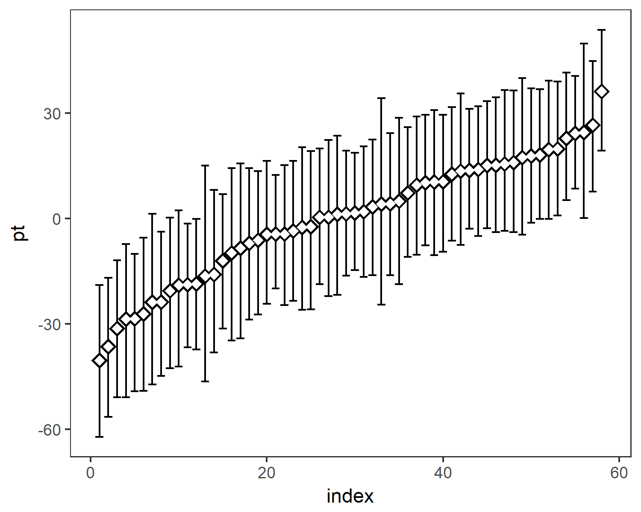

## Using brms and diamondPlot

Set Rtools folder, if not in C:/Rtools/:

# For some reason, having BINPREF in .Renviron doesn't work and I keep needing this:  
Sys.setenv("BINPREF" = "C:/HYApp/Rtools3.4/mingw_$(WIN)/bin/")

library(brms)  
  
# Centre the variable:  
df <- df %>% mutate(paAccelerometer_T1_centred =   
 paAccelerometer_T1 - mean(paAccelerometer_T1, na.rm = TRUE))  
  
m_1 <- brms::bf(paAccelerometer_T1_centred ~ (1 | group))   
get_prior(m_1, data = df)  
  
fit_1 <- brms::brm(m_1, df)  
  
pt <- brms::ranef(fit_1, robust = TRUE) %>%   
 data.frame %>%   
 select(credintLow = group.2.5.ile.Intercept,  
 intercept = group.Estimate.Intercept,   
 credintHigh = group.97.5.ile.Intercept) %>%   
 arrange(intercept)  
  
  
plot1 <- userfriendlyscience::diamondPlot(pt, color = 'green', alpha=.3, yLabels = 1:58, fixedSize = 0.3, xlab = NULL) +  
 coord_flip(expand = TRUE) +  
 labs(x = "Deviance from average MVPA", y = "Group")  
  
  
df %>% ggplot(aes(x = group, y = paAccelerometer_T1_centred)) +  
 userfriendlyscience::diamondPlot(pt, color = 'green', alpha=.3, yLabels = 1:58, fixedSize = 0.3, xlab = NULL, returnLayerOnly = TRUE) +  
 coord_flip(expand = TRUE) +  
 labs(x = "Deviance from average MVPA", y = "Group")  
   
forest(fit_1)

## Random effects in autonomous motivation

# Centre the variable:  
df <- df %>% mutate(PA_autonomous_T1_centred = PA_autonomous_T1 - mean(PA_autonomous_T1, na.rm = TRUE))  
  
m_1 <- brms::bf(PA_autonomous_T1_centred ~ (1 | group))   
get_prior(m_1, data = df)  
## Error in get_prior(m_1, data = df): could not find function "get_prior"  
  
fit_1 <- brms::brm(m_1, df)  
## Warning: Rows containing NAs were excluded from the model  
## Compiling the C++ model  
## Start sampling  
##   
## SAMPLING FOR MODEL 'gaussian brms-model' NOW (CHAIN 1).  
##   
## Gradient evaluation took 0 seconds  
## 1000 transitions using 10 leapfrog steps per transition would take 0 seconds.  
## Adjust your expectations accordingly!  
##   
##   
## Iteration: 1 / 2000 [ 0%] (Warmup)  
## Iteration: 200 / 2000 [ 10%] (Warmup)  
## Iteration: 400 / 2000 [ 20%] (Warmup)  
## Iteration: 600 / 2000 [ 30%] (Warmup)  
## Iteration: 800 / 2000 [ 40%] (Warmup)  
## Iteration: 1000 / 2000 [ 50%] (Warmup)  
## Iteration: 1001 / 2000 [ 50%] (Sampling)  
## Iteration: 1200 / 2000 [ 60%] (Sampling)  
## Iteration: 1400 / 2000 [ 70%] (Sampling)  
## Iteration: 1600 / 2000 [ 80%] (Sampling)  
## Iteration: 1800 / 2000 [ 90%] (Sampling)  
## Iteration: 2000 / 2000 [100%] (Sampling)  
##   
## Elapsed Time: 1.341 seconds (Warm-up)  
## 0.971 seconds (Sampling)  
## 2.312 seconds (Total)  
##   
##   
## SAMPLING FOR MODEL 'gaussian brms-model' NOW (CHAIN 2).  
##   
## Gradient evaluation took 0 seconds  
## 1000 transitions using 10 leapfrog steps per transition would take 0 seconds.  
## Adjust your expectations accordingly!  
##   
##   
## Iteration: 1 / 2000 [ 0%] (Warmup)  
## Iteration: 200 / 2000 [ 10%] (Warmup)  
## Iteration: 400 / 2000 [ 20%] (Warmup)  
## Iteration: 600 / 2000 [ 30%] (Warmup)  
## Iteration: 800 / 2000 [ 40%] (Warmup)  
## Iteration: 1000 / 2000 [ 50%] (Warmup)  
## Iteration: 1001 / 2000 [ 50%] (Sampling)  
## Iteration: 1200 / 2000 [ 60%] (Sampling)  
## Iteration: 1400 / 2000 [ 70%] (Sampling)  
## Iteration: 1600 / 2000 [ 80%] (Sampling)  
## Iteration: 1800 / 2000 [ 90%] (Sampling)  
## Iteration: 2000 / 2000 [100%] (Sampling)  
##   
## Elapsed Time: 1.351 seconds (Warm-up)  
## 1.321 seconds (Sampling)  
## 2.672 seconds (Total)  
##   
##   
## SAMPLING FOR MODEL 'gaussian brms-model' NOW (CHAIN 3).  
##   
## Gradient evaluation took 0 seconds  
## 1000 transitions using 10 leapfrog steps per transition would take 0 seconds.  
## Adjust your expectations accordingly!  
##   
##   
## Iteration: 1 / 2000 [ 0%] (Warmup)  
## Iteration: 200 / 2000 [ 10%] (Warmup)  
## Iteration: 400 / 2000 [ 20%] (Warmup)  
## Iteration: 600 / 2000 [ 30%] (Warmup)  
## Iteration: 800 / 2000 [ 40%] (Warmup)  
## Iteration: 1000 / 2000 [ 50%] (Warmup)  
## Iteration: 1001 / 2000 [ 50%] (Sampling)  
## Iteration: 1200 / 2000 [ 60%] (Sampling)  
## Iteration: 1400 / 2000 [ 70%] (Sampling)  
## Iteration: 1600 / 2000 [ 80%] (Sampling)  
## Iteration: 1800 / 2000 [ 90%] (Sampling)  
## Iteration: 2000 / 2000 [100%] (Sampling)  
##   
## Elapsed Time: 1.473 seconds (Warm-up)  
## 1.35 seconds (Sampling)  
## 2.823 seconds (Total)  
##   
##   
## SAMPLING FOR MODEL 'gaussian brms-model' NOW (CHAIN 4).  
##   
## Gradient evaluation took 0 seconds  
## 1000 transitions using 10 leapfrog steps per transition would take 0 seconds.  
## Adjust your expectations accordingly!  
##   
##   
## Iteration: 1 / 2000 [ 0%] (Warmup)  
## Iteration: 200 / 2000 [ 10%] (Warmup)  
## Iteration: 400 / 2000 [ 20%] (Warmup)  
## Iteration: 600 / 2000 [ 30%] (Warmup)  
## Iteration: 800 / 2000 [ 40%] (Warmup)  
## Iteration: 1000 / 2000 [ 50%] (Warmup)  
## Iteration: 1001 / 2000 [ 50%] (Sampling)  
## Iteration: 1200 / 2000 [ 60%] (Sampling)  
## Iteration: 1400 / 2000 [ 70%] (Sampling)  
## Iteration: 1600 / 2000 [ 80%] (Sampling)  
## Iteration: 1800 / 2000 [ 90%] (Sampling)  
## Iteration: 2000 / 2000 [100%] (Sampling)  
##   
## Elapsed Time: 1.491 seconds (Warm-up)  
## 1.309 seconds (Sampling)  
## 2.8 seconds (Total)  
  
pt <- brms::ranef(fit_1, robust = TRUE) %>%   
 data.frame %>%   
 select(credintLow = group.2.5.ile.Intercept,  
 intercept = group.Estimate.Intercept,   
 credintHigh = group.97.5.ile.Intercept) %>%   
 arrange(intercept)  
  
  
plot1 <- userfriendlyscience::diamondPlot(pt, color = 'blue', alpha=.3, yLabels = 1:59, fixedSize = 0.3, xlab = NULL) +  
 coord_flip(expand = TRUE) +  
 labs(x = "Deviance from average motivation", y = "Group")  
  
  
df %>% ggplot(aes(x = group, y = PA_autonomous_T1_centred)) +  
 userfriendlyscience::diamondPlot(pt, color = 'blue', alpha=.3, yLabels = 1:59, fixedSize = 0.3, xlab = NULL, returnLayerOnly = TRUE) +  
 coord_flip(expand = TRUE) +  
 labs(x = "Deviance from average motivation", y = "Group")

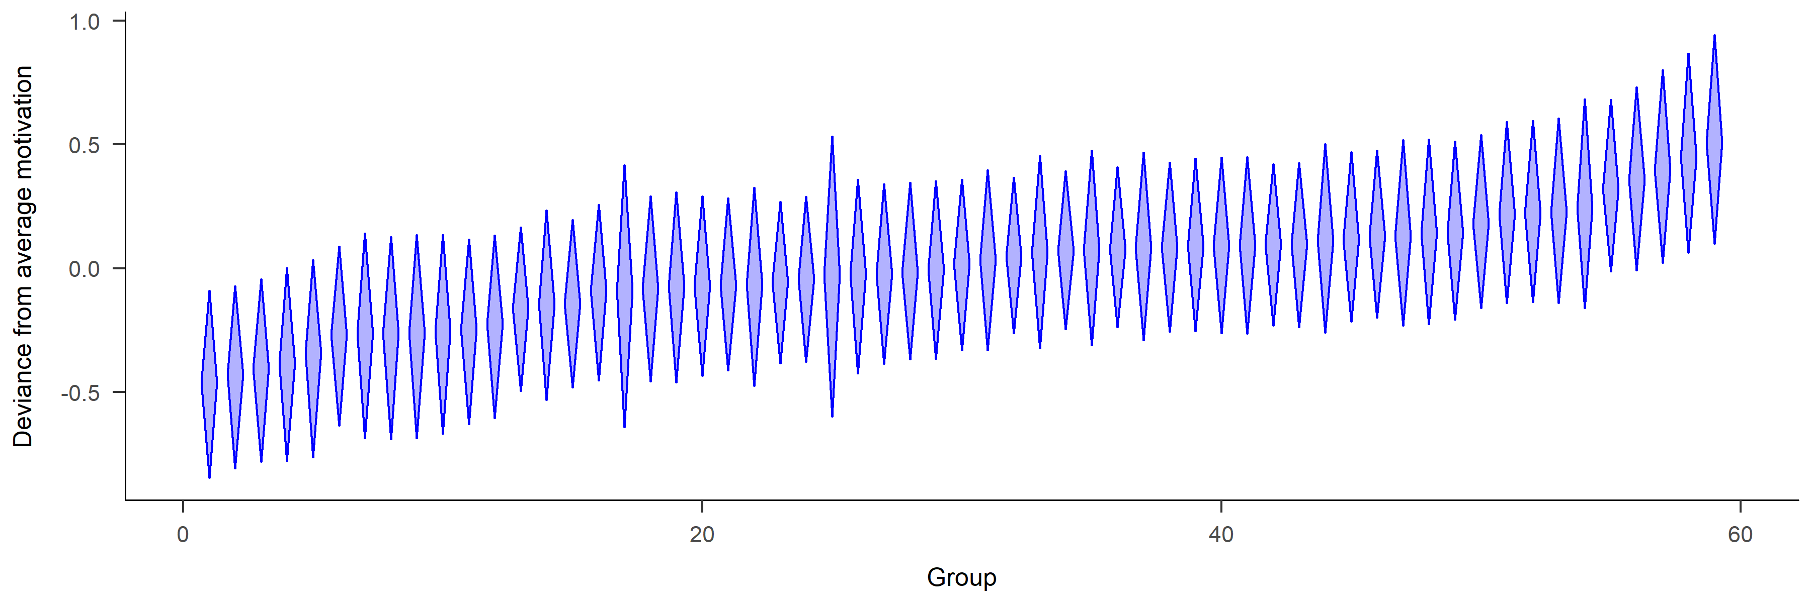

# Ridge plots

## PA motivation

plot1 <- df %>% dplyr::select(id,  
 intervention,  
 group,  
 school,  
 girl,  
 'PA autonomous \nmotivation' = PA_autonomous_T1,  
'PA controlled \nmotivation' = PA_controlled_T1,  
'PA amotivation' = PA_amotivation_T1) %>%  
 # select(noquote(order(colnames(.)))) %>% # Orders columns alphabetically  
 tidyr::gather(key = Variable, value = Value, 6:ncol(.)) %>%   
 ggplot(aes(y = Variable)) +  
 ggridges::geom_density_ridges(aes(x = Value, fill = paste(Variable, girl)),   
 alpha = .6, color = "black", from = 1, to = 7, scale = 1) +  
 labs(x = "",  
 y = "") +  
 scale_y_discrete(expand = c(0.01, 0)) +  
 scale_x_continuous(expand = c(0.01, 0)) +  
 ggridges::scale_fill_cyclical(breaks = c("PA amotivation Boy", "PA amotivation Girl"),  
 labels = c( 'PA amotivation Girl' = "Boy", 'PA amotivation Boy' = "Girl"),  
 values = c("#3bc600", "#0000ff", "#9cc68b", "#8080ff"),  
 name = "", guide = "legend") +  
 ggridges::theme_ridges(grid = FALSE) +  
 theme(legend.position="bottom")  
  
plot2 <- df %>% dplyr::select(id,  
 intervention,  
 group,  
 school,  
 girl,  
 'PA autonomous \nmotivation' = PA_autonomous_T1,  
'PA controlled \nmotivation' = PA_controlled_T1,  
'PA amotivation' = PA_amotivation_T1) %>%  
 # select(noquote(order(colnames(.)))) %>% # Orders columns alphabetically  
 tidyr::gather(key = Variable, value = Value, 6:ncol(.)) %>%   
 ggplot(aes(y = Variable)) +  
 ggridges::geom_density_ridges(aes(x = Value, fill = paste(Variable, intervention)),   
 alpha = .6, color = "black", from = 1, to = 7, scale = 1) +  
 labs(x = "",  
 y = "") +  
 scale_y_discrete(expand = c(0.01, 0), labels = NULL) +  
 scale_x_continuous(expand = c(0.01, 0)) +  
 ggridges::scale_fill_cyclical(breaks = c("PA amotivation 1", "PA amotivation 0"),  
 labels = c('PA amotivation 1' = "Intervention", 'PA amotivation 0' = "Control"),  
 values = c("#ff0000", "#0000ff", "#ff8080", "#8080ff"),  
 name = "", guide = "legend") +  
 ggridges::theme_ridges(grid = FALSE) +  
 theme(legend.position="bottom")  
  
# grid.arrange(plot1, plot2, ncol = 2)  
  
grid::grid.newpage()  
grid::grid.draw(cbind(ggplotGrob(plot1), ggplotGrob(plot2), size = "first"))  
## Picking joint bandwidth of 0.216  
## Warning: Removed 272 rows containing non-finite values  
## (stat_density_ridges).  
## Picking joint bandwidth of 0.216  
## Warning: Removed 272 rows containing non-finite values  
## (stat_density_ridges).  
## Error: nrow(x) == nrow(y) is not TRUE

## Big 5 personality traits

plot1 <- df %>% dplyr::select(id,  
 intervention,  
 group,  
 school,  
 girl,  
'Agreeableness' = big5_agreeableness_T1,  
'Conscientiousness' = big5_conscientiousness_T1,  
'Extraversion' = big5_extraversion_T1,  
'Neuroticism' = big5_neuroticism_T1,  
'Openness' = big5_openness_T1) %>%  
 # select(noquote(order(colnames(.)))) %>% # Orders columns alphabetically  
 tidyr::gather(key = Variable, value = Value, 6:ncol(.)) %>%   
 ggplot(aes(y = Variable)) +  
 ggridges::geom_density_ridges(aes(x = Value, fill = paste(Variable, girl)),   
 alpha = .6, color = "black", from = 1, to = 7) +  
 labs(x = "",  
 y = "") +  
 scale_y_discrete(expand = c(0.01, 0)) +  
 scale_x_continuous(expand = c(0.01, 0)) +  
 ggridges::scale_fill_cyclical(breaks = c("Agreeableness 0", "Agreeableness 1"),  
 labels = c( 'Agreeableness 0' = "Boy", 'Agreeableness 1' = "Girl"),  
 values = c("#3bc600", "#0000ff", "#9cc68b", "#8080ff"),  
 name = "", guide = "legend") +  
 ggridges::theme_ridges(grid = FALSE) +  
 theme(legend.position="bottom")  
## Error in overscope_eval_next(overscope, expr): object 'big5_agreeableness_T1' not found  
  
plot2 <- df %>% dplyr::select(id,  
 intervention,  
 group,  
 school,  
 girl,  
'Agreeableness' = big5_agreeableness_T1,  
'Conscientiousness' = big5_conscientiousness_T1,  
'Extraversion' = big5_extraversion_T1,  
'Neuroticism' = big5_neuroticism_T1,  
'Openness' = big5_openness_T1) %>%  
 # select(noquote(order(colnames(.)))) %>% # Orders columns alphabetically  
 tidyr::gather(key = Variable, value = Value, 6:ncol(.)) %>%   
 ggplot(aes(y = Variable)) +  
 ggridges::geom_density_ridges(aes(x = Value, fill = paste(Variable, intervention)),   
 alpha = .6, color = "black", from = 1, to = 7) +  
 labs(x = "",  
 y = "") +  
 scale_y_discrete(expand = c(0.01, 0), labels = NULL) +  
 scale_x_continuous(expand = c(0.01, 0)) +  
 ggridges::scale_fill_cyclical(breaks = c("Agreeableness 1", "Agreeableness 0"),  
 labels = c('Agreeableness 1' = "Intervention", 'Agreeableness 0' = "Control"),  
 values = c("#ff0000", "#0000ff", "#ff8080", "#8080ff"),  
 name = "", guide = "legend") +  
 ggridges::theme_ridges(grid = FALSE) +  
 theme(legend.position="bottom")  
## Error in overscope_eval_next(overscope, expr): object 'big5_agreeableness_T1' not found  
  
# grid.arrange(plot1, plot2, ncol = 2)  
  
grid::grid.newpage()  
grid::grid.draw(cbind(ggplotGrob(plot1), ggplotGrob(plot2), size = "first"))  
## Picking joint bandwidth of 0.216  
## Warning: Removed 272 rows containing non-finite values  
## (stat_density_ridges).  
## Picking joint bandwidth of 0.216  
## Warning: Removed 272 rows containing non-finite values  
## (stat_density_ridges).  
## Error: nrow(x) == nrow(y) is not TRUE

## BCT use

### Ridge plots for means

plot1 <- df %>% dplyr::select(id,  
 intervention,  
 group,  
 school,  
 girl,  
'Frequency-\nrelated BCTs' = PA_frqbct_T1,  
'Agreement-\nrelated BCTs' = PA_agrbct_T1) %>%  
 # select(noquote(order(colnames(.)))) %>% # Orders columns alphabetically  
 tidyr::gather(key = Variable, value = Value, 6:ncol(.)) %>%   
 ggplot(aes(y = Variable)) +  
 ggridges::geom_density_ridges(aes(x = Value, fill = paste(Variable, girl)),   
 alpha = .6, color = "black", from = 1, to = 7) +  
 labs(x = "",  
 y = "") +  
 scale_y_discrete(expand = c(0.01, 0)) +  
 scale_x_continuous(expand = c(0.01, 0)) +  
 ggridges::scale_fill_cyclical(breaks = c("Agreement-\nrelated BCTs 0", "Agreement-\nrelated BCTs 1"),  
 labels = c( 'Agreement-\nrelated BCTs 0' = "Boy", 'Agreement-\nrelated BCTs 1' = "Girl"),  
 values = c("#3bc600", "#0000ff", "#9cc68b", "#8080ff"),  
 name = "", guide = "legend") +  
 ggridges::theme_ridges(grid = FALSE) +  
 theme(legend.position="bottom")  
  
plot2 <- df %>% dplyr::select(id,  
 intervention,  
 group,  
 school,  
 girl,  
'Frequency-\nrelated BCTs' = PA_frqbct_T1,  
'Agreement-\nrelated BCTs' = PA_agrbct_T1) %>%  
 # select(noquote(order(colnames(.)))) %>% # Orders columns alphabetically  
 tidyr::gather(key = Variable, value = Value, 6:ncol(.)) %>%   
 ggplot(aes(y = Variable)) +  
 ggridges::geom_density_ridges(aes(x = Value, fill = paste(Variable, intervention)),   
 alpha = .6, color = "black", from = 1, to = 7) +  
 labs(x = "",  
 y = "") +  
 scale_y_discrete(expand = c(0.01, 0), labels = NULL) +  
 scale_x_continuous(expand = c(0.01, 0)) +  
 ggridges::scale_fill_cyclical(breaks = c("Agreement-\nrelated BCTs 1", "Agreement-\nrelated BCTs 0"),  
 labels = c('Agreement-\nrelated BCTs 1' = "Intervention", 'Agreement-\nrelated BCTs 0' = "Control"),  
 values = c("#ff0000", "#0000ff", "#ff8080", "#8080ff"),  
 name = "", guide = "legend") +  
 ggridges::theme_ridges(grid = FALSE) +  
 theme(legend.position="bottom")  
  
grid::grid.newpage()  
grid::grid.draw(cbind(ggplotGrob(plot1), ggplotGrob(plot2), size = "first"))  
## Picking joint bandwidth of 0.319  
## Warning: Removed 189 rows containing non-finite values  
## (stat_density_ridges).  
## Picking joint bandwidth of 0.318  
## Warning: Removed 189 rows containing non-finite values  
## (stat_density_ridges).

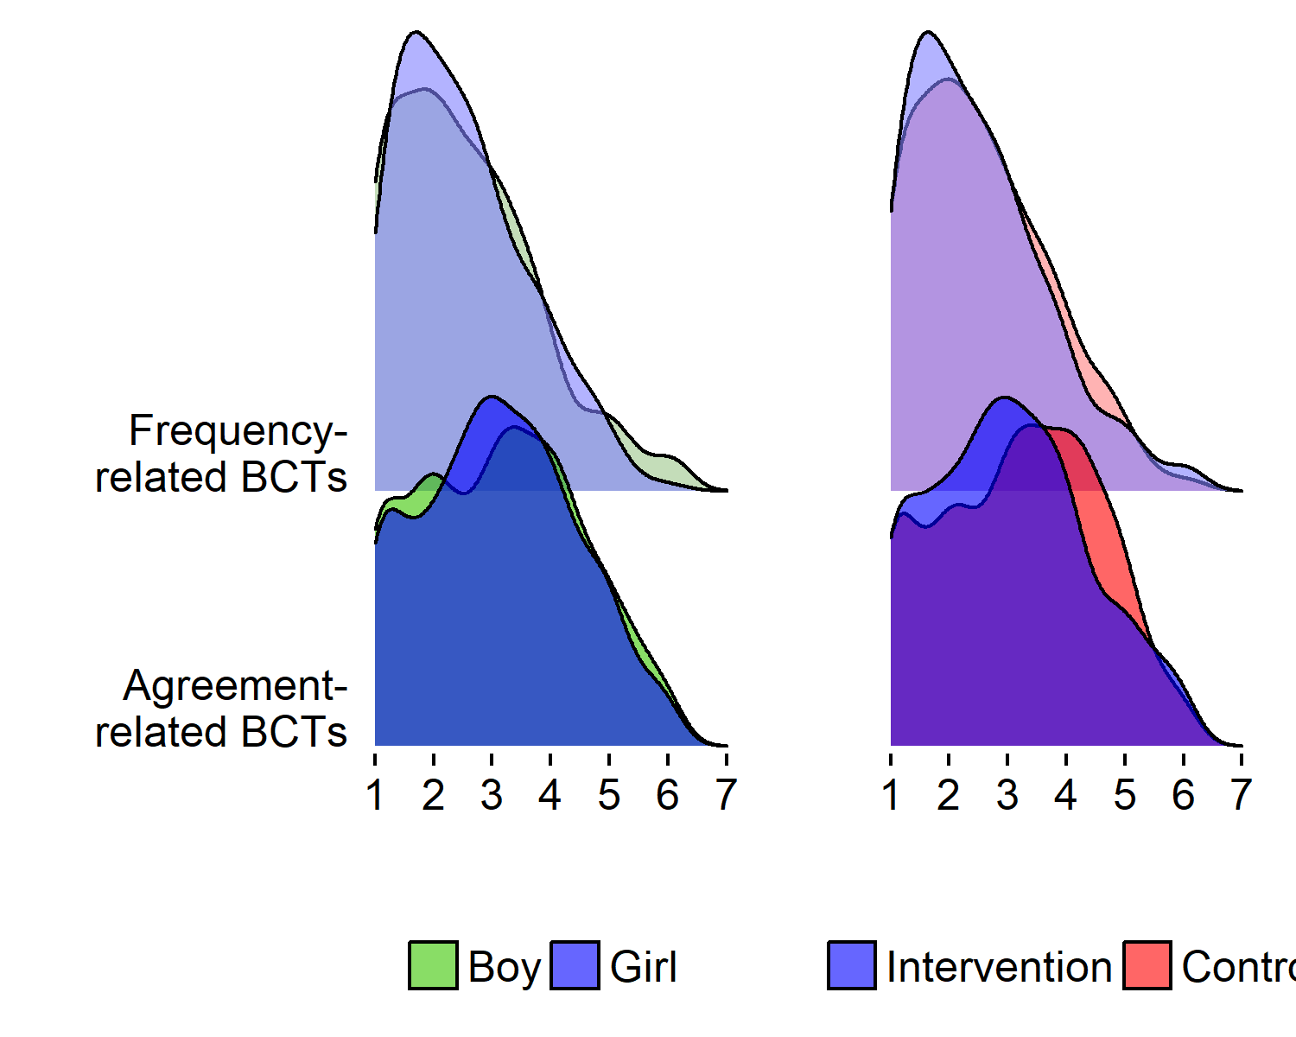

# grid.arrange(plot1, plot2, ncol = 2)

### sm kernel density plots for means

#### Frequency-measured BCTs

colfill <- c(1,2,3,4,5)  
  
# Create data frame  
densplot <- df  
levels(densplot$intervention) <- list("Intervention" = "1", "Control" = "0")  
levels(densplot$girl) <- list("Girl" = "1", "Boy" = "0")  
  
# This gives side-by-side plots  
 layout(matrix(c(1,2,3,3), nrow = 2, ncol = 2, byrow = TRUE), heights=c(2.5, 2))  
  
## Intervention vs. control  
# Choose only the variables needed and drop NA  
dens <- densplot %>% select(PA_frqbct_T1, intervention) %>%   
 na.omit(.)  
  
# Set random number generator for reproducibility of bootstrap test of equal densities  
set.seed(10)  
# Make plot  
sm.PA_frqbct_T1_1 <- sm.density.compare2(as.numeric(dens$PA_frqbct_T1), as.factor(dens$intervention), xlab="", col=colfill, lty=c(1,2), bandcol='LightGray', model="equal", lwd=(c(2,2)))  
##   
## Test of equal densities: p-value = 0.31  
legend("topright", levels(dens$intervention), fill=c(1, 2))  
  
## Girls vs. boys  
# Choose only the variables needed and drop NA  
dens <- densplot %>% select(PA_frqbct_T1, girl) %>%   
 na.omit(.)  
  
# Set random number generator for reproducibility of bootstrap test of equal densities  
set.seed(10)  
# Make plot  
sm.PA_frqbct_T1_2 <- sm.density.compare2(as.numeric(dens$PA_frqbct_T1), as.factor(dens$girl), xlab="", col=colfill, lty=c(1,2), bandcol='LightGray', model="equal", lwd=(c(2,2)))  
##   
## Test of equal densities: p-value = 0.11  
legend("topright", levels(dens$girl), fill=c(1, 2))  
  
## Differences in schools  
# Choose only the variables needed and drop NA  
dens <- densplot %>% select(PA_frqbct_T1, school) %>%   
 na.omit(.)  
  
# Set random number generator for reproducibility of bootstrap test of equal densities  
set.seed(10)  
  
# Intervention groups with solid thicker lines  
linetypes <- c(1,2,2,1,2)  
  
# Set random number generator for reproducibility of bootstrap test of equal densities  
set.seed(10)  
# Make plot  
sm.PA_frqbct_T1_3 <- sm::sm.density.compare(as.numeric(dens$PA_frqbct_T1), dens$school, xlab="", col=colfill, lty=linetypes, model="none")  
legend("topright", c("Intervention school", "Control school"), col = c(4, 3), lty = c(1, 2), lwd = c(2, 2))

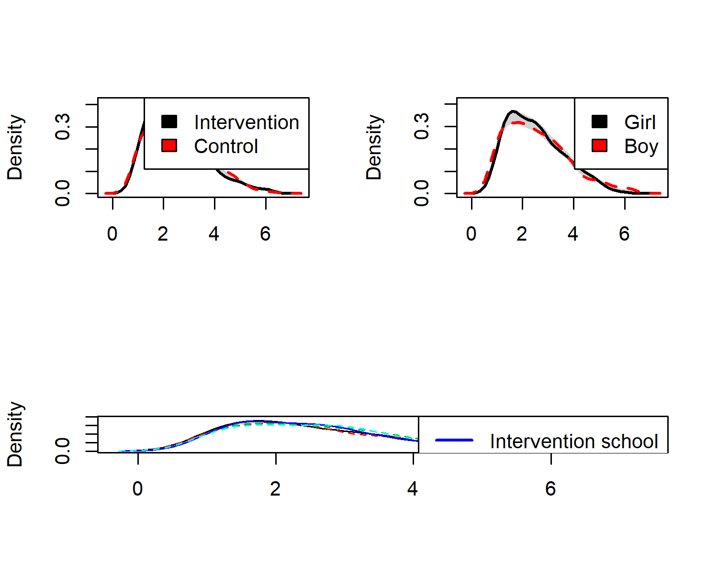

#### Agreement-measured BCTs

colfill <- c(1,2,3,4,5)  
  
# Create data frame  
densplot <- df  
levels(densplot$intervention) <- list("Intervention" = "1", "Control" = "0")  
levels(densplot$girl) <- list("Girl" = "1", "Boy" = "0")  
  
# This gives side-by-side plots  
 layout(matrix(c(1,2,3,3), nrow = 2, ncol = 2, byrow = TRUE), heights=c(2.5, 2))  
  
## Intervention vs. control  
# Choose only the variables needed and drop NA  
dens <- densplot %>% select(PA_agrbct_T1, intervention) %>%   
 na.omit(.)  
  
# Set random number generator for reproducibility of bootstrap test of equal densities  
set.seed(10)  
# Make plot  
sm.PA_agrbct_T1_1 <- sm.density.compare2(as.numeric(dens$PA_agrbct_T1), as.factor(dens$intervention), xlab="", col=colfill, lty=c(1,2), bandcol='LightGray', model="equal", lwd=(c(2,2)))  
##   
## Test of equal densities: p-value = 0  
legend("topright", levels(dens$intervention), fill=c(1, 2))  
  
## Girls vs. boys  
# Choose only the variables needed and drop NA  
dens <- densplot %>% select(PA_agrbct_T1, girl) %>%   
 na.omit(.)  
  
# Set random number generator for reproducibility of bootstrap test of equal densities  
set.seed(10)  
# Make plot  
sm.PA_agrbct_T1_2 <- sm.density.compare2(as.numeric(dens$PA_agrbct_T1), as.factor(dens$girl), xlab="", col=colfill, lty=c(1,2), bandcol='LightGray', model="equal", lwd=(c(2,2)))  
##   
## Test of equal densities: p-value = 0.27  
legend("topright", levels(dens$girl), fill=c(1, 2))  
  
## Differences in schools  
# Choose only the variables needed and drop NA  
dens <- densplot %>% select(PA_agrbct_T1, school) %>%   
 na.omit(.)  
  
# Intervention groups with solid thicker lines  
linetypes <- c(1,2,2,1,2)  
  
# Set random number generator for reproducibility of bootstrap test of equal densities  
set.seed(10)  
# Make plot  
sm.PA_agrbct_T1_3 <- sm::sm.density.compare(as.numeric(dens$PA_agrbct_T1), dens$school, xlab="", col=colfill, lty=linetypes, model="none")  
legend("topright", c("Intervention school", "Control school"), col = c(4, 3), lty = c(1, 2), lwd = c(2, 2))

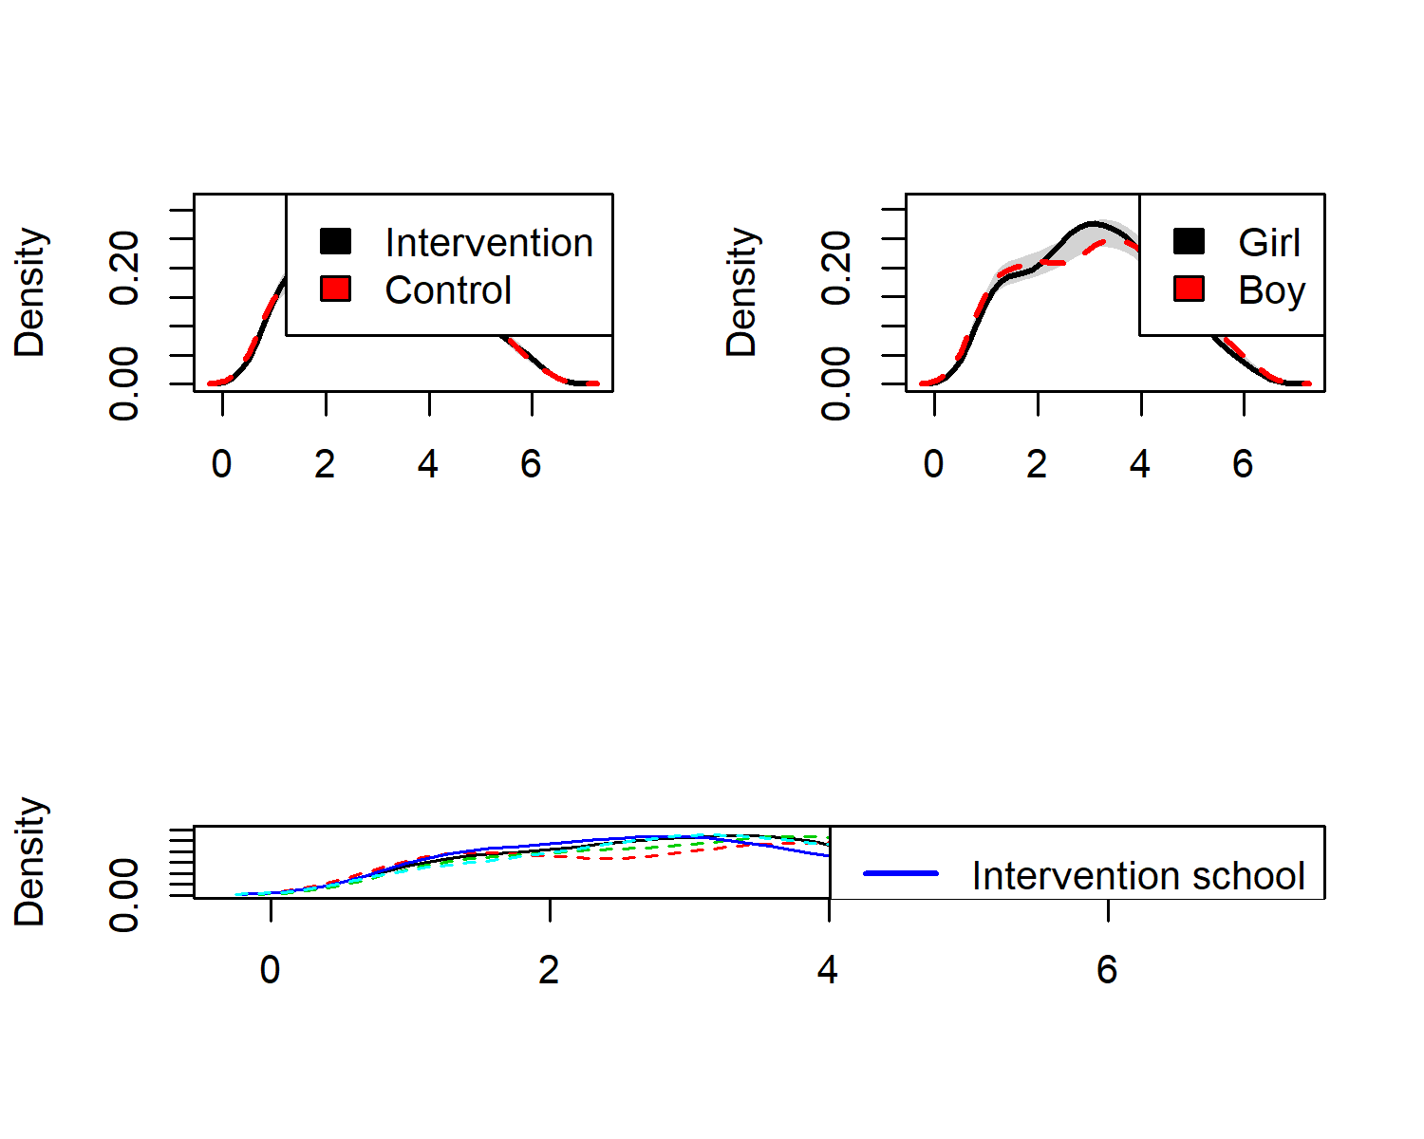

### Histograms for individual items

#### Frequency-measured BCTs

These questions were asked with the lead “Have you done the following during the last three weeks?”.

The answer scale was as follows:

0 = not once 1 = once 2 = twice 3 = weekly 4 = about every second day 5 = daily

Items are as follows:

1. I have reminded myself even in my spare time, what kind of positive consequences frequent PA would have in my life.
2. I have monitored my PA by marking the PA occasions on an exercise log on paper.
3. I have monitored my PA by using a smart phone, e.g. the Moves-app.
4. I use mnemonic cues with which I remember to implement my PA intention.
5. I have compared my actualized PA with the PA goal I have set.
6. I have thought about which reasons to do PA are important to me personally.
7. I have made changes in my home (e.g. my room or my computer), so that starting PA would be easier.
8. I have asked my friends or family for support to reach my PA goals.
9. If I haven’t reached my PA goal, I have evaluated, what went wrong.

bctGirls <- df %>% dplyr::select(id,  
 intervention,  
 group,  
 school,  
 girl,  
'Reminded self of positive consequences' = PA_frqbct_01_T1,  
'Has logged PA on paper' = PA_frqbct_02_T1,  
'Has monitored PA on smartphone' = PA_frqbct_03_T1,  
'Uses mnemonic cues' = PA_frqbct_04_T1,  
'Has compared actual with goal' = PA_frqbct_05_T1,  
'Has thought of relevance of PA' = PA_frqbct_06_T1,  
'Has made changes at home' = PA_frqbct_07_T1,  
'Has sought social support' = PA_frqbct_08_T1,  
'Has evaluated why goal not reached' = PA_frqbct_09_T1) %>%  
 tidyr::gather(key = Variable, value = Value, 6:ncol(.)) %>%  
 filter(girl == "1") %>%   
 ggplot(aes(x = Value, y = Variable, group = Variable)) +  
 ggridges::geom_density_ridges2(aes(fill = Variable), stat = "binline", binwidth = 1, scale = 0.95) +  
 scale_x_continuous(breaks = c(1:6), expand = c(0, 0),  
 name = "") +  
 scale_y_discrete(expand = c(0.01, 0), name = "", labels = NULL) +  
 ggridges::scale_fill_cyclical(values = c("darkolivegreen2", "darkolivegreen4")) +  
 labs(title = "Girls") +  
 guides(y = "none") +  
 ggridges::theme_ridges(grid = FALSE) +  
 theme(axis.title.x = element_text(hjust = 0.5),  
 axis.title.y = element_text(hjust = 0.5),  
 plot.title = element_text(hjust = 0.5),  
 axis.text=element_text(size=10, face="bold")) +  
coord_cartesian(xlim = c(0.5, 6.5))  
## Warning: attributes are not identical across measure variables;  
## they will be dropped  
  
bctBoys <- df %>% dplyr::select(id,  
 intervention,  
 group,  
 school,  
 girl,  
'Reminded self of positive consequences' = PA_frqbct_01_T1,  
'Has logged PA on paper' = PA_frqbct_02_T1,  
'Has monitored PA on smartphone' = PA_frqbct_03_T1,  
'Uses mnemonic cues' = PA_frqbct_04_T1,  
'Has compared actual with goal' = PA_frqbct_05_T1,  
'Has thought of relevance of PA' = PA_frqbct_06_T1,  
'Has made changes at home' = PA_frqbct_07_T1,  
'Has sought social support' = PA_frqbct_08_T1,  
'Has evaluated why goal not reached' = PA_frqbct_09_T1) %>%  
 tidyr::gather(key = Variable, value = Value, 6:ncol(.)) %>%  
 filter(girl == "0") %>%   
 ggplot(aes(x = Value, y = Variable, group = Variable)) +  
 ggridges::geom_density_ridges2(aes(fill = Variable), stat = "binline", binwidth = 1, scale = 0.95) +  
 scale_x_continuous(breaks = c(1:6), expand = c(0, 0),  
 name = "") +  
 scale_y_discrete(expand = c(0.01, 0), name = "", labels = NULL) +  
 ggridges::scale_fill_cyclical(values = c("darkolivegreen2", "darkolivegreen4")) +  
 labs(title = "Boys") +  
 guides(y = "none") +  
 ggridges::theme_ridges(grid = FALSE) +  
 theme(axis.title.x = element_text(hjust = 0.5),  
 axis.title.y = element_text(hjust = 0.5),  
 plot.title = element_text(hjust = 0.5),  
 axis.text=element_text(size=10, face="bold")) +  
coord_cartesian(xlim = c(0.5, 6.5))  
## Warning: attributes are not identical across measure variables;  
## they will be dropped  
  
bctInt <- df %>% dplyr::select(id,  
 intervention,  
 group,  
 school,  
 girl,  
'Reminded self of positive consequences' = PA_frqbct_01_T1,  
'Has logged PA on paper' = PA_frqbct_02_T1,  
'Has monitored PA on smartphone' = PA_frqbct_03_T1,  
'Uses mnemonic cues' = PA_frqbct_04_T1,  
'Has compared actual with goal' = PA_frqbct_05_T1,  
'Has thought of relevance of PA' = PA_frqbct_06_T1,  
'Has made changes at home' = PA_frqbct_07_T1,  
'Has sought social support' = PA_frqbct_08_T1,  
'Has evaluated why goal not reached' = PA_frqbct_09_T1) %>%  
 tidyr::gather(key = Variable, value = Value, 6:ncol(.)) %>%  
 filter(intervention == "1") %>%   
 ggplot(aes(x = Value, y = Variable, group = Variable)) +  
 ggridges::geom_density_ridges2(aes(fill = Variable), stat = "binline", binwidth = 1, scale = 0.95) +  
 scale_x_continuous(breaks = c(1:6), expand = c(0, 0),  
 name = "") +  
 scale_y_discrete(expand = c(0.01, 0), name = "") +  
 ggridges::scale_fill_cyclical(values = c("deepskyblue", "deepskyblue4")) +  
 labs(title = "Intervention") +  
 guides(y = "none") +  
 ggridges::theme_ridges(grid = FALSE) +  
 theme(axis.title.x = element_text(hjust = 0.5),  
 axis.title.y = element_text(hjust = 0.5),  
 axis.text=element_text(size=10, face="bold")) +  
coord_cartesian(xlim = c(0.5, 6.5))  
## Warning: attributes are not identical across measure variables;  
## they will be dropped  
  
bctCont <- df %>% dplyr::select(id,  
 intervention,  
 group,  
 school,  
 girl,  
'Reminded self of positive consequences' = PA_frqbct_01_T1,  
'Has logged PA on paper' = PA_frqbct_02_T1,  
'Has monitored PA on smartphone' = PA_frqbct_03_T1,  
'Uses mnemonic cues' = PA_frqbct_04_T1,  
'Has compared actual with goal' = PA_frqbct_05_T1,  
'Has thought of relevance of PA' = PA_frqbct_06_T1,  
'Has made changes at home' = PA_frqbct_07_T1,  
'Has sought social support' = PA_frqbct_08_T1,  
'Has evaluated why goal not reached' = PA_frqbct_09_T1) %>%  
 tidyr::gather(key = Variable, value = Value, 6:ncol(.)) %>%  
 filter(intervention == "0") %>%   
 ggplot(aes(x = Value, y = Variable, group = Variable)) +  
 ggridges::geom_density_ridges2(aes(fill = Variable), stat = "binline", binwidth = 1, scale = 0.95) +  
 scale_x_continuous(breaks = c(1:6), expand = c(0, 0),  
 name = "") +  
 scale_y_discrete(expand = c(0.01, 0), name = "", labels = NULL) +  
 ggridges::scale_fill_cyclical(values = c("deepskyblue", "deepskyblue4")) +  
 labs(title = "Control") +  
 guides(y = "none") +  
 ggridges::theme_ridges(grid = FALSE) +  
 theme(axis.title.x = element_text(hjust = 0.5),  
 axis.title.y = element_text(hjust = 0.5),  
 axis.text=element_text(size=10, face="bold")) +  
coord_cartesian(xlim = c(0.5, 6.5))  
## Warning: attributes are not identical across measure variables;  
## they will be dropped  
  
#grid.arrange(bctInt, bctGirls, bctCont, bctBoys, ncol = 2)  
  
# ("Seldom or never", "About once a month", "About once a week", "Almost daily")  
  
# This draws all histograms next to each other:  
grid::grid.newpage()  
grid::grid.draw(cbind(ggplotGrob(bctInt), ggplotGrob(bctCont), ggplotGrob(bctGirls), ggplotGrob(bctBoys), size = "last"))  
## Warning: Removed 54 rows containing non-finite values (stat_binline).  
## Warning: Removed 72 rows containing non-finite values (stat_binline).  
## Warning: Removed 54 rows containing non-finite values (stat_binline).  
## Warning: Removed 72 rows containing non-finite values (stat_binline).

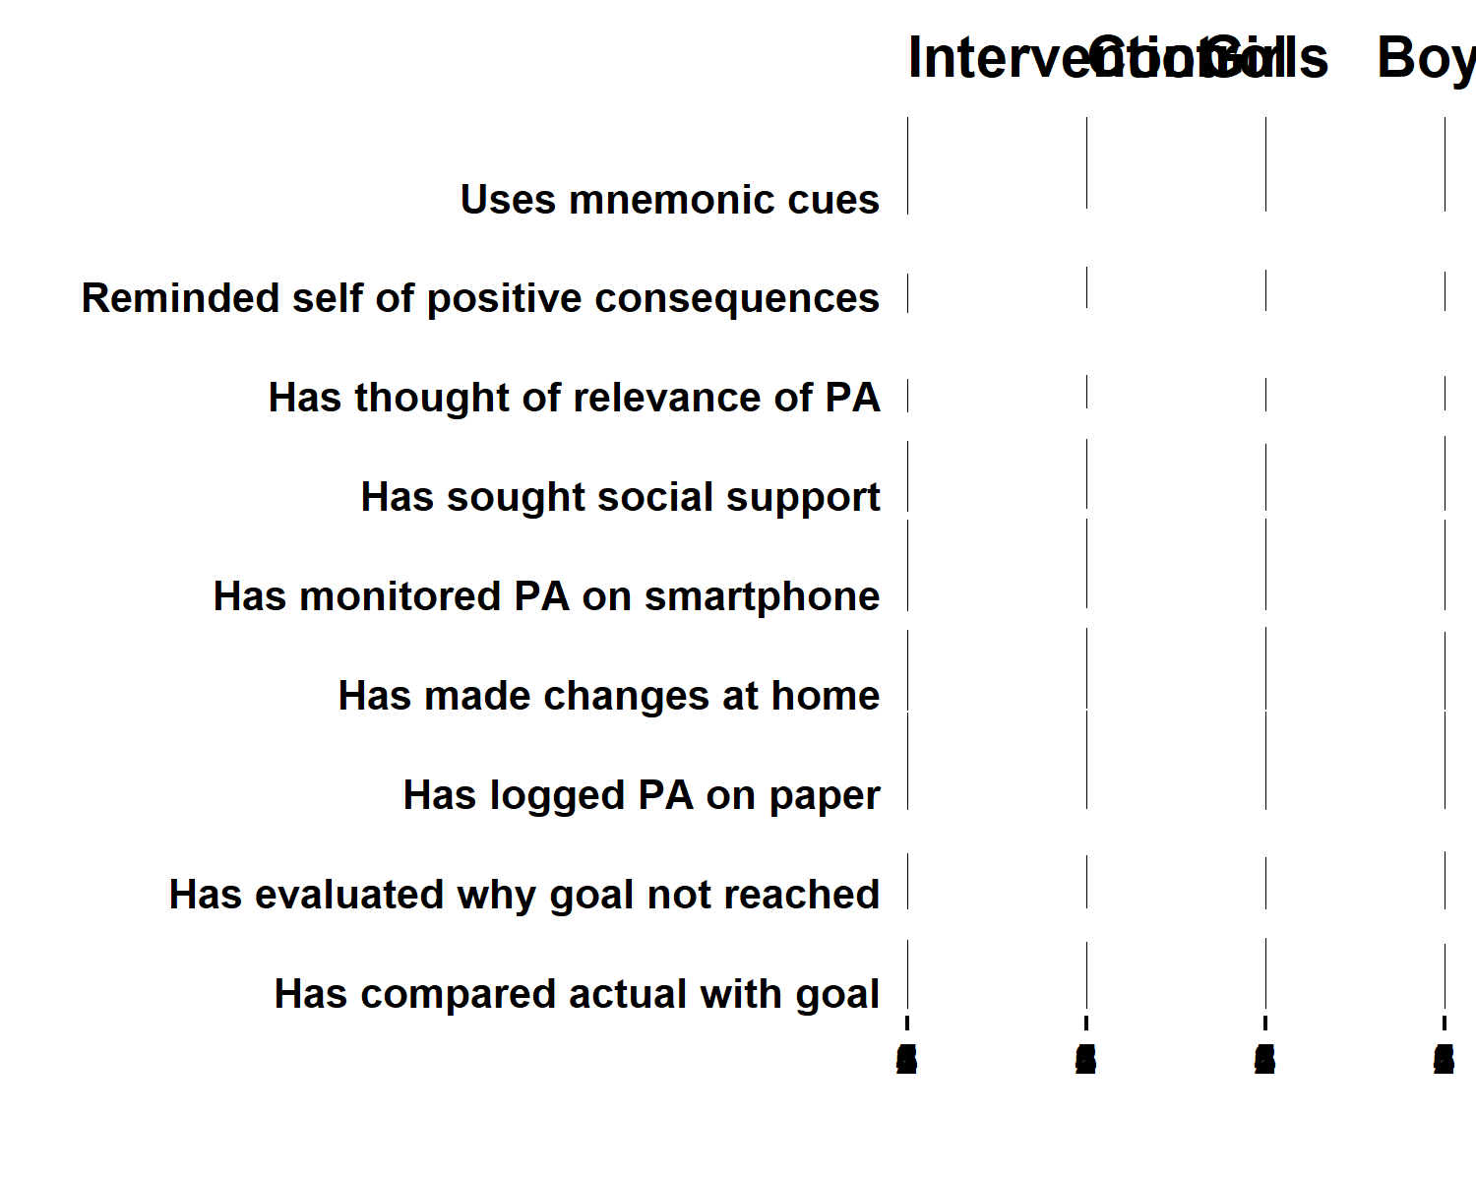

# This draws 2 histograms per row:  
# grid.newpage()  
# grid.draw(rbind(cbind(ggplotGrob(bctInt), ggplotGrob(bctCont), size = "last"), cbind(ggplotGrob(bctGirls), ggplotGrob(bctBoys), size = "last")))

#### Agreement-measured BCTs

These questions were asked with the lead “Have you done the following during the last three weeks?”.

The answer scale was as follows:

0 = not at all true 1 … 4 [unlabeled] 5 = completely true

Items are as follows:

1. I have set PA goals for myself.
2. I have personally made a specific plan (“what, where, how”) to implement my PA.
3. I have a PA plan, which has been made by someone else, e.g. my sports club (e.g. a workout schedule).
4. I have a way by which I remind myself of my PA plan, e.g. I write it down in the calendar.
5. I have cut larger PA goals to smaller subgoals.
6. I have tried out new ways for me to be physically active.
7. I have pondered, what kind of difficult situations or barriers prevent me from implementing my PA plan.
8. I have planned for ways to overcome barriers to doing PA.
9. I have thought about how PA fits my identity (self concept).
10. I have attempted to find ways to exercise so, that it won’t obstruct but instead helps actualise my other life values.

bctGirls <- df %>% dplyr::select(id,  
 intervention,  
 group,  
 school,  
 girl,  
 'Has set goals' = PA_agrbct_01_T1,  
 'Has made plan' = PA_agrbct_02_T1,  
 'Plan made by other' = PA_agrbct_03_T1,  
 'Has reminder of plan' = PA_agrbct_04_T1,  
 'Has cut goals to subgoals' = PA_agrbct_05_T1,  
 'Has tried new PA options' = PA_agrbct_06_T1,  
 'Has thought of barriers' = PA_agrbct_07_T1,  
 'Has planned for barriers' = PA_agrbct_08_T1,  
 'Has thought of PA identity' = PA_agrbct_09_T1,  
 'Has fitted PA to life values' = PA_agrbct_10_T1) %>%  
 tidyr::gather(key = Variable, value = Value, 6:ncol(.)) %>%  
 filter(girl == "1") %>%   
 ggplot(aes(x = Value, y = Variable, group = Variable)) +  
 ggridges::geom_density_ridges2(aes(fill = Variable), stat = "binline", binwidth = 1, scale = 0.95) +  
 scale_x_continuous(breaks = c(1:6), expand = c(0, 0),  
 name = "") +  
 scale_y_discrete(expand = c(0.01, 0), name = "", labels = NULL) +  
 ggridges::scale_fill_cyclical(values = c("darkolivegreen2", "darkolivegreen4")) +  
 labs(title = "Girls") +  
 guides(y = "none") +  
 ggridges::theme_ridges(grid = FALSE) +  
 theme(axis.title.x = element_text(hjust = 0.5),  
 axis.title.y = element_text(hjust = 0.5),  
 plot.title = element_text(hjust = 0.5),  
 axis.text=element_text(size=10, face="bold")) +  
coord_cartesian(xlim = c(0.5, 6.5))  
## Warning: attributes are not identical across measure variables;  
## they will be dropped  
  
bctBoys <- df %>% dplyr::select(id,  
 intervention,  
 group,  
 school,  
 girl,  
 'Has set goals' = PA_agrbct_01_T1,  
 'Has made plan' = PA_agrbct_02_T1,  
 'Plan made by other' = PA_agrbct_03_T1,  
 'Has reminder of plan' = PA_agrbct_04_T1,  
 'Has cut goals to subgoals' = PA_agrbct_05_T1,  
 'Has tried new PA options' = PA_agrbct_06_T1,  
 'Has thought of barriers' = PA_agrbct_07_T1,  
 'Has planned for barriers' = PA_agrbct_08_T1,  
 'Has thought of PA identity' = PA_agrbct_09_T1,  
 'Has fitted PA to life values' = PA_agrbct_10_T1) %>%  
 tidyr::gather(key = Variable, value = Value, 6:ncol(.)) %>%  
 filter(girl == "0") %>%   
 ggplot(aes(x = Value, y = Variable, group = Variable)) +  
 ggridges::geom_density_ridges2(aes(fill = Variable), stat = "binline", binwidth = 1, scale = 0.95) +  
 scale_x_continuous(breaks = c(1:6), expand = c(0, 0),  
 name = "") +  
 scale_y_discrete(expand = c(0.01, 0), name = "", labels = NULL) +  
 ggridges::scale_fill_cyclical(values = c("darkolivegreen2", "darkolivegreen4")) +  
 labs(title = "Boys") +  
 guides(y = "none") +  
 ggridges::theme_ridges(grid = FALSE) +  
 theme(axis.title.x = element_text(hjust = 0.5),  
 axis.title.y = element_text(hjust = 0.5),  
 plot.title = element_text(hjust = 0.5),  
 axis.text=element_text(size=10, face="bold")) +  
coord_cartesian(xlim = c(0.5, 6.5))  
## Warning: attributes are not identical across measure variables;  
## they will be dropped  
  
bctInt <- df %>% dplyr::select(id,  
 intervention,  
 group,  
 school,  
 girl,  
 'Has set goals' = PA_agrbct_01_T1,  
 'Has made plan' = PA_agrbct_02_T1,  
 'Plan made by other' = PA_agrbct_03_T1,  
 'Has reminder of plan' = PA_agrbct_04_T1,  
 'Has cut goals to subgoals' = PA_agrbct_05_T1,  
 'Has tried new PA options' = PA_agrbct_06_T1,  
 'Has thought of barriers' = PA_agrbct_07_T1,  
 'Has planned for barriers' = PA_agrbct_08_T1,  
 'Has thought of PA identity' = PA_agrbct_09_T1,  
 'Has fitted PA to life values' = PA_agrbct_10_T1) %>%  
 tidyr::gather(key = Variable, value = Value, 6:ncol(.)) %>%  
 filter(intervention == "1") %>%   
 ggplot(aes(x = Value, y = Variable, group = Variable)) +  
 ggridges::geom_density_ridges2(aes(fill = Variable), stat = "binline", binwidth = 1, scale = 0.95) +  
 scale_x_continuous(breaks = c(1:6), expand = c(0, 0),  
 name = "") +  
 scale_y_discrete(expand = c(0.01, 0), name = "") +  
 ggridges::scale_fill_cyclical(values = c("deepskyblue", "deepskyblue4")) +  
 labs(title = "Intervention") +  
 guides(y = "none") +  
 ggridges::theme_ridges(grid = FALSE) +  
 theme(axis.title.x = element_text(hjust = 0.5),  
 axis.title.y = element_text(hjust = 0.5),  
 axis.text=element_text(size=10, face="bold")) +  
coord_cartesian(xlim = c(0.5, 6.5))  
## Warning: attributes are not identical across measure variables;  
## they will be dropped  
  
bctCont <- df %>% dplyr::select(id,  
 intervention,  
 group,  
 school,  
 girl,  
 'Has set goals' = PA_agrbct_01_T1,  
 'Has made plan' = PA_agrbct_02_T1,  
 'Plan made by other' = PA_agrbct_03_T1,  
 'Has reminder of plan' = PA_agrbct_04_T1,  
 'Has cut goals to subgoals' = PA_agrbct_05_T1,  
 'Has tried new PA options' = PA_agrbct_06_T1,  
 'Has thought of barriers' = PA_agrbct_07_T1,  
 'Has planned for barriers' = PA_agrbct_08_T1,  
 'Has thought of PA identity' = PA_agrbct_09_T1,  
 'Has fitted PA to life values' = PA_agrbct_10_T1) %>%  
 tidyr::gather(key = Variable, value = Value, 6:ncol(.)) %>%  
 filter(intervention == "0") %>%   
 ggplot(aes(x = Value, y = Variable, group = Variable)) +  
 ggridges::geom_density_ridges2(aes(fill = Variable), stat = "binline", binwidth = 1, scale = 0.95) +  
 scale_x_continuous(breaks = c(1:6), expand = c(0, 0),  
 name = "") +  
 scale_y_discrete(expand = c(0.01, 0), name = "", labels = NULL) +  
 ggridges::scale_fill_cyclical(values = c("deepskyblue", "deepskyblue4")) +  
 labs(title = "Control") +  
 guides(y = "none") +  
 ggridges::theme_ridges(grid = FALSE) +  
 theme(axis.title.x = element_text(hjust = 0.5),  
 axis.title.y = element_text(hjust = 0.5),  
 axis.text=element_text(size=10, face="bold")) +  
coord_cartesian(xlim = c(0.5, 6.5))  
## Warning: attributes are not identical across measure variables;  
## they will be dropped  
  
#grid.arrange(bctInt, bctGirls, bctCont, bctBoys, ncol = 2)  
  
# ("Seldom or never", "About once a month", "About once a week", "Almost daily")  
  
# This draws all histograms next to each other:  
grid::grid.newpage()  
grid::grid.draw(cbind(ggplotGrob(bctInt), ggplotGrob(bctCont), ggplotGrob(bctGirls), ggplotGrob(bctBoys), size = "last"))  
## Warning: Removed 60 rows containing non-finite values (stat_binline).  
## Warning: Removed 70 rows containing non-finite values (stat_binline).  
## Warning: Removed 60 rows containing non-finite values (stat_binline).  
## Warning: Removed 70 rows containing non-finite values (stat_binline).

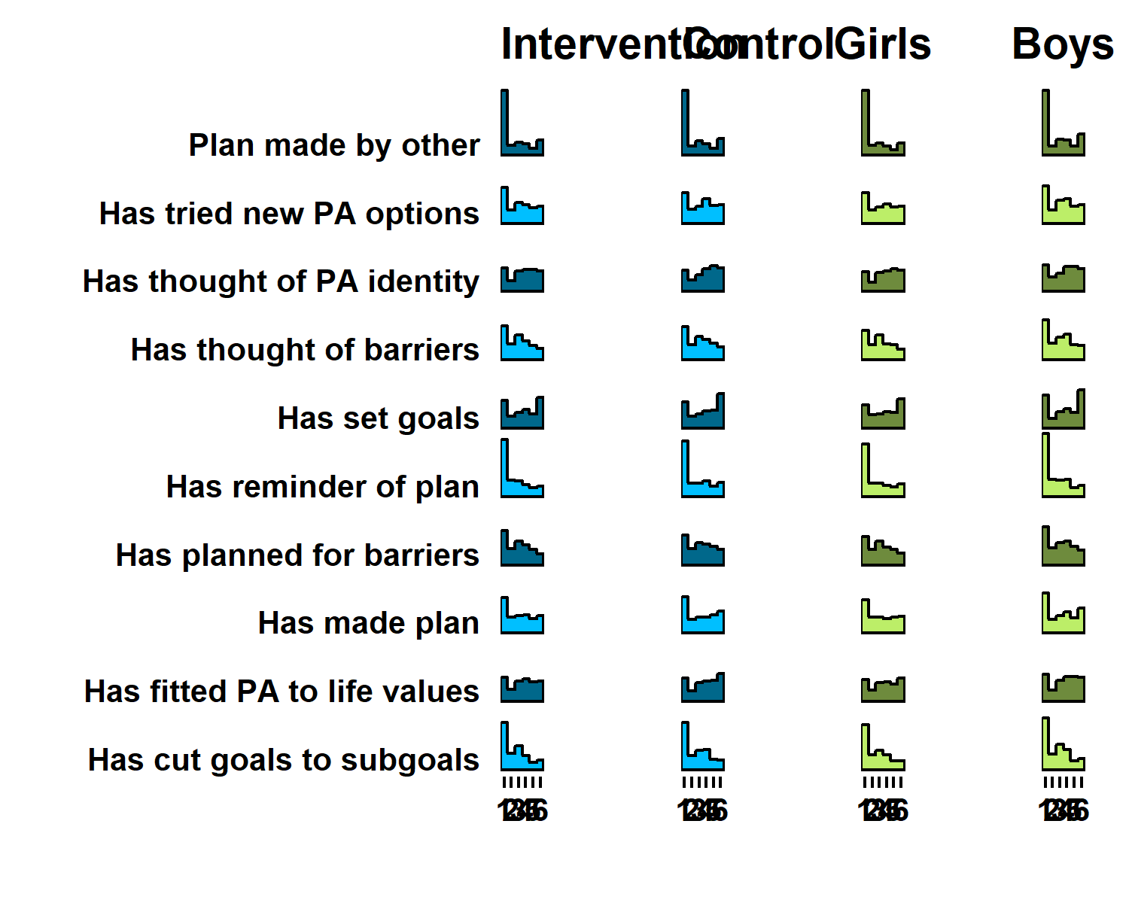

# This draws 2 histograms per row:  
# grid.newpage()  
# grid.draw(rbind(cbind(ggplotGrob(bctInt), ggplotGrob(bctCont), size = "last"), cbind(ggplotGrob(bctGirls), ggplotGrob(bctBoys), size = "last")))  
  
# bctBoys <- df %>% dplyr::select(id,  
# intervention,  
# group,  
# school,  
# girl,  
# 'Has set goals' = PA_agrbct_01_T1,  
# 'Has made plan' = PA_agrbct_02_T1,  
# 'Plan made by other' = PA_agrbct_03_T1,  
# 'Has reminder of plan' = PA_agrbct_04_T1,  
# 'Has cut goals to subgoals' = PA_agrbct_05_T1,  
# 'Has tried new PA options' = PA_agrbct_06_T1,  
# 'Has thought of barriers' = PA_agrbct_07_T1,  
# 'Has planned for barriers' = PA_agrbct_08_T1,  
# 'Has thought of PA identity' = PA_agrbct_09_T1,  
# 'Has fitted PA to life values' = PA_agrbct_10_T1)  
#   
# mean(bctBoys$`Has set goals`, na.rm = T)  
# mean(bctBoys$`Has made plan`, na.rm = T)  
# mean(bctBoys$`Plan made by other`, na.rm = T)  
# mean(bctBoys$`Has reminder of plan`, na.rm = T)  
# mean(bctBoys$`Has cut goals to subgoals`, na.rm = T)  
# mean(bctBoys$`Has tried new PA options`, na.rm = T)  
# mean(bctBoys$`Has thought of barriers`, na.rm = T)  
# mean(bctBoys$`Has planned for barriers`, na.rm = T)  
# mean(bctBoys$`Has thought of PA identity`, na.rm = T)  
# mean(bctBoys$`Has fitted PA to life values`, na.rm = T)

## PA determinants

### Plot without fill

plot1 <- df %>% dplyr::select(id,  
 intervention,  
 group,  
 school,  
 girl,  
 'PA intention' = PA_intention_T1,  
 'PA outcome\nexpectations' = PA_outcomeExpectations_T1,  
 'PA perceived\nbehavioural control' = PA_pbc_T1,  
 'PA self efficacy' = PA_selfefficacy_T1,  
 'PA perceived\nopportunities' = PA_opportunities_T1,  
 'PA descriptive\nnorm' = PA_dnorm_T1,  
 'PA injunctive\nnorm' = PA_inorm_T1) %>%  
 # select(noquote(order(colnames(.)))) %>% # Orders columns alphabetically  
 tidyr::gather(key = Variable, value = Value, 6:ncol(.), factor_key = TRUE) %>%  
 ggplot(aes(y = Variable)) +  
 ggridges::geom_density_ridges(aes(x = Value, colour = paste(Variable, girl),   
 fill = paste(Variable, girl)),   
 alpha = 0, size = 0.75, from = 1, to = 7) +  
 labs(x = "",  
 y = "") +  
 scale_y_discrete(expand = c(0.01, 0)) +  
 scale_x_continuous(expand = c(0.01, 0)) +  
 ggridges::scale_fill_cyclical(breaks = c("PA injunctive\nnorm 0", "PA injunctive\nnorm 1"),  
 labels = c( 'PA injunctive\nnorm 0' = "Boy", 'PA injunctive\nnorm 1' = "Girl"),  
 values = viridis::viridis(4, end = 0.8)[c(1, 3)], #c("#3bc600", "#0000ff", "#9cc68b", "#8080ff"),  
 name = "", guide = guide_legend(override.aes = list(alpha = 1))) +  
 ggridges::scale_colour_cyclical(values = viridis::viridis(4, end = 0.8, alpha = 0.9)[c(1, 3)]) +  
 ggridges::theme_ridges(grid = FALSE) +  
 theme(legend.position="bottom", axis.text=element_text(size=10)) +  
 geom_hline(yintercept = 1:7)  
## Warning: attributes are not identical across measure variables;  
## they will be dropped  
  
target = c(  
"PA_intention_T1",  
"PA_outcomeExpectations_T1",  
"PA_pbc_T1",  
"PA_selfefficacy_T1",  
"PA_opportunities_T1",  
"PA_dnorm_T1",  
"PA_inorm_T1")  
  
PA_ci_girls <- ci_girls %>% filter(diamondlabels %in% names(scales_T1) &   
 grepl("PA_intention_T1", diamondlabels) |   
 grepl("PA_outcomeExpectations_T1", diamondlabels) |   
 grepl("PA_pbc_T1", diamondlabels) |   
 grepl("PA_selfefficacy_T1", diamondlabels) |   
 grepl("PA_opportunities_T1", diamondlabels) |   
 grepl("PA_dnorm_T1", diamondlabels) |   
 grepl("PA_inorm_T1", diamondlabels))  
  
PA_ci_girls <- PA_ci_girls[match(target, PA_ci_girls$diamondlabels), ]  
  
PA_ci_boys <- ci_boys %>% filter(diamondlabels %in% names(scales_T1) &   
 grepl("PA_intention_T1", diamondlabels) |   
 grepl("PA_outcomeExpectations_T1", diamondlabels) |   
 grepl("PA_pbc_T1", diamondlabels) |   
 grepl("PA_selfefficacy_T1", diamondlabels) |   
 grepl("PA_opportunities_T1", diamondlabels) |   
 grepl("PA_dnorm_T1", diamondlabels) |   
 grepl("PA_inorm_T1", diamondlabels))  
  
PA_ci_boys <- PA_ci_boys[match(target, PA_ci_boys$diamondlabels), ]  
  
plot1 <- plot1 + userfriendlyscience::diamondPlot(PA_ci_girls, returnLayerOnly = TRUE, color=viridis::viridis(4, end = 0.8)[c(3)],   
 alpha=.6, fixedSize = 0.15, otherAxisCol = (1:length(target) + .2)) +  
 userfriendlyscience::diamondPlot(PA_ci_boys, returnLayerOnly = TRUE, color=viridis::viridis(4, end = 0.8)[c(1)],   
 alpha=.6, fixedSize = 0.15, otherAxisCol = (1:length(target) + .2))  
  
plot2 <- df %>% dplyr::select(id,  
 intervention,  
 group,  
 school,  
 girl,  
 'PA intention' = PA_intention_T1,  
 'PA outcome\nexpectations' = PA_outcomeExpectations_T1,  
 'PA perceived\nbehavioural control' = PA_pbc_T1,  
 'PA self efficacy' = PA_selfefficacy_T1,  
 'PA perceived\nopportunities' = PA_opportunities_T1,  
 'PA descriptive\nnorm' = PA_dnorm_T1,  
 'PA injunctive\nnorm' = PA_inorm_T1) %>%  
 # select(noquote(order(colnames(.)))) %>% # Orders columns alphabetically  
 tidyr::gather(key = Variable, value = Value, 6:ncol(.), factor_key = TRUE) %>%  
 ggplot(aes(y = Variable)) +  
 ggridges::geom_density_ridges(aes(x = Value, colour = paste(Variable, intervention),   
 fill = paste(Variable, intervention)),   
 alpha = 0, size = 0.75, from = 1, to = 7) +  
 labs(x = "",  
 y = "") +  
 scale_y_discrete(expand = c(0.01, 0), labels = NULL) +  
 scale_x_continuous(expand = c(0.01, 0)) +  
 ggridges::scale_fill_cyclical(breaks = c("PA injunctive\nnorm 0", "PA injunctive\nnorm 1"),  
 labels = c( 'PA injunctive\nnorm 0' = "Control", 'PA injunctive\nnorm 1' = "Intervention"),  
 values = c(viridis::viridis(4, end = 0.8)[c(2, 4)], viridis::viridis(8, end = 0.8)[c(4, 8)]), # get 2 x 2 colors, close to each other MUUTTAAKO MITÄÄN?  
 name = "", guide = guide_legend(override.aes = list(alpha = 1))) +  
 ggridges::scale_colour_cyclical(values = viridis::viridis(4, end = 0.8, alpha = 0.9)[c(2, 4)]) +  
 ggridges::theme_ridges(grid = FALSE) +  
 theme(legend.position="bottom", axis.text=element_text(size=10)) +  
 geom_hline(yintercept = 1:7)  
## Warning: attributes are not identical across measure variables;  
## they will be dropped  
  
PA_ci_intervention <- ci_intervention %>% filter(diamondlabels %in% names(scales_T1) &   
 grepl("PA_intention_T1", diamondlabels) |   
 grepl("PA_outcomeExpectations_T1", diamondlabels) |   
 grepl("PA_pbc_T1", diamondlabels) |   
 grepl("PA_selfefficacy_T1", diamondlabels) |   
 grepl("PA_opportunities_T1", diamondlabels) |   
 grepl("PA_dnorm_T1", diamondlabels) |   
 grepl("PA_inorm_T1", diamondlabels))  
  
PA_ci_intervention <- PA_ci_intervention[match(target, PA_ci_intervention$diamondlabels), ]  
  
PA_ci_control <- ci_control %>% filter(diamondlabels %in% names(scales_T1) &   
 grepl("PA_intention_T1", diamondlabels) |   
 grepl("PA_outcomeExpectations_T1", diamondlabels) |   
 grepl("PA_pbc_T1", diamondlabels) |   
 grepl("PA_selfefficacy_T1", diamondlabels) |   
 grepl("PA_opportunities_T1", diamondlabels) |   
 grepl("PA_dnorm_T1", diamondlabels) |   
 grepl("PA_inorm_T1", diamondlabels))  
  
PA_ci_control <- PA_ci_control[match(target, PA_ci_control$diamondlabels), ]  
  
plot2 <- plot2 +   
 userfriendlyscience::diamondPlot(PA_ci_intervention, returnLayerOnly = TRUE, color=viridis::viridis(4, end = 0.8)[c(4)],  
 alpha=.6, fixedSize = 0.15, otherAxisCol = (1:length(target) + .2)) +  
 userfriendlyscience::diamondPlot(PA_ci_control, returnLayerOnly = TRUE, color=viridis::viridis(4, end = 0.8)[c(2)],   
 alpha=.6, fixedSize = 0.15, otherAxisCol = (1:length(target) + .2))  
  
# grid.arrange(plot1, plot2, ncol = 2)  
grid::grid.newpage()  
grid::grid.draw(cbind(ggplotGrob(plot1), ggplotGrob(plot2), size = "first"))  
## Picking joint bandwidth of 0.355  
## Warning: Removed 641 rows containing non-finite values  
## (stat_density_ridges).  
## Picking joint bandwidth of 0.359  
## Warning: Removed 641 rows containing non-finite values  
## (stat_density_ridges).

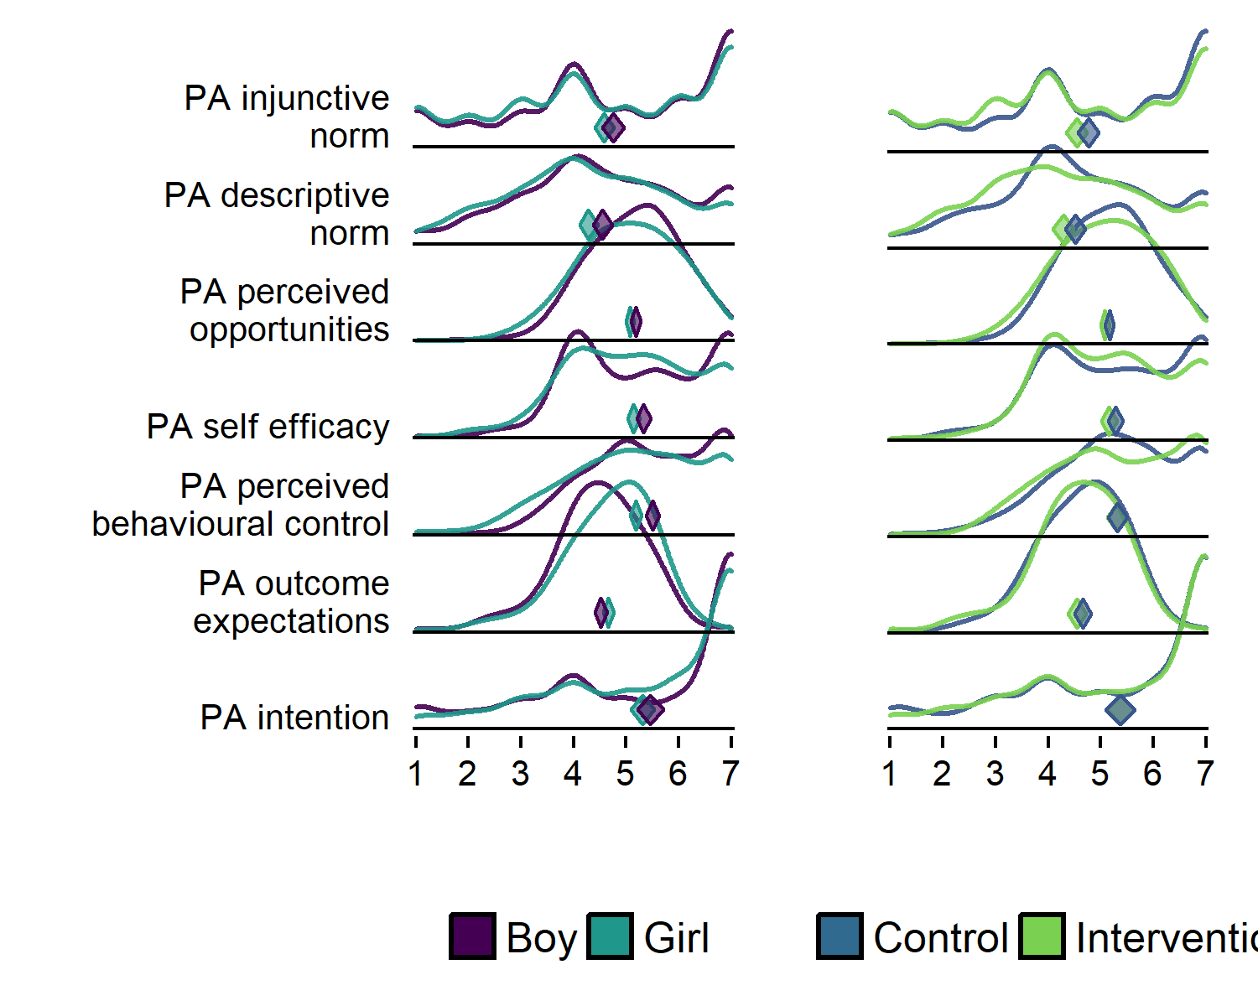

### Pretty plot with fill

plot1 <- df %>% dplyr::select(id,  
 intervention,  
 group,  
 school,  
 girl,  
 'PA intention' = PA_intention_T1,  
 'PA outcome\nexpectations' = PA_outcomeExpectations_T1,  
 'PA perceived\nbehavioural control' = PA_pbc_T1,  
 'PA self efficacy' = PA_selfefficacy_T1,  
 'PA perceived\nopportunities' = PA_opportunities_T1,  
 'PA descriptive\nnorm' = PA_dnorm_T1) %>%  
 # select(noquote(order(colnames(.)))) %>% # Orders columns alphabetically  
 tidyr::gather(key = Variable, value = Value, 6:ncol(.), factor_key = TRUE) %>%  
 ggplot(aes(y = Variable)) +  
 ggridges::geom_density_ridges(aes(x = Value, colour = "black",   
 fill = paste(Variable, girl)),   
 alpha = 0.6, size = 0.25, from = 1, to = 7) +  
 labs(x = "",  
 y = "") +  
 scale_y_discrete(expand = c(0.01, 0)) +  
 scale_x_continuous(expand = c(0.01, 0)) +  
 ggridges::scale_fill_cyclical(breaks = c("PA descriptive\nnorm 0", "PA descriptive\nnorm 1"),  
 labels = c( 'PA descriptive\nnorm 0' = "Boy", 'PA descriptive\nnorm 1' = "Girl"),  
 values = viridis::viridis(4, end = 0.8)[c(1, 3)],  
 name = "", guide = guide_legend(override.aes = list(alpha = 1))) +  
 ggridges::scale_colour_cyclical(values = "black") +  
 ggridges::theme_ridges(grid = FALSE) +  
 theme(legend.position="bottom", axis.text=element_text(size=10))  
  
target = c(  
"PA_intention_T1",  
"PA_outcomeExpectations_T1",  
"PA_pbc_T1",  
"PA_selfefficacy_T1",  
"PA_opportunities_T1",  
"PA_dnorm_T1")  
  
PA_ci_girls <- ci_girls %>% filter(diamondlabels %in% names(scales_T1) &   
 grepl("PA_intention_T1", diamondlabels) |   
 grepl("PA_outcomeExpectations_T1", diamondlabels) |   
 grepl("PA_pbc_T1", diamondlabels) |   
 grepl("PA_selfefficacy_T1", diamondlabels) |   
 grepl("PA_opportunities_T1", diamondlabels) |   
 grepl("PA_dnorm_T1", diamondlabels))  
  
PA_ci_girls <- PA_ci_girls[match(target, PA_ci_girls$diamondlabels), ]  
  
PA_ci_boys <- ci_boys %>% filter(diamondlabels %in% names(scales_T1) &   
 grepl("PA_intention_T1", diamondlabels) |   
 grepl("PA_outcomeExpectations_T1", diamondlabels) |   
 grepl("PA_pbc_T1", diamondlabels) |   
 grepl("PA_selfefficacy_T1", diamondlabels) |   
 grepl("PA_opportunities_T1", diamondlabels) |   
 grepl("PA_dnorm_T1", diamondlabels))  
  
PA_ci_boys <- PA_ci_boys[match(target, PA_ci_boys$diamondlabels), ]  
  
plot1 <- plot1 + userfriendlyscience::diamondPlot(PA_ci_girls, returnLayerOnly = TRUE, lineColor = "black", color=viridis::viridis(4, end = 0.8)[3],   
 alpha=.6, fixedSize = 0.15, otherAxisCol = (1:length(target) + .2)) +  
 userfriendlyscience::diamondPlot(PA_ci_boys, returnLayerOnly = TRUE, lineColor = "black", linetype = "solid", color=viridis::viridis(4, end = 0.8)[1],   
 alpha=.6, fixedSize = 0.15, otherAxisCol = (1:length(target) + .2))  
  
plot2 <- df %>% dplyr::select(id,  
 intervention,  
 group,  
 school,  
 girl,  
 'PA intention' = PA_intention_T1,  
 'PA outcome\nexpectations' = PA_outcomeExpectations_T1,  
 'PA perceived\nbehavioural control' = PA_pbc_T1,  
 'PA self efficacy' = PA_selfefficacy_T1,  
 'PA perceived\nopportunities' = PA_opportunities_T1,  
 'PA descriptive\nnorm' = PA_dnorm_T1) %>%  
 # select(noquote(order(colnames(.)))) %>% # Orders columns alphabetically  
 tidyr::gather(key = Variable, value = Value, 6:ncol(.), factor_key = TRUE) %>%  
 ggplot(aes(y = Variable)) +  
 ggridges::geom_density_ridges(aes(x = Value, colour = "black",   
 fill = paste(Variable, intervention)),   
 alpha = 0.75, size = 0.25, from = 1, to = 7) +  
 labs(x = "",  
 y = "") +  
 scale_y_discrete(expand = c(0.01, 0), labels = NULL) +  
 scale_x_continuous(expand = c(0.01, 0)) +  
 ggridges::scale_fill_cyclical(breaks = c("PA descriptive\nnorm 0", "PA descriptive\nnorm 1"),  
 labels = c( 'PA descriptive\nnorm 0' = "Control", 'PA descriptive\nnorm 1' = "Intervention"),  
 values = viridis::viridis(4, end = 0.8)[c(2, 4)],  
 name = "", guide = guide_legend(override.aes = list(alpha = 1))) +  
 ggridges::scale_colour_cyclical(values = "black") +  
 ggridges::theme_ridges(grid = FALSE) +  
 theme(legend.position="bottom", axis.text=element_text(size=10))  
  
PA_ci_intervention <- ci_intervention %>% filter(diamondlabels %in% names(scales_T1) &   
 grepl("PA_intention_T1", diamondlabels) |   
 grepl("PA_outcomeExpectations_T1", diamondlabels) |   
 grepl("PA_pbc_T1", diamondlabels) |   
 grepl("PA_selfefficacy_T1", diamondlabels) |   
 grepl("PA_opportunities_T1", diamondlabels) |   
 grepl("PA_dnorm_T1", diamondlabels))  
  
PA_ci_intervention <- PA_ci_intervention[match(target, PA_ci_intervention$diamondlabels), ]  
  
PA_ci_control <- ci_control %>% filter(diamondlabels %in% names(scales_T1) &   
 grepl("PA_intention_T1", diamondlabels) |   
 grepl("PA_outcomeExpectations_T1", diamondlabels) |   
 grepl("PA_pbc_T1", diamondlabels) |   
 grepl("PA_selfefficacy_T1", diamondlabels) |   
 grepl("PA_opportunities_T1", diamondlabels) |   
 grepl("PA_dnorm_T1", diamondlabels))  
  
PA_ci_control <- PA_ci_control[match(target, PA_ci_control$diamondlabels), ]  
  
plot2 <- plot2 +   
 userfriendlyscience::diamondPlot(PA_ci_intervention, returnLayerOnly = TRUE, lineColor = "black", color=viridis::viridis(4, end = 0.8)[4],  
 alpha=.6, fixedSize = 0.15, otherAxisCol = (1:length(target) + .2)) +  
 userfriendlyscience::diamondPlot(PA_ci_control, returnLayerOnly = TRUE, lineColor = "black", color=viridis::viridis(4, end = 0.8)[2],   
 alpha=.6, fixedSize = 0.15, otherAxisCol = (1:length(target) + .2))  
  
# grid.arrange(plot1, plot2, ncol = 2)  
grid::grid.newpage()  
grid::grid.draw(cbind(ggplotGrob(plot1), ggplotGrob(plot2), size = "first"))  
## Picking joint bandwidth of 0.327  
## Warning: Removed 549 rows containing non-finite values  
## (stat_density_ridges).  
## Picking joint bandwidth of 0.332  
## Warning: Removed 549 rows containing non-finite values  
## (stat_density_ridges).

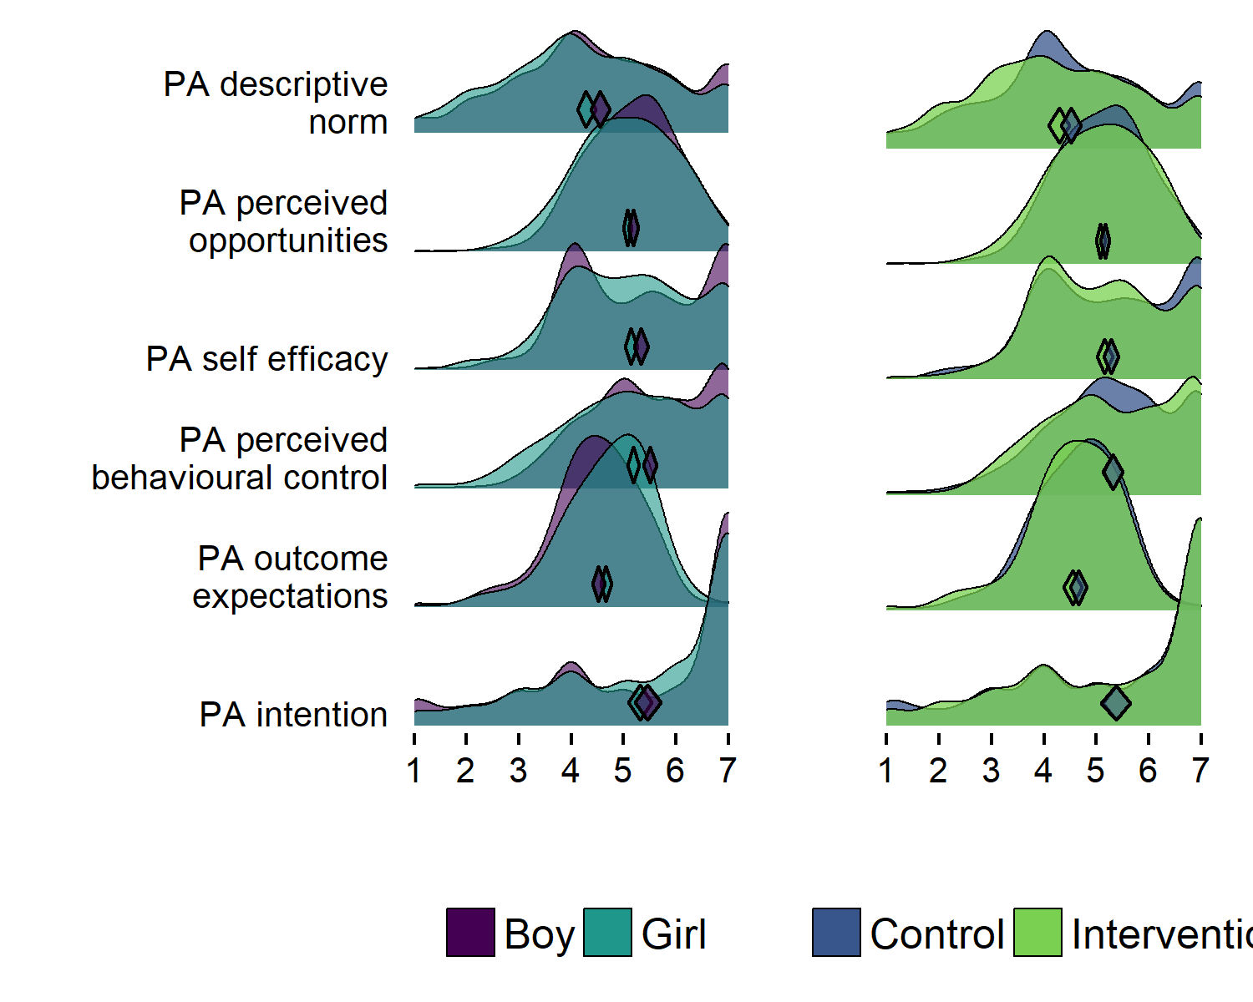

# Test that the legend is right; descriptive norms are smaller for girls  
df %>% group_by(girl) %>% summarise(mean = mean(PA_dnorm_T1, na.rm = T)) %>% filter(girl == "1") %>% select(mean) < df %>% group_by(girl) %>% summarise(mean = mean(PA_dnorm_T1, na.rm = T)) %>% filter(girl == "0") %>% select(mean)  
## mean  
## [1,] TRUE  
  
# KESKEN: iv/ctrl-legend  
df %>% group_by(intervention) %>% summarise(mean = mean(PA_dnorm_T1, na.rm = TRUE)) %>% filter(intervention == "1") %>% select(mean) < df %>% group_by(intervention) %>% summarise(mean = mean(PA_dnorm_T1, na.rm = T)) %>% filter(intervention == "0") %>% select(mean)  
## mean  
## [1,] TRUE

### MVPA, girls and boys in different educational tracks

plot1 <- df %>% dplyr::select(id,  
 track = track,  
 girl,  
 PA = paAccelerometer_T1) %>%  
 filter(!is.na(track), track != "Other") %>% # Drop category "Other"  
 ggplot(aes(y = track)) +  
 ggridges::geom_density_ridges2(aes(x = PA, colour = "black",   
 fill = paste(track, girl)),  
 scale = 1,  
 alpha = 0.6, size = 0.25,  
 from = 0, to = 450,  
 jittered_points=TRUE, point_shape=21,  
 point_fill="black") +  
 labs(x = "",  
 y = "") +  
 scale_y_discrete(expand = c(0.01, 0)) +  
 scale_x_continuous(expand = c(0.01, 0)) +  
 ggridges::scale_fill_cyclical(  
 labels = c('Business Admin boy' = "Boy", 'Business Admin girl' = "Girl"),  
 values = viridis::viridis(4, end = 0.8)[c(1, 3)],  
 name = "", guide = guide_legend(override.aes = list(alpha = 1))) +  
 ggridges::scale_colour_cyclical(values = "black") +  
 ggridges::theme_ridges(grid = FALSE) +  
 theme(legend.position="bottom", axis.text=element_text(size=10))  
plot1  
## Picking joint bandwidth of 18.1  
## Warning: Removed 370 rows containing non-finite values  
## (stat_density_ridges).

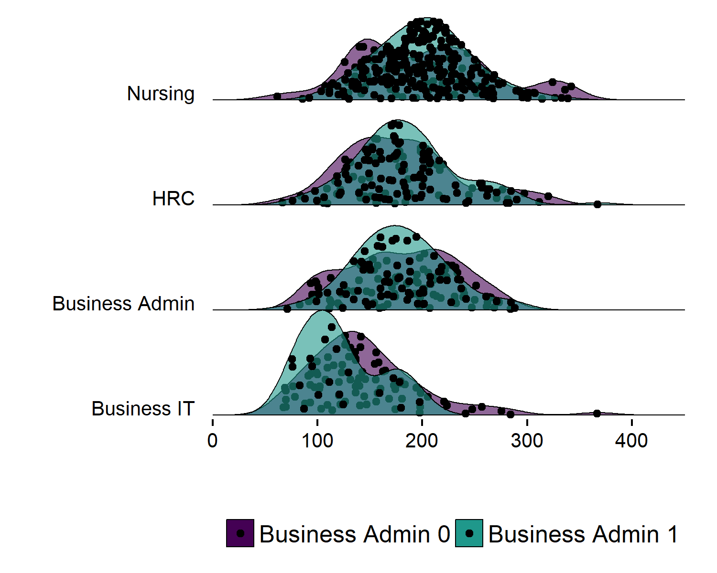

df %>% select(paAccelerometer_T1, girl, track) %>%   
 group_by(girl, track) %>%   
 summarise(mean = mean(paAccelerometer_T1, na.rm = TRUE),  
 median = median(paAccelerometer_T1, na.rm = TRUE),  
 max = max(paAccelerometer_T1, na.rm = TRUE),  
 min = min(paAccelerometer_T1, na.rm = TRUE),  
 sd = sd(paAccelerometer_T1, na.rm = TRUE),  
 n = n())  
## # A tibble: 11 x 8  
## # Groups: girl [?]  
## girl track mean median max min sd n  
## <fctr> <fctr> <dbl> <dbl> <dbl> <dbl> <dbl> <int>  
## 1 1 Other 188 198 264 102 48.6 17  
## 2 1 Business IT 122 114 197 75.7 37.7 26  
## 3 1 Business Admin 179 176 288 71.2 43.5 110  
## 4 1 HRC 185 178 367 76.0 49.8 129  
## 5 1 Nursing 201 201 339 92.1 44.9 331  
## 6 0 Other 182 217 262 73.4 75.9 7  
## 7 0 Business IT 146 137 367 67.6 53.5 137  
## 8 0 Business Admin 180 176 284 83.2 52.2 172  
## 9 0 HRC 179 177 320 66.5 56.3 84  
## 10 0 Nursing 201 203 342 61.5 65.9 71  
## 11 <NA> <NA> 194 162 291 138 65.9 81  
  
df %>% select(paAccelerometer_T1, girl, track) %>%   
 group_by(girl) %>%   
 summarise(mean = mean(paAccelerometer_T1, na.rm = TRUE),  
 median = median(paAccelerometer_T1, na.rm = TRUE),  
 max = max(paAccelerometer_T1, na.rm = TRUE),  
 min = min(paAccelerometer_T1, na.rm = TRUE),  
 sd = sd(paAccelerometer_T1, na.rm = TRUE),  
 n = n())  
## # A tibble: 3 x 7  
## girl mean median max min sd n  
## <fctr> <dbl> <dbl> <dbl> <dbl> <dbl> <int>  
## 1 1 190 189 367 71.2 48.6 613  
## 2 0 174 165 367 61.5 59.4 471  
## 3 <NA> 194 162 291 138 65.9 81  
  
# target = c(  
# "PA_intention_T1",  
# "PA_outcomeExpectations_T1",  
# "PA_pbc_T1",  
# "PA_selfefficacy_T1",  
# "PA_opportunities_T1",  
# "PA_dnorm_T1")  
#   
# PA_ci_girls <- ci_girls %>% filter(paAccelerometer)  
#   
# PA_ci_girls <- PA_ci_girls[match(target, PA_ci_girls$diamondlabels), ]  
#   
# PA_ci_boys <- ci_boys %>% filter(diamondlabels %in% names(scales_T1) &   
# grepl("PA_intention_T1", diamondlabels) |   
# grepl("PA_outcomeExpectations_T1", diamondlabels) |   
# grepl("PA_pbc_T1", diamondlabels) |   
# grepl("PA_selfefficacy_T1", diamondlabels) |   
# grepl("PA_opportunities_T1", diamondlabels) |   
# grepl("PA_dnorm_T1", diamondlabels))  
#   
# PA_ci_boys <- PA_ci_boys[match(target, PA_ci_boys$diamondlabels), ]  
#   
# plot1 <- plot1 + userfriendlyscience::diamondPlot(PA_ci_girls, returnLayerOnly = TRUE, lineColor = "black", color=viridis::viridis(4, end = 0.8)[3],   
# alpha=.6, fixedSize = 0.15, otherAxisCol = (1:length(target) + .2)) +  
# userfriendlyscience::diamondPlot(PA_ci_boys, returnLayerOnly = TRUE, lineColor = "black", linetype = "solid", color=viridis::viridis(4, end = 0.8)[1],   
# alpha=.6, fixedSize = 0.15, otherAxisCol = (1:length(target) + .2))  
#

### MVPA, girls and boys in different educational tracks and schools

plot1 <- df %>% dplyr::select(id,  
 trackSchool = trackSchool,  
 girl,  
 PA = paAccelerometer_T1) %>%  
 filter(!is.na(trackSchool), !grepl('Other|NANA|Business Admin4|HRC2|Nursing2', trackSchool)) %>% # Drop categories with just few participants  
 ggplot(aes(y = trackSchool)) +  
 ggridges::geom_density_ridges2(aes(x = PA, colour = "black",   
 fill = paste(trackSchool, girl)),  
 scale = 1,  
 alpha = 0.6, size = 0.25,  
 from = 0, to = 450,  
 jittered_points=TRUE, point_shape=21,  
 point_fill="black") +  
 labs(x = "",  
 y = "") +  
 scale_y_discrete(expand = c(0.01, 0)) +  
 scale_x_continuous(expand = c(0.01, 0)) +  
 ggridges::scale_fill_cyclical(  
 labels = c('Business Admin1 boy' = "Boy", 'Business Admin1 girl' = "Girl"),  
 values = viridis::viridis(4, end = 0.8)[c(1, 3)],  
 name = "", guide = guide_legend(override.aes = list(alpha = 1))) +  
 ggridges::scale_colour_cyclical(values = "black") +  
 ggridges::theme_ridges(grid = FALSE) +  
 theme(legend.position="bottom", axis.text=element_text(size=10))  
plot1  
## Picking joint bandwidth of 20.3  
## Warning: Removed 367 rows containing non-finite values  
## (stat_density_ridges).

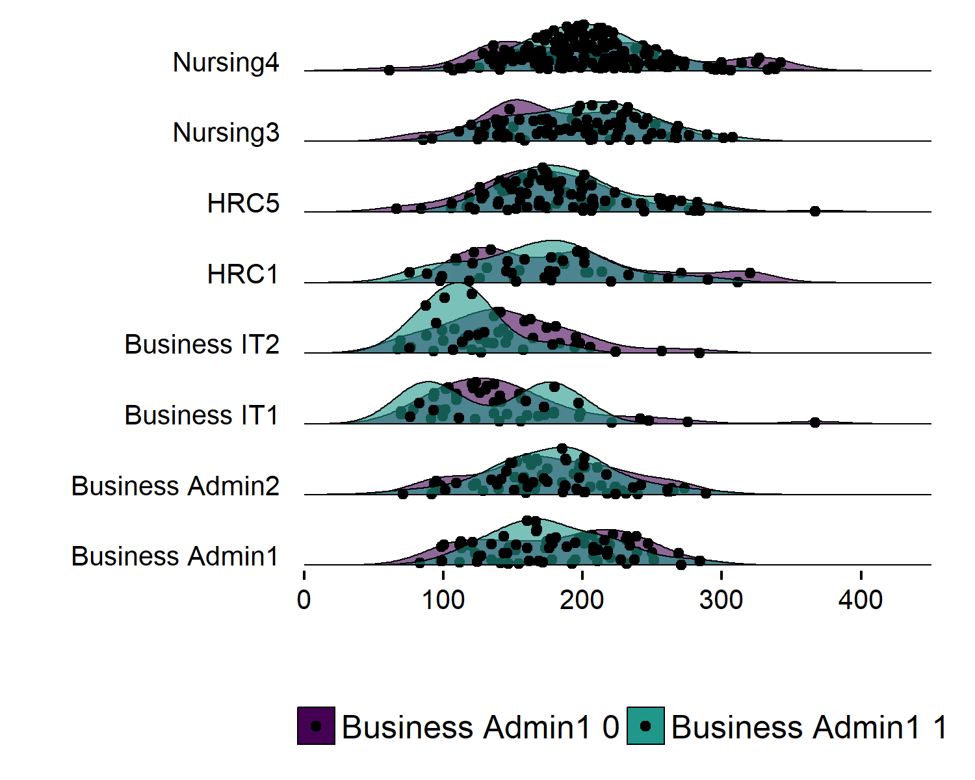

df %>% select(paAccelerometer_T1, girl, trackSchool) %>%   
 group_by(girl, trackSchool) %>%   
 summarise(mean = mean(paAccelerometer_T1, na.rm = TRUE),  
 median = median(paAccelerometer_T1, na.rm = TRUE),  
 max = max(paAccelerometer_T1, na.rm = TRUE),  
 min = min(paAccelerometer_T1, na.rm = TRUE),  
 sd = sd(paAccelerometer_T1, na.rm = TRUE),  
 n = n())  
## # A tibble: 29 x 8  
## # Groups: girl [?]  
## girl trackSchool mean median max min sd n  
## <fctr> <chr> <dbl> <dbl> <dbl> <dbl> <dbl> <int>  
## 1 1 Business Admin1 179 172 284 99.1 42.7 56  
## 2 1 Business Admin2 179 186 288 71.2 45.0 53  
## 3 1 Business Admin4 NaN NA -Inf Inf NaN 1  
## 4 1 Business IT1 134 135 197 76.2 48.4 12  
## 5 1 Business IT2 114 114 178 75.7 27.0 14  
## 6 1 HRC1 169 176 290 76.0 52.6 39  
## 7 1 HRC5 191 182 367 106 47.8 90  
## 8 1 Nursing3 198 203 308 92.1 48.4 104  
## 9 1 Nursing4 203 201 339 104 43.3 227  
## 10 1 Other1 142 142 142 142 NaN 1  
## # ... with 19 more rows  
  
df %>% select(paAccelerometer_T1, girl, trackSchool) %>%   
 group_by(girl) %>%   
 summarise(mean = mean(paAccelerometer_T1, na.rm = TRUE),  
 median = median(paAccelerometer_T1, na.rm = TRUE),  
 max = max(paAccelerometer_T1, na.rm = TRUE),  
 min = min(paAccelerometer_T1, na.rm = TRUE),  
 sd = sd(paAccelerometer_T1, na.rm = TRUE),  
 n = n())  
## # A tibble: 3 x 7  
## girl mean median max min sd n  
## <fctr> <dbl> <dbl> <dbl> <dbl> <dbl> <int>  
## 1 1 190 189 367 71.2 48.6 613  
## 2 0 174 165 367 61.5 59.4 471  
## 3 <NA> 194 162 291 138 65.9 81

library(viridis::viridis)  
## Error in library(viridis::viridis): 'package' must be of length 1  
plot1 <- df %>% dplyr::select(id,  
 intervention,  
 group,  
 school,  
 girl,  
'PA action and\ncoping planning' = PA_actCop_T1,  
'PA intention' = PA_intention_T1,  
'PA outcome\nexpectations' = PA_outcomeExpectations_T1,  
'PA perceived\nbehavioural control' = PA_pbc_T1,  
'PA self efficacy' = PA_selfefficacy_T1,  
'PA perceived\nopportunities' = PA_opportunities_T1,  
'PA descriptive\nnorm' = PA_dnorm_T1,  
'PA injunctive\nnorm' = PA_inorm_T1) %>%  
 # select(noquote(order(colnames(.)))) %>% # Orders columns alphabetically  
 tidyr::gather(key = Variable, value = Value, 6:ncol(.), factor_key = TRUE) %>%   
 ggplot(aes(y = Variable)) +  
 ggridges::geom_density_ridges(aes(x = Value, fill = paste(Variable, girl)),   
 alpha = .1, color = "black", from = 1, to = 7) +  
 labs(x = "",  
 y = "") +  
 scale_y_discrete(expand = c(0.01, 0)) +  
 scale_x_continuous(expand = c(0.01, 0)) +  
 ggridges::scale_fill_cyclical(breaks = c("PA injunctive\nnorm 0", "PA injunctive\nnorm 1"),  
 labels = c( 'PA injunctive\nnorm 0' = "Boy", 'PA injunctive\nnorm 1' = "Girl"),  
 values = viridis::viridis(4, end = 0.8)[1:2], #c("#3bc600", "#0000ff", "#9cc68b", "#8080ff"),  
 name = "", guide = "legend") +  
 ggridges::theme_ridges(grid = FALSE) +  
 theme(legend.position="bottom", axis.text=element_text(size=10))  
## Warning: attributes are not identical across measure variables;  
## they will be dropped  
  
plot2 <- df %>% dplyr::select(id,  
 intervention,  
 group,  
 school,  
 girl,  
'PA action and\ncoping planning' = PA_actCop_T1,  
'PA intention' = PA_intention_T1,  
'PA outcome\nexpectations' = PA_outcomeExpectations_T1,  
'PA perceived\nbehavioural control' = PA_pbc_T1,  
'PA self efficacy' = PA_selfefficacy_T1,  
'PA perceived\nopportunities' = PA_opportunities_T1,  
'PA descriptive\nnorm' = PA_dnorm_T1,  
'PA injunctive\nnorm' = PA_inorm_T1) %>%  
 # select(noquote(order(colnames(.)))) %>% # Orders columns alphabetically  
 tidyr::gather(key = Variable, value = Value, 6:ncol(.), factor_key = TRUE) %>%   
 ggplot(aes(y = Variable)) +  
 ggridges::geom_density_ridges(aes(x = Value, fill = paste(Variable, intervention)),   
 alpha = .9, color = "black", from = 1, to = 7) +  
 labs(x = "",  
 y = "") +  
 scale_y_discrete(expand = c(0.01, 0), labels = NULL) +  
 scale_x_continuous(expand = c(0.01, 0)) +  
 ggridges::scale_fill_cyclical(breaks = c("PA injunctive\nnorm 1", "PA injunctive\nnorm 0"),  
 labels = c('PA injunctive\nnorm 1' = "Intervention", 'PA injunctive\nnorm 0' = "Control"),  
 values = viridis::viridis(4, end = 0.8)[3:4], #c("#ff0000", "#0000ff", "#ff8080", "#8080ff"),  
 name = "", guide = "legend") +  
 ggridges::theme_ridges(grid = FALSE) +  
 theme(legend.position="bottom", axis.text=element_text(size=10))  
## Warning: attributes are not identical across measure variables;  
## they will be dropped  
  
target = c("PA_actCop_T1",  
"PA_intention_T1",  
"PA_outcomeExpectations_T1",  
"PA_pbc_T1",  
"PA_selfefficacy_T1",  
"PA_opportunities_T1",  
"PA_dnorm_T1",  
"PA_inorm_T1")  
  
PA_ci_girls <- ci_girls %>% filter(diamondlabels %in% names(scales_T1) &   
 grepl("PA_actCop_T1", diamondlabels) |   
 grepl("PA_intention_T1", diamondlabels) |   
 grepl("PA_outcomeExpectations_T1", diamondlabels) |   
 grepl("PA_pbc_T1", diamondlabels) |   
 grepl("PA_selfefficacy_T1", diamondlabels) |   
 grepl("PA_opportunities_T1", diamondlabels) |   
 grepl("PA_dnorm_T1", diamondlabels) |   
 grepl("PA_inorm_T1", diamondlabels))  
  
PA_ci_girls <- PA_ci_girls[match(target, PA_ci_girls$diamondlabels), ]  
  
PA_ci_boys <- ci_boys %>% filter(diamondlabels %in% names(scales_T1) &   
 grepl("PA_actCop_T1", diamondlabels) |   
 grepl("PA_intention_T1", diamondlabels) |   
 grepl("PA_outcomeExpectations_T1", diamondlabels) |   
 grepl("PA_pbc_T1", diamondlabels) |   
 grepl("PA_selfefficacy_T1", diamondlabels) |   
 grepl("PA_opportunities_T1", diamondlabels) |   
 grepl("PA_dnorm_T1", diamondlabels) |   
 grepl("PA_inorm_T1", diamondlabels))  
  
PA_ci_boys <- PA_ci_boys[match(target, PA_ci_boys$diamondlabels), ]  
  
plot1 <- plot1 +   
 userfriendlyscience::diamondPlot(PA_ci_girls, returnLayerOnly = TRUE, color=viridis::viridis(4, end = 0.8)[1],# 'blue',   
 alpha=.95, fixedSize = 0.15, otherAxisCol = (1:length(target) + .2)) +  
 userfriendlyscience::diamondPlot(PA_ci_boys, returnLayerOnly = TRUE, color=viridis::viridis(4, end = 0.8)[2], #'green',   
 alpha=.95, fixedSize = 0.15, otherAxisCol = (1:length(target) + .2))  
  
PA_ci_intervention <- ci_intervention %>% filter(diamondlabels %in% names(scales_T1) &   
 grepl("PA_actCop_T1", diamondlabels) |   
 grepl("PA_intention_T1", diamondlabels) |   
 grepl("PA_outcomeExpectations_T1", diamondlabels) |   
 grepl("PA_pbc_T1", diamondlabels) |   
 grepl("PA_selfefficacy_T1", diamondlabels) |   
 grepl("PA_opportunities_T1", diamondlabels) |   
 grepl("PA_dnorm_T1", diamondlabels) |   
 grepl("PA_inorm_T1", diamondlabels))  
  
PA_ci_intervention <- PA_ci_intervention[match(target, PA_ci_intervention$diamondlabels), ]  
  
PA_ci_control <- ci_control %>% filter(diamondlabels %in% names(scales_T1) &   
 grepl("PA_actCop_T1", diamondlabels) |   
 grepl("PA_intention_T1", diamondlabels) |   
 grepl("PA_outcomeExpectations_T1", diamondlabels) |   
 grepl("PA_pbc_T1", diamondlabels) |   
 grepl("PA_selfefficacy_T1", diamondlabels) |   
 grepl("PA_opportunities_T1", diamondlabels) |   
 grepl("PA_dnorm_T1", diamondlabels) |   
 grepl("PA_inorm_T1", diamondlabels))  
  
PA_ci_control <- PA_ci_control[match(target, PA_ci_control$diamondlabels), ]  
  
plot2 <- plot2 +   
 userfriendlyscience::diamondPlot(PA_ci_intervention, returnLayerOnly = TRUE, color=viridis::viridis(4, end = 0.8)[4],# 'blue',  
 alpha=.95, fixedSize = 0.15, otherAxisCol = (1:length(target) + .2)) +  
 userfriendlyscience::diamondPlot(PA_ci_control, returnLayerOnly = TRUE, color=viridis::viridis(4, end = 0.8)[3], #'red',   
 alpha=.95, fixedSize = 0.15, otherAxisCol = (1:length(target) + .2))  
  
# grid.arrange(plot1, plot2, ncol = 2)  
grid::grid.newpage()  
grid::grid.draw(cbind(ggplotGrob(plot1), ggplotGrob(plot2), size = "first"))  
## Picking joint bandwidth of 0.337  
## Warning: Removed 733 rows containing non-finite values  
## (stat_density_ridges).  
## Picking joint bandwidth of 0.341  
## Warning: Removed 733 rows containing non-finite values  
## (stat_density_ridges).

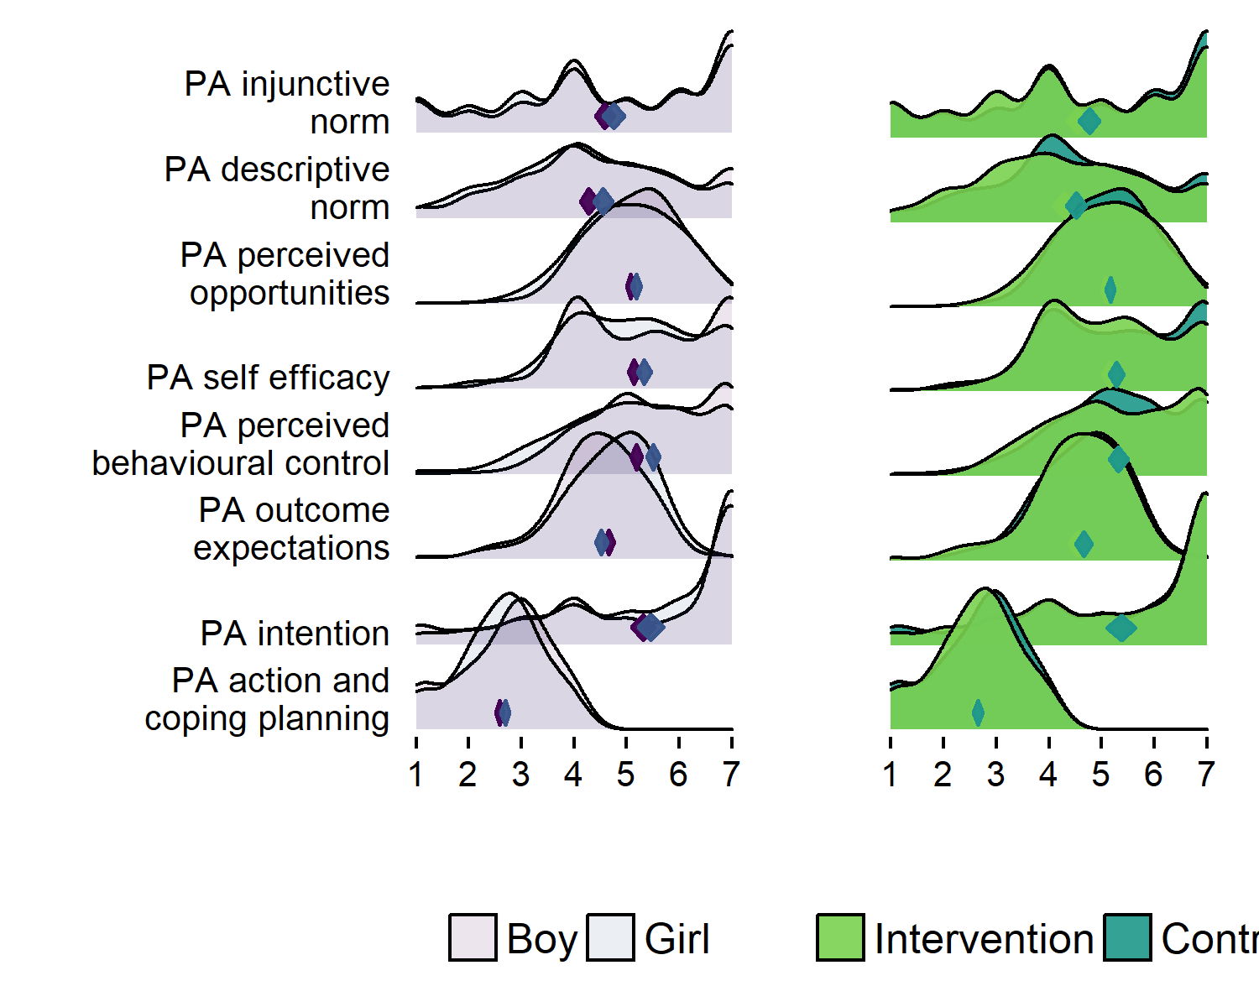

library(visreg)  
library(broom)  
  
m_pbcgirl <- lme4::lmer(PA_pbc_T1 ~ girl + (1 | school), data = df)  
summary(m_pbcgirl)  
## Linear mixed model fit by REML ['lmerMod']  
## Formula: PA_pbc_T1 ~ girl + (1 | school)  
## Data: df  
##   
## REML criterion at convergence: 3561.2  
##   
## Scaled residuals:   
## Min 1Q Median 3Q Max   
## -3.2903 -0.6705 0.1155 0.9014 1.4253   
##   
## Random effects:  
## Groups Name Variance Std.Dev.   
## school (Intercept) 1.393e-14 1.180e-07  
## Residual 1.619e+00 1.272e+00  
## Number of obs: 1071, groups: school, 5  
##   
## Fixed effects:  
## Estimate Std. Error t value  
## (Intercept) 5.18644 0.05164 100.43  
## girl0 0.32578 0.07846 4.15  
##   
## Correlation of Fixed Effects:  
## (Intr)  
## girl0 -0.658  
  
visreg::visreg(m_pbcgirl, "school", type = "contrast")

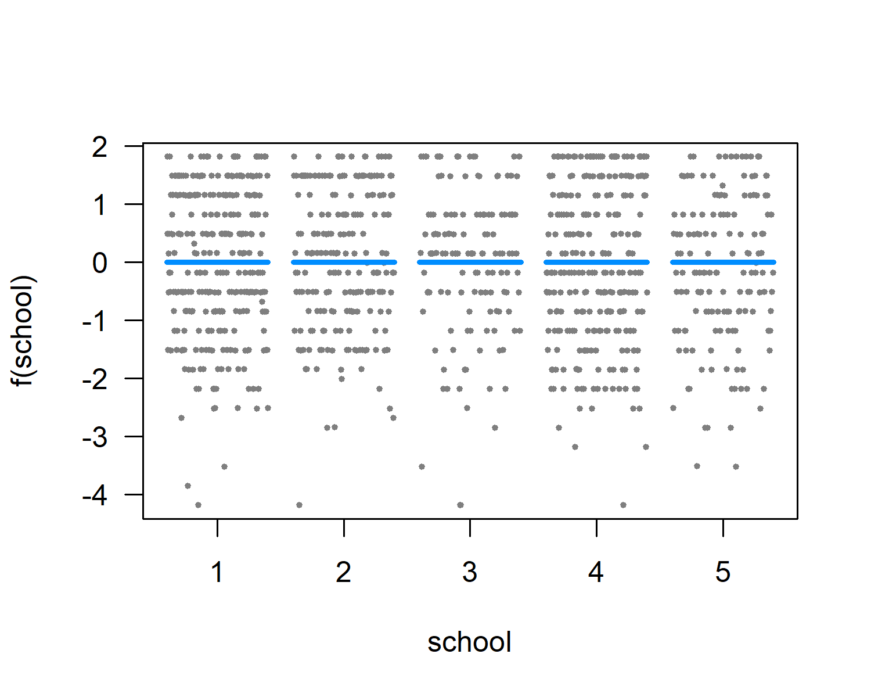

visreg(m_pbcgirl, "girl", by="school", re.form=~(1|school))

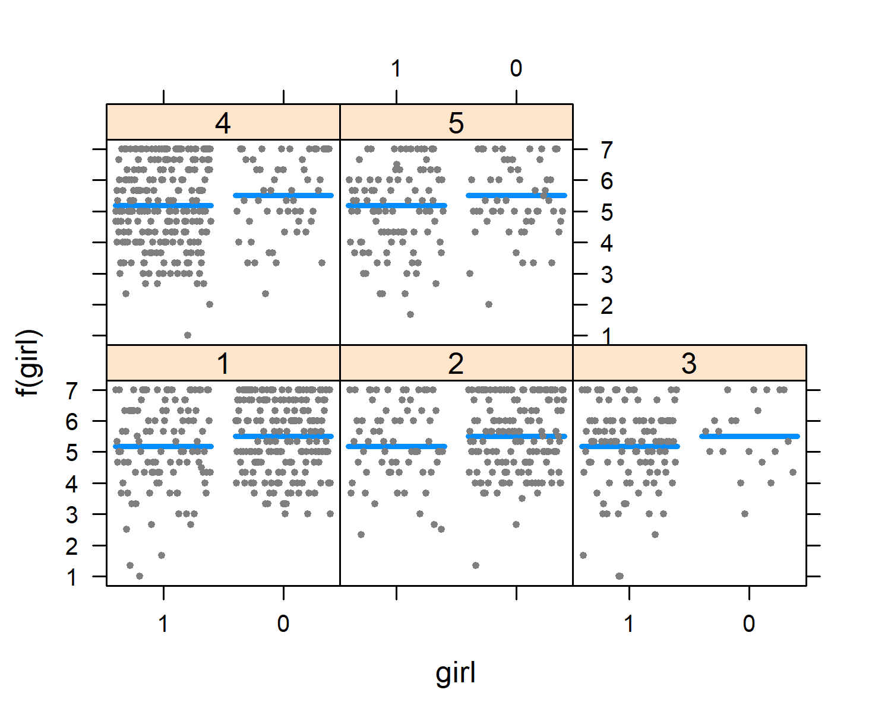

glance(m_pbcgirl)  
## sigma logLik AIC BIC deviance df.residual  
## 1 1.272372 -1780.624 3569.247 3589.153 3553.336 1067

## SB determinants

plot1 <- df %>% dplyr::select(id,  
 intervention,  
 group,  
 school,  
 girl,  
'SB intention' = SB_intention_T1,  
'SB outcome\nexpectations' = SB_outcomeExpectations_T1,  
'SB self-efficacy\nand perceived\nbehavioural control' = SB_sePbc_T1,  
'SB descriptive\nnorm' = SB_dnorm_T1,  
'SB injunctive\nnorm' = SB_inorm_T1) %>%  
 # select(noquote(order(colnames(.)))) %>% # Orders columns alphabetically  
 tidyr::gather(key = Variable, value = Value, 6:ncol(.)) %>%   
 ggplot(aes(y = Variable)) +  
 ggridges::geom_density_ridges(aes(x = Value, fill = paste(Variable, girl)),   
 alpha = .6, color = "black", from = 1, to = 7) +  
 labs(x = "",  
 y = "") +  
 scale_y_discrete(expand = c(0.01, 0)) +  
 scale_x_continuous(expand = c(0.01, 0)) +  
 ggridges::scale_fill_cyclical(breaks = c("SB injunctive\nnorm 0", "SB injunctive\nnorm 1"),  
 labels = c( 'SB injunctive\nnorm 0' = "Boy", 'SB injunctive\nnorm 1' = "Girl"),  
 values = c("#3bc600", "#0000ff", "#9cc68b", "#8080ff"),  
 name = "", guide = "legend") +  
 ggridges::theme_ridges(grid = FALSE) +  
 theme(legend.position="bottom")  
  
plot2 <- df %>% dplyr::select(id,  
 intervention,  
 group,  
 school,  
 girl,  
'SB intention' = SB_intention_T1,  
'SB outcome\nexpectations' = SB_outcomeExpectations_T1,  
'SB self-efficacy\nand perceived\nbehavioural control' = SB_sePbc_T1,  
'SB descriptive\nnorm' = SB_dnorm_T1,  
'SB injunctive\nnorm' = SB_inorm_T1) %>%  
 # select(noquote(order(colnames(.)))) %>% # Orders columns alphabetically  
 tidyr::gather(key = Variable, value = Value, 6:ncol(.)) %>%   
 ggplot(aes(y = Variable)) +  
 ggridges::geom_density_ridges(aes(x = Value, fill = paste(Variable, intervention)),   
 alpha = .6, color = "black", from = 1, to = 7) +  
 labs(x = "",  
 y = "") +  
 scale_y_discrete(expand = c(0.01, 0), labels = NULL) +  
 scale_x_continuous(expand = c(0.01, 0)) +  
 ggridges::scale_fill_cyclical(breaks = c("SB injunctive\nnorm 1", "SB injunctive\nnorm 0"),  
 labels = c('SB injunctive\nnorm 1' = "Intervention", 'SB injunctive\nnorm 0' = "Control"),  
 values = c("#ff0000", "#0000ff", "#ff8080", "#8080ff"),  
 name = "", guide = "legend") +  
 ggridges::theme_ridges(grid = FALSE) +  
 theme(legend.position="bottom")  
  
gridExtra::grid.arrange(plot1, plot2, ncol = 2)  
## Picking joint bandwidth of 0.311  
## Warning: Removed 507 rows containing non-finite values  
## (stat_density_ridges).  
## Picking joint bandwidth of 0.317  
## Warning: Removed 507 rows containing non-finite values  
## (stat_density_ridges).

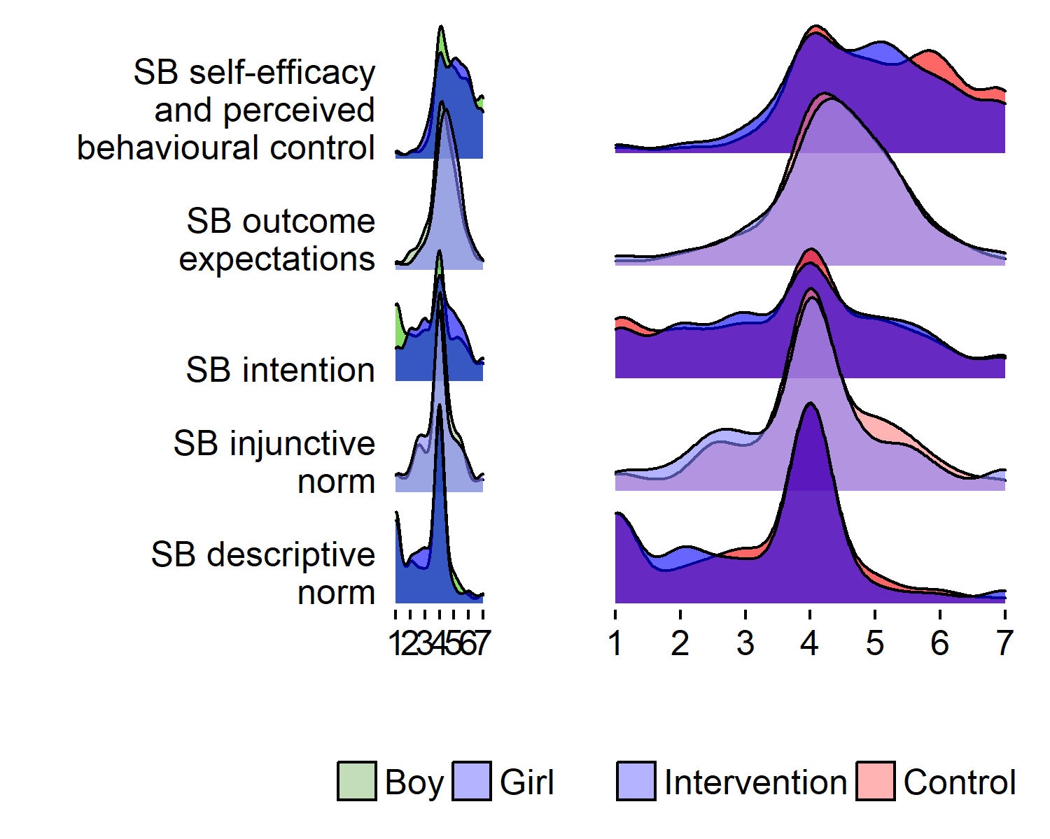

# CIBER (not included for now)

#p_install("userfriendlyscience")  
  
# cat(names(df), sep = "\",\n\"")  
  
# Make variables numeric, and d as data frame  
d_num <- df %>% mutate_all(as.numeric)   
d_num <- as.data.frame(d_num)  
  
userfriendlyscience::CIBER(data = d_num,  
 determinants = c(  
 "actCop_T1",  
 "agrbct_T1",  
 "amotivation_T1",  
 "autonomous_T1",  
 "big5_agreeableness_T1.1",  
 "big5_conscientiousness_T1.1",  
 "big5_extraversion_T1.1",  
 "big5_neuroticism_T1.1",  
 "big5_openness_T1.1",  
 "controlled_T1",  
 "dnorm_T1",  
 "frqbct_T1",  
 "goal_T1",  
 "inorm_T1",  
 "intention_T1",  
 "outcomeExpectations_T1",  
 "opportunities_T1",  
 "pbc_T1",  
 "selfefficacy_T1"),  
 targets = c("paT1", "fatpct_T1"),  
 conf.level = list(means = 0.9999,  
 associations = 0.99)  
 )  
  
userfriendlyscience::CIBER(data = d_num,  
 determinants = c(  
 "actCop_T1",  
 "agrbct_T1",  
 "frqbct_T1",  
 "amotivation_T1",  
 "autonomous_T1",  
 "controlled_T1",  
 "dnorm_T1",  
 "intention_T1",  
 "outcomeExpectations_T1",  
 "opportunities_T1",  
 "sePbc_T1"),  
 targets = c("paT1", "fatpct_T1"),  
 conf.level = list(means = 0.9999,  
 associations = 0.99)  
 )  
  
# to create variable list for CIBER:  
# cat(names(d), sep = "\",\n\"")  
  
userfriendlyscience::CIBER(data = d_num,  
 determinants = c(  
 "agrbct_01_T1",  
 "agrbct_02_T1",  
 "agrbct_03_T1",  
 "agrbct_04_T1",  
 "agrbct_05_T1",  
 "agrbct_06_T1",  
 "agrbct_07_T1",  
 "agrbct_08_T1",  
 "agrbct_09_T1",  
 "agrbct_10_T1",  
 "frqbct_01_T1",  
 "frqbct_02_T1",  
 "frqbct_03_T1",  
 "frqbct_04_T1",  
 "frqbct_05_T1",  
 "frqbct_06_T1",  
 "frqbct_07_T1",  
 "frqbct_08_T1",  
 "frqbct_09_T1"),  
 targets = c("MVPA", "SB"),  
 leftAnchors = rep("", 19),  
 rightAnchors = rep("", 19))  
  
userfriendlyscience::CIBER(data = d_num,  
 determinants = c(  
 "autonomous_01_T1",  
 "autonomous_02_T1",  
 "autonomous_03_T1",  
 "autonomous_04_T1",  
 "autonomous_05_T1",  
 "autonomous_06_T1",  
 "autonomous_07_T1",  
 "autonomous_08_T1",  
 "autonomous_09_T1"),  
 targets = c("MVPA", "SB"),  
 leftAnchors = rep("", 9),  
 rightAnchors = rep("", 9))  
  
userfriendlyscience::CIBER(data = d_num,  
 determinants = c(  
 "intention_01_T1",  
 "intention_02_T1",  
 "selfefficacy_01_T1",  
 "selfefficacy_02_T1",  
 "pbc_01_T1",  
 "pbc_02_T1",  
 "pbc_03_T1",  
 "norm_01_T1",  
 "norm_02_T1",  
 "outcomeExpectations_01_T1",  
 "outcomeExpectations_02_T1",  
 "outcomeExpectations_03_T1",  
 "outcomeExpectations_04_T1",  
 "outcomeExpectations_05_T1",  
 "outcomeExpectations_06_T1",  
 "outcomeExpectations_07_T1",  
 "outcomeExpectations_08_T1",  
 "outcomeExpectations_09_T1",  
 "outcomeExpectations_10_T1",  
 "outcomeExpectations_11_T1",  
 "outcomeExpectations_12_T1"),  
 targets = c("MVPA", "SB"),  
 leftAnchors = rep("", 21),  
 rightAnchors = rep("", 21))

# Density plots

## Accelerometer-measured PA

Contrary to some other findings, in our sample girls were more active than boys.

MVPAgirl_df <- df %>% group_by(girl) %>% select(girl, paAccelerometer_T1) %>% summarise(mean = mean(paAccelerometer_T1, na.rm = TRUE), median = median(paAccelerometer_T1, na.rm = TRUE))  
MVPAgirl_df[1, 2] - MVPAgirl_df[2, 2]  
## mean  
## 1 16.81268  
MVPAgirl_df[1, 3] - MVPAgirl_df[2, 3]  
## median  
## 1 24.52857  
  
userfriendlyscience::meanDiff(df$girl, df$paAccelerometer_T1)  
## Input variables:  
##   
## girl (grouping variable)  
## paAccelerometer_T1 (dependent variable)  
## Mean 1 (1) = 190.36, sd = 48.6, n = 425  
## Mean 2 (0)= 173.55, sd = 59.39, n = 281  
##   
## Independent samples t-test (tested for equal variances, p < .001, so unequal variances)  
## (standard deviation used of largest sample, 48.6)  
##   
## 95% confidence intervals:  
## Absolute mean difference: [8.45, 25.17] (Absolute mean difference: 16.81)  
## Cohen's d for difference: [0.19, 0.5] (Cohen's d point estimate: 0.35)  
## Hedges g for difference: [0.19, 0.5] (Hedges g point estimate: 0.35)  
##   
## Achieved power for d=0.35: 0.9957 (for small: 0.756; medium: 1; large: 1)  
##   
## (secondary information (NHST): t[516] = 3.95, p < .001)  
##   
##   
## NOTE: because the t-test is based on unequal variances, the NHST p-value may be inconsistent with the confidence interval. Although this is not a problem, if you wish to ensure consistency, you can use parameter "var.equal = 'yes'" to force equal variances.

colfill <- c(1,2,3,4,5)  
  
# Create data frame  
densplot <- d  
levels(densplot$intervention) <- list("Intervention" = "1", "Control" = "0")  
levels(densplot$girl) <- list("Girl" = "1", "Boy" = "0")  
  
# This gives side-by-side plots  
 layout(matrix(c(1,2,3,3), nrow = 2, ncol = 2, byrow = TRUE), heights=c(2.5, 2))  
  
## Intervention vs. control  
# Choose only the variables needed and drop NA  
dens <- densplot %>% select(paAccelerometer_T1, intervention) %>%   
 filter(complete.cases(.))  
  
# Set random number generator for reproducibility of bootstrap test of equal densities  
set.seed(10)  
# Make plot  
sm.paAccelerometer_T1_1 <- sm.density.compare2(as.numeric(dens$paAccelerometer_T1), as.factor(dens$intervention), xlab="", col=colfill, lty=c(1,2), bandcol='LightGray', model="equal", lwd=(c(2,2)))  
##   
## Test of equal densities: p-value = 0.25  
legend("topright", levels(dens$intervention), fill=c(1, 2))  
  
## Girls vs. boys  
# Choose only the variables needed and drop NA  
dens <- densplot %>% select(paAccelerometer_T1, girl) %>%   
 filter(complete.cases(.))  
  
# Set random number generator for reproducibility of bootstrap test of equal densities  
set.seed(10)  
# Make plot  
sm.paAccelerometer_T1_2 <- sm.density.compare2(as.numeric(dens$paAccelerometer_T1), as.factor(dens$girl), xlab="", col=colfill, lty=c(1,2), bandcol='LightGray', model="equal", lwd=(c(2,2)))  
## Warning in min(x): no non-missing arguments to min; returning Inf  
  
## Warning in min(x): no non-missing arguments to min; returning Inf  
## Warning in max(x): no non-missing arguments to max; returning -Inf  
  
## Warning in max(x): no non-missing arguments to max; returning -Inf  
## Warning in min(x): no non-missing arguments to min; returning Inf  
## Warning in max(x): no non-missing arguments to max; returning -Inf  
## Error in seq.default(opt$xlim[1], opt$xlim[2], length = opt$ngrid): 'from' must be a finite number  
legend("topright", levels(dens$girl), fill=c(1, 2))  
  
## Differences in schools  
# Choose only the variables needed and drop NA  
dens <- densplot %>% select(paAccelerometer_T1, school) %>%   
 filter(complete.cases(.))  
  
# Set random number generator for reproducibility of bootstrap test of equal densities  
set.seed(10)  
  
# Intervention groups with solid thicker lines  
linetypes <- c(1,2,2,1,2)  
  
# Make plot  
sm.paAccelerometer_T1_3 <- sm::sm.density.compare(as.numeric(dens$paAccelerometer_T1), dens$school, xlab="", col=colfill, lty=linetypes, model="none")  
legend("topright", c("Intervention school", "Control school"), col = c(4, 3), lty = c(1, 2), lwd = c(2, 2))

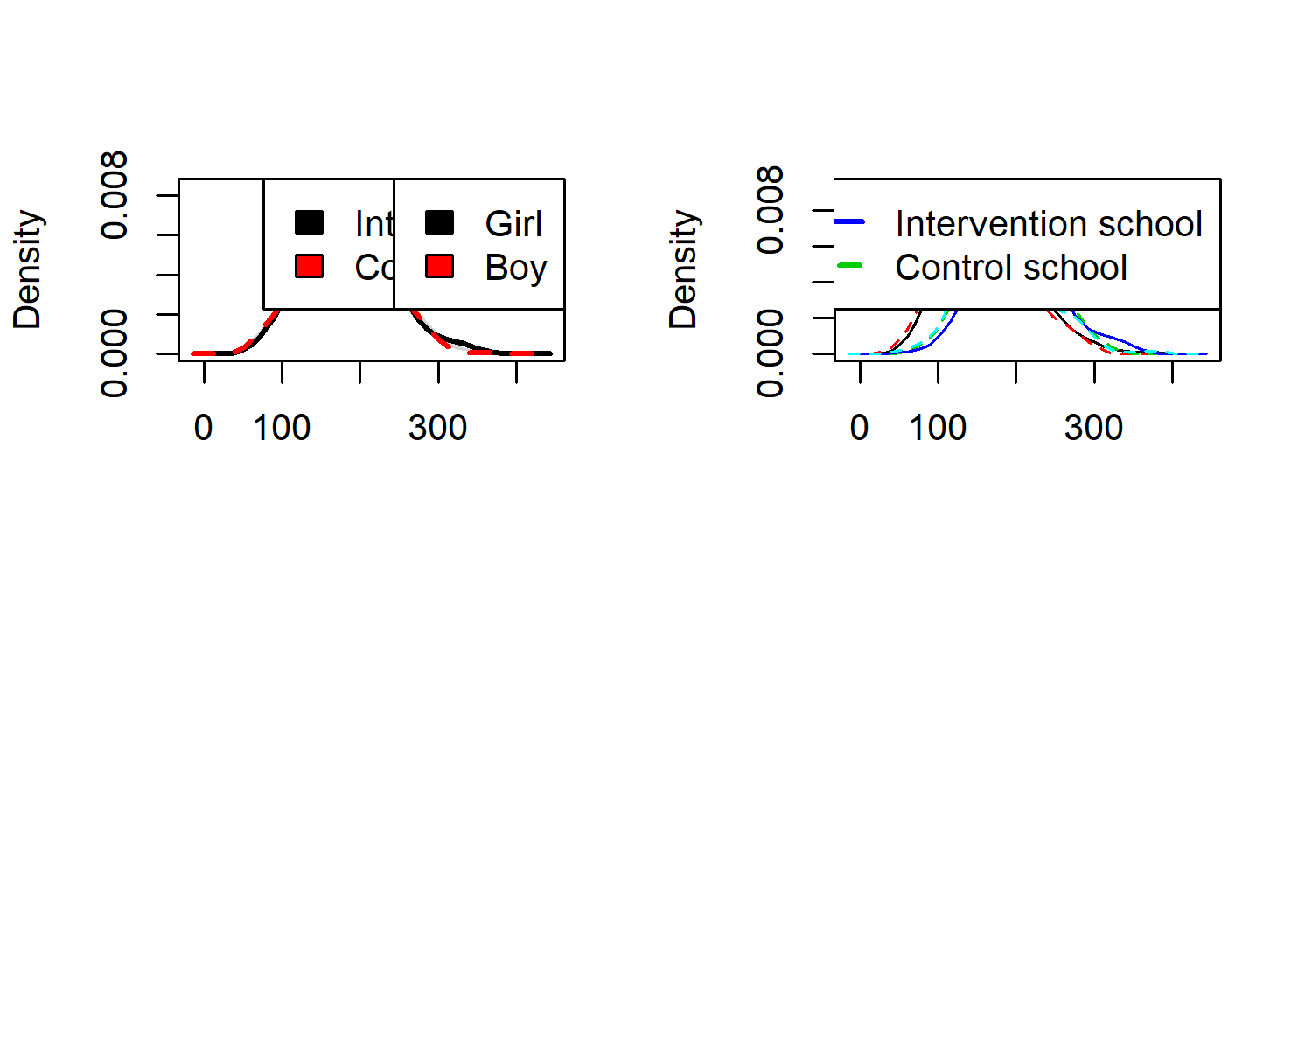

## Time spent sitting and lying down

colfill <- c(1,2,3,4,5)  
  
# Create data frame  
densplot <- d  
levels(densplot$intervention) <- list("Intervention" = "1", "Control" = "0")  
levels(densplot$girl) <- list("Girl" = "1", "Boy" = "0")  
  
# This gives side-by-side plots  
 layout(matrix(c(1,2,3,3), nrow = 2, ncol = 2, byrow = TRUE), heights=c(2.5, 2))  
  
## Intervention vs. control  
# Choose only the variables needed and drop NA  
dens <- densplot %>% select(sitLieAccelerometer_T1, intervention) %>%   
 filter(complete.cases(.))  
  
# Set random number generator for reproducibility of bootstrap test of equal densities  
set.seed(10)  
  
# Make plot  
sm.sitLieAccelerometer_T1_1 <- sm.density.compare2(as.numeric(dens$sitLieAccelerometer_T1), as.factor(dens$intervention), xlab="", col=colfill, lty=c(1,2), bandcol='LightGray', model="equal", lwd=(c(2,2)))  
##   
## Test of equal densities: p-value = 0.09  
legend("topright", levels(dens$intervention), fill=c(1, 2))  
  
## Girls vs. boys  
# Choose only the variables needed and drop NA  
dens <- densplot %>% select(sitLieAccelerometer_T1, girl) %>%   
 filter(complete.cases(.))  
  
# Set random number generator for reproducibility of bootstrap test of equal densities  
set.seed(10)  
  
# Make plot  
sm.sitLieAccelerometer_T1_2 <- sm.density.compare2(as.numeric(dens$sitLieAccelerometer_T1), as.factor(dens$girl), xlab="", col=colfill, lty=c(1,2), bandcol='LightGray', model="equal", lwd=(c(2,2)))  
## Warning in min(x): no non-missing arguments to min; returning Inf  
  
## Warning in min(x): no non-missing arguments to min; returning Inf  
## Warning in max(x): no non-missing arguments to max; returning -Inf  
  
## Warning in max(x): no non-missing arguments to max; returning -Inf  
## Warning in min(x): no non-missing arguments to min; returning Inf  
## Warning in max(x): no non-missing arguments to max; returning -Inf  
## Error in seq.default(opt$xlim[1], opt$xlim[2], length = opt$ngrid): 'from' must be a finite number  
legend("topright", levels(dens$girl), fill=c(1, 2))  
  
## Differences in schools  
# Choose only the variables needed and drop NA  
dens <- densplot %>% select(sitLieAccelerometer_T1, school) %>%   
 filter(complete.cases(.))  
  
# Set random number generator for reproducibility of bootstrap test of equal densities  
set.seed(10)  
  
# Intervention groups with solid thicker lines  
linetypes <- c(1,2,2,1,2)  
  
# Make plot  
sm.sitLieAccelerometer_T1_3 <- sm::sm.density.compare(as.numeric(dens$sitLieAccelerometer_T1), dens$school, xlab="", col=colfill, lty=linetypes, model="none")  
legend("topright", c("Intervention school", "Control school"), col = c(4, 3), lty = c(1, 2), lwd = c(2, 2))

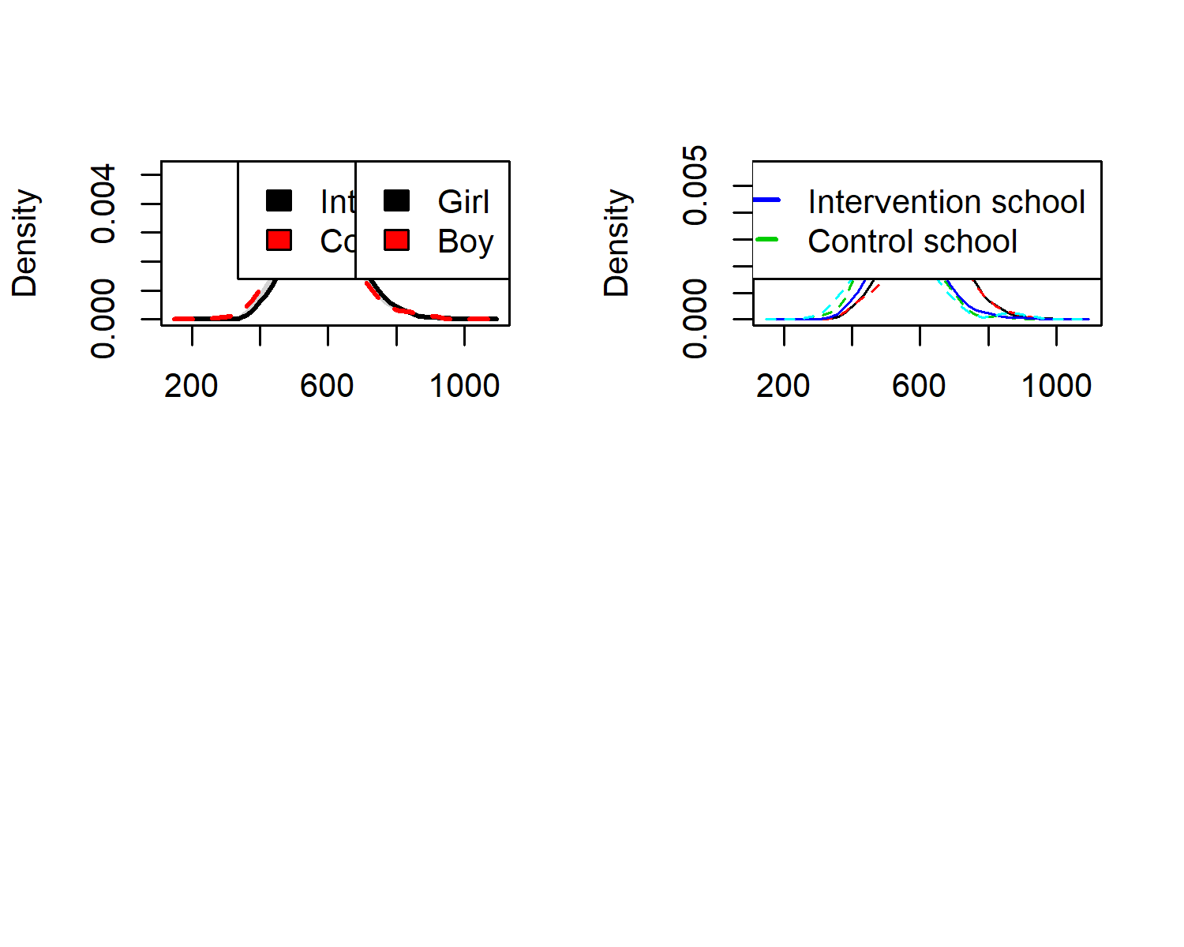

# Symptoms

colfill <- c(1,2,3,4,5)  
  
# Create data frame  
densplot <- df  
levels(densplot$intervention) <- list("Intervention" = "1", "Control" = "0")  
levels(densplot$girl) <- list("Girl" = "1", "Boy" = "0")  
  
# This gives side-by-side plots  
 layout(matrix(c(1,2,3,3), nrow = 2, ncol = 2, byrow = TRUE), heights=c(2.5, 2))  
  
## Intervention vs. control  
# Choose only the variables needed and drop NA  
dens <- densplot %>% select(symptom_T1, intervention) %>% na.omit(densplot)  
  
# Set random number generator for reproducibility of bootstrap test of equal densities  
set.seed(10)  
  
# Make plot  
sm.symptom_T1_1 <- sm.density.compare2(as.numeric(dens$symptom_T1), as.factor(dens$intervention), xlab="", col=colfill, lty=c(1,2), bandcol='LightGray', model="equal", lwd=(c(2,2)))  
##   
## Test of equal densities: p-value = 0.59  
legend("topright", levels(dens$intervention), fill=c(1, 2))  
  
## Girls vs. boys  
# Choose only the variables needed and drop NA  
dens <- densplot %>% select(symptom_T1, girl) %>% na.omit(densplot)  
  
# Set random number generator for reproducibility of bootstrap test of equal densities  
set.seed(10)  
  
# Make plot  
sm.symptom_T1_2 <- sm.density.compare2(as.numeric(dens$symptom_T1), as.factor(dens$girl), xlab="", col=colfill, lty=c(1,2), bandcol='LightGray', model="equal", lwd=(c(2,2)))  
##   
## Test of equal densities: p-value = 0  
legend("topright", levels(dens$girl), fill=c(1, 2))  
  
## Differences in schools  
# Choose only the variables needed and drop NA  
dens <- densplot %>% select("Symptom sum score" = symptom_T1, school) %>% na.omit(densplot)  
  
# Set random number generator for reproducibility of bootstrap test of equal densities  
set.seed(10)  
  
# Intervention groups with solid thicker lines  
linetypes <- c(1,2,2,1,2)  
linewidths <- c(2,1,1,2,1)  
  
# Make plot  
sm.symptom_T1_3 <- sm::sm.density.compare(dens$`Symptom sum score`, dens$school, xlab="", col=colfill, lty=linetypes, model="equal", lwd=linewidths)  
## Reference band available to compare two groups only.

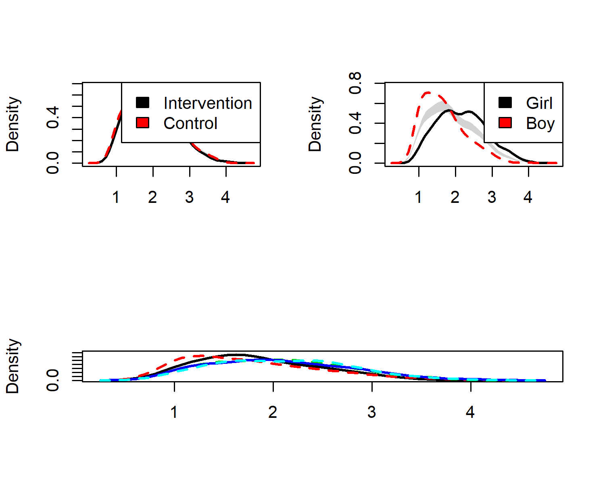

##   
## Test of equal densities: p-value = 0  
xlab = ""

## Symptom histograms

### intervention / gender

sympGirls <- df %>% dplyr::select(id,  
 intervention,  
 group,  
 school,  
 girl,  
 "Neck and shoulder pain" = symptom_neckShoulderPain_T1,  
 "Lower back pain" = symptom_lowerBackPain_T1,  
 "Stomach ache" = symptom_stomachAche_T1,  
 "Tension or nervousness" = symptom_tensionNervousness_T1,  
 "Irritability or anger bursts" = symptom_irritabilityAngerbursts_T1,  
 "Difficulty with sleep" = symptom_sleepDifficulty_T1,  
 "Headache" = symptom_headAche_T1,  
 "Tiredness or faintness" = symptom_tirednessFaintness_T1) %>%  
 tidyr::gather(key = Variable, value = Value, 6:ncol(.)) %>%  
 filter(girl == "1") %>%   
 ggplot(aes(x = Value, y = Variable, group = Variable)) +  
 ggridges::geom_density_ridges2(aes(fill = Variable), stat = "binline", binwidth = 1, scale = 0.95) +  
 scale_x_continuous(breaks = c(1:4), expand = c(0, 0),  
 name = "") +  
 scale_y_discrete(expand = c(0.01, 0), name = "", labels = NULL) +  
 ggridges::scale_fill_cyclical(values = c("darkolivegreen2", "darkolivegreen4")) +  
 labs(title = "Girls") +  
 guides(y = "none") +  
 ggridges::theme_ridges(grid = FALSE) +  
 theme(axis.title.x = element_text(hjust = 0.5),  
 axis.title.y = element_text(hjust = 0.5),  
 plot.title = element_text(hjust = 0.5, size = 10),  
 axis.text=element_text(size=10, face="bold")) +  
coord_cartesian(xlim = c(0.5, 4.5))  
## Warning: attributes are not identical across measure variables;  
## they will be dropped  
  
sympBoys <- df %>% dplyr::select(id,  
 intervention,  
 group,  
 school,  
 girl,  
 "Neck and shoulder pain" = symptom_neckShoulderPain_T1,  
 "Lower back pain" = symptom_lowerBackPain_T1,  
 "Stomach ache" = symptom_stomachAche_T1,  
 "Tension or nervousness" = symptom_tensionNervousness_T1,  
 "Irritability or anger bursts" = symptom_irritabilityAngerbursts_T1,  
 "Difficulty with sleep" = symptom_sleepDifficulty_T1,  
 "Headache" = symptom_headAche_T1,  
 "Tiredness or faintness" = symptom_tirednessFaintness_T1) %>%  
 tidyr::gather(key = Variable, value = Value, 6:ncol(.)) %>%  
 filter(girl == "0") %>%   
 ggplot(aes(x = Value, y = Variable, group = Variable)) +  
 ggridges::geom_density_ridges2(aes(fill = Variable), stat = "binline", binwidth = 1, scale = 0.95) +  
 scale_x_continuous(breaks = c(1:4), expand = c(0, 0),  
 name = "") +  
 scale_y_discrete(expand = c(0.01, 0), name = "", labels = NULL) +  
 ggridges::scale_fill_cyclical(values = c("darkolivegreen2", "darkolivegreen4")) +  
 labs(title = "Boys") +  
 guides(y = "none") +  
 ggridges::theme_ridges(grid = FALSE) +  
 theme(axis.title.x = element_text(hjust = 0.5),  
 axis.title.y = element_text(hjust = 0.5),  
 plot.title = element_text(hjust = 0.5, size = 10),  
 axis.text=element_text(size=10, face="bold")) +  
coord_cartesian(xlim = c(0.5, 4.5))  
## Warning: attributes are not identical across measure variables;  
## they will be dropped  
  
sympInt <- df %>% dplyr::select(id,  
 intervention,  
 group,  
 school,  
 girl,  
 "Neck and shoulder pain" = symptom_neckShoulderPain_T1,  
 "Lower back pain" = symptom_lowerBackPain_T1,  
 "Stomach ache" = symptom_stomachAche_T1,  
 "Tension or nervousness" = symptom_tensionNervousness_T1,  
 "Irritability or anger bursts" = symptom_irritabilityAngerbursts_T1,  
 "Difficulty with sleep" = symptom_sleepDifficulty_T1,  
 "Headache" = symptom_headAche_T1,  
 "Tiredness or faintness" = symptom_tirednessFaintness_T1) %>%  
 tidyr::gather(key = Variable, value = Value, 6:ncol(.)) %>%  
 filter(intervention == "1") %>%   
 ggplot(aes(x = Value, y = Variable, group = Variable)) +  
 ggridges::geom_density_ridges2(aes(fill = Variable), stat = "binline", binwidth = 1, scale = 0.95) +  
 scale_x_continuous(breaks = c(1:4), expand = c(0, 0),  
 name = "") +  
 scale_y_discrete(expand = c(0.01, 0), name = "") +  
 ggridges::scale_fill_cyclical(values = c("deepskyblue", "deepskyblue4")) +  
 labs(title = "Intervention") +  
 guides(y = "none") +  
 ggridges::theme_ridges(grid = FALSE) +  
 theme(axis.title.x = element_text(hjust = 0.5),  
 axis.title.y = element_text(hjust = 0.5),  
 plot.title = element_text(hjust = 0.5, size = 10),  
 axis.text=element_text(size=10)) +  
coord_cartesian(xlim = c(0.5, 4.5))  
## Warning: attributes are not identical across measure variables;  
## they will be dropped  
  
sympCont <- df %>% dplyr::select(id,  
 intervention,  
 group,  
 school,  
 girl,  
 "Neck and shoulder pain" = symptom_neckShoulderPain_T1,  
 "Lower back pain" = symptom_lowerBackPain_T1,  
 "Stomach ache" = symptom_stomachAche_T1,  
 "Tension or nervousness" = symptom_tensionNervousness_T1,  
 "Irritability or anger bursts" = symptom_irritabilityAngerbursts_T1,  
 "Difficulty with sleep" = symptom_sleepDifficulty_T1,  
 "Headache" = symptom_headAche_T1,  
 "Tiredness or faintness" = symptom_tirednessFaintness_T1) %>%  
 tidyr::gather(key = Variable, value = Value, 6:ncol(.)) %>%  
 filter(intervention == "0") %>%   
 ggplot(aes(x = Value, y = Variable, group = Variable)) +  
 ggridges::geom_density_ridges2(aes(fill = Variable), stat = "binline", binwidth = 1, scale = 0.95) +  
 scale_x_continuous(breaks = c(1:4), expand = c(0, 0),  
 name = "") +  
 scale_y_discrete(expand = c(0.01, 0), name = "", labels = NULL) +  
 ggridges::scale_fill_cyclical(values = c("deepskyblue", "deepskyblue4")) +  
 labs(title = "Control") +  
 guides(y = "none") +  
 ggridges::theme_ridges(grid = FALSE) +  
 theme(axis.title.x = element_text(hjust = 0.5),  
 axis.title.y = element_text(hjust = 0.5),  
 plot.title = element_text(hjust = 0.5, size = 10),  
 axis.text=element_text(size=10, face="bold")) +  
coord_cartesian(xlim = c(0.5, 4.5))  
## Warning: attributes are not identical across measure variables;  
## they will be dropped  
  
#grid.arrange(sympInt, sympGirls, sympCont, sympBoys, ncol = 2)  
  
# ("Seldom or never", "About once a month", "About once a week", "Almost daily")  
  
# This draws all histograms next to each other:  
grid::grid.newpage()  
grid::grid.draw(cbind(ggplotGrob(sympInt), ggplotGrob(sympCont), ggplotGrob(sympGirls), ggplotGrob(sympBoys), size = "last"))  
## Warning: Removed 198 rows containing non-finite values (stat_binline).  
## Warning: Removed 93 rows containing non-finite values (stat_binline).  
## Warning: Removed 197 rows containing non-finite values (stat_binline).  
## Warning: Removed 94 rows containing non-finite values (stat_binline).

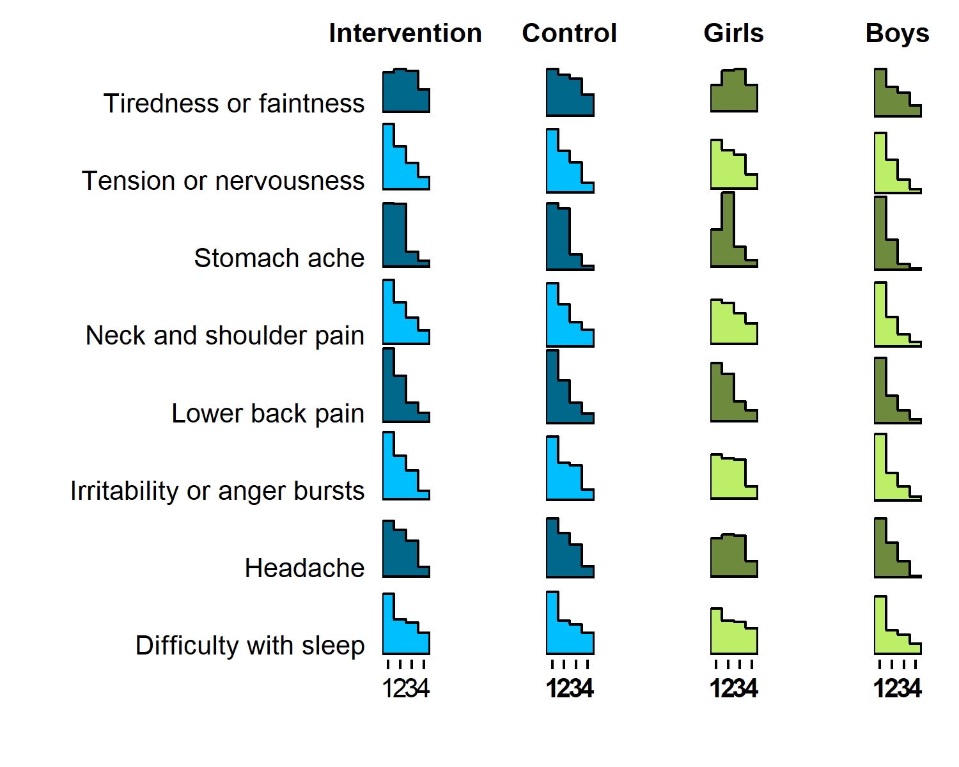

# This draws 2 histograms per row:  
#grid.newpage()  
#grid.draw(rbind(cbind(ggplotGrob(sympInt), ggplotGrob(sympCont), size = "last"), cbind(ggplotGrob(sympGirls), ggplotGrob(sympBoys), size = "last")))

### educational track

sympHRC <- df %>% dplyr::select(id,  
 intervention,  
 track,  
 school,  
 girl,  
 "Neck and shoulder pain" = symptom_neckShoulderPain_T1,  
 "Lower back pain" = symptom_lowerBackPain_T1,  
 "Stomach ache" = symptom_stomachAche_T1,  
 "Tension or nervousness" = symptom_tensionNervousness_T1,  
 "Irritability or anger bursts" = symptom_irritabilityAngerbursts_T1,  
 "Difficulty with sleep" = symptom_sleepDifficulty_T1,  
 "Headache" = symptom_headAche_T1,  
 "Tiredness or faintness" = symptom_tirednessFaintness_T1) %>%  
 tidyr::gather(key = Variable, value = Value, 6:ncol(.)) %>%  
 filter(track == "HRC") %>%   
 ggplot(aes(x = Value, y = Variable, group = Variable)) +  
 ggridges::geom_density_ridges2(aes(fill = Variable), stat = "binline", binwidth = 1, scale = 0.95) +  
 scale_x_continuous(breaks = c(1:4), expand = c(0, 0),  
 name = "") +  
 scale_y_discrete(expand = c(0.01, 0), name = "", labels = NULL) +  
 ggridges::scale_fill_cyclical(values = c("darkolivegreen2", "darkolivegreen4")) +  
 labs(title = "HRC") +  
 guides(y = "none") +  
 ggridges::theme_ridges(grid = FALSE) +  
 theme(axis.title.x = element_text(hjust = 0.5),  
 axis.title.y = element_text(hjust = 0.5),  
 plot.title = element_text(hjust = 0.5, size = 10),  
 axis.text=element_text(size=10, face="bold")) +  
coord_cartesian(xlim = c(0.5, 4.5))  
## Warning: attributes are not identical across measure variables;  
## they will be dropped  
  
sympNursing <- df %>% dplyr::select(id,  
 intervention,  
 track,  
 school,  
 girl,  
 "Neck and shoulder pain" = symptom_neckShoulderPain_T1,  
 "Lower back pain" = symptom_lowerBackPain_T1,  
 "Stomach ache" = symptom_stomachAche_T1,  
 "Tension or nervousness" = symptom_tensionNervousness_T1,  
 "Irritability or anger bursts" = symptom_irritabilityAngerbursts_T1,  
 "Difficulty with sleep" = symptom_sleepDifficulty_T1,  
 "Headache" = symptom_headAche_T1,  
 "Tiredness or faintness" = symptom_tirednessFaintness_T1) %>%  
 tidyr::gather(key = Variable, value = Value, 6:ncol(.)) %>%  
 filter(track == "Nursing") %>%   
 ggplot(aes(x = Value, y = Variable, group = Variable)) +  
 ggridges::geom_density_ridges2(aes(fill = Variable), stat = "binline", binwidth = 1, scale = 0.95) +  
 scale_x_continuous(breaks = c(1:4), expand = c(0, 0),  
 name = "") +  
 scale_y_discrete(expand = c(0.01, 0), name = "", labels = NULL) +  
 ggridges::scale_fill_cyclical(values = c("darkolivegreen2", "darkolivegreen4")) +  
 labs(title = "Nursing") +  
 guides(y = "none") +  
 ggridges::theme_ridges(grid = FALSE) +  
 theme(axis.title.x = element_text(hjust = 0.5),  
 axis.title.y = element_text(hjust = 0.5),  
 plot.title = element_text(hjust = 0.5, size = 10),  
 axis.text=element_text(size=10, face="bold")) +  
coord_cartesian(xlim = c(0.5, 4.5))  
## Warning: attributes are not identical across measure variables;  
## they will be dropped  
  
sympIT <- df %>% dplyr::select(id,  
 intervention,  
 track,  
 school,  
 girl,  
 "Neck and shoulder pain" = symptom_neckShoulderPain_T1,  
 "Lower back pain" = symptom_lowerBackPain_T1,  
 "Stomach ache" = symptom_stomachAche_T1,  
 "Tension or nervousness" = symptom_tensionNervousness_T1,  
 "Irritability or anger bursts" = symptom_irritabilityAngerbursts_T1,  
 "Difficulty with sleep" = symptom_sleepDifficulty_T1,  
 "Headache" = symptom_headAche_T1,  
 "Tiredness or faintness" = symptom_tirednessFaintness_T1) %>%  
 tidyr::gather(key = Variable, value = Value, 6:ncol(.)) %>%  
 filter(track == "Business IT") %>%   
 ggplot(aes(x = Value, y = Variable, group = Variable)) +  
 ggridges::geom_density_ridges2(aes(fill = Variable), stat = "binline", binwidth = 1, scale = 0.95) +  
 scale_x_continuous(breaks = c(1:4), expand = c(0, 0),  
 name = "") +  
 scale_y_discrete(expand = c(0.01, 0), name = "") +  
 ggridges::scale_fill_cyclical(values = c("deepskyblue", "deepskyblue4")) +  
 labs(title = "Business IT") +  
 guides(y = "none") +  
 ggridges::theme_ridges(grid = FALSE) +  
 theme(axis.title.x = element_text(hjust = 0.5),  
 axis.title.y = element_text(hjust = 0.5),  
 plot.title = element_text(hjust = 0.5, size = 10),  
 axis.text=element_text(size=10)) +  
coord_cartesian(xlim = c(0.5, 4.5))  
## Warning: attributes are not identical across measure variables;  
## they will be dropped  
  
sympBA <- df %>% dplyr::select(id,  
 intervention,  
 track,  
 school,  
 girl,  
 "Neck and shoulder pain" = symptom_neckShoulderPain_T1,  
 "Lower back pain" = symptom_lowerBackPain_T1,  
 "Stomach ache" = symptom_stomachAche_T1,  
 "Tension or nervousness" = symptom_tensionNervousness_T1,  
 "Irritability or anger bursts" = symptom_irritabilityAngerbursts_T1,  
 "Difficulty with sleep" = symptom_sleepDifficulty_T1,  
 "Headache" = symptom_headAche_T1,  
 "Tiredness or faintness" = symptom_tirednessFaintness_T1) %>%  
 tidyr::gather(key = Variable, value = Value, 6:ncol(.)) %>%  
 filter(track == "Business Admin") %>%   
 ggplot(aes(x = Value, y = Variable, group = Variable)) +  
 ggridges::geom_density_ridges2(aes(fill = Variable), stat = "binline", binwidth = 1, scale = 0.95) +  
 scale_x_continuous(breaks = c(1:4), expand = c(0, 0),  
 name = "") +  
 scale_y_discrete(expand = c(0.01, 0), name = "", labels = NULL) +  
 ggridges::scale_fill_cyclical(values = c("deepskyblue", "deepskyblue4")) +  
 labs(title = "Business Admin") +  
 guides(y = "none") +  
 ggridges::theme_ridges(grid = FALSE) +  
 theme(axis.title.x = element_text(hjust = 0.5),  
 axis.title.y = element_text(hjust = 0.5),  
 plot.title = element_text(hjust = 0.5, size = 10),  
 axis.text=element_text(size=10, face="bold")) +  
coord_cartesian(xlim = c(0.5, 4.5))  
## Warning: attributes are not identical across measure variables;  
## they will be dropped  
  
#grid.arrange(sympIT, sympHRC, sympBA, sympNursing, ncol = 2)  
  
# ("Seldom or never", "About once a month", "About once a week", "Almost daily")  
  
# This draws all histograms next to each other:  
grid::grid.newpage()  
grid::grid.draw(cbind(ggplotGrob(sympIT), ggplotGrob(sympBA), ggplotGrob(sympHRC), ggplotGrob(sympNursing), size = "last"))  
## Warning: Removed 26 rows containing non-finite values (stat_binline).  
## Warning: Removed 49 rows containing non-finite values (stat_binline).  
  
## Warning: Removed 49 rows containing non-finite values (stat_binline).  
## Warning: Removed 141 rows containing non-finite values (stat_binline).

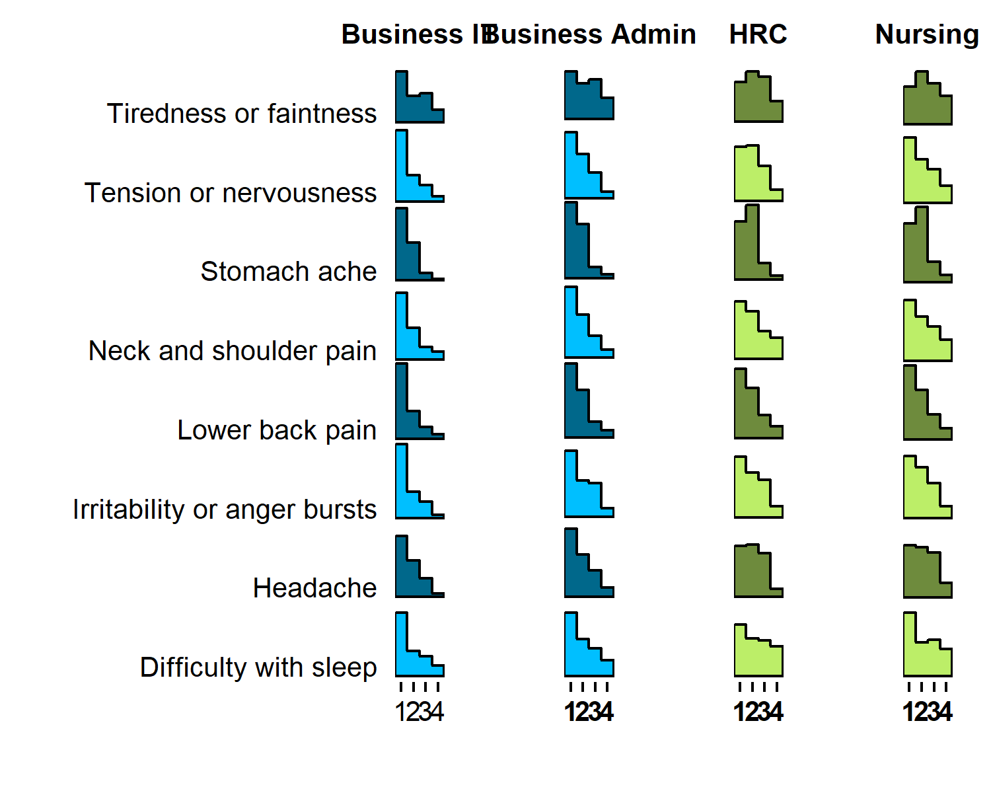

# This draws 2 histograms per row:  
#grid.newpage()  
#grid.draw(rbind(cbind(ggplotGrob(sympIT), ggplotGrob(sympBA), size = "last"), cbind(ggplotGrob(sympHRC), ggplotGrob(sympNursing), size = "last")))