Studying behaviour change mechanisms under complexity

Matti T. J. Heino1, Keegan Knittle1, Chris Noone2, Fred Hasselman3, & Nelli Hankonen1

1 Faculty of Social Sciences, University of Helsinki, PO Box 54, 00014 University of Helsinki, Finland

2 School of Psychology, National University of Ireland, Galway, Ireland

3 Behavioural Science Institute, Radboud University Nijmegen, The Netherlands

Author note

Correspondence concerning this article should be addressed to Nelli Hankonen, Faculty of Social Sciences, University of Helsinki, PO Box 54, 00014 University of Helsinki, Finland. E-mail: [nelli.hankonen@helsinki.fi](mailto:nelli.hankonen@helsinki.fi)

Abstract

Understanding the mechanisms underlying the effects of behaviour change interventions is vital for accumulating valid scientific evidence, and useful to informing practice and policy-making across multiple domains. Traditional approaches to such evaluations have applied study designs and statistical models, which implicitly assume that change is linear, constant and caused by independent influences on behaviour (such as behaviour change techniques). This article illustrates limitations of these standard tools, and considers the benefits of adopting a complex adaptive systems approach to behaviour change research. It 1) outlines the complexity of behaviours and behaviour change interventions, 2) introduces readers to some key features of complex systems and how these relate to human behaviour change, and 3) provides suggestions for how researchers can better account for implications of complexity in analysing change mechanisms. We focus on three common features of complex systems (i.e. interconnectedness, non-ergodicity and non-linearity), and introduce Recurrence Analysis, a method for nonlinear time series analysis which is able to quantify complex dynamics. The supplemental website (<https://git.io/Jffrm>) provides exemplifying code and data for practical analysis applications. The complex adaptive systems approach can complement traditional investigations by opening up novel avenues for understanding and theorising about the dynamics of behaviour change.

*Keywords:* complex systems, wellbeing, methodology, behaviour change

# 

# 1 Introduction

In order to understand why behavioural interventions often fail to produce sustainable effects [1], especially when transferred from one context to another, a core interest of behaviour change science is to improve our understanding of mechanisms of behaviour change. Behavioural theories identify hundreds of potential “determinants” of behaviour, that is, factors that potentially influence the behaviour of interest, constituting the mechanisms by which behaviour change techniques might influence behaviour [2]. These range from social cognitions such as self-efficacy and attitudes, to biological factors, and certain elements of the social and built environments in which behaviours take place [3]. When studied using typical factorial designs and linear statistical models, the relationships between causal precedents and behaviour change are assumed to be additive, constant and linear (i.e. the outputs are proportional to the inputs). However, it is our position that this offers behaviour change researchers and the general public an inaccurate or at least imprecise understanding of behaviour change. We should consider the relevant factors as complex, potentially non-linear, and dynamic.

The evaluation of behaviour change interventions often involves randomly assigning participants to receive an intervention of interest or a specific comparator and measuring subjective and objective indicators of behaviour [4]. Usually, these measurements occur immediately before and after the delivery of the intervention, though sometimes additional follow-up measurements may take place weeks or months later. This is the classic Randomised Controlled Trial design and the data produced are most often analysed using statistical techniques that are specific cases of the General Linear Model. In this paper, we refer to this as the “conventional approach”. If the interest is only in assessing whether the treatment overall was more effective, on average, in the intervention group than the control group, comparing averages in randomised controlled trials can be purposeful and acceptable (i.e. answering questions such as “Does the intervention have an effect on the target behaviour?”, “Do cohorts differ from each other?”). However, using so few measurement points to study behaviour change mechanisms (“How do intervention participants change?”) may present problems.

Currently, mechanisms of change in behaviour change interventions are typically studied using mediation analysis [5], where one variable’s (X) impact on another (Y) is modelled to pass through a third variable (M). In its classical form, one expects the path X-Y to go near zero, when M is added to the model. If this is observed, the researcher concludes there is evidence for mediation. For example, within an RCT, researchers can collect not only outcome data (e.g. physical activity behaviour, Y), but so called process variables (e.g. autonomous motivation for physical activity, self-regulation skills (M)), reflecting e.g. psychological mechanisms that are hypothesised to be the explanation for what makes the intervention (X) effective in changing behaviour (case example from members of the current author group: [6]).

Inferring mechanisms from contemporary mediation analyses is problematic on various grounds [7–12], but of particular importance to human behaviour change, the results depend on four key assumptions, discussed by [13]. We can only consider the results of such mediation analyses to be accurate when we assume that: 1) The number of variables involved is small, and dynamics can be meaningfully assessed with only a few time points, 2) The process of change is the same for all individuals, e.g. follows the same sequence, 3) The dynamic between variables is linear, additive, and does not change in time, and 4) The included variables are not entangled with the context, omitted variables, or each other, in bi-directional recursive relationships. Researchers can of course include more variables (leading to new issues, e.g. mixing up mediators, confounders and colliders [14] or lowering the already worrisome statistical power [15,16]), try to incorporate non-linear effects [17], and add more time points (for caveats regarding latent variable modeling, see e.g. [18,19]). But limiting the notion of a mechanism to a (multiple) mediation/moderation problem limits our understanding of how changes occur over time [20,21].

During the first two decades of the 21st century, behaviour change researchers have started embracing designs with an increased focus on temporal processes [22,23], extending the traditional approach. Recently, alternative solutions stemming from complex systems science [24,25] have become increasingly accessible and helpful in tackling problems of understanding change processes. We will explore these ideas and how they help us surpass traditional assumptions. In what follows, this paper will 1) outline the complexity of behaviours and behaviour change interventions, 2) introduce readers to some key features of complex systems and how these can be applied to human behaviour, and 3) provide concrete suggestions for how researchers can better account for the implications of complexity in analysing behaviour change mechanisms.

## 1.1 What are complex systems?

A system is “a delineated part of the universe which is distinguished from the rest by an imaginary boundary” [26], although other definitions exist [27]. Many things—an airplane, a car, a robot, a central nervous system, a school, a community, a society—can be conceptualised as systems. This paper focuses on individual people, which are complex systems. Complex systems can be characterised as webs of many *interdependent self-organising* parts that operate without central control, whose interactions give rise to *emergent* properties and behaviours, irreducible to a sum of its parts [28]. The future behaviour of such a complex system strongly depends on its *unique history of interactions*, that is, past experience. Additionally, the system adapts to each its environment and actors therein, *coevolving* with each other to create macro-level behaviour, which is difficult to predict and usually not changeable in a stepwise engineering sense [29]. These characteristics (in italics) distinguish complex systems from those which are just complicated. Highly complicated processes or systems (e.g. an airplane), unlike complex ones (e.g. an organism) cannot, for example, self-organise to function adaptively when a part is removed [30]. Guides to basic terminology of complexity for scientists working with health behaviours can be found in [30] as well as table 1 of [29]. The promise of complex adaptive systems approaches in health behaviour change research has been previously discussed by e.g. [31], but over a decade ago, not many empirical solutions were easily accessible to investigators in this field. Recently, methods to study complex adaptive systems in health behaviour change have been presented [32], with a focus on simulation and qualitative methods. This article discusses novel quantitative solutions, which have recently become available, to investigate behavior change phenomena with a complex systems lens.

## 1.2 The relevance of complexity for behaviour change

To paint a picture of just how complex the behavioural world is, take the case of physical activity as an example behaviour. Already three and a half decades ago, more than 30 influences on (or “determinants of”) this behaviour were being considered, along with calls for better understanding of their dynamics, interactions, and the time scales over which these develop [33]. While any influence (e.g. intention, attitude) could have a direct relationship with physical activity, some rely on interactions with other influences to affect behaviour [34,35]. Furthermore, these interactions may be moderated by additional factors, and by other variables which themselves have no direct relationship with physical activity, with synergistic and opposing effects which may themselves depend on whether some threshold is exceeded. The extent to which all known (and unknown) influences on physical activity interact with one another presents a map of practically infinite, intertwined ‘routes’ to initiating and maintaining the activity.

The role of time brings added complexity to this behavioural world, as dynamic patterns change over time and at varying frequencies. For example, fluctuations in physical activity clearly occur within a day, as most individuals are (at least in the absence of highly sedentary working conditions and considerable somnambulism) more active while awake than while asleep. Fluctuation also occurs over the course of a week, as activity levels tend to be higher on weekdays than on weekends [36]; over the course of months, as activity levels are higher in warmer seasons and lower in colder ones [37]; and over the course of years, as activity levels tend to decline with age [38]. How determinants—which are postulated to comprise the mechanisms underlying changes in behaviour—fluctuate and interact with the fluctuations in behaviour, is largely unknown.

Human behaviour is complex, and while we have formulated theoretical constructs to be as amenable as possible to linear methods of analysis, this may obscure important characteristics of behaviour change. Why are linear models inappropriate for many of our research questions in the behavioural sciences? First, with many nonlinear interactions across time scales, mechanistic causality (including mediation and moderation) becomes suspect or intractable [19,39,40]. Second, traditional statistical analyses start from the simplification that everything is independent from everything else, whereas in actuality, nearly everything eventually depends on everything else, contributing to what Paul E. Meehl [41] seminally coined as “the crud factor”. Jacob Cohen, the developer of power analysis, similarly exclaimed that [in the absence of randomisation], the nil hypothesis of no effect is always a priori false [42] – these well-known ideas demonstrate violations of the classical assumptions regarding independence and interference [43,44]. In the same vein, forecasting in complex systems is notoriously difficult [45–47], making hypothesis testing—which is, after all, the test of a prediction—in intervention evaluation a curious challenge. Complexity science, which starts from the assumption that everything is intertwined, can provide us with new hypotheses which respect the complexity of the phenomena under study [48]. This is necessary, because a conventional linear analysis will only give results that are correct given the assumption that the components in the model are independent, with additive effects that can be decomposed and attributed to their causes (e.g. beta coefficients in multiple regression). If, on the other hand, these “component-dominant” dynamics are not driving the system, but instead the effects are intertwined, overlapping and inseparable [49], and thus the dynamics are “interaction-dominant”, then replication and generalisation issues for results stemming from the linear analysis are almost inevitable [44]. Instead, intensive longitudinal methods are necessary to monitor how processes unfold; this information can then be used to dynamically tune interventions in real time, making success less dependent on having a correct program theory at the outset [50,51]. Made possible by N-of-1 methodologies [52], this goal has been recently pursued by using e.g. control systems engineering approaches [53] and just-in-time interventions [54].

Although e.g. behaviour change maintenance has been theorised at length [1], theories outlining complex systems principles (which largely avoid the aforementioned issues) have been missing from this work. From the viewpoint of complex systems science, the effects of behaviour change interventions can be considered as shocks to the system in which they take place – the aim of the shock is to alter the system’s status, pushing against existing forces to affect change [55,56]. This is akin to attempts to work against gravity, which pulls a ball in a valley (a relatively stable state, also known as an attractor; see Figure 1) to the bottom of it [57,58]. Taking the analogy further, pushing the ball outside of the valley may lead it to roll off a peak, ending up in a deeper valley (i.e. less unstable, more deep-rooted state) than from where it started. A complex systems perspective implies, that even in the event of a successful intervention, stabilizing a system in a more functional state may require at least as many resources as the initial change itself [59]. In general, while complex systems may often be impossible to control precisely, they can be stewarded approximately, while allowing for variability stemming from self-organisation to flourish instead of trying to iron it out [60,61]. The necessity of complex systems approach is increasingly recognized; for example, it is highlighted in the UK Medical Research Council’s recently updated guidance for development and evaluation of complex interventions [62].

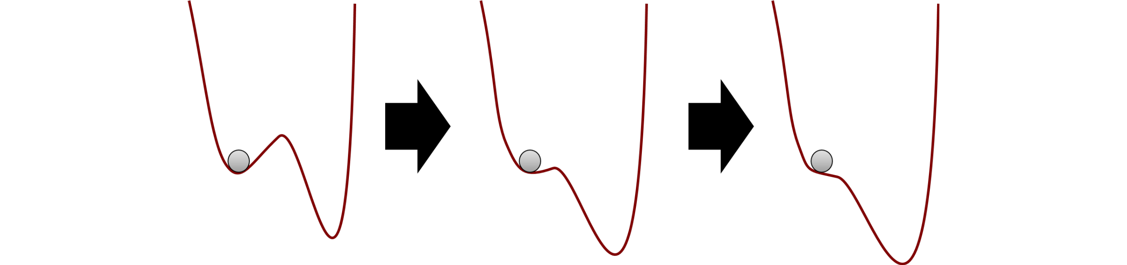

*Figure* *1.*  Evolution in attractor landscape: An intervention moulds a system, making it less stable, hence easier for the ball to move from current state (left) to another one (right). Alternatively, an intervention – or random events – can jolt the system over the ridge, i.e. a tipping point.

Having now undergone a brief conceptual introduction to complexity, we can describe behaviour change as *“a collection of contextualised processes, that are nontrivially specific to each individual, forming a complex interconnected system, which is not restricted to linear dynamics”* (see [63], p. 4). We highlight three features of this definition:

* *A complex interconnected system*: A multitude of variables and timescales which are interwoven, interdependent, and interacting.
* *Contextualised processes, specific to each individual*: Individuals follow meaningfully different change trajectories that develop and change with time.
* *Not restricted to linear dynamics*: Inputs are not necessarily proportional to outputs, and long periods of apparent stability can be followed with short periods of rapid change.

# 2 Behaviour change mechanisms under complexity: Three key features

In the following three sections, we drill further down into these ideas. In the first, we introduce interaction-dominant dynamics, which flow from point 1 above; second, we present how idiosyncratic, non-stationary change trajectories lead to non-ergodicity, a technical term for point 2; third, we highlight that the flexibility of complex systems leads to ubiquitous nonlinear processes as alluded to in point 3. Table 1 provides an overview of these ideas.

Table 1:

Three common features of complex systems, with recommendations for behaviour change research.

|  |  |  |  |
| --- | --- | --- | --- |
|  | Interconnectedness | Non-ergodicity | Non-linear dynamics |
| Description | The structure of a system—how it is organised and the relationships between its component parts—can matter more than the component parts themselves. Includes interconnectedness of different variables such as attitudes or perceived norms, as well as that of their temporal dependence; dynamic dependencies of complex systems are not restricted to one or a few previous time points. | Psychological processes are non-stationary and heterogeneous, hence non-ergodic (group-level measurements do not correspond to those of individuals in time). This means within-individual processes cannot, in general, be inferred from between-individual data. The lack of group-to-individual generalisability implies a threat to validity of results in many areas of science. | In a linear progression of a phenomenon, the whole is exactly the sum of its parts: You can calculate how much each influencer of behaviour changes, and add them together to get the total effect. Non-linearity occurs when a systems’s inputs are disproportionate to its outputs. For example, an effect might be imperceptible for a long time, then explode (as in exponential growth), or suddenly switch states upon reaching a threshold. |
| Main lesson | Dynamic, intertwined processes do not exist in a vacuum, but are always co-dependent and cannot be partialed out into variance components without losing essential information on how the system as a whole operates. | Drawing individual-level inferences from group-level data (the ecological fallacy) leads to misleading or incorrect inferences regarding individual behaviour. A statistical relationship in the population may not hold for any of the individuals. | Viewing the world solely from the lens of linear phenomena and relationships, leads to missed opportunities and misunderstood impacts of interventions. |
| Recommendations for the research community | Moving from traditional regression-based approaches, which are inspired by component-dominant, additive dynamics (that the effects, or beta coefficients, of each variable can be summed together), linear approximations and Gaussian distributions, to methods able to cope with multiplicative effects and thick-tailed distributions. | Moving from large-sample research with many variables and many people but few time points (one model per sample), to N-of-1 and time series designs, with usually less people and less variables, but more data per variable (one model per individual). | Moving from linear approximations with the illusion of predictability, to methods which can accommodate non-linear patterns and disproportionate influences. |
| Useful resources | [39]; [44]; [64] | [65]; [66]; [67] | [68]; [69]; [70] |

## 2.1 Interconnectedness

When processes in complex systems are not independent, they are said to be coupled. Coupling can be unidirectional (where, for example, physical activity increases muscle mass but not the other way around), or bidirectional, where the elements of a system (e.g. good performance and rewards) simultaneously reinforce or suppress each other as time progresses, demonstrating a type of circular causality. Dynamics in living systems tend to be dominated by synergies (“interaction-dominant causation”) instead of their component parts [39,44,71]. Many psychological and behaviour change theories seem to at least implicitly assume the presence of reciprocal causation and intertwined processes (e.g. [72], p. 6), but empirical testing of such processes has to date been limited.

As mentioned earlier, within the conventional approach to behaviour change intervention evaluation, researchers commonly employ mediation analyses to examine mechanisms. However, given its assumptions, the clean *independent variable* *mediator* *dependent variable* type of path analysis can be misleading, when change is in fact driven by self-reinforcing, “autocatalytic” interactions, flowing in time. In component-dominant causation, effects follow causes in a billiard-ball fashion, and one variable can change without everything else changing. For example, a study developed with the component-dominant mindset could aim to find out how using a specific behaviour change technique, say goal setting, affects behaviour. On the other hand, variables of interest to behaviour change researchers are unlikely to change without affecting a large amount of other, related variables [49], producing highly context-dependent effects [73]. This, too, implies that interaction-dominant causation is a more plausible framework for the behaviour change domain, wherein effects emerge (and are conditional upon) the system’s holistic multivariate dynamics, with everything potentially taking place simultaneously in a circularly causal manner. Interaction-dominant dynamics are also characterised by heavy-tailed distributions [64], such as the log-normal distribution [74], which are common in psychological data [75,76], as well as the presence of long-range temporal correlations and power-law scaling [77–79]. Importantly, interplay happens not just between variables, but also their temporal dynamics: Processes taking place on fast timescales (e.g. lack of physical activity) modulate slow-timescale processes (e.g. development of obesity, lower energy levels), which feed back and affect the fast-timescale processes [39].

One way of looking at mutually interacting processes with reciprocal causality is to consider the system as a network. Network science is a well-established field with applications ranging from physiology to the organisation of cities [80], and health [81,82]. An illustrative example comes from the study of depression, where the traditional latent variable thinking assumes that a latent factor—depression—causes the symptoms. On the contrary, a network science perspective leads to an alternative view, where the network of mutually interacting symptoms constitutes the phenomenon [83,84]. This approach has provided new avenues into understanding and treating depression, such as locating the symptoms which are most relevant to the activation of the network (i.e. the emergence of depression), or considering how intervening on specific symptoms might affect the system, given all dampening and reinforcing pairwise relationships between symptoms.

Although the network theory of mental disorders [83] aligns with and stems from complexity science, the psychological network models usually associated with the approach [85,86] rely on many assumptions stemming from their grounding in multiple regression; including multivariate normality (i.e. linearity) and stationarity [87], as well as being very different from their physical counterparts with properties such as nonlinear scaling and space-filling [70,88]. Still, the conceptual frameworks such models represent—coupled processes interacting in a system, instead of “root causes” [89]—ought to be the primary ontology considered by behaviour change researchers. In the later section on empirical solutions, we present a recurrence-based network modelling approach to consider these coupled processes [90].

## 2.2 Non-ergodicity

To be useful to individuals, processes postulated by psychology ought to work on the individual level [91]. However, we can only directly draw individual-level conclusions from between-individual data when the data come from a so-called ergodic process: meaning that all statistical characteristics must be equivalent at both within-individual and between-individual levels [92]. In essence, this would mean that in a 100x100 spreadsheet, where participants are rows and measurement occasions are columns, calculating an average of values within one column (“ensemble average”), would give the same result as calculating the same statistic from one row (“time average”). For example, in an ergodic process, the mean and standard deviation of each person’s daily minutes of physical activity over a 100-day period would be the same as the mean and standard deviation of 100 people’s daily physical activity minutes measured once. Or, observing that 20% of a given population are smokers, would mean that everyone is a smoker for 20% of their lives. In terms of coupled processes, the correlation between physical activity and intention would be the same in the population measured once, as it is for one person over time.

Hence, to make the inference from between-individual data to within-individual processes, the researcher is forced to make two stringent assumptions. The first of these, sometimes referred to as homogeneity across subjects, is that all individuals are the same [66]. Almost by definition, the behaviour change researcher’s interests in between-individual data are ruled out, as we are interested in how people (can) change, and it is quite clear that people do not all follow the same behaviour change processes. Indeed, it would seem preposterous to suggest that, for example, self-regulation is a constant process during an individual’s life span. Although the mathematical proof for the non-equivalence of inter-individual and intra-individual data structures was published over a decade ago [93], only recently has serious research attempted to quantify the threat stemming from lack of group-to-individual generalisability [65]. This preliminary work indicates that even if we could work with “generalisable” ideal random samples from well-defined populations, we would still be committing the ecological fallacy (i.e. drawing individual-level inferences from group-level data) if we wanted to apply our knowledge to individuals.

The second stringent assumption for making inferences from between-individual data to within-individual processes is that the statistical properties of these processes must not change over time. This assumption is generally referred to as stationarity. In the context of physical activity, the extent to which physical activity is influenced by other factors, is likely to change over time. For example, the effect of discomfort on physical activity is likely to change in a non-linear manner over time, as fitness and tolerance of discomfort fluctuate not only because of randomness, but as core features of the phenomena itself [94]. However, the tools most often used in research for thinking about and analysing behaviour change, such as linear regression, do not account for these kinds of temporal dynamics. This is because temporal cognitive change fundamentally violates the assumption of stationarity, which we outline next.

For the processes underlying physical activity outlined above to be considered stationary, the average level of discomfort must remain stable across time for all individuals. In addition, the sequential dependence between repeated measures must be stable [92]. In terms of the relationships between variables, the assumption of stationarity requires that the causal structure which leads to a particular outcome is unchanging across time [95]. Examining behaviour change usually involves an attempt to change the causal structure underlying a behaviour (e.g. after learning to make coping plans to tackle barriers to physical activity, the causal relationship from perceiving a barrier to subsequently deviating from one’s plan to be active, ought to be diminished), and generally means that either a decrease or increase in a particular behaviour is expected as learning and development progress. Stationary data is therefore rare in behaviour change research. This lack of stationarity has however rarely been acknowledged or (statistically) accounted for in empirical studies evaluating behavioural processes. The result is analogous to the ecological fallacy of taking a population-level mean and extrapolating to individual-level attributes; an average over an individual’s time series describes that individual better than the population-level snapshot, but still might not applicable to any particular time period. As a simple example, think 100 days of data in which a linear dependence relationship is strongly positive for the first 50, and strongly negative the other; you might observe the average correlation over the whole time series to be zero.

Figure 2 illustrates non-stationarity in the case of work motivation, a key feature of occupational health psychology. Data is from one participant in an observational study of motivation self-management (Heino et al., in prep). We can observe that the relationships vary drastically, as the study progresses.

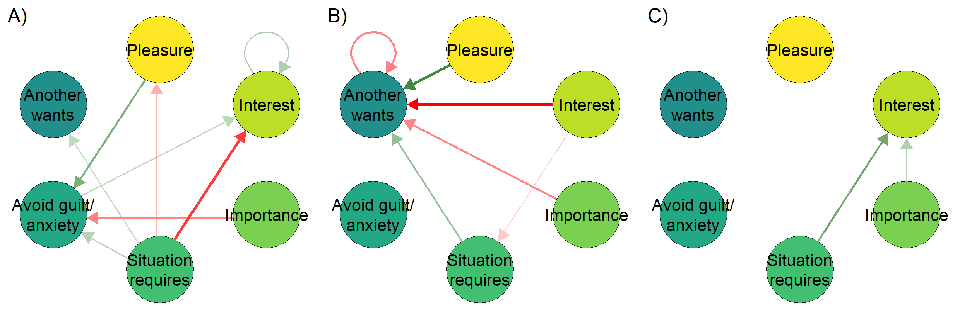

*Figure* *2.*  Relationships between a single participant’s motivational variables varying in time (time-varying autoregressive model). Networks represent relationships between variables around the time points where 10% (panel A), 50% (B) and 90% (C) of the study had been completed. An arrow from one variable to the next means the former predicts the latter at the next time point; green for positive and red for negative correlation. If a stationary model was used, all periods would be collapsed to a single result, creating the impression that the relationships were homogeneous across the study period.

Idiographic science, which tries to unveil person-level processes, does not aim to inductively go from data to universal or statistical laws which hold in hypothetical infinitely large populations [96]. Instead, it applies general principles, such as universal properties of complex systems, to study how specific individuals behave in their particular contexts. Answering more than half a century of calls to expand focus beyond outcomes to processes, new technology in data collection and analysis has now made the idiographic approach possible [97]. The basic solution is to not average individuals and then model the behaviour of the averages, but to first model individuals, then aggregate those models to search for commonalities [63]. Recent work has made use of methods such as ecological momentary assessment [98] to gather intensive longitudinal data on behaviour and determinants from one or more individuals which can then be represented as time-series. In the case of smoking, analyses of such idiographic data have yielded individualized models which can predict behaviour with stunning accuracy [99,100].

Coming back to the notion of mechanisms; if the mechanisms happen within an individual, we need to study them at the appropriate level, that is, within-individual. However, when we study individual time series data, it becomes quickly obvious that the methods used in the conventional approach for studying group averages (e.g. pre-post measurements with a long time between them) leave us wanting. Figure 3 illustrates that if insufficient within-individual time points are sampled, a deceptively linear picture of the process emerges (see also [51], p. 3). The same logic applies if we are studying groups but cannot rely on the means being informative due to a lack of power (as demonstrated in [101]).

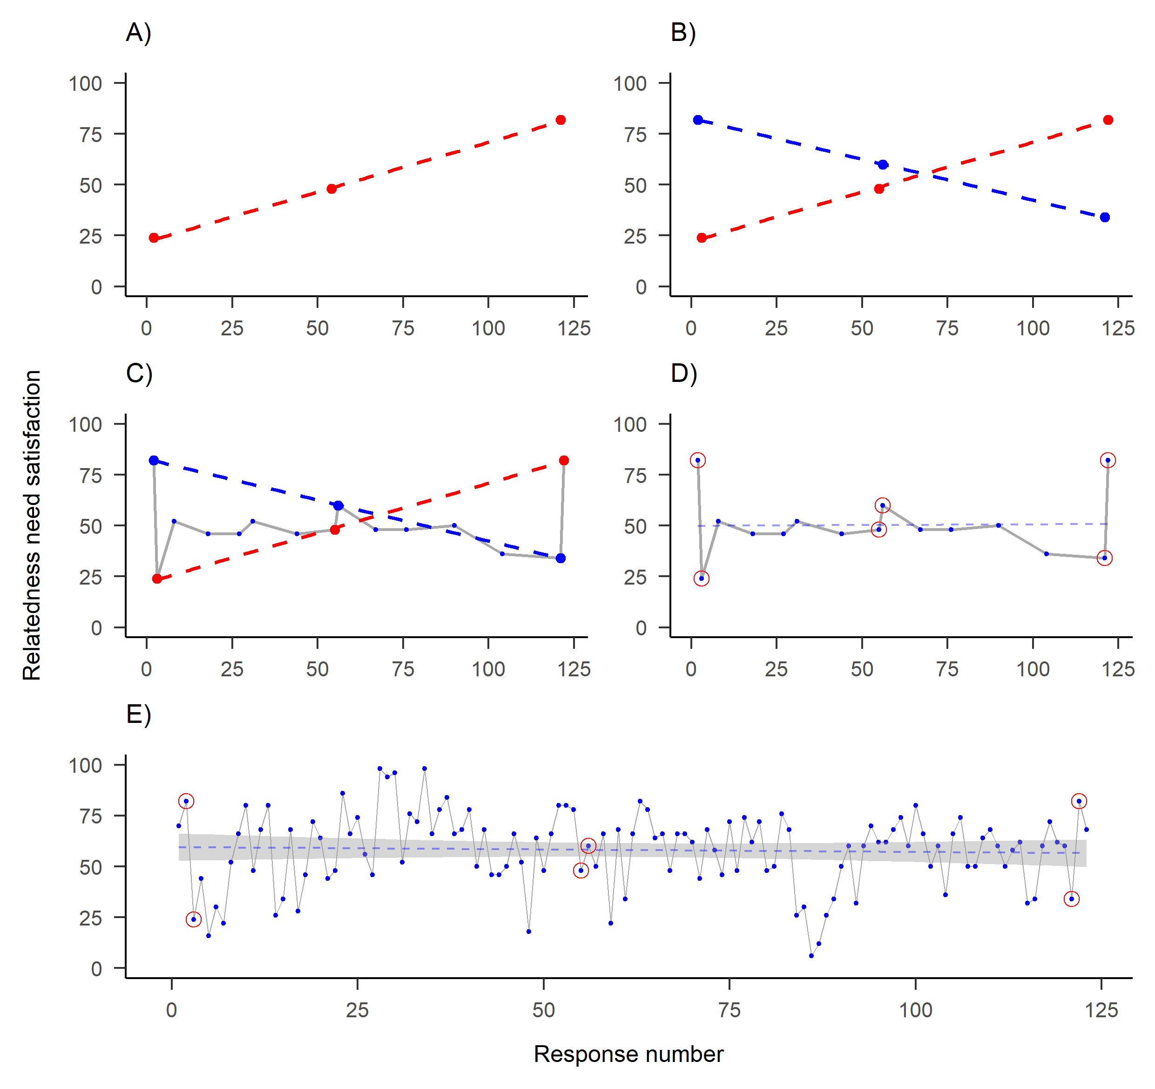

*Figure* *3.*  One of the time series collected by the participant featured in previous figure. Dots indicate answers to a visual analog scale question on their relatedness need satisfaction, as posited by self-determination theory (y-axis), measured on different time points (x-axis). A) Measuring three time points—representing conventional evaluation of baseline, post-intervention and a longer-term follow-up—shows a decreasing trend. B) Same measurement on slightly different days shows an opposite trend. C) Measuring 15 time points instead of three would have accommodated both observed “trends”. D) New linear regression line (dashed) indicates stationarity. E) Including all of the 122 time points, a more complete picture of the dynamics emerges.

In sum, to study individual behaviour change, we need to not only collect intensive longitudinal data on the individual-level, but we must also consider the time evolution of the phenomenon and apply statistical analyses which can accurately model non-stationary data. In the health psychology context, Bolger and Zee [102] argue, that not only temporal processes need to be considered, but also the heterogeneity therein. Consistent with the idiographic approach outlined above, every individual may exhibit idiosyncratic dynamics. As we will see next, the possibilities are vast outside of linear world.

## 2.3 Nonlinear dynamics

As mentioned above, the linear methods traditionally used in psychology (e.g., multiple linear regression, ANOVA, and other cases of the general linear model) view psychological phenomena as following benign gradual changes over time. While sometimes useful as approximations, the assumptions of linear models are usually violated in practice [24]. Furthermore, linear models may be invalid when ceiling or floor effects are present [103,104], or under *hysterisis*, when the temporal direction of a relationship matters for its impact (e.g. prevention is important precisely because it takes more effort to exit the state of having a lifestyle disease, than to enter it) [105,106].

While a reliance on linear models simplifies the analytical approaches needed to explore relationships between variables, it does not contribute to our understanding of how the world works, as “most of everyday life is nonlinear” [107] and outside the physical sciences, nonlinear systems are “the rule, not the exception” [108]. As an intuitive example, consider that falling from 10 meters is likely to kill you, but falling from one meter does not make you 1/10th dead – in fact, it makes you stronger [109,110]. Or that eating twice the size of a normal meal rarely results in twice the pleasure.

Nonlinear dynamics, on the other hand, can be very useful, but unintuitive, to grasp, as the world discovered during the COVID-19 pandemic: An exponential growth starting from 10 cases with a growth rate of 20% can lead to 4030 cases by day 30, and 81030 cases by day 45 – whereas a mere 1% reduction in the growth rate would have resulted in approximately 29000 fewer cases by that time. Theories and methods to understand non-linear change phenomena in individuals can provide to different types of answers than linear analyses. The most important factors in predicting behaviour change may not be the strength of a variable’s relationship with behaviour (e.g. regression weights), but rather the type of fluctuation that the variable exhibits in response to an intervention [71,111,112], or how fast the dynamics recover after shocks [113]. Another key insight is that, while we cannot usually predict what the value of the next observation will be, we can predict which system states are possible, and evaluate the risks and opportunities for intervention from there.

Polynomial regression is perhaps the most commonly used model when linearity is questioned. This method allows for identifying curves that may better fit data on the relationships between variables than a straight line [114], and can also be used to represent non-linear changes that occur over time. Polynomial regression models do not, however, adequately capture the essence of complex systems; nonlinear, irregular changes, periodic peaks and plateaus, and with recoveries after negative shocks and deterioration after positive ones [115].

When we consider the situation where all components of a system interact, many features evident in everyday life but ambiguous in linear modelling become salient. Long periods with no discernible changes in outcomes might be followed by short bursts with large shifts. For example, a person’s conscious intention to smoke may remain stable, while social norms keep changing, until one day a seemingly innocuous event causes the person to quit. When a system finally reaches a “tipping point” (e.g. an individual’s behaviour changes), conventional analytic methods have difficulty determining whether the effect was caused by a critically important incident, or by less obvious, small, cumulative effects over time which preceded the so-called *phase transition*. Obviously, in such situations, the consequences of an incident (i.e. the camel’s back breaking) do not relate linearly to the intensity of the event (i.e. loading the last straw on the camel). This is a common dynamic in complex systems [61], but it is extremely difficult to evaluate if information regarding the system is only available for a few points in time. Intensive longitudinal data is therefore needed.

# 3 Empirical solutions

To model intensive longitudinal data, models developed within the literature on time series analysis are necessary [63,116]. A time series in this case is a sequence of values representing one variable in one individual, and time series analysis consists of methods for studying time evolution of one or more data generating processes.

The most common modelling framework, lag-1 autoregression, uses one previous time point as input to predicting the next one. In behavioural science, vector autoregression—vectors being sequences of numbers, representing values of variables—is often used to test the effects of several variables on the outcome of interest. One drawback of such autoregressive models is that they assume that there exists an average value around which the process fluctuates, which also motivates the common practice of “detrending”. In detrending, the researcher transforms the data by fitting a linear regression line and continuing the analysis with the residuals, often not taking into account that there can be several trends in subsections of the data (i.e. the trend is non-stationary), which all contribute to what the linear model interprets as normally distributed “errors”. Moreover, the supposed mean value—as well as variance around it—may not remain the same across time (i.e. the level is stationary), and the impact of previous time points on future ones is assumed to remain constant [117]. One way to overcome this particular shortcoming, is to let the parameters in autoregressive models vary across time, leading to the time-varying autoregressive model depicted in Figure 2. But even time-varying autoregressive models operate under the linear regression framework, with its accompanying assumptions, such as normally distributed errors. Furthermore, in Figure 2 we have limited ourselves to investigating the lag-1 relationships, whereas long-range dependencies are common in ecological momentary assessment data [79,90,112,118].

Regression-based approaches including time-varying autoregressive models are only appropriate when the dynamics of all variables in the model conform to the required assumptions. Empirical researchers have a wide variety of assumption tests at their disposal. The supplementary website (section <https://git.io/JfLmm>) presents a plethora of these tests applied to a sample of 20 individuals collecting motivation data for nine variables. We can see that many or most time series indeed seem to exhibit non-stationary trends and levels, as well as non-linearities. Also, longer time series reject more of the assumptions, as the deviations from assumptions are not necessarily present in small samples, and larger samples confer higher statistical power. This does not suggest that we ought to only gather short time series, as doing so would limit our abilities to detect deviations from assumptions and generalise to data outside the sample.

There are many ways to study nonlinear change processes in complex systems. Behavioural researchers may find the generalised logistic model [104] a good starting point. This method produces readily-interpretable parameters indicating the floors and ceilings of the variables intervened upon, as well as the growth rate and timing of changes. Researchers may also be interested in identifying critical transformations taking place in a system (e.g. a person’s motivational system). In complex systems, these shifts may be preceded by warning signs such as increased turbulence (quantified as e.g. *dynamic complexity*; [119]), or critical slowing down (i.e. heightened autocorrelations in a time series), before (re)lapses occur [120,121]. In clinical psychology interventions, intensive monitoring of psychopathological symptoms has allowed researchers to examine symptoms’ variability, autocorrelations and other indicators of dynamics. This has yielded considerable advances in the prediction of phase transitions between adaptive and maladaptive states during interventions in the field of psychopathology [56,122–124]. A conceptual replication was recently done in a population undergoing a weight loss intervention, where [125] found that sudden drops in physical activity levels could be predicted by the emergence of erratic fluctuations in day-to-day activity. While [56] identified that the presence of critical fluctuations was a key indicator of the effectiveness of psychotherapy for mood disorders, this has not yet been investigated in other behaviour change contexts.

In the next section, we exemplify one particular family of analysis methods, recurrence quantification, due to its suitability for analysing many existing longitudinal data sets while making fewer a-priori assumptions. This enables us to observe more granularity in the dynamics, than allowed by e.g. multilevel models.

## 3.1 Modeling complex time series data with Recurrence-based Analyses

To explore the dynamics of a phenomenon while making no assumptions about distributional shapes of observations or their errors, about linearity, or about the time-lags involved, researchers can perform Recurrence Quantification Analysis, which provides a robust visual intuition about the organisation of a system (recall from Table 1 that in complex systems, the organisation of components can be more important than the components themselves). An in-depth walkthrough of the analysis with code is provided in the supplementary website (see section <https://git.io/JfLs3>), hence we will be brief in the background and focus on the results. The data we use for this demonstration is a single participant, who at each time point was prompted by a mobile app to answer six questions about their motivation. A more detailed exposition of the data is found at the supplementary website (see section <https://git.io/JfLmQ>).

Recurrence networks display relationships between multivariate observations in a time series in an intuitive way, which in the case of multidimensional Recurrence Quantification Analysis (see [126] for a tutorial) can be thought of as displaying a type of multivariate “correlation”, indicating which occasions (be they single values or combinations of values of different variables as a system state) repeat a particular previously-observed pattern. These patterns or configurations can be thought of as being produced around attractors, towards which the system is drawn.

Figure 4 demonstrates such a multidimensional recurrence network, where each point is a measurement occasion, and recurrences of “motivation profiles” (consisting of the six motivation-related questions) are shown as links between time points. We can see that most of the recurrences take place in the second half of the data. In addition, all the patterns (or, equivalently: attractors, profiles, configurations) which occur only once, take place in the first half of data collection. Having only measured the first 50% of observations would have missed much of the action.

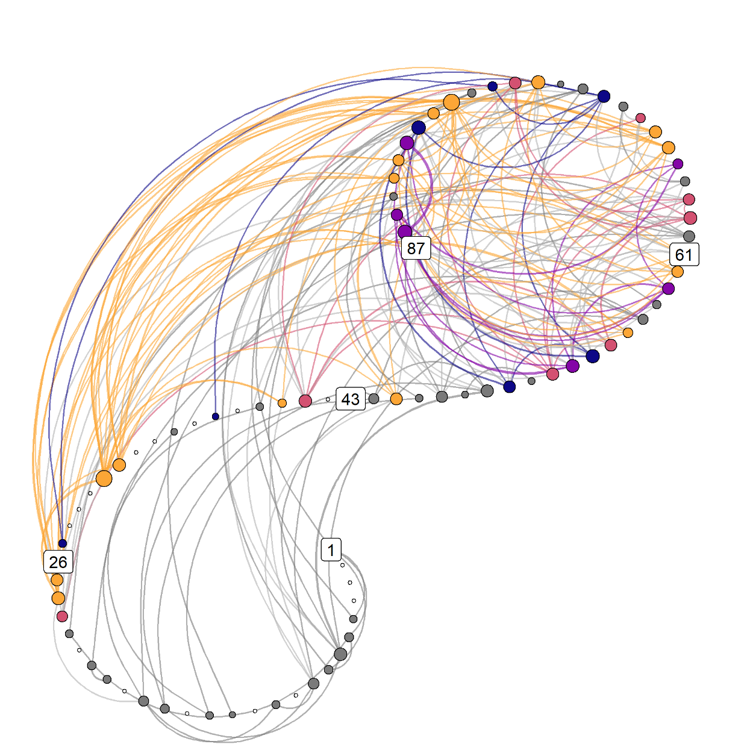

*Figure* *4.*  Weighted multidimensional recurrence network. Each circle (“node”) is a measurement occasion, numbers indicate their running number, and colors represent different motivation profiles. These profiles are configurations of six variables, and can be conceived of as attractors. Lines indicate the same motivational state reoccurring at a later time point. Yellow nodes indicate the strongest state, red nodes the second strongest, followed by purple and blue. Grey nodes depict uncategorised configurations which occur at least twice, and white ones the configurations, which only occur once. Nodes that are larger, are connected to more other nodes. Drawn with R package casnet [127].

Figure 5 shows the participant’s four major repeating profiles, which correspond to the coloured nodes in Figure 4. We can observe that about a fifth of the participant’s responses fall into a relatively balanced profile, while 17% (second and fourth profile combined) indicate what self-determination theory [128] would consider an “optimal” motivation profile – high in autonomous forms of motivation and low in controlled ones.

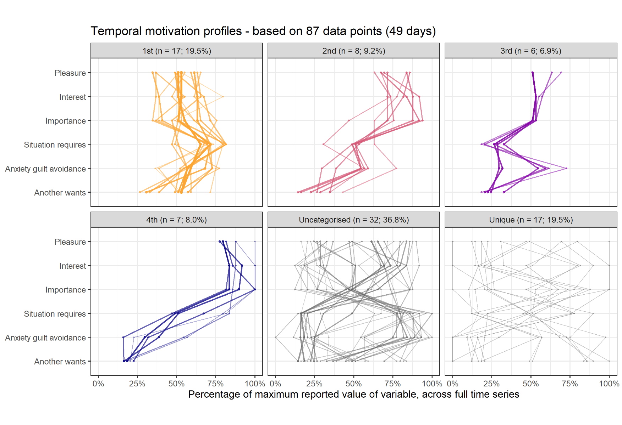

*Figure* *5.*  Main profiles corresponding to the colors indicated in the previous plot. See supplementary website (section <https://git.io/JfLmS>) for a thorough exposition.

If we want to simplify, the information in Figure 4 can be collapsed to the relative frequencies of a particular state following another, that is, demonstrating a *transition network*. It answers the question “If you are in state x, what is the probability of transitioning to state y?”. Figure 6 (panel A) depicts the relative frequencies on which a particular state precedes the next – in the case of linear dynamics, the matrix would be symmetric with similar values observed above and below the diagonal drawn from bottom left to the top right cell. Panel B of Figure 6 presents the same information as a network.

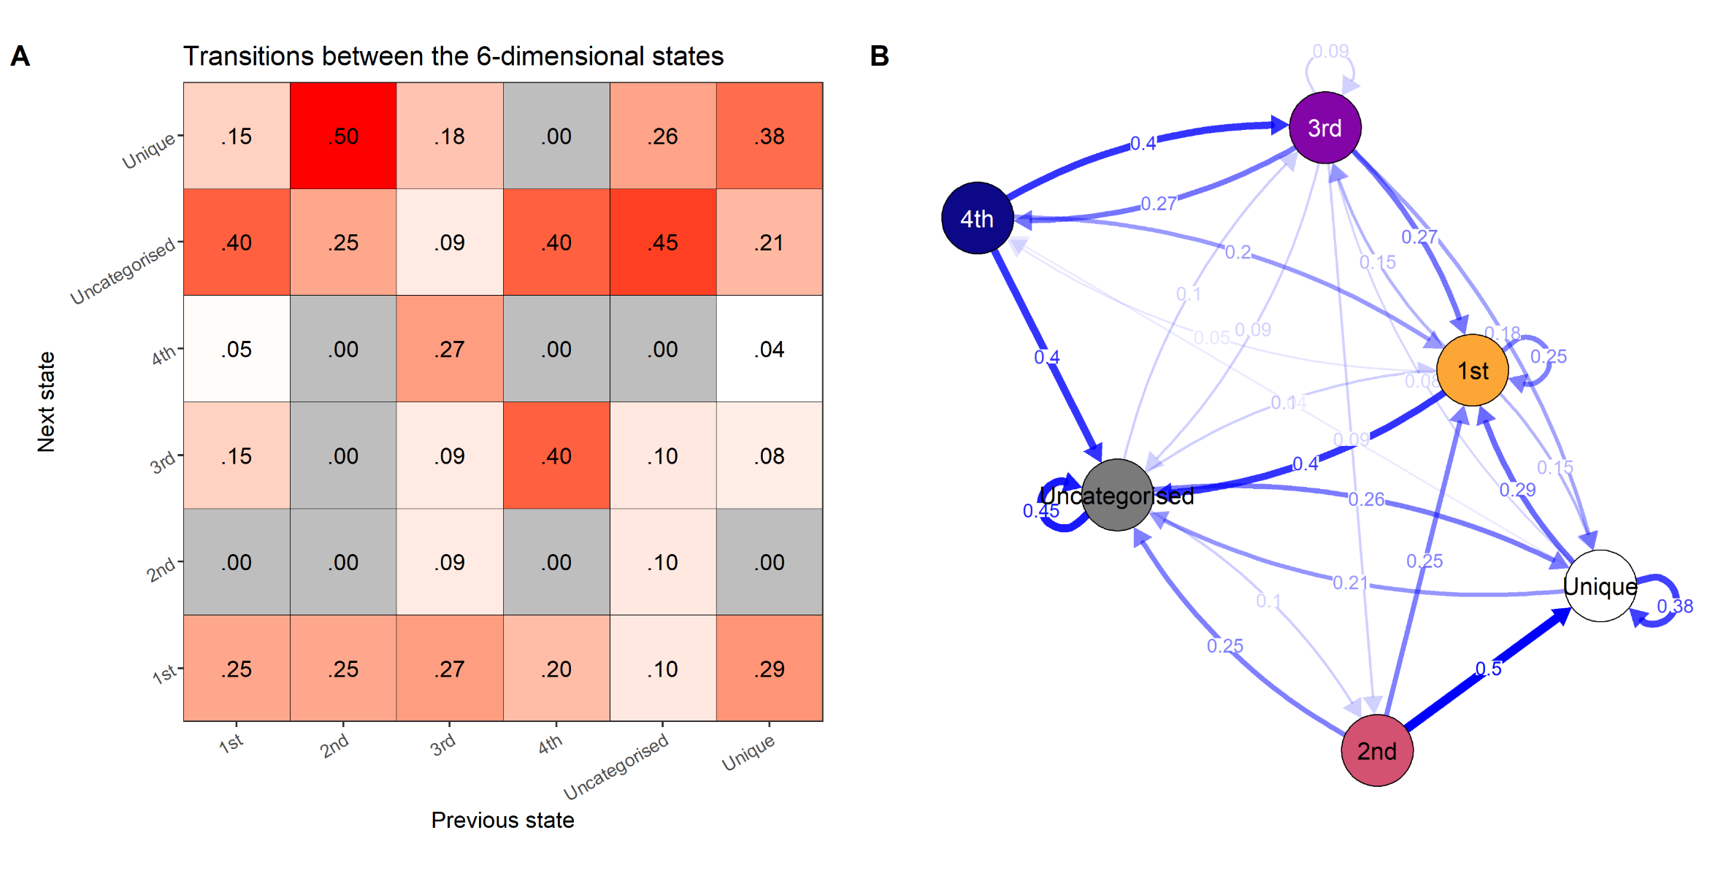

*Figure* *6.*  A transition network. If the system is in the configuration labelled 1st, based on the relative frequencies of observed transitions, there is 25% chance it stays in the same configuration, and a 40% chance it transitions to one of the uncategorised states – that is, states that are less strong than the state labelled 4th, but which appear more than once. Note that the .00 values in panel A do not signify this transition is impossible, only that it did not appear once during the data collection period.

Following the idiographic approach outlined earlier, this information could now be used to develop a personalised intervention. Designer of such an intervention – possibly the person themself, using self-enactable behaviour change techniques [129] – has several new perspectives to consider: How could transitions to the “optimal” profiles (2nd and 4th) be increased? In the sample, they are immediately exited (note the absence of self-loops in Figure 6, panel B); could they be made more “sticky”, and the 1st state less so? Could e.g. just-in-time interventions – such as prompts on a mobile device – be used to make the person more aware of the state they are in, and remind them of techniques that are helpful to staying in, or leaving, that state?

To summarise: Having looked at all the time scales instead of just the previous time points, while not restricting ourselves to linear dynamics, we observe the features outlined in Table 1. The repeating states are connected across time, demonstrating interconnectedness instead of independence. They are not equally spaced in time, demonstrating non-stationarity and hence non-ergodicity. In addition, going from state a to state b does not generally happen with the same probability as the reverse, hence demonstrating non-linear dynamics. These features would by default be smoothed out in regular approaches, but they are potent information for formulating interventions and understanding the dynamics at play.

# 4 Discussion

Applied behavioural sciences, have always studied phenomena, like behaviour change mechanisms, which take place within complex ecological systems [130], but in the majority of cases we have tried to understand these phenomena using linear models, when the tools of complexity science would have been more appropriate [131]. Behavioural scientists have an opportune moment to start considering complexity, as the field of behavioural intervention research is now taking committed first steps in this direction [62,73], and there is a growing interest toward intervention programme theories that explicitly model complex aspects, such as recursive causality, disproportionate relationships, “tipping points”, and emergent outcomes [132]. In addition, analytical methods that are compatible with complexity science, have recently been, and are increasingly being, developed [127].

In an empirical dataset of 20 individuals, we have shown similar results to a plethora of studies, which find complex dynamics in ecological momentary assessment data [79,112,118,133]: Nonlinear, non-ergodic, non-independent dynamics, which defy traditional assumptions. Moreover, the empirical case example of a single person shows the importance of observing change over long periods of time: There are several reoccurring “ways of being”, patterns of experience which change dynamically within the individual. These patterns of recurring states, and the nature of which states recur, are likely to be different across individuals. An added benefit of using multivariate recurrence-based methods [90] is, that they do not require partialing out variance, allowing the researcher to examine conceptually overlapping variables from multiple theories in the same analysis [134]. This makes intervention process evaluation possible from a more holistic perspective – that is, looking for changes in e.g. attractors or complexity measures.

Critically appraising the often hidden assumptions of models, especially in the context of complex systems such as human behaviour change interventions, is necessary for understanding the phenomena of interest and building a credible science. While researchers who study stable phenomena and only wish to draw group-level inferences (e.g. to select promising public health interventions) are probably best served with traditional models, this is rarely the case for psychologists and behaviour change intervention researchers who wish to understand how behaviour changes. For theory to advance, assumptions need to be justified: We cannot conclude both that our models for empirical testing omit crucial facets of reality, and at the same time imply real-life consequences. We propose that a more fruitful approach would be to model coupled processes with individual-level psychological data from intensive longitudinal designs, using analyses which are are reasonably free from assumptions regarding independence, ergodicity and linearity. By studying what other sciences know about change processes in complex systems, and replicating studies where the ideas have been applied to human behaviour change, researchers can work towards uncovering more general principles of behaviour change. As Molenaar [135] pointed out, “the set of person-specific time series models thus obtained then can in the next step be subjected to standard analysis of inter-individual variation in order to detect subsets of subjects who are homogeneous with respect to particular aspects of the dynamical laws concerned”. In other words, information obtained from individual-level studies can then possibly inform models of larger groups, leading to better (or at least humbler and more nuanced) social scientific theories [136].

# 5 Limitations

The field of complexity science and aligned novel methods is fast-moving, with new developments always on the horizon. However, there remain many practical and methodological barriers to fully embracing the complexity perspective in behaviour change research. Many of these barriers relate to data collection. While the development of smartphones and an array of other devices for ambulatory assessment allow the convenient collection of intensive longitudinal data, there are few stable and user-friendly open source options. This has resulted in large variability in the data collection tools used to produce intensive longitudinal data [137]. Ensuring good adherence to these forms of data collection can be a challenge for researchers. For participants, adapting to intensive assessment is a behaviour change in itself – particularly if they are required to use a specific device or smartphone application. Although measurement burst designs [138] have been proposed to alleviate some challenges, they are replaced with other, perhaps graver ones, such as a mismatch between the sampling rate and the time scale on which the phenomenon in interest unfolds.

Long time series can be time-consuming and effortful to collect. It also creates a much greater burden on participants than traditional questionnaires and few timepoints only. However, in behaviour change research and health psychology, much of the core research interests of our theories—influences on behaviours—have traditionally been subjective factors (e.g., sense of self-efficacy, motivations and motives, outcome expectancies), only—by definition—accessible via self-report. This presents an undeniable practical challenge, along with the fact that observations generally need to be spread equidistantly in time, allowing one individual to collect only 1-2 data points per day. Still, examples of more than a hundred time points being collected, are found from weight loss maintenance [139] to psychotherapy [123], with some studies collecting more than a 1000 observations [112].

A number of methodological challenges for the study of dynamic systems in behavioural science have been identified [140], including measurement reactivity, the optimal choice of measurement intervals, and measurement quality. To properly address measurement reactivity, it is necessary to know whether the anticipation of measurement or the self-monitoring process itself (or both) interact with the outcomes of interest. Choosing an optimal measurement interval requires knowing the timescale of the behaviour change dynamics, which is rarely well understood. As regards measurement quality, we still lack a comprehensive approach to developing and establishing the quality of momentary measures of psychological constructs. Ensuring the validity and reliability of these measures can be difficult due to the requirement to use few items, not to mention that the questionnaire scales are themselves bounded, whereas experience hardly is. One solution for this is to inspect change profiles of responses [90] instead of raw scores.

# 6 Conclusion

When a study finds that variables have explained an unsatisfactory proportion of behaviour, researchers often follow the pattern seen in social and organisational sciences and conclude that either: “(a) significant, explanatory variables have been omitted from the study, (b) the measurement instrument is too imprecise and ‘rough’, or that (c) the random or stochastic part of the problem has overwhelmed the patterned part” [141]. But if the result stems from a statistical model that makes unfounded assumptions regarding independence, ergodicity and linearity, is it any wonder that it fails to satisfactorily describe reality? In this paper, we have attempted to show that many real-world dynamics of behaviour change are inadequately captured by our seminal modelling strategies, and that changes can advance our understanding of behaviour and behaviour change processes. In our view, these changes should move research on behaviour change towards the embrace of complexity science and its methods.

## 6.1 Declarations

### 6.1.1 Conflict of interest.

The authors report no conflict of interest.

### 6.1.2 Ethical approval.

The research proposal was reviewed by the University of Helsinki Ethical Review Board in the Humanities and Social Sciences.

### 6.1.3 Authors’ contributions.

MH wrote the analysis code, including the full online supplement, formulated the initial draft of the manuscript and revised it. KK, CN, NH and FH revised the paper for its intellectual content in several rounds. MH, KK and NH contributed to collecting the empirical data. FH wrote and adapted the R package used for analysis, and provided expertise in the analytical approach. All authors read and approved the final manuscript.

### 6.1.4 Funding.

MH and KK were supported by Academy of Finland (grant number 295765 to principal investigator NH). NH was supported by an Academy of Finland Research Fellowship (grant number 285283).

### 6.1.5 Reporting.

We report all data exclusions, all manipulations, and all measures in the study on the supplementary website (section <https://git.io/JfLmQ>).

### 6.1.6 Data, materials, and online resources.

The Open Science Framework repository for this project is at <https://osf.io/hnpse/>. This manuscript was created with the R package papaja [142], and the source code is available at <https://git.io/JfLY1>. All analyses and code are available on the supplementary website (<https://git.io/Jffrm>, GitHub repository at <https://git.io/JfLYr>). Data is available at <https://git.io/JfLYo>.

### 6.1.7 Acknowledgements.

We would like to thank Daniele Proverbio and Jonas Haslbeck for their comments, as well as Anton Kunnari for the idea of transition networks.

# 7 References

1. Kwasnicka, D.; Dombrowski, S.U.; White, M.; Sniehotta, F. Theoretical explanations for maintenance of behaviour change: A systematic review of behaviour theories. *Health Psychology Review* **2016**, *10*, 277–296, doi:[10.1080/17437199.2016.1151372](https://doi.org/10.1080/17437199.2016.1151372).

2. Carey, R.N.; Connell, L.E.; Johnston, M.; Rothman, A.J.; de Bruin, M.; Kelly, M.P.; Michie, S. Behavior Change Techniques and Their Mechanisms of Action: A Synthesis of Links Described in Published Intervention Literature. *Annals of Behavioral Medicine* **2019**, *53*, 693–707, doi:[10.1093/abm/kay078](https://doi.org/10.1093/abm/kay078).

3. Michie, S.; West, R.; Campbell, R.; Brown, J.; Gainforth, H. ABC of behaviour change theories. **2014**.

4. Matthews, L.; Simpson, S.A. Evaluation of Behavior Change Interventions. In *The Handbook of Behavior Change*; Hamilton, K., Cameron, L.D., Hagger, M.S., Hankonen, N., Lintunen, T., Eds.; Cambridge Handbooks in Psychology; Cambridge University Press: Cambridge, 2020; pp. 318–332 ISBN [978-1-108-49639-1](https://worldcat.org/isbn/978-1-108-49639-1).

5. Hagger, M.S.; Moyers, S.; McAnally, K.; McKinley, L.E. Known knowns and known unknowns on behavior change interventions and mechanisms of action. *Health Psychology Review* **2020**, *14*, 199–212, doi:[10.1080/17437199.2020.1719184](https://doi.org/10.1080/17437199.2020.1719184).

6. Hankonen, N.; Heino, M.T.J.; Kujala, E.; Hynynen, S.-T.; Absetz, P.; Araújo-Soares, V.; Borodulin, K.; Haukkala, A. What explains the socioeconomic status gap in activity? Educational differences in determinants of physical activity and screentime. *BMC Public Health* **2017**, *17*, 144, doi:[10.1186/s12889-016-3880-5](https://doi.org/10.1186/s12889-016-3880-5).

7. Bullock, J.G.; Green, D.P.; Ha, S.E. Yes, but what’s the mechanism? (Don’t expect an easy answer). *Journal of Personality and Social Psychology* **2010**, *98*, 550–558, doi:[10.1037/a0018933](https://doi.org/10.1037/a0018933).

8. Fiedler, K.; Schott, M.; Meiser, T. What mediation analysis can (not) do. *Journal of Experimental Social Psychology* **2011**, *47*, 1231–1236, doi:[10.1016/j.jesp.2011.05.007](https://doi.org/10.1016/j.jesp.2011.05.007).

9. Green, D.P.; Ha, S.E.; Bullock, J.G. Enough Already about “Black Box” Experiments: Studying Mediation Is More Difficult than Most Scholars Suppose. *The ANNALS of the American Academy of Political and Social Science* **2010**, *628*, 200–208, doi:[10.1177/0002716209351526](https://doi.org/10.1177/0002716209351526).

10. Kline, R.B. The Mediation Myth. *Basic and Applied Social Psychology* **2015**, *37*, 202–213, doi:[10.1080/01973533.2015.1049349](https://doi.org/10.1080/01973533.2015.1049349).

11. Roe, R. What is wrong with mediators and moderators? *European Health Psychologist* **2012**, *14*, 4–10.

12. Keele, L. Causal Mediation Analysis: Warning! Assumptions Ahead. *American Journal of Evaluation* **2015**, *36*, 500–513, doi:[10.1177/1098214015594689](https://doi.org/10.1177/1098214015594689).

13. Hofmann, S.G.; Curtiss, J.E.; Hayes, S.C. Beyond linear mediation: Toward a dynamic network approach to study treatment processes. *Clinical Psychology Review* **2020**, *76*, 101824, doi:[10.1016/j.cpr.2020.101824](https://doi.org/10.1016/j.cpr.2020.101824).

14. Rohrer, J.M. Thinking Clearly About Correlations and Causation: Graphical Causal Models for Observational Data. *Advances in Methods and Practices in Psychological Science* **2018**, *1*, 27–42, doi:[10.1177/2515245917745629](https://doi.org/10.1177/2515245917745629).

15. Loeys, T.; Moerkerke, B.; Vansteelandt, S. A cautionary note on the power of the test for the indirect effect in mediation analysis. *Frontiers in Psychology* **2015**, *5*, doi:[10.3389/fpsyg.2014.01549](https://doi.org/10.3389/fpsyg.2014.01549).

16. Schoemann, A.M.; Boulton, A.J.; Short, S.D. Determining Power and Sample Size for Simple and Complex Mediation Models. *Social Psychological and Personality Science* **2017**, 194855061771506, doi:[10.1177/1948550617715068](https://doi.org/10.1177/1948550617715068).

17. Knafl, G.J.; Knafl, K.A.; Grey, M.; Dixon, J.; Deatrick, J.A.; Gallo, A.M. Incorporating nonlinearity into mediation analyses. *BMC Med Res Methodol* **2017**, *17*, 45, doi:[10.1186/s12874-017-0296-6](https://doi.org/10.1186/s12874-017-0296-6).

18. Hamaker, E.L.; Kuiper, R.M.; Grasman, R.P.P.P. A critique of the cross-lagged panel model. *Psychological Methods* **2015**, *20*, 102–116, doi:[10.1037/a0038889](https://doi.org/10.1037/a0038889).

19. Dawid, A.P. Beware of the DAG!; Guyon, I., Janzing, D., SchÃÂ¶lkopf, B., Eds.; PMLR: Whistler, Canada, 2010; Vol. 6, pp. 59–86.

20. Bechtel, W.; Abrahamsen, A.A. Thinking Dynamically About Biological Mechanisms: Networks of Coupled Oscillators. *Foundations of Science* **2013**, *18*, 707–723, doi:[10.1007/s10699-012-9301-z](https://doi.org/10.1007/s10699-012-9301-z).

21. Golonka, S.; Wilson, A.D. Ecological mechanisms in cognitive science. *Theory & Psychology* **2019**, *29*, 676–696, doi:[10.1177/0959354319877686](https://doi.org/10.1177/0959354319877686).

22. Bolger, N.; Laurenceau, J.-P. *Intensive Longitudinal Methods: An Introduction to Diary and Experience Sampling Research*; Guilford Press, 2013; ISBN [978-1-4625-0692-7](https://worldcat.org/isbn/978-1-4625-0692-7).

23. Reichert, M.; Giurgiu, M.; Koch, E.D.; Wieland, L.M.; Lautenbach, S.; Neubauer, A.B.; von Haaren-Mack, B.; Schilling, R.; Timm, I.; Notthoff, N. et al. Ambulatory assessment for physical activity research: State of the science, best practices and future directions. *Psychology of Sport and Exercise* **2020**, *50*, 101742, doi:[10.1016/j.psychsport.2020.101742](https://doi.org/10.1016/j.psychsport.2020.101742).

24. Siegenfeld, A.F.; Bar-Yam, Y. An Introduction to Complex Systems Science and its Applications. *arXiv:1912.05088 [physics]* **2019**.

25. Newman, M.E.J. Complex Systems: A Survey. *American Journal of Physics* **2011**, *79*, 800–810, doi:[10.1119/1.3590372](https://doi.org/10.1119/1.3590372).

26. Bar-Yam, Y. Concepts: System 2018.

27. Wright, D.; Meadows, D.H. *Thinking in Systems: A Primer*; First edition.; Routledge: London u.a.: Earthscan, 2009; ISBN [978-1-84407-726-7](https://worldcat.org/isbn/978-1-84407-726-7).

28. Mitchell, M. *Complexity: A guided tour*; Oxford University Press: Oxford [England] ; New York, 2009; ISBN [978-0-19-512441-5](https://worldcat.org/isbn/978-0-19-512441-5).

29. Brand, S.L.; Fleming, L.E.; Wyatt, K.M. Tailoring healthy workplace interventions to local healthcare settings: A complexity theory-informed workplace of well-being framework. *The Scientific World Journal* **2015**, *2015*.

30. Rickles, D.; Hawe, P.; Shiell, A. A simple guide to chaos and complexity. *Journal of Epidemiology & Community Health* **2007**, *61*, 933–937, doi:[10.1136/jech.2006.054254](https://doi.org/10.1136/jech.2006.054254).

31. Resnicow, K.; Vaughan, R. A chaotic view of behavior change: A quantum leap for health promotion. *International Journal of Behavioral Nutrition and Physical Activity* **2006**, *3*, 25, doi:[10.1186/1479-5868-3-25](https://doi.org/10.1186/1479-5868-3-25).

32. Gomersall, T. Complex adaptive systems: A new approach for understanding health practices. *Health Psychology Review* **2018**, *0*, 1–34, doi:[10.1080/17437199.2018.1488603](https://doi.org/10.1080/17437199.2018.1488603).

33. Dishman, R.K.; Sallis, J.F.; Orenstein, D.R. The determinants of physical activity and exercise. *Public Health Reports* **1985**, *100*, 158–171.

34. Kok, G.; Peters, G.-J.Y.; Kessels, L.T.; Ten Hoor, G.A.; Ruiter, R.A. Ignoring theory and misinterpreting evidence: The false belief in fear appeals. *Health psychology review* **2018**, *12*, 111–125.

35. Peters, G.-J.Y.; Ruiter, R.A.; Ten Hoor, G.A.; Kessels, L.T.; Kok, G. Towards consensus on fear appeals: A rejoinder to the commentaries on Kok, Peters, Kessels, ten Hoor, and Ruiter (2018). *Health psychology review* **2018**, *12*, 151–156.

36. Matthews, C.E.; Ainsworth, B.E.; Thompson, R.W.; Bassett, D.R. Sources of variance in daily physical activity levels as measured by an accelerometer. *Medicine and Science in Sports and Exercise* **2002**, *34*, 1376–1381.

37. Cepeda, M.; Koolhaas, C.M.; van Rooij, F.J.A.; Tiemeier, H.; Guxens, M.; Franco, O.H.; Schoufour, J.D. Seasonality of physical activity, sedentary behavior, and sleep in a middle-aged and elderly population: The Rotterdam study. *Maturitas* **2018**, *110*, 41–50, doi:[10.1016/j.maturitas.2018.01.016](https://doi.org/10.1016/j.maturitas.2018.01.016).

38. Dumith, S.C.; Gigante, D.P.; Domingues, M.R.; Kohl, H.W. Physical activity change during adolescence: A systematic review and a pooled analysis. *International Journal of Epidemiology* **2011**, *40*, 685–698, doi:[10.1093/ije/dyq272](https://doi.org/10.1093/ije/dyq272).

39. Richardson, M.J.; Kallen, R.W.; Eiler, B.A. Interaction-Dominant Dynamics, Timescale Enslavement, and the Emergence of Social Behavior. In *Computational Social Psychology*; Routledge: New York, 2017; pp. 121–142.

40. Rickles, D. Causality in complex interventions. *Medicine, Health Care, and Philosophy* **2009**, *12*, 77–90, doi:[10.1007/s11019-008-9140-4](https://doi.org/10.1007/s11019-008-9140-4).

41. Meehl, P.E. Why summaries of research on psychological theories are often uninterpretable. *Psychological Reports* **1990**, *66*, 195–244, doi:[10.2466/pr0.1990.66.1.195](https://doi.org/10.2466/pr0.1990.66.1.195).

42. Cohen, J. The earth is round (p0.6em.05). *American Psychologist* **1994**, *49*, 997–1003, doi:[10.1037/0003-066X.49.12.997](https://doi.org/10.1037/0003-066X.49.12.997).

43. Fink, D.S.; Keyes, K.M.; Cerdá, M. Social Determinants of Population Health: A Systems Sciences Approach. *Current Epidemiology Reports* **2016**, *3*, 98–105, doi:[10.1007/s40471-016-0066-8](https://doi.org/10.1007/s40471-016-0066-8).

44. Wallot, S.; Kelty-Stephen, D.G. Interaction-Dominant Causation in Mind and Brain, and Its Implication for Questions of Generalization and Replication. *Minds and Machines* **2017**, 1–22, doi:[10.1007/s11023-017-9455-0](https://doi.org/10.1007/s11023-017-9455-0).

45. Makridakis, S.; Taleb, N. Decision making and planning under low levels of predictability. *International Journal of Forecasting* **2009**, *25*, 716–733, doi:[10.1016/j.ijforecast.2009.05.013](https://doi.org/10.1016/j.ijforecast.2009.05.013).

46. Makridakis, S.; Hyndman, R.J.; Petropoulos, F. Forecasting in social settings: The state of the art. *International Journal of Forecasting* **2019**, doi:[10.1016/j.ijforecast.2019.05.011](https://doi.org/10.1016/j.ijforecast.2019.05.011).

47. Taleb, N.N. *Statistical Consequences of Fat Tails: Real World Preasymptotics, Epistemology, and Applications*; Illustrated Edition.; STEM Academic Press, 2020; ISBN [978-1-5445-0805-4](https://worldcat.org/isbn/978-1-5445-0805-4).

48. Heino, M.T.J.; Fried, E.I.; LeBel, E.P. Commentary: Reproducibility in Psychological Science: When Do Psychological Phenomena Exist? *Frontiers in Psychology* **2017**, *8*, doi:[10.3389/fpsyg.2017.01004](https://doi.org/10.3389/fpsyg.2017.01004).

49. Peters, G.-J.Y.; Crutzen, R. Pragmatic nihilism: How a Theory of Nothing can help health psychology progress. *Health Psychology Review* **2017**, *11*, 103–121, doi:[10.1080/17437199.2017.1284015](https://doi.org/10.1080/17437199.2017.1284015).

50. Hekler, E.B.; Klasnja, P.; Chevance, G.; Golaszewski, N.M.; Lewis, D.; Sim, I. Why we need a small data paradigm. *BMC Medicine* **2019**, *17*, 133, doi:[10.1186/s12916-019-1366-x](https://doi.org/10.1186/s12916-019-1366-x).

51. Schiepek, G.; Aichhorn, W.; Gruber, M.; Strunk, G.; Bachler, E.; Aas, B. Real-time monitoring of psychotherapeutic processes: Concept and compliance. *Frontiers in psychology* **2016**, *7*, 604.

52. Kwasnicka, D.; Inauen, J.; Nieuwenboom, W.; Nurmi, J.; Schneider, A.; Short, C.E.; Dekkers, T.; Williams, A.J.; Bierbauer, W.; Haukkala, A. et al. Challenges and solutions for N-of-1 design studies in health psychology. *Health Psychology Review* **2019**, *13*, 163–178, doi:[10.1080/17437199.2018.1564627](https://doi.org/10.1080/17437199.2018.1564627).

53. Hekler, E.B.; Rivera, D.E.; Martin, C.A.; Phatak, S.S.; Freigoun, M.T.; Korinek, E.; Klasnja, P.; Adams, M.A.; Buman, M.P. Tutorial for Using Control Systems Engineering to Optimize Adaptive Mobile Health Interventions. *Journal of Medical Internet Research* **2018**, *20*, e214, doi:[10.2196/jmir.8622](https://doi.org/10.2196/jmir.8622).

54. Hardeman, W.; Houghton, J.; Lane, K.; Jones, A.; Naughton, F. A systematic review of just-in-time adaptive interventions (JITAIs) to promote physical activity. *International Journal of Behavioral Nutrition and Physical Activity* **2019**, *16*, 31, doi:[10/gf35q9](https://doi.org/10/gf35q9).

55. Hawe, P.; Shiell, A.; Riley, T. Theorising Interventions as Events in Systems. *American Journal of Community Psychology* **2009**, *43*, 267–276, doi:[10.1007/s10464-009-9229-9](https://doi.org/10.1007/s10464-009-9229-9).

56. Olthof, M.; Hasselman, F.; Strunk, G.; Aas, B.; Schiepek, G.; Lichtwarck-Aschoff, A. Destabilization in self-ratings of the psychotherapeutic process is associated with better treatment outcome in patients with mood disorders. *Psychotherapy Research* **2019**, *0*, 1–12, doi:[10.1080/10503307.2019.1633484](https://doi.org/10.1080/10503307.2019.1633484).

57. Scheffer, M.; Bolhuis, J.E.; Borsboom, D.; Buchman, T.G.; Gijzel, S.M.W.; Goulson, D.; Kammenga, J.E.; Kemp, B.; Leemput, I.A. van de; Levin, S. et al. Quantifying resilience of humans and other animals. *Proceedings of the National Academy of Sciences* **2018**, 201810630, doi:[10.1073/pnas.1810630115](https://doi.org/10.1073/pnas.1810630115).

58. Ashwin, P.; Wieczorek, S.; Vitolo, R.; Cox, P. Tipping points in open systems: Bifurcation, noise-induced and rate-dependent examples in the climate system. *Philosophical Transactions of the Royal Society A: Mathematical, Physical and Engineering Sciences* **2012**, *370*, 1166–1184, doi:[10.1098/rsta.2011.0306](https://doi.org/10.1098/rsta.2011.0306).

59. Bar-Yam, Y. *Making things work: Solving complex problems in a complex world*; NECSI/Knowledge Press: Cambridge, Massachusetts, 2004;

60. Navarro, J.; Rueff-Lopes, R. Healthy variability in organizational behavior: Empirical evidence and new steps for future research. *Nonlinear dynamics, psychology, and life sciences* **2015**, *19*, 529–552.

61. Taleb, N.N.; Blyth, M. The Black Swan of Cairo. *Foreign Affairs* **2011**.

62. Skivington, K.; Matthews, L.; Craig, P.; Simpson, S.; Moore, L. Developing and evaluating complex interventions: Updating Medical Research Council guidance to take account of new methodological and theoretical approaches. *The Lancet* **2018**, *392*, S2, doi:[10.1016/S0140-6736(18)32865-4](https://doi.org/10.1016/S0140-6736(18)32865-4).

63. Wright, A.G.C.; Woods, W.C. Personalized Models of Psychopathology. *Annual Review of Clinical Psychology* **2020**, *16*, doi:[10.1146/annurev-clinpsy-102419-125032](https://doi.org/10.1146/annurev-clinpsy-102419-125032).

64. van Rooij, M.M.J.W.; Nash, B.A.; Rajaraman, S.; Holden, J.G. A fractal approach to dynamic inference and distribution analysis. *Frontiers in Physiology* **2013**, *4*, doi:[10.3389/fphys.2013.00001](https://doi.org/10.3389/fphys.2013.00001).

65. Fisher, A.J.; Medaglia, J.D.; Jeronimus, B.F. Lack of group-to-individual generalizability is a threat to human subjects research. *Proceedings of the National Academy of Sciences* **2018**, 201711978, doi:[10.1073/pnas.1711978115](https://doi.org/10.1073/pnas.1711978115).

66. Molenaar, P.C.M. On the implications of the classical ergodic theorems: Analysis of developmental processes has to focus on intra-individual variation. *Developmental Psychobiology* **2008**, *50*, 60–69, doi:[10.1002/dev.20262](https://doi.org/10.1002/dev.20262).

67. Peters, O. The ergodicity problem in economics. *Nature Physics* **2019**, *15*, 1216–1221, doi:[10.1038/s41567-019-0732-0](https://doi.org/10.1038/s41567-019-0732-0).

68. Helmich, M.A.; Wichers, M.; Olthof, M.; Strunk, G.; Aas, B.; Aichhorn, W.; Schiepek, G.; Snippe, E. Sudden gains in day-to-day change: Revealing nonlinear patterns of individual improvement in depression. *Journal of Consulting and Clinical Psychology* **2020**, *88*, 119–127, doi:[10.1037/ccp0000469](https://doi.org/10.1037/ccp0000469).

69. Kelty-Stephen, D.G.; Wallot, S. Multifractality Versus (Mono-) Fractality as Evidence of Nonlinear Interactions Across Timescales: Disentangling the Belief in Nonlinearity From the Diagnosis of Nonlinearity in Empirical Data. *Ecological Psychology* **2017**, *29*, 259–299, doi:[10.1080/10407413.2017.1368355](https://doi.org/10.1080/10407413.2017.1368355).

70. West, B.J. Homeostasis and Gauss statistics: Barriers to understanding natural variability: Homeostasis and Gauss statistics. *Journal of Evaluation in Clinical Practice* **2010**, *16*, 403–408, doi:[10.1111/j.1365-2753.2010.01459.x](https://doi.org/10.1111/j.1365-2753.2010.01459.x).

71. Bak, P.; Tang, C.; Wiesenfeld, K. Self-organized criticality: An explanation of the 1/f noise. *Physical Review Letters* **1987**, *59*, 381–384, doi:[10.1103/PhysRevLett.59.381](https://doi.org/10.1103/PhysRevLett.59.381).

72. Bandura, A. *Social foundations of thought and action: A social cognitive theory*; Social foundations of thought and action: A social cognitive theory; Prentice-Hall, Inc: Englewood Cliffs, NJ, US, 1986; ISBN [978-0-13-815614-5](https://worldcat.org/isbn/978-0-13-815614-5).

73. Craig, P.; Di Ruggiero, E.; Frolich, K.L.; Mykhalovskiy, E.; White, M.; Campbell, R.; Cummins, S.; Edwards, N.; Hunt, K.; Kee, F. Taking account of context in population health intervention research: Guidance for producers, users and funders of research. **2018**.

74. Trafimow, D.; Wang, T.; Wang, C. Means and standard deviations, or locations and scales? That is the question! *New Ideas in Psychology* **2018**, *50*, 34–37, doi:[10.1016/j.newideapsych.2018.03.001](https://doi.org/10.1016/j.newideapsych.2018.03.001).

75. Cain, M.K.; Zhang, Z.; Yuan, K.-H. Univariate and multivariate skewness and kurtosis for measuring nonnormality: Prevalence, influence and estimation. *Behavior Research Methods* **2017**, *49*, 1716–1735, doi:[10.3758/s13428-016-0814-1](https://doi.org/10.3758/s13428-016-0814-1).

76. Bono, R.; Blanca, M.J.; Arnau, J.; Gómez-Benito, J. Non-normal Distributions Commonly Used in Health, Education, and Social Sciences: A Systematic Review. *Frontiers in Psychology* **2017**, *8*, doi:[10.3389/fpsyg.2017.01602](https://doi.org/10.3389/fpsyg.2017.01602).

77. Van Orden, G.C.; Holden, J.G.; Turvey, M.T. Human Cognition and 1/f Scaling. *Journal of Experimental Psychology: General* **2005**, *134*, 117–123, doi:[10.1037/0096-3445.134.1.117](https://doi.org/10.1037/0096-3445.134.1.117).

78. Wijnants, M.L. A Review of Theoretical Perspectives in Cognitive Science on the Presence of 1 / f Scaling in Coordinated Physiological and Cognitive Processes. *Journal of Nonlinear Dynamics* **2014**, *2014*, 1–17, doi:[10.1155/2014/962043](https://doi.org/10.1155/2014/962043).

79. Olthof, M.; Hasselman, F.; Lichtwarck-Aschoff, A. Complexity in psychological self-ratings: Implications for research and practice. *BMC Medicine* **2020**, *18*, 317, doi:[10/ghmjmx](https://doi.org/10/ghmjmx).

80. Barabási, A.-L. *Network Science*; Cambridge University Press, 2016; ISBN [978-1-107-07626-6](https://worldcat.org/isbn/978-1-107-07626-6).

81. Centola, D. The Truth About Behavioral Change. *MIT Sloan Managment Review* **2018**, 10.

82. Zhang, J.; Centola, D. Social Networks and Health: New Developments in Diffusion, Online and Offline. *Annual Review of Sociology* **2019**, *45*, 91–109, doi:[10.1146/annurev-soc-073117-041421](https://doi.org/10.1146/annurev-soc-073117-041421).

83. Borsboom, D. A network theory of mental disorders. *World Psychiatry* **2017**, *16*, 5–13, doi:[10.1002/wps.20375](https://doi.org/10.1002/wps.20375).

84. Cramer, A.O.J.; van Borkulo, C.D.; Giltay, E.J.; van der Maas, H.L.J.; Kendler, K.S.; Scheffer, M.; Borsboom, D. Major Depression as a Complex Dynamic System. *PLoS ONE* **2016**, *11*, doi:[10.1371/journal.pone.0167490](https://doi.org/10.1371/journal.pone.0167490).

85. Heino, M.T.J.; Knittle, K.; Fried, E.; Sund, R.; Haukkala, A.; Borodulin, K.; Uutela, A.; Araujo-Soares, V.; Vasankari, T.; Hankonen, N. Visualisation and network analysis of physical activity and its determinants: Demonstrating opportunities in analysing baseline associations in the let’s move it trial. *Health Psychology and Behavioral Medicine* **2019**, *7*, 269–289, doi:[10.1080/21642850.2019.1646136](https://doi.org/10.1080/21642850.2019.1646136).

86. Mkhitaryan, S.; Crutzen, R.; Steenaart, E.; de Vries, N.K. Network approach in health behavior research: How can we explore new questions? *Health Psychology and Behavioral Medicine* **2019**, *7*, 362–384, doi:[10.1080/21642850.2019.1682587](https://doi.org/10.1080/21642850.2019.1682587).

87. Epskamp, S.; Waldorp, L.J.; Mõttus, R.; Borsboom, D. The Gaussian Graphical Model in Cross-Sectional and Time-Series Data. *Multivariate Behavioral Research* **2018**, *53*, 453–480, doi:[10.1080/00273171.2018.1454823](https://doi.org/10.1080/00273171.2018.1454823).

88. West, G. *Scale: The Universal Laws of Growth, Innovation, Sustainability, and the Pace of Life in Organisms, Cities, Economies, and Companies*; 1st ed.; Penguin Press: New York, 2017; ISBN [978-1-59420-558-3](https://worldcat.org/isbn/978-1-59420-558-3).

89. Bringmann, L.F.; Eronen, M.I. Don’t blame the model: Reconsidering the network approach to psychopathology. *Psychological Review* **2018**, *125*, 606–615, doi:[10.1037/rev0000108](https://doi.org/10.1037/rev0000108).

90. Hasselman, F.; Bosman, A.M.T. Studying Complex Adaptive Systems with Internal States: A Recurrence Network Approach to the Analysis of Multivariate Time Series Data Representing Self-Reports of Human Experience. *Frontiers in Applied Mathematics and Statistics* **2020**, *6*, doi:[10.3389/fams.2020.00009](https://doi.org/10.3389/fams.2020.00009).

91. Johnston, D.W.; Johnston, M. Useful theories should apply to individuals. *British Journal of Health Psychology* **2013**, *18*, 469–473, doi:[10.1111/bjhp.12049](https://doi.org/10.1111/bjhp.12049).

92. Molenaar, P.C.; Campbell, C.G. The new person-specific paradigm in psychology. *Current directions in psychological science* **2009**, *18*, 112–117.

93. Molenaar, P.C.M. A manifesto on psychology as idiographic science: Bringing the person back into scientific psychology, this time forever. *Measurement* **2004**, *2*, 201–218.

94. Hall, P.A.; Fong, G.T. Temporal self-regulation theory: A neurobiologically informed model for physical activity behavior. *Frontiers in Human Neuroscience* **2015**, *9*, doi:[10.3389/fnhum.2015.00117](https://doi.org/10.3389/fnhum.2015.00117).

95. Cole, D.A.; Maxwell, S.E. Testing mediational models with longitudinal data: Questions and tips in the use of structural equation modeling. *Journal of Abnormal Psychology* **2003**, *112*, 558–577, doi:[10.1037/0021-843X.112.4.558](https://doi.org/10.1037/0021-843X.112.4.558).

96. Gayles, J.G.; Molenaar, P.C.M. The utility of person-specific analyses for investigating developmental processes: An analytic primer on studying the individual. *International Journal of Behavioral Development* **2013**, *37*, 549–562, doi:[10.1177/0165025413504857](https://doi.org/10.1177/0165025413504857).

97. Hamaker, E.L.; Grasman, R.P.P.P.; Kamphuis, J.H. Modeling BAS Dysregulation in Bipolar Disorder: Illustrating the Potential of Time Series Analysis. *Assessment* **2016**, *23*, 436–446, doi:[10.1177/1073191116632339](https://doi.org/10.1177/1073191116632339).

98. Burke, L.E.; Shiffman, S.; Music, E.; Styn, M.A.; Kriska, A.; Smailagic, A.; Siewiorek, D.; Ewing, L.J.; Chasens, E.; French, B. et al. Ecological Momentary Assessment in Behavioral Research: Addressing Technological and Human Participant Challenges. *Journal of Medical Internet Research* **2017**, *19*, doi:[10.2196/jmir.7138](https://doi.org/10.2196/jmir.7138).

99. Fisher, A.J.; Soyster, P.D. *Generating Accurate Personalized Predictions of Future Behavior: A Smoking Exemplar*; PsyArXiv, 2019;

100. Soyster, P.D.; Fisher, A.J. Involving stakeholders in the design of ecological momentary assessment research: An example from smoking cessation. *PLOS ONE* **2019**, *14*, e0217150, doi:[10.1371/journal.pone.0217150](https://doi.org/10.1371/journal.pone.0217150).

101. Carello, C.; Moreno, M. Why nonlinear methods. In *Tutorials in contemporary nonlinear methods for the behavioral sciences*; 2005; pp. 1–25.

102. Bolger, N.; Zee, K.S. Heterogeneity in Temporal Processes: Implications for Theories in Health Psychology. *Applied Psychology: Health and Well-Being* **2019**, *11*, 198–201, doi:[10/ghhwz8](https://doi.org/10/ghhwz8).

103. González, M.; Coenders, G.; Saez, M.; Casas, F. Non-linearity, Complexity and Limited Measurement in the Relationship Between Satisfaction with Specific Life Domains and Satisfaction with Life as a Whole. *Journal of Happiness Studies* **2010**, *11*, 335–352, doi:[10.1007/s10902-009-9143-8](https://doi.org/10.1007/s10902-009-9143-8).

104. Verboon, P.; Peters, G.-J.Y. Applying the Generalized Logistic Model in Single Case Designs: Modeling Treatment-Induced Shifts. *Behavior Modification* **2020**, *44*, 27–48, doi:[10.1177/0145445518791255](https://doi.org/10.1177/0145445518791255).

105. Kelso, J.A.S. Haken-Kelso-Bunz model. *Scholarpedia* **2008**, *3*, 1612, doi:[10.4249/scholarpedia.1612](https://doi.org/10.4249/scholarpedia.1612).

106. van Rooij, M.M.J.W.; Favela, L.H.; Malone, M.; Richardson, M.J. Modeling the Dynamics of Risky Choice. *Ecological Psychology* **2013**, *25*, 293–303, doi:[10.1080/10407413.2013.810502](https://doi.org/10.1080/10407413.2013.810502).

107. Strogatz, S.H. *Nonlinear Dynamics and Chaos: With Applications to Physics, Biology, Chemistry, and Engineering*; 2018; ISBN [978-0-429-39964-0 978-0-429-68016-8 978-0-429-68015-1 978-0-429-49256-3 978-0-429-96111-3 978-0-429-68014-4](https://worldcat.org/isbn/978-0-429-39964-0%20978-0-429-68016-8%20978-0-429-68015-1%20978-0-429-49256-3%20978-0-429-96111-3%20978-0-429-68014-4).

108. May, R.M. Simple mathematical models with very complicated dynamics. *Nature* **1976**, *261*, 459–467, doi:[10.1038/261459a0](https://doi.org/10.1038/261459a0).

109. Taleb, N.N. *Antifragile: Things that gain from disorder*; 1st ed.; Random House: New York, 2012; ISBN [978-1-4000-6782-4](https://worldcat.org/isbn/978-1-4000-6782-4).

110. Taleb, N.N. ’Antifragility’ as a mathematical idea. *Nature* **2013**, *494*, 430–430, doi:[10.1038/494430e](https://doi.org/10.1038/494430e).

111. Almurad, Z.M.H.; Roume, C.; Blain, H.; Delignières, D. Complexity Matching: Restoring the Complexity of Locomotion in Older People Through Arm-in-Arm Walking. *Frontiers in Physiology* **2018**, *9*, doi:[10.3389/fphys.2018.01766](https://doi.org/10.3389/fphys.2018.01766).

112. Delignieres, D.; Fortes, M.; Ninot, G. The fractal dynamics of self-esteem and physical self. *Nonlinear dynamics, psychology, and life sciences* **2004**, *8*, 479–510.

113. Van Orden, G.C.; Kloos, H.; Wallot, S. Living in the Pink: Intentionality, Wellbeing, and Complexity. In *Philosophy of Complex Systems*; Hooker, C., Ed.; Handbook of the Philosophy of Science; North-Holland: Amsterdam, 2011; Vol. 10, pp. 629–672.

114. Chatzisarantis, N.L.D.; Yli-Piipari, S.; Schriefer, L.S.; Wang, D.; Barkoukis, V.; Hagger, M.S. Is the relationship between physical activity intentions and behaviour convex? A test across 13 studies. *Psychology of Sport and Exercise* **2019**, *43*, 114–122, doi:[10.1016/j.psychsport.2019.01.013](https://doi.org/10.1016/j.psychsport.2019.01.013).

115. Hofmans, J.; Vantilborgh, T.; Solinger, O.N. K-Centres Functional Clustering: A Person-Centered Approach to Modeling Complex Nonlinear Growth Trajectories. *Organizational Research Methods* **2017**, 1094428117725793, doi:[10.1177/1094428117725793](https://doi.org/10.1177/1094428117725793).

116. Bradley, E.; Kantz, H. Nonlinear time-series analysis revisited. *Chaos: An Interdisciplinary Journal of Nonlinear Science* **2015**, *25*, 097610.

117. Bringmann, L.F.; Hamaker, E.L.; Vigo, D.E.; Aubert, A.; Borsboom, D.; Tuerlinckx, F. Changing dynamics: Time-varying autoregressive models using generalized additive modeling. *Psychological methods* **2017**, *22*, 409.

118. Olthof, M.; Hasselman, F.; Wijnants, M.; Lichtwarck-Aschoff, A. Psychological dynamics are complex: A comparison of scaling, variance, and dynamic complexity in simulated and observed data. In; 2020; pp. 303–316 ISBN [978-3-658-29905-7](https://worldcat.org/isbn/978-3-658-29905-7).

119. Schiepek, G.; Strunk, G. The identification of critical fluctuations and phase transitions in short term and coarse-grained time seriesa method for the real-time monitoring of human change processes. *Biological Cybernetics* **2010**, *102*, 197–207, doi:[10.1007/s00422-009-0362-1](https://doi.org/10.1007/s00422-009-0362-1).

120. Leemput, I.A. van de; Wichers, M.; Cramer, A.O.J.; Borsboom, D.; Tuerlinckx, F.; Kuppens, P.; Nes, E.H. van; Viechtbauer, W.; Giltay, E.J.; Aggen, S.H. et al. Critical slowing down as early warning for the onset and termination of depression. *Proceedings of the National Academy of Sciences* **2014**, *111*, 87–92, doi:[10.1073/pnas.1312114110](https://doi.org/10.1073/pnas.1312114110).

121. Wichers, M.; Groot, P.C.; Psychosystems, E.G. Critical Slowing Down as a Personalized Early Warning Signal for Depression. *Psychotherapy and Psychosomatics* **2016**, *85*, 114–116, doi:[10.1159/000441458](https://doi.org/10.1159/000441458).

122. Jeronimus, B.F. Dynamic system perspectives on anxiety and depression. In *Psychosocial Development in Adolescence*; Kunnen, E.S., de Ruiter, N.M.P., Jeronimus, B.F., van der Gaag, M.A.E., Eds.; Routledge, 2019; pp. 100–126 ISBN [978-1-315-16584-4](https://worldcat.org/isbn/978-1-315-16584-4).

123. Olthof, M.; Hasselman, F.; Strunk, G.; van Rooij, M.; Aas, B.; Helmich, M.A.; Schiepek, G.; Lichtwarck-Aschoff, A. Critical Fluctuations as an Early-Warning Signal for Sudden Gains and Losses in Patients Receiving Psychotherapy for Mood Disorders. *Clinical Psychological Science* **2019**, 2167702619865969, doi:[10.1177/2167702619865969](https://doi.org/10.1177/2167702619865969).

124. Schiepek, G.; SchÃÂ¶ller, H.; de Felice, G.; Steffensen, S.V.; Bloch, M.S.; Fartacek, C.; Aichhorn, W.; Viol, K. Convergent Validation of Methods for the Identification of Psychotherapeutic Phase Transitions in Time Series of Empirical and Model Systems. *Front Psychol* **2020**, *11*, 1970, doi:[10/ghjsr9](https://doi.org/10/ghjsr9).

125. Chevance, G.; Baretta, D.; Heino, M.T.J.; Perski, O.; Klasnja, P.; Hekler, E.; Godino, J. Idiographic, day-to-day, fluctuations in walking behavior: Observation and prediction of sudden behavioral gains and losses. **2020**, doi:[10/ghgjq3](https://doi.org/10/ghgjq3).

126. Wallot, S.; Leonardi, G. Analyzing Multivariate Dynamics Using Cross-Recurrence Quantification Analysis (CRQA), Diagonal-Cross-Recurrence Profiles (DCRP), and Multidimensional Recurrence Quantification Analysis (MdRQA) A Tutorial in R. *Frontiers in Psychology* **2018**, *9*, doi:[10.3389/fpsyg.2018.02232](https://doi.org/10.3389/fpsyg.2018.02232).

127. Hasselman, F. *Casnet: A toolbox for studying Complex Adaptive Systems and NETworks*; 2020;

128. Ryan, R.M.; Deci, E.L. *Self-determination theory: Basic psychological needs in motivation, development, and wellness*; Guilford Press: New York, 2017; ISBN [978-1-4625-2876-9](https://worldcat.org/isbn/978-1-4625-2876-9).

129. Knittle, K.; Heino, M.; Marques, M.M.; Stenius, M.; Beattie, M.; Ehbrecht, F.; Hagger, M.S.; Hardeman, W.; Hankonen, N. The compendium of self-enactable techniques to change and self-manage motivation and behaviour v.1.0. *Nature Human Behaviour* **2020**, 1–9, doi:[10.1038/s41562-019-0798-9](https://doi.org/10.1038/s41562-019-0798-9).

130. Bronfenbrenner, U.; Morris, P.A. The ecology of developmental processes. In *Handbook of child psychology: Theoretical models of human development, Volume 1, 5th ed*; John Wiley & Sons Inc: Hoboken, NJ, US, 1998; pp. 993–1028 ISBN [978-0-471-05527-3](https://worldcat.org/isbn/978-0-471-05527-3).

131. Navarro, J.; Roe, R.A.; Artiles, M.I. Taking time seriously: Changing practices and perspectives in Work/Organizational Psychology. *Revista de Psicología del Trabajo y de las Organizaciones* **2015**, *31*, 135–145, doi:[10.1016/j.rpto.2015.07.002](https://doi.org/10.1016/j.rpto.2015.07.002).

132. Rogers, P.J. Using Programme Theory to Evaluate Complicated and Complex Aspects of Interventions. *Evaluation* **2008**, *14*, 29–48, doi:[10.1177/1356389007084674](https://doi.org/10.1177/1356389007084674).

133. Navarro, J.; Arrieta, C.; Ballén, C. An approach to the study of the dynamics of work motivation using diary method. *Nonlinear Dynamics, Psychology, and Life Sciences* **2007**, *11*, 473–498.

134. Gordon, R.A. Issues in Multiple Regression. *American Journal of Sociology* **1968**, *73*, 592–616.

135. Molenaar, P.C.M. Psychological Methodology will Change Profoundly Due to the Necessity to Focus on Intra-individual Variation. *Integrative Psychological and Behavioral Science* **2007**, *41*, 35–40, doi:[10.1007/s12124-007-9011-1](https://doi.org/10.1007/s12124-007-9011-1).

136. Smaldino, P.E.; Calanchini, J.; Pickett, C.L. Theory Development with Agent-Based Models. **2014**.

137. Trull, T.J.; Ebner-Priemer, U.W. Ambulatory assessment in psychopathology research: A review of recommended reporting guidelines and current practices. *Journal of Abnormal Psychology* **2020**, *129*, 56–63, doi:[10.1037/abn0000473](https://doi.org/10.1037/abn0000473).

138. Stawski, R.S.; MacDonald, S.W.S.; Sliwinski, M.J. Measurement Burst Design. In *The Encyclopedia of Adulthood and Aging*; American Cancer Society, 2015; pp. 1–5 ISBN [978-1-118-52137-3](https://worldcat.org/isbn/978-1-118-52137-3).

139. Kwasnicka, D.; Dombrowski, S.U.; White, M.; Sniehotta, F.F. N-of-1 study of weight loss maintenance assessing predictors of physical activity, adherence to weight loss plan and weight change. *Psychology & Health* **2017**, *32*, 686–708, doi:[10.1080/08870446.2017.1293057](https://doi.org/10.1080/08870446.2017.1293057).

140. Hamaker, E.L.; Wichers, M. No Time Like the Present: Discovering the Hidden Dynamics in Intensive Longitudinal Data. *Current Directions in Psychological Science* **2017**, *26*, 10–15, doi:[10.1177/0963721416666518](https://doi.org/10.1177/0963721416666518).

141. Mathews, K.M.; White, M.C.; Long, R.G. Why Study the Complexity Sciences in the Social Sciences? *Human Relations* **1999**, *52*, 439–462, doi:[10.1177/001872679905200402](https://doi.org/10.1177/001872679905200402).

142. Aust, F. *Papaja (Preparing APA Journal Articles)*; 2020;