Minutes of Meeting "Event API"

|  |  |
| --- | --- |
| **Meeting** | **Face To Face plus Telephone** |
| **Meeting Place** | Hapag-Lloyd Hamburg, Ericusspitze 2 |
| **Date & Time** | 2019-05-19 13:00 – 17:30 |
| **Participants** | **Maersk**  Nis Jespersen  **CMA-CGM**  Romain Genoulaz (per call starting approx. 16:00)  **Hapag Lloyd**  Uwe Rieksmeier (in the beginning),  Michael Schröder (first 2,5 hours)  Thore Lindemann  Kai Heinrich |
| **absent apologized** | Lutercia Porto (MSC), Rico Philipp (HL), Tamme Bohlen (HL) |
| **Minutes written by** | Kai Heinrich |

# Planned Agenda

1. Recap of the OpenShipping.org Event API and Tracking API
2. Discussion, how we might narrow the amount of end points on Event API.
3. Together create an updated version of the Event API.
4. Approx. at 16:00: Explain to the ones not being in Hamburg, but joining by phone, our reasoning and updated design.

# Compliance rules

A brief review was presented about the [openshipping.org - charter](https://www.openshipping.org/charter.html) and what would be inappropriate to discuss.

# Recap of the OpenShipping.org Event API and Tracking API

The purpose of the Event API is that everybody who wants to inform another party about a new status can post that event, e.g. Trucker, vessel operators or Terminals can post to an ocean Carrier or any other Data Aggregator. Carriers could use the same API interface to post events to their BCOs or also to the Data Aggregator.

The purpose of the Tracking API is to request the latest status information whenever you need it.

## Entity relationship model

The discussed model distinguishes between “Planned Events” which are related to the Consignment and “Estimated / Actual Events” related to the transport Equipment.

To avoid unnecessary changes to the Transport Equipment Entities, the Transport Equipment should not be instanced before the Transport Equipment ID (≈ container number) is determined.

Hapag-Lloyd gives to consider that there might be different **planned** dates/times for each container for the empty positioning and the full pick up at the container stuffing location.

* Action Item: find a solution for planned events related to a single Transport Equipment

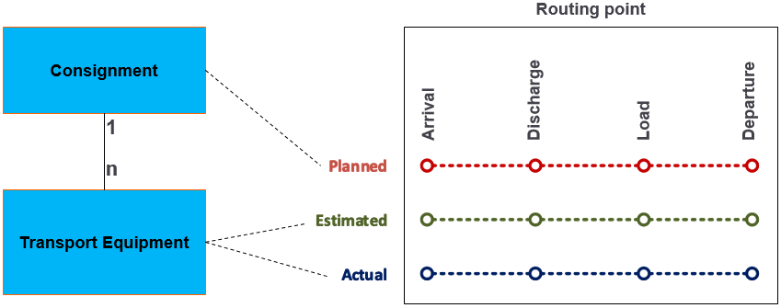

## How to deal with consignment changes

The scope of the event API is to provide information about the current consignment plan. The purpose **is not** to request booking changes.

The first Booking Confirmation will trigger the posting of the initial version of the consignment and all related plan events. Any booking changes trigger the posting of a complete new version of the Consignment plus a complete list of all related plan events. This posting of this complete new version is needed to avoid the determination and synchronisation of the difference between two plan versions. A PlanRef helps to distinguish the different plan editions.

### Booking split

In case a consignment needs to be split, new consignments will be created. Hapag-Lloyd suggests to end the lifecycle of the original consignment and to continue with two or more new consignments.

* Action Item: Define the appropriate booking split methods:
* How to reflect the relation between original consignment and derived consignments?
* Shall the original consignment be flagged as split?
* Shall the Transport Equipment instances and their related “estimated / Actual Events” be transferred to the new consignment or shall copies be created?

### Container swap

Sometimes we face the issue of a container swap: The shipper gets two containers for two separate bookings. When the empty containers leave the depot, the container numbers are assigned to the consignments. But if the shipper swaps the boxes during stuffing, he asks / expects the carrier to swap the container numbers in the booking as well:

|  |  |  |
| --- | --- | --- |
|  | Departure from Depot | Gate in at Terminal |
| Booking A | Container 1 | Container 2 |
| Booking B | Container 2 | Container 1 |

* Action Item: Define the appropriate Container Swap methods:
* How to swap the relation of the Transport Equipment from one consignment to the other?
* What happens with the “estimated / Actual Events” already posted with the now outdated consignment?

# Call with Romain

At 16:00 we have stopped the API recap and called Romain, informing him about our discussion.

## Discussion, how we might narrow the amount of end points on Event API

There was an agreement that the amount of currently proposed Event API endpoins should be reduced.

More generic end points could be archived by moving the Mode-of-Transport into an API parameter with an enumeration list of permitted values. This would make the API more flexible for adding new Modes of Transport.

Moreover a further option would be to move the event-type (= Arrival, Discharge, Load, Departure) to an attribute as well.

A third option would be to have a combined API for Estimated / Actual Events, meaning to include these as attributes as well.

The advantage of considering these three options were discussed, as this would fit to the design principles of the UN/EDIFACT standards. Today the EDIFACT message IFTSTA incorporates these ideas already and is utilized as proven standard.

Idea of Nis for the URLs:

/Consignment/{ID}/Event

/Consignment/{ID}/Transport_Event/{ID}/ Event

## Together create an updated version of the Event API.

We were running out of time to do this.