Information for Hein.

Source for trivy database: ghcr.io/aquasecurity/trivy-db
Trivy’s database aggregates security advisories from several sources, including:
- NVD, the National Vulnerability Database.
- Linux distribution security trackers.
- Vendor advisories such as Red Hat, Debian, Ubuntu, Alpine, Amazon Linux, and Oracle Linux.
- GitHub Advisory Database.
- Go Vulnerability Database.
- PyPI, npm, Ruby, Rust, NuGet, and other ecosystem advisory sources.
Trivy documents the specific source used for each operating system and programming-language ecosystem.
trivy image --download-db-only

For work flow process, we used trivy to update and download-db. The python you done will generate a CVE based on trivy db.
Good source of cve that I always used:
https://www.cve.org/CVERecord?id=CVE-2025-37164
https://nvd.nist.gov/vuln/detail/cve-2025-37164
From here, we derived scoring based on a CVSS vector based on this. To understand this vector, you can go to
https://www.first.org/cvss/calculator/3.1
CVSS:3.1/AV:N/AC:L/PR:N/UI:N/S:C/C:H/I:H/A:H
Based on the above CV calculator: AV: N would indicate this:
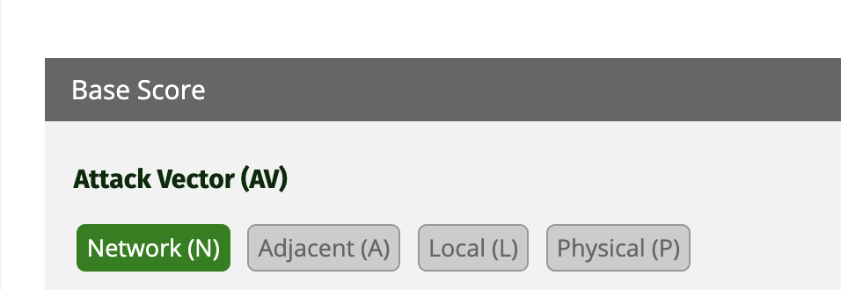
Therefore, you can insert the full vector to calculate the score.
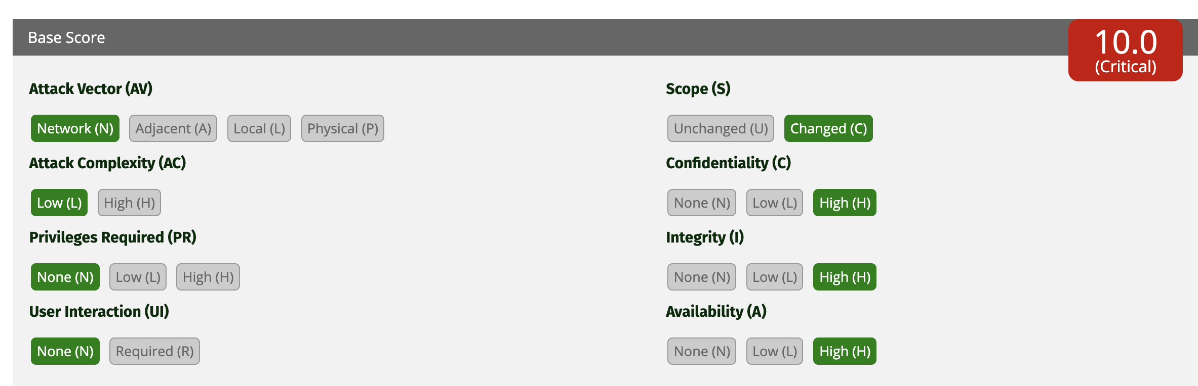
Using this eg:
CVE rate it as 10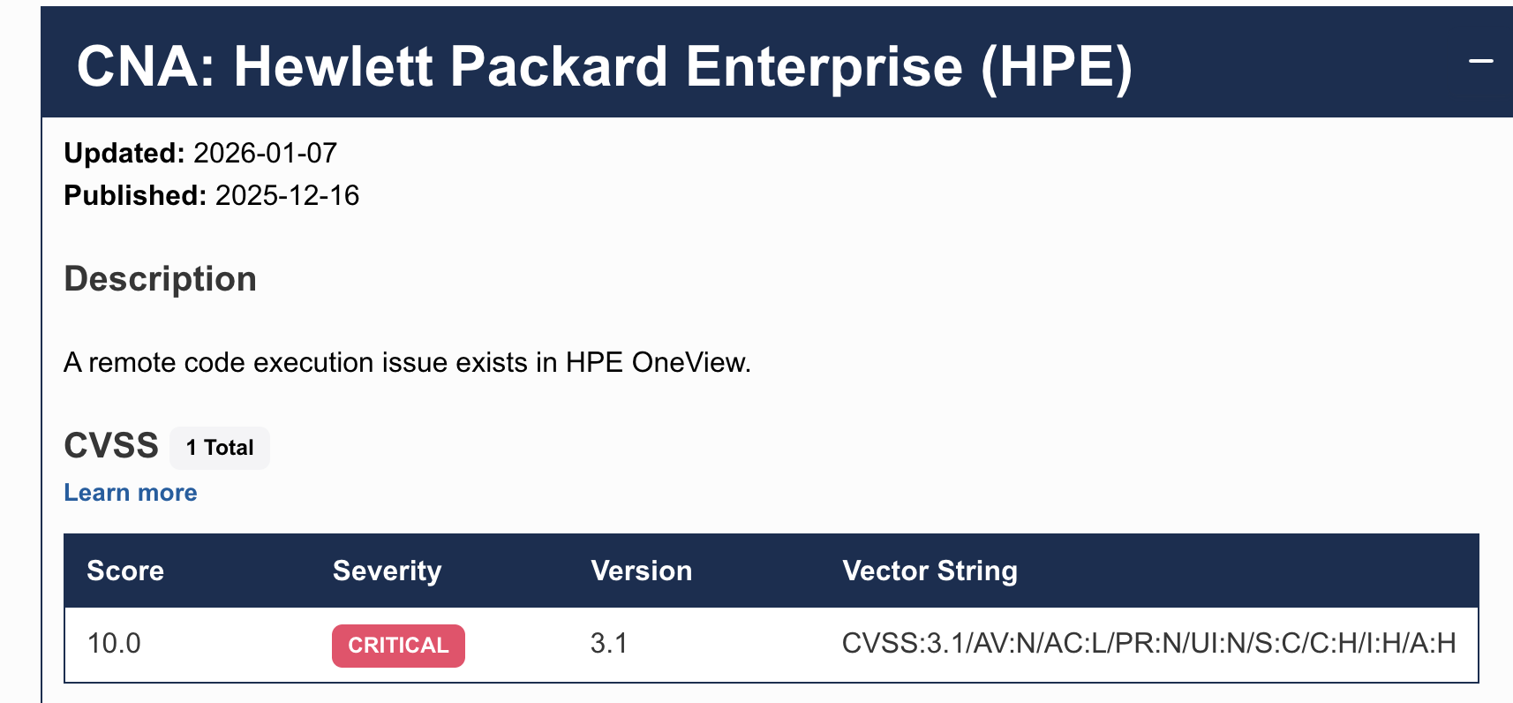
BUT Tenable rate it as 9.8:
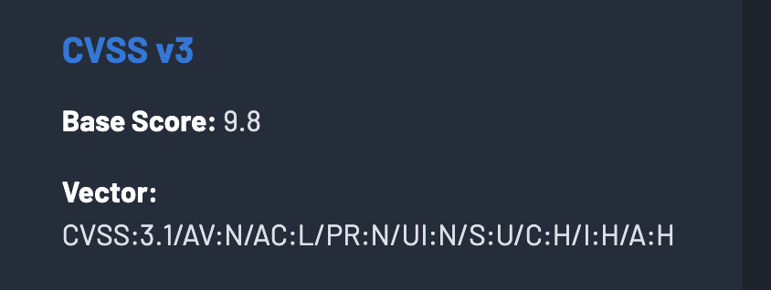
Based on today discussion, we can used this LLM to check for the whether this is sound???
Severity Level | CVSS v3.1 Ratings | Description of rating
Critical  (C) | 9.0 – 10.0 | Immediate review and attention to the issue should be given to this issue as exploitation of the vulnerability likely results in root-level/ administrator compromise of servers or infrastructure devices. Exploitation is usually straightforward, in the sense that the attacker does not need any special authentication credentials or knowledge about individual users.
High  (H) | 7.0 – 8.9 | Review and attention to the issue should be given within 1 month as the threat may pose significant confidentiality, integrity and availability risks to the enterprise’s information assets if breaches occur. Exploitation of this vulnerability is difficult to exploit and could result in elevated privileges. Exploitation could result in a significant data loss or downtime.
Medium  (M) | 4.0 – 6.9 | Requires review and attention within the near term (2 months). Such exploits are difficult to set up and usually require an attacker to reside on the same local network as the victim. If exploitation is successful, it provides only very limited access and may require user privileges for successful exploitation.
Low  (L) | 0.1 – 3.9 | Requires review and attentions if resources allow (2 months). Risk exposure does not have a significant impact on operations. Addressing this risk does provide improvement on existing controls and security.
Info | 0.0 | Requires review and attentions if resources allow.

Because scoring for a CVE can be different (because each vendor have a different interpretion of severity), for eg, some believe it is not as serious as it thought to be, so we take a few source of cve (for eg, cve website, nist website or tenable website -> feed the LLM with a slightly older model (qwen 2.5 perhaps), and let it determine if the score is closely align. After which, we used qwen3.8 to analyse. And the finally cloud based AI?
If the NVD CVSS score does not reflect your organisation’s interpretation, an LLM can help you create a contextual vulnerability assessment.
Separate the scores
Keep these as distinct fields:
NVD CVSS Base Score = vendor/NVD technical severity
Organisation Risk Score = your environment-specific assessment
LLM Explanation = reasoning and evidence for the difference

The NVD score describes the vulnerability’s general technical characteristics. CVSS allows consumers to adjust the assessment using Threat and Environmental metrics, including exploit maturity, asset criticality, compensating controls, and confidentiality, integrity, and availability requirements

Produce a second risk score
Rather than asking the LLM to invent a number, use a defined scoring model. The LLM can collect and justify inputs, while a deterministic program calculates the result.

Explain why your rating differs
The LLM can generate an auditable rationale such as:
NVD rates CVE-XXXX-YYYY as High because exploitation is possible over the network and can affect confidentiality and integrity. In our environment, the vulnerable endpoint is disabled, the service is isolated in a private subnet, and access is restricted through security groups. The residual risk is therefore assessed as Medium, subject to validation that the endpoint remains disabled.
The strongest design is therefore:
Official CVSS = baseline
LLM = contextual analyst and evidence summariser
Rules/calculator = score computation
Human = final risk decision
How it scores: https://www.first.org/cvss/v3.1/user-guide

