Brady Heinz 1.2 Assignment

https://github.com/heinzbrady/csd-325
Github
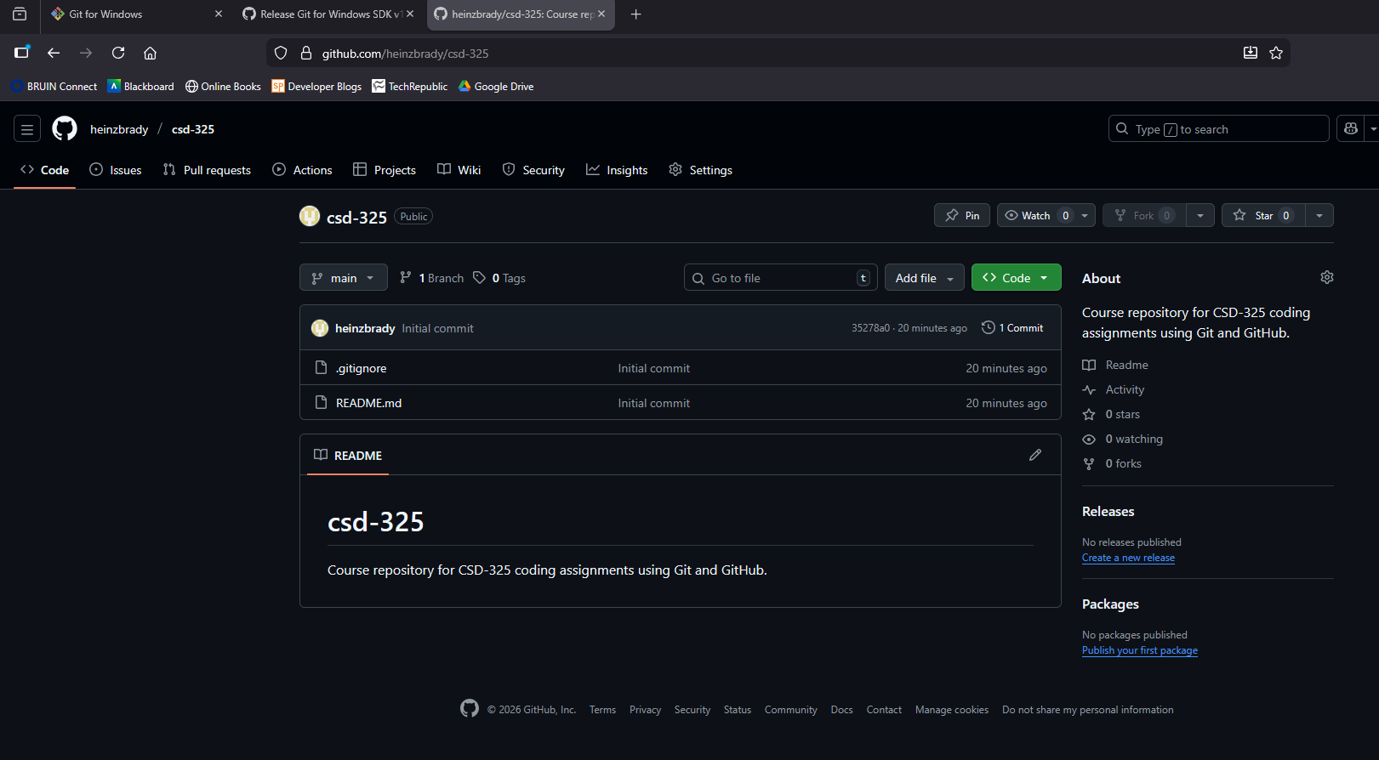
Git Global Configuration
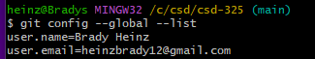

Git clone
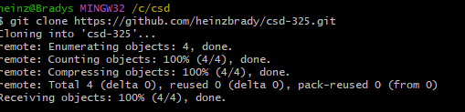

Local directory listing
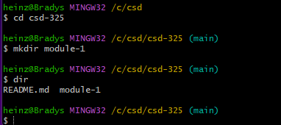
Git status
