Project: Todo Application
Course: CSD-380 DevOps
Description: Todo Application Functional Test Plan
Date: 9/3/2026
To complete the test case plan, fill out the information for Project, Course, Description and Date in the header below.

Suresh Shrestha
Module – 4.2 Assignment
TABLE OF CONTENTS
Create a New Todo Task Item 2
Edit a Todo Task Item 2
Delete a Todo Task Item 3
Prevent Empty Task Submission
Invalid URL / 404 Page

For each test, the developer should: provide a test description, a test objective, the developer name and date tested. For each step, fill out the actions to be taken and describe the expected results, and indicate yes or no for each step depending upon the result. The peer tester should provide their name, date tested, indicate yes or no for each step depending upon the result, and a screenshot (thumbnail) of the result.

Test 1 | Create a New Todo Task Item
 | Test Objective: Verify that a user can create and add a new task to the Todo List. | Developer: Suresh Shrestha  Date tested: 9/3/2026 | Peer tester: Brady Heinz  Date tested: 9/6/26
Step | Action | Expected results: | Developer pass/fail | Tester pass/fail  + Screenshot
1 | Open the Todo application in a web browser. | The Todo application opens successfully. | Yes | Yes  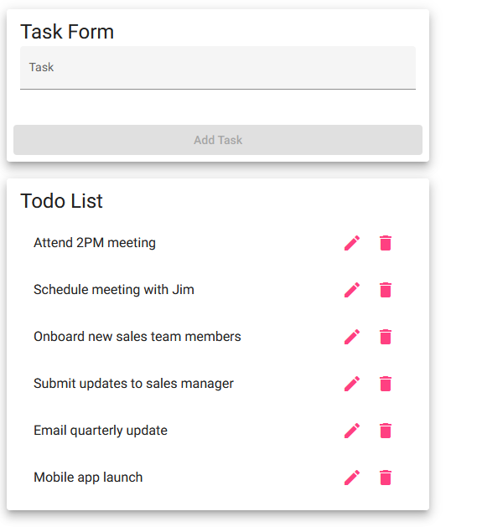
2 | Click inside the Task field. | The Task field is ready for input. | Yes | Yes
3 | Complete the CSD 380 assignment in the Task field. | The task text appears in the Task field | Yes | Yes
4 | Click the Add Task button. | The new task is added to the Todo List. | Yes | Yes
5 | Check the Todo List for the new task. | “Complete CSD 380 assignment” appears in the Todo List. | Yes | Yes  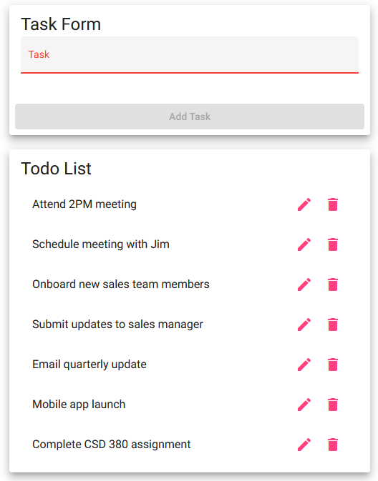
Comments | The new task was successfully added and displayed in the Todo List. The creation function worked as expected.

Test 2 | Edit a Todo Task Item
 | Test Objective: Verify that a user can edit an existing Todo task item. | Developer: Suresh Shrestha  Date tested: 9/3/2026 | Peer tester: Brady Heinz  Date tested: 09/6/26
Step | Action | Expected results: | Developer pass/fail | Tester pass/fail
1 | Locate “Complete CSD 380 assignment” in the Todo List. | The existing task is displayed | Yes | Yes  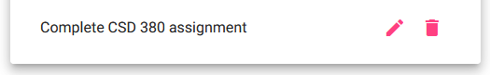
2 | Click the pencil icon next to the task. | The Edit Form opens with the existing task. | Yes | Yes
3 | Change the task to “Complete CSD Test Plan. | The new text appears in the Edit Form. | Yes | Yes
4 | Click the Save button. | The changes are saved, and the Edit Form closes. | Yes | Yes
5 | Check the Todo List for the updated task. | Complete CSD Test Plan appears in the Todo List. | Yes | Yes
Comments | The task was successfully edited, and the updated text appeared in the Todo List. The edit function worked as expected.

Test 3 | Delete a Todo Task Item
 | Test Objective: Verify that a user can delete an existing Todo task item from the Todo List. | Developer: Suresh Shrestha  Date tested: 9/3/2026 | Peer tester: Brady Heinz  Date tested: 09/6/26
Step | Action | Expected results: | Developer pass/fail | Tester pass/fail
1 | Open the Todo application. | The Todo application opens successfully. | Yes | Yes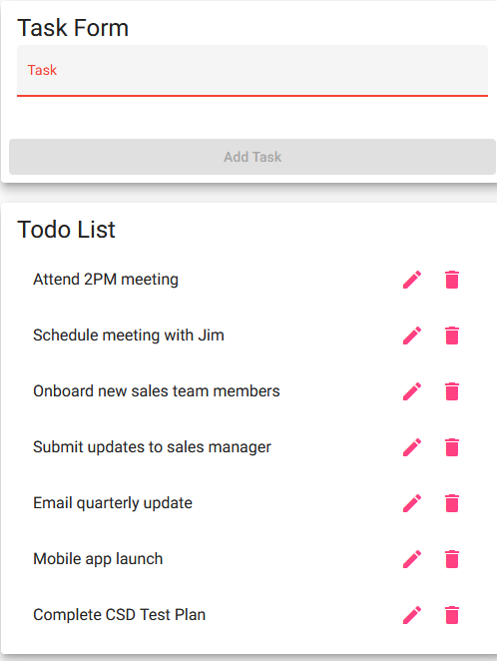
2 | Locate “Complete CSD Test Plan” in the Todo List. | The task is displayed in the Todo List. | Yes | Yes
3 | Click the trash can icon next to the task. | The selected task is deleted. | Yes | Yes
4 | Check the Todo List. | The Todo List updates after the task is deleted. | Yes | Yes
5 | Confirm “Complete CSD Test Plan” is no longer displayed. | The deleted task no longer appears in the Todo List. | Yes | Yes  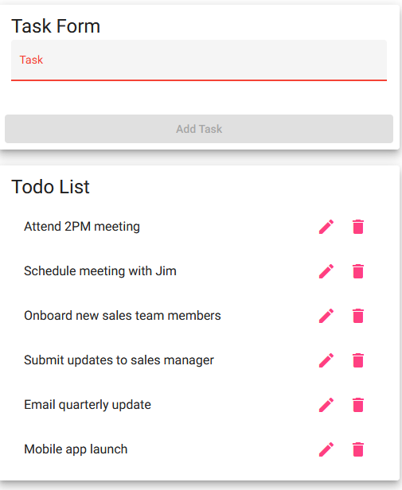
Comments | The selected task was successfully deleted from the Todo List. After clicking the delete icon, the task was no longer displayed, so the delete function worked as expected.

Test 4 | Prevent Empty Task Submission
 | Test Objective: Verify that a user cannot add a Todo when the Task field is empty. | Developer: Suresh Shrestha  Date tested: 9/3/2026 | Peer tester: Brady Heinz  Date tested: 09/6/26
Step | Action | Expected results: | Developer pass/fail | Tester pass/fail
1 | Open the Todo application. | The Todo application opens successfully. | Yes | Yes
2 | Leave the Task field empty. | The Task field remains empty. | Yes | Yes
3 | Check the Add Task button. | The Add Task button is disabled when the Task field is empty. | Yes | Yes
4 | Try to click the disabled Add Task button. | The user cannot submit an empty task. | Yes | Yes
5 | Check the Todo List. | No empty Todo task is added to the list. | Yes | Yes
Comments | The application did not allow an empty task to be submitted. The Add Task button remained disabled when the Task field was empty.

Test 5 | Invalid URL/ 404 Error Page
 | Test Objective: Verify that an invalid Todo URL displays the application’s custom not-found page. | Developer: Suresh Shrestha  Date tested: 9/3/2026 | Peer tester: Brady Heinz  Date tested: 09/6/26
Step | Action | Expected results: | Developer pass/fail | Tester pass/fail
1 | Open the Todo application. | The Todo application opens successfully. | Yes | Yes  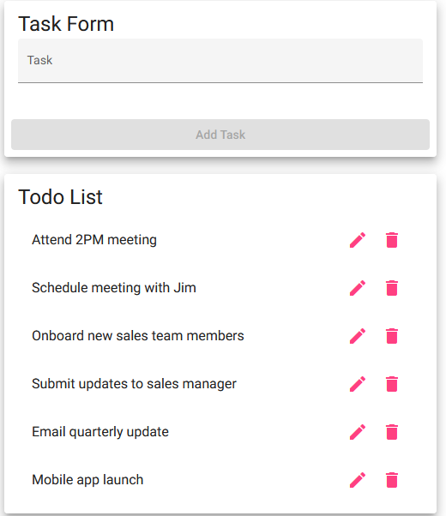
2 | Click the browser address bar. | The Todo website URL is displayed | Yes | Yes
3 | Enter an invalid Todo URL. | The application recognizes that the URL is invalid. | Yes | Yes
4 | Press Enter to visit the invalid URL. | The application redirects to the not-found page. | Yes | Yes
5 | Check the page displayed in the browser. | The custom not-found page displays “not-found works!” | Yes | Yes  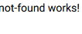
Comments | The application handled the invalid URL correctly and displayed the custom not-found page. The browser redirected to /Todo/not-found and displayed “not-found works!”, so the invalid URL requirement worked as expected.

