Brady Heinz
September 10, 2026
Module 5.2 – Working with CRUD-READ, JDBC & JavaBeans – Project Part 1

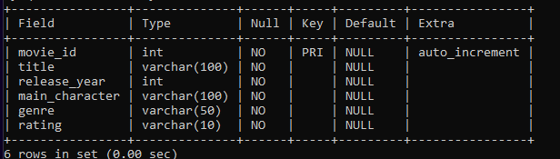
Figure 1 – Structure of the bradymoviesdata table showing six fields and movie_id as the primary key.

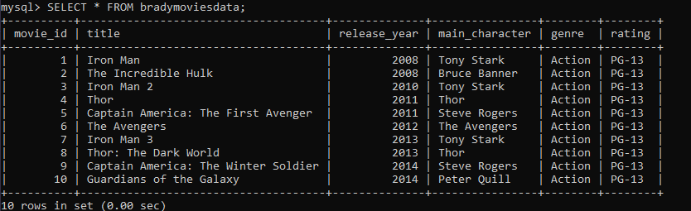
Figure 2 – Ten movie records populated in the bradymoviesdata table.

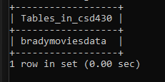
Figure 3 – bradymoviesdata table shown inside the CSD430 database.

