cam = webcam(2)

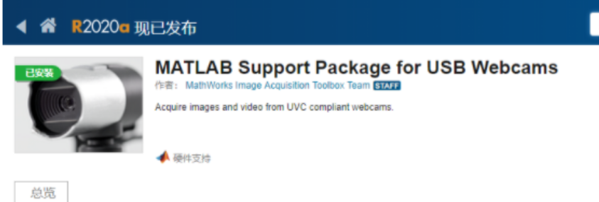

preview(cam)%%USB摄像头打开

img = snapshot(cam);

% Display the frame in a figure window.

image(img);

for idx = 1:20%这里学长建议用while一直循环读图像

img = snapshot(cam);

image(img);

end