[(35条消息) mysql8.0.25安装配置教程(windows 64位)最详细_聚精会神搞学习的博客-CSDN博客_mysql安装教程8.0.25](https://blog.csdn.net/weixin_43579015/article/details/117228159?ops_request_misc=%257B%2522request%255Fid%2522%253A%2522166278110816800182746785%2522%252C%2522scm%2522%253A%252220140713.130102334..%2522%257D&request_id=166278110816800182746785&biz_id=0&utm_medium=distribute.pc_search_result.none-task-blog-2~all~top_positive~default-2-117228159-null-null.142%5ev47%5econtrol,201%5ev3%5eadd_ask&utm_term=mysql%E5%AE%89%E8%A3%85%E9%85%8D%E7%BD%AE%E6%95%99%E7%A8%8B&spm=1018.2226.3001.4187)

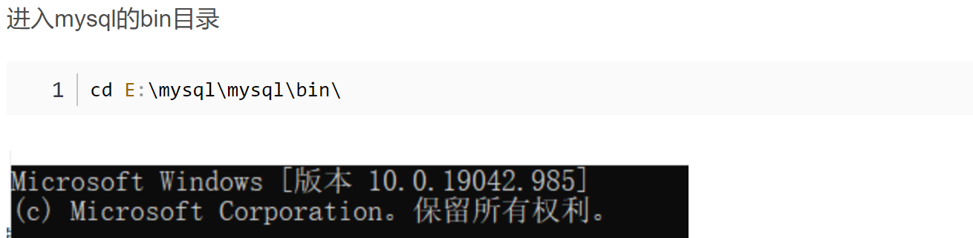

如果不能进入则在cd 后面加入 /d 表示开关打开

My.ini 需要选另存为（所有文件） 才能生成配置文件

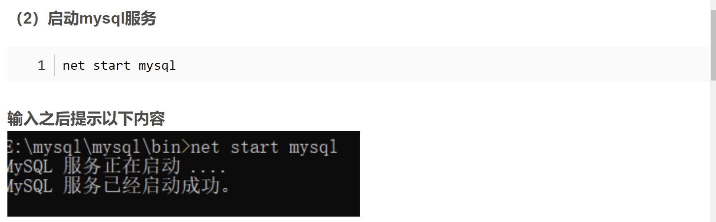

如果不能运行则在系统配置的path中加入C：\windows\system32