目 录

1 项目设计任务及要求 1
1.1 总体目标 1
1.2 具体功能要求 1
2 项目设计 1
2.1 设计思路 1
2.2 技术方案 1
2.3 详细设计 2
3 项目做中学 6
3.1 修改人员信息 6
3.2 连接数据库 6
3.3 添加人员 7
3.4 修改密码 7
4 总结提高 8
4.1过程中出现的问题： 8
4.2 总结 9
参考文献 10
附录 11
运行截图 11
程序源码 15

人力资源管理系统

1 项目设计任务及要求

1.1 总体目标
用JavaGUI编程技术和JDBC编程技术实现人力资源管理系统的大部分功能。
本项目实现一个人力资源管理系统，要求人力资源部的管理主要包括人的管理，岗位的管理，工资的管理，培训课程的管理。人员的管理包括人员的变动（人员部门间调动），以及与人员相关的档案的管理（姓名、工资及培训课程等的管理）。由人力资源部进行确认后，更改人员信息以及工资信息。岗位的管理包括修改人员所属部门名称，调整人员所属部门（部门调动），增加或删除部门。培训课程的管理包括对人员所选择的培训课程的开始及结束，查询人员选修培训课程的历史。

1.2 具体功能要求
人力资源管理系统的功能主要分为四个部分：登录、部门管理、人员管理、培训课程。
登录部分：数据库的获取，不同账号的注册和登录，及用户账号密码的修改。
部门管理：部门添加，部门信息的维护（管理）。部门维护包括部门查询、部门修改及部门修改。
人员管理：人员添加，人员信息的维护（管理），员工列表。人员信息的维护包括查询员工，修改人员的姓名、性别、员工描述、工资、培训计划以及所属部门。
培训课程：开始及结束培训，查看培训历史。
2 项目设计

2.1 设计思路
工作原理：数据库储存数据，使用Java编写程序，程序实现主要功能，从数据库中获取数据、更新数据及保存新数据。
功能规划：设计登录界面，登陆成功后建立主页面，在系统菜单中细分其他主要功能：部门管理、人员管理、培训课程管理。

2.2 技术方案
（1）JAVA编程软件：Eclipse
（2）swing技术：界面借助Eclipse swing插件Window Builder Pro来完成
（3）数据库采用MySQL 5.7
（4）数据库访问采用JDBC编程技术
（5）数据库连接、可视化管理使用软件Navicat for MySQL

2.3 详细设计
2.3.1 数据分析
数据库中主要包含以下表
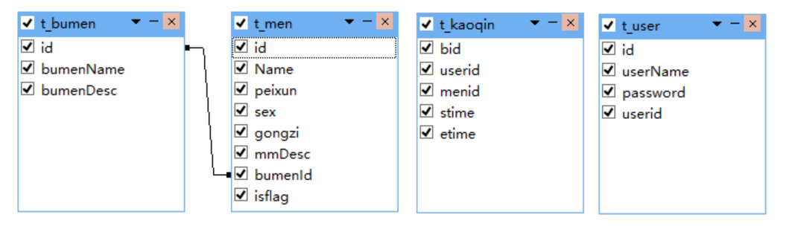
2.3.2 Java工程结构——类设计：
本项目分为视图层（view），，工具层（utils），数据访问层（model，dao）
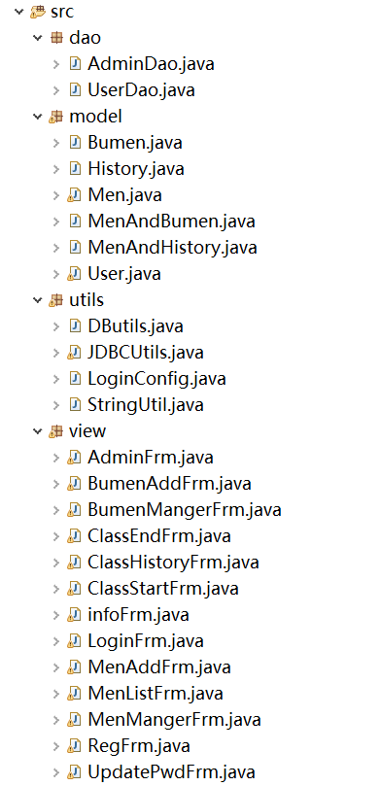
2.3.3 功能实现
（1）程序流程图如下：
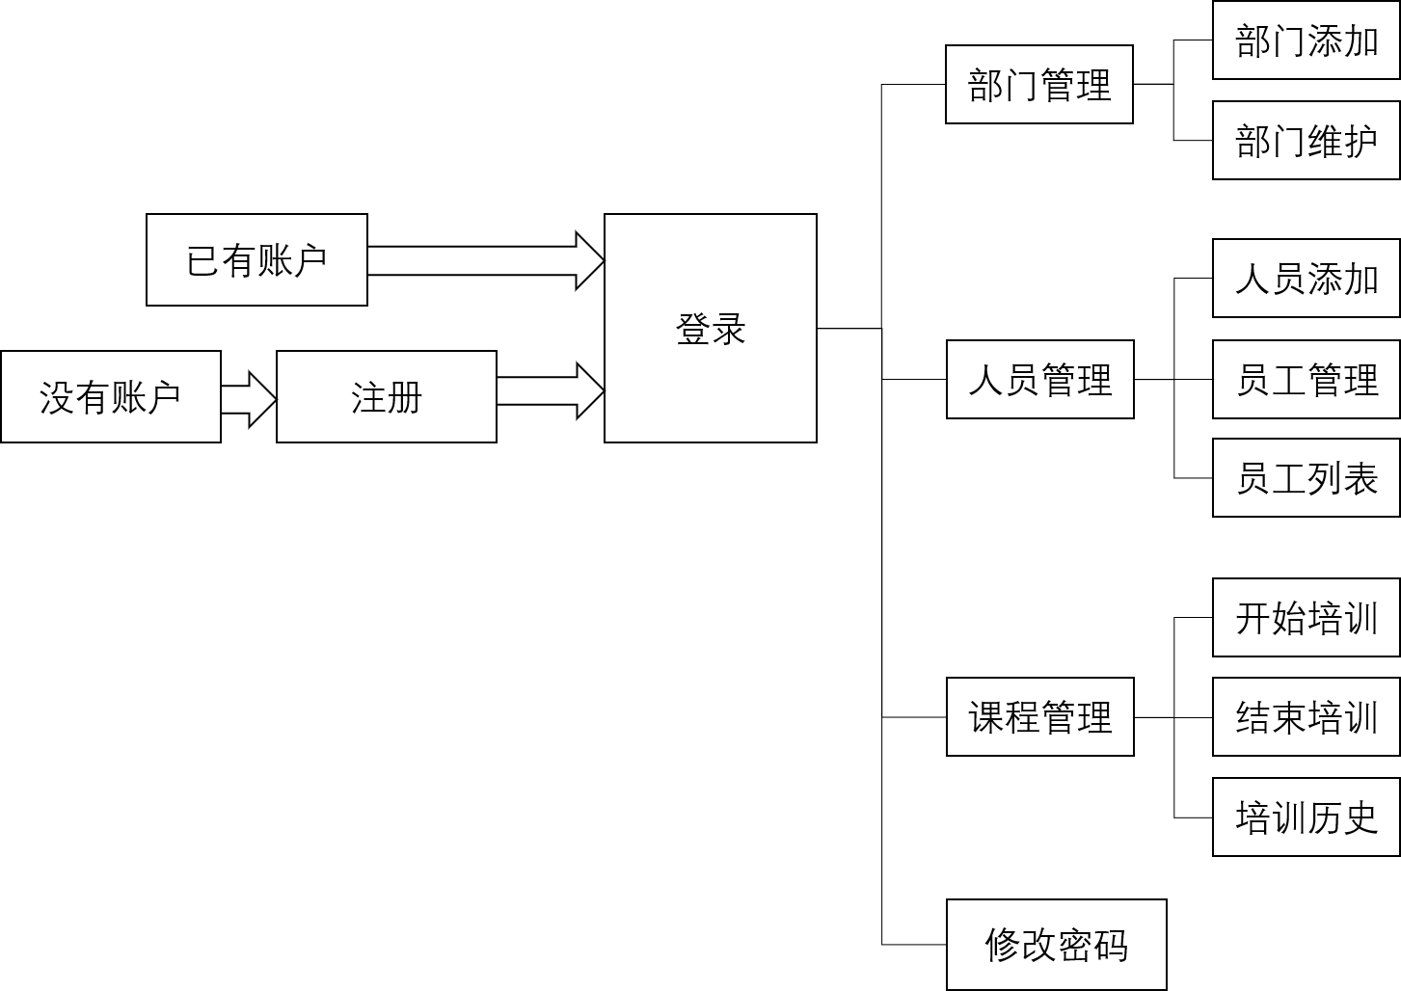
（2）主要代码
见附录
2.3.4 界面
（1）注册界面
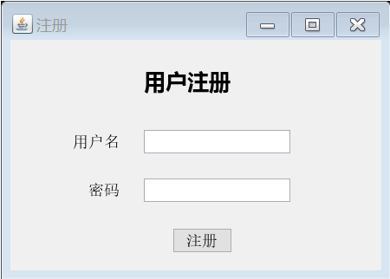
（2）登录界面
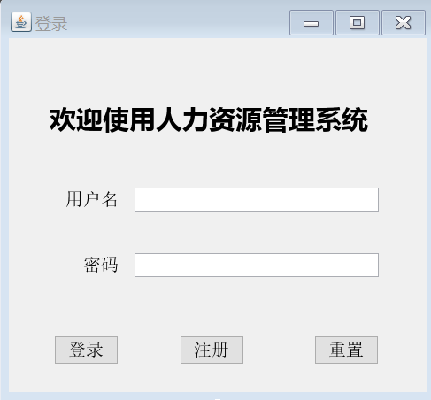
（3）主界面
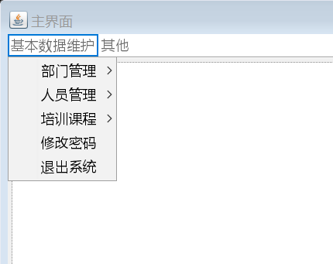
（4）部门添加
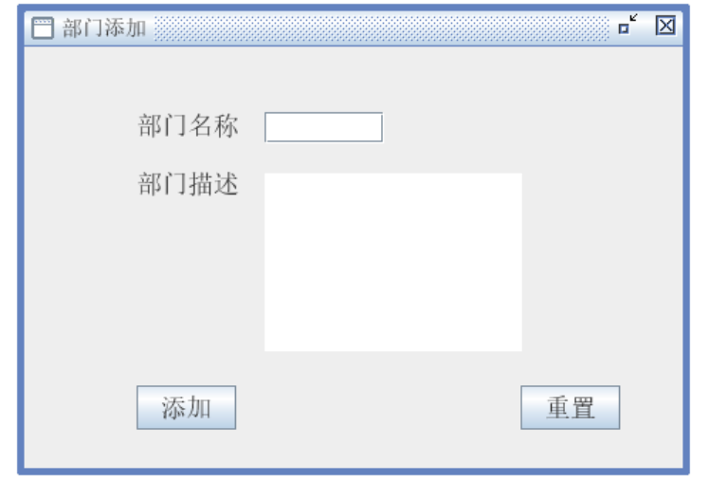
（5）部门维护
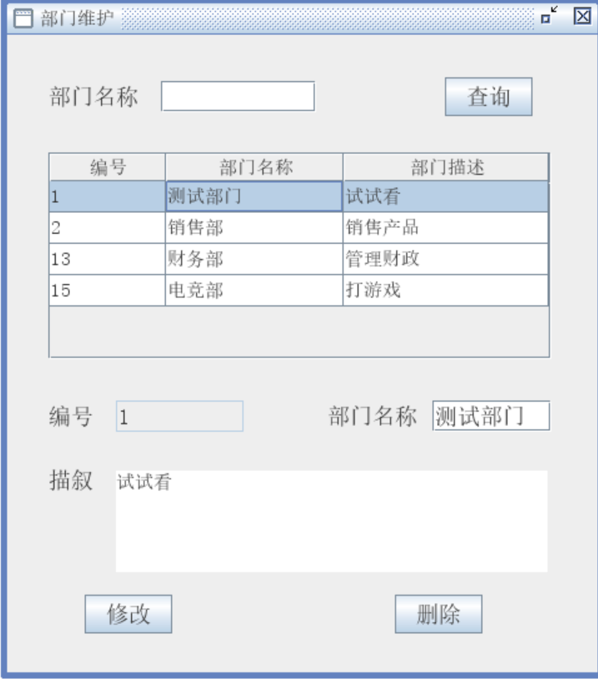
（6）人员添加
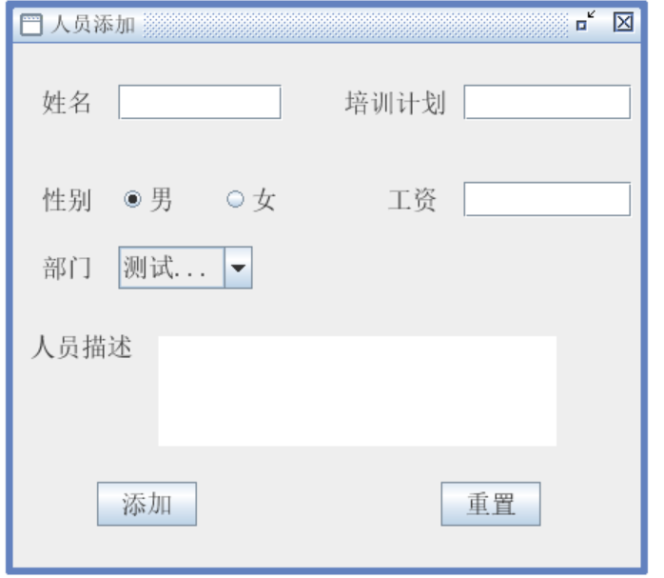
（7）人员维护
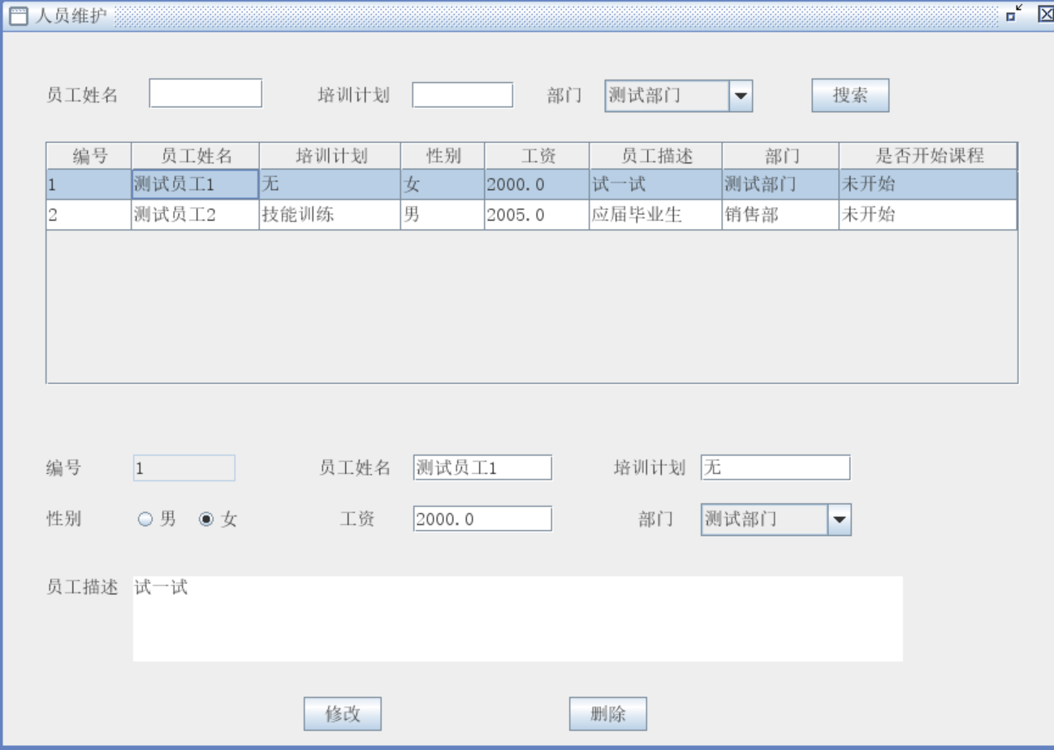
（8）员工列表
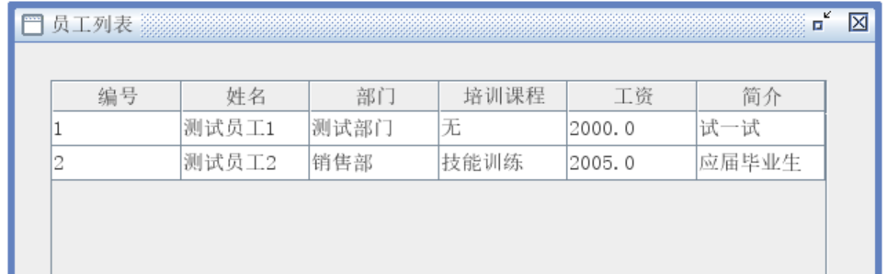
（9）培训计划
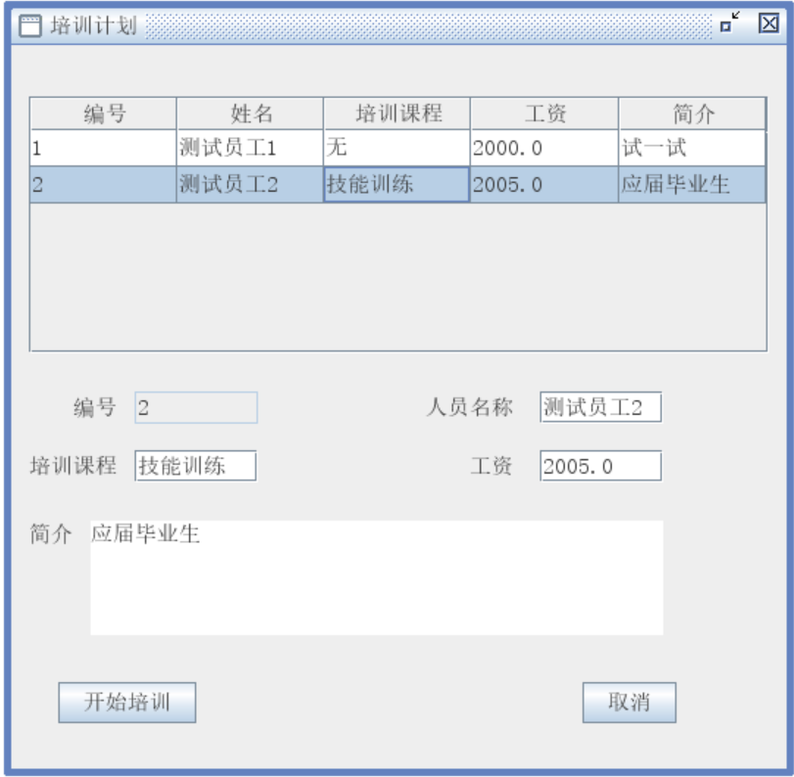
（10）课程签退
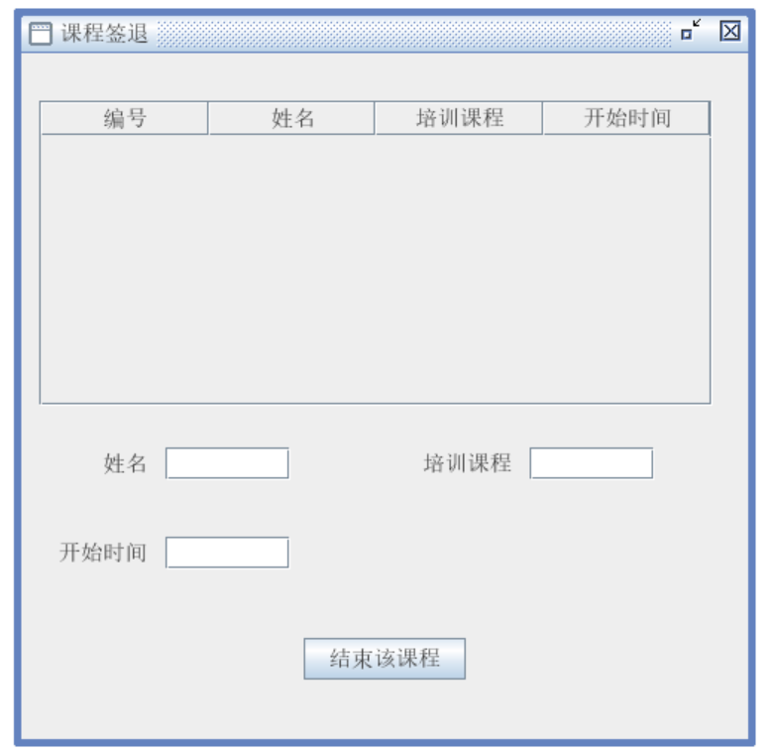
（11）培训历史
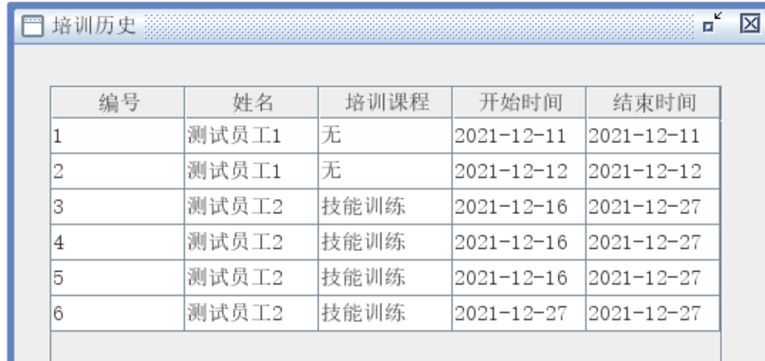
（12）修改密码
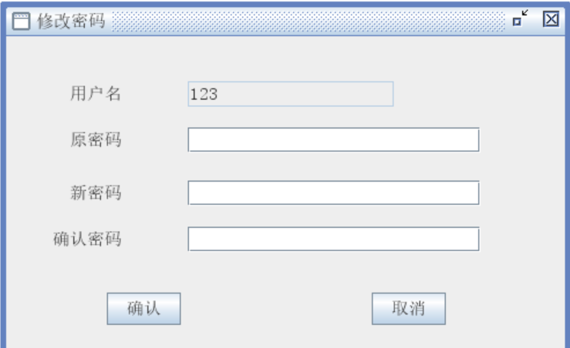
5.运行测试
见附录
3 项目做中学

3.1 修改人员信息
先获取用户填入的信息，然后传入数据库中对应数据项
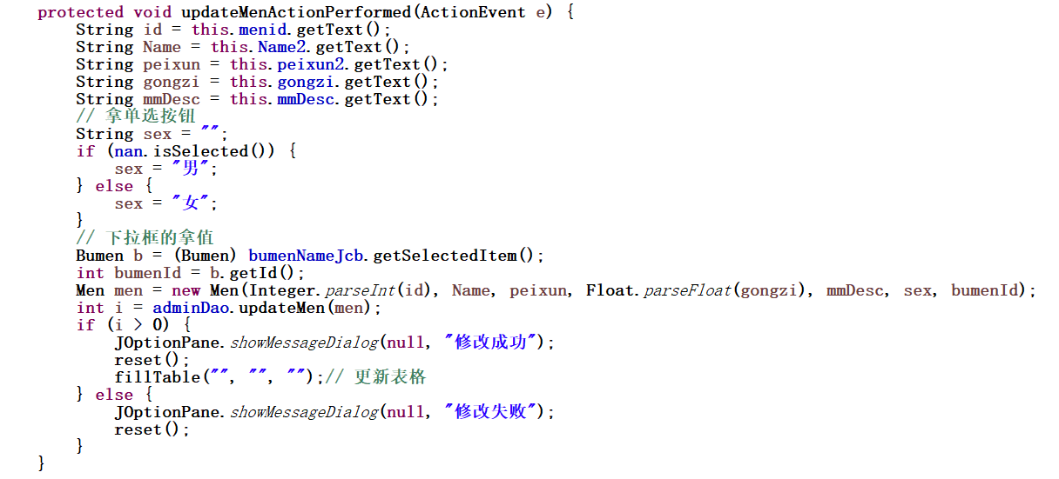

3.2 连接数据库
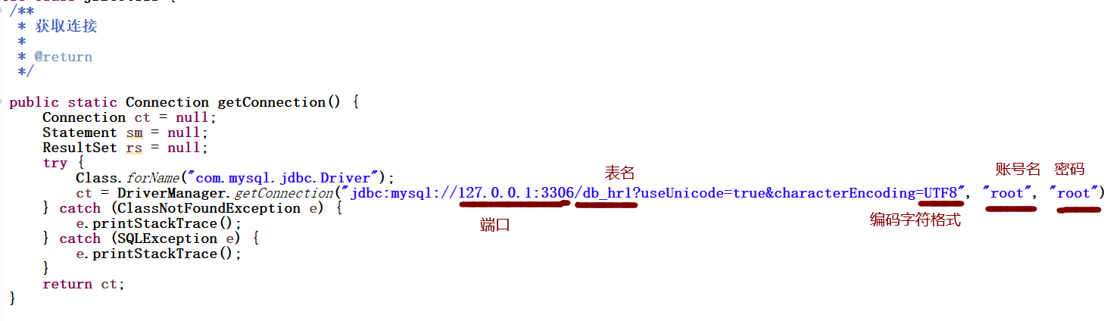

3.3 添加人员
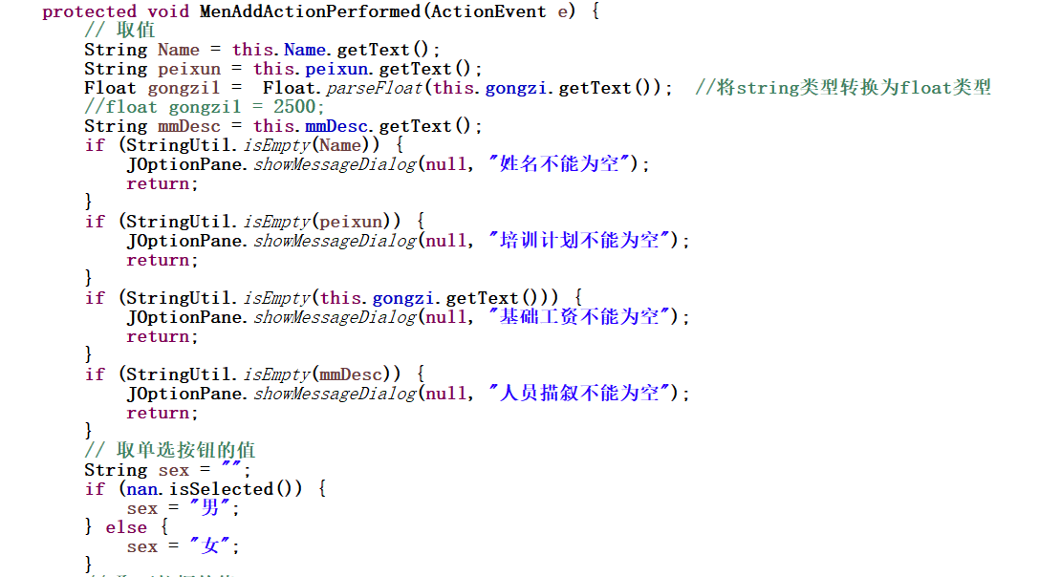
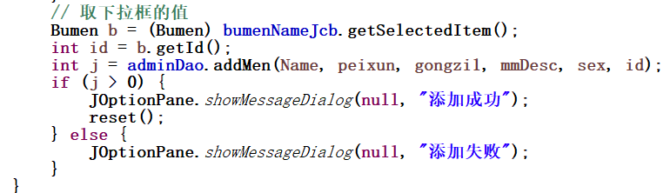

3.4 修改密码
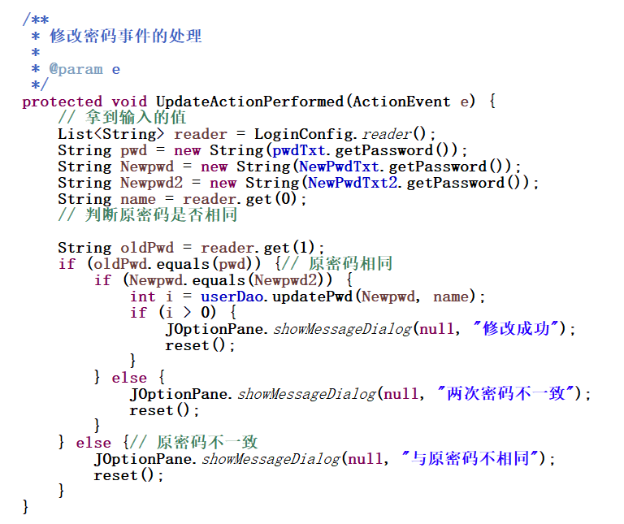
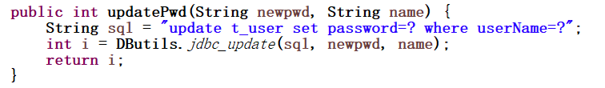
4 总结提高

4.1过程中出现的问题：
（1）数据库无法连接:保存提示SQL语法错误，一开始的人员简介这一栏在数据库中的名是Desc，与数据库中倒序排序的关键词Desc相同，所以出现语法错误无法连接
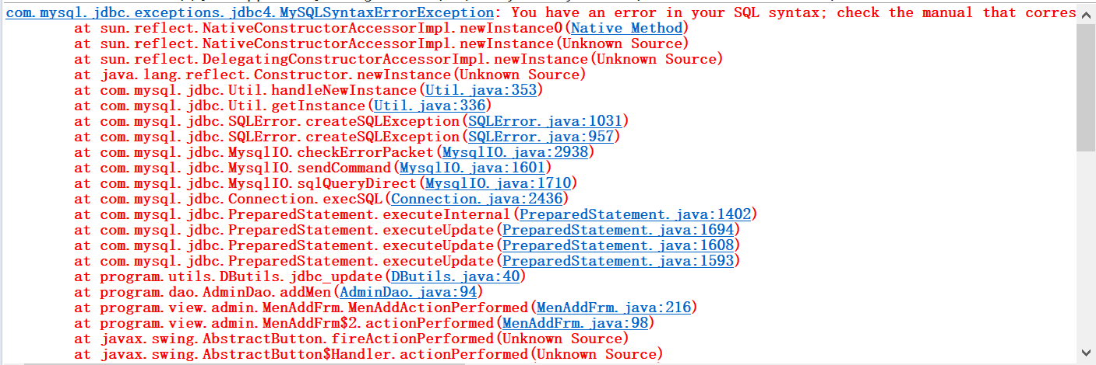
解决方法：定义变量名应注意不要使用关键词
（2）无法修改工资:错误提示插入的数据不合法。起初以为是数据库中设置的字符大小不够大，在修改之后仍然报错。
解决方法：最后查询发现是在函数定义变量时顺序有误，导致数据传错变量，修正变量顺序后问题解决

4.2 总结
总的来说，虽然本系统的功能不是很齐全，但是整个过程确是由自己一步步实现的，首先本次设计从最开始确定主题，然后对设计主题进行可行性分析、需求分析。然后对设计进行技术选型，设计数据库表。搭建工程环境，设计规范，之后进行开发环境中，即详细设计、具体代码编写。最后进入测试环境，测试是否符合最初的基本要求，实现了各模块的基本功能，排除了基本上可能出现的Bug。本次课程设计是一次非常好的演练和实践的机会，培养了我们独立思考问题的能力，锻炼了解决问题和自学的能力。
参考文献
[1] 陈刚．MyEclipse从入门到精通．北京：清华大学出版社, 2005.
[2] 张延军.Java程序设计教程.北京:清华大学出版社, 2017.
[3] 萨师煊,王珊.《数据库系统概论》.高等教育出版社,2002.
[4] 周绍斌,王红.Java语言程序设计教程.大连:东软电子出版社,2012.
[5] BiliBili弹幕网.https://www.bilibili.com/
附录

运行截图
- 部门添加
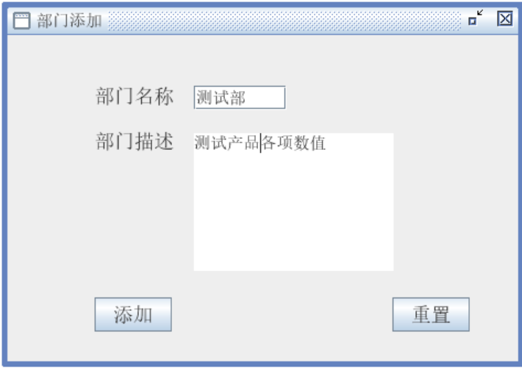
添加成功后提示并清空输入栏
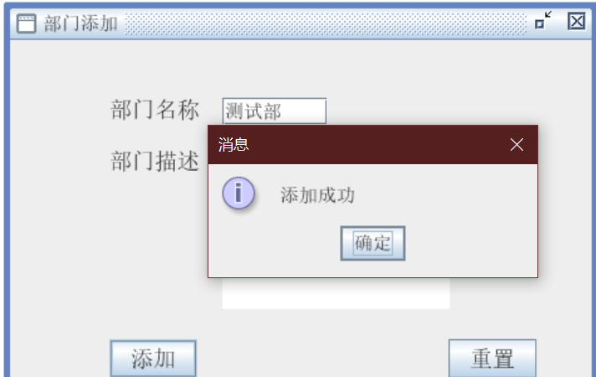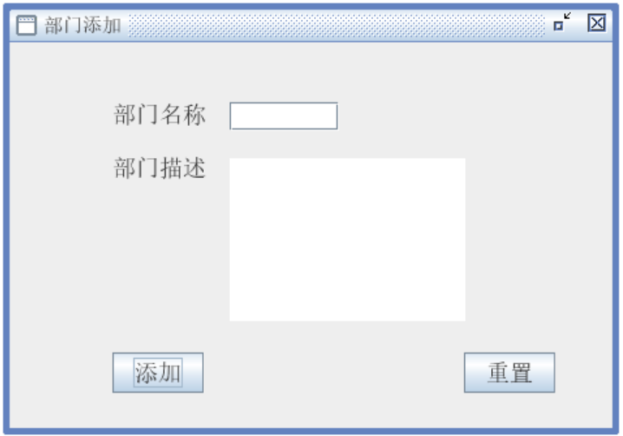
（2）部门维护
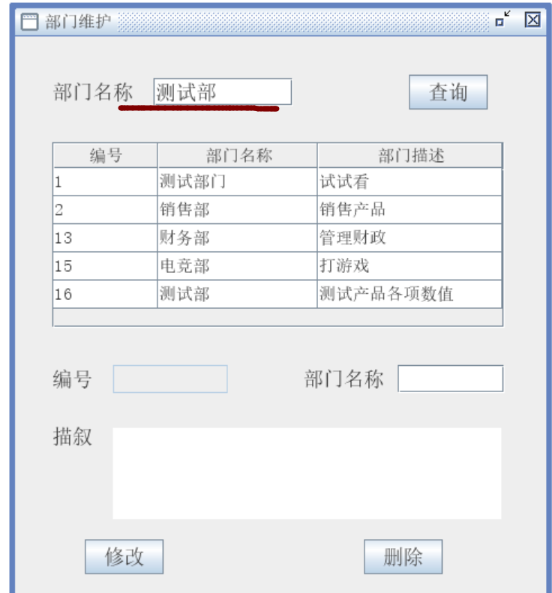
输入之后查询
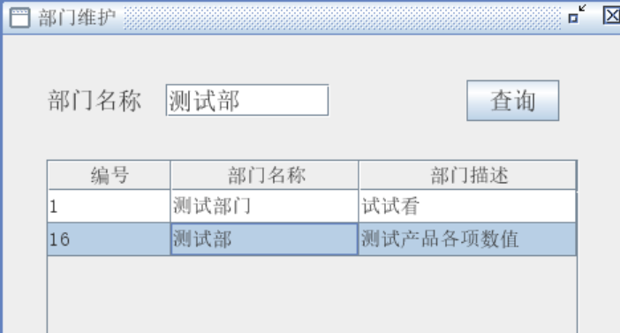
单击测试部之后详细信息出现在下方，可以进行修改与删除
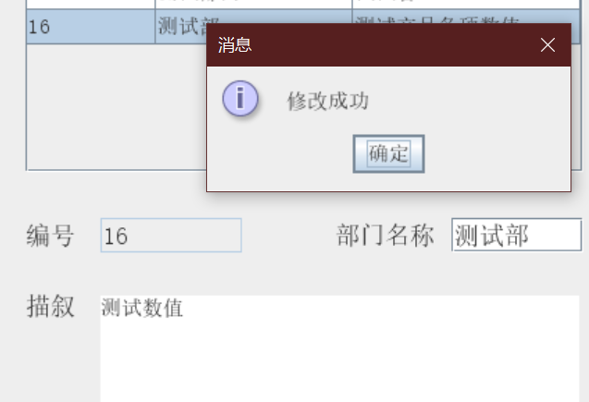
修改之后可以见到列表中显示的已经变化
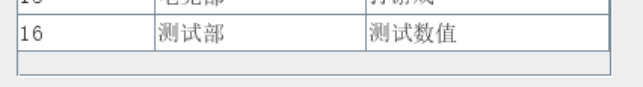
点击测试部，选择删除
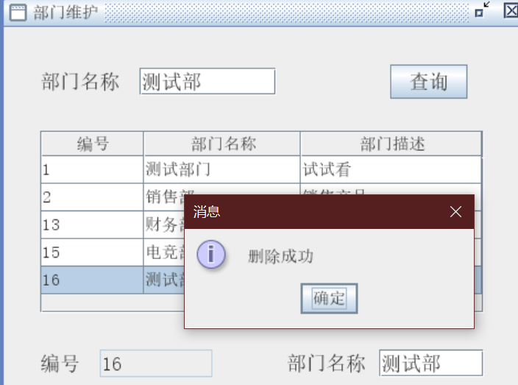
列表中的测试部已删除
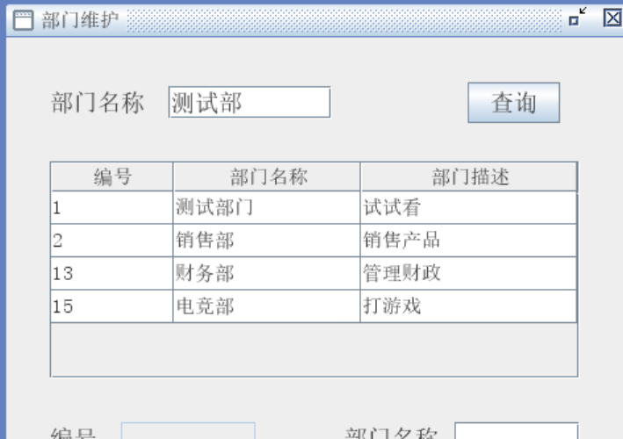
（3）人员添加

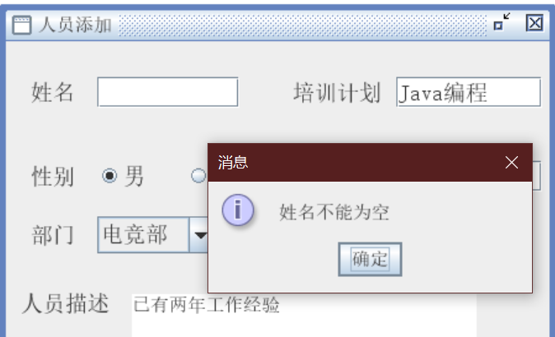
如果没有填入姓名或者工资则会提示不能为空
部门是下拉选项，方便储存与管理
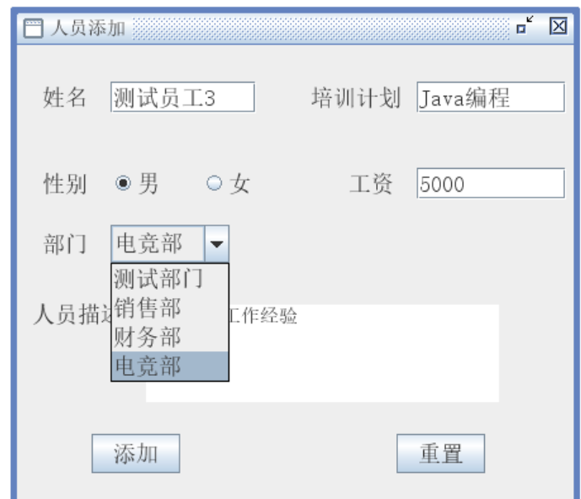
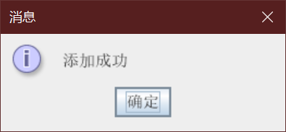
员工列表可看到新增加的测试员工3
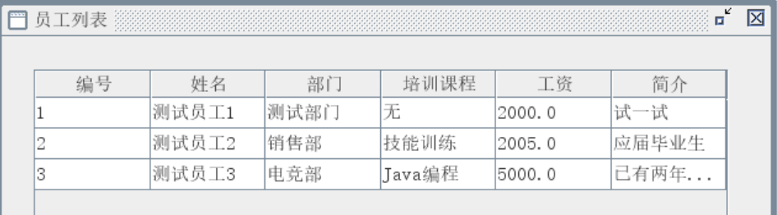
（4）人员维护
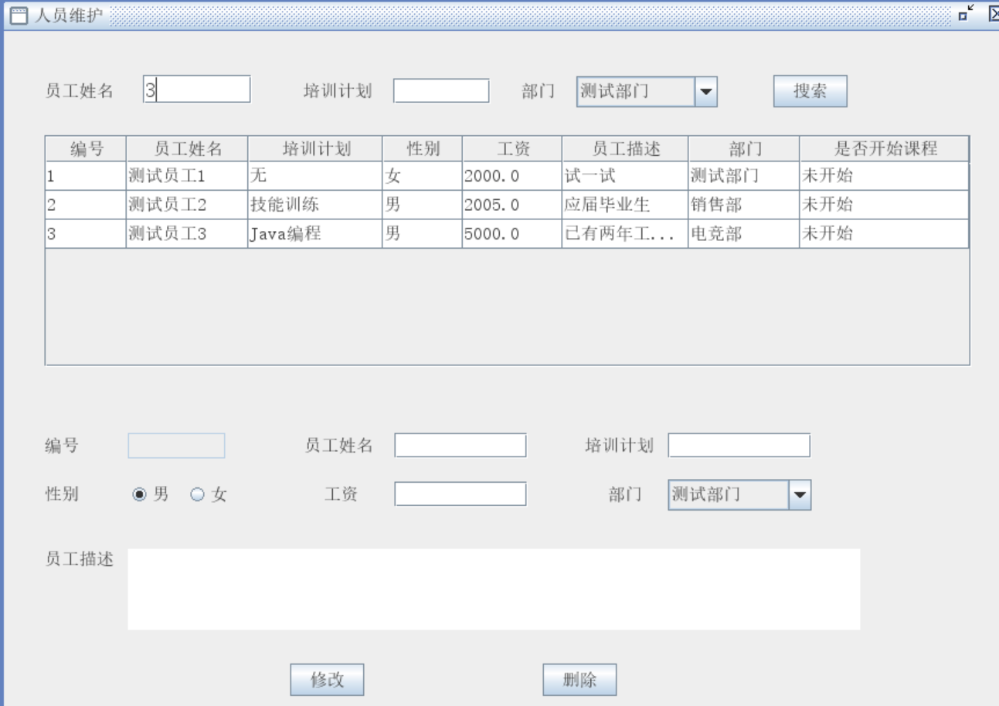
点击员工3，修改其部门为测试部门
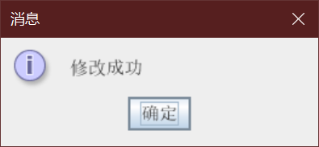
点击选择部门可以筛选查看所属员工
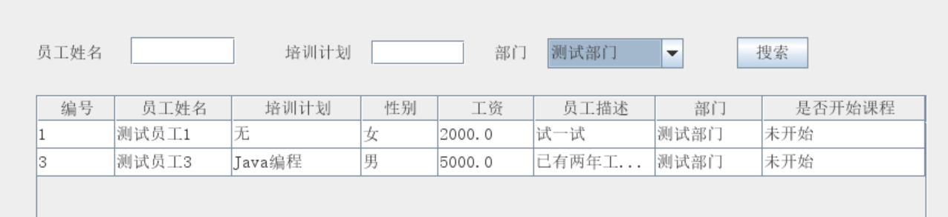
删除员工3之后员工列表已没有员工3
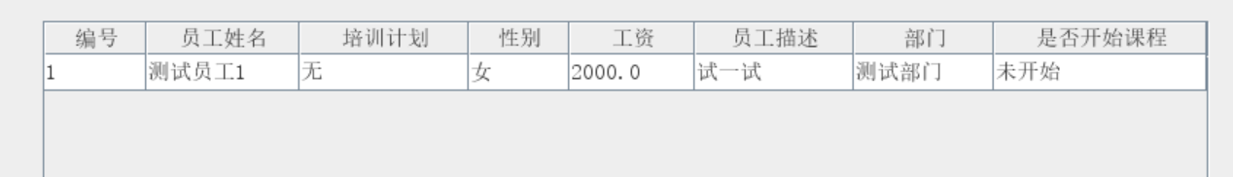
（5）培训课程
开始培训
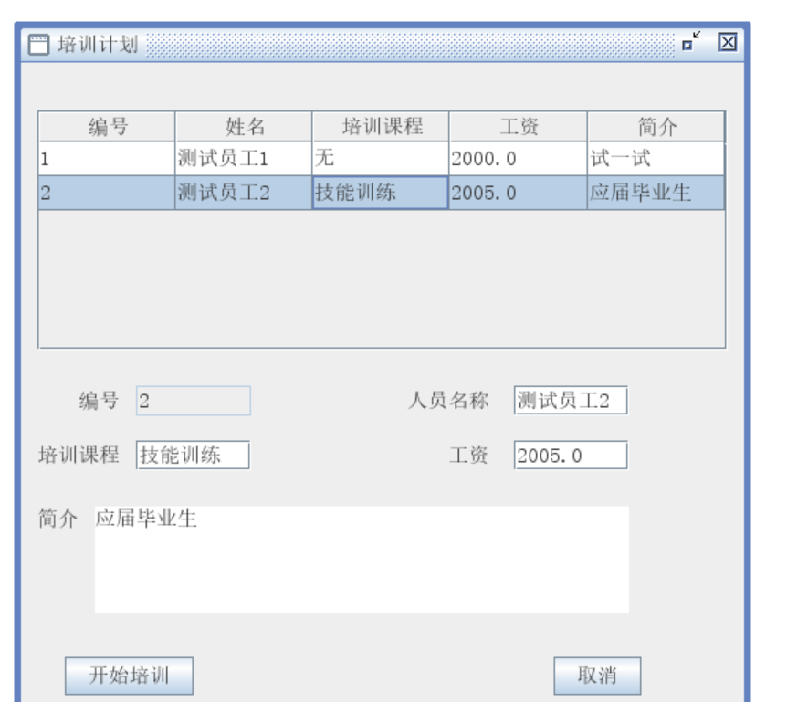
开始培训后
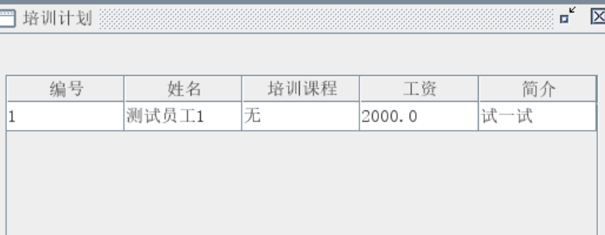
员工2在列表中消失（不会重复培训同一个课程）
结束培训后可以在培训历史查看
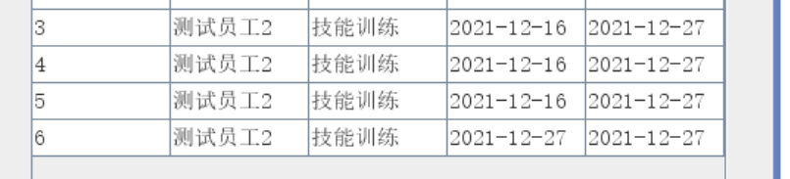

（6）修改密码
如两次密码不一致时会进行提示
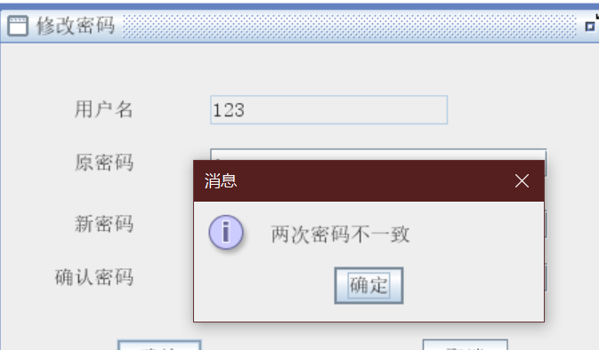

程序源码
dao
AdminDao.java
package dao;

import java.sql.Connection;
import java.sql.PreparedStatement;
import java.sql.ResultSet;
import java.sql.SQLException;
import java.util.ArrayList;
import java.util.List;

import model.MenAndBumen;
import model.Men;
import model.Bumen;
import utils.DButils;
import utils.JDBCUtils;

public class AdminDao {

public Bumen SelectBumenName(String bumenName) {
String sql = "select * from t_bumen where bumenName=?";
PreparedStatement ps = null;
ResultSet rs = null;
Connection conn = null;
conn = JDBCUtils.getConnection();
Bumen b = null;
try {
ps = conn.prepareStatement(sql);
ps.setString(1, bumenName);
rs = ps.executeQuery();
while (rs.next()) {
int id = rs.getInt("id");
String bumenName2 = rs.getString("bumenName");
String bumenDesc = rs.getString("bumenDesc");
b = new Bumen(id, bumenName2, bumenDesc);
}
} catch (SQLException e) {
e.printStackTrace();
} finally {
JDBCUtils.close(rs, null, ps, conn);
}
return b;

}

public int AddBumen(String bumenName, String bumenDesc) {
String sql = "insert into t_bumen(bumenName,bumenDesc) value(?,?)";
return DButils.jdbc_update(sql, bumenName, bumenDesc);
}

public List<Bumen> listBumen(String bumenName) {
String sql = "select * from t_bumen where bumenName like ?";
PreparedStatement ps = null;
ResultSet rs = null;
Connection conn = null;
conn = JDBCUtils.getConnection();
Bumen b = null;
List<Bumen> list = new ArrayList<Bumen>();
try {
ps = conn.prepareStatement(sql);
ps.setString(1, "%" + bumenName + "%");
rs = ps.executeQuery();
while (rs.next()) {
int id = rs.getInt("id");
String bumenName2 = rs.getString("bumenName");
String bumenDesc = rs.getString("bumenDesc");
b = new Bumen(id, bumenName2, bumenDesc);
list.add(b);
}
} catch (SQLException e) {
e.printStackTrace();
} finally {
JDBCUtils.close(rs, null, ps, conn);
}
return list;

}

public int udpateBumen(String bumenName, String bumenDesc, int bid) {
String sql = "update t_bumen set bumenName=?,bumenDesc=? where id=?";
return DButils.jdbc_update(sql, bumenName, bumenDesc, bid);
}

public int deleteBumen(int id) {
String sql = "delete from t_bumen where id=?";
return DButils.jdbc_update(sql, id);
}

public int deleteMen(int id) {
String sql = "delete from t_men where bumenid=?";
return DButils.jdbc_update(sql, id);
}

public int addMen(String Name, String peixun, Float gongzi, String mmDesc, String sex, int bumenId) {
String sql = "insert into t_men(Name,peixun,sex,gongzi,mmDesc,bumenId,isflag) value(?,?,?,?,?,?,?)";
return DButils.jdbc_update(sql, Name, peixun, sex ,gongzi ,mmDesc , bumenId, 0);
}

public List<MenAndBumen> listMen(String Name, String peixun, String bumenName2) {
String sql = "select * from t_men,t_bumen where t_men.bumenId=t_bumen.id and t_men.Name LIKE ? and t_men.peixun LIKE ? and t_bumen.bumenName LIKE ?";
PreparedStatement ps = null;
ResultSet rs = null;
Connection conn = null;
conn = JDBCUtils.getConnection();
MenAndBumen b = null;
List<MenAndBumen> list = new ArrayList<MenAndBumen>();
try {
ps = conn.prepareStatement(sql);
ps.setString(1, "%" + Name + "%");
ps.setString(2, "%" + peixun + "%");
ps.setString(3, "%" + bumenName2 + "%");
rs = ps.executeQuery();
while (rs.next()) {
int id = rs.getInt("id");
String Name2 = rs.getString("Name");
String peixun2 = rs.getString("peixun");
String sex = rs.getString("sex");
Float gongzi = rs.getFloat("gongzi");
String mmDesc = rs.getString("mmDesc");
String bumenName = rs.getString("bumenName");
int isFalg = rs.getInt("isflag");
b = new MenAndBumen(id, Name2, peixun2, sex, gongzi, mmDesc, bumenName, isFalg);
list.add(b);
}
} catch (SQLException e) {
e.printStackTrace();
} finally {
JDBCUtils.close(rs, null, ps, conn);
}
return list;
}

public int updateMen(Men men) {
String sql = "update t_men set Name=?,peixun=?,gongzi=?,mmDesc=?,sex=?,bumenId=? where id=?";
return DButils.jdbc_update(sql, men.getName(), men.getPeixun(), men.getGongzi(), men.getmmDesc(),men.getSex(), men.getBumenId(), men.getId());
}

public int deleteMen2(int menid) {
String sql = "delete from t_men where id=?";
return DButils.jdbc_update(sql, menid);
}

}
dao
UserDao.java
package dao;

import java.sql.Connection;
import java.sql.Date;
import java.sql.PreparedStatement;
import java.sql.ResultSet;
import java.sql.SQLException;
import java.util.ArrayList;
import java.util.List;

import model.MenAndBumen;
import model.Men;
import model.MenAndHistory;
import model.User;
import utils.DButils;
import utils.JDBCUtils;

public class UserDao {

public static List<User> login(String name, String pwd, String userid) {
String sql = "select * from t_user where userName=? and password=? and userid=?";
List<User> jdbc_select = DButils.jdbc_select(sql, User.class, name, pwd, userid);
return jdbc_select;
}

public int reg(String name, String pwd) {
String sql = "insert into t_user(userName,password,userid) value(?,?,?)";
int jdbc_update = DButils.jdbc_update(sql, name, pwd, "1");
return jdbc_update;
}

public List<MenAndHistory> listMen(int id) {
String sql = "select * from t_men,t_kaoqin where t_men.id=t_kaoqin.menid and userid=? and stime is not null and etime is null";
PreparedStatement ps = null;
ResultSet rs = null;
Connection conn = null;
conn = JDBCUtils.getConnection();
List<MenAndHistory> list = new ArrayList<MenAndHistory>();
try {
ps = conn.prepareStatement(sql);
ps.setInt(1, id);
rs = ps.executeQuery();
while (rs.next()) {
int id2 = rs.getInt("id");
String Name = rs.getString("Name");
String peixun = rs.getString("peixun");
Date rdate = rs.getDate("stime");
MenAndHistory men = new MenAndHistory(id2, Name, peixun, rdate);
list.add(men);
}
} catch (SQLException e) {
e.printStackTrace();
} finally {
JDBCUtils.close(rs, null, ps, conn);
}
return list;
}

public int updatePwd(String newpwd, String name) {
String sql = "update t_user set password=? where userName=?";
int i = DButils.jdbc_update(sql, newpwd, name);
return i;
}

public List<MenAndBumen> listMen2() {
String sql = "select * from t_men,t_bumen where t_men.bumenId=t_bumen.id and isflag=0";
PreparedStatement ps = null;
ResultSet rs = null;
Connection conn = null;
conn = JDBCUtils.getConnection();
List<MenAndBumen> list = new ArrayList<MenAndBumen>();
try {
ps = conn.prepareStatement(sql);
rs = ps.executeQuery();
while (rs.next()) {
int menid = rs.getInt("id");
String Name = rs.getString("Name");
String bumenName = rs.getString("bumenName");
String peixun = rs.getString("peixun");
Float gongzi = rs.getFloat("gongzi");
String mmDesc = rs.getString("mmDesc");
MenAndBumen men = new MenAndBumen(menid, Name, peixun, gongzi, mmDesc, bumenName);
list.add(men);
}
} catch (SQLException e) {
e.printStackTrace();
} finally {
JDBCUtils.close(rs, null, ps, conn);
}
return list;
}

public User selectUname(String name) {
String sql = "select * from t_user where userName=?";
PreparedStatement ps = null;
ResultSet rs = null;
Connection conn = null;
conn = JDBCUtils.getConnection();
User user = null;
try {
ps = conn.prepareStatement(sql);
ps.setString(1, name);
rs = ps.executeQuery();

while (rs.next()) {
int id = rs.getInt("id");
String username = rs.getString("userName");
String password = rs.getString("password");
user = new User(id, username, password);
}
} catch (SQLException e) {
e.printStackTrace();
} finally {
JDBCUtils.close(rs, null, ps, conn);
}
return user;
}

public Men Select(int menid) {
String sql = "select * from t_men where isFlag=1 and id=?";
PreparedStatement ps = null;
ResultSet rs = null;
Connection conn = null;
conn = JDBCUtils.getConnection();
Men men = null;
try {
ps = conn.prepareStatement(sql);
ps.setInt(1, menid);
rs = ps.executeQuery();
while (rs.next()) {
int id = rs.getInt("id");
String Name = rs.getString("Name");
String peixun = rs.getString("peixun");
men = new Men(id, Name, peixun);
}
} catch (SQLException e) {
e.printStackTrace();
} finally {
JDBCUtils.close(rs, null, ps, conn);
}
return men;
}

public int classStart(int menid) {
String sql = "update t_men set isFlag=1 where id=?";
return DButils.jdbc_update(sql, menid);
}

public int insertBorrow(int id, int menid) {
String sql = "insert into t_kaoqin(userid,menid,stime) value(?,?,?)";
return DButils.jdbc_update(sql, id, menid, new Date(System.currentTimeMillis()));
}

public int updateMenIsFlag(String Name) {
String sql = "update t_men set isflag=0 where Name=?";
return DButils.jdbc_update(sql, Name);
}

public Men Selectmenid(String Name) {
String sql = "select * from t_men where isflag=1 and Name=?";
PreparedStatement ps = null;
ResultSet rs = null;
Connection conn = null;
conn = JDBCUtils.getConnection();
Men men = null;
try {
ps = conn.prepareStatement(sql);
ps.setString(1, Name);
rs = ps.executeQuery();
while (rs.next()) {
int id = rs.getInt("id");
String Name2 = rs.getString("Name");
String peixun = rs.getString("peixun");
men = new Men(id, Name2, peixun);
}
} catch (SQLException e) {
e.printStackTrace();
} finally {
JDBCUtils.close(rs, null, ps, conn);
}
return men;
}

public int insertetime(int id, int menid) {
String sql = "update t_kaoqin set etime=? where userid=? and menid=?";
return DButils.jdbc_update(sql, new Date(System.currentTimeMillis()), id, menid);
}

public Men selectmenid(String Name) {
String sql = "select * from t_men where Name=?";
PreparedStatement ps = null;
ResultSet rs = null;
Connection conn = null;
conn = JDBCUtils.getConnection();
Men men = null;
try {
ps = conn.prepareStatement(sql);
ps.setString(1, Name);
rs = ps.executeQuery();
while (rs.next()) {
int id = rs.getInt("id");
String Name2 = rs.getString("Name");
String peixun = rs.getString("peixun");
men = new Men(id, Name2, peixun);
}
} catch (SQLException e) {
e.printStackTrace();
} finally {
JDBCUtils.close(rs, null, ps, conn);
}
return men;
}

public int updateIsFlag(int menid) {
String sql = "update t_men set isflag=0 where id=?";
return DButils.jdbc_update(sql, menid);
}

public int updateetime(int userid, int menid) {
String sql = "update t_kaoqin set etime=? where userid=? and menid=?";
return DButils.jdbc_update(sql, new Date(System.currentTimeMillis()), userid, menid);
}

public List<MenAndHistory> listMenHistory(int userid) {
String sql = "select t_men.Name ,t_men.peixun ,t_kaoqin.stime ,t_kaoqin.etime from t_kaoqin,t_men where t_men.id=t_kaoqin.menid and userid =? and etime is not NULL";
PreparedStatement ps = null;
ResultSet rs = null;
Connection conn = null;
conn = JDBCUtils.getConnection();
List<MenAndHistory> list = new ArrayList<>();
MenAndHistory men = null;
try {
ps = conn.prepareStatement(sql);
ps.setInt(1, userid);
rs = ps.executeQuery();
while (rs.next()) {
String Name = rs.getString("Name");
String peixun = rs.getString("peixun");
Date stime = rs.getDate("stime");
Date etime = rs.getDate("etime");
men = new MenAndHistory(Name, peixun, stime, etime);
list.add(men);
}
} catch (SQLException e) {
e.printStackTrace();
} finally {
JDBCUtils.close(rs, null, ps, conn);
}
return list;
}

}
model
Bumen
package model;

public class Bumen {
@Override
public String toString() {
return bumenName;
}

private int id;
private String bumenName;
private String bumenDesc;

public Bumen() {
super();
// TODO Auto-generated constructor stub
}

public Bumen(int id, String bumenName, String bumenDesc) {
super();
this.id = id;
this.bumenName = bumenName;
this.bumenDesc = bumenDesc;
}

public Bumen(String bumenName, String bumenDesc) {
super();
this.bumenName = bumenName;
this.bumenDesc = bumenDesc;
}

public Bumen(String bumenName) {
this.bumenName = bumenName;
}

public Bumen(int id) {
this.id = id;
}

public Bumen(String bumenName, String bumenDesc, int id) {
this.bumenName = bumenName;
this.bumenDesc = bumenDesc;
this.id = id;
}

public Bumen(int id, String bumenName) {
this.id = id;
this.bumenName = bumenName;
}

public Bumen(String bumenName, int id) {
this.bumenName = bumenName;
this.id = id;
}

public int getId() {
return id;
}

public void setId(int id) {
this.id = id;
}

public String getBumenName() {
return bumenName;
}

public void setBumenName(String bumenName) {
this.bumenName = bumenName;
}

public String getbumenDesc() {
return bumenDesc;
}

public void setbumenDesc(String bumenDesc) {
this.bumenDesc = bumenDesc;
}

}
model
History.java
package model;

import java.sql.Date;

/**
* 课程历史表
*
*/
public class History {
private int id;
private int userid;// 用户id
private int menid;// 人员id
private Date stime;// 开始日期
private Date etime;// 结束日期

public History() {
super();
// TODO Auto-generated constructor stub
}

public History(int id, int userid, int menid, Date stime, Date etime) {
super();
this.id = id;
this.userid = userid;
this.menid = menid;
this.stime = stime;
this.etime = etime;
}

public History(int userid, int menid) {
this.userid = userid;
this.menid = menid;
}

public History(int userid, int menid, Date stime) {
this.userid = userid;
this.menid = menid;
this.stime = stime;
}

public History(Date stime, Date etime) {
this.stime = stime;
this.etime = etime;
}

public History(int menid) {
this.menid = menid;
}

public int getId() {
return id;
}

public void setId(int id) {
this.id = id;
}

public int getUserid() {
return userid;
}

public void setUserid(int userid) {
this.userid = userid;
}

public int getMenid() {
return menid;
}

public void setMenid(int menid) {
this.menid = menid;
}

public Date getstime() {
return stime;
}

public void setstime(Date stime) {
this.stime = stime;
}

public Date getetime() {
return etime;
}

public void setetime(Date etime) {
this.etime = etime;
}

@Override
public String toString() {
return "Borrow [id=" + id + ", userid=" + userid + ", menid=" + menid + ", stime=" + stime + ", etime="
+ etime + "]";
}
}
model
Men.java
package model;

public class Men {
private int id;
private String Name;
private String peixun;
private String sex;
private float gongzi;
private String mmDesc;
private Integer bumenId;
private int isflag;

public Men(int id, String Name, String peixun, String sex, float gongzi, String mmDesc, Integer bumenId,
int isflag) {
super();
this.id = id;
this.Name = Name;
this.peixun = peixun;
this.sex = sex;
this.gongzi = gongzi;
this.mmDesc = mmDesc;
this.bumenId = bumenId;
this.isflag = isflag;
}

public Men(int id, String Name, String peixun, String sex, float gongzi, String mmDesc, Integer bumenId) {
super();
this.id = id;
this.Name = Name;
this.peixun = peixun;
this.sex = sex;
this.gongzi = gongzi;
this.mmDesc = mmDesc;
this.bumenId = bumenId;
}

public Men() {

}

public Men(String Name, String peixun, String sex, float gongzi, String mmDesc) {
super();
this.Name = Name;
this.peixun = peixun;
this.sex = sex;
this.gongzi = gongzi;
this.mmDesc = mmDesc;
}

public Men(int id, String Name, String peixun, String sex, float gongzi, String mmDesc, int bumenId) {

super();
this.id = id;
this.Name = Name;
this.peixun = peixun;
this.sex = sex;
this.gongzi = gongzi;
this.mmDesc = mmDesc;
this.bumenId = bumenId;
}

public Men(String Name) {
this.Name = Name;
}

public Men(int id, String Name, String peixun, float gongzi, String mmDesc, String sex, int bumenId) {
this.id = id;
this.Name = Name;
this.peixun = peixun;
this.gongzi = gongzi;
this.mmDesc = mmDesc;
this.sex = sex;
this.bumenId = bumenId;
}

public Men(int id, String Name, String peixun, Float gongzi, String mmDesc) {
this.id = id;
this.Name = Name;
this.peixun = peixun;
this.gongzi = gongzi;
this.mmDesc = mmDesc;
}

public Men(int id) {
this.id = id;
}

public Men(int id, String Name, String peixun) {
this.id = id;
this.Name = Name;
this.peixun = peixun;
}

public Men(int id, String Name, float gongzi, String peixun, String sex, int bumenId) {
this.id = id;
this.Name = Name;
this.gongzi = gongzi;
this.peixun = peixun;
this.sex = sex;
this.bumenId = bumenId;
}

public Men(int id, String Name, float gongzi, String peixun, String sex, String mmDesc, int bumenId) {
this.id = id;
this.Name = Name;
this.gongzi = gongzi;
this.peixun = peixun;
this.sex = sex;
this.mmDesc = mmDesc;
this.bumenId = bumenId;
}

public int getId() {
return id;
}

public void setId(int id) {
this.id = id;
}

public String getName() {
return Name;
}

public void setName(String Name) {
this.Name = Name;
}

public String getPeixun() {
return peixun;
}

public void setPeixun(String peixun) {
this.peixun = peixun;
}

public String getSex() {
return sex;
}

public void setSex(String sex) {
this.sex = sex;
}

public float getGongzi() {
return gongzi;
}

public void setGongzi(float gongzi) {
this.gongzi = gongzi;
}

public String getmmDesc() {
return mmDesc;
}

public void setmmDesc(String mmDesc) {
this.mmDesc = mmDesc;
}

public Integer getBumenId() {
return bumenId;
}

public void setBumenId(Integer bumenId) {
this.bumenId = bumenId;
}

@Override
public String toString() {
return "Men [id=" + id + ", Name=" + Name + ", peixun=" + peixun + ", sex=" + sex + ", gongzi=" + gongzi + ", mmDesc=" + mmDesc + ", bumenId=" + bumenId + "]";
}
}
model
MenAndBumen.java
package model;

public class MenAndBumen {
private int id;
private String Name;
private String peixun;
private String sex;
private float gongzi;
private String mmDesc;
private Integer bumenId;
private int isflag;
private int id2;
private String bumenName;
private String bumenDesc;

public MenAndBumen() {
super();
// TODO Auto-generated constructor stub
}

public MenAndBumen(int id, String Name, String peixun, String sex, float gongzi, String mmDesc,
Integer bumenId, int isflag, int id2, String bumenName, String bumenDesc) {
super();
this.id = id;
this.Name = Name;
this.peixun = peixun;
this.sex = sex;
this.gongzi = gongzi;
this.mmDesc = mmDesc;
this.bumenId = bumenId;
this.isflag = isflag;
this.id2 = id2;
this.bumenName = bumenName;
this.bumenDesc = bumenDesc;
}

public MenAndBumen(int id, String Name, String bumenName, String peixun, Float gongzi, String mmDesc) {
this.id = id;
this.Name = Name;
this.bumenName = bumenName;
this.peixun = peixun;
this.gongzi = gongzi;
this.mmDesc = mmDesc;
}

public MenAndBumen(int id, String Name, String peixun, Float gongzi, String mmDesc) {
this.id = id;
this.Name = Name;
this.peixun = peixun;
this.gongzi = gongzi;
this.mmDesc = mmDesc;
}

public MenAndBumen(int id, String Name, String peixun, String sex, Float gongzi, String mmDesc,
String bumenName, int isflag) {
this.id = id;
this.Name = Name;
this.peixun = peixun;
this.sex = sex;
this.gongzi = gongzi;
this.mmDesc = mmDesc;
this.bumenName = bumenName;
this.isflag = isflag;
}

public MenAndBumen(int id, String Name, String peixun, Float gongzi, String mmDesc, String bumenName) {
this.id = id;
this.Name = Name;
this.peixun = peixun;
this.gongzi = gongzi;
this.mmDesc = mmDesc;
this.bumenName = bumenName;
}

public int getId() {
return id;
}

public void setId(int id) {
this.id = id;
}

public String getName() {
return Name;
}

public void setName(String Name) {
this.Name = Name;
}

public String getPeixun() {
return peixun;
}

public void setPeixun(String peixun) {
this.peixun = peixun;
}

public String getSex() {
return sex;
}

public void setSex(String sex) {
this.sex = sex;
}

public float getGongzi() {
return gongzi;
}

public void setGongzi(float gongzi) {
this.gongzi = gongzi;
}

public String getmmDesc() {
return mmDesc;
}

public void setmmDesc(String mmDesc) {
this.mmDesc = mmDesc;
}

public Integer getBumenId() {
return bumenId;
}

public void setBumenId(Integer bumenId) {
this.bumenId = bumenId;
}

public int getIsflag() {
return isflag;
}

public void setIsflag(int isflag) {
this.isflag = isflag;
}

public int getId2() {
return id2;
}

public void setId2(int id2) {
this.id2 = id2;
}

public String getBumenName() {
return bumenName;
}

public void setBumenName(String bumenName) {
this.bumenName = bumenName;
}

public String getbumenDesc() {
return bumenDesc;
}

public void setbumenDesc(String bumenDesc) {
this.bumenDesc = bumenDesc;
}

@Override
public String toString() {
return "MenKAndBumen [id=" + id + ", Name=" + Name + ", peixun=" + peixun + ", sex=" + sex
+ ", gongzi=" + gongzi + ", mmDesc=" + mmDesc + ", bumenId=" + bumenId + ", isflag=" + isflag
+ ", id2=" + id2 + ", bumenName=" + bumenName + ", bumenDesc=" + bumenDesc + "]";
}

}
model
MenAndHistory.java
package model;

import java.sql.Date;

public class MenAndHistory {
private int id;
private String Name;
private String peixun;
private String sex;
private float gongzi;
private String mmDesc;
private Integer bumenId;
private int isflag;
private int id2;// 课程id
private int userid;// 用户id
private int menid;// 员工id
private Date stime;// 开始时间
private Date etime;// 结束时间

public MenAndHistory() {
super();
// TODO Auto-generated constructor stub
}

public MenAndHistory(int id, String Name, String peixun, String sex, float gongzi, String mmDesc,
Integer bumenId, int isflag, int id2, int userid, int menid, Date stime, Date etime) {
super();
this.id = id;
this.Name = Name;
this.peixun = peixun;
this.sex = sex;
this.gongzi = gongzi;
this.mmDesc = mmDesc;
this.bumenId = bumenId;
this.isflag = isflag;
this.id2 = id2;
this.userid = userid;
this.menid = menid;
this.stime = stime;
this.etime = etime;
}

public MenAndHistory(int id, String Name, String peixun, Date stime) {
this.id = id;
this.Name = Name;
this.peixun = peixun;
this.stime = stime;
}

public MenAndHistory(String Name, String peixun, Date stime, Date etime) {
this.Name = Name;
this.peixun = peixun;
this.stime = stime;
this.etime = etime;
}

public int getId() {
return id;
}

public void setId(int id) {
this.id = id;
}

public String getName() {
return Name;
}

public void setName(String Name) {
this.Name = Name;
}

public String getPeixun() {
return peixun;
}

public void setPeixun(String peixun) {
this.peixun = peixun;
}

public String getSex() {
return sex;
}

public void setSex(String sex) {
this.sex = sex;
}

public float getGongzi() {
return gongzi;
}

public void setGongzi(float gongzi) {
this.gongzi = gongzi;
}

public String getmmDesc() {
return mmDesc;
}

public void setmmDesc(String mmDesc) {
this.mmDesc = mmDesc;
}

public Integer getBumenId() {
return bumenId;
}

public void setBumenId(Integer bumenId) {
this.bumenId = bumenId;
}

public int getIsflag() {
return isflag;
}

public void setIsflag(int isflag) {
this.isflag = isflag;
}

public int getId2() {
return id2;
}

public void setId2(int id2) {
this.id2 = id2;
}

public int getUserid() {
return userid;
}

public void setUserid(int userid) {
this.userid = userid;
}

public int getMenid() {
return menid;
}

public void setMenid(int menid) {
this.menid = menid;
}

public Date getstime() {
return stime;
}

public void setstime(Date stime) {
this.stime = stime;
}

public Date getetime() {
return etime;
}

public void setetime(Date etime) {
this.etime = etime;
}

@Override
public String toString() {
return "MenAndHistory [id=" + id + ", Name=" + Name + ", peixun=" + peixun + ", sex=" + sex + ", gongzi="
+ gongzi + ", mmDesc=" + mmDesc + ", bumenId=" + bumenId + ", isflag=" + isflag + ", id2="
+ id2 + ", userid=" + userid + ", menid=" + menid + ", stime=" + stime + ", etime=" + etime + "]";
}

}
model
User.java
package model;

public class User {
private int id;
private String username;
private String password;
private String userid;// 用户类型标志符 0 --管理员 1---表示用户

public User() {
super();
// TODO Auto-generated constructor stub
}

public User(int id, String username, String password, String userid) {
super();
this.id = id;
this.username = username;
this.password = password;
this.userid = userid;
}

public int getId() {
return id;
}

public void setId(int id) {
this.id = id;
}

public String getUsername() {
return username;
}

public void setUsername(String username) {
this.username = username;
}

public String getPassword() {
return password;
}

public void setPassword(String password) {
this.password = password;
}

public String getUserid() {
return userid;
}

public void setUserid(String userid) {
this.userid = userid;
}

public User(String username, String password) {
super();
this.username = username;
this.password = password;
}

public User(String username, String password, String userid) {
super();
this.username = username;
this.password = password;
this.userid = userid;
}

public User(String username, String password, int id) {
this.username = username;
this.password = password;
this.id = id;
}

public User(String username2) {
this.username = username;
}

public User(int id, String username, String password) {
this.id = id;
this.username = username;
this.password = password;
}

@Override
public String toString() {
return "User [id=" + id + ", username=" + username + ", password=" + password + ", userid=" + userid + "]";
}

}
utils
DButils.java
package utils;

import java.lang.reflect.InvocationTargetException;
import java.sql.Connection;
import java.sql.PreparedStatement;
import java.sql.ResultSet;
import java.sql.ResultSetMetaData;
import java.sql.SQLException;
import java.util.ArrayList;
import java.util.HashMap;
import java.util.List;
import java.util.Map;

import org.apache.commons.beanutils.BeanUtils;

/**
* 对crud进行封装
*/
public class DButils {
/**
* 对任意表的一个非查询
*
* @param sql
* @param objects
* @return
*/
public static int jdbc_update(String sql, Object... objects) {
Connection conn = JDBCUtils.getConnection();
PreparedStatement ps = null;
int i = 0;
try {
// 预编译
ps = conn.prepareStatement(sql);
// 给sql赋值
for (int j = 0; j < objects.length; j++) {
ps.setObject(j + 1, objects[j]);
}
// 执行
i = ps.executeUpdate();
} catch (SQLException e) {
e.printStackTrace();
} finally {
// 关闭资源
JDBCUtils.close(null, null, ps, conn);
}
return i;
}

/**
* 查询任意表中的任意字段
*
* @param sql
* @param classes
* @param objects
* @return
*/
public static <T> List<T> jdbc_select(String sql, Class<T> classes, Object... objects) {
Connection conn = JDBCUtils.getConnection();
PreparedStatement ps = null;
ResultSet rs = null;
List<T> list = null;
try {
ps = conn.prepareStatement(sql);
// 给sql赋值
for (int i = 0; i < objects.length; i++) {
ps.setObject(i + 1, objects[i]);
}
rs = ps.executeQuery();
ResultSetMetaData rsmd = rs.getMetaData();// 数据表的结构
int col_count = rsmd.getColumnCount();// 获取到查询结果 列数
list = new ArrayList<T>();
while (rs.next()) {
T t = classes.newInstance();// 创建Javabean对象
Map<String, Object> map = new HashMap<String, Object>();
// 循环拿到当前行的数据
for (int i = 0; i < col_count; i++) {
String colName = rsmd.getColumnLabel(i + 1);// 拿到列名
Object colValue = rs.getObject(colName);// 拿到值
map.put(colName, colValue);
}
// 将map中key-value的值映射到对象
BeanUtils.populate(t, map);
list.add(t);
}
// System.out.println(rsmd);
} catch (SQLException e) {
e.printStackTrace();
} catch (InstantiationException e) {
e.printStackTrace();
} catch (IllegalAccessException e) {
e.printStackTrace();
} catch (InvocationTargetException e) {
e.printStackTrace();
}
return list;
}
}
utils
JDBCUtils.java
package utils;

import java.sql.Connection;
import java.sql.DriverManager;
import java.sql.PreparedStatement;
import java.sql.ResultSet;
import java.sql.SQLException;
import java.sql.Statement;

/**
* 数据库的连接，jdbc的封装
*
*/
public class JDBCUtils {
/**
* 获取连接
*
* @return
*/

public static Connection getConnection() {
Connection ct = null;
Statement sm = null;
ResultSet rs = null;
try {
Class.forName("com.mysql.jdbc.Driver");
ct = DriverManager.getConnection("jdbc:mysql://127.0.0.1:3306/db_hr1?useUnicode=true&characterEncoding=UTF8", "root", "root");
} catch (ClassNotFoundException e) {
e.printStackTrace();
} catch (SQLException e) {
e.printStackTrace();
}
return ct;
}

/**
* 释放资源
*
* @param rs
* @param stm
* @param ps
* @param conn
*/
public static void close(ResultSet rs, Statement stm, PreparedStatement ps, Connection conn) {
try {
if (null != rs) {
rs.close();
}
} catch (Exception e) {
}
try {
if (null != stm) {
stm.close();
}
} catch (Exception e) {
}
try {
if (null != ps) {
ps.close();
}
} catch (Exception e) {
}
try {
if (null != conn) {
conn.close();
}
} catch (Exception e) {
}
}
}
utils
LoginConfig.java
package utils;

import java.io.File;
import java.io.IOException;
import java.util.ArrayList;
import java.util.List;

import org.apache.commons.io.FileUtils;

import model.User;

/**
* 用于保存账号和密码
*
*
*/
public class LoginConfig {
/**
* 把账号密码写入文件
*
* @param user
*/
public static void save(User user) {
List<String> list = new ArrayList<>();
list.add("name" + user.getUsername());
list.add("pwd" + user.getPassword());
list.add("uid" + user.getId());
try {
FileUtils.writeLines(new File("password.txt"), list);
} catch (IOException e) {
e.printStackTrace();
}
}

/**
* 读取账号和密码 和用户id
*/
public static List<String> reader() {

String str = "";
try {
str = FileUtils.readFileToString(new File("password.txt"), "GBK");
} catch (IOException e) {
e.printStackTrace();
}
String userName = subString(str, "name", "pwd");// 账号
String passwprd = subString(str, "pwd", "uid");// 密码
// 拿用户id
int indexOf2 = str.indexOf("uid");
String userid = str.substring(indexOf2);
String uid = userid.substring(3);
List<String> list = new ArrayList<>();
list.add(userName.trim());
list.add(passwprd.trim());
list.add(uid.trim());
return list;
}

public static String subString(String str, String strStart, String strEnd) {
/* 找出指定的2个字符在 该字符串里面的 位置 */
int strStartIndex = str.indexOf(strStart);
int strEndIndex = str.indexOf(strEnd);

/* index 为负数 即表示该字符串中 没有该字符 */
if (strStartIndex < 0) {
return "字符串 :---->" + str + "<---- 中不存在 " + strStart + ", 无法截取目标字符串";
}
if (strEndIndex < 0) {
return "字符串 :---->" + str + "<---- 中不存在 " + strEnd + ", 无法截取目标字符串";
}
/* 开始截取 */
String result = str.substring(strStartIndex, strEndIndex).substring(strStart.length());
return result;
}

/**
* 清空文件
*/
public static void clean() {
File file = new File("password.txt");
if (!file.exists()) {
System.out.println("文件不存在");
} else {
file.delete();
}

}

public static void main(String[] args) {
List<String> list = reader();

System.out.println("用户名:" + list.get(0));
System.out.println("密码:" + list.get(1));
System.out.println("用户id:" + list.get(2));
}
}
utils
StringUtil.java
package utils;

/**
* 字符串工具类
*
*/

public class StringUtil {
/**
* 判断是否为空
*
* @param str
* @return
*/
public static boolean isEmpty(String str) {
if (str == null || "".equals(str.trim())) {
return true;
} else {
return false;
}
}

/**
* 判断是否不是空
*
* @param str
* @return
*/
public static boolean isNoEmpty(String str) {
if (str != null && "".equals(str.trim())) {
return true;
} else {
return false;
}
}
}
view
AdminFrm.java
package;

import java.awt.BorderLayout;
import java.awt.Color;
import java.awt.EventQueue;
import java.awt.event.ActionEvent;
import java.awt.event.ActionListener;
import java.util.Enumeration;

import javax.swing.ImageIcon;
import javax.swing.JDesktopPane;
import javax.swing.JFrame;
import javax.swing.JMenu;
import javax.swing.JMenuBar;
import javax.swing.JMenuItem;
import javax.swing.JPanel;
import javax.swing.UIManager;
import javax.swing.border.EmptyBorder;
import javax.swing.plaf.FontUIResource;

import utils.LoginConfig;
import view.MenAddFrm;
import view.MenMangerFrm;
import view.BumenAddFrm;
import view.BumenMangerFrm;
import view.infoFrm;
import java.awt.Font;

public class AdminFrm extends JFrame {
//主界面
private JPanel cc;
private JDesktopPane table;

/**
* Launch the application.
*/
public static void main(String[] args) {
EventQueue.invokeLater(new Runnable() {
public void run() {
try {
AdminFrm frame = new AdminFrm();
frame.setVisible(true);
} catch (Exception e) {
e.printStackTrace();
}
}
});
}

/**
* Create the frame.
*/
public AdminFrm() {
setTitle("\u4E3B\u754C\u9762");//主界面
setDefaultCloseOperation(JFrame.EXIT_ON_CLOSE);
setBounds(100, 100, 827, 799);

InitGlobalFont(new Font("宋体", Font.PLAIN, 15)); //统一设置字体

JMenuBar menuBar = new JMenuBar();
setJMenuBar(menuBar);
//菜单栏：基本数据维护
JMenu menu = new JMenu("\u57FA\u672C\u6570\u636E\u7EF4\u62A4");
menu.setFont(new Font("Microsoft YaHei UI", Font.PLAIN, 18));
menuBar.add(menu);

JMenu mnNewMenu = new JMenu("\u90E8\u95E8\u7BA1\u7406");
mnNewMenu.setFont(new Font("Microsoft YaHei UI", Font.PLAIN, 18));
mnNewMenu.setIcon(null);
menu.add(mnNewMenu);

JMenuItem mntmNewMenuItem = new JMenuItem("\u90E8\u95E8\u6DFB\u52A0");
mntmNewMenuItem.setFont(new Font("Microsoft YaHei UI", Font.PLAIN, 18));
mntmNewMenuItem.setIcon(null);
mntmNewMenuItem.addActionListener(new ActionListener() {
public void actionPerformed(ActionEvent e) {
BumenAddFrm b = new BumenAddFrm();
b.setVisible(true);
table.add(b);
}
});
mnNewMenu.add(mntmNewMenuItem);

JMenuItem menuItem = new JMenuItem("\u90E8\u95E8\u7EF4\u62A4");
menuItem.setFont(new Font("Microsoft YaHei UI", Font.PLAIN, 18));
menuItem.setIcon(null);
menuItem.addActionListener(new ActionListener() {
public void actionPerformed(ActionEvent e) {
// 部门维护
BumenMangerFrm bmf = new BumenMangerFrm();
bmf.setVisible(true);
table.add(bmf);
}
});
mnNewMenu.add(menuItem);

JMenu mnNewMenu_1 = new JMenu("\u4EBA\u5458\u7BA1\u7406");
mnNewMenu_1.setFont(new Font("Microsoft YaHei UI", Font.PLAIN, 18));
menu.add(mnNewMenu_1);

JMenuItem menuItem_1 = new JMenuItem("\u4EBA\u5458\u6DFB\u52A0");
menuItem_1.setFont(new Font("Microsoft YaHei UI", Font.PLAIN, 18));
menuItem_1.addActionListener(new ActionListener() {
public void actionPerformed(ActionEvent e) {
MenAddFrm b = new MenAddFrm();
b.setVisible(true);
table.add(b);
}
});
mnNewMenu_1.add(menuItem_1);

JMenuItem menuItem_2 = new JMenuItem("\u5458\u5DE5\u7EF4\u62A4");
menuItem_2.setFont(new Font("Microsoft YaHei UI", Font.PLAIN, 18));
menuItem_2.addActionListener(new ActionListener() {
public void actionPerformed(ActionEvent e) {
MenMangerFrm bm = new MenMangerFrm();
bm.setVisible(true);
table.add(bm);
}
});
mnNewMenu_1.add(menuItem_2);

JMenuItem menuItem_7 = new JMenuItem("\u5458\u5DE5\u5217\u8868");
menuItem_7.setFont(new Font("Microsoft YaHei UI", Font.PLAIN, 18));
menuItem_7.addActionListener(new ActionListener() {
public void actionPerformed(ActionEvent e) {
MenListFrm MenSelect = new MenListFrm();
MenSelect.setVisible(true);
table.add(MenSelect);
}
});
mnNewMenu_1.add(menuItem_7);

JMenuItem menuItem_4 = new JMenuItem("\u9000\u51FA\u7CFB\u7EDF");
menuItem_4.setFont(new Font("Microsoft YaHei UI", Font.PLAIN, 18));
menuItem_4.addActionListener(new ActionListener() {
public void actionPerformed(ActionEvent e) {
ExitActionPerformed(e);
}
});

JMenuItem menuItem_5 = new JMenuItem("\u4FEE\u6539\u5BC6\u7801");
menuItem_5.setFont(new Font("Microsoft YaHei UI", Font.PLAIN, 18));
menuItem_5.addActionListener(new ActionListener() {
public void actionPerformed(ActionEvent e) {
// 修改密码
UpdatePwdFrm userupdatePwd = new UpdatePwdFrm();
userupdatePwd.setVisible(true);
table.add(userupdatePwd);
}
});

JMenu menu_2 = new JMenu("\u57F9\u8BAD\u8BFE\u7A0B");
menu_2.setFont(new Font("Microsoft YaHei UI", Font.PLAIN, 18));
menu.add(menu_2);

JMenuItem menuItem_6 = new JMenuItem("\u57F9\u8BAD\u5386\u53F2");
menuItem_6.setFont(new Font("Microsoft YaHei UI", Font.PLAIN, 18));
menuItem_6.addActionListener(new ActionListener() {
public void actionPerformed(ActionEvent e) {
ClassHistoryFrm history = new ClassHistoryFrm();
history.setVisible(true);
table.add(history);
}
});

JMenuItem menuItem_8 = new JMenuItem("\u5F00\u59CB\u57F9\u8BAD");
menuItem_8.setFont(new Font("Microsoft YaHei UI", Font.PLAIN, 18));
menuItem_8.addActionListener(new ActionListener() {
public void actionPerformed(ActionEvent e) {
ClassStartFrm kaoqin = new ClassStartFrm();
kaoqin.setVisible(true);
table.add(kaoqin);
}
});
menu_2.add(menuItem_8);

JMenuItem menuItem_9 = new JMenuItem("\u7ED3\u675F\u57F9\u8BAD");
menuItem_9.setFont(new Font("Microsoft YaHei UI", Font.PLAIN, 18));
menuItem_9.addActionListener(new ActionListener() {
public void actionPerformed(ActionEvent e) {
ClassEndFrm end = new ClassEndFrm();
end.setVisible(true);
table.add(end);
}
});
menu_2.add(menuItem_9);
menu_2.add(menuItem_6);
menu.add(menuItem_5);
menu.add(menuItem_4);
//菜单栏：关于系统
JMenu menu_1 = new JMenu("\u5176\u4ED6");
menu_1.setFont(new Font("Microsoft YaHei UI", Font.PLAIN, 18));
menuBar.add(menu_1);

JMenuItem menuItem_3 = new JMenuItem("关于系统");
menuItem_3.setFont(new Font("Microsoft YaHei UI", Font.PLAIN, 18));
menuItem_3.addActionListener(new ActionListener() {
public void actionPerformed(ActionEvent e) {
infoFrm i = new infoFrm();
i.setVisible(true);
table.add(i);
}
});
menu_1.add(menuItem_3);
cc = new JPanel();
cc.setForeground(Color.WHITE);
cc.setBorder(new EmptyBorder(5, 5, 5, 5));
cc.setLayout(new BorderLayout(0, 0));
setContentPane(cc);

table = new JDesktopPane();
table.setBackground(Color.WHITE);
cc.add(table, BorderLayout.CENTER);
this.setLocationRelativeTo(null);// 居中显示
}

protected void ExitActionPerformed(ActionEvent e) {
dispose();
LoginConfig.clean();
}

private void InitGlobalFont(Font font) {
// TODO Auto-generated method stub
FontUIResource fontRes = new FontUIResource(font);
for (Enumeration<Object> keys = UIManager.getDefaults().keys();
keys.hasMoreElements(); ) {
Object key = keys.nextElement();
Object value = UIManager.get(key);
if (value instanceof FontUIResource) {
UIManager.put(key, fontRes);
}
}
}
}
view
BumenAddFrm.java
package view;

import java.awt.EventQueue;
import java.awt.event.ActionEvent;
import java.awt.event.ActionListener;

import javax.swing.GroupLayout;
import javax.swing.GroupLayout.Alignment;
import javax.swing.JButton;
import javax.swing.JInternalFrame;
import javax.swing.JLabel;
import javax.swing.JOptionPane;
import javax.swing.JTextArea;
import javax.swing.JTextField;
import javax.swing.LayoutStyle.ComponentPlacement;

import dao.AdminDao;
import model.Bumen;
import utils.StringUtil;
import java.awt.Font;

public class BumenAddFrm extends JInternalFrame {
//部门添加
private JTextField bumenName;
private JTextArea bumenDesc;
private AdminDao adminDao = new AdminDao();

/**
* Launch the application.
*/
public static void main(String[] args) {
EventQueue.invokeLater(new Runnable() {
public void run() {
try {
BumenAddFrm frame = new BumenAddFrm();
frame.setVisible(true);
} catch (Exception e) {
e.printStackTrace();
}
}
});
}

/**
* Create the frame.
*/
public BumenAddFrm() {
setIconifiable(true);
setClosable(true);
setTitle("\u90E8\u95E8\u6DFB\u52A0");
setBounds(100, 100, 473, 331);

JLabel label = new JLabel("\u90E8\u95E8\u540D\u79F0");
label.setFont(new Font("宋体", Font.PLAIN, 18));

bumenName = new JTextField();
bumenName.setColumns(10);

JLabel label_1 = new JLabel("\u90E8\u95E8\u63CF\u8FF0");
label_1.setFont(new Font("宋体", Font.PLAIN, 18));

bumenDesc = new JTextArea();

JButton button = new JButton("\u6DFB\u52A0");
button.setFont(new Font("宋体", Font.PLAIN, 18));
button.addActionListener(new ActionListener() {
public void actionPerformed(ActionEvent e) {
BumenAddActionPerformed(e);
}
});

JButton button_1 = new JButton("\u91CD\u7F6E");
button_1.setFont(new Font("宋体", Font.PLAIN, 18));
GroupLayout groupLayout = new GroupLayout(getContentPane());
groupLayout.setHorizontalGroup(
groupLayout.createParallelGroup(Alignment.LEADING)
.addGroup(groupLayout.createSequentialGroup()
.addGap(79)
.addGroup(groupLayout.createParallelGroup(Alignment.TRAILING)
.addGroup(groupLayout.createSequentialGroup()
.addComponent(button)
.addPreferredGap(ComponentPlacement.RELATED, 196, Short.MAX_VALUE)
.addComponent(button_1)
.addGap(44))
.addGroup(groupLayout.createSequentialGroup()
.addGroup(groupLayout.createParallelGroup(Alignment.TRAILING)
.addComponent(label_1)
.addComponent(label))
.addPreferredGap(ComponentPlacement.UNRELATED)
.addGroup(groupLayout.createParallelGroup(Alignment.LEADING)
.addComponent(bumenDesc, GroupLayout.DEFAULT_SIZE, 180, Short.MAX_VALUE)
.addComponent(bumenName, GroupLayout.PREFERRED_SIZE, GroupLayout.DEFAULT_SIZE, GroupLayout.PREFERRED_SIZE))
.addContainerGap(111, Short.MAX_VALUE))))
);
groupLayout.setVerticalGroup(
groupLayout.createParallelGroup(Alignment.LEADING)
.addGroup(groupLayout.createSequentialGroup()
.addGap(45)
.addGroup(groupLayout.createParallelGroup(Alignment.BASELINE)
.addComponent(label)
.addComponent(bumenName, GroupLayout.PREFERRED_SIZE, GroupLayout.DEFAULT_SIZE, GroupLayout.PREFERRED_SIZE))
.addGap(18)
.addGroup(groupLayout.createParallelGroup(Alignment.BASELINE)
.addComponent(label_1)
.addComponent(bumenDesc, GroupLayout.PREFERRED_SIZE, 125, GroupLayout.PREFERRED_SIZE))
.addPreferredGap(ComponentPlacement.RELATED, 18, Short.MAX_VALUE)
.addGroup(groupLayout.createParallelGroup(Alignment.BASELINE)
.addComponent(button_1)
.addComponent(button))
.addGap(27))
);
getContentPane().setLayout(groupLayout);

}

/**
* 部门添加的事件处理
*
* @param e
*/
protected void BumenAddActionPerformed(ActionEvent e) {
String bumenName = this.bumenName.getText();
String bumenDesc = this.bumenDesc.getText();
if (StringUtil.isEmpty(bumenName)) {
JOptionPane.showMessageDialog(null, "部门名称不能为空");
return;
}
if (StringUtil.isEmpty(bumenDesc)) {
JOptionPane.showMessageDialog(null, "部门描叙不能为空");
return;
}
Bumen b = adminDao.SelectBumenName(bumenName);
if (b != null) {
JOptionPane.showMessageDialog(null, "此部门已经添加,请重新添加");
reset();
} else {
int i = adminDao.AddBumen(bumenName, bumenDesc);
if (i > 0) {
JOptionPane.showMessageDialog(null, "添加成功");
reset();
} else {
JOptionPane.showMessageDialog(null, "添加失败");
}
}
}

/**
* 重置事件的处理
*/
private void reset() {
this.bumenName.setText("");
this.bumenDesc.setText("");
}
}
view
BumenMangerFrm.java
package view;

import java.awt.EventQueue;
import java.awt.event.ActionEvent;
import java.awt.event.ActionListener;
import java.awt.event.MouseAdapter;
import java.awt.event.MouseEvent;
import java.util.List;
import java.util.Vector;

import javax.swing.GroupLayout;
import javax.swing.GroupLayout.Alignment;
import javax.swing.ImageIcon;
import javax.swing.JButton;
import javax.swing.JInternalFrame;
import javax.swing.JLabel;
import javax.swing.JOptionPane;
import javax.swing.JScrollPane;
import javax.swing.JTable;
import javax.swing.JTextArea;
import javax.swing.JTextField;
import javax.swing.LayoutStyle.ComponentPlacement;
import javax.swing.table.DefaultTableModel;

import dao.AdminDao;
import model.Bumen;
import utils.StringUtil;
import java.awt.Font;

public class BumenMangerFrm extends JInternalFrame {
//部门维护窗口——查询、修改、删除部门
private JTextField bumenName;
private JTable table;
private JTextField bumenId;
private JTextField bumenName2;
private AdminDao adminDao = new AdminDao();
private JTextArea bumenDesc;

/**
* Launch the application.
*/
public static void main(String[] args) {
EventQueue.invokeLater(new Runnable() {
public void run() {
try {
BumenMangerFrm frame = new BumenMangerFrm();
frame.setVisible(true);
} catch (Exception e) {
e.printStackTrace();
}
}
});
}

/**
* Create the frame.
*/
public BumenMangerFrm() {
setIconifiable(true);
setClosable(true);
setTitle("\u90E8\u95E8\u7EF4\u62A4");
setBounds(100, 100, 482, 544);

JLabel label = new JLabel("\u90E8\u95E8\u540D\u79F0");
label.setFont(new Font("宋体", Font.PLAIN, 18));

bumenName = new JTextField();
bumenName.setFont(new Font("SimSun", Font.PLAIN, 18));
bumenName.setColumns(10);

JButton button = new JButton("\u67E5\u8BE2");
button.setFont(new Font("宋体", Font.PLAIN, 18));
button.addActionListener(new ActionListener() {
public void actionPerformed(ActionEvent e) {
SelectBumenActionPerformed(e);
}
});

JScrollPane scrollPane = new JScrollPane();

JLabel lblNewLabel = new JLabel("\u7F16\u53F7");
lblNewLabel.setFont(new Font("宋体", Font.PLAIN, 18));

bumenId = new JTextField();
bumenId.setFont(new Font("SimSun", Font.PLAIN, 18));
bumenId.setEditable(false);
bumenId.setColumns(10);

JLabel lblNewLabel_1 = new JLabel("\u90E8\u95E8\u540D\u79F0");
lblNewLabel_1.setFont(new Font("宋体", Font.PLAIN, 18));

bumenName2 = new JTextField();
bumenName2.setFont(new Font("SimSun", Font.PLAIN, 18));
bumenName2.setColumns(10);

JLabel label_1 = new JLabel("\u63CF\u53D9");
label_1.setFont(new Font("宋体", Font.PLAIN, 18));

bumenDesc = new JTextArea();

JButton button_1 = new JButton("\u4FEE\u6539");
button_1.setFont(new Font("宋体", Font.PLAIN, 18));
button_1.addActionListener(new ActionListener() {
public void actionPerformed(ActionEvent e) {
UpdateBumenActionPerformed(e);
}
});

JButton button_2 = new JButton("\u5220\u9664");
button_2.setFont(new Font("宋体", Font.PLAIN, 18));
button_2.addActionListener(new ActionListener() {
public void actionPerformed(ActionEvent e) {
DeleteBumenActionPerformed(e);
}
});

GroupLayout groupLayout = new GroupLayout(getContentPane());
groupLayout.setHorizontalGroup(
groupLayout.createParallelGroup(Alignment.LEADING)
.addGroup(groupLayout.createSequentialGroup()
.addGap(33)
.addGroup(groupLayout.createParallelGroup(Alignment.LEADING)
.addGroup(groupLayout.createSequentialGroup()
.addComponent(label)
.addPreferredGap(ComponentPlacement.UNRELATED)
.addComponent(bumenName, GroupLayout.PREFERRED_SIZE, 124, GroupLayout.PREFERRED_SIZE)
.addPreferredGap(ComponentPlacement.RELATED, 101, Short.MAX_VALUE)
.addComponent(button)
.addGap(52))
.addGroup(groupLayout.createSequentialGroup()
.addGroup(groupLayout.createParallelGroup(Alignment.TRAILING)
.addGroup(Alignment.LEADING, groupLayout.createSequentialGroup()
.addComponent(label_1)
.addPreferredGap(ComponentPlacement.UNRELATED)
.addComponent(bumenDesc, GroupLayout.PREFERRED_SIZE, 345, GroupLayout.PREFERRED_SIZE))
.addGroup(Alignment.LEADING, groupLayout.createSequentialGroup()
.addComponent(lblNewLabel)
.addPreferredGap(ComponentPlacement.UNRELATED)
.addComponent(bumenId, GroupLayout.PREFERRED_SIZE, 102, GroupLayout.PREFERRED_SIZE)
.addGap(67)
.addComponent(lblNewLabel_1)
.addPreferredGap(ComponentPlacement.RELATED)
.addComponent(bumenName2, 0, 0, Short.MAX_VALUE))
.addComponent(scrollPane, Alignment.LEADING, GroupLayout.DEFAULT_SIZE, 396, Short.MAX_VALUE))
.addGap(37))
.addGroup(groupLayout.createSequentialGroup()
.addGap(29)
.addComponent(button_1)
.addPreferredGap(ComponentPlacement.RELATED, 174, Short.MAX_VALUE)
.addComponent(button_2)
.addGap(92))))
);
groupLayout.setVerticalGroup(
groupLayout.createParallelGroup(Alignment.LEADING)
.addGroup(groupLayout.createSequentialGroup()
.addGap(34)
.addGroup(groupLayout.createParallelGroup(Alignment.BASELINE)
.addComponent(label)
.addComponent(bumenName, GroupLayout.PREFERRED_SIZE, GroupLayout.DEFAULT_SIZE, GroupLayout.PREFERRED_SIZE)
.addComponent(button))
.addGap(29)
.addComponent(scrollPane, GroupLayout.PREFERRED_SIZE, 165, GroupLayout.PREFERRED_SIZE)
.addGap(33)
.addGroup(groupLayout.createParallelGroup(Alignment.BASELINE)
.addComponent(bumenId, GroupLayout.PREFERRED_SIZE, GroupLayout.DEFAULT_SIZE, GroupLayout.PREFERRED_SIZE)
.addComponent(lblNewLabel_1)
.addComponent(bumenName2, GroupLayout.PREFERRED_SIZE, GroupLayout.DEFAULT_SIZE, GroupLayout.PREFERRED_SIZE)
.addComponent(lblNewLabel))
.addGap(28)
.addGroup(groupLayout.createParallelGroup(Alignment.BASELINE)
.addComponent(label_1)
.addComponent(bumenDesc, GroupLayout.PREFERRED_SIZE, 81, GroupLayout.PREFERRED_SIZE))
.addGap(18)
.addGroup(groupLayout.createParallelGroup(Alignment.BASELINE)
.addComponent(button_1)
.addComponent(button_2))
.addContainerGap(GroupLayout.DEFAULT_SIZE, Short.MAX_VALUE))
);

table = new JTable();
table.setRowHeight(25);
table.addMouseListener(new MouseAdapter() {
@Override
public void mousePressed(MouseEvent e) {
BumenTableMousePressed(e);
}
});

table.setModel(new DefaultTableModel(new Object[][] {}, new String[] { "编号",
"部门名称", "部门描述" }));
table.getColumnModel().getColumn(1).setPreferredWidth(124);
table.getColumnModel().getColumn(2).setPreferredWidth(146);
scrollPane.setViewportView(table);
getContentPane().setLayout(groupLayout);
fillTable("");
}

protected void DeleteBumenActionPerformed(ActionEvent e) {
String id = this.bumenId.getText();
int bumenid = Integer.parseInt(id);
// 首先要删除部门表中对应的部门id的人员
int i = adminDao.deleteMen(bumenid);
int j = adminDao.deleteBumen(bumenid);
if (j > 0) {
JOptionPane.showMessageDialog(null, "删除成功");
reset();
fillTable("");
} else {
JOptionPane.showMessageDialog(null, "删除失败");
reset();
}
}

protected void UpdateBumenActionPerformed(ActionEvent e) {
String bumenName = this.bumenName2.getText();
String bumenDesc = this.bumenDesc.getText();
String id = bumenId.getText();
int btid = Integer.parseInt(id);
if (StringUtil.isEmpty(bumenName)) {
JOptionPane.showMessageDialog(null, "部门名称不能为空");
return;
}
if (StringUtil.isEmpty(bumenDesc)) {
JOptionPane.showMessageDialog(null, "部门描述不能为空");
return;
}
int i = adminDao.udpateBumen(bumenName, bumenDesc, btid);
if (i > 0) {
JOptionPane.showMessageDialog(null, "修改成功");
reset();
fillTable("");
} else {
JOptionPane.showMessageDialog(null, "修改失败");
reset();
}
}

protected void BumenTableMousePressed(MouseEvent e) {
int row = table.getSelectedRow();// 获得行号
bumenId.setText(String.valueOf(table.getValueAt(row, 0)));// 获取第一列的信息
bumenName2.setText((String) table.getValueAt(row, 1));// 获取第一列的信息
bumenDesc.setText((String) table.getValueAt(row, 2));// 获取第一列的信息
}

protected void SelectBumenActionPerformed(ActionEvent e) {
String bumenName = this.bumenName.getText();
fillTable(bumenName);
}

public void fillTable(String bumenName) {
DefaultTableModel dtm = (DefaultTableModel) table.getModel();
dtm.setRowCount(0);// 设置成0行
// 查询记录
List<Bumen> b = adminDao.listBumen(bumenName);
System.out.println(b);
for (Bumen men2 : b) {
Vector v = new Vector<>();
v.add(men2.getId());
v.add(men2.getBumenName());
v.add(men2.getbumenDesc());
dtm.addRow(v);
}
}

public void reset() {
this.bumenId.setText("");
this.bumenName2.setText("");
this.bumenDesc.setText("");
}
}
view
ClassEndFrm.java
package view;

import java.awt.EventQueue;
import java.awt.event.ActionEvent;
import java.awt.event.ActionListener;
import java.awt.event.MouseAdapter;
import java.awt.event.MouseEvent;
import java.util.List;
import java.util.Vector;

import javax.swing.GroupLayout;
import javax.swing.GroupLayout.Alignment;
import javax.swing.ImageIcon;
import javax.swing.JButton;
import javax.swing.JInternalFrame;
import javax.swing.JLabel;
import javax.swing.JOptionPane;
import javax.swing.JScrollPane;
import javax.swing.JTable;
import javax.swing.JTextField;
import javax.swing.LayoutStyle.ComponentPlacement;
import javax.swing.table.DefaultTableModel;

import dao.UserDao;
import model.Men;
import model.MenAndHistory;
import model.User;
import utils.LoginConfig;

public class ClassEndFrm extends JInternalFrame {
//课程结束窗口
private UserDao userDao = new UserDao();
private JTable table;
private JTextField NameTXT;
private JTextField peixunTxt;
private JTextField stimeTXT;

/**
* Launch the application.
*/
public static void main(String[] args) {
EventQueue.invokeLater(new Runnable() {
public void run() {
try {
ClassEndFrm frame = new ClassEndFrm();
frame.setVisible(true);
} catch (Exception e) {
e.printStackTrace();
}
}
});
}

/**
* Create the frame.
*/
public ClassEndFrm() {
setClosable(true);
setIconifiable(true);
setTitle("\u8BFE\u7A0B\u7B7E\u9000");
setBounds(100, 100, 499, 496);

JScrollPane scrollPane = new JScrollPane();

JLabel label = new JLabel("\u59D3\u540D");

NameTXT = new JTextField();
NameTXT.setColumns(10);

JLabel label_1 = new JLabel("\u57F9\u8BAD\u8BFE\u7A0B");

peixunTxt = new JTextField();
peixunTxt.setColumns(10);

JLabel label_2 = new JLabel("\u5F00\u59CB\u65F6\u95F4");

stimeTXT = new JTextField();
stimeTXT.setColumns(10);

JButton button = new JButton("\u7ED3\u675F\u8BE5\u8BFE\u7A0B");
button.addActionListener(new ActionListener() {
public void actionPerformed(ActionEvent e) {
// 结束课程
classEndActionformed(e);
}
});

button.setIcon(null);
GroupLayout groupLayout = new GroupLayout(getContentPane());
groupLayout.setHorizontalGroup(
groupLayout.createParallelGroup(Alignment.LEADING)
.addGroup(groupLayout.createSequentialGroup()
.addGroup(groupLayout.createParallelGroup(Alignment.LEADING)
.addGroup(groupLayout.createSequentialGroup()
.addGap(25)
.addGroup(groupLayout.createParallelGroup(Alignment.TRAILING)
.addComponent(label)
.addComponent(label_2))
.addPreferredGap(ComponentPlacement.RELATED)
.addGroup(groupLayout.createParallelGroup(Alignment.LEADING)
.addComponent(NameTXT, Alignment.TRAILING, GroupLayout.PREFERRED_SIZE, GroupLayout.DEFAULT_SIZE, GroupLayout.PREFERRED_SIZE)
.addComponent(stimeTXT, Alignment.TRAILING, GroupLayout.PREFERRED_SIZE, GroupLayout.DEFAULT_SIZE, GroupLayout.PREFERRED_SIZE))
.addGap(89)
.addComponent(label_1)
.addPreferredGap(ComponentPlacement.RELATED)
.addComponent(peixunTxt, GroupLayout.PREFERRED_SIZE, GroupLayout.DEFAULT_SIZE, GroupLayout.PREFERRED_SIZE))
.addGroup(groupLayout.createSequentialGroup()
.addContainerGap()
.addComponent(scrollPane, GroupLayout.PREFERRED_SIZE, GroupLayout.DEFAULT_SIZE, GroupLayout.PREFERRED_SIZE)))
.addContainerGap(16, Short.MAX_VALUE))
.addGroup(Alignment.TRAILING, groupLayout.createSequentialGroup()
.addContainerGap(204, Short.MAX_VALUE)
.addComponent(button)
.addGap(190))
);
groupLayout.setVerticalGroup(
groupLayout.createParallelGroup(Alignment.LEADING)
.addGroup(groupLayout.createSequentialGroup()
.addGap(32)
.addComponent(scrollPane, GroupLayout.PREFERRED_SIZE, 205, GroupLayout.PREFERRED_SIZE)
.addGap(28)
.addGroup(groupLayout.createParallelGroup(Alignment.BASELINE)
.addComponent(peixunTxt, GroupLayout.PREFERRED_SIZE, GroupLayout.DEFAULT_SIZE, GroupLayout.PREFERRED_SIZE)
.addComponent(NameTXT, GroupLayout.PREFERRED_SIZE, GroupLayout.DEFAULT_SIZE, GroupLayout.PREFERRED_SIZE)
.addComponent(label)
.addComponent(label_1))
.addGap(38)
.addGroup(groupLayout.createParallelGroup(Alignment.BASELINE)
.addComponent(stimeTXT, GroupLayout.PREFERRED_SIZE, GroupLayout.DEFAULT_SIZE, GroupLayout.PREFERRED_SIZE)
.addComponent(label_2))
.addGap(46)
.addComponent(button)
.addContainerGap(23, Short.MAX_VALUE))
);

table = new JTable();
table.setRowHeight(25);
table.addMouseListener(new MouseAdapter() {
@Override
public void mousePressed(MouseEvent e) {
MyMenMousePressed(e);
}
});
table.setModel(new DefaultTableModel(new Object[][] {},
new String[] { "编号", "姓名", "培训课程", "开始时间" }));
scrollPane.setViewportView(table);
getContentPane().setLayout(groupLayout);
fillTable();
}

/**
* 结束培训课程的事件处理
*
* @param e
*/
/**
* 1. 把人员表中的isflag改成0
*
* 2. 在历史表中对应插入一个结束日期
*/

protected void classEndActionformed(ActionEvent e) {
String Name = this.NameTXT.getText();
Men b = userDao.selectmenid(Name);
int menid = b.getId();
List<String> reader = LoginConfig.reader();
String name = reader.get(0);
User u = userDao.selectUname(name);
int userid = u.getId();
int i = userDao.updateIsFlag(menid);
if (i > 0) {
int j = userDao.updateetime(userid, menid);
if (j > 0) {
JOptionPane.showMessageDialog(null, "课程结束");
fillTable();
reset();
} else {
JOptionPane.showMessageDialog(null, "出错了");
}
} else {
JOptionPane.showMessageDialog(null, "出错了");
}
}

/**
* 点击表格行数据显示事件处理
*
* @param e
*/
protected void MyMenMousePressed(MouseEvent e) {
int row = table.getSelectedRow();// 获得行号
NameTXT.setText((String) table.getValueAt(row, 1));// 获取第一列的信息
peixunTxt.setText((String) table.getValueAt(row, 2));// 获取第一列的信息
stimeTXT.setText((String) table.getValueAt(row, 3));// 获取第一列的信息
}

/**
* 初始化表格
*/
public void fillTable() {
DefaultTableModel dtm = (DefaultTableModel) table.getModel();
dtm.setRowCount(0);// 设置成0行
// 查询记录
List<String> reader = LoginConfig.reader();
String uname = reader.get(0);
User u = userDao.selectUname(uname);
List<MenAndHistory> b = userDao.listMen(u.getId());
for (MenAndHistory men2 : b) {
Vector v = new Vector<>();
v.add(dtm.getRowCount() + 1);
v.add(men2.getName());
v.add(men2.getPeixun());
v.add(men2.getstime().toString());
dtm.addRow(v);
}
}

public void reset() {
this.NameTXT.setText("");
this.peixunTxt.setText("");
this.stimeTXT.setText("");
}
}
view
ClassHistoryFrm.java
package view;

import java.awt.EventQueue;
import java.util.List;
import java.util.Vector;

import javax.swing.GroupLayout;
import javax.swing.GroupLayout.Alignment;
import javax.swing.JInternalFrame;
import javax.swing.JScrollPane;
import javax.swing.JTable;
import javax.swing.table.DefaultTableModel;

import dao.UserDao;
import model.MenAndHistory;
import model.User;
import utils.LoginConfig;

public class ClassHistoryFrm extends JInternalFrame {
//历史窗口
private JTable table;
private UserDao userDao = new UserDao();

/**
* Launch the application.
*/
public static void main(String[] args) {
EventQueue.invokeLater(new Runnable() {
public void run() {
try {
ClassHistoryFrm frame = new ClassHistoryFrm();
frame.setVisible(true);
} catch (Exception e) {
e.printStackTrace();
}
}
});
}

/**
* Create the frame.
*/
public ClassHistoryFrm() {
setIconifiable(true);
setClosable(true);
setTitle("\u57F9\u8BAD\u5386\u53F2");
setBounds(100, 100, 539, 349);

JScrollPane scrollPane = new JScrollPane();
GroupLayout groupLayout = new GroupLayout(getContentPane());
groupLayout.setHorizontalGroup(
groupLayout.createParallelGroup(Alignment.LEADING)
.addGroup(groupLayout.createSequentialGroup()
.addGap(25)
.addComponent(scrollPane, GroupLayout.PREFERRED_SIZE, 473, GroupLayout.PREFERRED_SIZE)
.addContainerGap(25, Short.MAX_VALUE))
);
groupLayout.setVerticalGroup(
groupLayout.createParallelGroup(Alignment.LEADING)
.addGroup(groupLayout.createSequentialGroup()
.addGap(29)
.addComponent(scrollPane, GroupLayout.PREFERRED_SIZE, 246, GroupLayout.PREFERRED_SIZE)
.addContainerGap(33, Short.MAX_VALUE))
);

table = new JTable();
table.setRowHeight(25);
table.setModel(new DefaultTableModel(new Object[][] {}, new String[] { "编号", "姓名",
"培训课程", "开始时间", "结束时间" }));
scrollPane.setViewportView(table);
getContentPane().setLayout(groupLayout);
fillTable();
}

public void fillTable() {
DefaultTableModel dtm = (DefaultTableModel) table.getModel();
dtm.setRowCount(0);// 设置成0行
// 查询出人员
List<String> reader = LoginConfig.reader();
String name = reader.get(0);
User u = userDao.selectUname(name);
int userid = u.getId();
List<MenAndHistory> b = userDao.listMenHistory(userid);
for (MenAndHistory men2 : b) {
Vector v = new Vector<>();
v.add(dtm.getRowCount() + 1);
v.add(men2.getName());
v.add(men2.getPeixun());
v.add(men2.getstime().toString());
v.add(men2.getetime().toString());
dtm.addRow(v);
}
}
}
view
ClassStartFrm.java
package view;

import java.awt.EventQueue;
import java.awt.event.ActionEvent;
import java.awt.event.ActionListener;
import java.awt.event.MouseAdapter;
import java.awt.event.MouseEvent;
import java.util.List;
import java.util.Vector;

import javax.swing.GroupLayout;
import javax.swing.GroupLayout.Alignment;
import javax.swing.JButton;
import javax.swing.JInternalFrame;
import javax.swing.JLabel;
import javax.swing.JOptionPane;
import javax.swing.JScrollPane;
import javax.swing.JTable;
import javax.swing.JTextArea;
import javax.swing.JTextField;
import javax.swing.LayoutStyle.ComponentPlacement;
import javax.swing.table.DefaultTableModel;

import dao.UserDao;
import model.MenAndBumen;
import model.Men;
import model.User;
import utils.LoginConfig;

public class ClassStartFrm extends JInternalFrame {
//开始培训窗口
private JTable table;
private JTextField menid;
private JTextField Name;
private JTextField peixun;
private JTextField gongzi;
private UserDao userDao = new UserDao();
private JTextArea mmDesc;

/**
* Launch the application.
*/
public static void main(String[] args) {
EventQueue.invokeLater(new Runnable() {
public void run() {
try {
ClassStartFrm frame = new ClassStartFrm();
frame.setVisible(true);
} catch (Exception e) {
e.printStackTrace();
}
}
});
}

/**
* Create the frame.
*/
public ClassStartFrm() {
setIconifiable(true);
setClosable(true);
setTitle("\u57F9\u8BAD\u8BA1\u5212");
setBounds(100, 100, 538, 528);

JScrollPane scrollPane = new JScrollPane();

JLabel label = new JLabel("\u7F16\u53F7");

menid = new JTextField();
menid.setEditable(false);
menid.setColumns(10);

JLabel label_1 = new JLabel("\u4EBA\u5458\u540D\u79F0");

Name = new JTextField();
Name.setColumns(10);

JLabel lblNewLabel = new JLabel("\u57F9\u8BAD\u8BFE\u7A0B");

peixun = new JTextField();
peixun.setColumns(10);

JLabel label_2 = new JLabel("\u5DE5\u8D44");

gongzi = new JTextField();
gongzi.setColumns(10);

JLabel label_3 = new JLabel("\u7B80\u4ECB");

mmDesc = new JTextArea();

JButton button = new JButton("\u5F00\u59CB\u57F9\u8BAD");
button.addActionListener(new ActionListener() {
public void actionPerformed(ActionEvent e) {
MenYJActionPerformed(e);
}
});

JButton button_1 = new JButton("\u53D6\u6D88");
GroupLayout groupLayout = new GroupLayout(getContentPane());
groupLayout.setHorizontalGroup(
groupLayout.createParallelGroup(Alignment.LEADING)
.addGroup(groupLayout.createSequentialGroup()
.addGap(32)
.addComponent(button)
.addPreferredGap(ComponentPlacement.RELATED, 241, Short.MAX_VALUE)
.addComponent(button_1)
.addGap(75))
.addGroup(groupLayout.createSequentialGroup()
.addContainerGap()
.addGroup(groupLayout.createParallelGroup(Alignment.LEADING)
.addComponent(scrollPane, GroupLayout.DEFAULT_SIZE, 492, Short.MAX_VALUE)
.addGroup(groupLayout.createParallelGroup(Alignment.TRAILING, false)
.addGroup(groupLayout.createSequentialGroup()
.addComponent(label_3)
.addPreferredGap(ComponentPlacement.RELATED)
.addComponent(mmDesc))
.addGroup(Alignment.LEADING, groupLayout.createSequentialGroup()
.addGroup(groupLayout.createParallelGroup(Alignment.TRAILING)
.addComponent(lblNewLabel)
.addComponent(label))
.addPreferredGap(ComponentPlacement.RELATED)
.addGroup(groupLayout.createParallelGroup(Alignment.LEADING)
.addComponent(menid, GroupLayout.PREFERRED_SIZE, GroupLayout.DEFAULT_SIZE, GroupLayout.PREFERRED_SIZE)
.addComponent(peixun, GroupLayout.PREFERRED_SIZE, GroupLayout.DEFAULT_SIZE, GroupLayout.PREFERRED_SIZE))
.addGap(114)
.addGroup(groupLayout.createParallelGroup(Alignment.TRAILING)
.addComponent(label_1)
.addComponent(label_2))
.addGap(18)
.addGroup(groupLayout.createParallelGroup(Alignment.LEADING)
.addComponent(gongzi, GroupLayout.PREFERRED_SIZE, GroupLayout.DEFAULT_SIZE, GroupLayout.PREFERRED_SIZE)
.addComponent(Name, GroupLayout.PREFERRED_SIZE, GroupLayout.DEFAULT_SIZE, GroupLayout.PREFERRED_SIZE)))))
.addContainerGap())
);
groupLayout.setVerticalGroup(
groupLayout.createParallelGroup(Alignment.LEADING)
.addGroup(groupLayout.createSequentialGroup()
.addGap(35)
.addComponent(scrollPane, GroupLayout.PREFERRED_SIZE, 175, GroupLayout.PREFERRED_SIZE)
.addGap(26)
.addGroup(groupLayout.createParallelGroup(Alignment.BASELINE)
.addComponent(label)
.addComponent(menid, GroupLayout.PREFERRED_SIZE, GroupLayout.DEFAULT_SIZE, GroupLayout.PREFERRED_SIZE)
.addComponent(Name, GroupLayout.PREFERRED_SIZE, GroupLayout.DEFAULT_SIZE, GroupLayout.PREFERRED_SIZE)
.addComponent(label_1))
.addGap(18)
.addGroup(groupLayout.createParallelGroup(Alignment.BASELINE)
.addComponent(lblNewLabel)
.addComponent(peixun, GroupLayout.PREFERRED_SIZE, GroupLayout.DEFAULT_SIZE, GroupLayout.PREFERRED_SIZE)
.addComponent(gongzi, GroupLayout.PREFERRED_SIZE, GroupLayout.DEFAULT_SIZE, GroupLayout.PREFERRED_SIZE)
.addComponent(label_2))
.addGap(26)
.addGroup(groupLayout.createParallelGroup(Alignment.BASELINE)
.addComponent(label_3)
.addComponent(mmDesc, GroupLayout.PREFERRED_SIZE, 78, GroupLayout.PREFERRED_SIZE))
.addPreferredGap(ComponentPlacement.RELATED, 14, Short.MAX_VALUE)
.addGroup(groupLayout.createParallelGroup(Alignment.BASELINE)
.addComponent(button)
.addComponent(button_1))
.addGap(31))
);

table = new JTable();
table.setRowHeight(25);
table.addMouseListener(new MouseAdapter() {
@Override
public void mousePressed(MouseEvent e) {
MenyjMousePressed(e);
}
});
table.setModel(new DefaultTableModel(new Object[][] {},
new String[] { "编号", "姓名", "培训课程",
"工资", "简介" }));
scrollPane.setViewportView(table);
getContentPane().setLayout(groupLayout);
fillTable();
}

protected void MenYJActionPerformed(ActionEvent e) {
int menid = Integer.parseInt(this.menid.getText());
String Name = this.Name.getText();
String peixun = this.peixun.getText();
Float gongzi = Float.parseFloat(this.gongzi.getText());
String mmDesc = this.mmDesc.getText();
// 是否已有正在培训的课程
Men men = userDao.Select(menid);
if (men != null) {// 该员工已经开始课程了
JOptionPane.showMessageDialog(null, "已经在培训了");
reset();
} else {// 没有培训课程，可以进行培训
int i = userDao.classStart(menid);
if (i > 0) {
List<String> reader = LoginConfig.reader();
String name = reader.get(0);
User u = userDao.selectUname(name);
int id = u.getId();
int j = userDao.insertBorrow(id, menid);
if (j > 0) {
JOptionPane.showMessageDialog(null, "课程开始");
fillTable();
reset();
}
}
}
}

protected void MenyjMousePressed(MouseEvent e) {
int row = table.getSelectedRow();// 获得行号
menid.setText(String.valueOf(table.getValueAt(row, 0)));// 获取第一列的信息
Name.setText((String) table.getValueAt(row, 1));// 获取第一列的信息
peixun.setText((String) table.getValueAt(row, 2));// 获取第一列的信息
gongzi.setText(String.valueOf(table.getValueAt(row, 3)));// 获取第一列的信息
mmDesc.setText((String) table.getValueAt(row, 4));// 获取第一列的信息
}

public void fillTable() {
DefaultTableModel dtm = (DefaultTableModel) table.getModel();
dtm.setRowCount(0);// 设置成0行
// 查询出人员
List<MenAndBumen> b = userDao.listMen2();
System.out.println(b);
for (MenAndBumen men2 : b) {
Vector v = new Vector<>();
v.add(men2.getId());
v.add(men2.getName());
v.add(men2.getPeixun());
v.add(men2.getGongzi());
v.add(men2.getmmDesc());
dtm.addRow(v);
}
}

public void reset() {
menid.setText("");
Name.setText("");
peixun.setText("");
gongzi.setText("");
mmDesc.setText("");
}
}
view
infoFrm.java
package view;

import java.awt.BorderLayout;
import java.awt.Color;
import java.awt.EventQueue;
import java.awt.Font;

import javax.swing.ImageIcon;
import javax.swing.JDesktopPane;
import javax.swing.JInternalFrame;
import javax.swing.JLabel;
import java.awt.SystemColor;

public class infoFrm extends JInternalFrame {
//关于我们
/**
* Launch the application.
*/
public static void main(String[] args) {
EventQueue.invokeLater(new Runnable() {
public void run() {
try {
infoFrm frame = new infoFrm();
frame.setVisible(true);
} catch (Exception e) {
e.printStackTrace();
}
}
});
}

/**
* Create the frame.
*/
public infoFrm() {
getContentPane().setForeground(Color.RED);

JDesktopPane desktopPane = new JDesktopPane();
desktopPane.setBackground(SystemColor.control);
getContentPane().add(desktopPane, BorderLayout.CENTER);

JLabel lblJava = new JLabel("JAVA\u5B9E\u9A8C\u7B2C6\u7EC4");
lblJava.setFont(new Font("仿宋", Font.PLAIN, 22));
lblJava.setBounds(55, 40, 330, 66);
desktopPane.add(lblJava);

JLabel label_1 = new JLabel("26\u6768\u6653\u7487 30\u6731\u5E0C 31\u5434\u767B\u743C");
label_1.setFont(new Font("仿宋", Font.PLAIN, 22));
label_1.setBounds(65, 121, 330, 66);
desktopPane.add(label_1);
setIconifiable(true);
setClosable(true);
setTitle("\u7CFB\u7EDF");
setBounds(100, 100, 450, 300);

}
}
view
LoginFrm.java
package view;

import java.awt.EventQueue;
import java.awt.Font;
import java.awt.event.ActionEvent;
import java.awt.event.ActionListener;
import java.util.List;

import javax.swing.DefaultComboBoxModel;
import javax.swing.GroupLayout;
import javax.swing.GroupLayout.Alignment;
import javax.swing.ImageIcon;
import javax.swing.JButton;
import javax.swing.JComboBox;
import javax.swing.JFrame;
import javax.swing.JLabel;
import javax.swing.JOptionPane;
import javax.swing.JPanel;
import javax.swing.JPasswordField;
import javax.swing.JTextField;
import javax.swing.border.EmptyBorder;

import dao.UserDao;
import model.User;
import utils.LoginConfig;
import utils.StringUtil;
import javax.swing.LayoutStyle.ComponentPlacement;
import javax.swing.JTabbedPane;

public class LoginFrm extends JFrame {
//登录窗口
private JPanel contentPane;
private JTextField userNameTxt;
private JPasswordField PwdTxt;

/**
* Launch the application.
*/
public static void main(String[] args) {
EventQueue.invokeLater(new Runnable() {
public void run() {
try {
LoginFrm frame = new LoginFrm();
frame.setVisible(true);
} catch (Exception e) {
e.printStackTrace();
}
}
});
}

/**
* Create the frame.
*/
public LoginFrm() {
setTitle("登录");
setDefaultCloseOperation(JFrame.EXIT_ON_CLOSE);
setBounds(100, 100, 495, 456);
contentPane = new JPanel();
contentPane.setBorder(new EmptyBorder(5, 5, 5, 5));
setContentPane(contentPane);

JLabel label = new JLabel("欢迎使用人力资源管理系统");
label.setFont(new Font("微软雅黑", Font.BOLD, 30));

JLabel label_1 = new JLabel("用户名");
label_1.setFont(new Font("宋体", Font.PLAIN, 20));

userNameTxt = new JTextField();
userNameTxt.setFont(new Font("宋体", Font.PLAIN, 18));
userNameTxt.setColumns(10);

JLabel label_2 = new JLabel("密码");
label_2.setFont(new Font("宋体", Font.PLAIN, 20));

PwdTxt = new JPasswordField();
PwdTxt.setFont(new Font("宋体", Font.PLAIN, 18));

JButton button = new JButton("登录");
button.setFont(new Font("宋体", Font.PLAIN, 20));
button.addActionListener(new ActionListener() {
public void actionPerformed(ActionEvent e) {
LoginActionPerformed(e);
}
});

JButton button_1 = new JButton("注册");
button_1.setFont(new Font("宋体", Font.PLAIN, 20));
button_1.addActionListener(new ActionListener() {
public void actionPerformed(ActionEvent e) {
RegActionPerformed(e);
}
});

JButton button_2 = new JButton("重置");
button_2.setFont(new Font("宋体", Font.PLAIN, 20));
button_2.addActionListener(new ActionListener() {
public void actionPerformed(ActionEvent e) {
ResetActionPerformed(e);
}
});

GroupLayout gl_contentPane = new GroupLayout(contentPane);
gl_contentPane.setHorizontalGroup(
gl_contentPane.createParallelGroup(Alignment.LEADING)
.addGroup(gl_contentPane.createSequentialGroup()
.addGroup(gl_contentPane.createParallelGroup(Alignment.LEADING)
.addGroup(gl_contentPane.createSequentialGroup()
.addGap(41)
.addComponent(label, GroupLayout.PREFERRED_SIZE, 370, GroupLayout.PREFERRED_SIZE))
.addGroup(gl_contentPane.createSequentialGroup()
.addGap(46)
.addGroup(gl_contentPane.createParallelGroup(Alignment.TRAILING)
.addComponent(label_1)
.addComponent(label_2)
.addComponent(button))
.addGroup(gl_contentPane.createParallelGroup(Alignment.TRAILING, false)
.addGroup(gl_contentPane.createSequentialGroup()
.addGap(69)
.addComponent(button_1)
.addPreferredGap(ComponentPlacement.RELATED, GroupLayout.DEFAULT_SIZE, Short.MAX_VALUE)
.addComponent(button_2))
.addGroup(gl_contentPane.createSequentialGroup()
.addGap(18)
.addGroup(gl_contentPane.createParallelGroup(Alignment.LEADING, false)
.addComponent(PwdTxt)
.addComponent(userNameTxt, GroupLayout.DEFAULT_SIZE, 276, Short.MAX_VALUE))))))
.addContainerGap(41, Short.MAX_VALUE))
);
gl_contentPane.setVerticalGroup(
gl_contentPane.createParallelGroup(Alignment.LEADING)
.addGroup(gl_contentPane.createSequentialGroup()
.addGap(60)
.addComponent(label, GroupLayout.PREFERRED_SIZE, 51, GroupLayout.PREFERRED_SIZE)
.addGap(53)
.addGroup(gl_contentPane.createParallelGroup(Alignment.BASELINE)
.addComponent(label_1)
.addComponent(userNameTxt, GroupLayout.PREFERRED_SIZE, GroupLayout.DEFAULT_SIZE, GroupLayout.PREFERRED_SIZE))
.addGap(47)
.addGroup(gl_contentPane.createParallelGroup(Alignment.BASELINE)
.addComponent(label_2)
.addComponent(PwdTxt, GroupLayout.PREFERRED_SIZE, GroupLayout.DEFAULT_SIZE, GroupLayout.PREFERRED_SIZE))
.addPreferredGap(ComponentPlacement.RELATED, 66, Short.MAX_VALUE)
.addGroup(gl_contentPane.createParallelGroup(Alignment.BASELINE)
.addComponent(button)
.addComponent(button_2)
.addComponent(button_1))
.addGap(26))
);
contentPane.setLayout(gl_contentPane);
this.setLocationRelativeTo(null);// 居中显示
}

protected void RegActionPerformed(ActionEvent e) {
dispose();// 销毁当前窗体
new RegFrm().setVisible(true);// 显示窗体
}

/**
* 点击重置的事件的处理
*
* @param e
*/
protected void ResetActionPerformed(ActionEvent e) {
reset();
}

/**
* 重置（清空）
*/
public void reset() {
this.userNameTxt.setText("");
this.PwdTxt.setText("");
}

/**
* 点击登录的事件的处理
*
* @param e
*/
protected void LoginActionPerformed(ActionEvent e) {
String name = this.userNameTxt.getText();
String pwd = new String(this.PwdTxt.getPassword());
if (StringUtil.isEmpty(name)) {
JOptionPane.showMessageDialog(null, "用户名不能为空");
return;
}
if (StringUtil.isEmpty(pwd)) {
JOptionPane.showMessageDialog(null, "密码不能为空");
return;
}
String userid = "";
//String qxValue = (String) this.UserBoxTxt.getSelectedItem();
userid = "1";
List<User> list = UserDao.login(name, pwd, userid);
if (list.size() != 0) {// 登录成功
dispose();
LoginConfig.save(new User(name, pwd, userid));
new AdminFrm().setVisible(true);
} else {
JOptionPane.showMessageDialog(null, "账号或密码错误");
}
}
}
view
MenAddFrm.java
package view;

import java.awt.EventQueue;
import java.awt.event.ActionEvent;
import java.awt.event.ActionListener;
import java.util.List;

import javax.swing.ButtonGroup;
import javax.swing.GroupLayout;
import javax.swing.GroupLayout.Alignment;
import javax.swing.ImageIcon;
import javax.swing.JButton;
import javax.swing.JComboBox;
import javax.swing.JInternalFrame;
import javax.swing.JLabel;
import javax.swing.JOptionPane;
import javax.swing.JRadioButton;
import javax.swing.JTextArea;
import javax.swing.JTextField;
import javax.swing.LayoutStyle.ComponentPlacement;

import dao.AdminDao;
import model.Bumen;
import utils.StringUtil;
import java.awt.Font;

public class MenAddFrm extends JInternalFrame {
//添加员工
private JTextField Name;
private JTextField peixun;
private JTextField gongzi;
private AdminDao adminDao = new AdminDao();
private JComboBox bumenNameJcb;
private JTextArea mmDesc;
private JRadioButton nan;
private JRadioButton nv;
private final ButtonGroup buttonGroup = new ButtonGroup();

/**
* Launch the application.
*/
public static void main(String[] args) {
EventQueue.invokeLater(new Runnable() {
public void run() {
try {
MenAddFrm frame = new MenAddFrm();
frame.setVisible(true);
} catch (Exception e) {
e.printStackTrace();
}
}
});
}

/**
* Create the frame.
*/
public MenAddFrm() {
getContentPane().setFont(new Font("SimSun", Font.PLAIN, 18));
setClosable(true);
setIconifiable(true);
setTitle("人员添加");
setBounds(100, 100, 450, 402);

JLabel label = new JLabel("姓名");
label.setFont(new Font("SimSun", Font.PLAIN, 18));

Name = new JTextField();
Name.setFont(new Font("SimSun", Font.PLAIN, 18));
Name.setColumns(10);

JLabel label_1 = new JLabel("培训计划");
label_1.setFont(new Font("SimSun", Font.PLAIN, 18));

peixun = new JTextField();
peixun.setFont(new Font("SimSun", Font.PLAIN, 18));
peixun.setColumns(10);

JLabel lblNewLabel = new JLabel("性别");
lblNewLabel.setFont(new Font("SimSun", Font.PLAIN, 18));

nan = new JRadioButton("男");
nan.setFont(new Font("SimSun", Font.PLAIN, 18));
buttonGroup.add(nan);
nan.setSelected(true);

nv = new JRadioButton("女");
nv.setFont(new Font("SimSun", Font.PLAIN, 18));
buttonGroup.add(nv);

JLabel label_2 = new JLabel("工资");
label_2.setFont(new Font("SimSun", Font.PLAIN, 18));

gongzi = new JTextField();
gongzi.setFont(new Font("SimSun", Font.PLAIN, 18));
gongzi.setColumns(10);

JLabel lblNewLabel_1 = new JLabel("部门");
lblNewLabel_1.setFont(new Font("SimSun", Font.PLAIN, 18));

bumenNameJcb = new JComboBox();
bumenNameJcb.setFont(new Font("SimSun", Font.PLAIN, 18));

JLabel label_3 = new JLabel("人员描述");
label_3.setFont(new Font("SimSun", Font.PLAIN, 18));

mmDesc = new JTextArea();

JButton button = new JButton("添加");
button.setFont(new Font("SimSun", Font.PLAIN, 18));
button.addActionListener(new ActionListener() {
public void actionPerformed(ActionEvent e) {
MenAddActionPerformed(e);
}
});

JButton button_1 = new JButton("重置");
button_1.setFont(new Font("SimSun", Font.PLAIN, 18));
button_1.addActionListener(new ActionListener() {
public void actionPerformed(ActionEvent e) {
reset();
}
});

GroupLayout groupLayout = new GroupLayout(getContentPane());
groupLayout.setHorizontalGroup(
groupLayout.createParallelGroup(Alignment.LEADING)
.addGroup(groupLayout.createSequentialGroup()
.addGroup(groupLayout.createParallelGroup(Alignment.LEADING)
.addGroup(groupLayout.createSequentialGroup()
.addGap(20)
.addGroup(groupLayout.createParallelGroup(Alignment.TRAILING)
.addComponent(lblNewLabel)
.addComponent(label)
.addComponent(lblNewLabel_1))
.addPreferredGap(ComponentPlacement.UNRELATED)
.addGroup(groupLayout.createParallelGroup(Alignment.LEADING)
.addGroup(groupLayout.createSequentialGroup()
.addGroup(groupLayout.createParallelGroup(Alignment.TRAILING, false)
.addGroup(groupLayout.createSequentialGroup()
.addComponent(nan)
.addPreferredGap(ComponentPlacement.RELATED, GroupLayout.DEFAULT_SIZE, Short.MAX_VALUE)
.addComponent(nv))
.addComponent(Name, GroupLayout.PREFERRED_SIZE, 115, GroupLayout.PREFERRED_SIZE))
.addGap(43)
.addGroup(groupLayout.createParallelGroup(Alignment.LEADING, false)
.addGroup(groupLayout.createSequentialGroup()
.addComponent(label_1)
.addPreferredGap(ComponentPlacement.RELATED)
.addComponent(peixun, GroupLayout.PREFERRED_SIZE, 118, GroupLayout.PREFERRED_SIZE))
.addGroup(groupLayout.createSequentialGroup()
.addGap(30)
.addComponent(label_2)
.addPreferredGap(ComponentPlacement.UNRELATED)
.addComponent(gongzi))))
.addComponent(bumenNameJcb, GroupLayout.PREFERRED_SIZE, 94, GroupLayout.PREFERRED_SIZE)))
.addGroup(groupLayout.createSequentialGroup()
.addContainerGap()
.addComponent(label_3)
.addGap(18)
.addComponent(mmDesc, GroupLayout.PREFERRED_SIZE, 279, GroupLayout.PREFERRED_SIZE)))
.addContainerGap(GroupLayout.DEFAULT_SIZE, Short.MAX_VALUE))
.addGroup(Alignment.TRAILING, groupLayout.createSequentialGroup()
.addGap(59)
.addComponent(button)
.addPreferredGap(ComponentPlacement.RELATED, 167, Short.MAX_VALUE)
.addComponent(button_1)
.addGap(76))
);
groupLayout.setVerticalGroup(
groupLayout.createParallelGroup(Alignment.LEADING)
.addGroup(groupLayout.createSequentialGroup()
.addGap(29)
.addGroup(groupLayout.createParallelGroup(Alignment.BASELINE)
.addComponent(label)
.addComponent(Name, GroupLayout.PREFERRED_SIZE, GroupLayout.DEFAULT_SIZE, GroupLayout.PREFERRED_SIZE)
.addComponent(label_1)
.addComponent(peixun, GroupLayout.PREFERRED_SIZE, GroupLayout.DEFAULT_SIZE, GroupLayout.PREFERRED_SIZE))
.addGap(41)
.addGroup(groupLayout.createParallelGroup(Alignment.BASELINE)
.addComponent(gongzi, GroupLayout.PREFERRED_SIZE, GroupLayout.DEFAULT_SIZE, GroupLayout.PREFERRED_SIZE)
.addComponent(nv)
.addComponent(nan)
.addComponent(lblNewLabel)
.addComponent(label_2))
.addGap(18)
.addGroup(groupLayout.createParallelGroup(Alignment.BASELINE)
.addComponent(bumenNameJcb, GroupLayout.PREFERRED_SIZE, GroupLayout.DEFAULT_SIZE, GroupLayout.PREFERRED_SIZE)
.addComponent(lblNewLabel_1))
.addGap(30)
.addGroup(groupLayout.createParallelGroup(Alignment.BASELINE)
.addComponent(label_3)
.addComponent(mmDesc, GroupLayout.PREFERRED_SIZE, 77, GroupLayout.PREFERRED_SIZE))
.addPreferredGap(ComponentPlacement.RELATED, 24, Short.MAX_VALUE)
.addGroup(groupLayout.createParallelGroup(Alignment.BASELINE)
.addComponent(button_1)
.addComponent(button))
.addGap(29))
);
getContentPane().setLayout(groupLayout);
fillBumen();

}

protected void MenAddActionPerformed(ActionEvent e) {
// 取值
String Name = this.Name.getText();
String peixun = this.peixun.getText();
//Float gongzi1 = Float.parseFloat(this.gongzi.getText()); //将string类型转换为float类型
float gongzi1 = 2500;
//String gongzi = this.gongzi.getText();
String mmDesc = this.mmDesc.getText();
if (StringUtil.isEmpty(Name)) {
JOptionPane.showMessageDialog(null, "姓名不能为空");
return;
}
if (StringUtil.isEmpty(peixun)) {
JOptionPane.showMessageDialog(null, "培训计划不能为空");
return;
}
if (StringUtil.isEmpty(this.gongzi.getText())) {
JOptionPane.showMessageDialog(null, "基础工资不能为空");
return;
}
if (StringUtil.isEmpty(mmDesc)) {
JOptionPane.showMessageDialog(null, "人员描叙不能为空");
return;
}
// 取单选按钮的值
String sex = "";
if (nan.isSelected()) {
sex = "男";
} else {
sex = "女";
}
// 取下拉框的值
Bumen b = (Bumen) bumenNameJcb.getSelectedItem();
int id = b.getId();
int j = adminDao.addMen(Name, peixun, gongzi1, mmDesc, sex, id);
if (j > 0) {
JOptionPane.showMessageDialog(null, "添加成功");
reset();
} else {
JOptionPane.showMessageDialog(null, "添加失败");
}
}

private void reset() {
this.Name.setText("");
this.mmDesc.setText("");
this.gongzi.setText("");
this.peixun.setText("");
}

public void fillBumen() {
List<Bumen> listBumen = adminDao.listBumen("");
for (Bumen bumen : listBumen) {
String bumenName = bumen.getBumenName();
int id = bumen.getId();
Bumen b = new Bumen(bumenName, id);
this.bumenNameJcb.addItem(b);
}
}
}
view
MenListFrm.java
package view;

import java.awt.Color;
import java.awt.EventQueue;
import java.util.List;
import java.util.Vector;

import javax.swing.JInternalFrame;
import javax.swing.JScrollPane;
import javax.swing.JTable;
import javax.swing.table.DefaultTableModel;

import dao.UserDao;
import model.MenAndBumen;

public class MenListFrm extends JInternalFrame {
//员工列表窗口
private JTable table;
private UserDao userDao = new UserDao();

/**
* Launch the application.
*/
public static void main(String[] args) {
EventQueue.invokeLater(new Runnable() {
public void run() {
try {
MenListFrm frame = new MenListFrm();
frame.setVisible(true);
} catch (Exception e) {
e.printStackTrace();
}
}
});
}

/**
* Create the frame.
*/
public MenListFrm() {
getContentPane().setForeground(Color.WHITE);
setClosable(true);
setIconifiable(true);
setTitle("\u5458\u5DE5\u5217\u8868");
setBounds(100, 100, 634, 403);
getContentPane().setLayout(null);

JScrollPane scrollPane = new JScrollPane();
scrollPane.setBounds(26, 27, 564, 309);
getContentPane().add(scrollPane);

table = new JTable();
table.setRowHeight(25);
table.setModel(new DefaultTableModel(new Object[][] {},
new String[] { "编号", "姓名", "部门",
"培训课程", "工资", "简介" }));
scrollPane.setViewportView(table);
fillTable();
}

public void fillTable() {
DefaultTableModel dtm = (DefaultTableModel) table.getModel();
dtm.setRowCount(0);// 设置成0行
// 查询出员工
List<MenAndBumen> b = userDao.listMen2();
System.out.println(b);
for (MenAndBumen men2 : b) {
Vector v = new Vector<>();
v.add(men2.getId());
v.add(men2.getName());
v.add(men2.getBumenName());
v.add(men2.getPeixun());
v.add(men2.getGongzi());
v.add(men2.getmmDesc());
dtm.addRow(v);
}
}
}
view
MenMangerFrm.java
package view;

import java.awt.EventQueue;
import java.awt.event.ActionEvent;
import java.awt.event.ActionListener;
import java.awt.event.MouseAdapter;
import java.awt.event.MouseEvent;
import java.util.Enumeration;
import java.util.List;
import java.util.Vector;

import javax.swing.ButtonGroup;
import javax.swing.GroupLayout;
import javax.swing.GroupLayout.Alignment;
import javax.swing.ImageIcon;
import javax.swing.JButton;
import javax.swing.JComboBox;
import javax.swing.JInternalFrame;
import javax.swing.JLabel;
import javax.swing.JOptionPane;
import javax.swing.JRadioButton;
import javax.swing.JScrollPane;
import javax.swing.JTable;
import javax.swing.JTextArea;
import javax.swing.JTextField;
import javax.swing.LayoutStyle.ComponentPlacement;
import javax.swing.UIManager;
import javax.swing.plaf.FontUIResource;
import javax.swing.table.DefaultTableModel;

import dao.AdminDao;
import model.MenAndBumen;
import model.Men;
import model.Bumen;
import java.awt.Font;

public class MenMangerFrm extends JInternalFrame {
//人员维护——查询、修改、删除员工
private JTextField Name;
private JTextField peixun;
private JTable table;
private JTextField menid;
private JTextField Name2;
private JTextField gongzi;
private JTextField peixun2;
private final ButtonGroup buttonGroup = new ButtonGroup();
private JComboBox bumenName;
private AdminDao adminDao = new AdminDao();
private JRadioButton nan;
private JRadioButton nv;
private JTextArea mmDesc;
private JComboBox bumenNameJcb;

/**
* Launch the application.
*/
public static void main(String[] args) {
EventQueue.invokeLater(new Runnable() {
public void run() {
try {
MenMangerFrm frame = new MenMangerFrm();
frame.setVisible(true);
} catch (Exception e) {
e.printStackTrace();
}
}
});
}

/**
* Create the frame.
*/
public MenMangerFrm() {
getContentPane().setFont(new Font("SimSun", Font.PLAIN, 18));
setClosable(true);
setIconifiable(true);
setTitle("\u4EBA\u5458\u7EF4\u62A4");
setBounds(100, 100, 879, 664);

JLabel label = new JLabel("员工姓名");

Name = new JTextField();
Name.setFont(new Font("SimSun", Font.PLAIN, 18));
Name.setColumns(10);

JLabel label_1 = new JLabel("培训计划");

peixun = new JTextField();
peixun.setColumns(10);

JLabel lblNewLabel = new JLabel("部门");

bumenName = new JComboBox();

JScrollPane scrollPane = new JScrollPane();

JLabel label_2 = new JLabel("编号");

menid = new JTextField();
menid.setEditable(false);
menid.setColumns(10);

JLabel label_3 = new JLabel("员工姓名");

Name2 = new JTextField();
Name2.setColumns(10);

JLabel label_4 = new JLabel("性别");

nan = new JRadioButton("\u7537");
nan.setSelected(true);
buttonGroup.add(nan);

JLabel label_5 = new JLabel("\u5DE5\u8D44");

gongzi = new JTextField();
gongzi.setColumns(10);

JLabel label_6 = new JLabel("\u57F9\u8BAD\u8BA1\u5212");

peixun2 = new JTextField();
peixun2.setColumns(10);

JLabel label_7 = new JLabel("\u90E8\u95E8");

bumenNameJcb = new JComboBox();

JLabel label_8 = new JLabel("\u5458\u5DE5\u63CF\u8FF0");

mmDesc = new JTextArea();

nv = new JRadioButton("\u5973");
buttonGroup.add(nv);

JButton button = new JButton("搜索");
button.addActionListener(new ActionListener() {
public void actionPerformed(ActionEvent e) {
SelectMenActionPerformed(e);
}
});

JButton button_1 = new JButton("\u4FEE\u6539");
button_1.addActionListener(new ActionListener() {
public void actionPerformed(ActionEvent e) {
updateMenActionPerformed(e);
}
});

JButton button_2 = new JButton("\u5220\u9664");
button_2.addActionListener(new ActionListener() {
public void actionPerformed(ActionEvent e) {
DleteMenActionPerformed(e);
}
});

GroupLayout groupLayout = new GroupLayout(getContentPane());
groupLayout.setHorizontalGroup(
groupLayout.createParallelGroup(Alignment.LEADING)
.addGroup(groupLayout.createSequentialGroup()
.addGap(35)
.addGroup(groupLayout.createParallelGroup(Alignment.LEADING)
.addComponent(scrollPane, GroupLayout.PREFERRED_SIZE, 800, GroupLayout.PREFERRED_SIZE)
.addGroup(groupLayout.createSequentialGroup()
.addGroup(groupLayout.createParallelGroup(Alignment.LEADING)
.addComponent(label_8)
.addComponent(label_2)
.addComponent(label)
.addComponent(label_4))
.addPreferredGap(ComponentPlacement.RELATED)
.addGroup(groupLayout.createParallelGroup(Alignment.LEADING)
.addGroup(groupLayout.createSequentialGroup()
.addGroup(groupLayout.createParallelGroup(Alignment.LEADING)
.addComponent(menid, GroupLayout.PREFERRED_SIZE, GroupLayout.DEFAULT_SIZE, GroupLayout.PREFERRED_SIZE)
.addGroup(groupLayout.createSequentialGroup()
.addGap(13)
.addComponent(Name, GroupLayout.PREFERRED_SIZE, GroupLayout.DEFAULT_SIZE, GroupLayout.PREFERRED_SIZE))
.addGroup(groupLayout.createSequentialGroup()
.addComponent(nan)
.addGap(10)
.addComponent(nv)))
.addPreferredGap(ComponentPlacement.RELATED)
.addGroup(groupLayout.createParallelGroup(Alignment.LEADING)
.addGroup(groupLayout.createSequentialGroup()
.addGap(44)
.addComponent(label_1)
.addGap(18)
.addComponent(peixun, GroupLayout.PREFERRED_SIZE, GroupLayout.DEFAULT_SIZE, GroupLayout.PREFERRED_SIZE)
.addGap(26)
.addComponent(lblNewLabel)
.addPreferredGap(ComponentPlacement.UNRELATED)
.addComponent(bumenName, GroupLayout.PREFERRED_SIZE, 122, GroupLayout.PREFERRED_SIZE)
.addGap(48)
.addComponent(button))
.addGroup(groupLayout.createSequentialGroup()
.addGroup(groupLayout.createParallelGroup(Alignment.LEADING)
.addGroup(groupLayout.createSequentialGroup()
.addGap(45)
.addComponent(label_3)
.addGap(18))
.addGroup(Alignment.TRAILING, groupLayout.createSequentialGroup()
.addComponent(label_5)
.addGap(31)))
.addGroup(groupLayout.createParallelGroup(Alignment.TRAILING, false)
.addComponent(gongzi, Alignment.LEADING)
.addComponent(Name2, Alignment.LEADING, GroupLayout.DEFAULT_SIZE, 115, Short.MAX_VALUE))
.addGap(49)
.addGroup(groupLayout.createParallelGroup(Alignment.LEADING)
.addComponent(label_6)
.addGroup(groupLayout.createSequentialGroup()
.addGap(20)
.addComponent(label_7)))
.addPreferredGap(ComponentPlacement.RELATED)
.addGroup(groupLayout.createParallelGroup(Alignment.LEADING, false)
.addComponent(bumenNameJcb, 0, GroupLayout.DEFAULT_SIZE, Short.MAX_VALUE)
.addComponent(peixun2, GroupLayout.DEFAULT_SIZE, 124, Short.MAX_VALUE)))))
.addGroup(groupLayout.createSequentialGroup()
.addGap(140)
.addComponent(button_1)
.addGap(154)
.addComponent(button_2))
.addComponent(mmDesc, GroupLayout.PREFERRED_SIZE, 632, GroupLayout.PREFERRED_SIZE))))
.addGap(58))
);
groupLayout.setVerticalGroup(
groupLayout.createParallelGroup(Alignment.LEADING)
.addGroup(groupLayout.createSequentialGroup()
.addGap(38)
.addGroup(groupLayout.createParallelGroup(Alignment.BASELINE)
.addComponent(label)
.addComponent(Name, GroupLayout.PREFERRED_SIZE, GroupLayout.DEFAULT_SIZE, GroupLayout.PREFERRED_SIZE)
.addComponent(label_1)
.addComponent(peixun, GroupLayout.PREFERRED_SIZE, GroupLayout.DEFAULT_SIZE, GroupLayout.PREFERRED_SIZE)
.addComponent(lblNewLabel)
.addComponent(bumenName, GroupLayout.PREFERRED_SIZE, GroupLayout.DEFAULT_SIZE, GroupLayout.PREFERRED_SIZE)
.addComponent(button))
.addGap(24)
.addComponent(scrollPane, GroupLayout.PREFERRED_SIZE, 200, GroupLayout.PREFERRED_SIZE)
.addGap(57)
.addGroup(groupLayout.createParallelGroup(Alignment.BASELINE)
.addComponent(menid, GroupLayout.PREFERRED_SIZE, GroupLayout.DEFAULT_SIZE, GroupLayout.PREFERRED_SIZE)
.addComponent(label_2)
.addComponent(label_3)
.addComponent(Name2, GroupLayout.PREFERRED_SIZE, GroupLayout.DEFAULT_SIZE, GroupLayout.PREFERRED_SIZE)
.addComponent(label_6)
.addComponent(peixun2, GroupLayout.PREFERRED_SIZE, GroupLayout.DEFAULT_SIZE, GroupLayout.PREFERRED_SIZE))
.addGap(18)
.addGroup(groupLayout.createParallelGroup(Alignment.BASELINE)
.addComponent(bumenNameJcb, GroupLayout.PREFERRED_SIZE, GroupLayout.DEFAULT_SIZE, GroupLayout.PREFERRED_SIZE)
.addComponent(gongzi, GroupLayout.PREFERRED_SIZE, GroupLayout.DEFAULT_SIZE, GroupLayout.PREFERRED_SIZE)
.addComponent(label_4)
.addComponent(nan)
.addComponent(nv)
.addComponent(label_7)
.addComponent(label_5))
.addGap(33)
.addGroup(groupLayout.createParallelGroup(Alignment.BASELINE)
.addComponent(label_8)
.addComponent(mmDesc, GroupLayout.PREFERRED_SIZE, 70, GroupLayout.PREFERRED_SIZE))
.addPreferredGap(ComponentPlacement.RELATED, 53, Short.MAX_VALUE)
.addGroup(groupLayout.createParallelGroup(Alignment.BASELINE)
.addComponent(button_1)
.addComponent(button_2))
.addContainerGap())
);

table = new JTable();
table.setRowHeight(25);
table.addMouseListener(new MouseAdapter() {
@Override
public void mousePressed(MouseEvent e) {
MenMousePressed(e);
}
});

table.setModel(new DefaultTableModel(
new Object[][] {
},
new String[] {
"\u7F16\u53F7", "\u5458\u5DE5\u59D3\u540D", "\u57F9\u8BAD\u8BA1\u5212", "\u6027\u522B", "\u5DE5\u8D44", "\u5458\u5DE5\u63CF\u8FF0", "\u90E8\u95E8", "\u662F\u5426\u5F00\u59CB\u8BFE\u7A0B"
}
));
table.getColumnModel().getColumn(0).setPreferredWidth(54);
table.getColumnModel().getColumn(0).setMinWidth(50);
table.getColumnModel().getColumn(0).setMaxWidth(2147483639);
table.getColumnModel().getColumn(1).setPreferredWidth(89);
table.getColumnModel().getColumn(1).setMinWidth(20);
table.getColumnModel().getColumn(2).setPreferredWidth(100);
table.getColumnModel().getColumn(3).setPreferredWidth(53);
table.getColumnModel().getColumn(4).setPreferredWidth(70);
table.getColumnModel().getColumn(4).setMinWidth(29);
table.getColumnModel().getColumn(5).setPreferredWidth(93);
table.getColumnModel().getColumn(6).setPreferredWidth(80);
table.getColumnModel().getColumn(7).setPreferredWidth(130);
scrollPane.setViewportView(table);
getContentPane().setLayout(groupLayout);
fill();
fillTable("", "", "");
}

protected void DleteMenActionPerformed(ActionEvent e) {
String id = this.menid.getText();
int menid = Integer.parseInt(id);
int i = adminDao.deleteMen2(menid);
if (i > 0) {
JOptionPane.showMessageDialog(null, "删除成功");
reset();
fillTable("", "", "");// 更新表格
} else {
JOptionPane.showMessageDialog(null, "删除失败");
reset();
}
}

protected void updateMenActionPerformed(ActionEvent e) {
String id = this.menid.getText();
String Name = this.Name2.getText();
String peixun = this.peixun2.getText();
String gongzi = this.gongzi.getText();
String mmDesc = this.mmDesc.getText();
// 拿单选按钮
String sex = "";
if (nan.isSelected()) {
sex = "男";
} else {
sex = "女";
}
// 下拉框的拿值
Bumen b = (Bumen) bumenNameJcb.getSelectedItem();
int bumenId = b.getId();
Men men = new Men(Integer.parseInt(id), Name, peixun, Float.parseFloat(gongzi), mmDesc, sex, bumenId);
int i = adminDao.updateMen(men);
if (i > 0) {
JOptionPane.showMessageDialog(null, "修改成功");
reset();
fillTable("", "", "");// 更新表格
} else {
JOptionPane.showMessageDialog(null, "修改失败");
reset();
}
}

private void reset() {
this.menid.setText("");
this.Name2.setText("");
this.peixun2.setText("");
this.gongzi.setText("");
this.mmDesc.setText("");
}

protected void MenMousePressed(MouseEvent e) {
int row = table.getSelectedRow();// 获得行号
menid.setText(String.valueOf(table.getValueAt(row, 0)));// 获取第一列的信息
Name2.setText((String) table.getValueAt(row, 1));// 获取第一列的信息
peixun2.setText((String) table.getValueAt(row, 2));// 获取第一列的信息
// 性别
String sex = (String) table.getValueAt(row, 3);
if ("男".equals(sex)) {
nan.setSelected(true);
} else {
nv.setSelected(true);
}
gongzi.setText(String.valueOf(table.getValueAt(row, 4)));// 获取第一列的信息
mmDesc.setText((String) table.getValueAt(row, 5));// 获取第一列的信息
// 类别
String bumenNamejcb = (String) table.getValueAt(row, 6);
int n = this.bumenNameJcb.getItemCount();
for (int i = 0; i < n; i++) {
Bumen b = (Bumen) this.bumenNameJcb.getItemAt(i);
if (b.getBumenName().equals(bumenNamejcb)) {
this.bumenNameJcb.setSelectedIndex(i);
}
}
}

protected void SelectMenActionPerformed(ActionEvent e) {
String Name = this.Name.getText();
String peixun = this.peixun.getText();
Bumen bumen = (Bumen) this.bumenName.getSelectedItem();
String bumenName2 = bumen.getBumenName();
fillTable(Name, peixun, bumenName2);
}

public void fillTable(String Name, String peixun, String bumenName) {
DefaultTableModel dtm = (DefaultTableModel) table.getModel();
dtm.setRowCount(0);// 设置成0行
List<MenAndBumen> b = adminDao.listMen(Name, peixun, bumenName);
for (MenAndBumen men2 : b) {
Vector v = new Vector<>();
v.add(men2.getId());
v.add(men2.getName());
v.add(men2.getPeixun());
v.add(men2.getSex());
v.add(men2.getGongzi());
v.add(men2.getmmDesc());
v.add(men2.getBumenName());
if (men2.getIsflag() == 0) {
v.add("未开始");
} else {
v.add("已开始");
}
dtm.addRow(v);
}
}

/**
* 初始化下拉框
*/
public void fill() {
List<Bumen> listBumen = adminDao.listBumen("");
for (Bumen bumen : listBumen) {
String bumenName = bumen.getBumenName();
int id = bumen.getId();
Bumen b = new Bumen(bumenName, id);
this.bumenName.addItem(b);
this.bumenNameJcb.addItem(b);

}
}
}
view
RegFrm.java
package view;

import java.awt.EventQueue;
import java.awt.Font;
import java.awt.event.ActionEvent;
import java.awt.event.ActionListener;

import javax.swing.GroupLayout;
import javax.swing.GroupLayout.Alignment;
import javax.swing.ImageIcon;
import javax.swing.JButton;
import javax.swing.JFrame;
import javax.swing.JLabel;
import javax.swing.JOptionPane;
import javax.swing.JPanel;
import javax.swing.JPasswordField;
import javax.swing.JTextField;
import javax.swing.LayoutStyle.ComponentPlacement;
import javax.swing.border.EmptyBorder;

import dao.UserDao;
import model.User;
import utils.StringUtil;

public class RegFrm extends JFrame {
//注册窗口
private JPanel contentPane;
private JTextField nameTxt;
private JPasswordField pwdTxt;
private UserDao userDao = new UserDao();

/**
* Launch the application.
*/
public static void main(String[] args) {
EventQueue.invokeLater(new Runnable() {
public void run() {
try {
RegFrm frame = new RegFrm();
frame.setVisible(true);
} catch (Exception e) {
e.printStackTrace();
}
}
});
}

/**
* Create the frame.
*/
public RegFrm() {
setTitle("\u6CE8\u518C");
setDefaultCloseOperation(JFrame.EXIT_ON_CLOSE);
setBounds(100, 100, 450, 322);
contentPane = new JPanel();
contentPane.setBorder(new EmptyBorder(5, 5, 5, 5));
setContentPane(contentPane);

JLabel label = new JLabel("\u7528\u6237\u6CE8\u518C");
label.setFont(new Font("微软雅黑", Font.BOLD, 25));

JLabel label_1 = new JLabel("\u7528\u6237\u540D");
label_1.setIcon(null);

nameTxt = new JTextField();
nameTxt.setColumns(10);

JLabel label_2 = new JLabel("\u5BC6\u7801");
label_2.setIcon(null);

JButton button = new JButton("\u6CE8\u518C");
button.addActionListener(new ActionListener() {
public void actionPerformed(ActionEvent e) {
RegActionPerformed(e);
}
});
button.setIcon(null);

pwdTxt = new JPasswordField();
GroupLayout gl_contentPane = new GroupLayout(contentPane);
gl_contentPane.setHorizontalGroup(
gl_contentPane.createParallelGroup(Alignment.TRAILING)
.addGroup(gl_contentPane.createSequentialGroup()
.addContainerGap(182, Short.MAX_VALUE)
.addComponent(button)
.addGap(167))
.addGroup(gl_contentPane.createSequentialGroup()
.addGap(67)
.addGroup(gl_contentPane.createParallelGroup(Alignment.TRAILING)
.addComponent(label_2)
.addComponent(label_1))
.addGap(28)
.addGroup(gl_contentPane.createParallelGroup(Alignment.LEADING, false)
.addComponent(label, GroupLayout.PREFERRED_SIZE, 131, GroupLayout.PREFERRED_SIZE)
.addComponent(nameTxt, GroupLayout.DEFAULT_SIZE, 169, Short.MAX_VALUE)
.addComponent(pwdTxt))
.addContainerGap(100, Short.MAX_VALUE))
);
gl_contentPane.setVerticalGroup(
gl_contentPane.createParallelGroup(Alignment.LEADING)
.addGroup(gl_contentPane.createSequentialGroup()
.addGap(25)
.addComponent(label)
.addPreferredGap(ComponentPlacement.RELATED, 40, Short.MAX_VALUE)
.addGroup(gl_contentPane.createParallelGroup(Alignment.BASELINE)
.addComponent(nameTxt, GroupLayout.PREFERRED_SIZE, GroupLayout.DEFAULT_SIZE, GroupLayout.PREFERRED_SIZE)
.addComponent(label_1))
.addGap(29)
.addGroup(gl_contentPane.createParallelGroup(Alignment.BASELINE)
.addComponent(label_2)
.addComponent(pwdTxt, GroupLayout.PREFERRED_SIZE, GroupLayout.DEFAULT_SIZE, GroupLayout.PREFERRED_SIZE))
.addPreferredGap(ComponentPlacement.RELATED, 30, Short.MAX_VALUE)
.addComponent(button)
.addContainerGap())
);
contentPane.setLayout(gl_contentPane);
this.setLocationRelativeTo(null);// 居中显示
}

/**
* 注册事件的处理
*
* @param e
*/
protected void RegActionPerformed(ActionEvent e) {
String name = this.nameTxt.getText();
String pwd = new String(this.pwdTxt.getPassword());
User user = userDao.selectUname(name);
if (user != null) {
JOptionPane.showConfirmDialog(null, "用户名已经注册");
reset();
} else {
int i = userDao.reg(name, pwd);
if (StringUtil.isEmpty(name)) {
JOptionPane.showMessageDialog(null, "用户名不能为空");
return;
}
if (StringUtil.isEmpty(pwd)) {
JOptionPane.showMessageDialog(null, "密码不能为空");
return;
}
if (i > 0) {// 注册成功
dispose();
new LoginFrm().setVisible(true);
} else {// 注册失败
JOptionPane.showMessageDialog(null, "注册失败");
}
}

}

public void reset() {
this.nameTxt.setText("");
this.pwdTxt.setText("");
}
}
view
UpdatePwdFrm.java
package view;

import java.awt.EventQueue;
import java.awt.event.ActionEvent;
import java.awt.event.ActionListener;
import java.util.List;

import javax.swing.GroupLayout;
import javax.swing.GroupLayout.Alignment;
import javax.swing.ImageIcon;
import javax.swing.JButton;
import javax.swing.JInternalFrame;
import javax.swing.JLabel;
import javax.swing.JOptionPane;
import javax.swing.JPasswordField;
import javax.swing.JTextField;
import javax.swing.LayoutStyle.ComponentPlacement;

import dao.UserDao;
import utils.LoginConfig;

public class UpdatePwdFrm extends JInternalFrame {
//修改密码窗口

private JTextField UserNameTxt;
private JPasswordField pwdTxt;
private JPasswordField NewPwdTxt;
private JPasswordField NewPwdTxt2;
private UserDao userDao = new UserDao();

/**
* Launch the application.
*/
public static void main(String[] args) {
EventQueue.invokeLater(new Runnable() {
public void run() {
try {
UpdatePwdFrm frame = new UpdatePwdFrm();
frame.setVisible(true);
} catch (Exception e) {
e.printStackTrace();
}
}
});
}

/**
* Create the frame.
*/
public UpdatePwdFrm() {
setClosable(true);
setIconifiable(true);
setTitle("\u4FEE\u6539\u5BC6\u7801");
setBounds(100, 100, 493, 352);

JLabel lblNewLabel = new JLabel("\u7528\u6237\u540D");
lblNewLabel.setIcon(null);

JLabel lblNewLabel_1 = new JLabel("\u539F\u5BC6\u7801");
lblNewLabel_1.setIcon(null);

JLabel label = new JLabel("\u65B0\u5BC6\u7801");
label.setIcon(null);

JLabel label_1 = new JLabel("\u786E\u8BA4\u5BC6\u7801");
label_1.setIcon(null);

UserNameTxt = new JTextField();
UserNameTxt.setEditable(false);
UserNameTxt.setColumns(10);

pwdTxt = new JPasswordField();

NewPwdTxt = new JPasswordField();

NewPwdTxt2 = new JPasswordField();

JButton button = new JButton("\u786E\u8BA4");
button.addActionListener(new ActionListener() {
public void actionPerformed(ActionEvent e) {
UpdateActionPerformed(e);
}
});
button.setIcon(null);

JButton button_1 = new JButton("\u53D6\u6D88");
button_1.setIcon(null);
GroupLayout groupLayout = new GroupLayout(getContentPane());
groupLayout.setHorizontalGroup(
groupLayout.createParallelGroup(Alignment.LEADING)
.addGroup(groupLayout.createSequentialGroup()
.addGroup(groupLayout.createParallelGroup(Alignment.LEADING)
.addGroup(groupLayout.createSequentialGroup()
.addGap(40)
.addGroup(groupLayout.createParallelGroup(Alignment.TRAILING)
.addComponent(label)
.addComponent(lblNewLabel_1)
.addComponent(lblNewLabel)
.addComponent(label_1)))
.addGroup(groupLayout.createSequentialGroup()
.addGap(87)
.addComponent(button)))
.addGroup(groupLayout.createParallelGroup(Alignment.LEADING)
.addGroup(groupLayout.createSequentialGroup()
.addPreferredGap(ComponentPlacement.RELATED)
.addGroup(groupLayout.createParallelGroup(Alignment.TRAILING, false)
.addComponent(NewPwdTxt2, Alignment.LEADING)
.addComponent(UserNameTxt, Alignment.LEADING, GroupLayout.PREFERRED_SIZE, 178, GroupLayout.PREFERRED_SIZE)
.addComponent(pwdTxt, Alignment.LEADING, GroupLayout.DEFAULT_SIZE, 253, Short.MAX_VALUE)
.addComponent(NewPwdTxt, Alignment.LEADING))
.addContainerGap(59, Short.MAX_VALUE))
.addGroup(Alignment.TRAILING, groupLayout.createSequentialGroup()
.addPreferredGap(ComponentPlacement.RELATED)
.addComponent(button_1)
.addGap(103))))
);
groupLayout.setVerticalGroup(
groupLayout.createParallelGroup(Alignment.LEADING)
.addGroup(groupLayout.createSequentialGroup()
.addGap(39)
.addGroup(groupLayout.createParallelGroup(Alignment.BASELINE)
.addComponent(UserNameTxt, GroupLayout.PREFERRED_SIZE, GroupLayout.DEFAULT_SIZE, GroupLayout.PREFERRED_SIZE)
.addComponent(lblNewLabel))
.addGap(18)
.addGroup(groupLayout.createParallelGroup(Alignment.BASELINE)
.addComponent(pwdTxt, GroupLayout.PREFERRED_SIZE, GroupLayout.DEFAULT_SIZE, GroupLayout.PREFERRED_SIZE)
.addComponent(lblNewLabel_1))
.addGap(24)
.addGroup(groupLayout.createParallelGroup(Alignment.BASELINE)
.addComponent(NewPwdTxt, GroupLayout.PREFERRED_SIZE, GroupLayout.DEFAULT_SIZE, GroupLayout.PREFERRED_SIZE)
.addComponent(label))
.addGap(18)
.addGroup(groupLayout.createParallelGroup(Alignment.BASELINE)
.addComponent(NewPwdTxt2, GroupLayout.PREFERRED_SIZE, GroupLayout.DEFAULT_SIZE, GroupLayout.PREFERRED_SIZE)
.addComponent(label_1))
.addGap(35)
.addGroup(groupLayout.createParallelGroup(Alignment.BASELINE)
.addComponent(button)
.addComponent(button_1))
.addContainerGap())
);
getContentPane().setLayout(groupLayout);
fillName();
}

/**
* 修改密码事件的处理
*
* @param e
*/
protected void UpdateActionPerformed(ActionEvent e) {
// 拿到输入的值
List<String> reader = LoginConfig.reader();
String pwd = new String(pwdTxt.getPassword());
String Newpwd = new String(NewPwdTxt.getPassword());
String Newpwd2 = new String(NewPwdTxt2.getPassword());
String name = reader.get(0);
// 判断原密码是否相同

String oldPwd = reader.get(1);
if (oldPwd.equals(pwd)) {// 原密码相同
if (Newpwd.equals(Newpwd2)) {
int i = userDao.updatePwd(Newpwd, name);
if (i > 0) {
JOptionPane.showMessageDialog(null, "修改成功");
reset();
}
} else {
JOptionPane.showMessageDialog(null, "两次密码不一致");
reset();
}
} else {// 原密码不一致
JOptionPane.showMessageDialog(null, "与原密码不相同");
reset();
}
}

/**
* 初始化用户名
*/
public void fillName() {
List<String> reader = LoginConfig.reader();
this.UserNameTxt.setText(reader.get(0));
}

/**
* 置空
*/
public void reset() {
pwdTxt.setText("");
NewPwdTxt.setText("");
NewPwdTxt2.setText("");
}
}

