

CSE370 : Database Systems
Project Report
Project Title : Earthquake Management System (TaTuBo)

Group No : 07, CSE370 Lab Section : 16, Spring 2026
ID | Name | Contribution
24101416 | Afri Anjum Tutul | Schema  Frontend (Templates) Backend (Partial)
24141016 | Tasnim Ramjan | EER  Frontend (Templates) and  Backend (Partial)
24101279 | Dhrubojyoti Saha | Frontend(Design and Logic) and Backend(Partial)

Table of Contents

Section  No | Content | Page No
1 | Introduction | 3
2 | Project Features | 3
3 | ER/EER Diagram | 4
4 | Schema Diagram | 5
5 | Normalization | 6
6 | Frontend Development | 7-11
7 | Backend Development | 12-16
8 | Source Code Repository | 17
9 | Conclusion | 17
10 | References | 17

Introduction

During an earthquake information gets scattered. When getting and sending help should be the main purpose we have to have structured data of earthquake events, open routes and those people who are eager to help people. We are connecting all of these in our project where there will be an administrative panel, who will manage all this information and a user can view the necessary information in case of emergency. This project aims to centralize all critical information in one place so admins can respond faster and users can stay informed and safe.

Project Features

ID,  Name | Features [3 per member]
24101416,  Afri Anjum Tutul | Ft 1 | Admin can add new earthquake event records , while both user and admin can view existing event data
 | Ft 2 | Admin can update event details
 | Ft 3 | Admin can remove duplicate or false alarm event records.
24141016,  Tasnim Ramjan | Ft 1 | Users can register as volunteers, Admin can register new volunteers and view existing volunteer information
 | Ft 2 | Admin can update volunteer assignment status
 | Ft 3 | Admin can remove inactive or unavailable volunteers
24101279,  Dhrubojyoti Saha | Ft 1 | Admin can add evacuation routes and view existing routes
 | Ft 2 | Admin can update route status
 | Ft 3 | Admin can remove routes

ER/EER Diagram

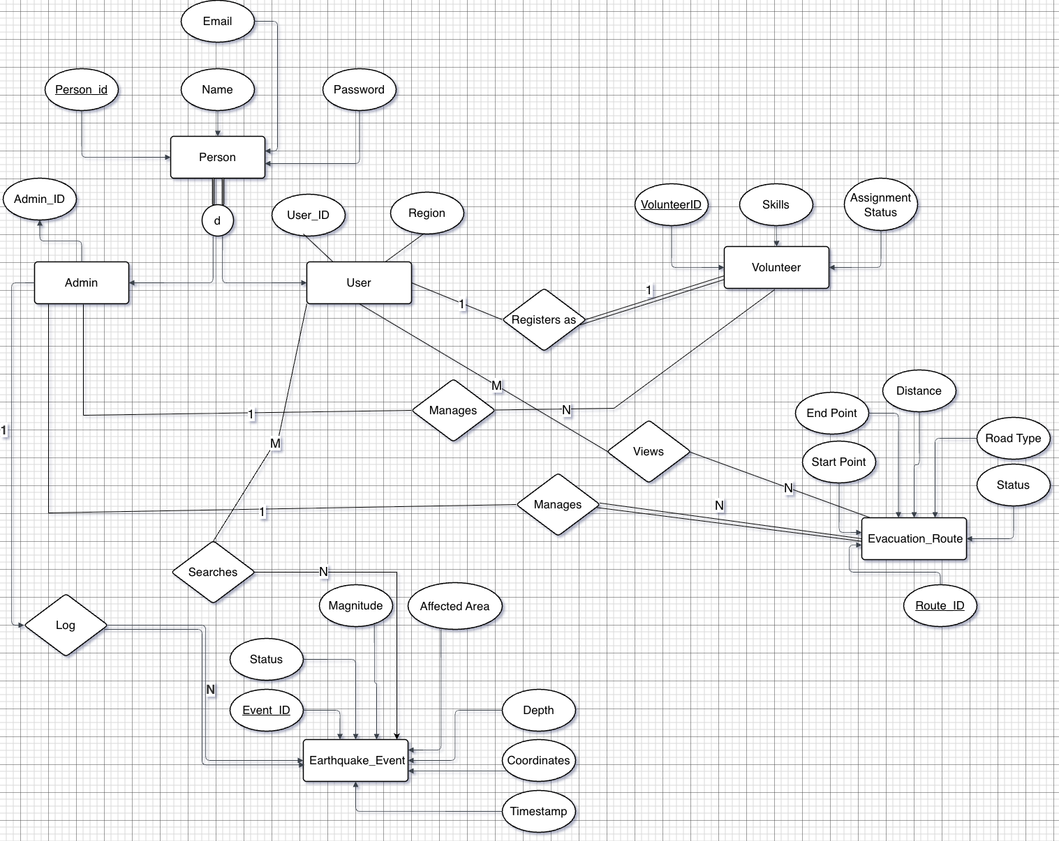

Schema Diagram
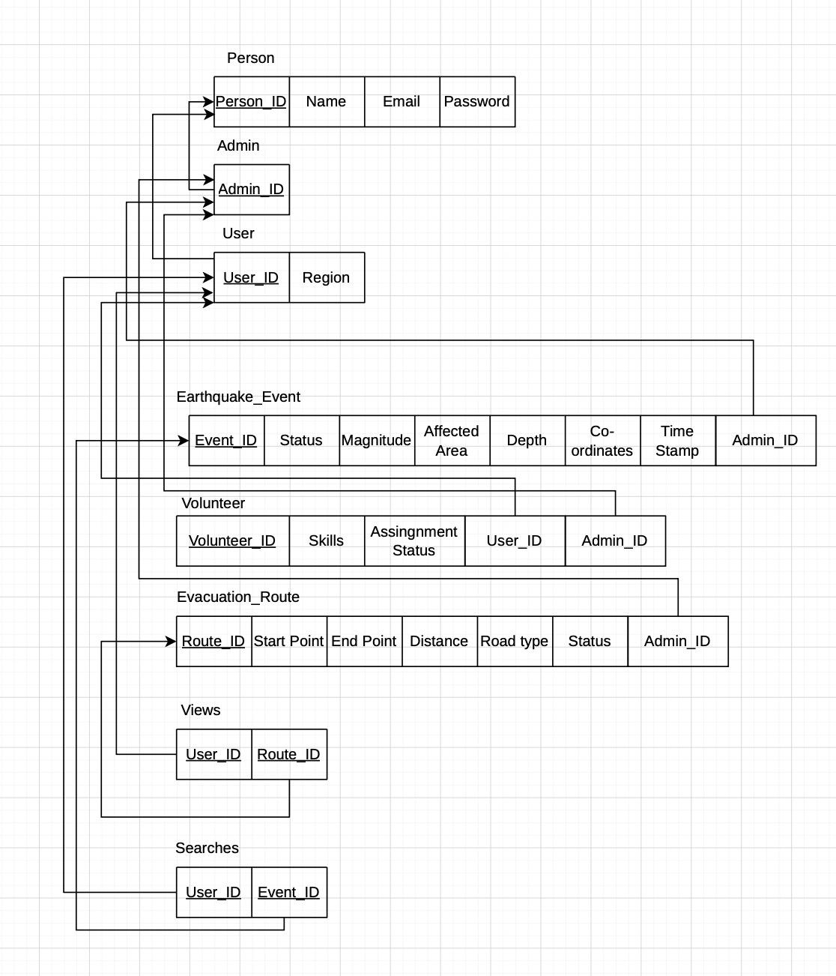

Normalization

- Explain if your converted Schema is in 1NF or not. If not, decompose it to 1NF.
- Explain if your converted Schema is in 2NF or not. If not, decompose it to 2NF. Can there be any partial functional dependencies in your relational schema?
- Explain if your converted Schema is in 3NF or not. If not, decompose it to 3NF. Can there be any transitive dependencies in your relational schema?

- Our Schema is already in 1NF
- Our Schema is already in 2NF
- Our Schema is already in 3NF

Frontend Development

Briefly discuss about Frontend Development and add relevant Screenshots (if required) by mentioning Individual Contributions

Contribution of ID : 24101416, Name : Afri Anjum Tutul

template/ directory
events.html
Displays all seismic events in a table using dynamic data from the backend (Jinja
templating).
Includes live filtering (area, magnitude, depth, status) using JavaScript.
Also provides role-based access where only admins can see Add, Edit, Delete options.
event_form.html
Used for both adding and editing seismic events.
The form takes inputs like magnitude, depth, coordinates, affected area, and status.
It also pre-fills existing data during editing and submits data to the backend using POST method.
user_dashboard.html
Provides a user-friendly dashboard interface with navigation to different modules like evacuation routes and volunteer registration.
Integrates the seismic system with the overall application.
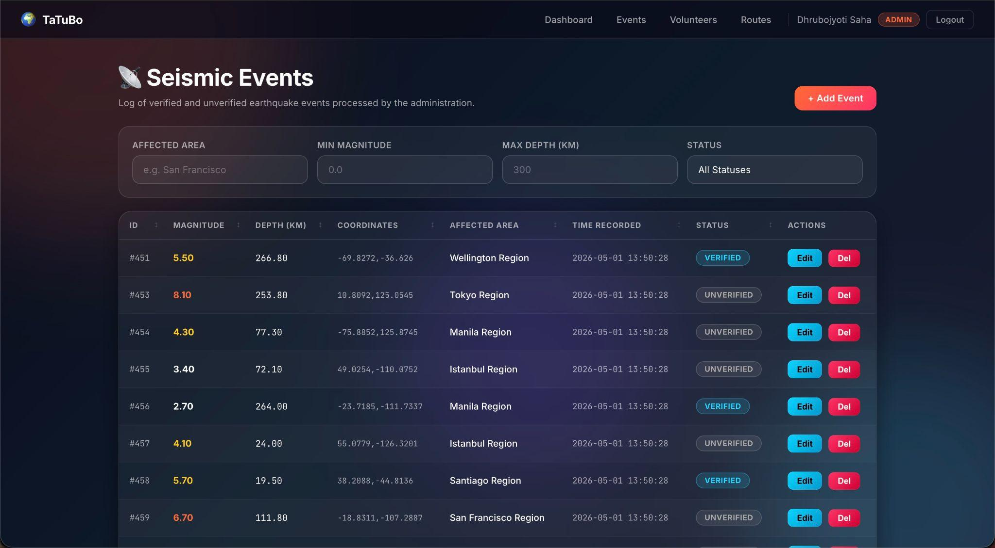

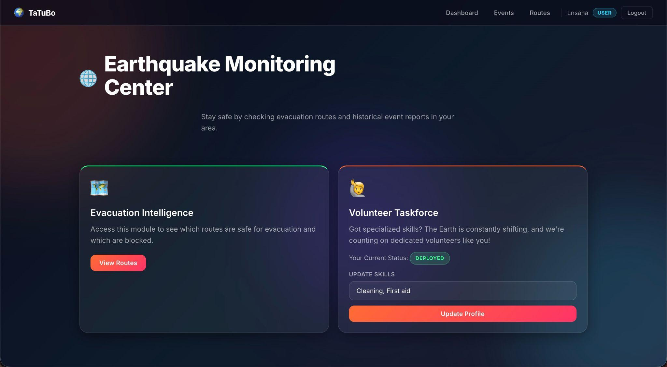

Contribution of ID : 24141016, Name : Tasnim Ramjan
template/ directory
volunteers.html
Displays all registered volunteers in a table using dynamic backend data.
Admins can view, edit, and delete volunteer records from this page.
volunteer_form.html
Reusable form page for volunteer editing and volunteer registration management.
Used by admins to add and manage volunteer information, while users can register themselves as volunteers through a dedicated volunteer registration option.
login.html
Provides login functionality for both Admin and User accounts using email and password authentication.
signup.html
Provides registration functionality for creating new User or Admin accounts with secure password handling.

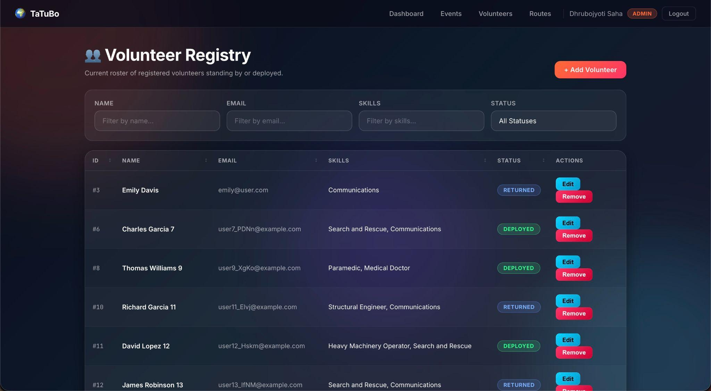
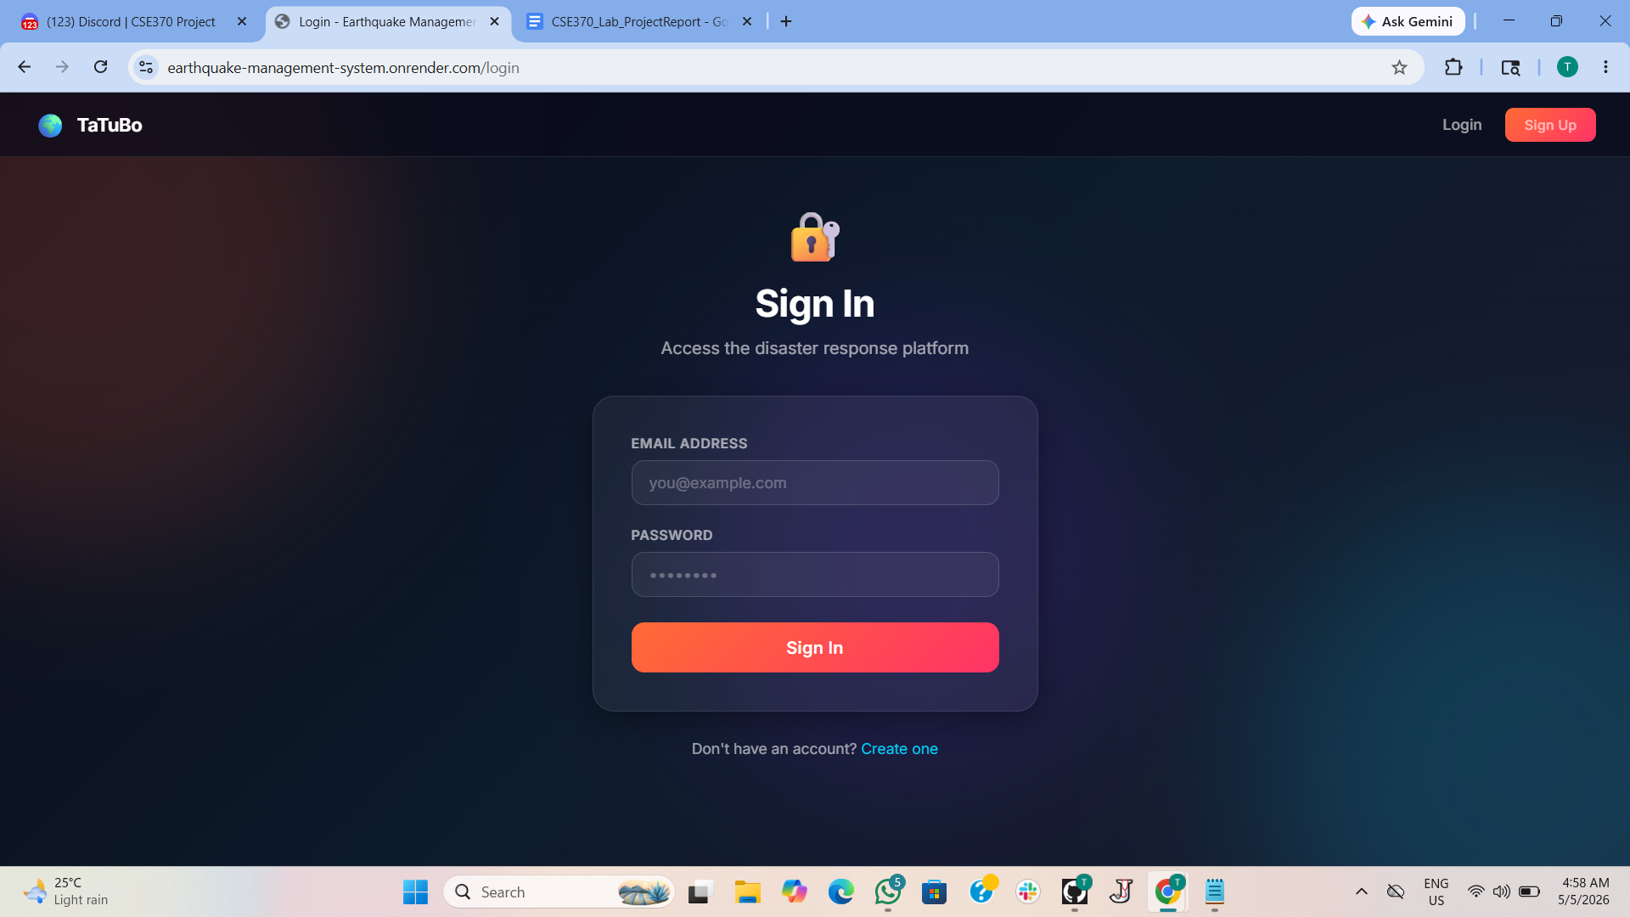
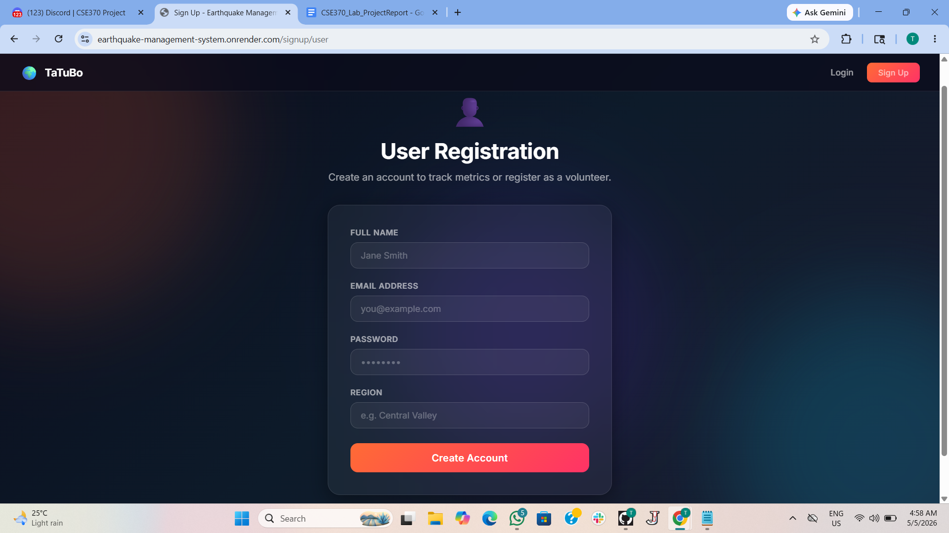

Contribution of ID : 24101279, Name : Dhrubojyoti Saha

static/style.css file is made using the help of premade template files from the internet ensuring a consistent, premium, and responsive visual experience.

static/script.jss (The client-side logic handler.)
Purpose: Adds dynamic interactivity to the UI without requiring page reloads from the server.
Features:
Table Sorting: Listens for clicks on table headers (th.sortable) and alphabetically/numerically sorts the rows in ascending or descending order using a custom comparer function
Multi-column Filtering: Listens to input and dropdown changes on the /volunteers, /events, and /routes pages. It dynamically hides or shows table rows based on whether the cell text matches the search criteria (e.g., searching for a specific skill or filtering by route status)
DOM Ready: Uses DOMContentLoaded event to ensure all elements are loaded before attaching event listeners.
template/ directory
base.html: The master layout file. It contains the <head>, global <nav>, animated background (.bg-canvas with blobs), and flash message rendering. All other templates extend this file, keeping the code DRY (Don't Repeat Yourself).
index.html: A generic dashboard template displaying overarching system statistics (total events, verified incidents, volunteers, disrupted routes) that serves as a foundational layout for system overviews.
routes.html : This displays routes that are added by the admin panel. Admin can add, edit and delete paths as needed.
routes_form.html : This is a reusable form page to create new routes from if signed in as admin.
admin_dashboard.html : While logged in as an admin, one can view the status of total events, verified incidents, active volunteers and disrupted routes from the dashboard. Also an admin can register another admin from this page, deploy volunteers, manage events and view routes.
admin_add_volunteer.html : This is a reusable page to register an existing user as volunteer or if the user doesn’t exist it will create a new user and register it as a volunteer.
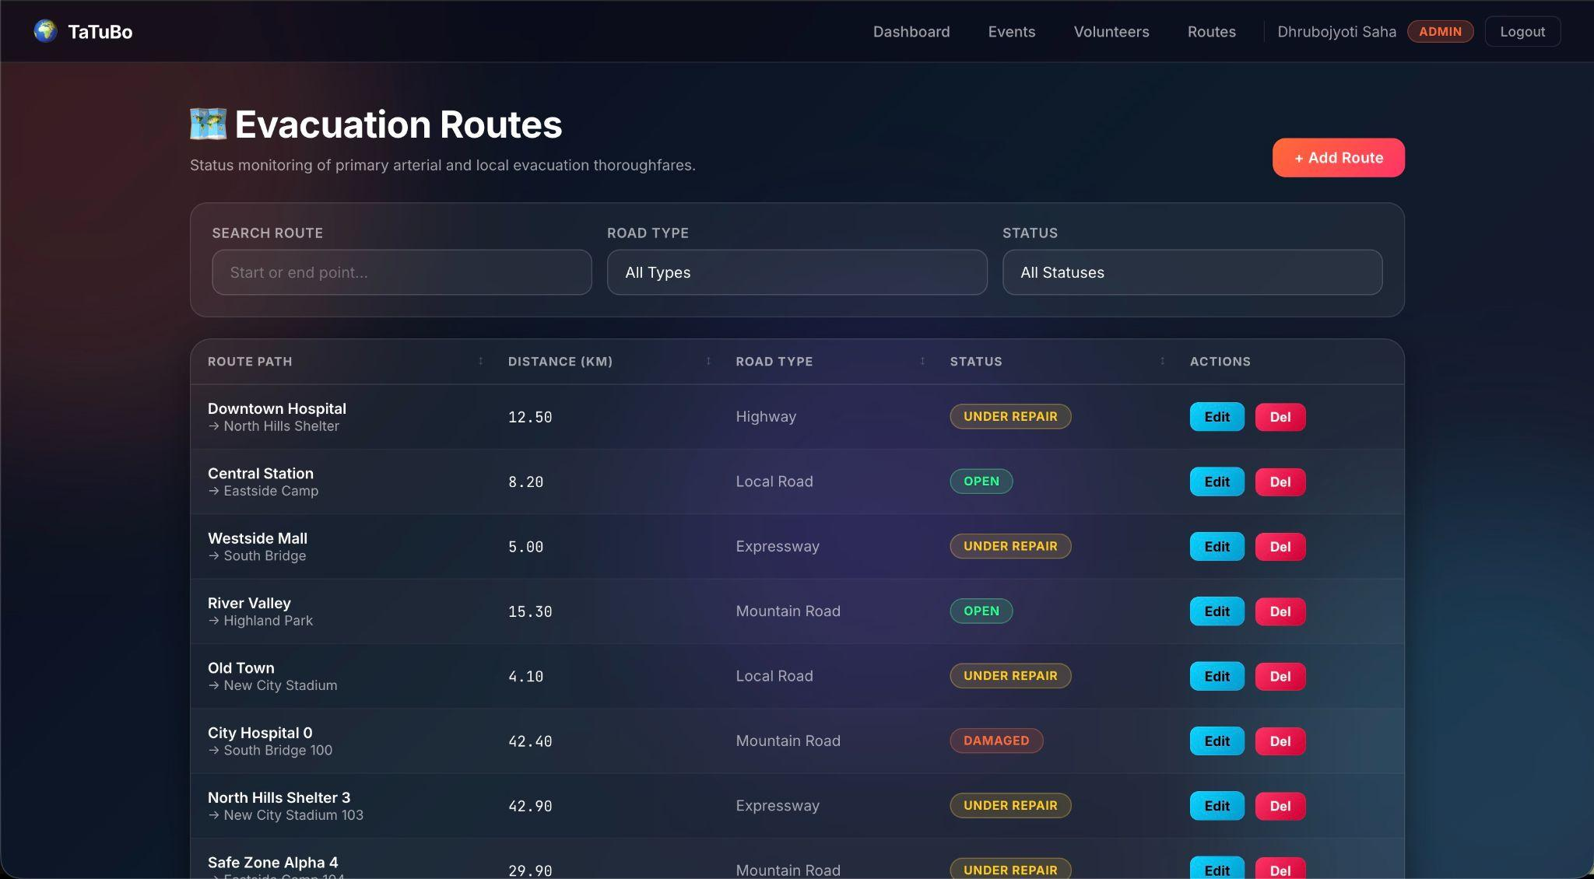

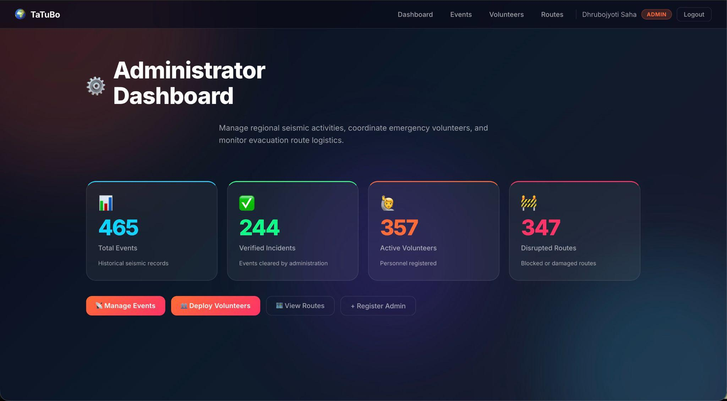

Backend Development

Briefly discuss about Backend Development and add relevant Screenshots (if required) by mentioning Individual Contributions

Contribution of ID : 24101416, Name : Afri Anjum Tutul

I implemented the backend logic for the Seismic Event Tracker, including all CRUD operations (Create, Read, Update, Delete), database connectivity, and integration with frontend pages using Flask routes.
events() – READ Operation
Fetches all seismic event records from the database using SQL query
SELECT * FROM Earthquake_Event ORDER BY Timestamp DESC.
Also retrieves distinct event statuses for filtering.
Data is then passed to the frontend (events.html) for display.
add_event() – CREATE Operation
Allows admin to add new earthquake events.
Uses POST request to insert data into the database:
INSERT INTO Earthquake_Event (...) VALUES (...).
After insertion, changes are saved using commit() and user is redirected to events page.
edit_event(id) – UPDATE Operation
Updates existing event details based on Event ID.
Uses SQL query:
UPDATE Earthquake_Event SET ... WHERE EventID=%s.
Existing data is first fetched and shown in form, then updated after submission.
delete_event(id) – DELETE Operation
Deletes a specific event using:
DELETE FROM Earthquake_Event WHERE EventID=%s.
Used to remove incorrect or duplicate records.
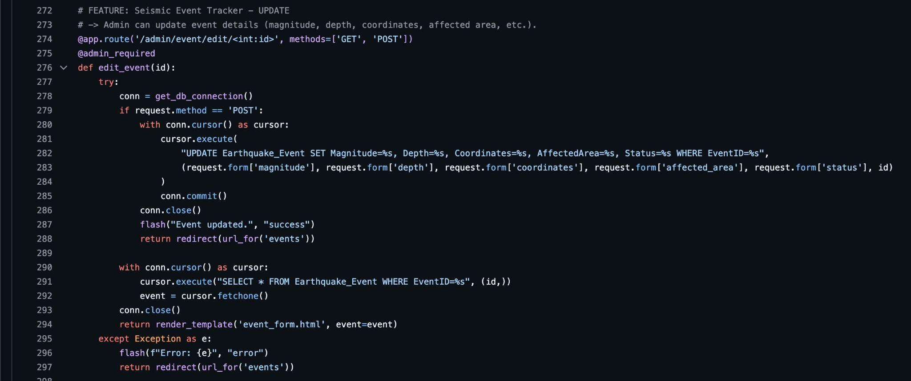

Contribution of ID : 24141016, Name : Tasnim Ramjan
I implemented the backend logic for the Volunteer Management and Authentication module, including volunteer registration, viewing, updating, deletion and user authentication functionalities using Flask routes and SQL queries.

volunteers() – READ Operation
Allows administrators to view all registered volunteers in the system.
Fetches volunteer information using SQL JOIN operations between the Volunteer, User,
and Person tables:
SELECT v.VolunteerID, p.Name, p.Email, v.Skills, v.AssignmentStatus
FROM Volunteer v
JOIN User u ON v.UserID = u.UserID
JOIN Person p ON u.UserID = p.PersonID
The retrieved data is then passed to volunteers.html for display.

admin_add_volunteer() – CREATE Operation
Allows administrators to register volunteers into the system.
The system first checks whether the person already exists in the database using:
SELECT * FROM Person WHERE Email=%s
If the user does not exist, a new account is created in the Person and User tables.
Then volunteer information is inserted into the Volunteer table with default status “Standby”.

register_volunteer() – CREATE / UPDATE Operation
Allows logged-in users to register themselves as volunteers or update their skills.
The system checks whether the user already has a volunteer profile:
SELECT * FROM Volunteer WHERE UserID=%s
If a profile exists, it updates the skills field; otherwise, it inserts a new volunteer record into the database.

edit_volunteer(id) – UPDATE Operation
Allows administrators to update volunteer information such as skills and assignment status (Standby, Deployed, Returned). Uses the SQL query:
UPDATE Volunteer SET Skills=%s, AssignmentStatus=%s, AdminID=%s WHERE VolunteerID=%s

delete_volunteer(id) – DELETE Operation
Removes inactive or unavailable volunteers from the system using:
DELETE FROM Volunteer WHERE VolunteerID=%s
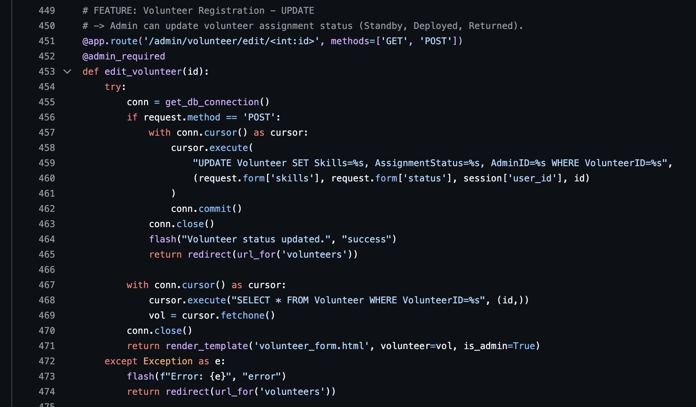

Contribution of ID : 24101279, Name : Dhrubojyoti Saha

The authorization, admin dashboard and signup
The system is built using a Flask-based routing architecture with role-based access control. When a user accesses the /dashboard route, the system first checks session data to verify authentication. If the user is not logged in, they are redirected to the login page. If authenticated, the system determines the user’s role and redirects them to either the administrator dashboard or the user dashboard.
For the administrator dashboard, the backend connects to the database and executes multiple SQL queries to retrieve aggregated system data. These include total earthquake events, verified incidents, registered volunteers, and disrupted evacuation routes. A try–except mechanism is used to handle potential database errors, ensuring system stability by returning default values when necessary.
For the user dashboard, the system retrieves personalized information by querying the Volunteer table using the logged-in user’s ID. It extracts details such as assignment status and skills, which are then displayed in the user interface.
Authorization is enforced through custom decorators (admin_required and user_required), which restrict access to specific routes based on user roles. Additionally, password security is maintained by storing hashed passwords in the database instead of plain text.
The Routes Backend logic
The Evacuation Route Management module implements full CRUD operations through Flask routes restricted to administrators using role-based access control.
For route creation, the /admin/route/add endpoint processes POST requests by inserting form data into the database using INSERT INTO Evacuation_Route (StartPoint, EndPoint, Distance, RoadType, Status, AdminID) VALUES (%s, %s, %s, %s, %s, %s);, followed by a commit.
For updating routes, the /admin/route/edit/<id> endpoint retrieves existing data with SELECT * FROM Evacuation_Route WHERE RouteID=%s; (GET request) and updates records using UPDATE Evacuation_Route SET StartPoint=%s, EndPoint=%s, Distance=%s, RoadType=%s, Status=%s WHERE RouteID=%s; (POST request).
For deletion, the /admin/route/delete/<id> endpoint removes records using DELETE FROM Evacuation_Route WHERE RouteID=%s;. Additionally, route data is displayed using SELECT * FROM Evacuation_Route;. All database interactions use parameterized queries to ensure security, along with proper transaction management and error handling for reliability.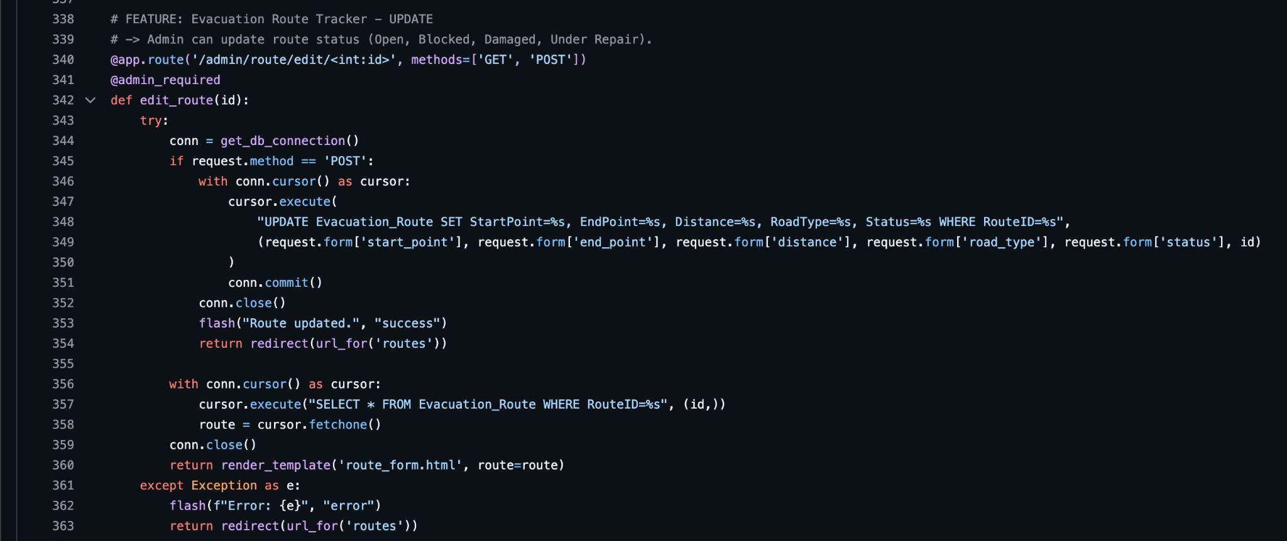

Source Code Repository

Upload source code to GitHub or Google Drive and share a publicly accessible link in this section of the report.

GitHub

Conclusion

We hope that this project will help humanity in need. We know there are lots to improve. From an academic perspective we have learned to use database and sql queries with practical implementation. We have implemented this project with python so that it will be easier for us if we want to further improve our project in future with ML models.

References

- https://claude.ai
- https://www.geeksforgeeks.org/
- https://www.w3schools.com/
- https://flask.palletsprojects.com/en/stable/
- https://pypi.org/project/PyMySQL/
- https://gemini.google.com/
- https://chatgpt.com/
- https://dev.mysql.com/doc/
- draw.io

