CAMPUS CHOIR ACCOMPLISHMENT REPORT
Period Covered: January -October 2025

AREA | Programs/Activities/ Projects | Photo Documentation | Unit/Personnel/Student Involves | Date and Place | No. Of Students Reached/ Involved |  | Remarks
 |  |  |  |  | Male | Female | Remarks
BISU BALILIHAN CAMPUS CHOIR | Opening mass for school year 2024- 2025 | 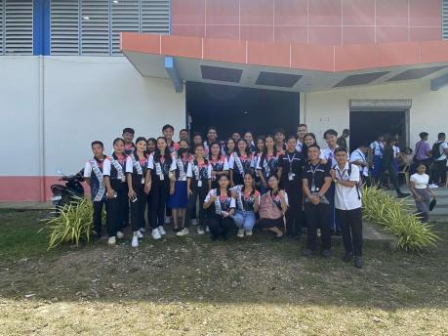  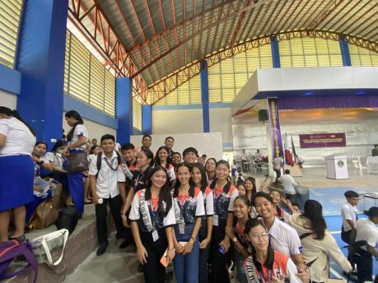 | BISU Balilihan Faculty and Staffs  Campus Choir Adviser  Campus Choir Trainor  Campus Choir Members  Students | August 19, 2024

Prepared by: Noted:

JESA RUBY G. ABUEVA MARC BENIGNO C. OLAGUIR, PhD
Campus Choir President Campus Choir Adviser

