To 14/08/2021

Accounts Department

EduVantage Private Limited

Delhi,

Dear Sir/Madam,

Sub: Confirmation of outstanding balance as on 31.03.2021.

I hereby confirm that total balance of Rs. 6200/- is due to be paid to me for all the assessments done by me till 31.03.2021. This accounts for all the batches done through me, as assessor or proctor or any in other capacity on or before 31st March 2021.

Thanking You

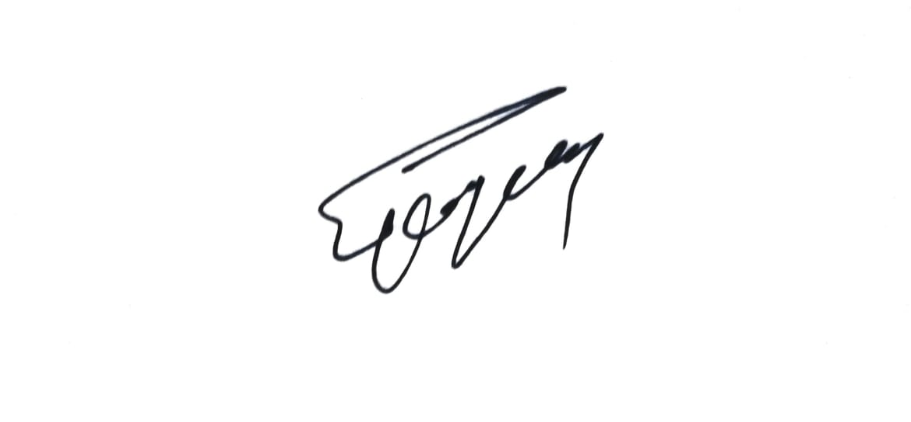

(Authorized Signatory)

**CONFIRMATION**

I *We agree that the above balance is correct. ( Rs.6200*/- )

Name Sanjay Kumar

Designation Proprietor Signature

Date 14 August 2021