**EXPERIMENT-1**

Amartya Sharma

500119407

Batch-1

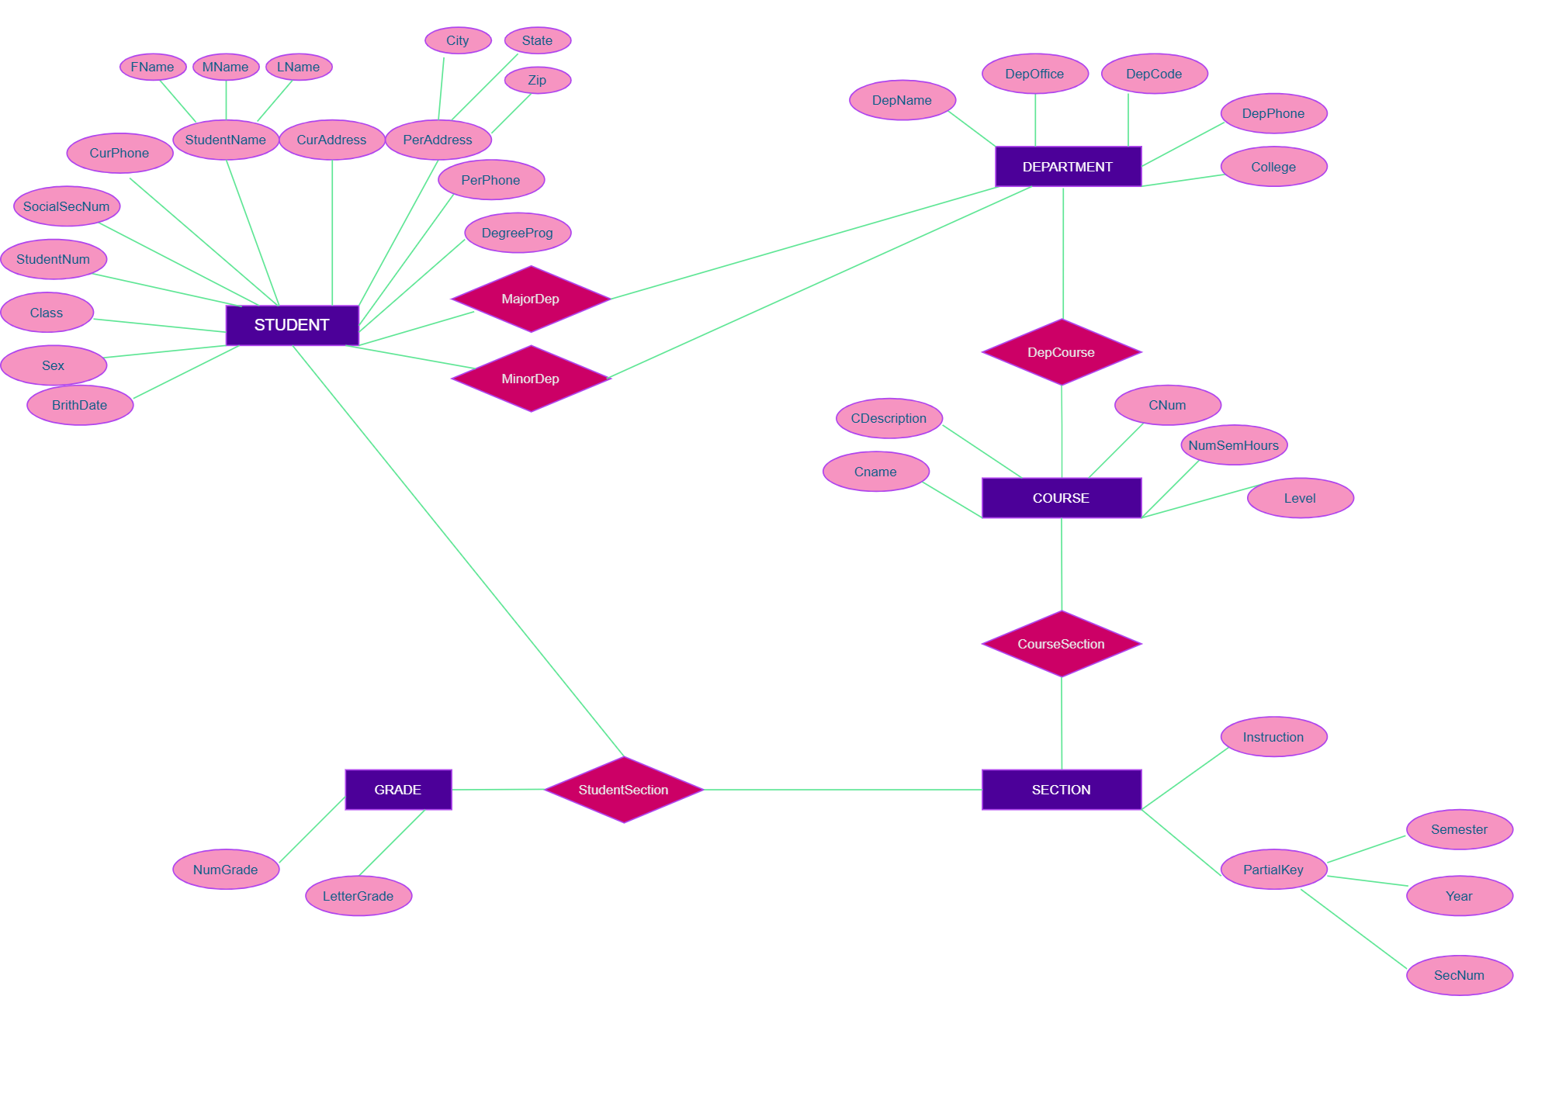

**Key Attributes for Each Entity Type**

**1. Student**

* **Key Attributes**:
  + **StudentID (PK)**: Unique identifier for each student.
  + **SocialSecNum (Unique)**: Social Security Number (optional but unique).
* **Other Attributes**:
  + First Name, Middle Name, Last Name.
  + Current Address (Street, City, State, ZIP), Permanent Address (Street, City, State, ZIP).
  + Current Phone, Permanent Phone.
  + Birth Date, Sex.
  + Class (Freshman, Sophomore, etc.).
  + Degree Program (e.g., B.A., B.S., Ph.D.).
  + Major Department (FK), Minor Department (FK, optional).

**2. Department**

* **Key Attributes**:
  + **DepCode (PK)**: Unique code for each department.
* **Other Attributes**:
  + Department Name (Unique).
  + Office Number, Office Phone.
  + College.

**3. Course**

* **Key Attributes**:
  + **CourseNum (PK)**: Unique identifier for each course.
* **Other Attributes**:
  + Course Name, Course Description.
  + Number of Semester Hours.
  + Level (e.g., Undergraduate, Graduate).
  + Offering Department (FK).

**4. Section**

* **Key Attributes**:
  + **SectionID (PK)**: Unique identifier for each section.
* **Other Attributes**:
  + Section Number (distinguishes sections of the same course within the same semester).
  + Semester, Year.
  + Instructor.
  + CourseNum (FK).

**5. Grade Report**

* **Key Attributes**:
  + **GradeID (PK)**: Unique identifier for each grade report (can be a composite of StudentID and SectionID).
* **Other Attributes**:
  + StudentID (FK), SectionID (FK).
  + Letter Grade.
  + Numeric Grade (0–4).