EXPERIMENT-15

Amartya Sharma

500119407

Batch-1

create database lab15;

use lab15;

-- Create EMPLOYEES table

CREATE TABLE EMPLOYEES (

employee_id INT PRIMARY KEY,

first_name VARCHAR(50),

last_name VARCHAR(50),

salary DECIMAL(10, 2)

);

-- Insert sample data into EMPLOYEES table

INSERT INTO EMPLOYEES (employee_id, first_name, last_name, salary)

VALUES

(1, 'John', 'Doe', 2000),

(2, 'Jane', 'Smith', 3000),

(3, 'Robert', 'Johnson', 4000),

(4, 'Emily', 'Davis', 1500);

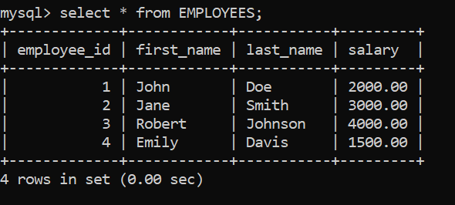

-- Update salaries and count the number of records updated

DELIMITER $$

CREATE PROCEDURE UpdateSalaries()

BEGIN

DECLARE rows_updated INT;

-- Update salaries

UPDATE EMPLOYEES

SET salary = salary * 1.10;

-- Get the number of affected rows

SET rows_updated = ROW_COUNT();

-- Display the result

IF rows_updated = 0 THEN

SELECT 'No Change' AS Message;

ELSE

SELECT CONCAT(rows_updated, ' record(s) updated') AS Message;

END IF;

END$$

DELIMITER ;

-- Call the procedure

CALL UpdateSalaries();

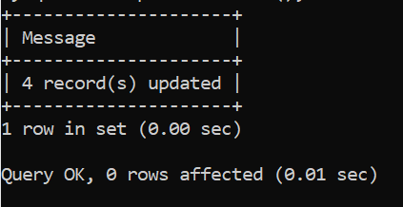

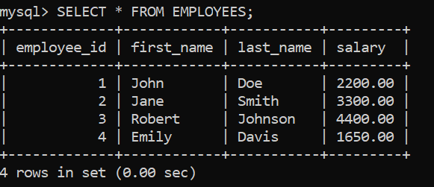

DELIMITER $$

CREATE PROCEDURE FetchEmployeeDetails()

BEGIN

DECLARE done INT DEFAULT 0;

DECLARE emp_id INT;

DECLARE emp_name VARCHAR(100);

DECLARE emp_salary DECIMAL(10, 2);

-- Cursor declaration

DECLARE emp_cursor CURSOR FOR

SELECT employee_id, CONCAT(first_name, ' ', last_name), salary FROM EMPLOYEES;

-- Handler for end of data

DECLARE CONTINUE HANDLER FOR NOT FOUND SET done = 1;

-- Open the cursor

OPEN emp_cursor;

FETCH emp_cursor INTO emp_id, emp_name, emp_salary;

-- Loop through the cursor

REPEAT

IF NOT done THEN

SELECT emp_id AS Employee_ID, emp_name AS Name, emp_salary AS Salary;

END IF;

FETCH emp_cursor INTO emp_id, emp_name, emp_salary;

UNTIL done END REPEAT;

-- Close the cursor

CLOSE emp_cursor;

END$$

DELIMITER ;

-- Call the procedure

CALL FetchEmployeeDetails();

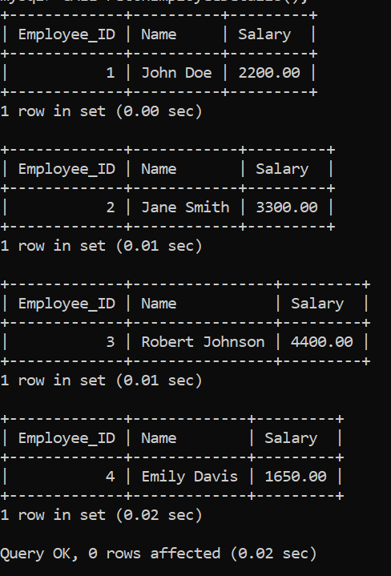

-- Create TEMP_EMP table

CREATE TABLE TEMP_EMP (

employee_id INT PRIMARY KEY,

last_name VARCHAR(50),

salary DECIMAL(10, 2)

);

DELIMITER $$

CREATE PROCEDURE InsertHighSalaryEmployees()

BEGIN

DECLARE done INT DEFAULT 0;

DECLARE emp_id INT;

DECLARE emp_last_name VARCHAR(50);

DECLARE emp_salary DECIMAL(10, 2);

-- Cursor declaration

DECLARE emp_cursor CURSOR FOR

SELECT employee_id, last_name, salary FROM EMPLOYEES WHERE salary > 2500;

-- Handler for end of data

DECLARE CONTINUE HANDLER FOR NOT FOUND SET done = 1;

-- Open the cursor

OPEN emp_cursor;

FETCH emp_cursor INTO emp_id, emp_last_name, emp_salary;

-- Loop through the cursor

REPEAT

IF NOT done THEN

INSERT INTO TEMP_EMP (employee_id, last_name, salary)

VALUES (emp_id, emp_last_name, emp_salary);

END IF;

FETCH emp_cursor INTO emp_id, emp_last_name, emp_salary;

UNTIL done END REPEAT;

-- Close the cursor

CLOSE emp_cursor;

-- Display inserted data

SELECT * FROM TEMP_EMP;

END$$

DELIMITER ;

-- Call the procedure

CALL InsertHighSalaryEmployees();

