**EXPERIMENT-2**

Amartya Sharma

500119407

Batch-1

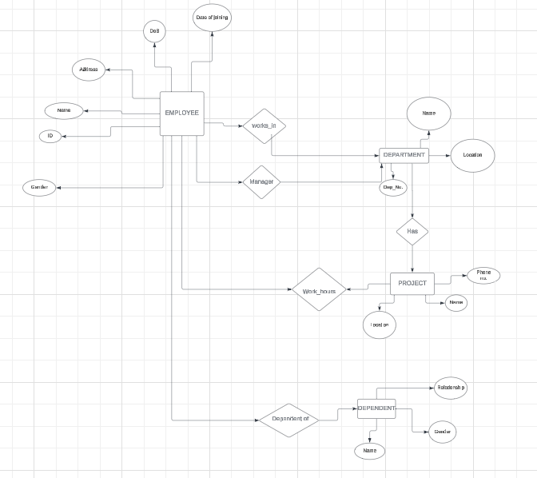

**Key Attributes for Each Entity Type**

**1. Employee**

* **Key Attributes**:
  + **EmployeeID (PK)**: Unique identifier for each employee.
* **Other Attributes**:
  + Name: Full name of the employee.
  + Gender: Gender of the employee.
  + DateOfBirth (DoB): Birthdate of the employee.
  + Address: Employee's residential address.
  + DateOfHiring: Date the employee was hired.

**2. Department**

* **Key Attributes**:
  + **DepartmentNumber (PK)**: Unique identifier for each department.
* **Other Attributes**:
  + Name: Name of the department.
  + Location: Physical location of the department.

**3. Project**

* **Key Attributes**:
  + **ProjectNumber (PK)**: Unique identifier for each project.
* **Other Attributes**:
  + Name: Name of the project.
  + PhoneNumber: Contact number for the project.

**4. Dependent**

* **Key Attributes**:
  + **DependentID (PK)**: Unique identifier for each dependent.
* **Other Attributes**:
  + Name: Full name of the dependent.
  + RelationToEmployee: Relation of the dependent to the employee (e.g., spouse, child).

**Structural Constraints on Relationships**

**1. Employee ↔ Department**

* **Relationship**: works_in
* Each employee works in one department, but a department can have many employees.
* **Cardinality**: 1

(One Department ↔ Many Employees).

* **Relationship**: Manager
* A department has one manager, and an employee can manage only one department.
* **Cardinality**: 1:1 (One Department ↔ One Manager).

**2. Department ↔ Project**

* **Relationship**: Has
* Each department can manage multiple projects, but a project belongs to one department.
* **Cardinality**: 1

(One Department ↔ Many Projects).

**3. Employee ↔ Project**

* **Relationship**: Work_hours
* An employee can work on multiple projects, and a project can have multiple employees working on it.
* **Attributes**:
  + WorkHours: Number of hours the employee works on the project.
* **Cardinality**: M

(Many Employees ↔ Many Projects).

**4. Employee ↔ Dependent**

* **Relationship**: Dependent_of
* An employee can have multiple dependents, but each dependent is related to only one employee.
* **Cardinality**: 1

(One Employee ↔ Many Dependents).

**Assumptions or Unspecified Requirements**

1. **Employee Address**:
   * Assumed to be a single field. If detailed address fields are required (e.g., street, city, ZIP), the entity can be extended.
2. **Manager Relationship**:
   * Assumed that every department must have exactly one manager and each employee manages at most one department. If no manager is assigned to a department, the constraint should be relaxed.
3. **Dependent Relationship**:
   * Dependents are assumed to be optional (an employee may not have any dependents).
4. **Project Phone Number**:
   * Assumed to be the primary contact for the project team or project office.