**DBMS LAB-6**

**Amartya Sharma**

**500119407**

**Batch-1**

**1.Create tables**

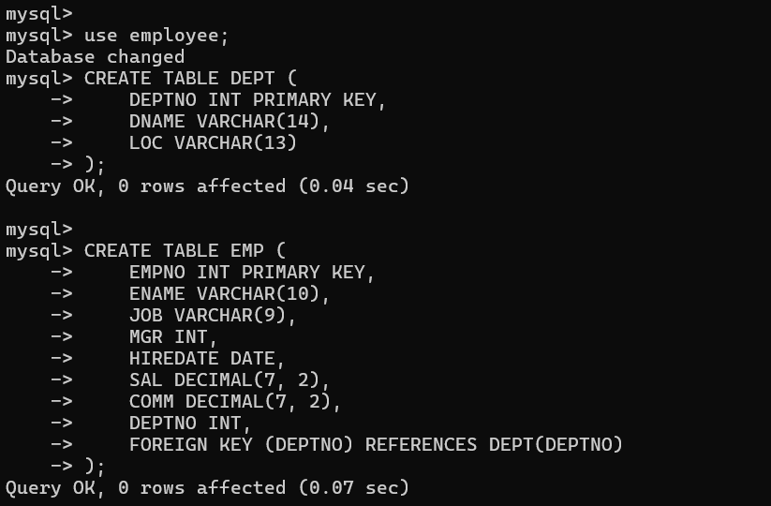

**2.Insert values**

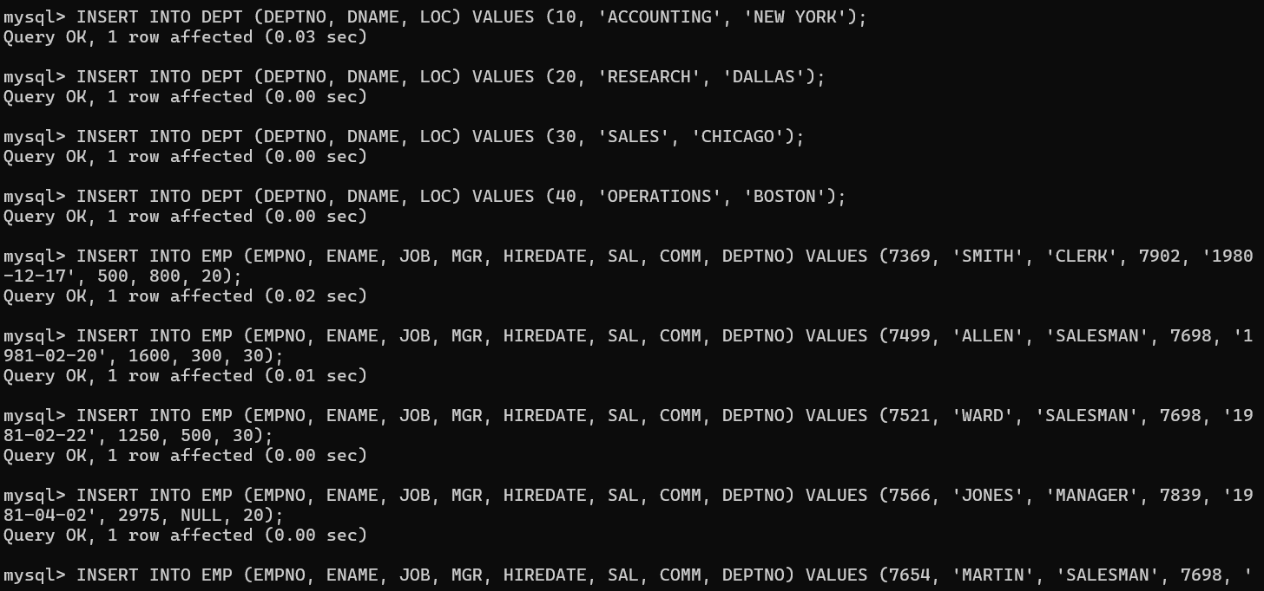

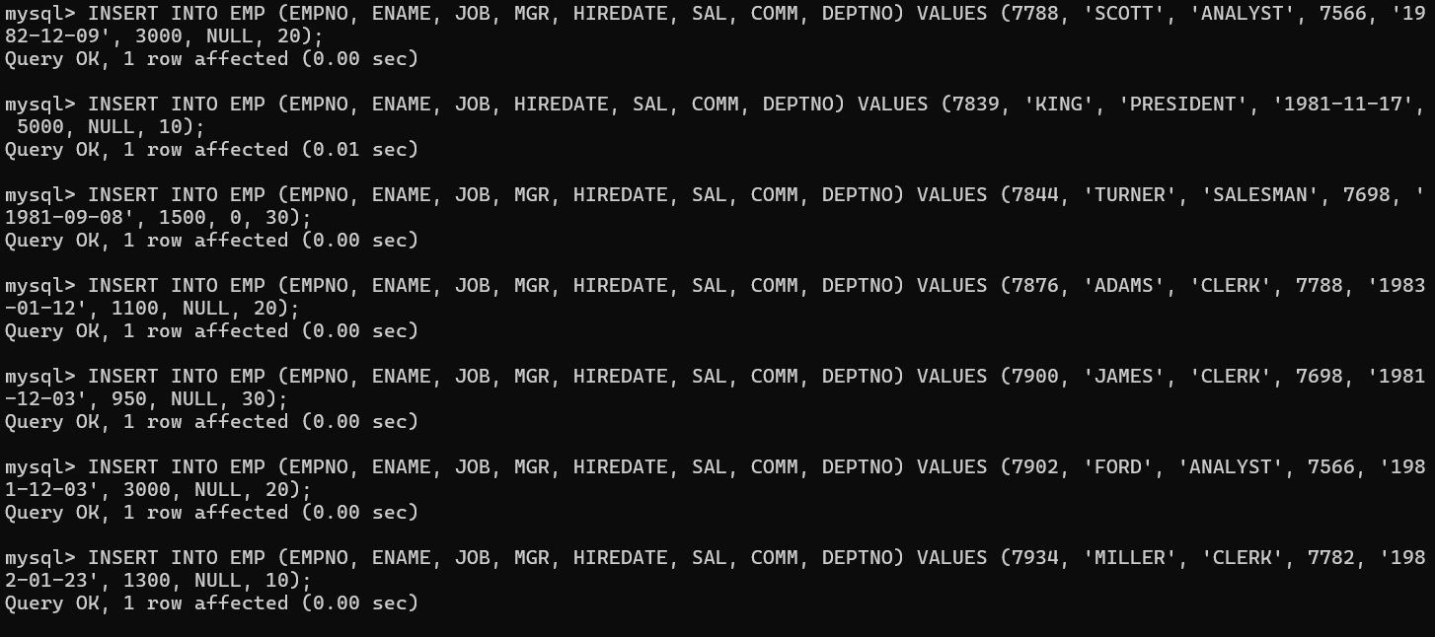

**3.Displaying tables**

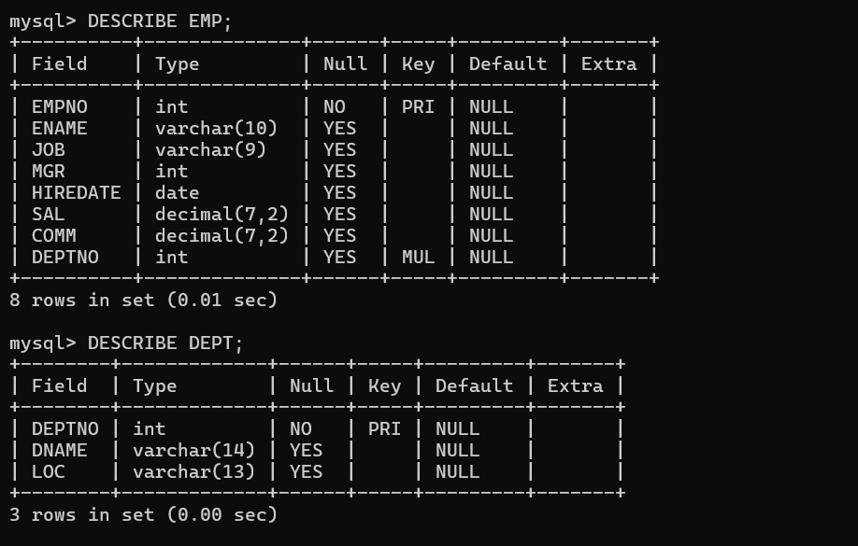

**Retrieve average salary of all employees.**

1. **Retrieve the number of employees.**
2. **Retrieve distinct number of employee.**
3. **Retrieve total salary of employee group by job.**
4. **Display the employee information with maximum salary.**

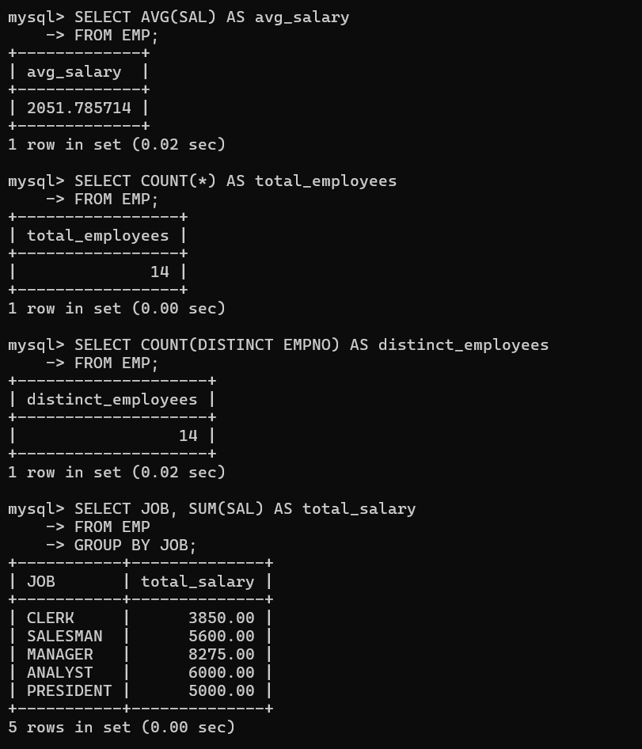

**Find the highest paid employee in department 10.**

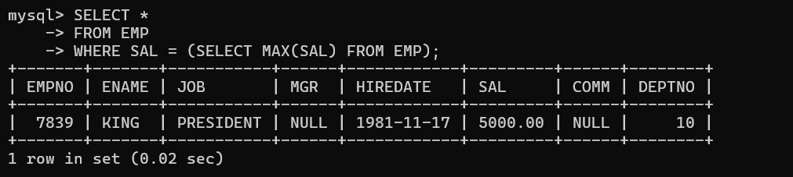

**List the emps whose sal is equal to the average of max and minimum.**



**List the emps who joined in the company on the same date.**

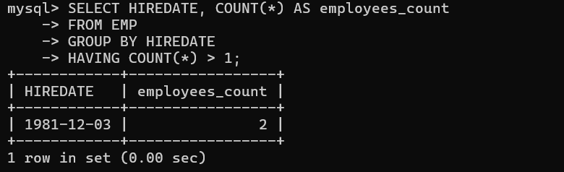

**Display the employee names in upper and lower case.**

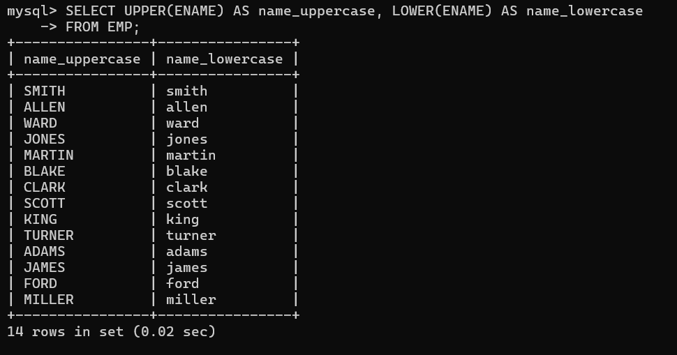

**Find the date of 3 days later from hiredate.**

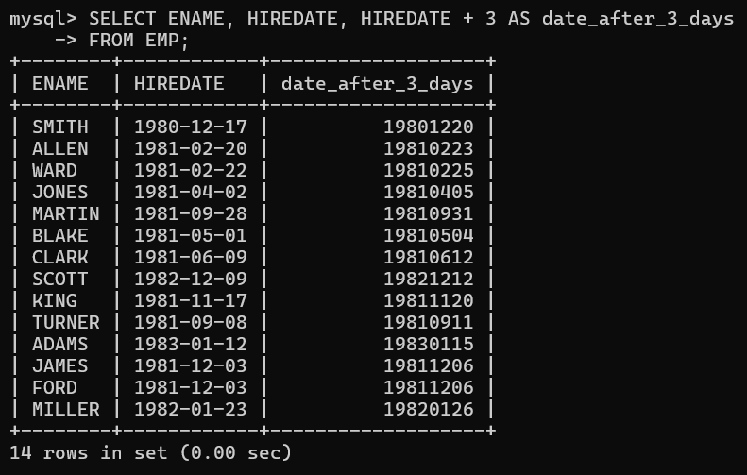

**Display the employee information with 2nd maximum salary.**

