

External Documentation - Game with Zombies

Robin Calamatta

December 10, 2014

Table of Contents

Version History 3

Game Description 4

Controls 5

Interface Sketch 6 - 9

Screen Descriptions 10

Game World 11

Levels 12

Characters 13

Enemies 14

Scoring 15

Sound Index 16

Version History

Detailed Game Description

The game is a classic zombie survival, you are one of the few strong men left in the world, your mission, to kick ass and save survivors from death.

Controls

Move Forward: UP ARROW

Stop: DOWN ARROW

Turn Left: LEFT ARROW

Turn Right: RIGHT ARROW

Reset: SPACEBAR (Only if the user is dead)

Screen Descriptions

Menu Screen

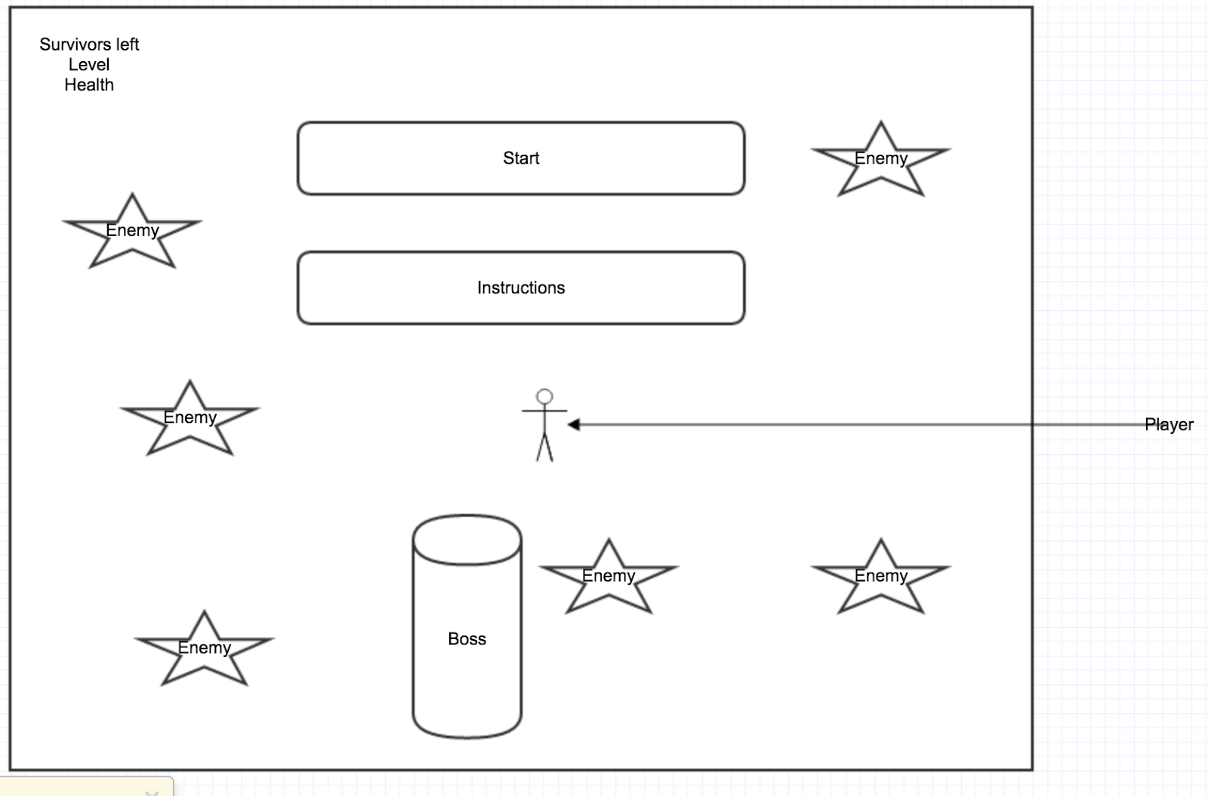

Instructions screen

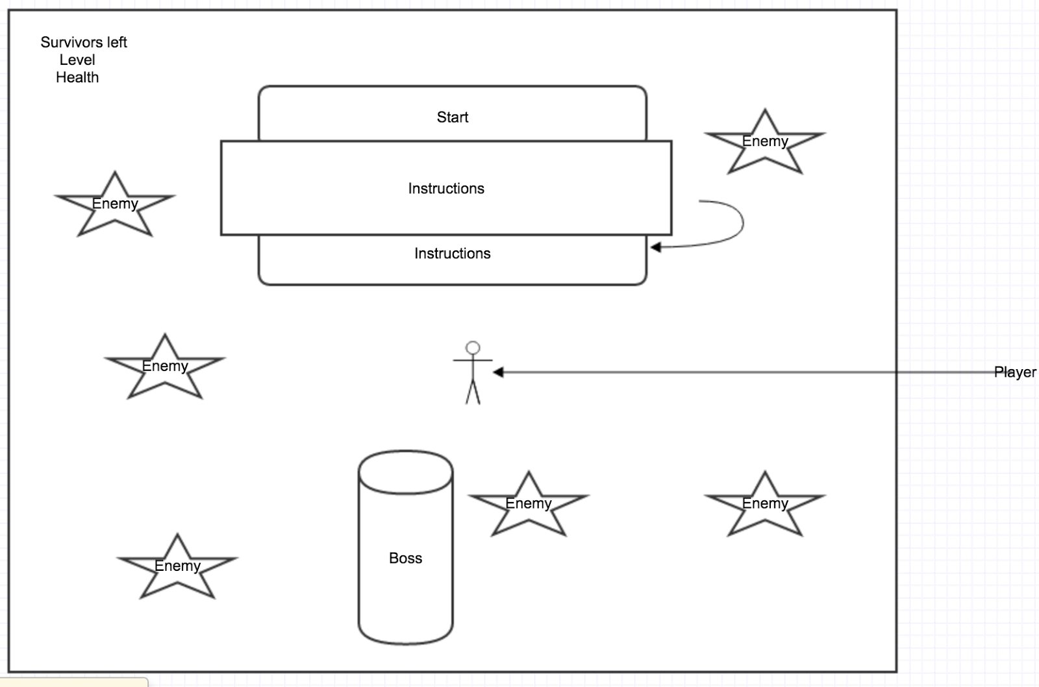

Game Over Screen

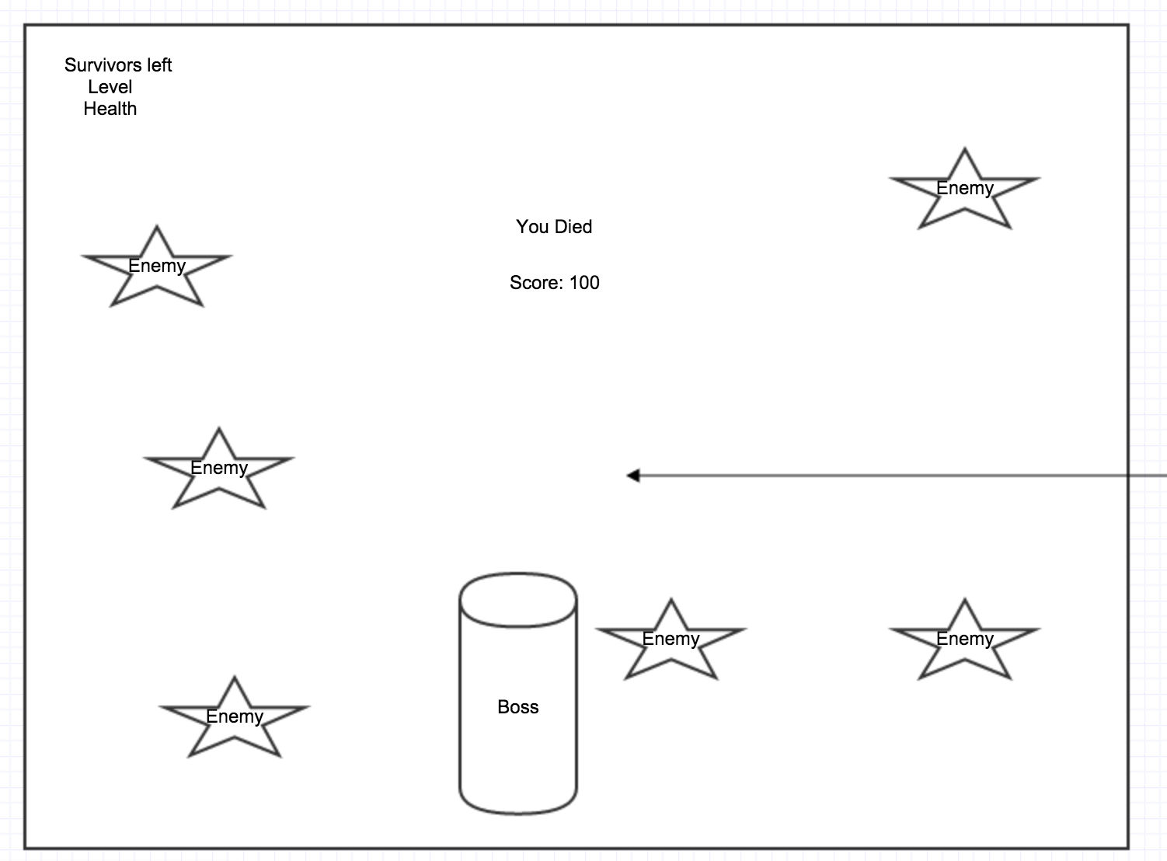

Game Screen

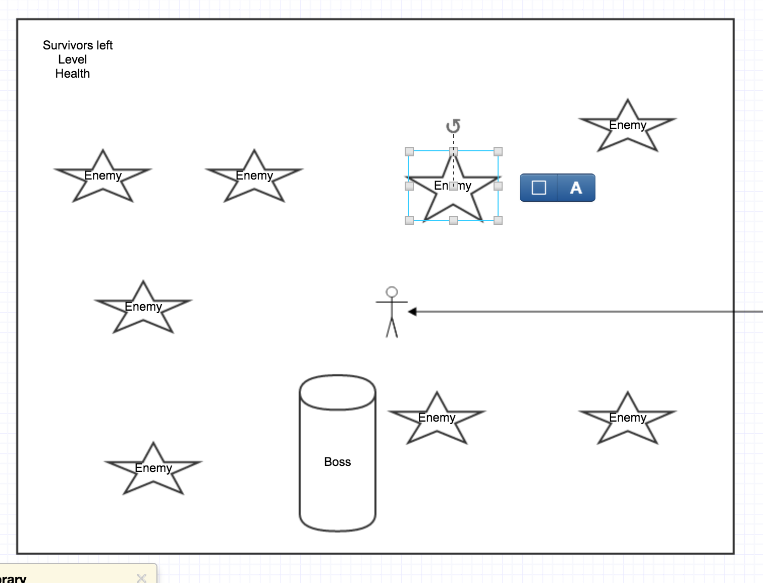

Game World

The game world is a tiled, post apocalyptic style map. The parameters go beyond the screen, giving the user the ability to travel around much more than he can see.

Levels

The levels increase as all of the innocent people are collected. Initially, there is only one type of minion, and then after the first level, the next minion is placed on the map, doing more damage. There are also more minions put on the map and a boss minion.

Characters

 - Cheerleader

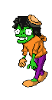- Boss Zombie

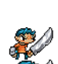- Survivor

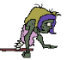- Zombie Chick

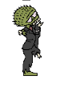- Zombie Dude

- Hero

Instructions Menu

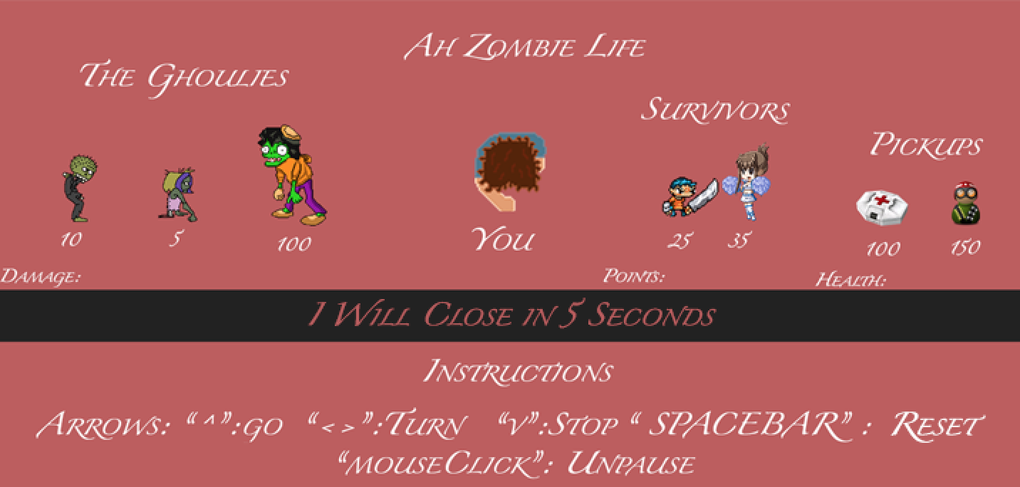

Instructions button



Start Button



Health Powerup

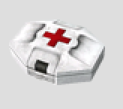

Armour Powerup



Scoring

Zombie girl = 25 points

Zombie guy = 35 points

Multimedia Index

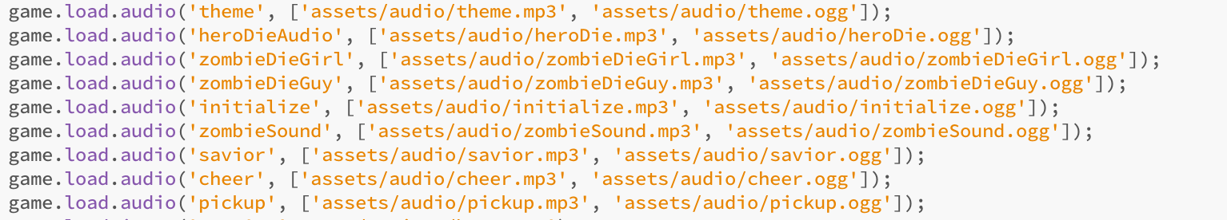

Citing

Thanks go out to the guys from Phaser.Js who created the framework which I used for my game.