FLASHNET
Potential Builders PBX System
PREPARED BY: Ayaan Jamal
DATE: 21TH February 2026

1.1 Introduction

This deployment consists of a Yeastar S20 IP PBX connected directly to a ZLT X25 Max2 router. The Yealink W70B DECT base station is also directly connected to the same router.
The router provides:
- Internet connectivity (LTE via Airtel)
- DHCP services
- Local LAN communication between PBX and base station
1.2 Device Information
System Components:
- IP Phone: Yealink W71H
- Base Station: Yealink W70B
- PBX: Yeastar S20
- Internet Router: ZLT X25 Max2 (Airtel Home Wi-Fi)
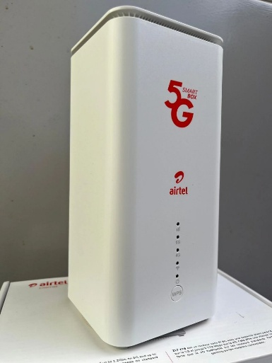
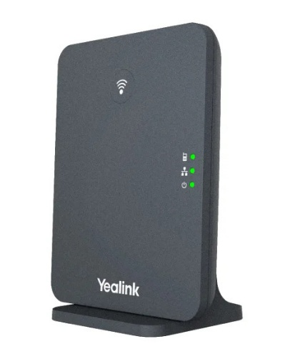

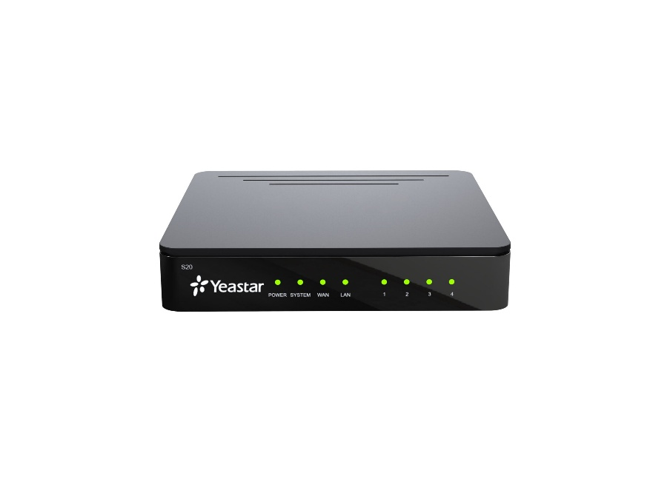

Fig 1.2 Yealink S20

Fig 1.3 Yealink S20

Fig 1.2 Yealink W70B

Fig 1.1 Airtel Home Wi-Fi Router

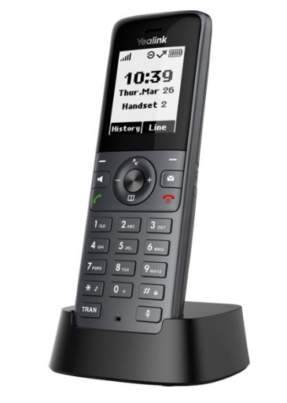

Fig 1.4 Yealink W71H

2. IP Addressing Scheme

All the devices obtain connectivity directly from the router.

2.1 Recommended Configuration
Device | IP Method | Recommended IP | Username | Password
Router | Default | 192.168.1.1 | Admin | Admin
Yeastar S20 | Static | 192.168.1.69 | admin | Admin@2026
W70B Base | Static | 192.168.1.70 | admin | Admin@123
DHCP Pool | Automatic | 192.168.1.100-200

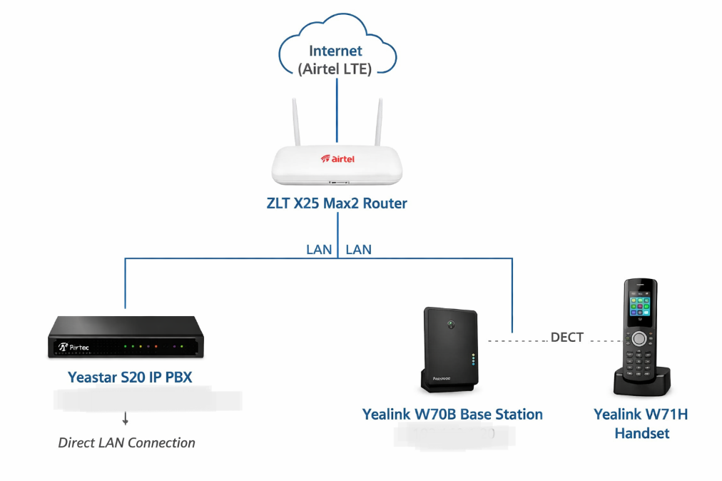

Fig 1.5 Topology of the System

2.2 Installing Active Directory Domain Services

Log into router (http://192.168.1.1).

Confirm internet and both LANS are active.

Enable DHCP.

5. Yeastar S20 Configuration
5.1 Access PBX
Connect to LAN.
Access via browser:

http://192.168.1.10
Change default admin password immediately.

5.2 Create SIP Extension

Navigate to:
PBX → Extensions → Add

Example:

Field Value
Extension 101
Type SIP
Password Strong Password

Save and apply.
Repeat for additional users.

5.3 Access Web Interface

- Find IP via router DHCP list.
- Access:
http://192.168.1.69
- Login.
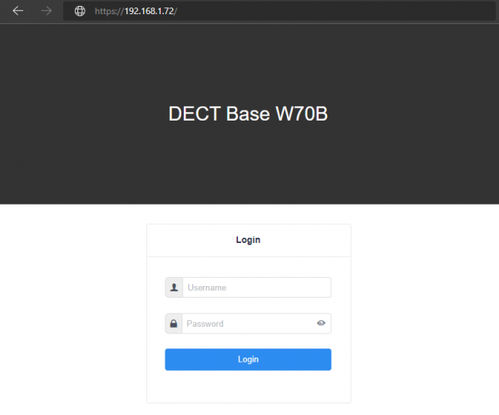

1.6 Login Page for W70B

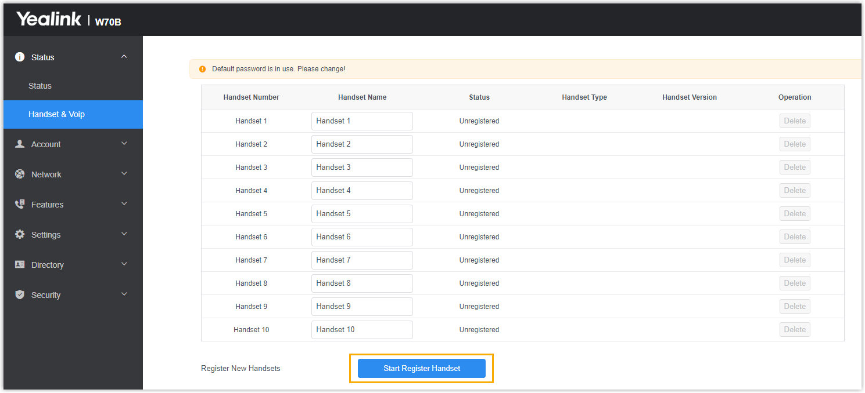
1.7 Registering Wireless Handsets W71H

Register Base to PBX
Go to: Account → Register
Field | Value
Register Name | 500
Username | 500
Password | Extension Password
SIP Server | 192.168.1.10
Confirm registration.
Status must show: Registered
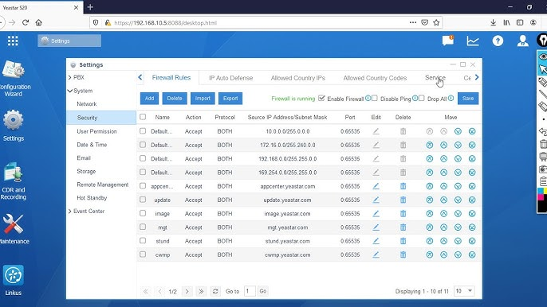

1.8 PBX Menu for Configuration of Extensions and to Connect to Base

Customer Support Contacts
Email | cs@flashnet.co.tz, support@flashnet.co.tz
Call/WhatsApp | +255 22 2113687 (Call), +255-777- 988-883 (WhatsApp)

