FLASHNET
NetGate 1100 Documentation
PREPARED BY: Ayaan Jamal
DATE: 23TH February 2026

- Device Overview
The Netgate 1100 is a small-form-factor firewall/router appliance designed by Netgate.
Hardware Features
- 3x 1GbE switch ports (WAN/LAN configurable)
- ARM-based CPU
- Console access via micro-USB
- Pre-installed pfSense Plus

Default Settings
- LAN IP: 192.168.1.1
- Username: admin
- Password: pfsense

2. Device Information

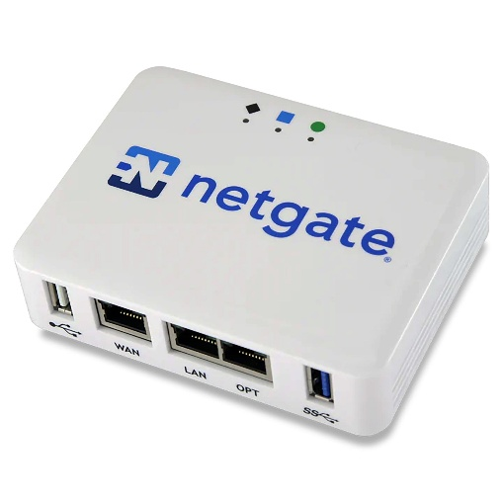

Fig 1.1 NetGate 1100 Appliance

2.1 Physical Setup
- Step 1: Cabling
Connect WAN port to ISP modem.
Connect LAN port to PC or switch.
Power on device.
- Step 2: Access Web GUI
From a LAN-connected PC:
- http://192.168.1.1
Login with default credentials.

2.2 Physical Connectivity
To get started, connect the cables in this specific order:
- WAN Port: Connect to your Internet Service Provider (ISP) modem.
- LAN Port: Connect to your computer or a network switch.
- Console Port: (As seen in your screenshot) Connect to your PC via Micro-USB to use PuTTY.
- Power: Plug in the 12V adapter.
  - Note: Wait 4–5 minutes for the system to boot fully.

2.3 Initial Software Configuration
Once the boot loader menu (from your screenshot) finishes, you will see the pfSense Console Menu.

1. The Console Menu (Serial Access)
If you need to change settings before the web interface is accessible, use these common options:
- Option 2: Set Interface IP Address (Use this if you need to change the default 192.168.1.1).
- Option 3: Reset Admin Password (Useful if you're locked out).
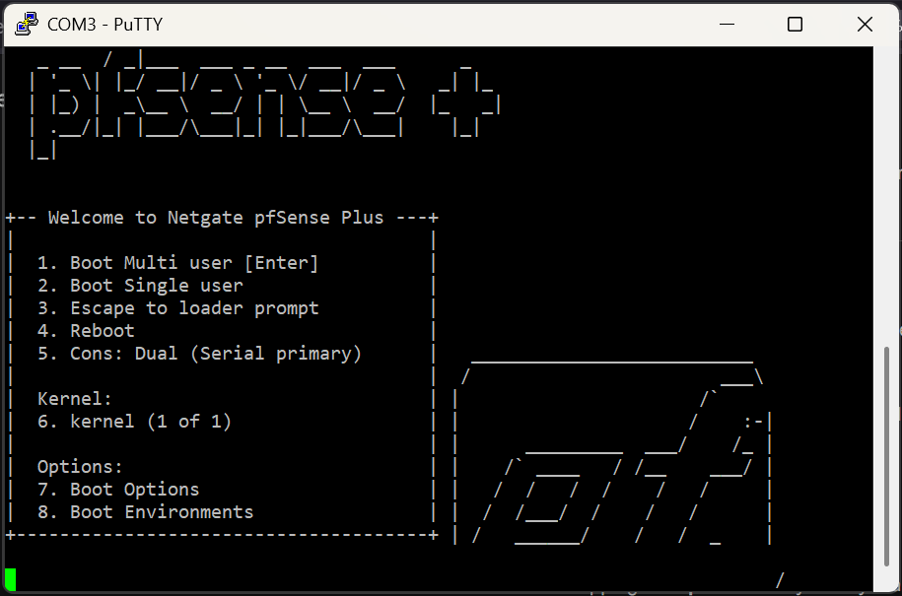
- Option 4: Reset to Factory Defaults.

Fig 1.2 PF Sense serial controller through PuTTY

2. The WebGUI (The Main Interface)
Most users will manage the device here.
- Default URL: https://192.168.1.1
- Default Username: admin
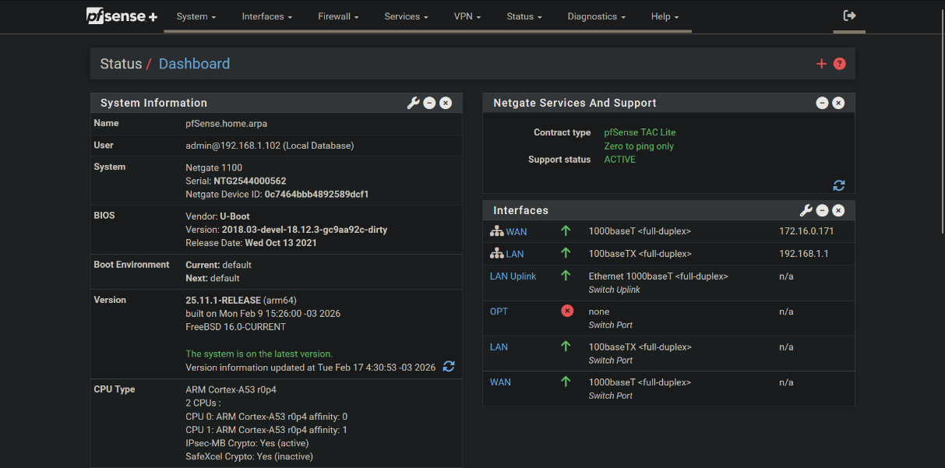
- Default Password: pfsense

Fig 1.3 PFsense through the webGUI

Section 3: Advanced Security Services (Packages)
The real power of the Netgate 1100 lies in its ability to run enterprise-grade security packages. In your demo, navigate to System > Package Manager.
- pfBlockerNG: This is the most popular add-on. It blocks ads, malicious domains, and entire countries (Geo-IP blocking) at the DNS level.
- Snort or Suricata: These are IDS/IPS (Intrusion Detection/Prevention Systems). They inspect packets for known "fingerprints" of hackers or malware.
- Surveillance: Explain that while the 1100 is an entry-level device, it can still handle light-duty traffic inspection for a home or small office.

Section 4: Remote Access & Secure Connectivity
This is the "Work From Anywhere" section. Show how the Netgate 1100 creates a secure tunnel into the network.

1. WireGuard: The New Standard
Navigate to VPN > WireGuard.
- Speed: Emphasize that WireGuard is incredibly "light" on the CPU. For the Netgate 1100's ARM processor, this is the most efficient way to get high-speed VPN.
- Simplicity: Show how a QR code can be generated to instantly set up a smartphone to connect back to the office securely.

2. OpenVPN with Client Export
Navigate to VPN > OpenVPN > Client Export.
- This is a "Quality of Life" feature. Explain that pfSense makes a custom installer for Windows/Mac users.
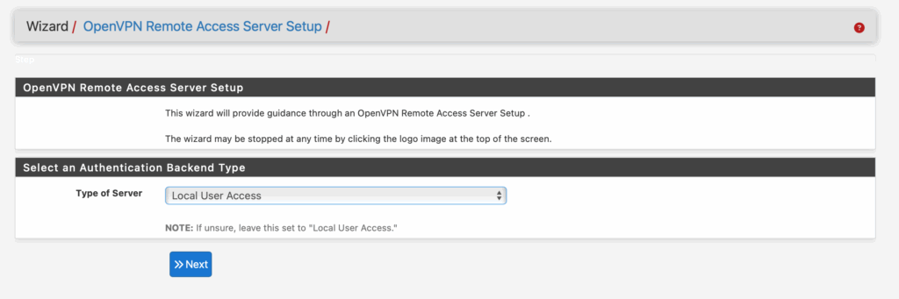

Fig 1.4 OpenVPN Setup through wizard

Tailscale (Package)
Many users love Tailscale for its "Zero Config" nature.
- Mention that Tailscale can be installed as a package on the Netgate 1100, allowing it to act as a Subnet Router or Exit Node. This allows you to route all your phone's cellular traffic through your home's encrypted pfSense connection with zero port forwarding.

Section 5: Firewall Rules & Logic
The firewall reads rules from the top of the list to the bottom. Once a packet matches a rule, it stops looking.

1. The Anatomy of a Rule
Navigate to Firewall > Rules > LAN. Show a rule and explain the three main actions:
- Pass: The green checkmark. "You are allowed through."
- Block: The red "X". The packet is dropped silently. (Best for WAN to hide your presence from hackers).
- Reject: The orange "X". The firewall tells the sender "No, go away." (Best for internal LAN to stop apps from "spinning" while waiting for a timeout).

2. Best Practice: The "Default Deny"
Explain that by default, pfSense blocks everything coming from the internet (WAN) but allows everything leaving your network (LAN).

Section 6: Traffic Shaping & Limiters
This is the "No More Lag" section. It's perfect for households where one person downloading a large game ruins the internet for everyone else.

1. The Traffic Shaper Wizard
Navigate to Firewall > Traffic Shaper > Wizards.
- Show the Multi-WAN / Dedicated Link wizard.
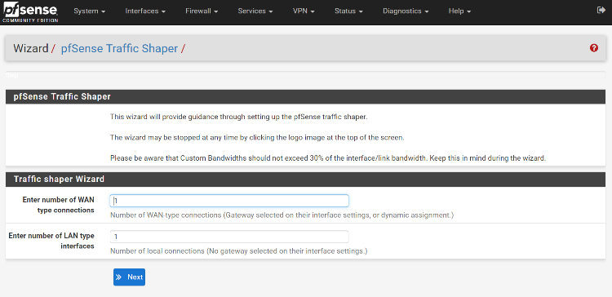
- It asks for your Upload/Download speeds and automatically prioritizes VoIP (Phone calls) and Gaming over "background" traffic like Windows Updates.

Fig 1.5 Pfsense Traffic Shaper

2. Bandwidth Limiters (The "Penalty Box")
Navigate to Firewall > Traffic Shaper > Limiters.
- Show how to create a "5Mbps Pipe."
- Demo Scenario: "If your roommate's BitTorrent is hogging the line, you can create a limiter and apply it to their specific IP. They will never be able to use more than 5Mbps, leaving the rest of the pipe open for your Zoom calls."
Section 6: Firewall Schedules
Navigate to Firewall > Schedules. This is a favorite for parents or office managers.
- How it works: You define a time range (e.g., "Bedtime" from 10:00 PM to 6:00 AM).
- Applying it: Go back to your Firewall Rules, edit a rule for the Kids_Devices alias, and select the "Bedtime" schedule.
- The Result: At 10:01 PM, the internet simply "turns off" for those specific devices, but stays on for yours.

Fig 1.5 Assigning the configuration file for default browser
Customer Support Contacts
Email | cs@flashnet.co.tz, support@flashnet.co.tz
Call/WhatsApp | +255 22 2113687 (Call), +255-777- 988-883 (WhatsApp)

