FLASHNET
Huawei E-Kit Configuration and Testing
PREPARED BY: Ayaan Jamal
DATE: 16TH February 2026

This document provides the configuration steps for a Huawei eKit deployment using the Huawei eKit mobile phone application. The setup includes local LAN connectivity, PoE powering, access point onboarding, SSID creation, and Wi-Fi testing.
2. Device Information

Device | Model | Function
Switch | Huawei S380-L4P1T | LAN distribution + PoE
Access Point | Huawei AP266 | Indoor Wi-Fi
Access Point | Huawei AP326E

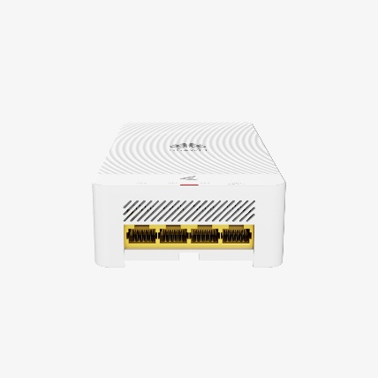
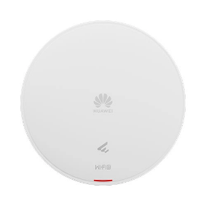

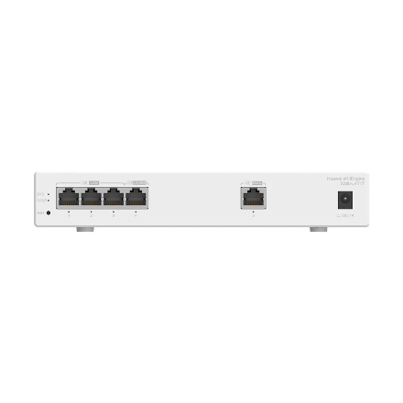

Fig 1.3 Huawei AP266
Fig 1.1 Huawei S380-L4P1T
Fig 1.2 Huawei AP326E

2.1 Device Requirements

- Huawei eKit App installed on phone
- Internet connection on phone (for login)
- Router providing DHCP (or a DHCP server)
- Ethernet cables
- PoE switch ports available

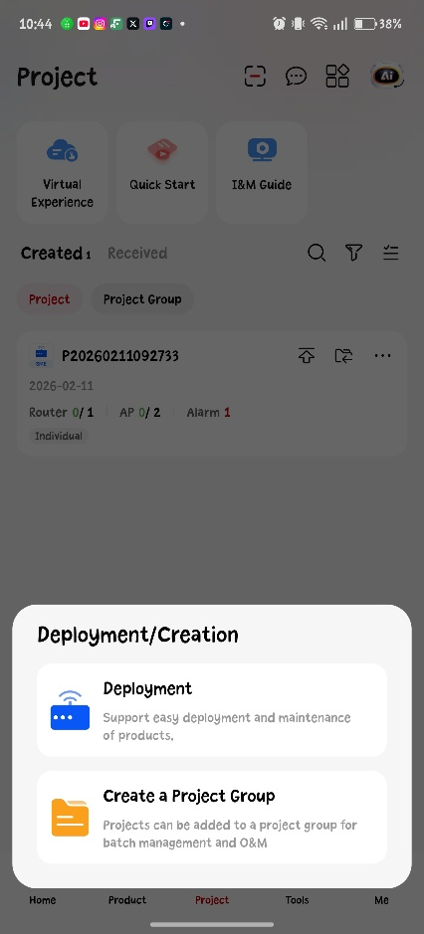
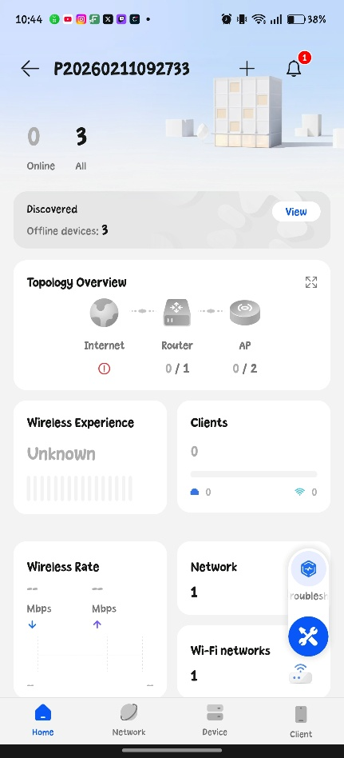

Fig 1.4 Huawei eKit Deployment (before)
Fig 1.5 Huawei eKit Deloyment (after)

2.2 Connections

Port | Connected To | Purpose
GE0/0/1 | Router / Firewall | Uplink + Internet
GE0/0/2 | AP266 | Wi-Fi coverage
GE0/0/3 | AP326E | Wi-Fi coverage

2.3 Adding the Devices (Switch + APs)

2.3.1 Adding the S380-L4P1T Switch

- In the Site dashboard select Add Device
- Choose Scan QR Code
- Scan the QR code on the switch
- Confirm device is added to the site

2.3.2 Adding AP266 and AP326E

- Select Add Device
- Scan QR code on:
  - AP266
  - AP326E
- Wait for the APs to appear online
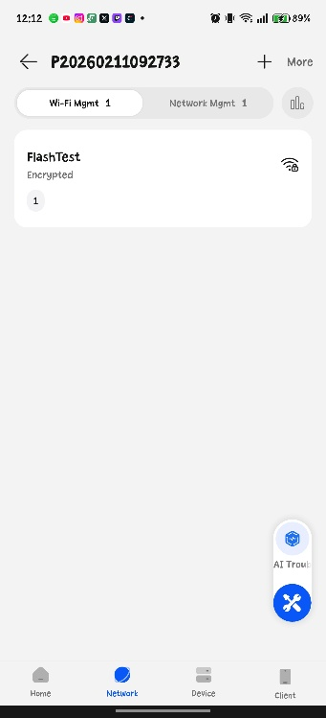

Fig 1.6 Wi-Fi Management Page for Wi-Fi distribution

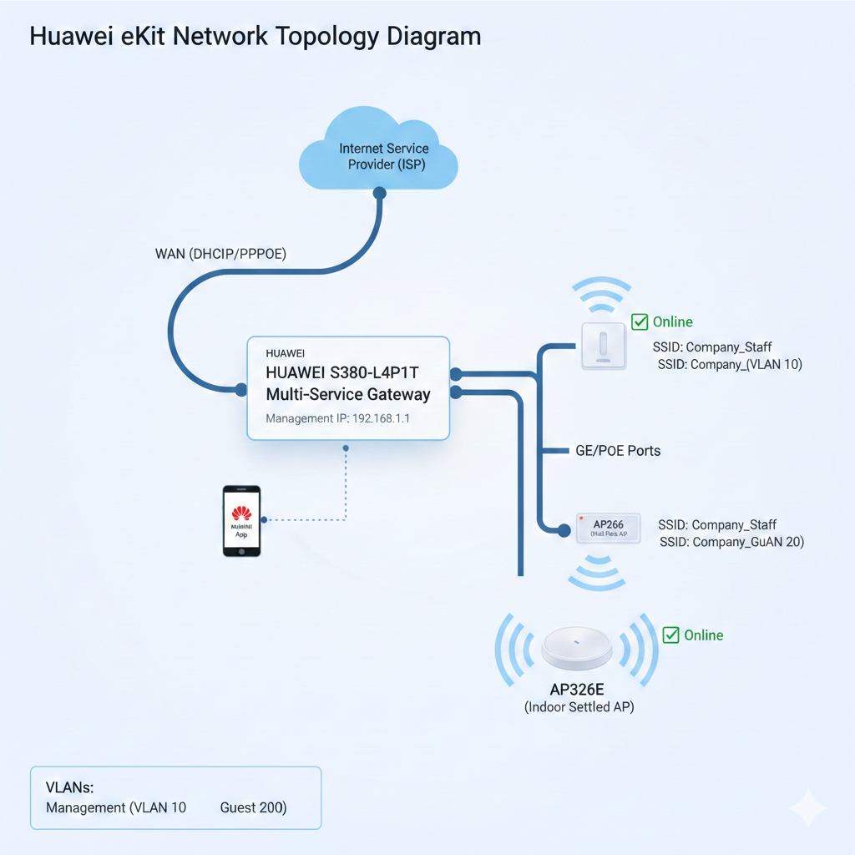
Topology design Example:

Fig 1.8 Topology example for Enterprises

Customer Support Contacts
Email | cs@flashnet.co.tz, support@flashnet.co.tz
Call/WhatsApp | +255 22 2113687 (Call), +255-777- 988-883 (WhatsApp)

