FLASHNET
Proxmox Server Documentation
PREPARED BY: Ayaan Jamal
DATE: 18TH February 2026

This documentation explains how Proxmox Virtual Environment (Proxmox VE) is used to deploy virtual machines for organizational use, and how domain user configurations such as software deployment, default browser, and desktop wallpaper are applied using Active Directory Group Policy.

The configurations implemented include:
- Deploying software to domain computers/users
- Setting a default browser
- Setting a default wallpaper for domain accounts

2. Device Information

- Create and deploy Windows Server and Windows Client VMs in Proxmox
- Configure a Domain Controller (Active Directory + DNS)
- Join Windows client machines to the domain
- Apply Group Policy for:
- Software deployment
- Default browser settings
- Domain wallpaper

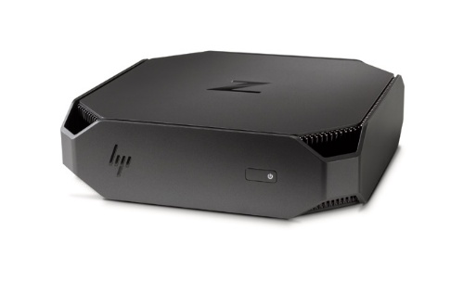

Fig 1.1 HP Z2 G4 Mini Workstation

2.1 Virtual Machine Deployment in Proxmox

Accessing Proxmox
- Open a browser.
- Navigate to:
https://172.16.0.250:8006
- Log in as:
  - User: root
  - Realm: Flashnet@2026
The Proxmox dashboard displays the node (HP-Z2-G4) and available storage.

- Click Create VM.
- Enter VM Name: {any name}
- Select Windows Server ISO.
- Configure:
- CPU: 2 cores
- RAM: 4096 MB
- Disk: 80 GB
- Network: vmbr0
2.2 Installing Active Directory Domain Services
Steps performed:
- Open Server Manager.
- Select Add Roles and Features.
- Install:
  - Active Directory Domain Services
  - DNS Server
After installation, the server was promoted to a Domain Controller.

Domain Controller (Add a new forest):
- Select Promote this server to a domain controller.
- Choose Add a new forest.
- Domain name used:
company.local
- Restart the server.
The system now functions as a Domain Controller managing domain users and computers.

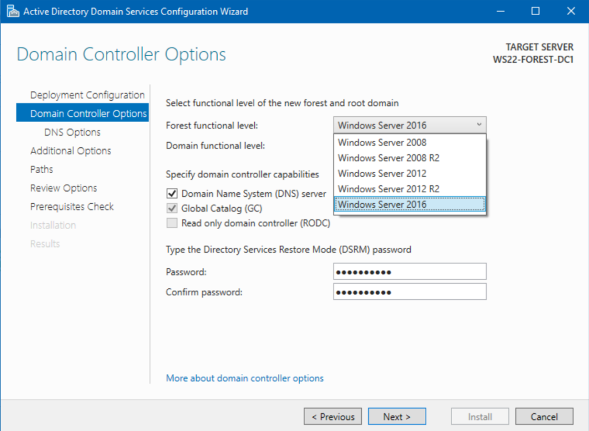

Fig 1.2 Domain Controller for Server Manager (Add a new Forest)

2.3 Applying Wallpaper via GPO

Create GPO:

- Domain Wallpaper Policy

- Navigate to: User Configuration → Administrative Templates → Desktop → Desktop

Configure:

- Wallpaper path:

- \\DC01\WallpaperShare\wallpaper.jpg

- Style: Fill

After users log in, the wallpaper is automatically applied.

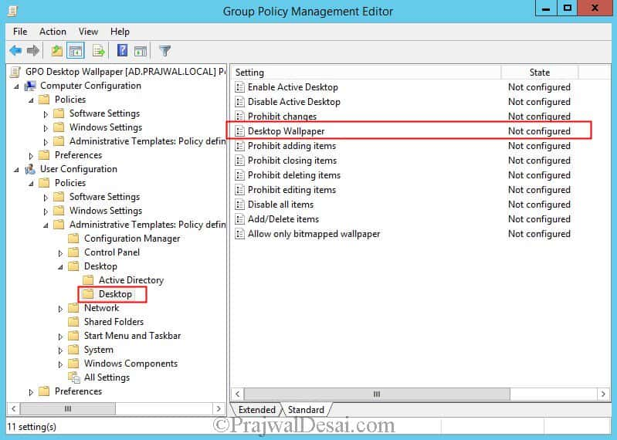

Fig 1.3 Group Policy Management Editor (Desktop Wallpaper)

2.4 Deploying Software via GPO

Open Group Policy Management.

Create a new GPO:
Install Chrome

Navigate to:

- Computer Configuration → Policies → Software Settings → Software Installation

Add MSI package using UNC path:

- \\[yourusername] \SoftwareShare\GoogleChrome.msi

- Link the GPO to the appropriate Organizational Unit (OU).

After running:

- gpupdate /force and restarting the client, Google Chrome installed automatically.

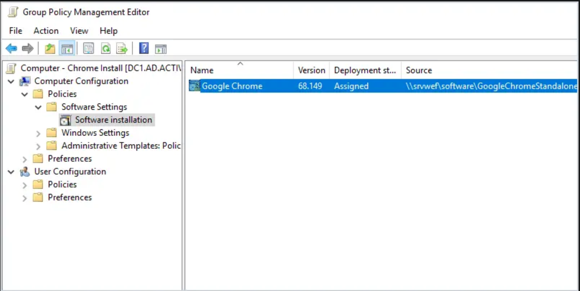

Fig 1.4 Assigning the Software on GPO Editor

3. Exporting Default App Associations
On a configured client PC:
Dism /Online /Export-DefaultAppAssociations:C:\AppAssoc.xml
The XML file was copied to:
\\DC01\SoftwareShare\AppAssoc.xml

3.1 Applying via Group Policy
- Create GPO:
Default Browser Policy
- Navigate to:
Computer Configuration → Administrative Templates → Windows Components → File Explorer
- Enable:
Set a default associations configuration file
- Enter UNC path:
\\DC01\SoftwareShare\AppAssoc.xml
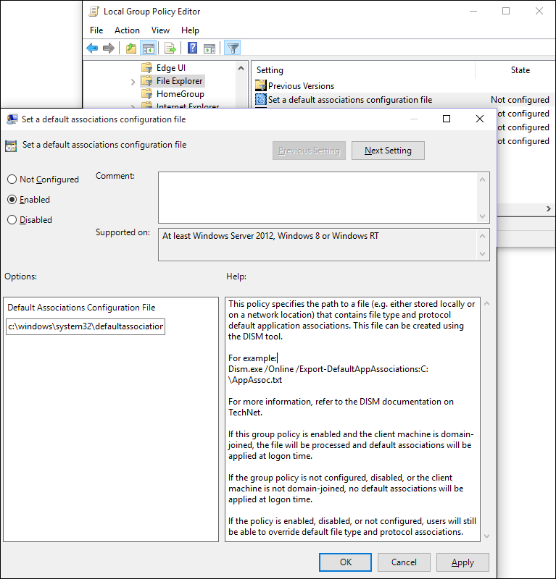
After restart, Google Chrome became the default browser for all domain users.

Fig 1.5 Assigning the configuration file for default browser
Customer Support Contacts
Email | cs@flashnet.co.tz, support@flashnet.co.tz
Call/WhatsApp | +255 22 2113687 (Call), +255-777- 988-883 (WhatsApp)

