Alhushoom
SOPHOS CENTRAL PROJECT DOCUMENTATION
PREPARED BY:FLASHNET
DATE: 3rd January 2026

Sophos Model
XGS118
Serial: X11505HB6JM9Q2B

XGS88
Serial: X01308FD9987BC2

License Information
Account: - sophos@flashnet.co.tz
Password -

Admin Users and Passwords:
- Username: ahmedally@alhushoom.co.tz
- Password: Al#c3nt25
- Access method: Web browser
https://central.sophos.com/
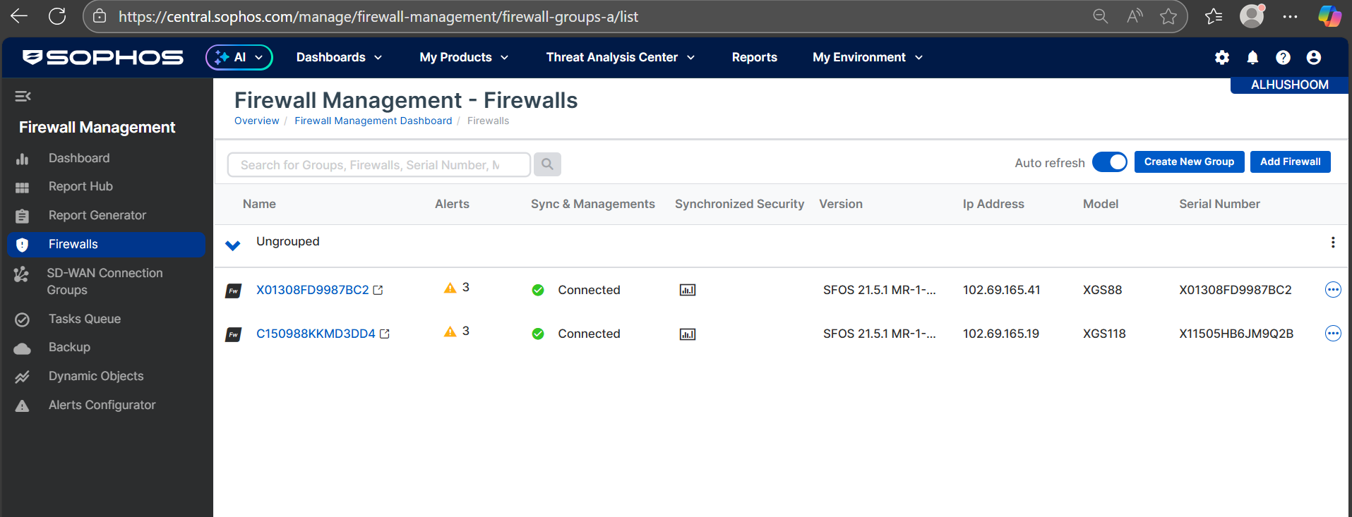
Customer Support Contacts
Email | cs@flashnet.co.tz, support@flashnet.co.tz
Call/WhatsApp | +255 22 2113687 (Call), +255-777- 988-883 (WhatsApp)

