**SOLUTION TO PROBLEM PROGRAMME:** BSSE/BSCS/BIT

**YEAR/SEM:** YEAR 2 SEM 1

**COURSE CODE:** BIT2115

**PROBLEM NAME:** WORKING WITH INSTANCE INTIALIZATION BLOCKS AND STATIC BLOCKS

STUDENT DETAILS:

|  |  |
| --- | --- |
| **NAME OF STUDENT** | EMMANUEL KUAL MAGOK |
| **REG NUMBER** | 24/789/BSS-J |

Contents

CLASS SOURCE-CODE SCREENSHOT 2

Detailed explanation 2

MAIN METHOD SCREENSHOT 3

Detailed Explanation 3

OUTPUT SCREENSHOT 3

Detailed explanation of the output 4

# CLASS SOURCE-CODE SCREENSHOT

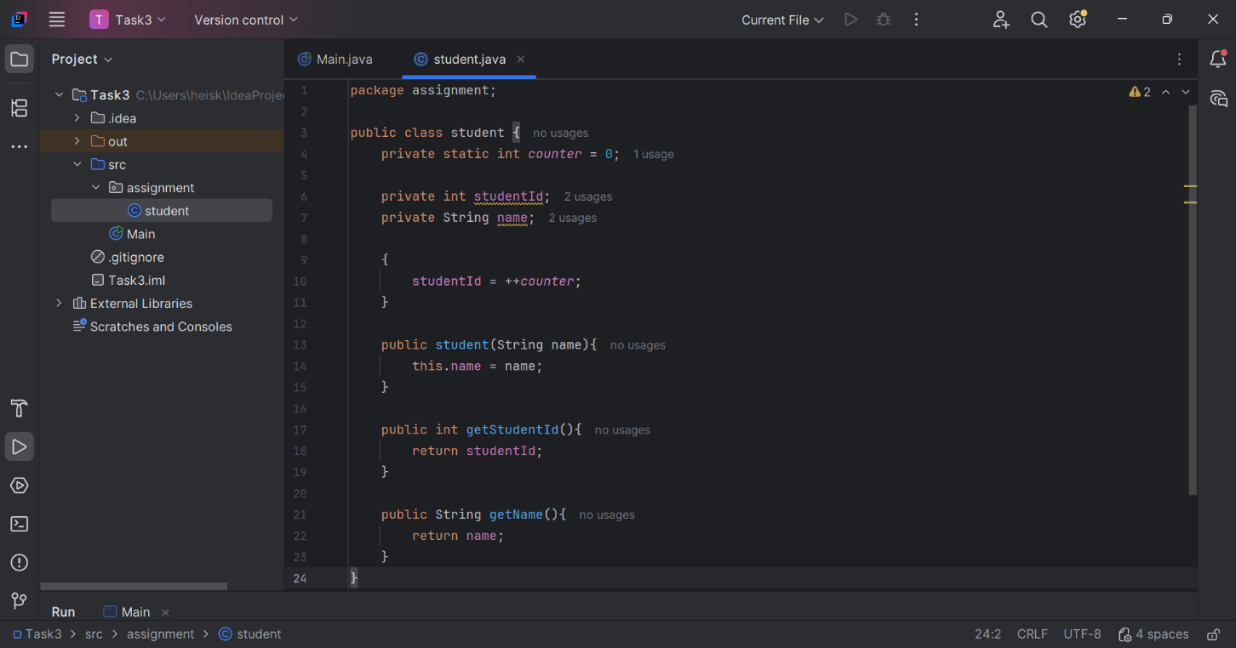

## Detailed explanation

|  |  |
| --- | --- |
| Line of codes | Explanation |
| #1 | Package named “assignment” is created |
| #3 | A class named “student” is declared inside the package |
| #4 | A static int variable named “counter” is declared and 0 is initialized to it |
| #6 | A private int variable named “studentId” is declared with no intialization |
| #7 | A private String variable named “name” is declared without initializing it |
| #9 | IIB is declared |
| #10 | Variable named “studentId” is assigned to incremental variable named “counter” |
| #13 | A constructor is declared |
| #17 | A method (getter method) named “getStudentId” is declared that returns a variable named “studentId” |
| #21 | A method (getter method) named “getName” is declared that returns a variable named “name” |

# MAIN METHOD SCREENSHOT

## Detailed Explanation

|  |  |
| --- | --- |
| Line of codes | **Explanation** |
| **#3** | A class student imported from assignment package inside the main method |
| **#7** | An instance of class named student1 from a class named “student” |
| **#8** | An instance of class named student2 from a class named “student” |
| **#10** | Display of a student1 ID and name |
| **#11** | Display of a student2 ID and name |

## OUTPUT SCREENSHOT

## Detailed explanation of the output

After running the codes, the output shown “student1 -> ID: 1, Name: Chris” and “student2 -> ID: 1, Name: “Michael”

Which means the codes are successfully running