ASSIGNMENT -2

NAME: -Mohammed Sharikh Irfaan.

Section: -02

Subject code: -CSCE 5350

* Firstly, I have installed the MySQL Workbench 8.0 C. E and platform independent database driver and the eclipse IDE. tools are helpful for accessing and managing database contents.

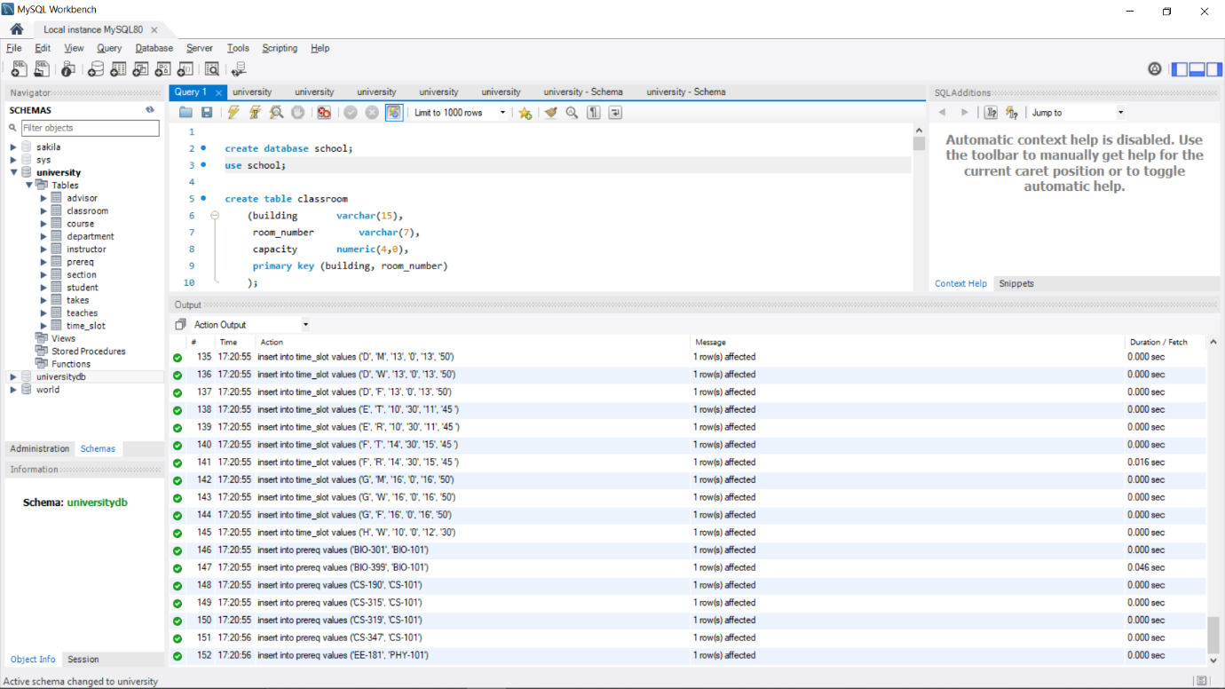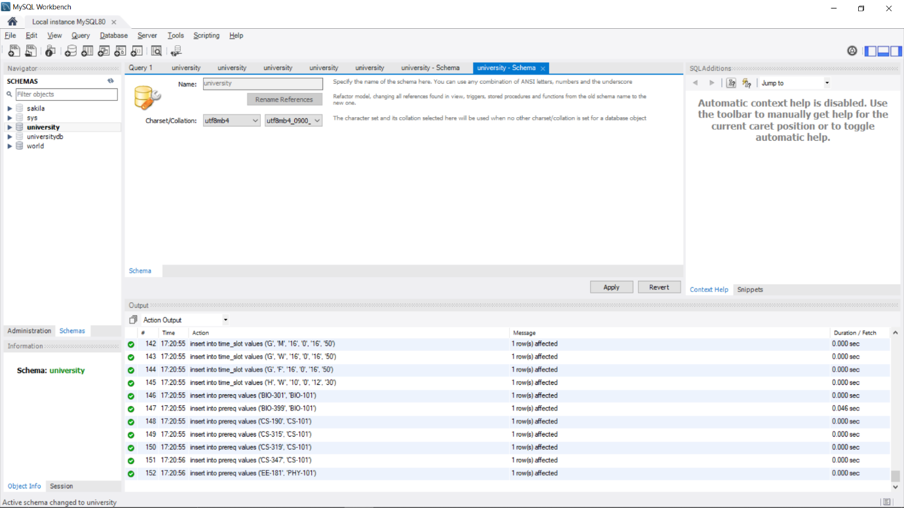**1a).** I have downloaded University Database from class university website and loaded into MySQL Workbench 8.0 C. E database server.

Here I have loaded all the tables from the university database into MySQL database servers

**1b**) I have loaded simple data set into database server same as above for DDL and by running this we obtained this output.

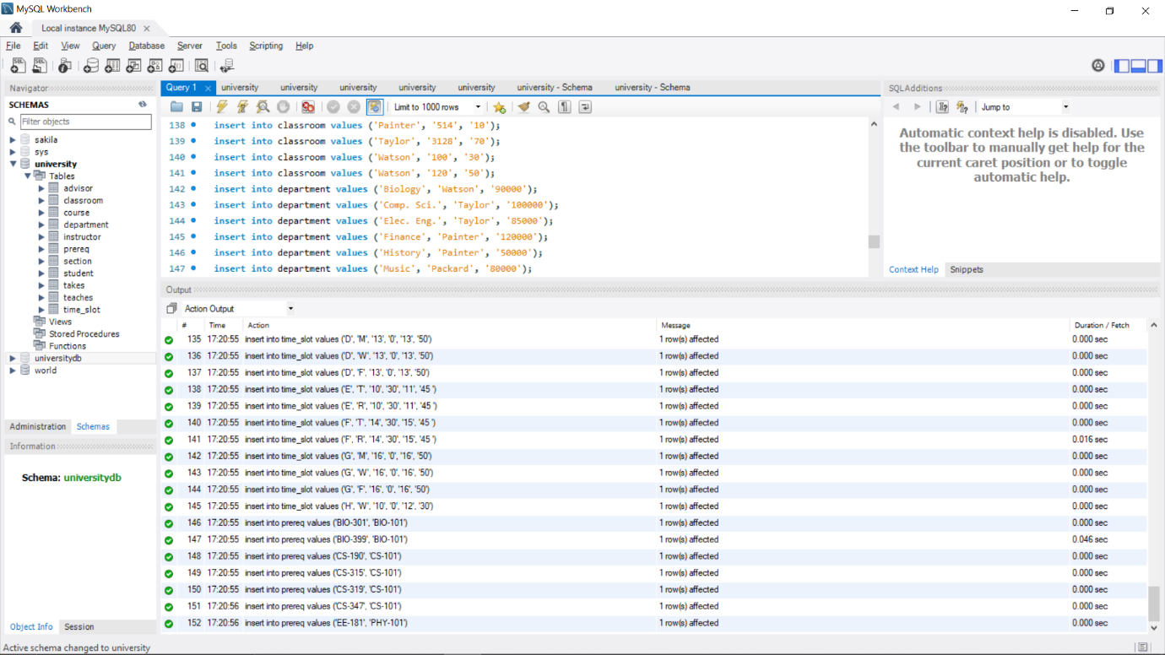

**1c)** mysql-connector.java, a database driver for Java, was downloaded and installed on the system. Via the provided link, the file is downloaded.

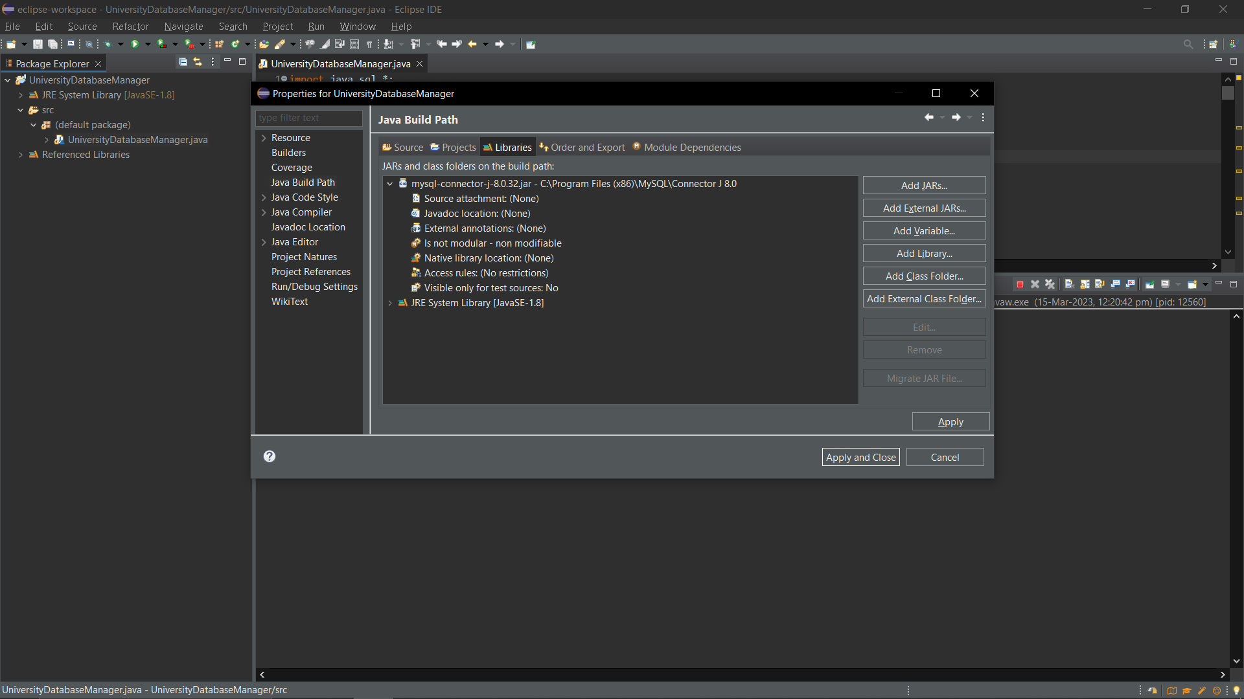

**1d)** **I.** The program is created through Java program to display the options of table names and requests a choice as input; following input, the chosen tables are shown.

1. **Displaying the main menu content and ask to enter our choice.**

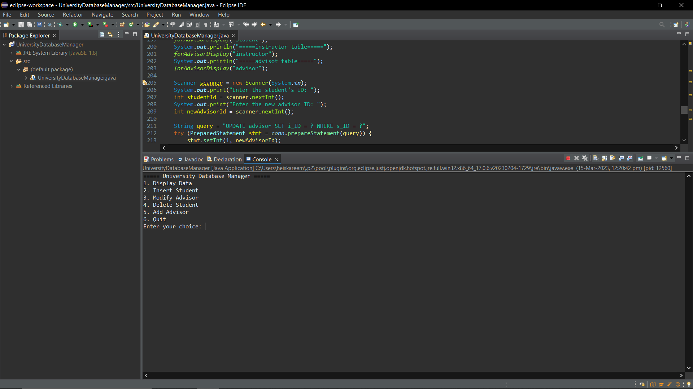

1. If user wants to view **“Instructor table”** then they need to choose for option **“1”** and it will display the contents in **“Instructor table”**.

1. If user wants to view **“Advisor table”** then they need to choose for option **“1”** and it will display the contents in **“Advisor table”**.

1. Text

   Description automatically generatedIf user wants to view **“Student table”** then they need to choose for option **“1”** and it will display the contents in **“Student table”**.

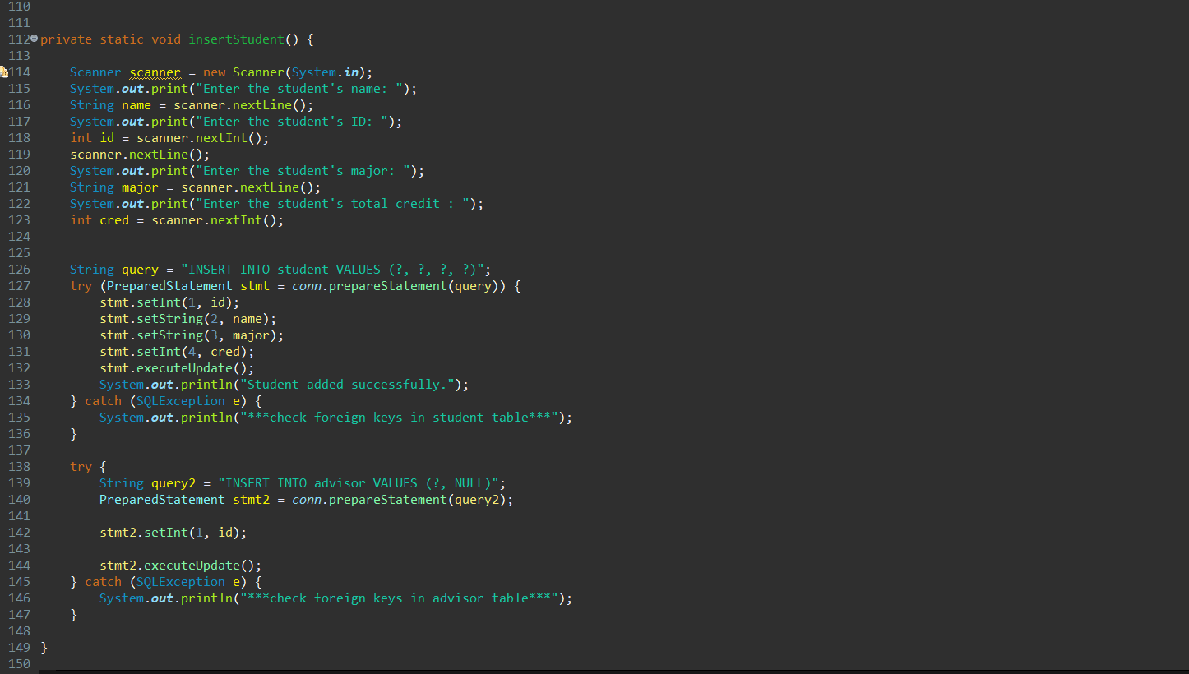**1e )** If user want to insert a new student record into the student table it follows through below program.

**ii)** The user needs to enter choice “2” and it asked to enter the data for new student record as below mentioned.

Verifying in MySQL workbench

**1f)** If user want to Modify advisor table, it follows through below program.

**1f)** In order to list Advisor classes and add a menu item.

**1f)** The user can view the advisor classes if they choose option 3 from the menu.

After entering new record of the student, the current advisor is **“null”.**

An advisor is allotment to the new student record which has updated successfully.

Verifying in MySQL Workbench.

**1g)** adding delete for student table in main menu.

**Enter student id if student it match with the tables it will show data of the student. After showing the data it will give two options either delete or not to delete.**

Verifying in MySQL Workbench

