2021-2022

IT114105 - ITP4507

Contemporary Topics in Software Engineering

Assignment

200022972 - Tang Chun Hei

Group 2B

**Assumptions regarding the problem context**

* Different type of toy creation may need redirect to a new create command factory.

As adding a new type of toy, the command and command factory also need to create a new file to control the specific return value and string. That means if user want to add a new toy, he/her need to create 3 files in a roll.

* Only “create toy”, “purchase toy” and “sell toy” need to redo or undo.

The “display toy” and “display undo/redo list” will not need to redo or undo.

**Application design with class diagram**

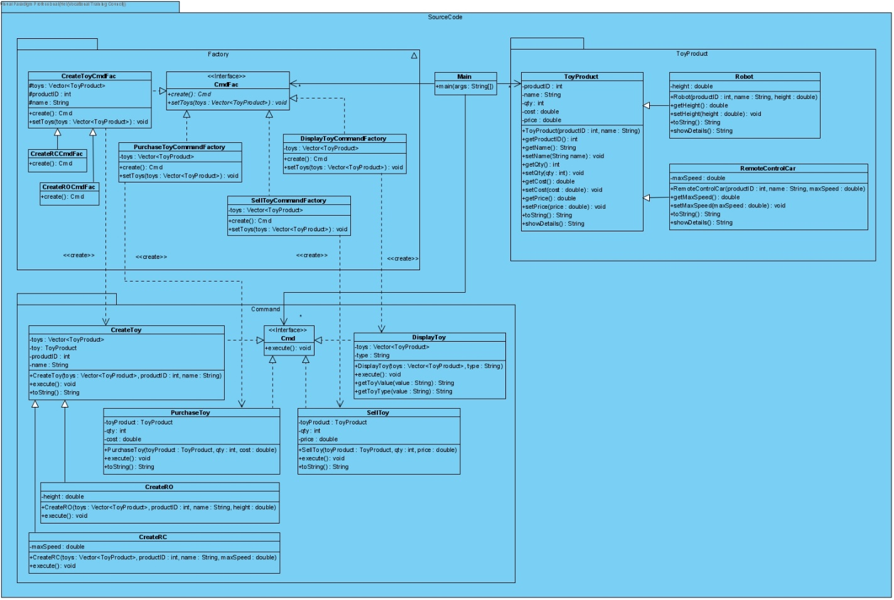

**Discussion and explanation on each of the design patterns applied to the application**

The Factory pattern was applied to the ToyProduct.java so that new type of toy(s) can be add easily by extending the new toy type to ToyProduct.java.

The Command pattern was applied to the command control of the whole program to provide all the command user needs. Main is acting the invoker and the CmdFac create Cmd command.

**User Guide**

* When user open the software, user will see the main panel to control this system. The command and the meaning are shown below the system name. User only need to type the corresponding command to manage the system, such as create toy, buy/sell toy etc. (The command can be type as capital letter or small letter.)

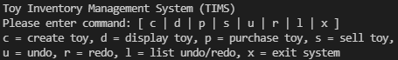

* When the system starts, the database is empty. User need to create toy first. After entering command “c”, the system will ask for input the type of the toy. Hance, the system will ask user the details of the toy.

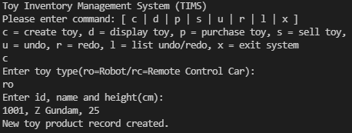

* Once the toy’s details were entered correctly, the information will store at the database. User can check it by enter command “d”. Then, user can choose to display one toy or all the toys by enter the specific ID or “*”.

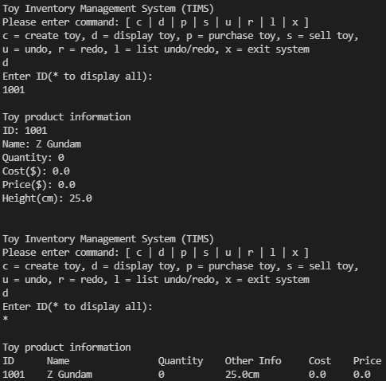

* Next, user need to enter the details of buying the toy by command “p”. The system will ask user to provide the quantity and cost the buying that toy

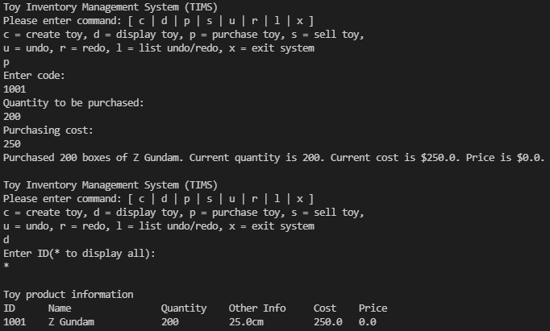

* After that, user can also sell the toy by using command “s”. User need to enter the quantity and selling price to the system.

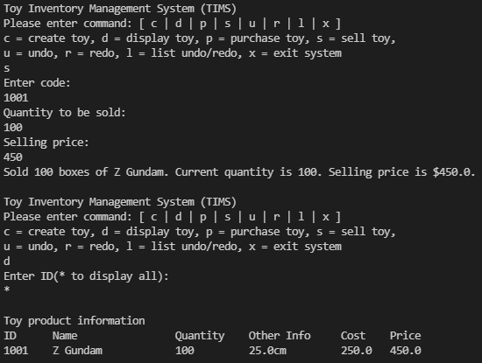

* If user sell the toy again, the system will calculate the total price and the quantity.

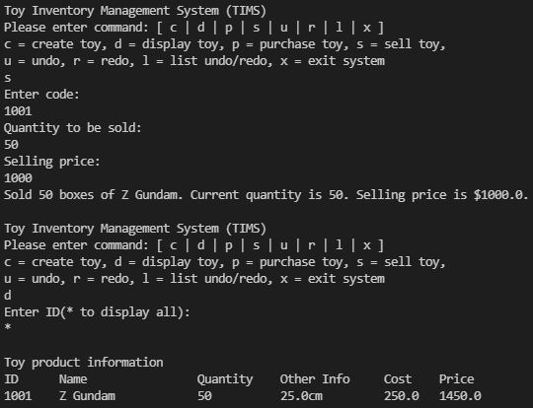

* User can enter command “x” to exit the system.

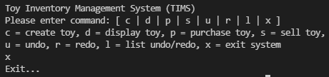

**Test Plan and Test Cases**

|  |  |
| --- | --- |
| Case 1 | Enter wrong command on main menu. |
| Expected output | Warning message (“Please enter correct option”) displayed. |
| Actual output |  |

|  |  |
| --- | --- |
| Case 2 | Enter wrong command on create toy menu. |
| Expected output | Warning message (“Please enter correct option”) displayed and re-enter type. |
| Actual output |  |

|  |  |
| --- | --- |
| Case 3 | Enter wrong information on toy creation. |
| Expected output | Warning message (“Index out of bounds”) displayed. |
| Actual output |  |

|  |  |
| --- | --- |
| Case 4 | Enter 0 height on robot creation. |
| Expected output | Warning message (“Height can not less than or equal to 0”) displayed. |
| Actual output |  |

|  |  |
| --- | --- |
| Case 5 | Enter negative value maximum speed on remote car creation. |
| Expected output | Warning message (“Maximum speed can not less than 0”) displayed. |
| Actual output |  |

|  |  |
| --- | --- |
| Case 6 | Enter duplicate product ID. |
| Expected output | Warning message (“ID duplicated”) displayed. |
| Actual output |  |

|  |  |
| --- | --- |
| Case 7 | Enter wrong product ID on display toy. |
| Expected output | Warning message (“ID not found”) displayed. |
| Actual output |  |

|  |  |
| --- | --- |
| Case 8 | Enter wrong product ID on purchase toy. |
| Expected output | Warning message (“ID not round”) displayed. |
| Actual output |  |

|  |  |
| --- | --- |
| Case 9 | Enter 0 quantity on purchase toy. |
| Expected output | Warning message (“Quantity can not less than or equal to 0”) displayed. |
| Actual output |  |

|  |  |
| --- | --- |
| Case 10 | Enter negative value on purchasing cost. |
| Expected output | Warning message (“Cost can not less than 0”) displayed. |
| Actual output |  |

|  |  |
| --- | --- |
| Case 11 | Enter wrong product ID on sell toy. |
| Expected output | Warning message (“ID not found”) displayed. |
| Actual output |  |

|  |  |
| --- | --- |
| Case 12 | Enter quantity more than stock. |
| Expected output | Warning message (“Invalid quantity (current quantity < selling quantity”) displayed. |
| Actual output |  |

|  |  |
| --- | --- |
| Case 13 | Enter 0 quantity on sell toy. |
| Expected output | Warning message (“Quantity can not less than or equal to 0”) displayed. |
| Actual output |  |

|  |  |
| --- | --- |
| Case 14 | Enter negative value on selling price. |
| Expected output | Warning message (“Price can not less than 0”) displayed. |
| Actual output |  |