1.General Introduction

Technology and business have been both in relationship. Whether to promote for a startup or look for investors, many involved individuals may use technology and networking platform to spread the information in an efficient way and without delay.

Individuals that are engaged in this process are :

* Founders , who have an idea and create businesses around that idea
* Co-founders, who may have been brought on early by the founder because they had skills that the founder lacks.
* Investors ,who play a crucial role in providing funding and support for startups
* The startup itself,after foundation, is being made available for purchase.

Our project consists of building StartMatch , a plateform dedicated to all actors in enterpreneurship, that can do the match-making between founder,co-founder or founder-investor or investor-startup.

1.1.Introduction

In this chapter will primarily concentrate on discussing the overall context of our project. we will commence by introducing the project context and criticism of the existing. Subsequently, we will evaluate the existing solutions in order to explain the additional benefits of our proposed solution.

1.2. Project context and criticism of the existing

Many entrepreneurs struggle to find the right platform where they can connect, search for opportunities, and explore the world of entrepreneurship around them . They often lack a designated space tailored to their needs where they can easily network and discover new opportunities. The existing platforms are even general networking spaces such as social media or they don’t cover entrepreneurs needs specifically. they don’t have a platform for their own .

The most common challenges for entrepreneurs were the

following:

* Some of them face the task of turning their passions into a singular, viable business idea, . This journey demands both creativity and strategic thinking as they seek to identify opportunities that address important needs in the marketplace, which leads to feel the need of finding someone to collaborate with and built this idea together by matching the perspectives and vision .
* On the other hand , some great ideas have been stopped before they even grew due to lack of funding .its one of the most common problems coming up to entrepreneurs  in the initial stages of their journay and a viable solution is to seek assistance from investors or consider co-founding.
* Entrepreneurs and investors alike often find themselves navigating a fragmented marketplace, struggling to identify promising startups to buy.It is difficult to find startups available for acquisition. This lack of accessibility blocks the potential growth opportunities and innovation.
* Startups often face the absence of a centralized platform where they can express their needs, seek investments, This lack of a specialized marketplace not only inhibits their ability to attract funding but also limits their visibility and opportunities for growth

1.3.Presented Solution

To address the identified challenges and criticisms of existing platforms, our proposed solution, “StartMatch”, aims to create a dedicated and comprehensive platform specifically designed for the needs of entrepreneurs, founders, co-founders start-ups and investors.It provides a user-friendly platform where users can connect, collaborate, and grow together.

The key features offered by the platform include:

* + Create and Share Posts: Founders can share investment opportunities, co-founders can seek collaboration, and investors can showcase their preferences. Every user can post their needs to the entire StartMatch community.
  + Search and Discover: Users can search for specific posts, projects, or profiles that match their criteria. Whether it's a startup in need of funds or a founder seeking a technical co-founder. Users can customize their search with filters such as domain and expertise.

**2.Specification of Functional requirements**

**2.1 Functional requirements**

Functional requirements, known also as the functional specification, are a collection of requirements that outlines the main goal of the system and the purpose of its offerings to all users [s1]. It features the systems functionalities that the team must fulfil during the process of development,

what helps them to keep track of their progress.

• Authenticate

* Create account;

• Manage profile

• manage my posts

• Consult other profile

• Consult Posts

• react to posts

• Consult news feed

• Consult notification box

• Delete posts

• Report posts

* Report profiles

• Delete accounts.

**2.2.Actors Identification**

An actor is the role fulfilled by a user interacting with the developed system. This compartment actors are the following:

Co-founder

Founder

Investor

Startup

Person

user

admin

|  |  |
| --- | --- |
| ACTORS | Role |
| Admin | Authenticate  Delete posts  Delete accounts |
| User:   * Startup * Person:   * Investor  * Founder  * Co-founder | Authenticate  Create account  Manage profile  Search  Manage posts  Consult other profiles  Consult posts  React to posts  Consult news feed  Consult notifications  Report posts  Report profiles |

**3. Specification of Non-Functional requirements**

The non-functional requirements paint a picture of how the system behaves while executing its various use cases. Rather than specifying particular functions, they establish criteria for maintaining the integrity and effectiveness of the software system. Without meeting these requirements, both the owner and the user will find the system lacking. However, it's worth noting that even if these requirements aren't strictly adhered to, the system may still function . These include aspects like:

* Security measures ensuring data protection.
* Installation capability for user convenience.
* Offline functionality for uninterrupted usage.
* Progressive enhancements for continual improvement.
* Cross-platform compatibility for broader accessibility.
* Discoverability to facilitate easy navigation.
* Re-engagement features to keep users invested.
* Ergonomics**:** Designing for comfort and efficiency in user interactions
* Fiability **:** encompasses the trustworthiness and dependability of the system

**4. UML Designs**

**4.1.USE CASE diagrams**

**4.1.1.Global**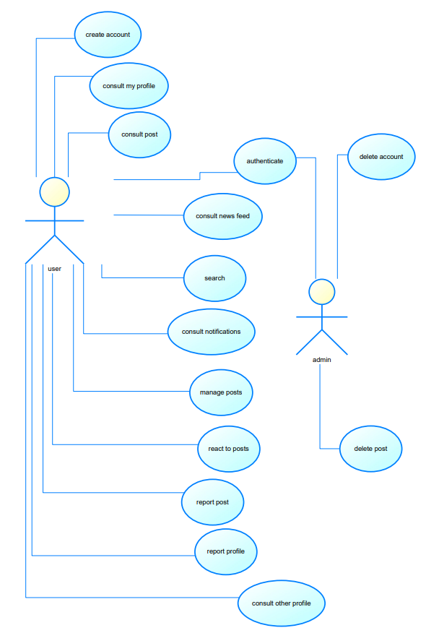

**4.1.1: Detailed**

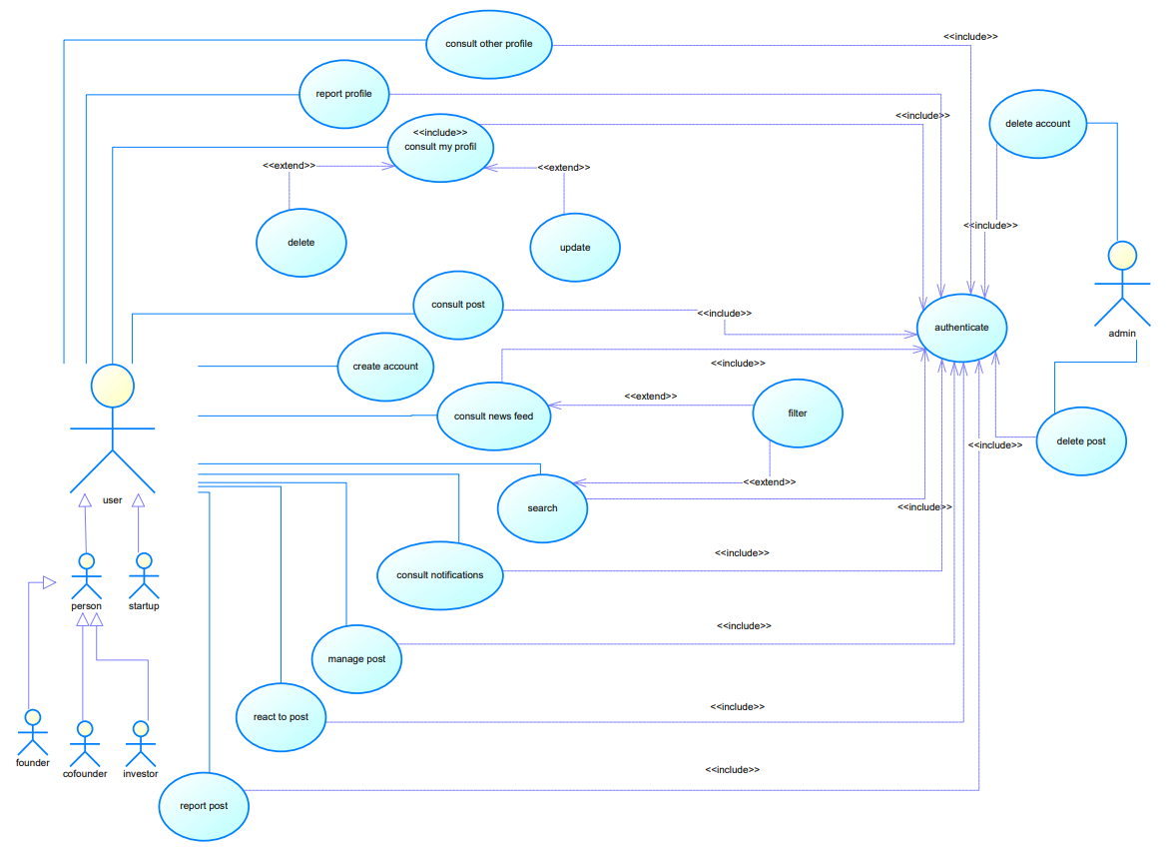

**4.2.Sequences diagrams**

• Authenticate

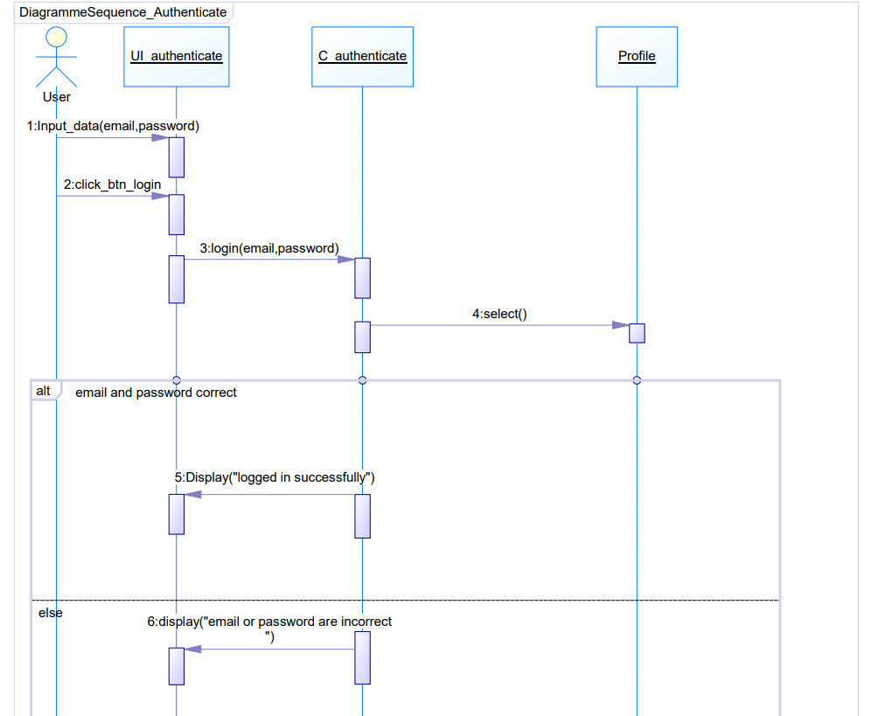

* Create account

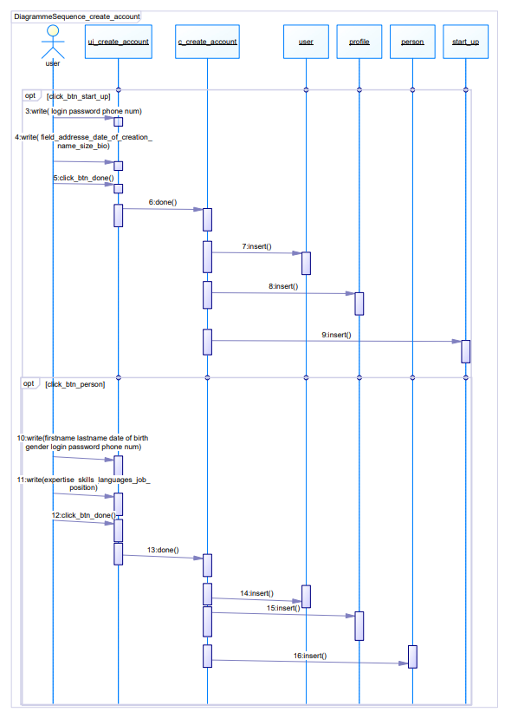

• Manage profile

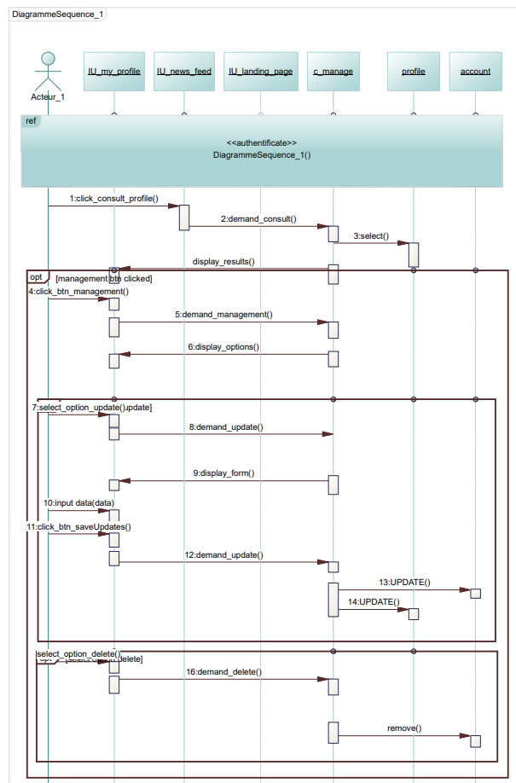



• manage my posts

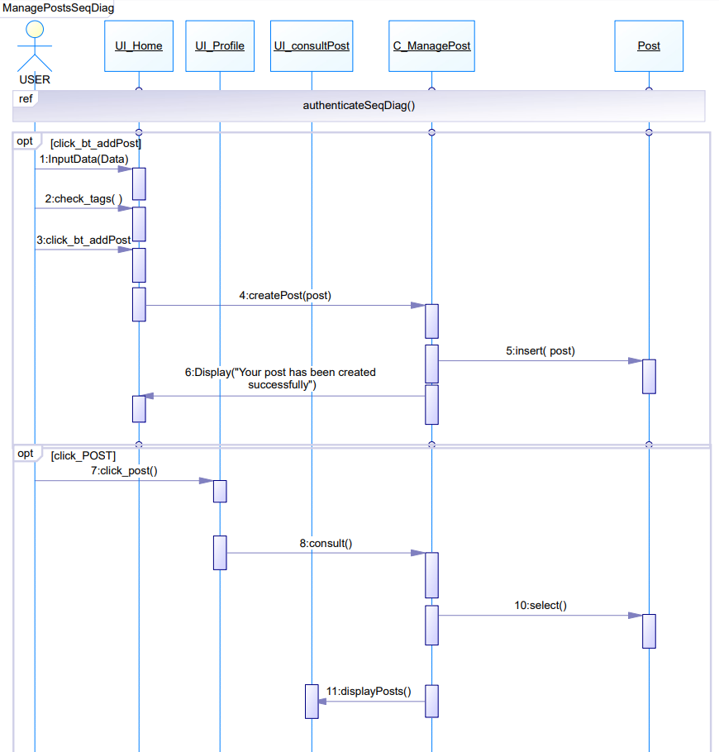

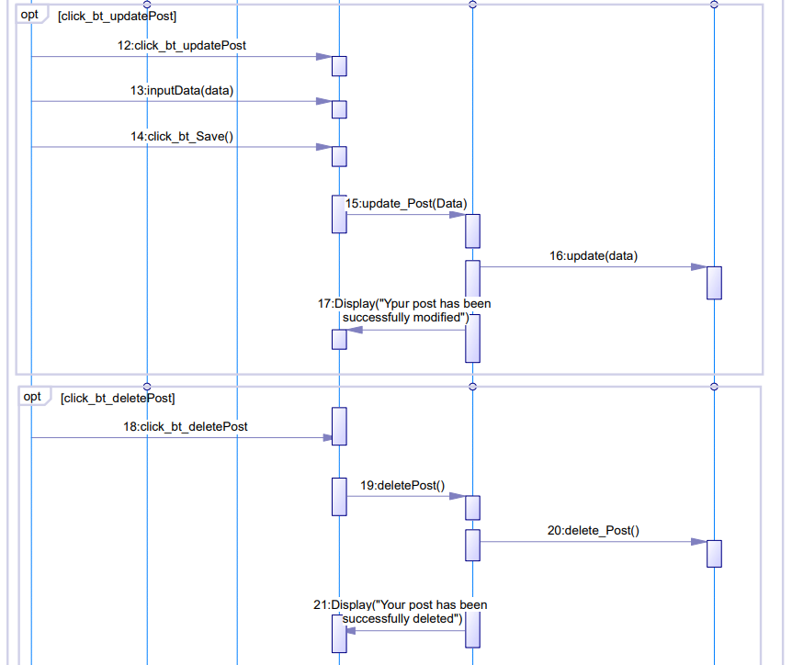

* 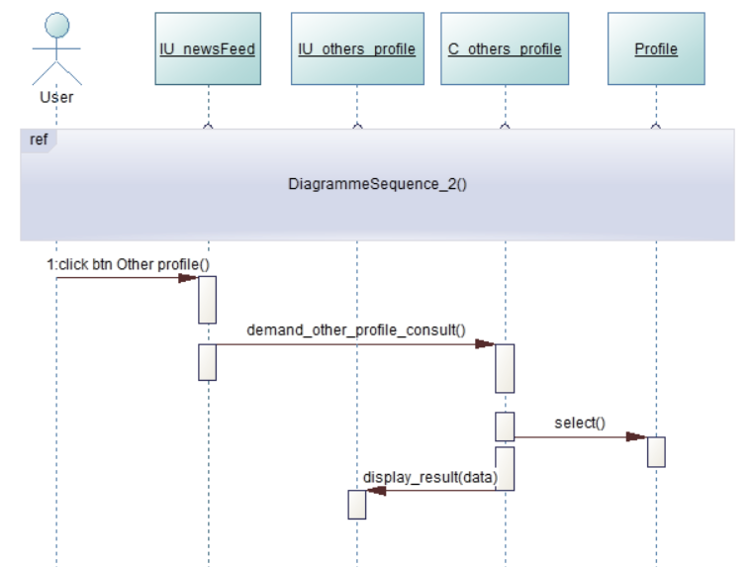Consult other profiles

• Consult Posts

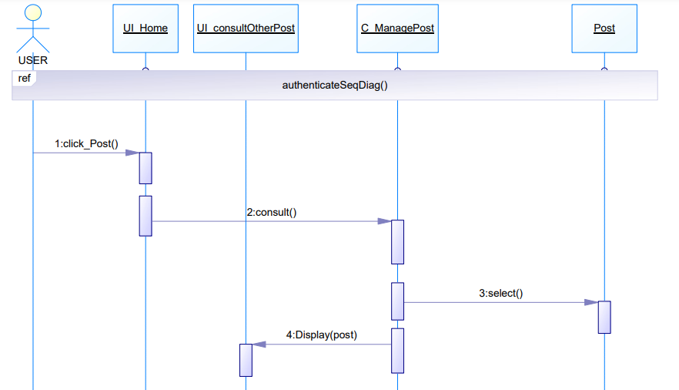

• react to posts

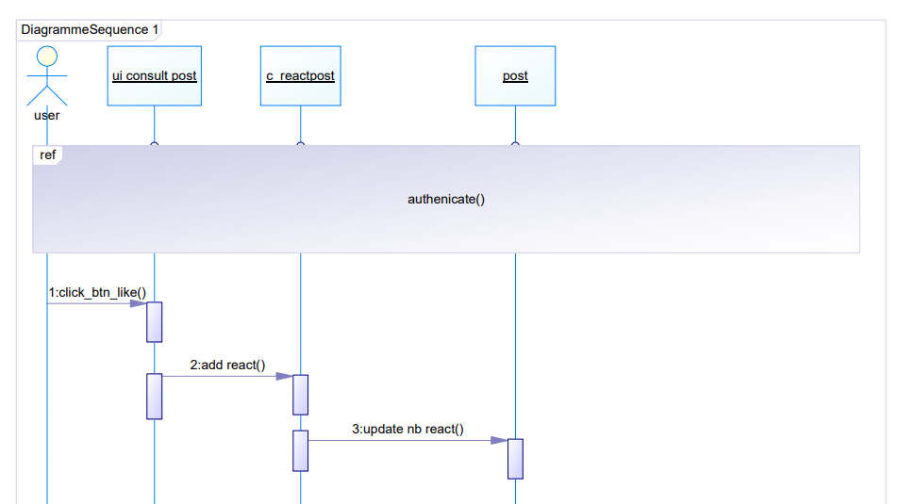

* 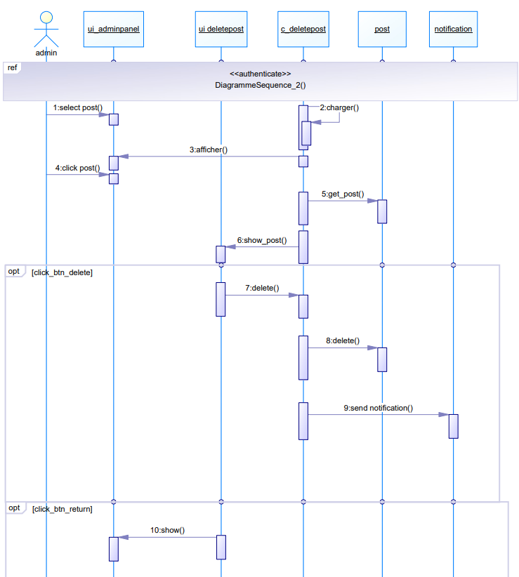Delete post

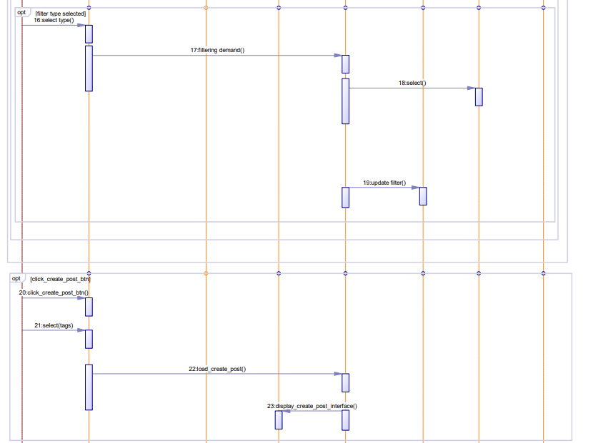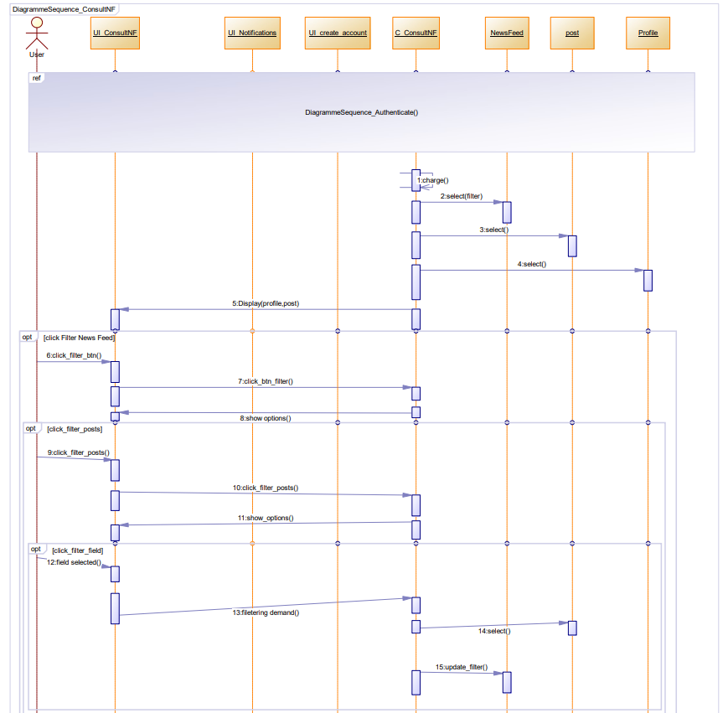• Consult news feed

• Consult notifications



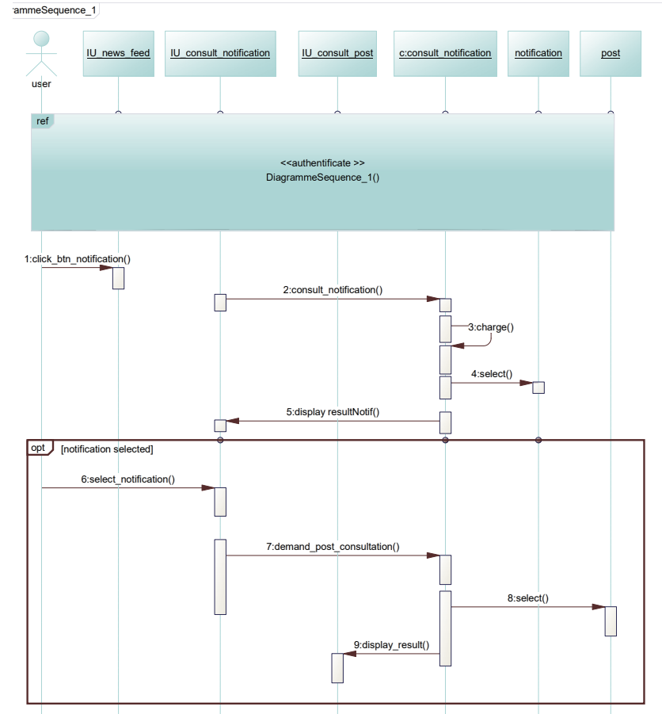

• Report posts

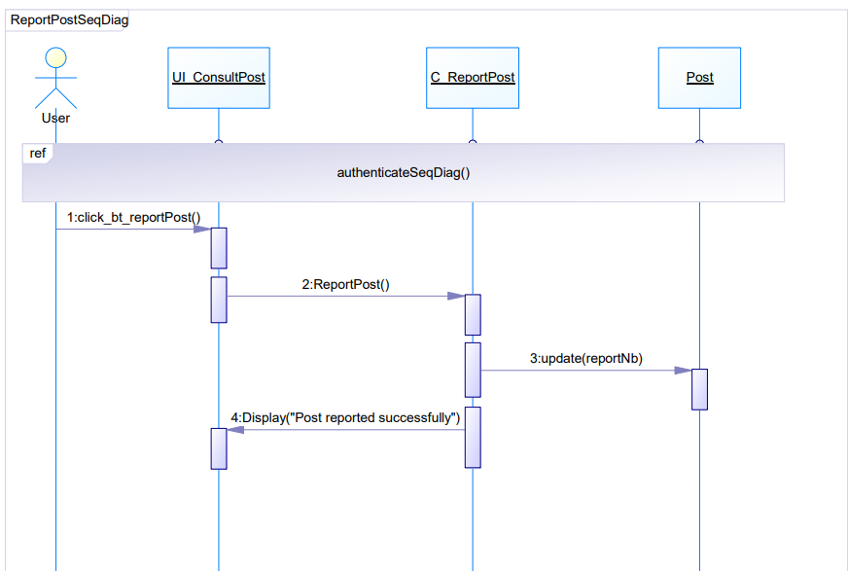

* Report profile

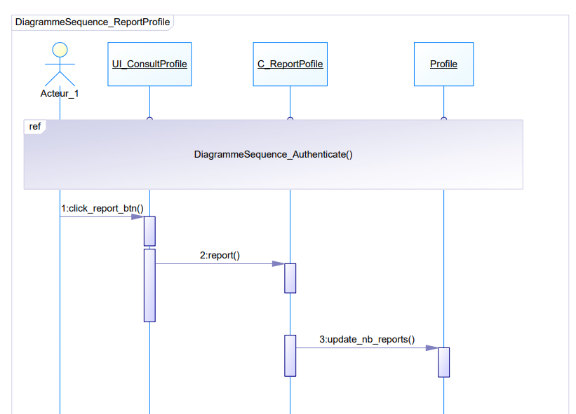





• Delete account.

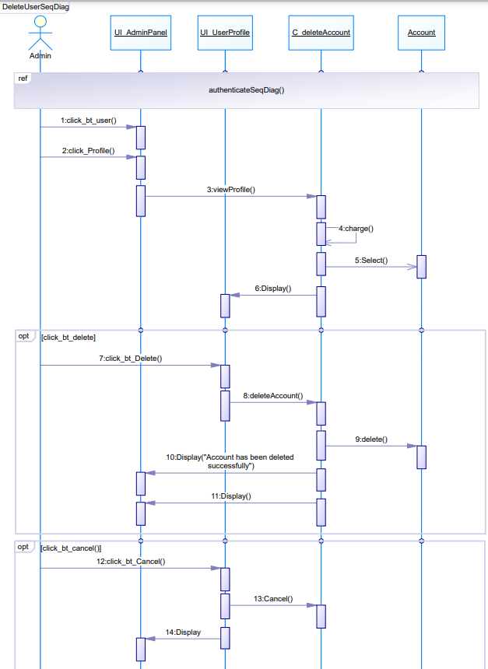

* Search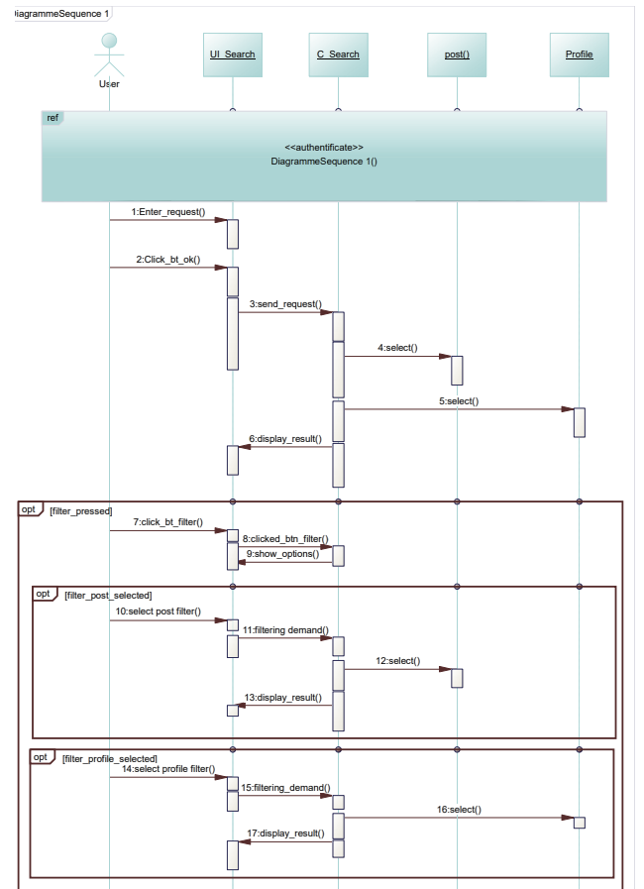



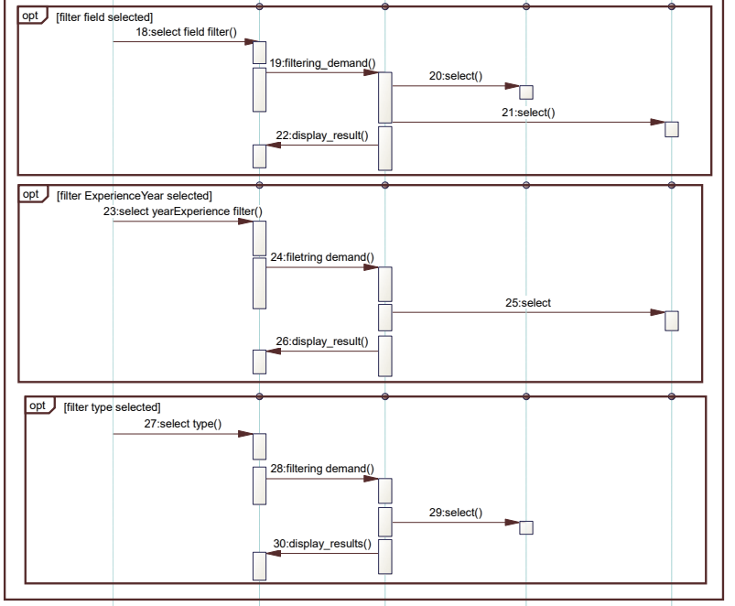

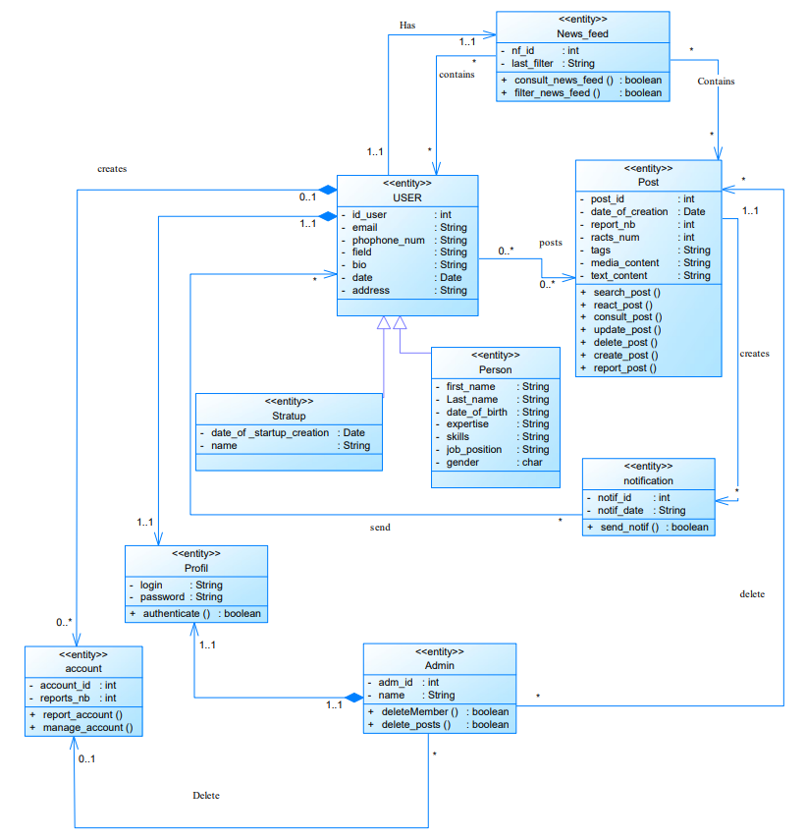**4.3.Classes diagram**

**5.Conclusion**

To tackle existing platform challenges, our solution, "StartMatch," creates a tailored platform for entrepreneurs, founders, co-founders, startups, and investors. It offers a user-friendly space for connection, collaboration, and growth.

**Technological choices**

For this part, we will focus on presenting the technology choices that we have worked with during the process of developing the plateform. These technological choices are categorized into front-end technologies and back-end technologies.

**Front-End :**

The front-End technologies build the interface of a web page or an application. The user can communicate and interact with the platform using these interfaces.



Angular is a platform and framework for building single-page client applications using HTML and TypeScript. Angular is written in TypeScript. It implements core and optional functionality as a set of TypeScript libraries that you import into your applications. (source : <https://angular.io/guide/architecture>)

**Back-end :**

Backend technologies manage everything that can’t be seen in the interface (storing data,handling requests) and which user can’t directly interact with .

MySQL is an open-source relational database management system (RDBMS) that allows users to interact with databases either directly by using SQL, or more often with other programs to implement applications that require relational database capabilities. (resources : <https://www.mysql.com/>)

PHP is a general-purpose scripting language geared towards web development. PHP is mainly focused on server-side scripting, so you can do anything any other CGI program can do, such as collect form data, generate dynamic page content, or send and receive cookies. (Ressources : <https://www.php.net/manual/en/intro-whatcando.php>)

**Software:**

**Visual Studio Code:**

Visual Studio Code, also commonly referred to as VS Code, is a source-code editor developed by Microsoft for Windows, Linux and macOS. Features include support for debugging, syntax highlighting, intelligent code completion, snippets, code refactoring, and embedded Git. (resource : [Wikipedia](https://en.wikipedia.org/wiki/Visual_Studio_Code))

**PowerAMC :**

PowerAMC™ is a software modeling platform that supports UML (Unified Modeling Language). It is based on UML version 1.4 and provides eleven different types of diagram, and it accepts UML 2.0 notation. (ressource : <https://documentation.help/poweramc/what_is_poweramc.htm>)

**Teamwork Tools :**

GitHub, Inc. is a developer platform that allows developers to create, store, manage and share their code. It uses Git software, providing the distributed version control of Git plus access control, bug tracking, software feature requests, task management, continuous integration, and wikis for every project. ([Wikipedia](https://en.wikipedia.org/wiki/GitHub))