GNSS displacement detection and extraction based on Bayesian inference

Nan Shen1, Liang Chen 1, 2, *, and Ruizhi Chen1, 2

**Abstract**

**Keywords** high-frequency GNSS observations. vibration detection. interactive multiple model. Kalman filter.

1  State Key Laboratory of Information Engineering in Surveying, Mapping and Remote Sensing, Wuhan University, Wuhan 430079, China

2 Collaborative Innovation Center for Geospatial Technology, Wuhan, Hubei, China, 430079

Nan Shen [nanshen@whu.edu.cn](mailto:nanshen@whu.edu.cn)

🖂 Liang Chen [l.chen@whu.edu.cn](mailto:l.chen@whu.edu.cn)

Ruizhi Chen [ruizhi.chen@whu.edu.cn](mailto:ruizhi.chen@whu.edu.cn)

Introduction

Methods











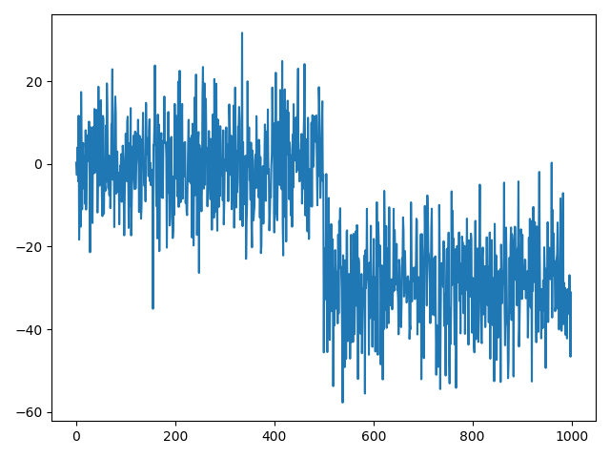

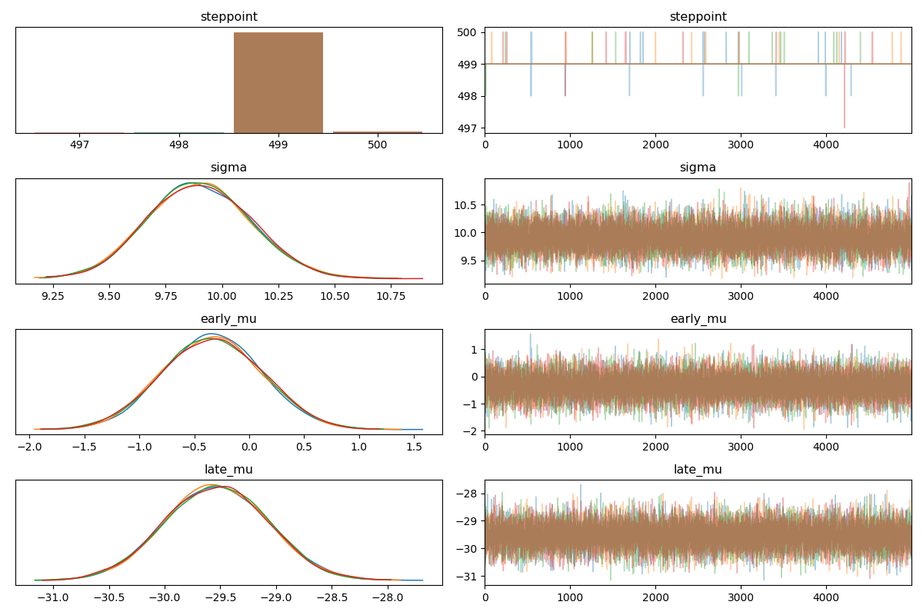

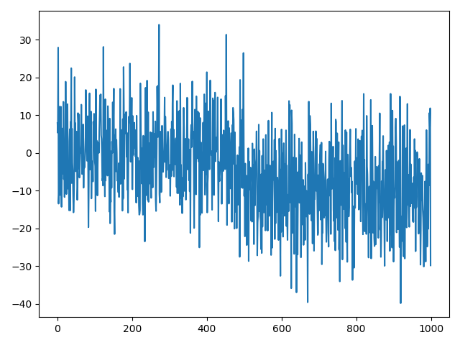

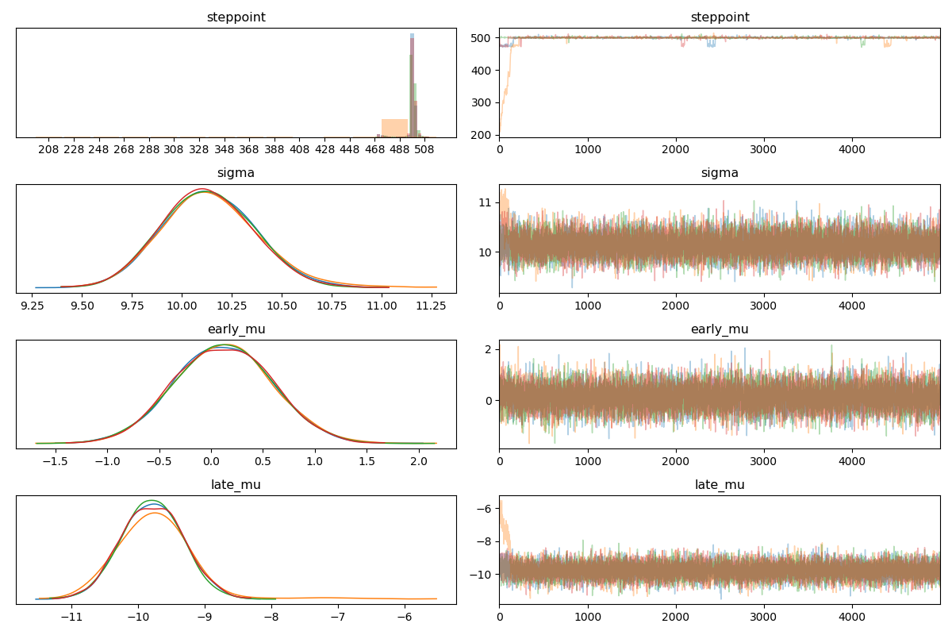





Experiments and results

Simulation experiments

Field experiments

Discussion

**Acknowledgment:** This research was funded by the National Key Research and Development Program with Project No.2018YFB0505400, the Natural Science Fund of Hubei Province with Project No. 2018CFA007, and the Zhejiang Lab’s International Talent Fund for Young Professionals.

**Data Availability**

All data generated during and analyzed during the current study are available from the first author on reasonable request.

References

**Author Biographies**

**Nan Shen** is currently a Ph.D. student at State Key Laboratory of Information Engineering in Surveying, Mapping and Remote Sensing at Wuhan University. His research interests focus on precise GNSS data processing, software-defined receiver.

**Liang Chen** is a professor of State Key Laboratory of Surveying, Mapping and Remote Sensing Information Engineering, Wuhan University. His research interests include navigation new signal theory and method, ubiquitous smartphone positioning, and indoor and outdoor seamless positioning and navigation.

**Yantian Xu** is a researcher at the satellite navigation and positioning technology research center of Chinese Academy of Surveying and Mapping. His research interests focus on GNSS high-precision navigation and positioning technology, GNSS time series analysis, and GNSS engineering application.

**Xiangchen Lu** is currently a master student at State Key Laboratory of Information Engineering in Surveying, Mapping and Remote Sensing at Wuhan University. His main research direction is software-defined receiver.

**Yanlin Ruan** is currently pursuing the Ph.D. degree in major of communication and information systems at Wuhan University. His research interests mainly include indoor positioning and navigation technology, signal processing, and machine learning.

**Xiaoyan Liu** received an M.Sc. degree in Surveying and Mapping from Liaoning Technical University in 2015. Now, she is a Ph.D. candidate in the State Key Laboratory of Surveying and Remote Sensing Information Engineering, Wuhan University, China. Her doctoral research interests include indoor positioning and navigation based on 3D vision and inertial sensors in smartphones.

**Hao Hu** is currently a master student at State Key Laboratory of Information Engineering in Surveying, Mapping and Remote Sensing at Wuhan University. His main research direction is software-defined receiver.

**Zhetao Zhang** works at Hohai University in Nanjing, China, where his primary research is the GNSS precise positioning with a focus on functional and stochastic models. He obtained his Ph.D. from Tongji University.

**Lei Wang** is currently an associate research fellow at State Key Laboratory of Information Engineering in Surveying, Mapping and Remote Sensing at Wuhan University. His research interests include GNSS precise positioning and LEO navigation augmentation system.

**Ruizhi Chen** is a professor at the State Key Laboratory of Surveying, Mapping and Remote Sensing Information Engineering, Wuhan University, and director of the laboratory. His main research interests include smartphone ubiquitous positioning and satellite navigation and positioning.