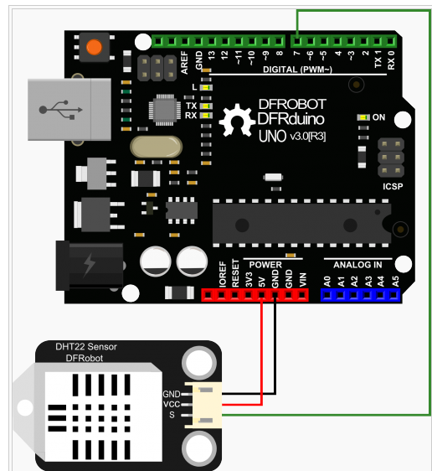

示例1

/*******************************************************

这个程序用来测试DHT22的温湿度。

********************************************************/

#include <dht.h>

dht DHT;

#define DHT22_PIN 7

void setup()

{

Serial.begin(115200);

Serial.println("DHT TEST PROGRAM ");

Serial.print("LIBRARY VERSION: ");

Serial.println(DHT_LIB_VERSION);

Serial.println();

Serial.println("Type,\tstatus,\tHumidity (%),\tTemperature (C)");

}

void loop()

{

Serial.print("DHT22, \t");

int chk = DHT.read22(DHT22_PIN); //读取数据

switch (chk)

{

case DHTLIB_OK:

Serial.print("OK,\t");

break;

case DHTLIB_ERROR_CHECKSUM:

Serial.print("Checksum error,\t");

break;

case DHTLIB_ERROR_TIMEOUT:

Serial.print("Time out error,\t");

break;

default:

Serial.print("Unknown error,\t");

break;

}

// 显示数据

Serial.print(DHT.humidity, 1);

Serial.print(",\t");

Serial.println(DHT.temperature, 1);

delay(1000);

}

示例2，**请注意!目前最新版本的arduinoIDE 1.6.0版本无法正常使用该样例，您可以使用早前的版本1.0.X**

**/\*\*\*\*\*\*\*\*\*\*\*\*\*\*\*\*\*\*\*\*\*\*\*\*\*\*\*\*\*\*\*\*\*\*\*\*\*\*\*\*\*\*\*\*\*\*\*\*\*\*\*\*\*\*\***

**这个程序用来测试DHT22的温湿度。**

**\*\*\*\*\*\*\*\*\*\*\*\*\*\*\*\*\*\*\*\*\*\*\*\*\*\*\*\*\*\*\*\*\*\*\*\*\*\*\*\*\*\*\*\*\*\*\*\*\*\*\*\*\*\*\*\*/**

**#include <DHT22.h>**

**#include <stdio.h>**

**// 信号线接Arduino数字口7**

**#define DHT22_PIN 7**

**DHT22 myDHT22(DHT22_PIN);**

**void setup(void)**

**{**

**Serial.begin(9600);**

**Serial.println("DHT22 Library Demo");**

**}**

**void loop(void)**

**{**

**DHT22_ERROR_t errorCode;**

**delay(2000);**

**Serial.print("Requesting data...");**

**errorCode = myDHT22.readData();**

**switch(errorCode)**

**{**

**case DHT_ERROR_NONE:**

**Serial.print("Got Data ");**

**Serial.print(myDHT22.getTemperatureC());**

**Serial.print("C ");**

**Serial.print(myDHT22.getHumidity());**

**Serial.println("%");**

**char buf[128];**

**sprintf(buf, "Integer-only reading: Temperature %hi.%01hi C, Humidity %i.%01i %% RH",**

**myDHT22.getTemperatureCInt()/10, abs(myDHT22.getTemperatureCInt()%10),**

**myDHT22.getHumidityInt()/10, myDHT22.getHumidityInt()%10);**

**Serial.println(buf);**

**break;**

**case DHT_ERROR_CHECKSUM:**

**Serial.print("check sum error ");**

**Serial.print(myDHT22.getTemperatureC());**

**Serial.print("C ");**

**Serial.print(myDHT22.getHumidity());**

**Serial.println("%");**

**break;**

**case DHT_BUS_HUNG:**

**Serial.println("BUS Hung ");**

**break;**

**case DHT_ERROR_NOT_PRESENT:**

**Serial.println("Not Present ");**

**break;**

**case DHT_ERROR_ACK_TOO_LONG:**

**Serial.println("ACK time out ");**

**break;**

**case DHT_ERROR_SYNC_TIMEOUT:**

**Serial.println("Sync Timeout ");**

**break;**

**case DHT_ERROR_DATA_TIMEOUT:**

**Serial.println("Data Timeout ");**

**break;**

**case DHT_ERROR_TOOQUICK:**

**Serial.println("Polled to quick ");**

**break;**

**}**

**}**