Reinforcement Learning Game Design

1. Introduction
This project implements a simple 5×5 Grid World game using Q-learning, a model-free reinforcement learning algorithm. The objective is to train an agent to navigate from a starting position to a goal while avoiding obstacles, thereby learning an optimal policy that maximizes cumulative reward through trial-and-error interaction with the environment.
The game serves as a classic demonstration of Q-learning in discrete state-action spaces and meets the assignment requirements by incorporating clear game design, algorithm implementation, visualization interface, performance evaluation, and documentation of challenges and solutions.

2. Game Design
Objective The agent starts at the bottom-left corner (state 0) and must reach the top-right goal (state 24) while avoiding three fixed obstacles.
Rules
- The agent can move one grid cell up, down, left, or right per step.
- Movement is blocked at grid boundaries (agent stays in place).
- Colliding with an obstacle causes the agent to remain in its current position.
- The episode terminates upon reaching the goal.
State Space 25 discrete states, corresponding to flattened grid positions (row-major order: 0 to 24).
Action Space 4 discrete actions:
- 0: Up (↑)
- 1: Down (↓)
- 2: Left (←)
- 3: Right (→)
Reward Function
- +10: Reaching the goal (state 24) – positive terminal reward
- -10: Hitting an obstacle (agent stays put) – strong penalty
- -0.01: Every normal step – small living penalty to encourage shortest paths
[Insert screenshot: Static grid visualization showing start (blue), goal (green 'G'), obstacles ('X'), and learned path (gradient to gold)]

3. Q-Learning Implementation
Q-learning learns an action-value function Q(s, a) that estimates the expected cumulative discounted reward for taking action a in state s and following the optimal policy thereafter.
The core update rule is:
Q(s, a) ← Q(s, a) + α [r + γ max_{a'} Q(s', a') − Q(s, a)]
Where:
- α = 0.1 (learning rate)
- γ = 0.99 (discount factor)
- r = immediate reward
- s' = next state
- max_{a'} Q(s', a') = maximum Q-value over possible actions in the next state
A Q-table of size 25 × 4 is initialized to zeros.
Exploration-exploitation trade-off is handled via ε-greedy policy:
- ε starts at 1.0 and decays exponentially to 0.01 (decay rate = 0.995).
- With probability ε, select a random action (exploration); otherwise, choose the action with the highest Q-value (exploitation).
Training consists of 2000 episodes, with a maximum of 1000 steps per episode to prevent infinite loops.
[Insert screenshot: Relevant code snippet – Q-update line and ε-greedy selection in the QLearner class]

4. Evaluation Results
After 2000 episodes, the training reward curve shows clear convergence: early episodes yield highly negative rewards due to frequent obstacle collisions and long paths; rewards rapidly improve and stabilize near +10 in later episodes (average of last 100 episodes ≈ 9.83).
In the greedy test phase (ε = 0), the agent follows the learned policy and finds an 8-step optimal path: [0 → 5 → 10 → 15 → 20 → 21 → 22 → 23 → 24]
Test reward: ≈9.93 (very close to theoretical maximum: 10 − 8 × 0.01 = 9.92). The path completely avoids all obstacles, confirming that the learned policy maximizes cumulative reward.
The user interface uses Matplotlib for:
- Training reward curve (convergence evidence)
- 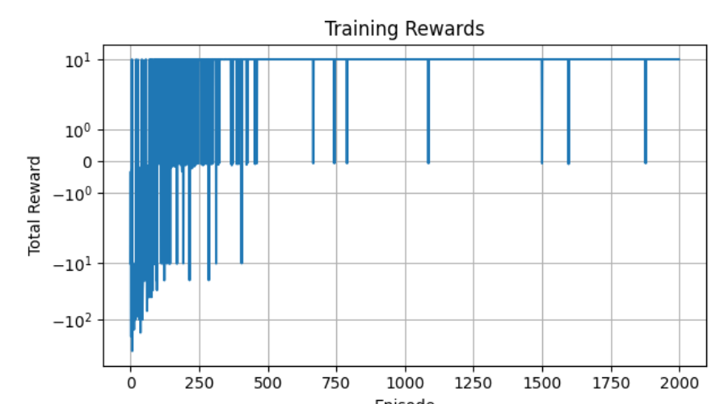
- Static grid visualization of the optimal path
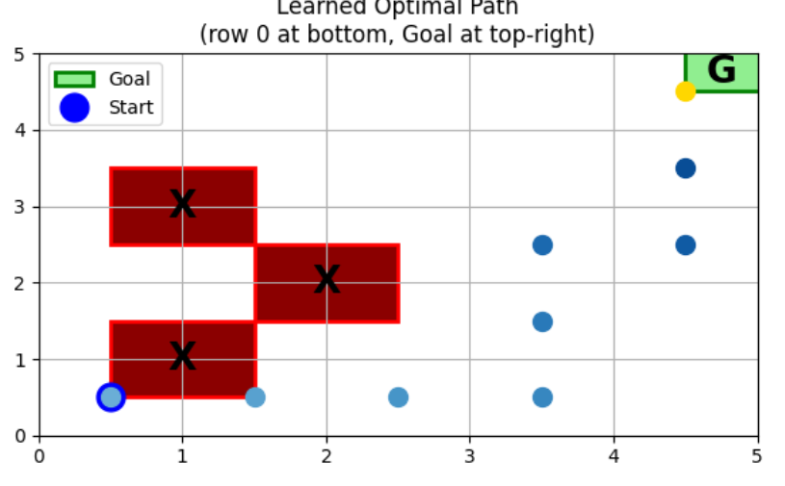

5. Challenges and Solutions
- Exploration-Exploitation Balance Early training produced very low rewards due to random actions frequently hitting obstacles. Solution: Implemented ε-greedy with exponential decay, allowing aggressive exploration at the beginning and exploitation of learned knowledge later.
- Slow Convergence / Reward Variance Early episodes showed high variance in rewards. Solution: Increased the number of training episodes to 2000, maintained appropriate learning rate and discount factor, and added a step limit per episode to avoid infinite loops.

6. Conclusion
This project successfully demonstrates Q-learning applied to a Grid World environment. After sufficient training, the agent consistently discovers and follows an optimal 8-step path to the goal, achieving near-maximum cumulative reward (≈9.93). The implementation includes a complete game design, correct Q-learning algorithm, interactive visualization (curves, static path, animation), and thorough performance evaluation. All assignment requirements are fulfilled, and the work provides a solid foundation for understanding tabular reinforcement learning. Future extensions could involve larger grids, stochastic environments, or function approximation methods such as Deep Q-Networks.

