# PM3 MAX

# Product features

1. Comes with two fully functional USB ports. Both the TYPE-C and MICRO ports can be connected to a computer.
2. A brand new chip model, although it cannot flash RDv4 firmware, it can flash Iceman firmware with consistent functionality.
3. FPC connector with 9-pin, supports modification of Bluetooth module, extended USB interface, SAM card module, etc.
4. 512KB memory, all functions are retained without deletion.
5. Reserve low-frequency coil solder joints for easy modification by users.
6. There are 4 solder joints on the back, which can switch between card reading mode and sniffing mode. When disconnected, it is card reading mode, stable card reading, and moderate sniffing. When short circuiting (using materials such as soldering iron, wire, conductive tape, etc.), switching the sniffing mode greatly improves the sniffing ability, and the distance is even slightly farther than RDV4.
7. The low-frequency antenna is processed with PCB hollowing out and supports multiple installation methods, making it an added advantage in some low-frequency sniffing situations. For example, hitag2 (PCF9736...)
8. Offline sniffing mode, can sniff without an app. Just power up the product and press and hold the three second button to enter the sniffing mode (green light on). At this time, card sniffing can be performed. After sniffing, the log will be stored inside the chip and can be extracted from the computer GUI. It also supports offline continuous sniffing, and the log will be added on its own. Theoretically, it can support up to 50 sniffing attempts.
9. With the offline password storage feature, frequently used passwords can be saved inside the chip via the GUI. Even after changing computers, these passwords can still be retrieved through the GUI. This offers a convenient way to store passwords without the need for an internet connection. In theory, up to1000+ passwords can be stored offline.
10. Equipped with free computer GUI software and English APP. The APP supports both OTG and Bluetooth connection.When using the computer GUI, it is necessary to flash the PC firmware，When using the APP, it is necessary to flash the APP firmware
11. Continuously updated, with features consistent with the official Iceman. If you need to flash other firmware, please add the parameter=PM3ICOPYX during compilation
12. https://github.com/rfidreadermaker/proxmark3-max

# Product images

## 1. Front view

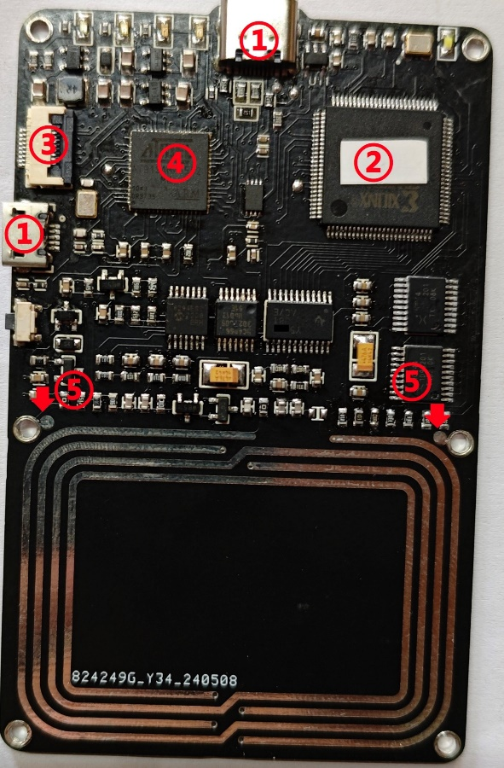

## 2. Back view

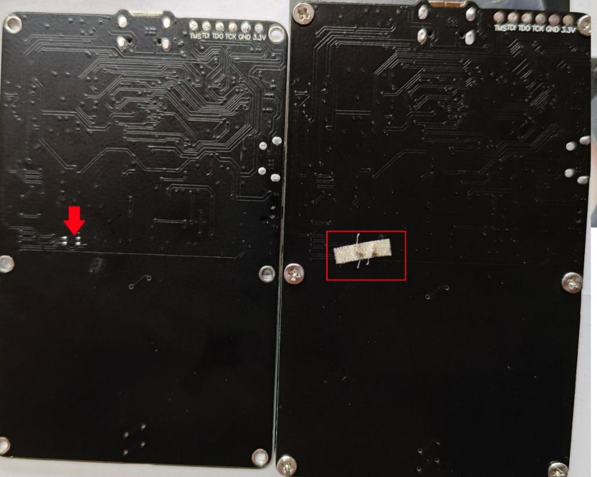

## 3. Low frequency antenna hollowing treatment and various installation methods

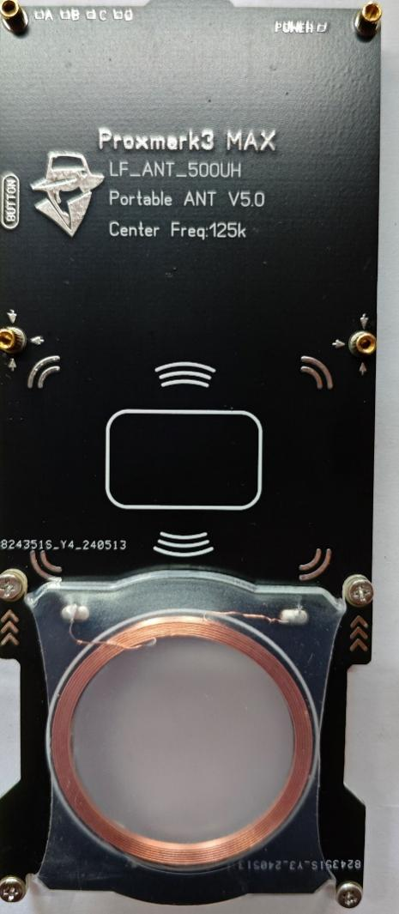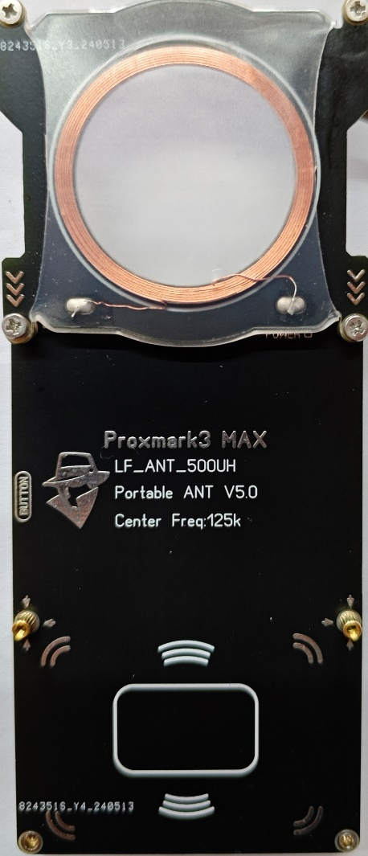

3.Free computer GUI and APP

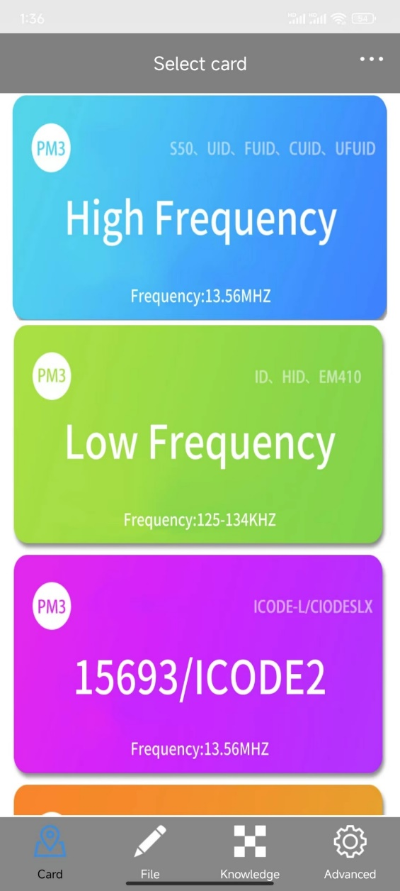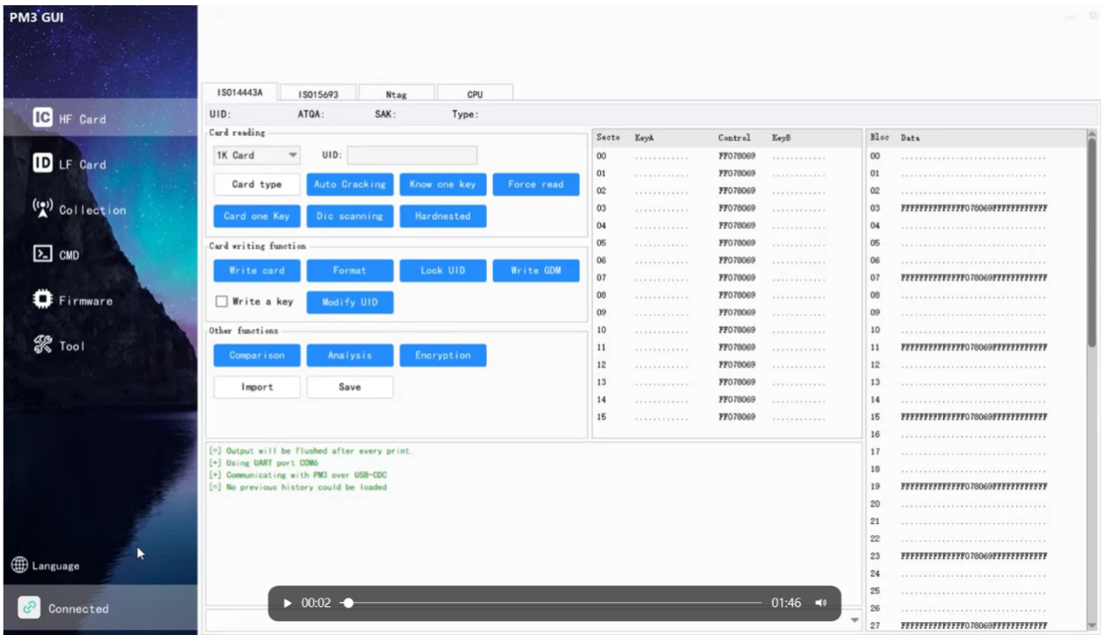



## 4. Bluetooth module modification

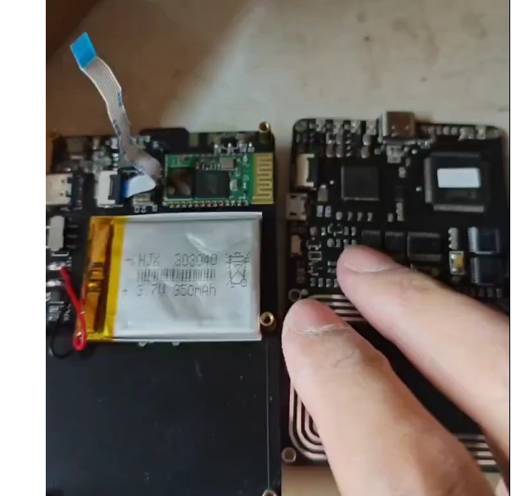

## 5. FPC connector -9PIN

