TUTORIAL

—— TTEC ON CLOTHO

- Execute TTEC ON CLOTHO program


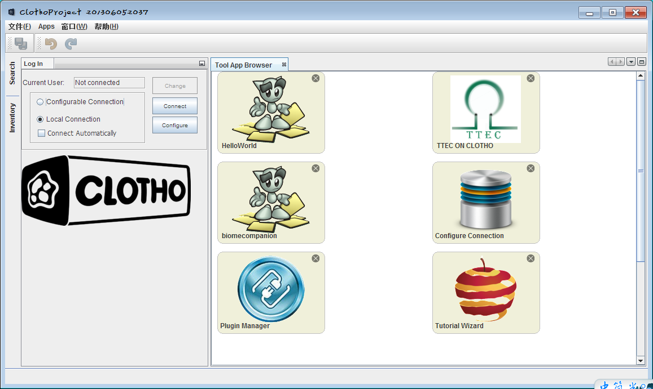

- Follow is the main window
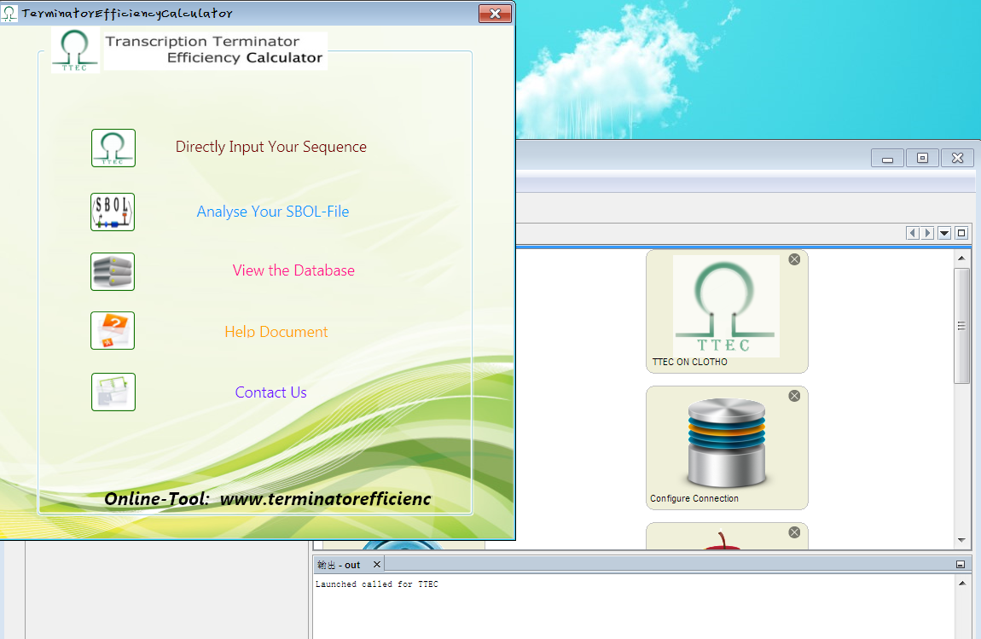

Keyboard input

- TTEC button to input your sequence by keyboard and choose the direction.

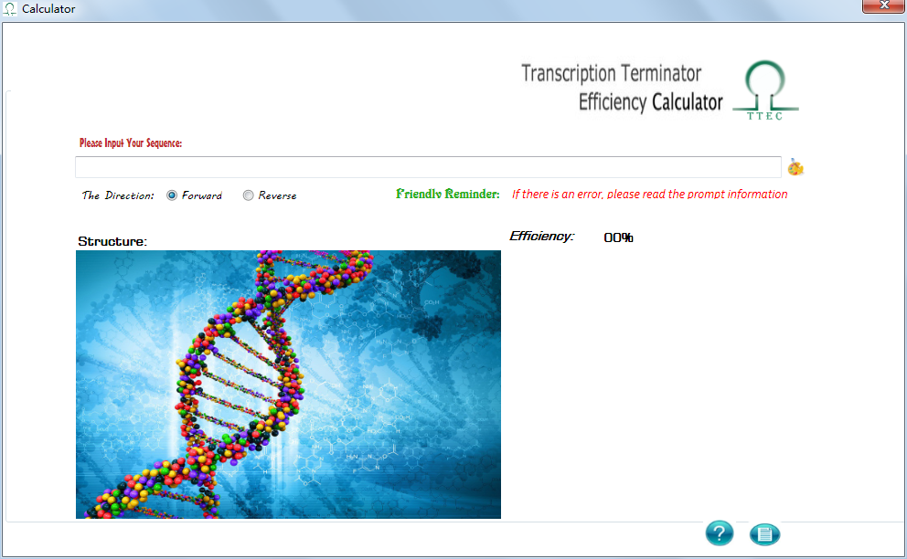

- Input your Sequence, then Click TTEC RUN to get result .

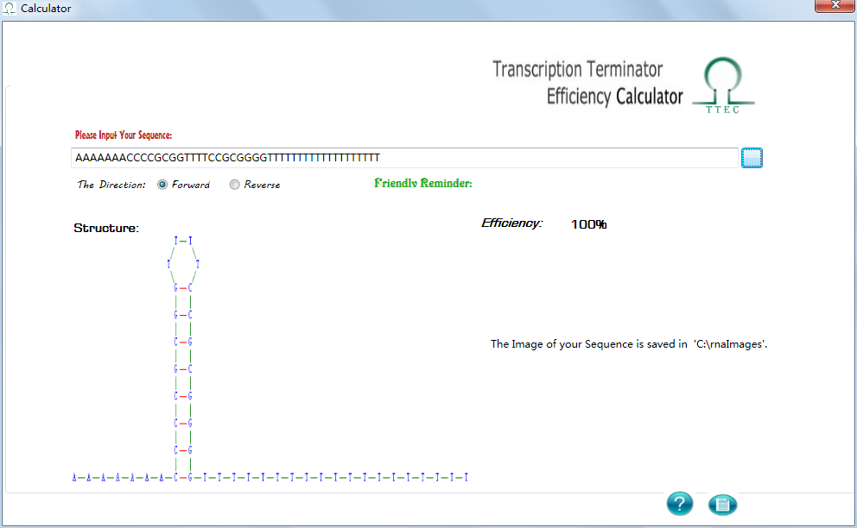

SBOL format input
- Click SBOL button to input XML file.

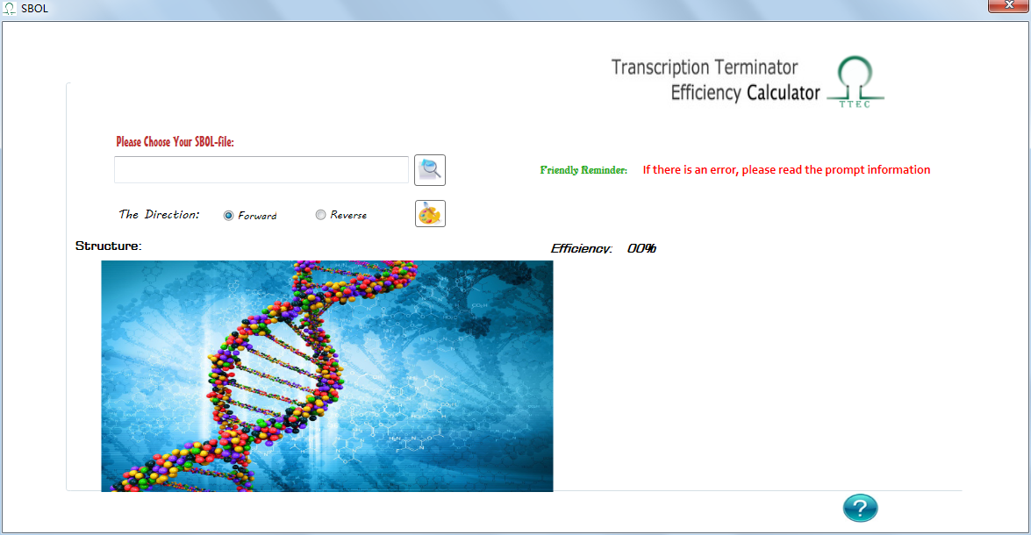

- Choose the direction and run.

About us

There is some information about our team, and you can get our e-mail address from here

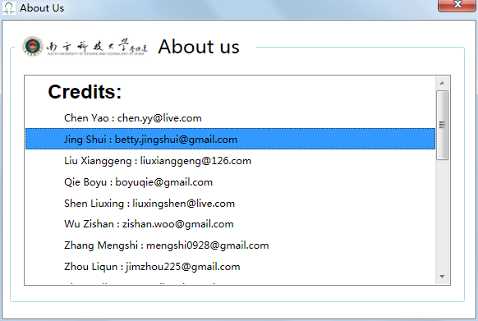

View the database
You guys can see our database here

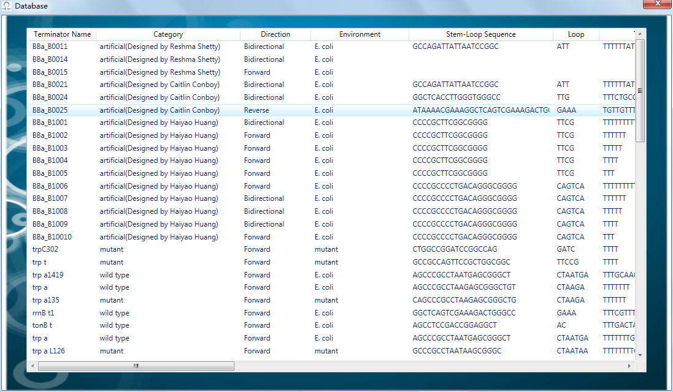

HELP
If you have some questions about how to use our Plugin, you can click HELP

