Formal Progress Update for the Preliminary Screening
Dental Caries Detection: Upgrade from Round 3 to Round 4
Executive summary. Round 4 did not replace the upgraded Round 3 model as the strongest overall system. However, it was not a superficial parameter tweak. The work moved from a single-stage four-class detector to a two-stage ROI-based pipeline, rebuilt the lesion-only training set, reduced empty samples from an unusable level to a controlled level, completed threshold calibration, and closed the loop with hard-case review. In short, the main value of Round 4 is methodological: it improved Caries and Cavity detection, clarified where the current bottlenecks really are, and demonstrates stronger research judgement than a simple additional YOLO run.

This report focuses on one question only: what was done after the upgraded Round 3 result, what changed in Round 4, and what those changes say about the feasibility of the project. The intention is not to overclaim an overall win for Round 4, but to present a precise account of the technical decisions, the measurable gains, and the remaining weaknesses.
1. Reference point: what Round 3 had already achieved
The upgraded Round 3 model remained the strongest full-image result in headline terms. Its best checkpoint achieved Precision 0.613, Recall 0.545, mAP50 0.523, and mAP50-95 0.365 on the validation setting. After threshold sweep, the best operating point further improved to Precision 0.677, Recall 0.491, mAP50 0.577, and mAP50-95 0.425. This made Round 3 the correct reference point for any later upgrade.
At the same time, Round 3 also exposed the structural limitation of the single-stage setting. The Tooth class was extremely strong and lifted the overall score, while the lesion classes remained the real difficulty, especially under severe class imbalance and background interference. Therefore, Round 4 was designed as a methodological upgrade rather than another small adjustment to the same pipeline.
2. Main comparison between Round 3 and Round 4
The table below compares the most important summary metrics. A direct one-to-one comparison should be made carefully: Round 3 is a full-image four-class detector, while the final Round 4 detector is a lesion-only three-class detector after ROI filtering. Even so, the comparison is still useful because it shows whether the new route improves the lesion detection problem or not.
Pipeline | Checkpoint / setting | Precision | Recall | mAP50 | mAP50-95
Round 3 upgraded model | best.pt | 0.613 | 0.545 | 0.523 | 0.365
Round 3 upgraded model | sweep-best | 0.677 | 0.491 | 0.577 | 0.425
Round 4 two-stage pipeline | Stage-2 best.pt | 0.567 | 0.411 | 0.438 | 0.241
Round 4 two-stage pipeline | Stage-2 sweep-best | 0.557 | 0.406 | 0.498 | 0.315
The strict conclusion is straightforward. Round 4 did not surpass Round 3 overall. Even after threshold sweep, the new pipeline remained below the upgraded Round 3 result in overall headline metrics. However, that is not the whole story. The class-wise comparison shows that Round 4 improved Caries and Cavity, while Crack remained the major weakness.
For the lesion classes only, the pattern becomes clearer.
Class | R3 P | R3 R | R3 mAP50 | R3 mAP50-95 | R4 P | R4 R | R4 mAP50 | R4 mAP50-95
Caries | 0.433 | 0.430 | 0.345 | 0.161 | 0.557 | 0.436 | 0.439 | 0.212
Cavity | 0.477 | 0.434 | 0.397 | 0.205 | 0.559 | 0.484 | 0.529 | 0.272
Crack | 0.655 | 0.358 | 0.384 | 0.250 | 0.585 | 0.312 | 0.344 | 0.237
This is the key result of Round 4. The ROI-based pipeline clearly improved Caries and Cavity, but it did not solve Crack. Therefore, the correct interpretation is not that the new method failed, but that it improved the easier lesion classes while leaving the hardest minority class largely unsolved.
3. What was added in Round 4 after Round 3
Round 4 introduced a different experimental logic. Instead of continuing to adjust the original end-to-end detector, the task was decomposed into a localisation stage and a lesion-only detection stage. This was intended to reduce tooth dominance, focus the detector on lesion-bearing regions, and produce a cleaner experimental setting for error analysis.
- Stage 1: a binary tooth + lesion localisation model was trained to provide stable region proposals. The best checkpoint reached val_dice 0.8965 and val_iou 0.8292, which was sufficient for downstream ROI construction.
- Stage 2 dataset reconstruction: the first ROI-based dataset version was found to be unusable because the empty-sample ratio was too high (train 35.4%, val 46.9%, test 37.5%).
- Dataset revision: a second filtering step retained all non-empty samples and kept only a limited number of empty crops as hard negatives. This reduced the empty ratio to train 13.4%, val 12.9%, and test 13.7%.
- Stage 2 detection: YOLOv8m was trained on the rebuilt lesion-only three-class dataset at 960 input size for 60 epochs.
- Threshold calibration: a validation sweep found the best operating point at conf 0.30 and iou 0.45, raising mAP50 from 0.438 to 0.498 and mAP50-95 from 0.241 to 0.315.
- Hard-case review: the most difficult validation samples were exported for manual inspection to identify recurrent failure modes rather than relying on a single summary score.
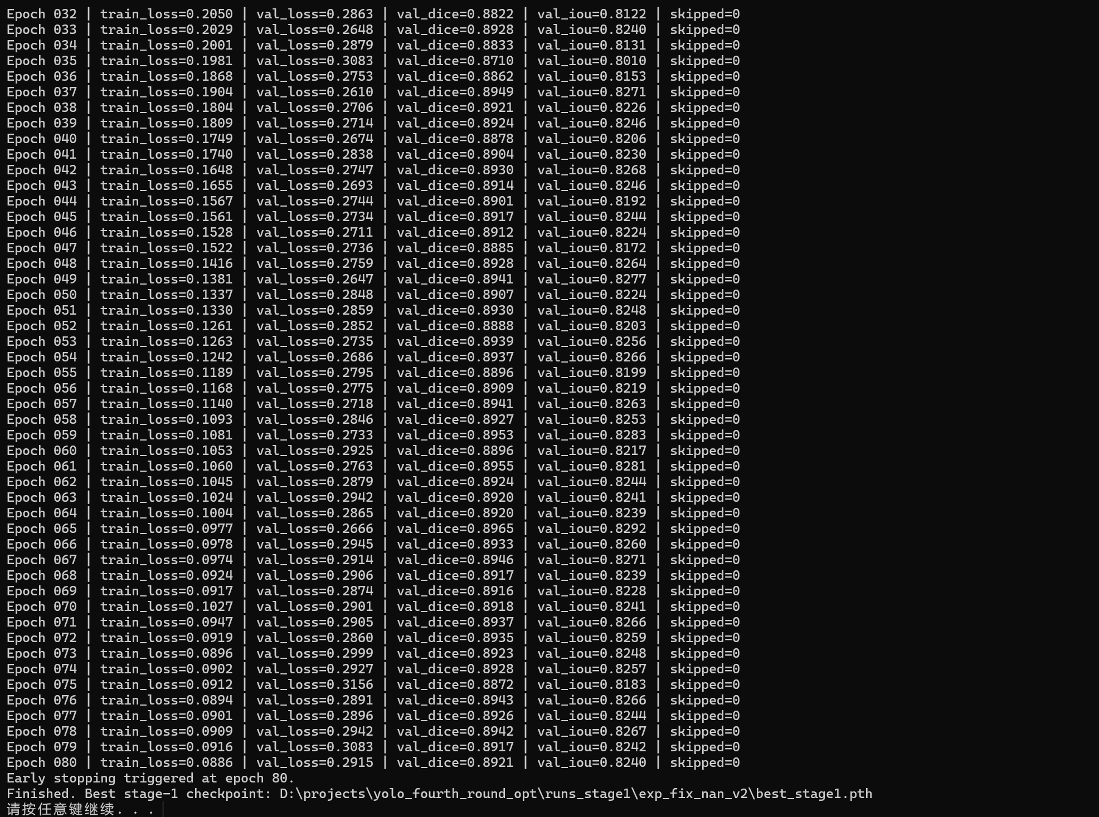 | 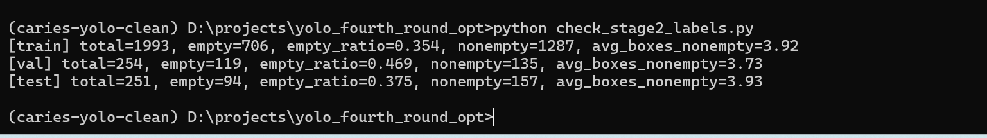
Figure 1. Round 4 intermediate evidence: Stage 1 training stability (left) and the initial Stage 2 empty-sample problem before filtering (right).
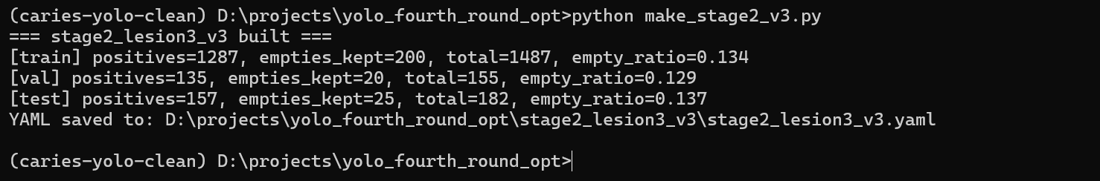
Figure 2. Reduced empty-sample ratio after Stage 2 dataset revision (left), and the Round 3 sweep-best reference used as the comparison anchor (right).
4. Stage 2 training behaviour and final output
The Stage 2 training curve is informative. The training losses decreased steadily, while the validation metrics rose and then entered a plateau. This indicates that the model did learn the lesion-only problem, but the later epochs no longer delivered large gains. In practical terms, the model had already extracted most of the useful signal before the final epoch.
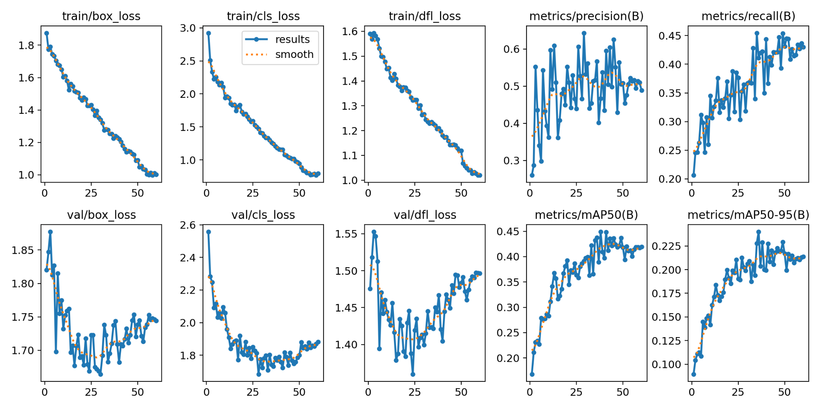
Figure 3. Stage 2 learning curves. Training losses decrease consistently; validation mAP50 and mAP50-95 rise and then flatten, which suggests convergence rather than instability.
The normalized confusion matrix shows that the dominant error is not simply inter-class confusion among Caries, Cavity, and Crack. The main problem is lesion-versus-background confusion. A large share of true lesions still falls into the background prediction, and some background regions are still misclassified as lesions.
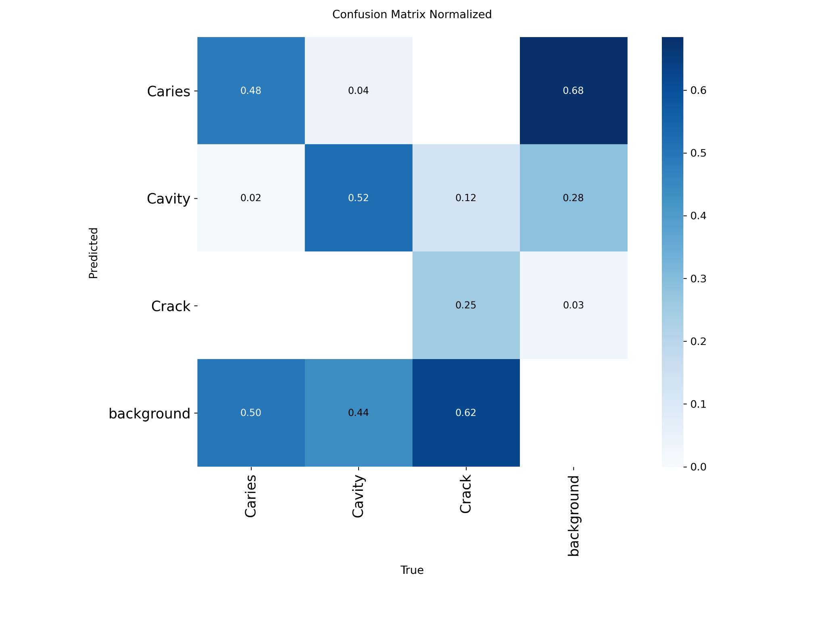 | 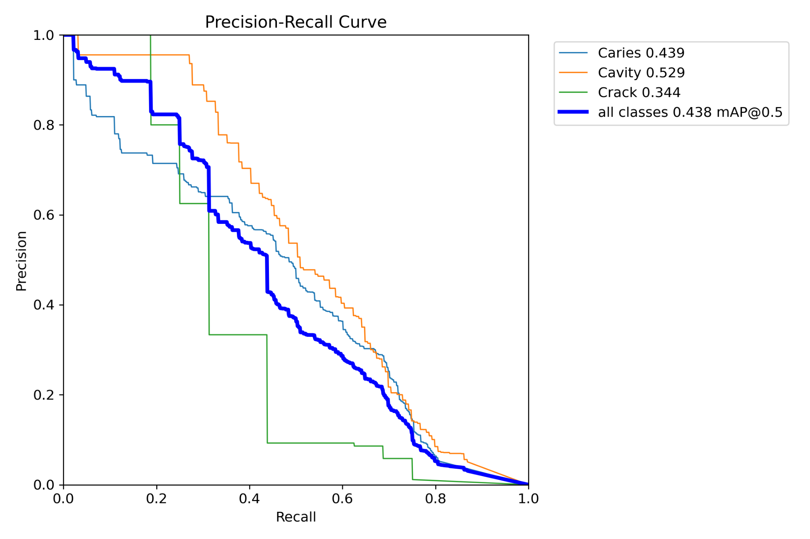
Figure 4. Normalized confusion matrix (left) and precision-recall curve (right) for the final Stage 2 model.
5. Diagnostic reading of the final result
The final best checkpoint of Round 4 achieved Precision 0.567, Recall 0.411, mAP50 0.438, and mAP50-95 0.241. After threshold sweep, the best operating point reached Precision 0.557, Recall 0.406, mAP50 0.498, and mAP50-95 0.315. This is a meaningful improvement over the raw best.pt reading and confirms that the Round 4 detector is sensitive to threshold choice.
However, the confusion matrix and PR behaviour show that the project bottleneck is now more specific. Caries and Cavity benefited from the ROI pipeline, but Crack remained weak because the class is both rare and visually fragile. In the labels distribution, Crack has only 150 instances, compared with 3449 for Caries and 1452 for Cavity. This scale difference is too large to ignore and explains why Crack recall remains substantially below the other classes.
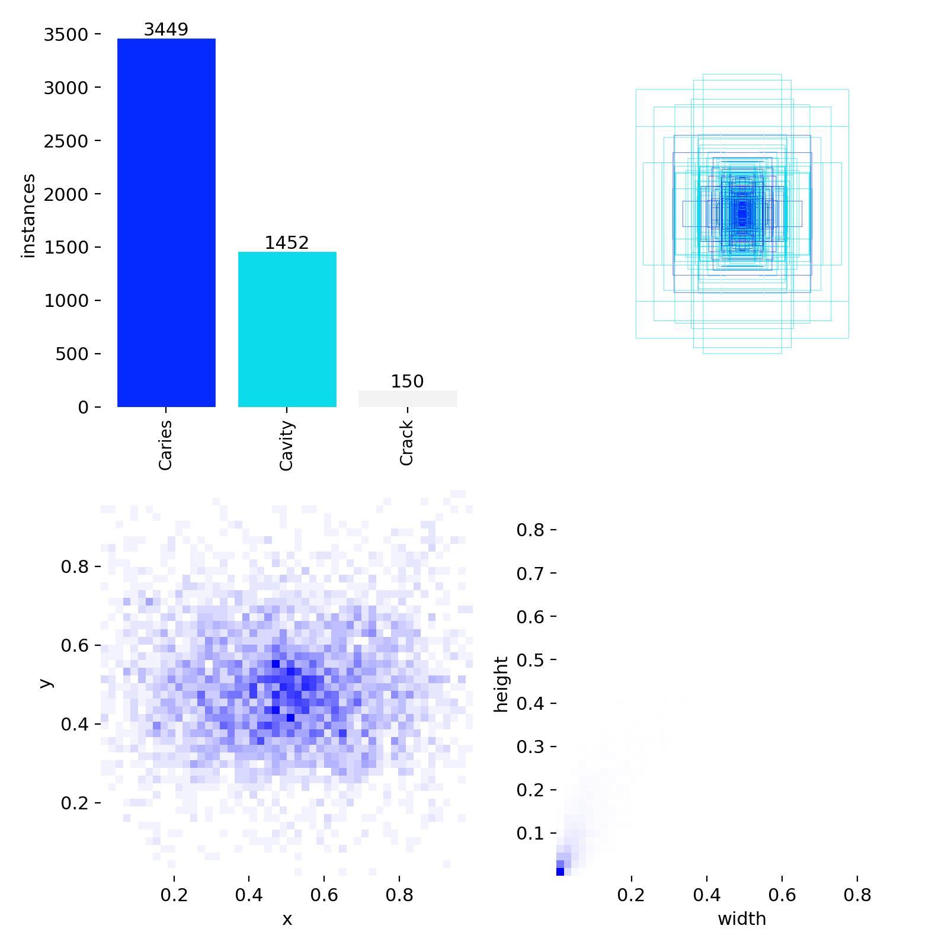 | 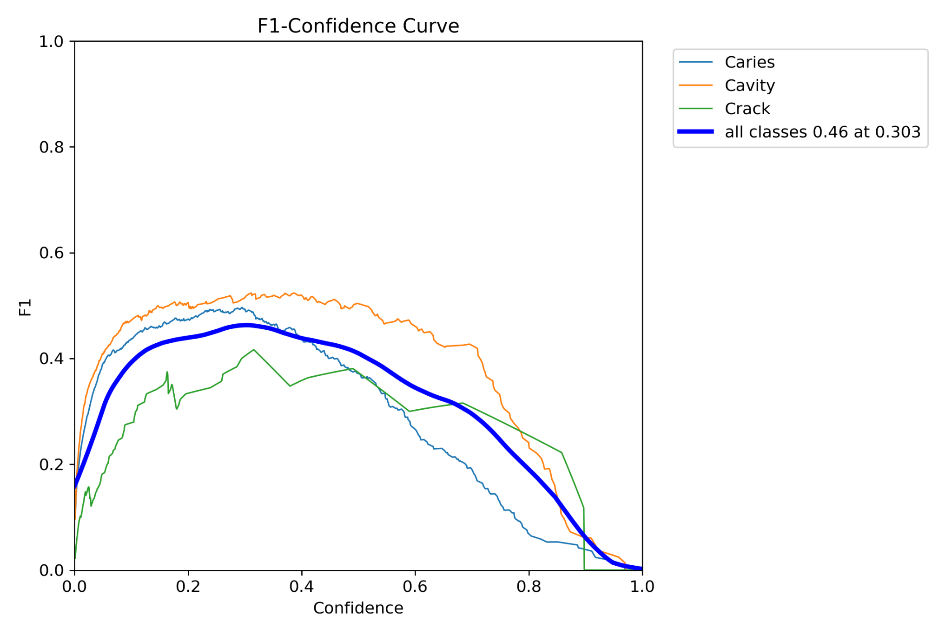
Figure 5. Class distribution and box-size pattern in the rebuilt Stage 2 dataset (left), and the F1-confidence curve of the final detector (right).
The optimal global F1 is around 0.46 at confidence approximately 0.30, which is consistent with the threshold sweep result. This means the final detector should not be judged only at a default confidence threshold. Its best operating region is in the low-to-mid confidence range, which is typical for a detector that still struggles with small or ambiguous lesions.
6. What this result says about the project and about my work
The most important point is methodological rather than cosmetic. Round 4 is not a random extra experiment. It shows a clear sequence of research decisions: identifying the limitation of the previous pipeline, redefining the task, rebuilding the data, validating the intermediate stage, calibrating the final detector, and then auditing difficult cases. This is the main evidence that the project work moved beyond simple parameter tuning.
The final judgement should therefore be balanced. Round 3 remains the stronger overall system and should still be treated as the best full-image result. Round 4 should be treated as a serious upgrade attempt that produced two concrete outcomes: first, it improved Caries and Cavity in the lesion-focused setting; second, it made the real bottlenecks visible, namely persistent lesion-versus-background confusion and the severe weakness of Crack as a minority class.
7. Recommended next step
If the work is continued, the most sensible next step is not another blind retraining run with the same configuration. The results already indicate where additional effort should go. The first priority should be inference-side improvement and targeted error reduction, especially threshold tuning, sliced inference for small lesions, and manual checking of the hardest false positives and false negatives. The second priority should be class-targeted strengthening for Crack rather than a broad, undirected expansion of the entire pipeline.
In other words, the current state of the project is credible: Round 3 is still the best overall benchmark, while Round 4 demonstrates stronger technical judgement and provides a better base for the next research decision.

