Final Experimental Report for Preliminary Screening: YOLO-Based Dental Caries Detection Implementation
Github Repositories: https://github.com/hejingxi6/Caries-Detection-Implementation
Executive Summary

An end-to-end YOLO-based dental caries detection pipeline was implemented for the preliminary screening task and then improved through three controlled optimization rounds. The main contribution of this work is a traceable engineering process: starting from a basic baseline, the detector was strengthened through threshold sweeping, imbalance-oriented training changes, and literature-guided design decisions.
The strongest retained operating point in the available evidence is Round 2 sweep for mAP@0.5 (0.595) and recall (0.592), while Round 3 sweep gives the best mAP@0.5:0.95 (0.425) and the highest precision (0.677). Compared with the initial baseline (mAP@0.5 = 0.312, mAP@0.5:0.95 = 0.216), this means the project achieved clear measurable improvement rather than only narrative progress.

1. Task and Reporting Basis

The preliminary-screening task was to complete a basic implementation of deep-learning-based dental caries detection within a short timeline and prepare for a follow-up technical discussion. This report therefore focuses on the completed pipeline, the retained experimental results from each round, and the technical interpretation of those results.

2. Experimental Design Across Rounds

To keep the comparison meaningful, the project followed one consistent evaluation logic: the same validation split was reused across rounds, final model quality was read from retained validation outputs, and each round also included a threshold sweep to separate raw training result from the selected deployable operating point. This is important because threshold choice, input size, and class imbalance can materially change detector performance even when the model family remains the same.

Round | Run name / evidence | Main change | Time cost | Reason for trying it
Initial baseline | baseline run | Basic YOLOv8 sanity pipeline | reference stage | Establish the initial YOLOv8 detector for later comparison
Round 1 | fast_stage1_fix | Stabilized first full training run + threshold sweep | 40 epochs; fast first comparison | Establish a reproducible first detector and identify the best validation threshold
Round 2 | rebalance_imgsz768 | Rebalanced training list / minority-class exposure + 768 input + sweep | 51 epochs completed | Address clear class imbalance and recover more lesion recall
Round 3 | lesionmix_imgsz960_e80 | Lesion-mix style augmented training set + higher resolution (960) + sweep | 69 epochs completed | Push lesion visibility and class exposure further while improving localization quality

Round 3 did not outperform the earlier rounds on every metric. Instead, it traded some recall for stronger precision and the best mAP@0.5:0.95. For that reason, the analysis separates coarse detection strength (mAP@0.5) from stricter localization quality (mAP@0.5:0.95), and interprets the selected operating point in relation to the screening objective.
3. Quantitative Results

Table 1 reports the strongest retained metrics from the available experimental evidence. The comparison is deliberately split into training result and sweep-best result because deployment quality depends on the operating threshold rather than on the raw training default alone. Here, mAP@0.5 means mean Average Precision at an IoU threshold of 0.5, while mAP@0.5:0.95 refers to the average AP computed across IoU thresholds from 0.5 to 0.95.
Stage | Variant | Precision | Recall | mAP@0.5 | mAP@0.5:0.95 | Notes
Initial baseline | baseline | 0.331 | 0.362 | 0.312 | 0.216 | Initial retained baseline result
Round 1 | train | 0.491 | 0.533 | 0.505 | 0.343 | First stable full training result
Round 1 | sweep-best | 0.653 | 0.470 | 0.562 | 0.402 | Best row: conf 0.25, IoU 0.50
Round 2 | train | 0.570 | 0.589 | 0.540 | 0.358 | Rebalanced training clearly lifted recall
Round 2 | sweep-best | 0.590 | 0.592 | 0.595 | 0.403 | Best row: conf 0.15, IoU 0.50
Round 3 | train | 0.613 | 0.545 | 0.523 | 0.365 | Higher precision, slightly lower mAP@0.5
Round 3 | sweep-best | 0.677 | 0.491 | 0.577 | 0.425 | Best row: conf 0.30, IoU 0.50

Compared with the initial baseline, the best available mAP@0.5 rose from 0.312 to 0.595 in the Round 2 sweep, while the best available mAP@0.5:0.95 rose from 0.216 to 0.425 in the Round 3 sweep. In practical terms, the project achieved clear improvement in both coarse detection and stricter localization, although the minority lesion classes remain challenging.
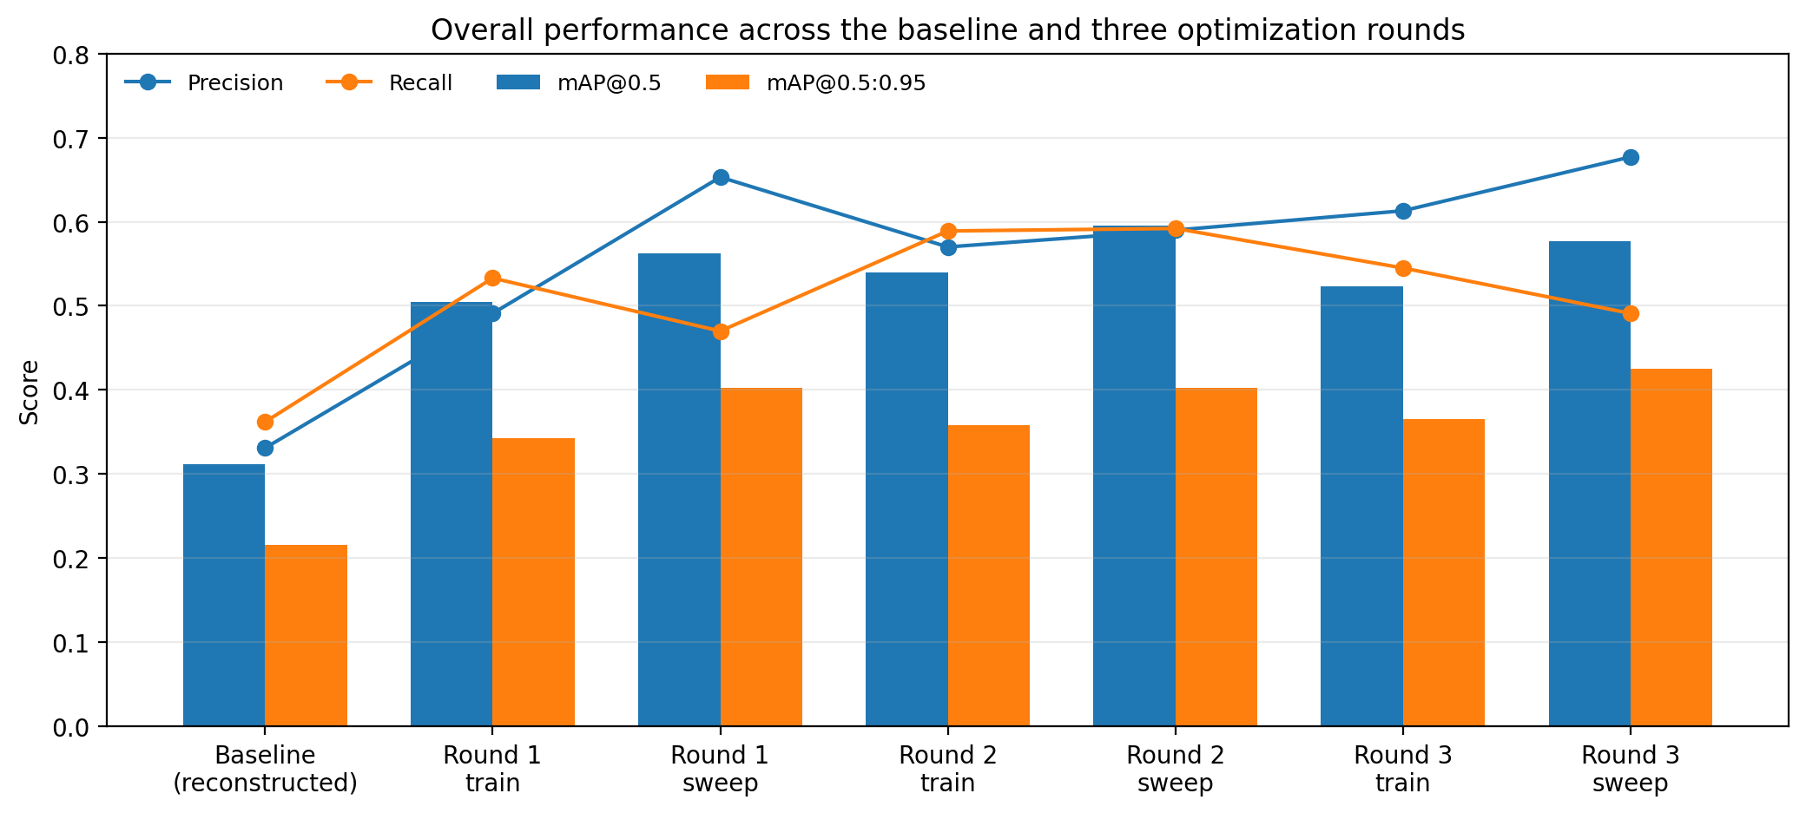
Figure 1. Overall performance across the baseline and the three optimization rounds.
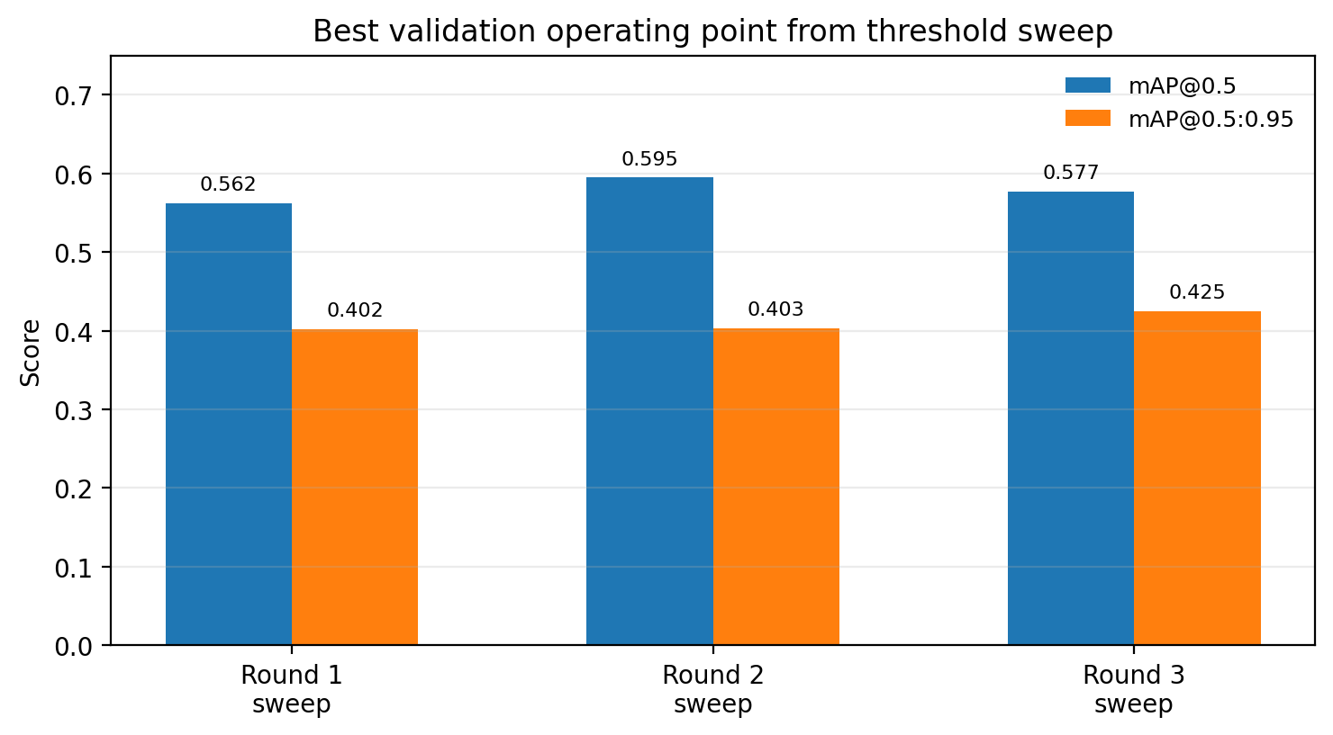
Figure 2. Best validation operating point selected by threshold sweep in each completed round.
4. Class-Wise Analysis

The model family consistently detects the Tooth class far more reliably than lesion classes. This is not surprising: Tooth has the largest number of visible instances, the clearest visual structure, and the most stable geometry. The three lesion classes are harder for different reasons: Caries is small and easily absorbed into background; Cavity is visually variable; Crack has extremely few examples and therefore unstable learning.
Class | Round 1 mAP@0.5 | Round 2 mAP@0.5 | Round 3 mAP@0.5 | Interpretation
Caries | 0.322 | 0.342 | 0.345 | Only modest improvement; still frequently confused with background and tooth-like patterns
Cavity | 0.429 | 0.412 | 0.397 | Reasonable but unstable; gains from rebalancing were not preserved under the later high-resolution lesion-mix setup
Crack | 0.299 | 0.437 | 0.384 | Strong jump in Round 2 suggests rebalancing mattered; later decline reflects tiny sample size and instability
Tooth | 0.976 | 0.970 | 0.966 | Already near ceiling; this class is not the bottleneck

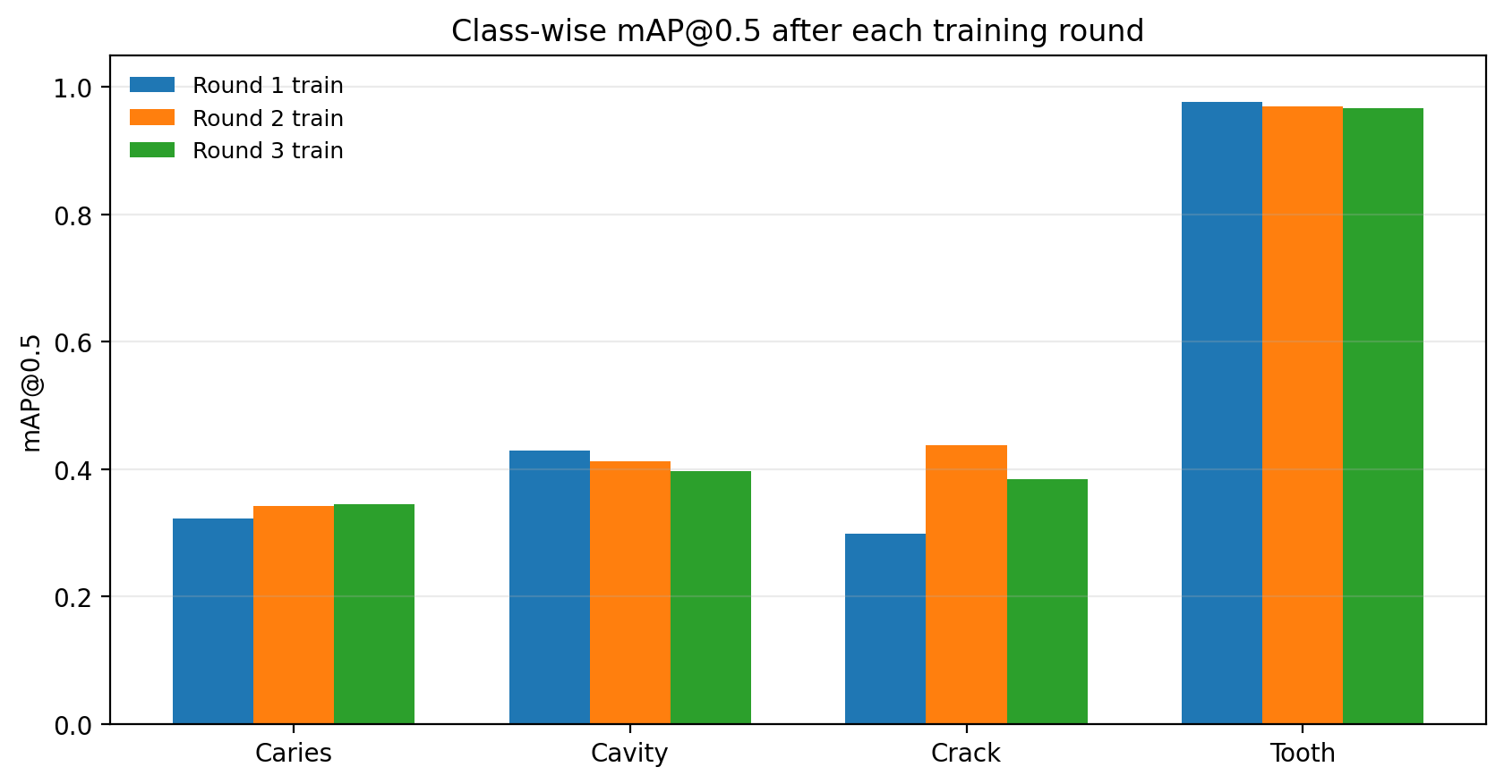
Figure 3. Class-wise mAP@0.5 across the three completed training rounds.
A report that only presents global mAP can look stronger than it really is, because clinically important failure modes may remain hidden. The class-wise results show the actual bottleneck in this project: tooth detection is already strong, while small lesion detection under class imbalance is still the main difficulty.

5. Error Analysis and Qualitative Review

The retained confusion matrix and validation-prediction panels show the same pattern as the metric table: many lesion instances are still lost to background, while tooth detection stays dominant. This means the model is not merely “low scoring”; it is systematically biased toward visually stronger and more frequent structures.
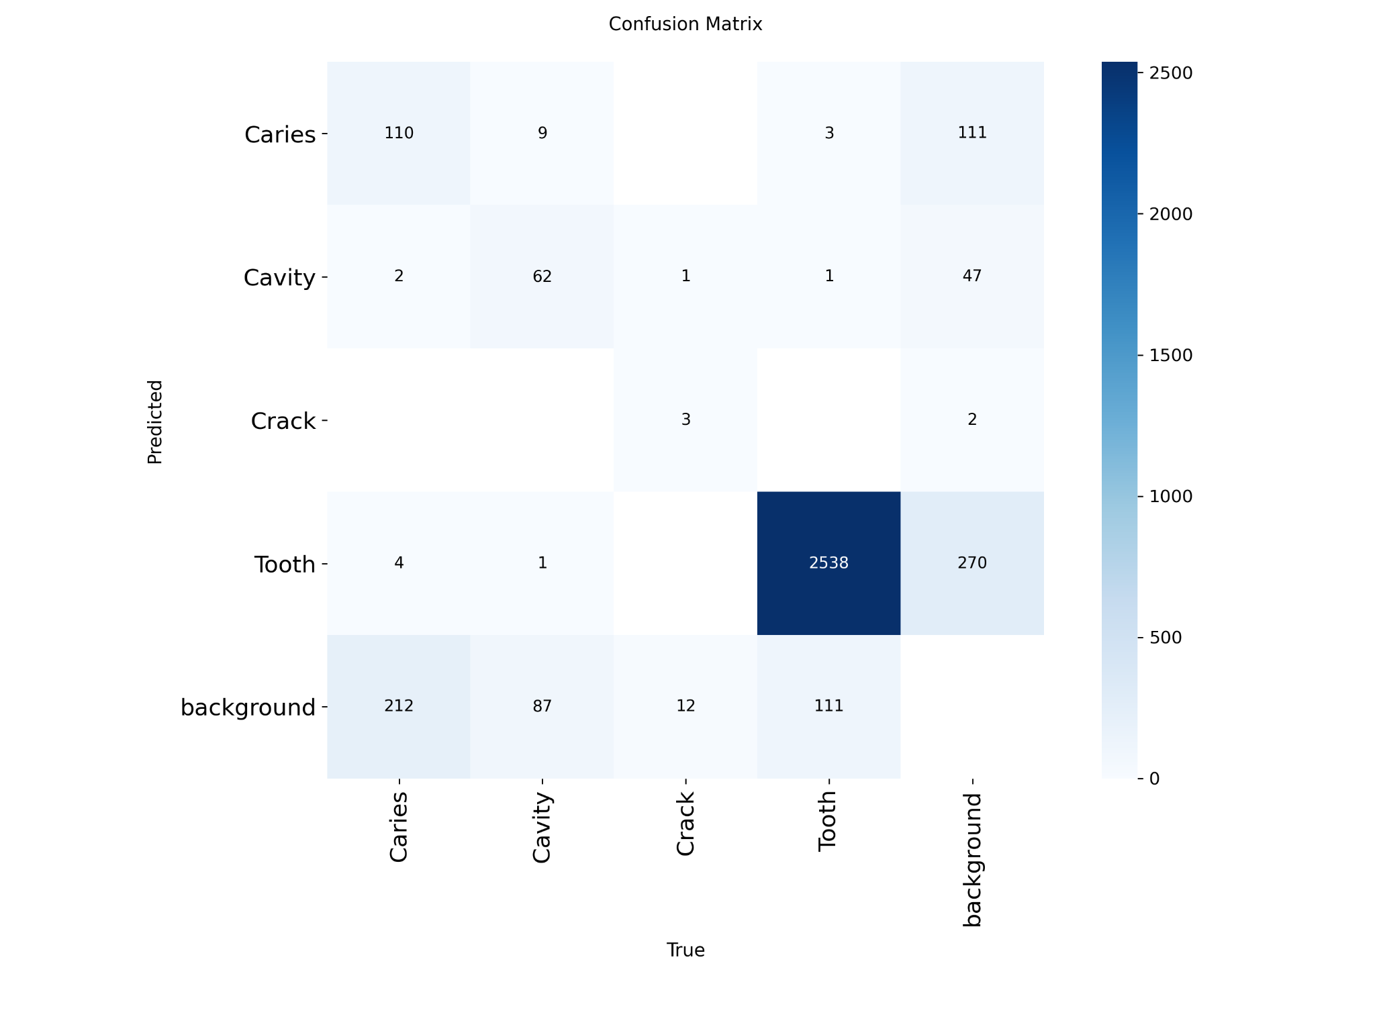
Figure 4. Retained confusion matrix export. Large background confusion remains for Caries, Cavity, and Crack.
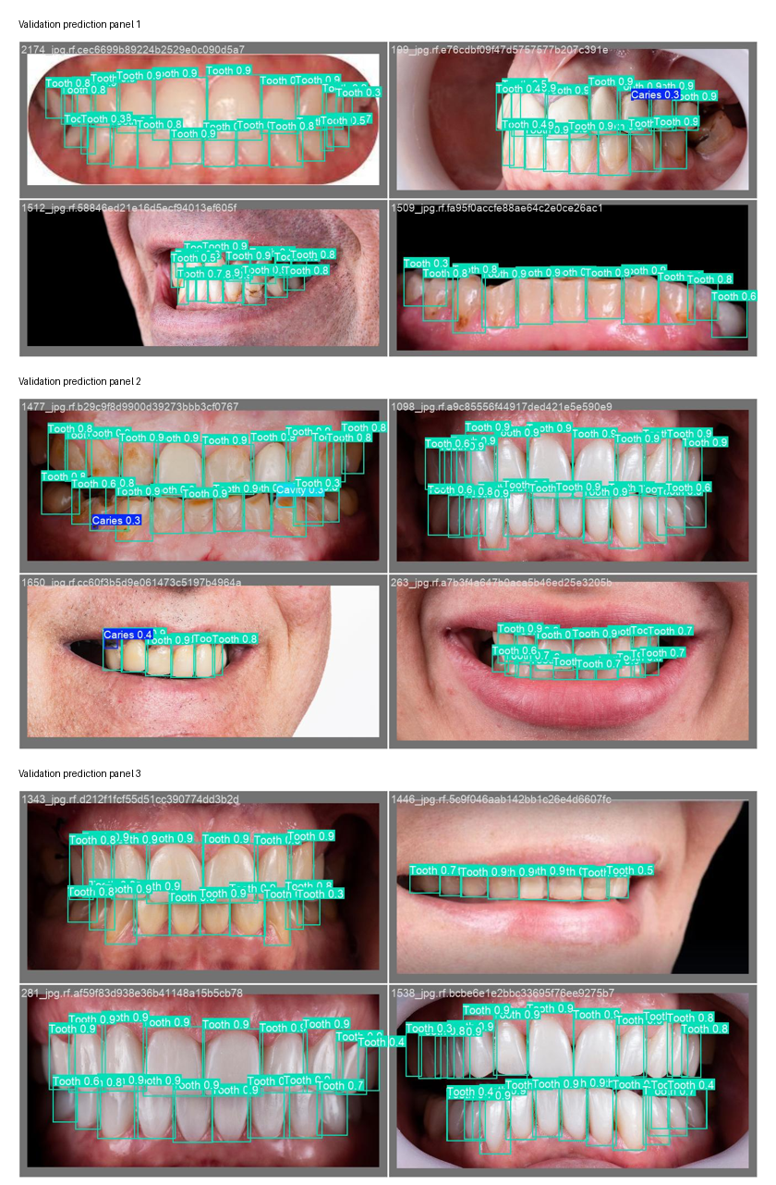
Figure 5. Representative validation prediction panels retained from the experiment artifacts.
These qualitative examples show both progress and remaining weaknesses. A positive signal is that lesion boxes do appear on genuinely difficult images, which indicates that the detector is learning more than a trivial “tooth = object” pattern. However, lesion recall remains sensitive to threshold choice, and several images still show dense tooth detections around sparse lesion evidence. Taken together, the preserved qualitative outputs are sufficient to illustrate the dominant validation pattern observed in this project: strong tooth detection, but still unstable minority-lesion detection under difficult visual conditions.

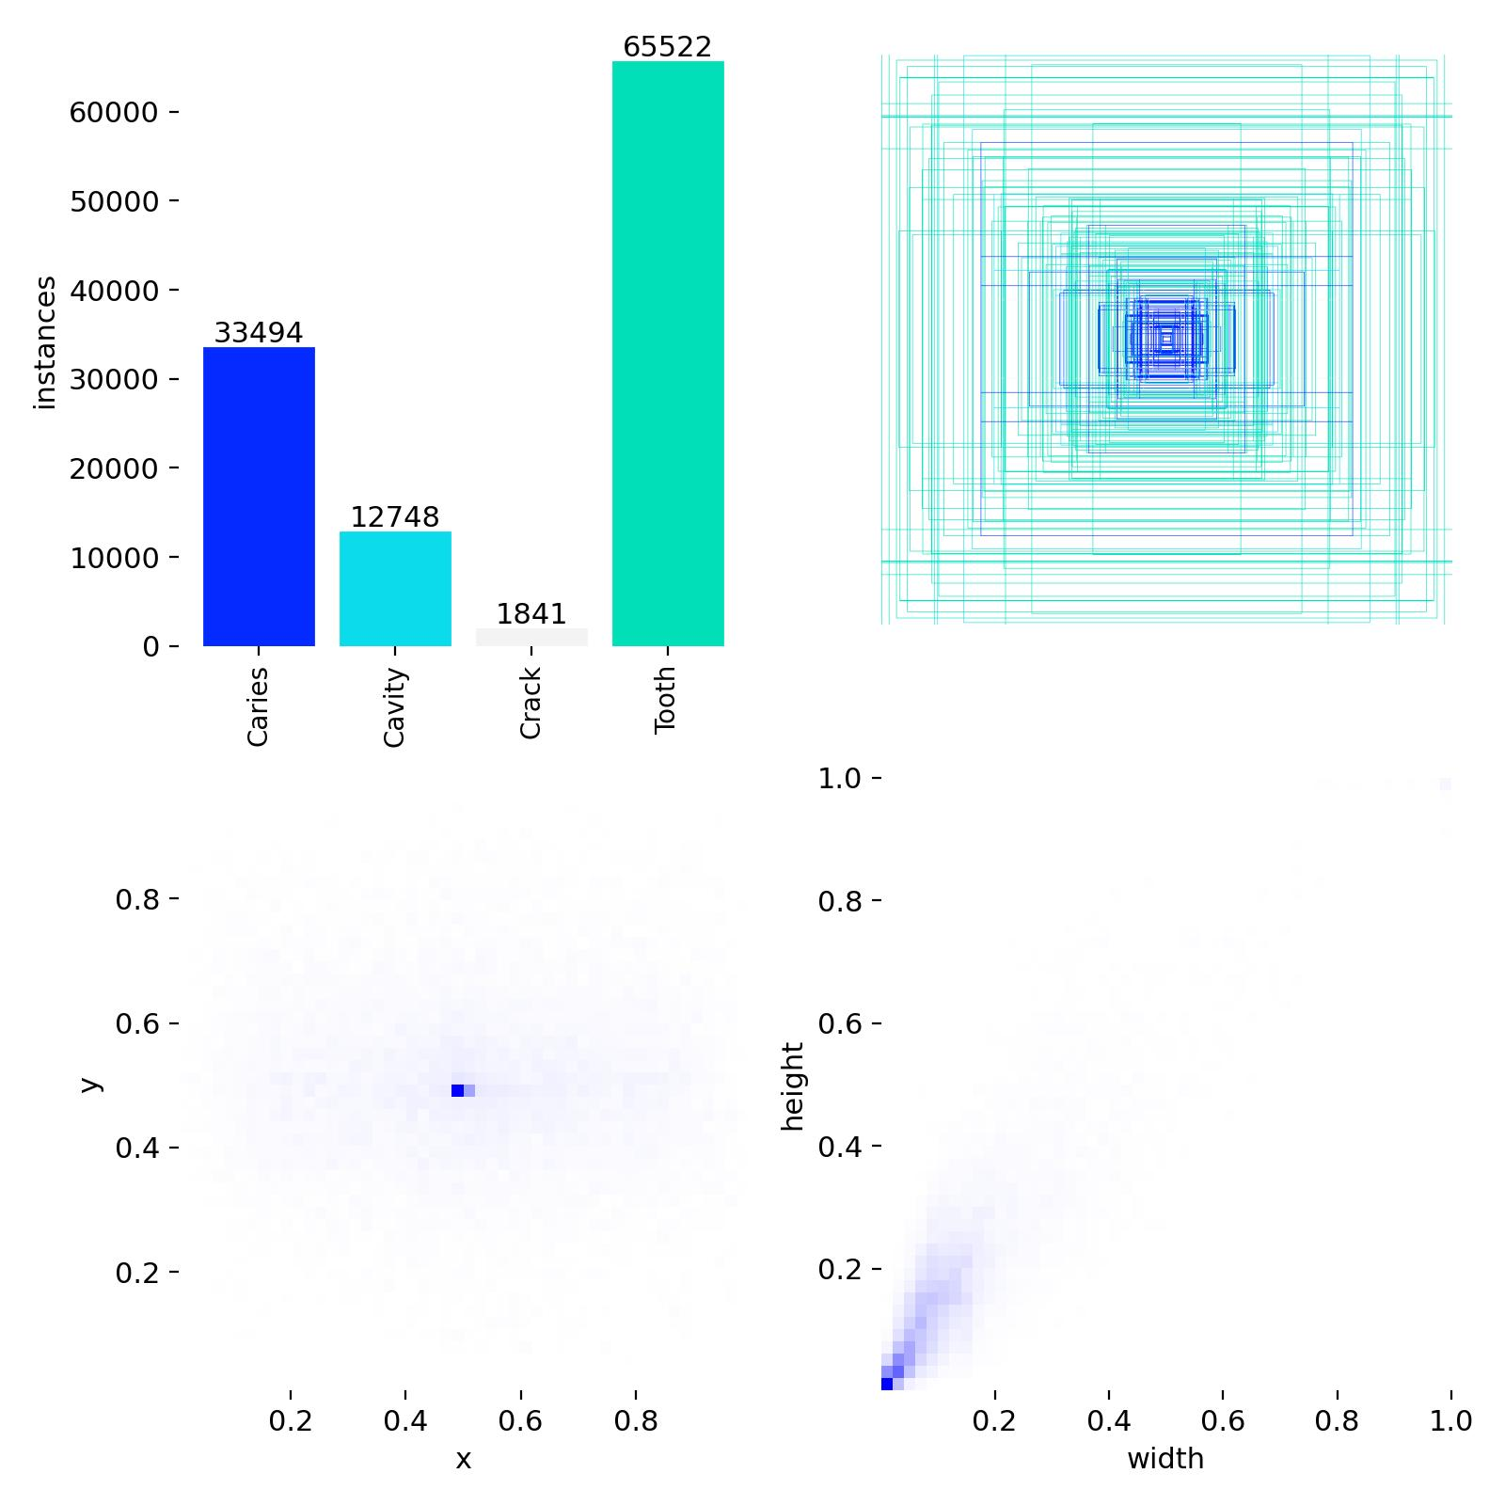
Figure 6. Retained label-distribution export from the lesion-mix round, showing that Tooth still dominates the training signal.
6. Literature-Guided Interpretation

Dental object-detection papers can report much stronger headline numbers than this project, yet they often use different modalities, curated institutional datasets, different label definitions, and different evaluation protocols. Therefore, those numbers should be used as methodological guidance rather than as a naive target for direct comparison.
Literature-backed finding | Evidence | How it maps to this project | Decision taken here
Threshold tuning materially changes dental detector behavior | Dental YOLOv7 bitewing study [3] | Separating raw training metrics from sweep-best metrics is necessary | Implemented in all three rounds
Strong papers are often not directly comparable because datasets and annotation protocols differ | Bayati 2025, Ayhan 2025, AI-Dentify 2024 [1][2][4] | Do not pretend that a 0.59 mAP on DentalAI should match curated bitewing studies | Explained explicitly in this report
Small lesions benefit from slicing/tiling and high-resolution treatment | SAHI and small-object literature [6] | Supports the move toward larger images and future sliced inference | Partially implemented via higher-resolution Round 3; SAHI identified as next strong candidate
Long-tail imbalance must be addressed directly, not only by changing backbones | Focal Loss / Class-Balanced Loss [7][8] | Supports rebalancing and lesion-mix style augmentation | Implemented in Round 2 and Round 3
Annotation inconsistency can cap performance on small lesions | Kunt 2023 and AI-Dentify 2024 [4][5] | Explains why minority-class metrics remain unstable even after optimization | Discussed as a genuine limitation, not hidden

The literature is used here to interpret model behavior, separate transferable methods from non-comparable headline results, and keep the final judgment aligned with the actual experimental setting used in this project.

7. Overall Assessment, Limitations, and Next-Step Recommendation
Overall, the preliminary screening demonstrates a completed YOLO-based dental caries detection implementation together with a structured optimization process. A working detector was built, trained, validated, inspected, and iteratively improved across three rounds. The retained evidence shows clear engineering progress: compared with the initial baseline, later rounds achieved substantially better validation performance, while the literature review helped interpret the results in a methodologically grounded way.
However, the detector is not yet clinically reliable. The main limitation is that minority lesion classes remain unstable and are still heavily affected by background confusion and small-object difficulty. In addition, some early raw artifacts were not preserved, so the final judgment in this report is based on retained evidence only. This does not invalidate the observed improvement, but it does limit the completeness of retrospective comparison across all earlier experiments.
Among the completed rounds, Round 2 provided the strongest mAP@0.5 and recall after rebalancing, while Round 3 provided the strongest precision and mAP@0.5:0.95 after lesion-mix augmentation and higher-resolution training. Therefore, the most reasonable short-cycle next step is to test SAHI sliced inference on the strongest retained checkpoint while keeping the same validation split. This directly targets the small-lesion detection problem observed in the retained error patterns. In parallel, a small annotation-quality audit or relabel check for the hardest lesion images would also be valuable before attempting more complex backbone or training changes.
- References

[1] Bayati, M., Savareh, B.A., Ahmadinejad, H. et al. Advanced AI-driven detection of interproximal caries in bitewing radiographs using YOLOv8. Scientific Reports, 15, 2025. DOI: 10.1038/s41598-024-84737-x.
[2] Ayhan, B., Ayan, E., Karadag, G., Bayraktar, Y. Evaluation of caries detection on bitewing radiographs: a comparative analysis of the improved deep learning model and dentist performance. Journal of Esthetic and Restorative Dentistry, 37(7), 1949-1961, 2025. DOI: 10.1111/jerd.13470.
[3] Panyarak, W., Wantanajittikul, K., Charuakkra, A. et al. Enhancing caries detection in bitewing radiographs using YOLOv7. Journal of Digital Imaging, 36(6), 2635-2647, 2023. DOI: 10.1007/s10278-023-00871-4.
[4] Perez de Frutos, J., Helland, R.H., Desai, S. et al. AI-Dentify: deep learning for proximal caries detection on bitewing x-ray - HUNT4 Oral Health Study. BMC Oral Health, 24, 344, 2024. DOI: 10.1186/s12903-024-04120-0.
[5] Kunt, L., Kybic, J., Nagyova, V., Tichy, A. Automatic caries detection in bitewing radiographs: part I - deep learning. Clinical Oral Investigations, 27(12), 7463-7471, 2023. DOI: 10.1007/s00784-023-05335-1.
[6] Akyon, F.C., Altinuc, S.O., Temizel, A. Slicing Aided Hyper Inference and Fine-tuning for Small Object Detection. Proceedings of the IEEE International Conference on Image Processing (ICIP), 2022, pp. 966-970. DOI: 10.1109/ICIP46576.2022.9897990.
[7] Lin, T.-Y., Goyal, P., Girshick, R., He, K., Dollar, P. Focal Loss for Dense Object Detection. Proceedings of the IEEE International Conference on Computer Vision (ICCV), 2017, pp. 2980-2988.
[8] Cui, Y., Jia, M., Lin, T.-Y., Song, Y., Belongie, S. Class-Balanced Loss Based on Effective Number of Samples. Proceedings of the IEEE/CVF Conference on Computer Vision and Pattern Recognition (CVPR), 2019, pp. 9268-9277.
[9] Ahmed, S.M.F., Ghori, M.H., Khalid, A. et al. Annotated intraoral image dataset for dental caries detection. Scientific Data, 12, 1297, 2025. DOI: 10.1038/s41597-025-05647-9.
[10] Fadilah, R.P.N., Rikmasari, R., Akbar, S., Setiawan, A.S. Examination of new clinical dental caries in school children using real intra oral photos with artificial intelligence model YOLO-V8x. BMC Oral Health, 26, 164, 2025. DOI: 10.1186/s12903-025-07486-x.

