There are two test cases at below.

**The first test case** does not have the Special Handle Notes on WEB UI, but it does exist in ACEC Core Payment History screen. UAT confirms they expect to see this notes on web UI as well, but it doesn’t.

My analysis shows the stored procedure does not find any matched Special Handle Notes from database, and the web UI is working fine.

**The second test case** shows a claim which has Special Handle Notes in ACES Core and also this note gets queried by stored procedure and eventually displayed on the web UI.

**The question is**: Why the 1st test case does not have the Special Handle Note found? Is this sort of database issue or Stored Procedure bug? Need a DBA to help investigate.

The following is the 1st test case which is documented in TTP.

The selected Claim Payment does have a special handling note in ACES Core, but the CSR cannot see the notes at ACES Web.

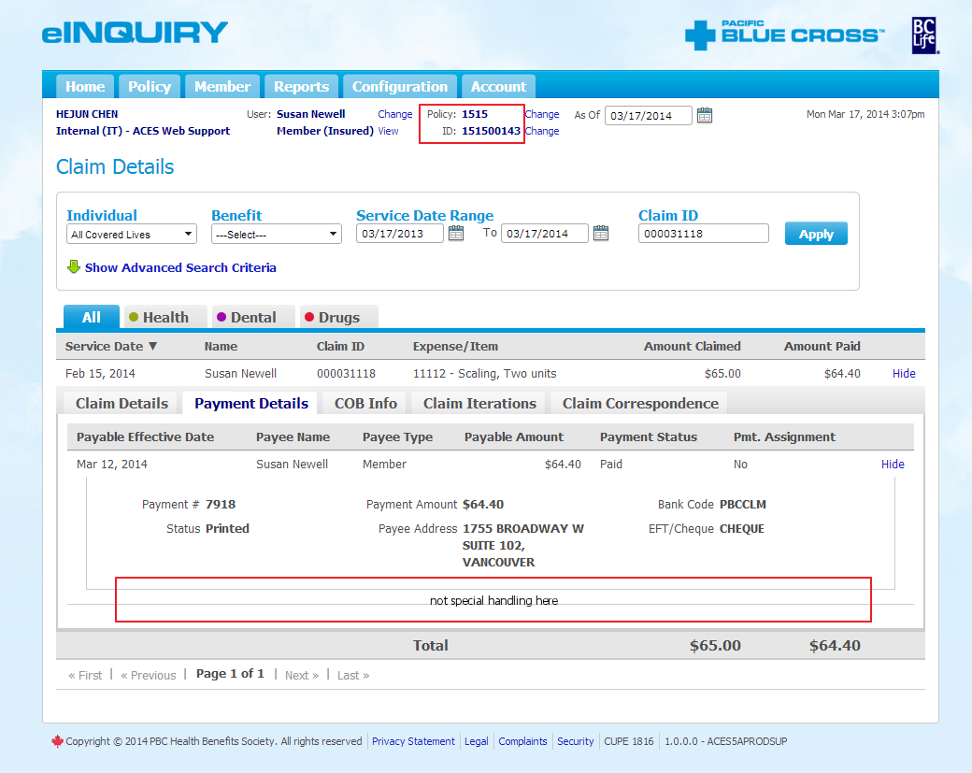

For the claim details page, the following stored procedure gets executed.

declare @p3 nvarchar(10)

set @p3=NULL

exec usp_CLMeInquiryClaimsFetch @psUserID=N'HCHEN',@piLanguage=1,@psErrorCode=@p3 output,@piClaimID=242425871,@piClaimLineSeqNum=1

Run the query at above, the returned tables does not have the Special Handling Notes data. The result matches what gets displayed on the UI.

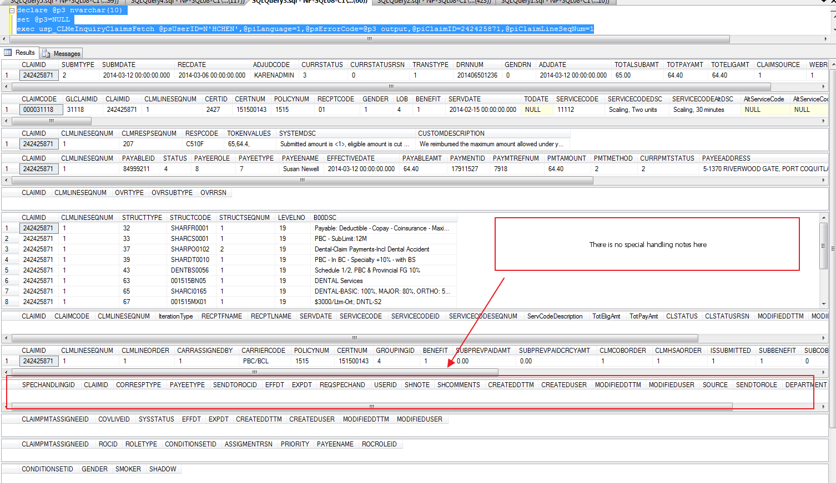

In ACES Core, the payment history screen does display the Special Handle Note.

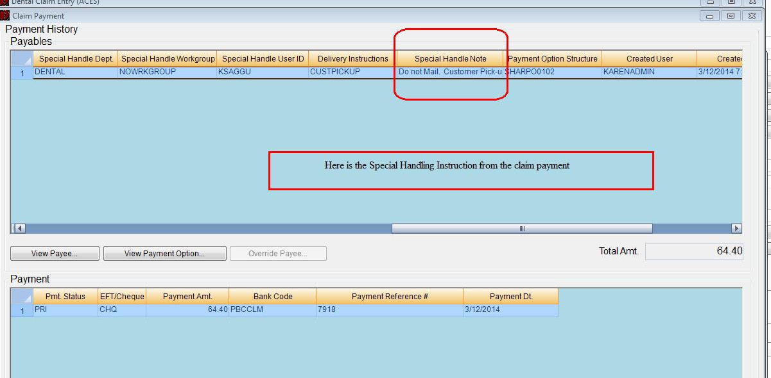

Here is the 2nd test case, where the member claim does have the Special Handle Notes.

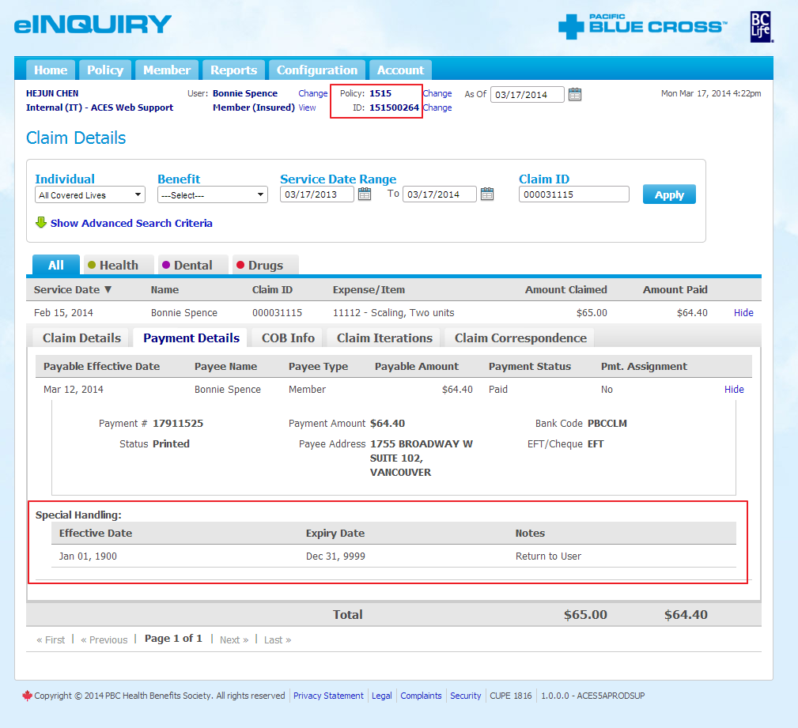

declare @p3 nvarchar(10)

set @p3=NULL

exec usp_CLMeInquiryClaimsFetch @psUserID=N'HCHEN',@piLanguage=1,@psErrorCode=@p3 output,@piClaimID=242425868,@piClaimLineSeqNum=1

