Task 3

What we need:

1 Router for Server Room

* **Mikrotik Cloud Core router ccr1036-12g-4s-em: $1195.00/RM4993**

CCR1036-12G-4S-EM is a carrier grade router with a cutting edge 36 core Tilera CPU. Unprecedented power and unbeatable performance. The Cloud Core supports throughput of up to 24 million packets per second, or up to 16 gigabits - full wire speed. It has two SODIMM slots, by default it is shipped with 16GB of RAM, but has no memory limit in RouterOS. It comes with power supply and 1U rackmount case.

1 Switch for Server Room

* **CRS317-1G-16S+RM: $399.00/RM1667**

The new Cloud Router Switch 317-1G-16S+RM is a rack-mountable manageable switch with Layer3 features, it has 16 SFP+ ports for high performance 10GbE connectivity and a 1GbE copper port for management.

1 Storage Server

* **Synology DiskStation DS412+: $1,500.00/RM6,267.60**

The new four-bay NAS (network-attached storage) server in a way is the follow-up to the award-winning DS410 that was released more than two years ago, and makes an excellent upgrade. It now offers an excellent drive bay design, much faster speeds, support for USB 3.0, and a lot more.

**Video Editing Lab**

1 Router

* **CCR1036-8G-2S+: $1095/RM4,576.55**

The device comes in a 1U rackmount case, has two SFP+ ports, eight Gigabit ethernet ports, a serial console cable and a USB port.

The CCR1036-8G-2S+ has two SODIMM slots, by default it is shipped with 4GB of RAM, but has no memory limit in RouterOS (will accept and utilize 16GB or more). Also available now, the EM model with 16GB of RAM!

2 switches

* **CRS328-24P-4S+RM:** **$379.00/RM 1,584.03 each**

CRS328-24P-4S+RM is a 28 independent port switch, it has 24 Gigabit Ethernet ports, which offer different power output options: Passive PoE, low voltage PoE, 802.3af/at (Type 1 “PoE” / Type 2 “PoE+”) with auto-sensing. PoE-Out is passed over mode B pins (4,5+)(7,8-). The four SFP+ ports provide up to 10 Gbps connectivity options via either optical fiber or Ethernet modules (not included).

1 Storage Server

* **WD My Cloud EX2: $495/RM2,068.85**

The My Cloud EX2 is the latest in WD's My Cloud series of NAS servers and share the same feature set as the original My Cloud and the My Cloud EX4. But it does at least one big thing of its own: In my testing, the new server registered the by far the best performance among the three. On top of that, you can replace/install the internal hard drives very easily.

**General Student Lab**

1 Router

* **CCR1036-8G-2S+ : $1095/RM4,576.55**

The device comes in a 1U rackmount case, has two SFP+ ports, eight Gigabit ethernet ports, a serial console cable and a USB port.

The CCR1036-8G-2S+ has two SODIMM slots, by default it is shipped with 4GB of RAM, but has no memory limit in RouterOS (will accept and utilize 16GB or more). Also available now, the EM model with 16GB of RAM!

2 switches

* **CRS328-24P-4S+RM:** **$379.00/RM 1,584.03 each**

CRS328-24P-4S+RM is a 28 independent port switch, it has 24 Gigabit Ethernet ports, which offer different power output options: Passive PoE, low voltage PoE, 802.3af/at (Type 1 “PoE” / Type 2 “PoE+”) with auto-sensing. PoE-Out is passed over mode B pins (4,5+)(7,8-). The four SFP+ ports provide up to 10 Gbps connectivity options via either optical fiber or Ethernet modules (not included).

1 Storage Server

-**WD My Cloud EX2: $495/RM2,068.85**

* The My Cloud EX2 is the latest in WD's My Cloud series of NAS servers and share the same feature set as the original My Cloud and the My Cloud EX4. But it does at least one big thing of its own: In my testing, the new server registered the by far the best performance among the three. On top of that, you can replace/install the internal hard drives very easily

**Digital Lab**

1 Router

- **CCR1036-8G-2S+: $1095/RM4,576.55**

The device comes in a 1U rackmount case, has two SFP+ ports, eight Gigabit ethernet ports, a serial console cable and a USB port.

The CCR1036-8G-2S+ has two SODIMM slots, by default it is shipped with 4GB of RAM, but has no memory limit in RouterOS (will accept and utilize 16GB or more). Also available now, the EM model with 16GB of RAM!

2 switches

- **CRS328-24P-4S+RM: $379.00/RM 1,584.03 each**

CRS328-24P-4S+RM is a 28 independent port switch, it has 24 Gigabit Ethernet ports, which offer different power output options: Passive PoE, low voltage PoE, 802.3af/at (Type 1 “PoE” / Type 2 “PoE+”) with auto-sensing. PoE-Out is passed over mode B pins (4,5+)(7,8-). The four SFP+ ports provide up to 10 Gbps connectivity options via either optical fiber or Ethernet modules (not included).

1 Storage Server

**-WD My Cloud EX2: $495/RM2,068.85**

The My Cloud EX2 is the latest in WD's My Cloud series of NAS servers and share the same feature set as the original My Cloud and the My Cloud EX4. But it does at least one big thing of its own: In my testing, the new server registered the by far the best performance among the three. On top of that, you can replace/install the internal hard drives very easily

**Common Area 1**

1 Wireless System Mikrotic

* **DynaDish 6 : $179/RM743.67**

The Dynadish 6 uses the same effective antenna design and enclosure as our successful 5 GHz model, but this new device operates in the licensed 6GHz frequency. This means less interference than the often saturated 5 GHz frequencies for higher speed and more reach. By operating above the most popular WiFi frequencies you are now able to build your wireless links from busy towers without suffering problems with noise.

**Common Area 2**

1 Wireless Repeater

* **Netgear AC1200 WiFi Range Extender EX6150: $89.00/RM3** **73.80**

NETGEAR AC1200 WiFi Range Extender boosts your existing network range with the AC dual band WiFi enables fast WiFi performance and delivers up to 1200Mbps. It works with any standard WiFi router and is ideal for very large homes and frustration free HD video streaming and gaming.

**TV Production area**

1 Wireless System

* **DynaDish 6 : $179/RM743.67**

The Dynadish 6 uses the same effective antenna design and enclosure as our successful 5 GHz model, but this new device operates in the licensed 6GHz frequency. This means less interference than the often saturated 5 GHz frequencies for higher speed and more reach. By operating above the most popular WiFi frequencies you are now able to build your wireless links from busy towers without suffering problems with noise.

1 Wireless Router

* **RB3011UiAS-RM:**  **$179.00/RM** **748.48**

The RB3011 is a new multi-port device, our first to be running an ARM architecture CPU for higher performance than ever before. The RB3011 has ten Gigabit ports divided in two switch groups, an SFP cage and for the first time a SuperSpeed full size USB 3.0 port, for adding storage or an external 3G/4G modem. RB3011UiAS-RM Unit comes with 1U rackmount enclosure, a touchscreen LCD panel, a serial console port and PoE output functionality on the last Ethernet port.

**Workstation**

For workstation we need at least 60 new pc for the 2 new labs …

**DELL**

PRECISION 7820 TOWER

Reference: <https://dellemcevents.com/uploads/Precision-7820-Tower-Spec-Sheet>

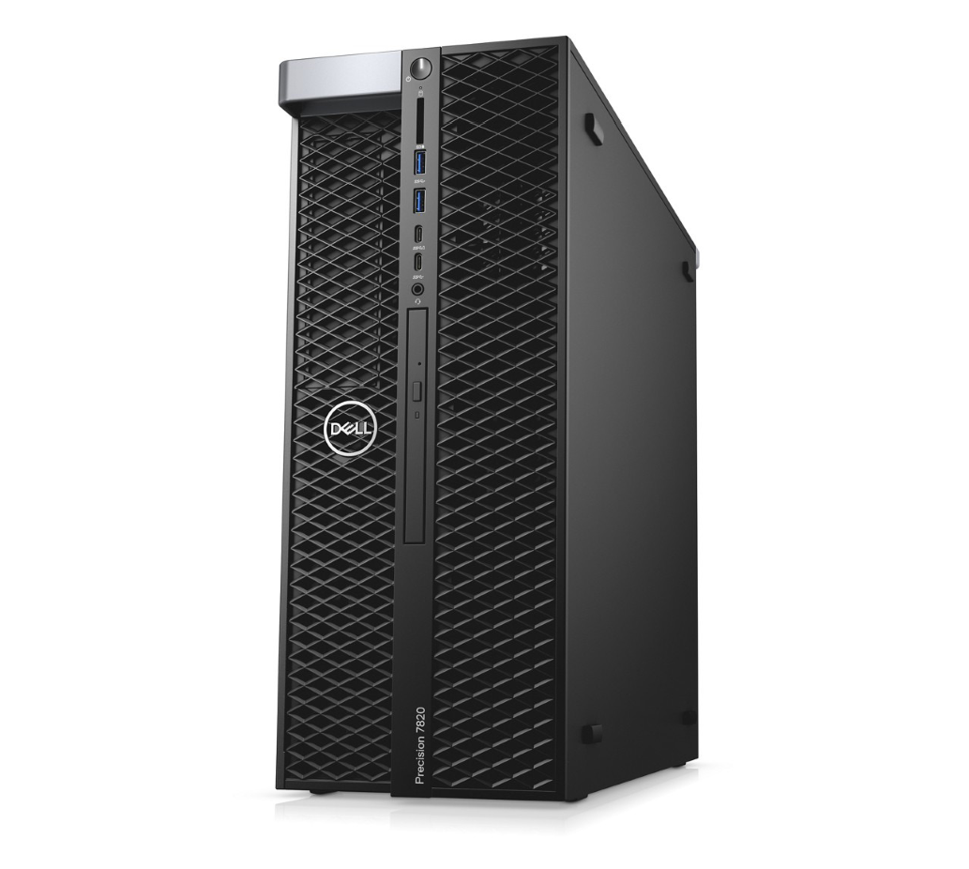

Features & Technical Specifications

|  |  |
| --- | --- |
| **Feature** | **Precision 7820 Tower Technical Specifications** |
| **Processor Options** | One or two Intel® Xeon® processor Scalable family CPUs with up to 28 cores per processor and Intel  Advanced Vector Extensions, Intel Trusted Execution Technology, Intel AES New instructions, Optimized Intel Turbo Boost and optional Intel vPro™ technology |
| **Operating System**  **Options** | Windows 10 Pro for Workstations (up to 4 Cores)  Windows 10 Pro for Workstations (4 Cores Plus)  Windows 10 Pro for Workstations Downgrade to Windows 7 (up to 4 Cores)  Windows 10 Pro for Workstations Downgrade to Windows 7 (4 Cores Plus)  Red Hat® Enterprise Linux® 7.3  Ubuntu Linux 16.04  Suse Linux (SLES 12 SP2) supported  NeoKylin 6.0 SP3 (China only) |
| **Chipset** | Intel® C621 (Lewisburg) |
| **Memory Options1** | Six channel memory up to 384GB 2666MHz DDR4 ECC memory with dual CPUs, 12 DIMM Slots (6 DIMMs per CPU).  Note: Memory speed is dependent on specific Intel Xeon Processor Scalable Family processor installed. |
| **Graphics Options** | Support for 2 PCI Express® x16 Gen 3 graphics cards - up to 500W with maximum of 2 x 250W double width graphics cards on single CPU configurations. Up to 2 x 150W single width graphics cards on dual CPU configurations.  **High end 3D cards:**  Radeon™ Pro WX 9100  Radeon™ Pro SSG (future)  NVIDIA Quadro GP100  NVIDIA Quadro P6000  NVIDIA Quadro P5000  **Mid-range 3D cards:**  Radeon™ Pro WX 7100  Radeon™ Pro WX 5100  Radeon™ Pro WX 4100  NVIDIA Quadro P4000  NVIDIA Quadro P2000  **Entry 3D cards:**  Radeon™ Pro WX 3100  Radeon™ Pro WX 2100  NVIDIA Quadro P1000  NVIDIA Quadro P600 NVIDIA Quadro P400  **Professional 2D cards:**  NVIDIA NVS 310  NVIDIA NVS 315 |
| **Storage Options**  **(Check regional availability)** | Front accessible FlexBays support up to 4 x 2.5”/3.5” SATA HDD/SSDs and up to 6 x 2.5” and 5 x 3.5” drives with 5.25” bay populated.  Up to 2 front accessible (hot plug) M.2 NVMe PCIe SSDs are supported in FlexBays on enabled PCIe chassis with integrated Intel controller.  NVMe RAID 0,1 option (Intel RSTe vROC). Dell M.2 carrier with PCIe SSD for PCIe FlexBay available as customer kit.  Up to 4 x M.2 NVMe PCIe SSDs via 1 x Dell Ultra-Speed Drive Quad x16 card. NVMe RAID 0,1,10 option (Intel RSTe vROC)  **M.2 NVMe PCIe SSDs**  Up to 4 x 1TB drives on 1 Dell Precision Ultra-Speed Drive Quad x16 cards. |

**Front FlexBay M.2 NVMe PCIe SSDs**

Up to 2 x 1TB drives

**2.5” SATA SSD**

Up to 6 x 1TB drives

**2.5” SAS SSD**

Up to 6 x 800GB drives

**3.5” SAS 7200 RPM 12Gb/s**

Up to 5 x 4TB

**2.5” SAS 10K RPM 12Gb/s**

Up to 6 x 1.8TB

**2.5” SAS 15K RPM 12Gb/s**

Up to 6x 900GB (future)

**2.5” Self Encrypting Drives**

512GB 2.5” SED (OPAL/ FIPS (140-2) HDD

**M.2 PCIe SED SSD**

512GB and 1TB Intel®

|  |  |  |  |
| --- | --- | --- | --- |
| **Storage Controller** | | **Integrated:** Intel® chipset SATA controller (6Gb/s) with 6 SATA ports plus 2 dedicated ports for optical drives. Intel RSTe software RAID 0,1,5,10  Intel RSTe (vROC) software RAID 0,1,10 option (motherboard activation key) for M.2 NVMe PCIe SSDs on 1st Dell Ultra-Speed Drive Quad x16  or Duo x8 card (RAID 0,1) or front FlexBay NVMe PCIe SSDs (RAID 0,1)  Customer kit available for Intel RSTe (vROC) motherboard activation key for NVMe RAID support. **Optional:** Broadcom MegaRAID® SAS 9440-8i 12Gb/s SAS (6Gb/s SATA) PCIe controller, 8 ports, Software RAID 0,1,5,10.  MegaRAID® SAS 9460-16i 12Gb/s SAS (6Gb/s SATA) ) PCIe controller (4GB cache with Flash module/ Super Cap backup) Hardware RAID 0,1,5,10.  Optional Intel SW (vROC) based RAID 0,1,10 support on Dell Ultra-Speed Drive Quad and Duo (RAID 0,1) cards with NVMe PCIe SSDs. | |
| **Communications** | | **Integrated:** Intel® i219 Gigabit Ethernet controllers with Intel Remote Wake UP, PXE and Jumbo frames support  **Optional:** Intel® i210 10/100/1000 single port PCIe (Gen 3 x1) gigabit network card, Intel® X550-T2  10GbE dual port PCIe (Gen 3 x4) network card,  Aquantia AQN-108 2.5Gbit/5Gbe single port PCIe (Gen3 x4) network card | |
| **Audio Controller** | | Integrated Realtek ALC3234 High Definition Audio Codec (2 Channel)  Optional Dell Digital Audio Interface (2Ch, 120dB S/N ratio – 5.25” FlexBay option (USB interface) (future) | |
| **Speakers** | | Internal Speaker; Optional Dell 2.0 stereo speaker systems available and Dell sound bar for select flat-panel displays | |
| **Add-in cards** | | **Optional:** Dell Precision Ultra-Speed Drive Duo (HH/HL,x8) & Ultra-Speed drive Quad (FH/FL,x16) with active cooling. Support for up to 2 and 4 M.2 PCIe NVMe SSDs respectively. Optional USB 3.1 (Gen 2) 10Gb/s Type C card (2 ports) 1 DP pass-through port  Optional dual & quad display Teradici PCoIP remote workstation host PCIe cards  Optional Thunderbolt 3 PCIe Card (2 ports) 1 DP pass-through port Optional Serial Port PCIe Card | |
| **I/O Ports** | | **Front**  2 – USB 3.1 Gen 1 Type A  2 – USB 3.1 Type C  1 – Universal Audio Jack  Up to 2 (future 4) x4 PCIe slots in PCIe enabled chassis for M.2 and U.2 (future) PCIe SSDs  **Internal**  1 – USB 2.0  1 - 2 x 5 USB 2.0 header. (requires 3rd party splitter cable to support 2 x USB 2.0 Type A ports) 8 – SATA @6Gb/s  **Rear**  6 – USB 3.1 Gen 1 Type A  1 – Serial   1. – RJ45 Network 2. – PS2   1 –Audio Line out  1– Audio Line in/Microphone | |
| **Chassis** | | **HxWxD:** 417.9mm x 176.5mm x 518.3mm. Optional 19” rackmount rail kit  **Bays:** (2) FlexBays and (1) 5.25” FlexBay (can support 1 x 3.5” or 2 x 2.5” HDD/SSD drives as factory option or customer kit)  (1) Slimline optical bay; (1) SD slot UHS ll Class 3 with read only support (SW enabled)  Available PCIe chassis with PCIe FlexBays supporting M.2 NVMe PCIe SSDs and future U.2 NVMe PCIe SSDs. PCIe FlexBay customer kit available.  **Slots:** All slots PCIe Gen 3: (2) PCIe x16, (1) PCIe x16 wired as x8, (1) PCie x16 wired as x4, (1) PCIe x16 wired as x1, 1 PCI 32/33  **Power Supply:** 950W (input voltage 100VAC - 240VAC) –90% efficient (80PLUS Gold Certified) Externally accessible/removable/lockable | |
| **Storage devices** | | **Slimline Bay Options:** DVD-ROM; DVD+/-RW 5.25” Bay Options: BD, DVD+/-RW; **Standard:** SD slot UHS ll Class 3 with read only support | |
| **Security Options**  **(Check regional availability)** | | Trusted Platform Module (TPM 2.0); Optional CAC/PIV card reader for slimline bay, chassis Intrusion switch; Setup/BIOS Password; I/O Interface Security; Kensington® lock slot, Padlock ring, lockable power supply; Optional hard drive locking sleds (key lock), Dell Data Guardian, Dell Endpoint Security  Suite Enterprise | |
| **Manageability4** | | AMT or vPro with DASH support  Dell vPro Enhancements (Grasslake)  SNMT/CIM vis OMCI  Dell Command Suite | |
| **Regulatory and**  **Environmental** | | Energy Star® configurations available including 80 PLUS® registered Gold power supplies; EPEAT® registered (see [epeat.net](http://epeat.net/) for specific registration rating/status by country); China CECP; GS Mark. For a complete listing of declarations & certifications, see Dell’s regulatory & compliance homepage at [dell.](http://dell.com/regulatory_compliance)  [com/regulatory_compliance](http://dell.com/regulatory_compliance) | |
| **Warranty & Support**  **Services5** | | 3-Year Limited Hardware Warranty and 3-year NBD On-Site Service after Remote Diagnosis  Optional: Dell ProSupport is designed to rapidly respond to your business’s needs, help protect your investment and sensitive data, and provide enhanced proactive support services to help reduce risk and complexity within your IT environment | |
| **TAA** | | YES (check regional availability) | |

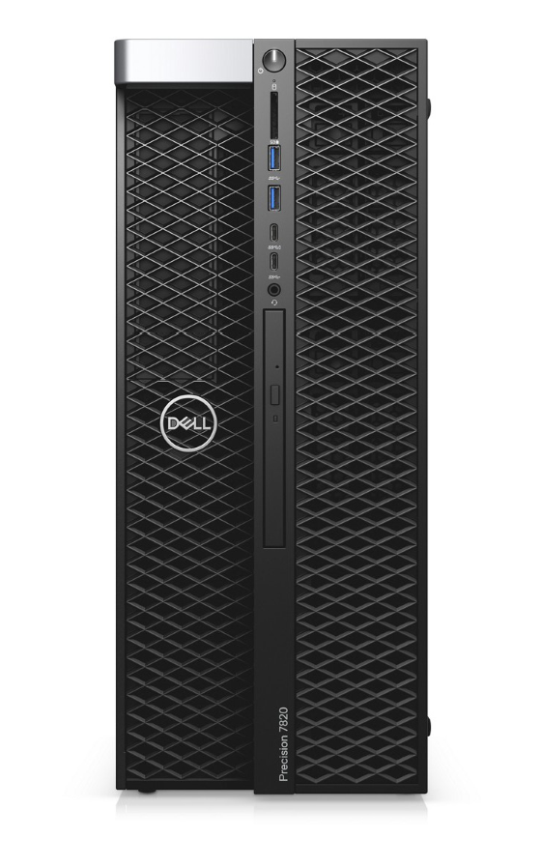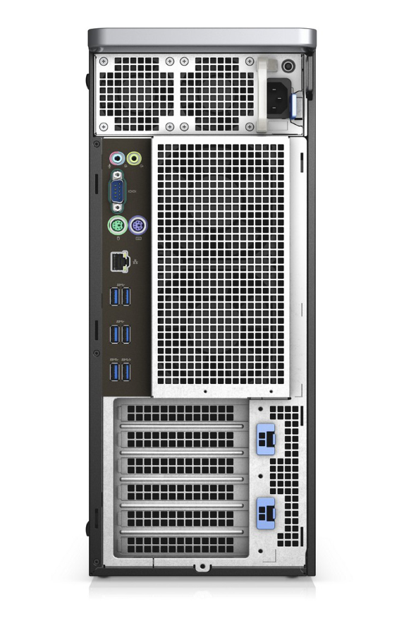

**ISV certification applies to select configurations:**

1. GB means 1 billion bytes and TB equals 1 trillion bytes; actual capacity varies with preloaded material and operating environment and will be less.
2. GB means 1 billion bytes and TB equals 1 trillion bytes; significant system memory may be used to support graphics, depending on system memory size andother factors.
3. Computrace is not a Dell offer. Certain conditions apply. For full details, see terms and conditions at [www.absolute.com/en/about/legal/agreements](http://www.absolute.com/en/about/legal/agreements).
4. Systems Management Options:Intel® vPro Technology - Fully vPro-capable at point of purchase; the vPro systems management option requires vPro processors. Includes support for Intel Advanced Management Technology (AMT) 9.x. Intel® Standard Manageability - Fully enabled at point of purchase, the Intel Standard Management option is a subset of the AMT features. ISM is not upgradeable to vPro technology post-purchase. No Out-of-Band Systems Management - This option entirely removes Intel out of band systems (OOB) management features. The system can still support in band management. OOB management support through AMT cannot be upgraded post-purchase.
5. Availability and terms of Dell Services vary by region. For more information, visit [Dell.com/servicecontracts/global](http://Dell.com/servicecontracts/global); Limited Hardware Warranty available by writing Dell USA LP, Attn: Warranties, One Dell Way, Round Rock, TX 78682 or see [www.dell.com/warranty](http://www.dell.com/warranty); Onsite Service after Remote Diagnosis: Remote Diagnosis is determination by online/phone technician of cause of issue; may involve customer access to inside of system and multiple or extended sessions. If issue is covered by Limited Hardware Warranty ([www.dell.com/warranty)](http://www.dell.com/warranty) and not resolved remotely, technician and/or part will be dispatched, usually within 1 business day following completion of Remote Diagnosis. Availability varies. Other conditions apply.

Dell, EMC, and other trademarks are trademarks of Dell Inc. or its subsidiaries. Other trademarks may be trademarks of their respective owners. Intel and the Intel logo are trademarks of Intel Corporation in the U.S. and/or other countries. Microsoft and Windows are trademarks of Microsoft Corporation in the U.S. and/or other countries.

Essential Accessories

**PRECISION 7820 TOWER**

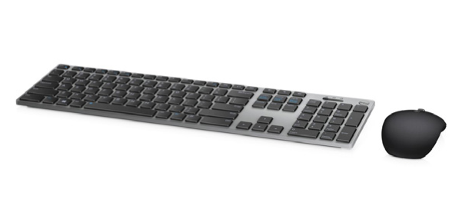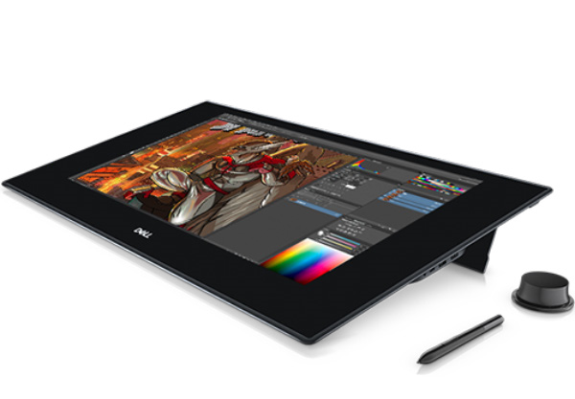

Dell Canvas Dell Wireless Premium

Keyboard & Mouse

Combo | KM717

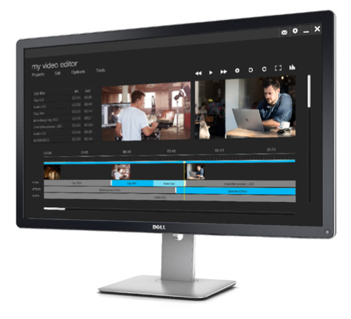

Dell UltraSharp Ultra HD

4K Monitor with

PremierColor | UP3216Q

**Price**  RM2202 each.

Total 2202*60= RM132120

**Are You surprise by the prices?**

Yes, we are. We tried to use the best current product for the labs

But the new technology does worth it.

Do you have a context for this equipment and its cost?

Yes, there were a good collection of new products we saw in the market.

But the review of some good consultant made us choose what was best for the buck.

- Have you ever considered cost as a factor for choosing networking devices?

Yes, Cost is an important thing when buying the products. But base on the institutions deal and preference we had to cut some corner.

- What is confusing about this price list?

The tricky thing about the price is that two products with the same price but different spec. But we already knew our need so that wasn’t tricky enough of us :/