1 --Can I see a list of Pokemon with only one type?

Select Distinct Name

From Pokemon

WHERE Type_2 IS Null

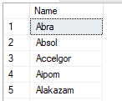

2 --Let me see the entries that are water type.

Select *

FROM Pokemon

WHERE Type_1 = 'Water' OR Type_2 = 'Water'

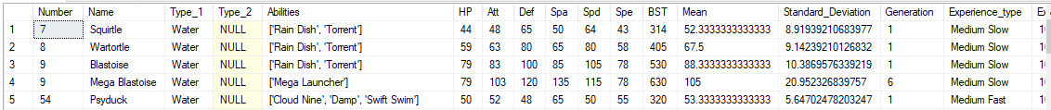

3 --What types have the most breeds of Pokemon, only show me the ones with more than 50.

Select Type_1,COUNT(Type_1)AS "Type Count" , COUNT(Type_2)AS "Other Type"

From Pokemon

GROUP By Type_1

Having COUNT(Type_1) > 50

Order By [Type Count] DESC

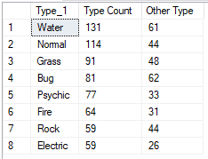

4 --Can I see the tables side-by-side?

Select *

From Pokemon

FULL OUTER JOIN

Pokemon_Wizard

ON Pokemon.Name = Pokemon_Wizard.Name

