**Athlone Institute of Technology**

**Faculty of Engineering & Informatics**

**Semester 1 Assignment 2022**

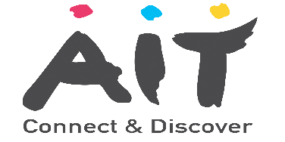

**Software Development for Cloud 3**

The purpose of this assignment is to write a python application that Links a Gui to a SQL Database (See Example)

1. **There are 3 deliverables:**

* **Assignment Proposal: 1 paragraph explanation of proposed topic/functionality (due 16/11) (see sample assignment proposal in moodle)**
* **Code for completed application**
* **Screencast video that briefly describes the code and then shows the features of the application as its executed**

1. **You must also submit a copy of a signed Plagiarism Form**
2. This assessment is worth 30% of the overall module mark
3. I have included in moodle a sample application and a video demonstrating this application
4. You cannot use/resubmit any previous assignments. This assignment must be something new and of your own work.

**Task: Design & Build a Python application that links a GUI to a Database that is based on any leisure/buisness activity. You must submit a screencast video demonstrating the functionality of your application in action.**

**Notes:**

* There is no limit to what you can do but it **must involve developing an application that links a GUI to a database with at least one table**
* **I have completed an application based on Movie Ratings, you should do a different application related to Sport, Business or any leisure activity**
* Use the coding available on Moodle as a starting point, however your assignment must be original and there are no limits to what you can do.
* There is an example in Moodle that can be found in the section “**Sample Application***”*
* The are three deliverables, each with a separate Marking scheme:
  + Python Code (**65%** of total assignment mark)
  + A 5-minute screencast which will serve as a demonstration of the application **(25%)**
  + A brief Assignment Proposal (see Example). (**10%)**

Mark also associated with the consistency between proposal and final application.

**Proposal Submission Date: Wednesday 16th of November 2022 @ 23:00**

**Main Submission Date (code & Video): Friday 25th of November 2022 @ 23:00**

**Main Submission Files:** Code, screencast and plagiarism form in 3 separate locations**.**

**ScreenCast Guidelines:**

* The screencast must be a **(3- 5 minutes)**
* The links to screencast-o-matic and tutorials are available on Moodle
* Screencast to be structured as follows:

1. Introduction: **Brief** description of what your application is about
2. A walkthrough (demonstration) of your application working with examples of its functionality
3. On screen briefly show and describe important aspects of the actual code including Key classes and some code snippets of key parts of code

**Main Submissions Links & files to be uploaded on Moodle:**

* **ScreenCast -** Submitted to the **Screencast** submission link
* **ZippedCoding –** Submit a **zipped copy of your code**
* scanned/photo copy of the **plagiarism form**

**Appendix Sample Application**

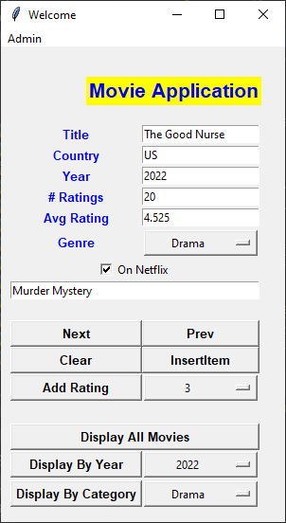

**# Database Setup**

**con = sqlite3.connect("../../Downloads/tutorial.db")**

**cur = con.cursor()**

**try:**

**cur.execute("CREATE TABLE Movie(title,country, year,count, rating,genre,**

**netflix,description)")**

**data = [**

**("The Good Nurse", "US",2022, 5, 3.5, "Drama", True, "Murder Mystery"),**

**("Op Mincemeat", "UK", 2021, 5, 3.8, "Drama", False, "World War 2"),**

**("Pixie", "UK", 2021, 5, 3.1, "Comedy", True, "Drug Caper"),**

**("Martian", "US", 2015, 5, 4.6, "SciFi", False, "Spacetrip to Mars"),**

**("Grimbsy", "UK", 2016, 5, 3.6, "Comedy", True, "Action Comedy"),**

**("We're the Millers", "US", 2013, 5, 4.1, "Comedy", False, "Road Movie"),**

**("First Man", "US", 2018, 5, 4.1, "SciFi", True, "First Moon Landing"),**

**("Brian and Charles", "UK", 2022, 5, 3.1, "Comedy", False, "AI Robot Inventor"), ]**

**cur.executemany("INSERT INTO Movie VALUES(?, ?, ?,?,?,?,?,?)", data)**

**con.commit()**

**except:**

**print("Movie Aready Exists")**