Table of Contents

Create and set up your Microsoft 365 Developer subscription (E5)

Activate Microsoft AI Cloud Partner Program Visual Studio benefits (Partner Center)
- Sign in to Partner Center and select Benefits.
- On the Developer Tools tab, select Visual Studio subscriptions benefits.
- 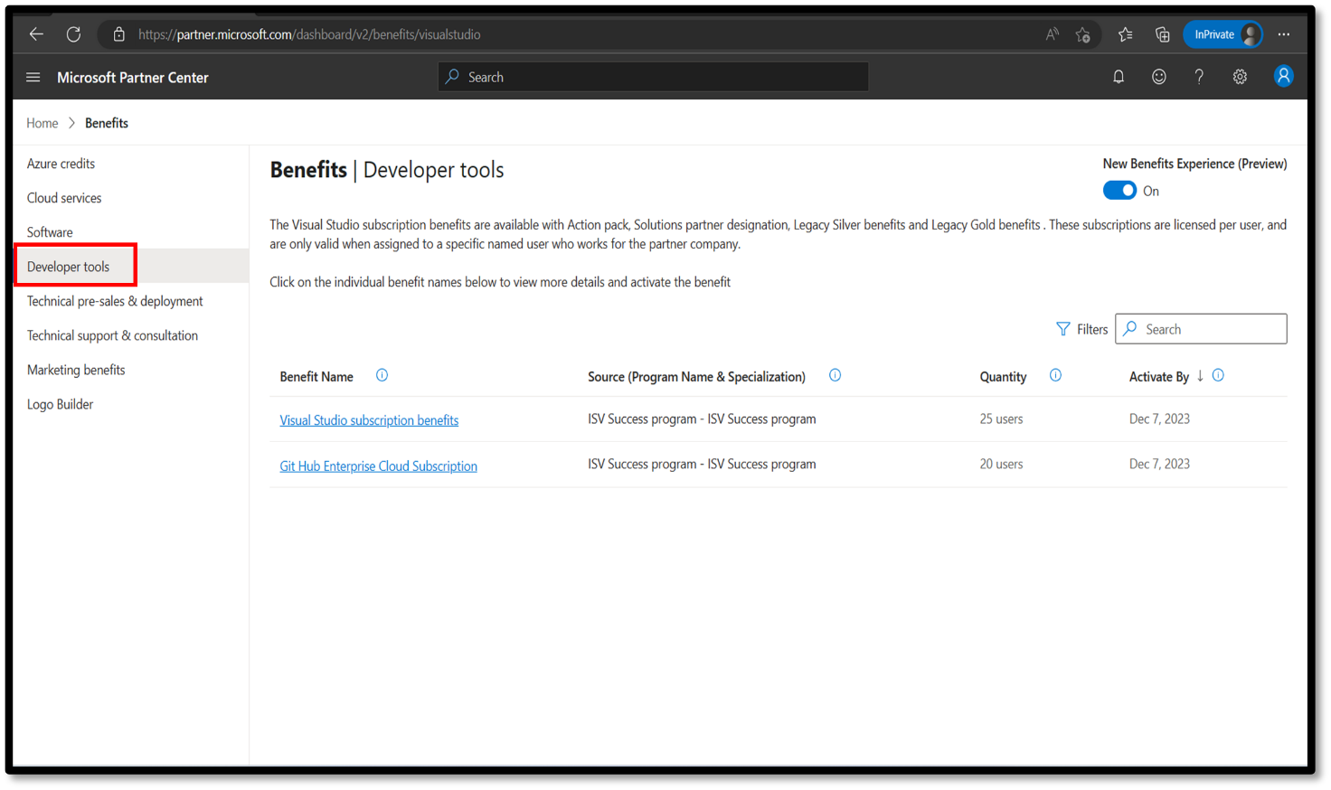
- To assign a user the Visual Studio benefit, select the Visual Studio benefit you want to activate. On the wizard pane, on the Activate benefits tab, select a user, then select Assign user. If the user isn't in the list, you can add new users in Account settings.
- Repeat this process for each subscription you want to assign. Users can manage their subscriptions in the Visual Studio portal:
  - View all assigned users — select the View and remove assigned users tab.
  - Remove a user — on the same tab, select Remove next to the user's name.
  - Reassign a subscription — select Reassign user. This option only appears 90 days after the subscription was activated. See the Microsoft Partner Programs Guide for details.

How users access these benefits
- Partner Program admins in Partner Center assign Visual Studio Enterprise IDE licenses to users. Once assigned, users activate and sign in to the IDE with their work email.
- The Visual Studio subscriptions portal is the access portal for Visual Studio-related Partner Program benefits. The benefits available are defined by Partner Program eligibility, not by Visual Studio subscription tier.

Create your Microsoft 365 Developer subscription (E5)
- Go to the Visual Studio subscriptions portal and sign in with your work email.
- Find the Microsoft 365 Developer subscription (E5) user benefits. The available benefits and layout may differ slightly from the reference image below.
- 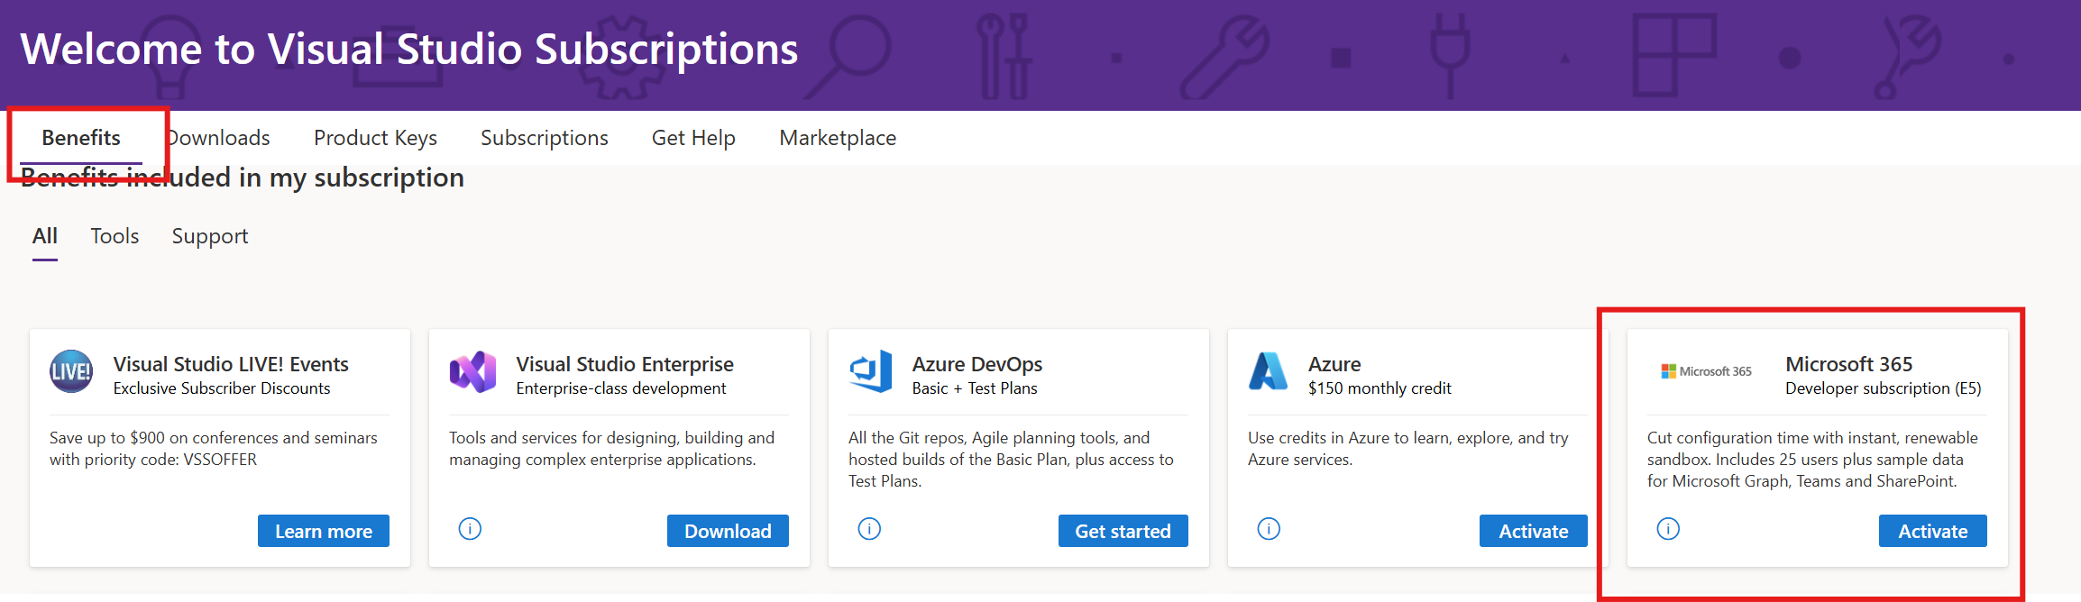
- Complete the setup wizard as shown in the images below.
- 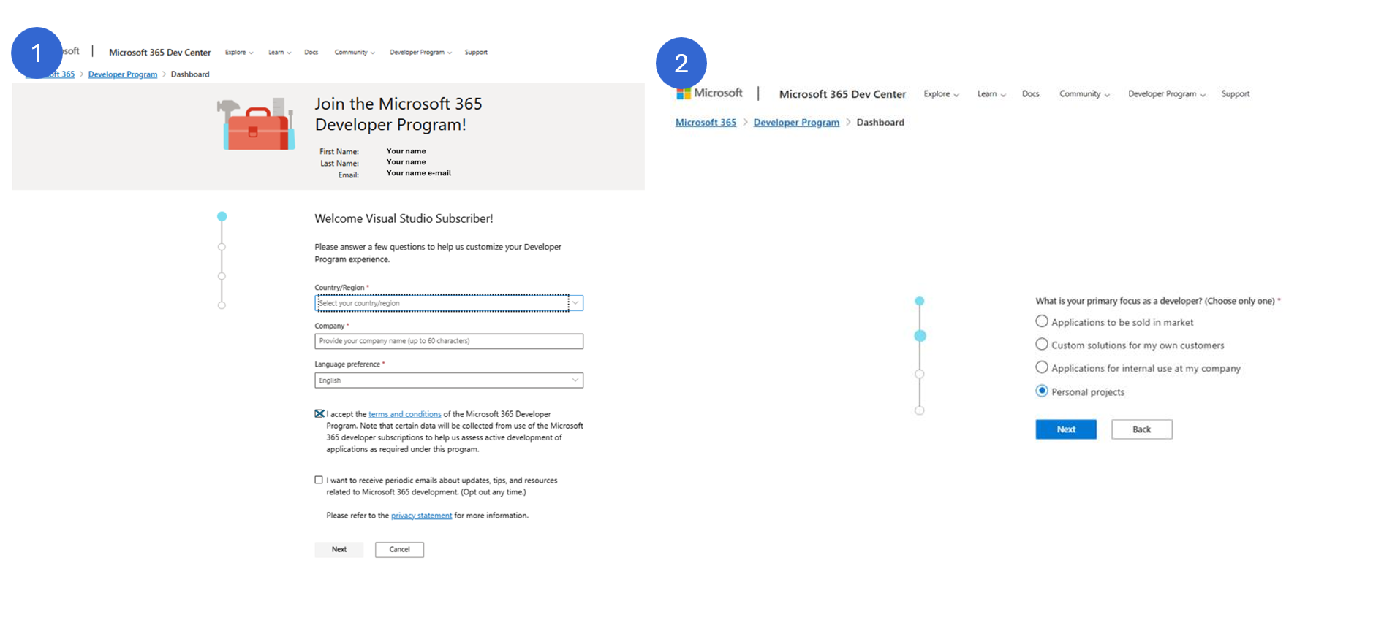
- 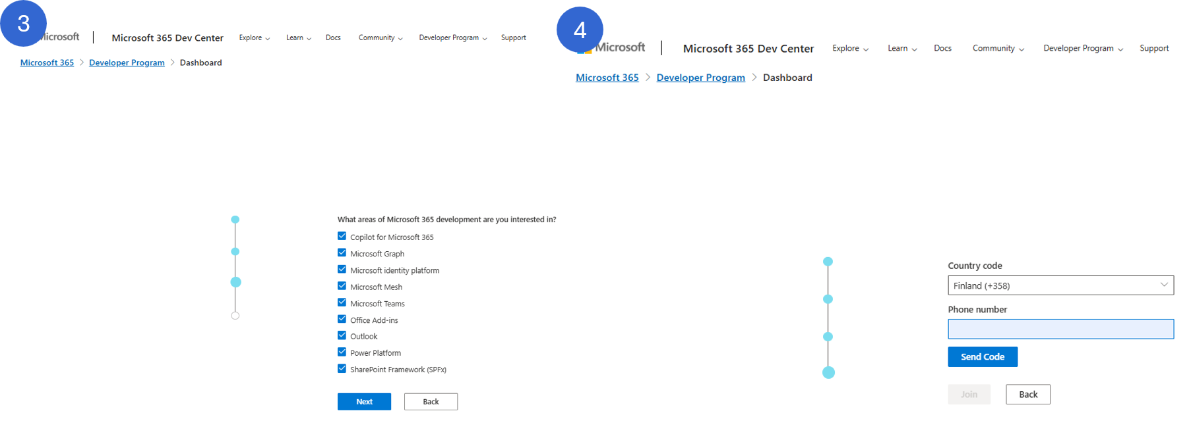
- When you reach the Set up your Microsoft 365 E5 sandbox view, select Instant sandbox (step 5 in the wizard). The username you choose here will be your admin user (step 6 in the wizard).
- 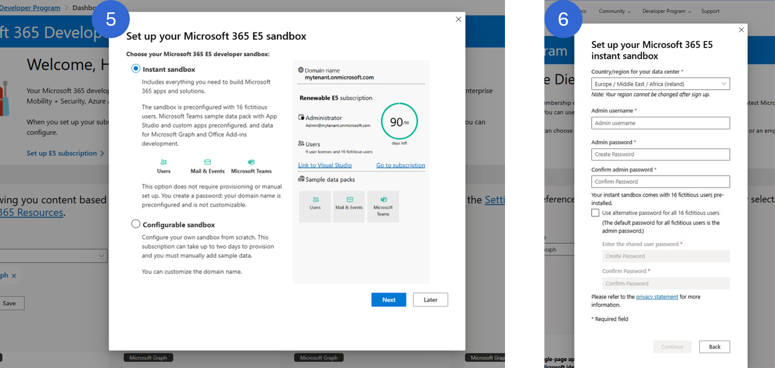
- 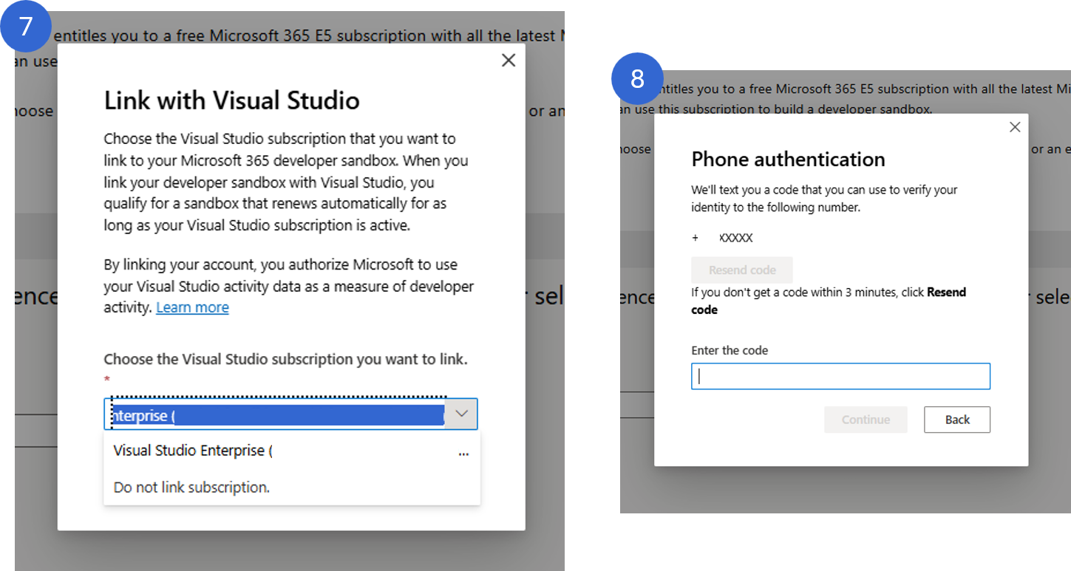
Verify: the new tenant is provisioned and you have the admin user's username (e.g. admin@<yourtenant>.onmicrosoft.com) and initial password.

Create a new Edge profile
Use a dedicated Edge profile for this lab to avoid conflicts with InPrivate browsing and cached sign-in state from your real account.
- In Microsoft Edge, select your profile icon (top-right corner), then select Set up a new profile > Work or school.
- 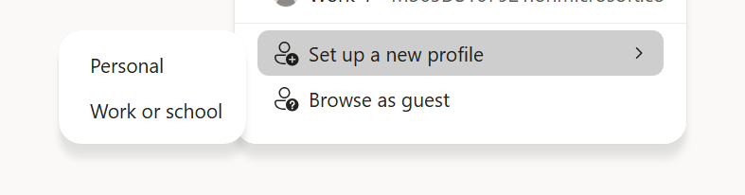
- Select Choose an account > Add new account, then select Sign in to sync data. Sign in with the credentials you just created and complete the initial MFA setup.
- 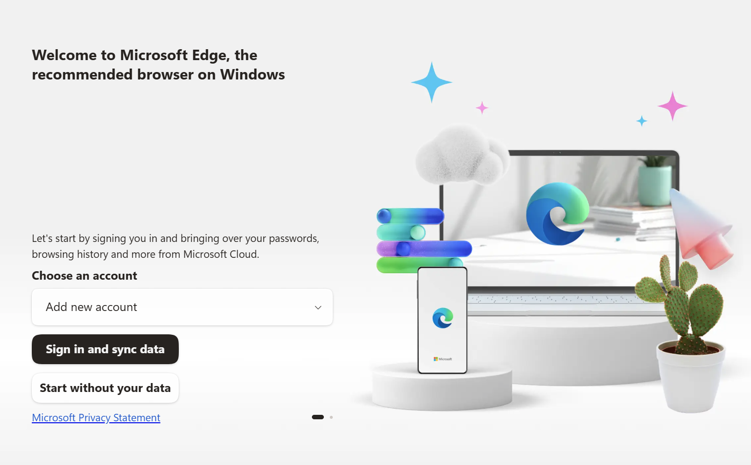
- When prompted "Stay signed in to all your apps", select No, sign in to this app only to avoid registering your device in the tenant.
- 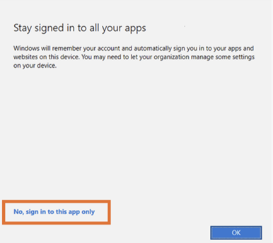
- In Edge profile settings, go to Profile preferences and turn on Automatically sign in to sites with your current work or school account.
- 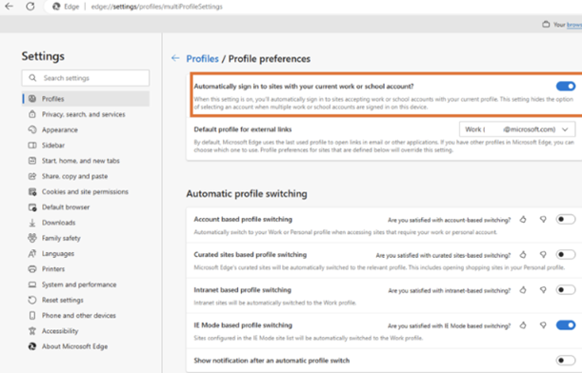
- Note: Come back to this guide when you need more user profiles for your demo users.

Install Hyper-V on Windows 11 (optional)
You can skip this if you prefer to use a physical machine for the lab, but using a VM lets you keep your host machine clean and easily reset the environment if needed.

Prerequisites

Check installed RAM
- Open Command Prompt.
- Type systeminfo and press Enter.
- Scroll down to Installed Physical Memory (RAM) and check the amount installed. You need at least 16 GB. You can proceed with less, but may encounter performance issues.

Check available disk space
- Open File Explorer (Windows + E).
- Under This PC, right-click Local Disk (C:) and select Properties. Free space should be at least 100 GB.

Install Hyper-V on Windows 11
- Open the Control Panel.
- Select Programs, then Programs and Features.
- Select Turn Windows features on or off.
- Select Hyper-V, then select OK.
- When the installation completes, you'll be prompted to restart your computer.

Create a virtual machine

Download the Windows 11 image (ISO)
Go to the Visual Studio subscriptions portal from your work profile, or sign in with your corporate credentials.
- Select Downloads.
- Enter Windows 11 business in the search bar.
- Download the most recent version and note where you saved it.

Create the virtual machine
- Open Hyper-V Manager. In the Actions pane, select New → Virtual Machine.
- Set the virtual machine name — enter a name, for example lab-vm.
- Select generation — choose Generation 2.
- Configure memory — set startup memory to 8000–12000 MB and keep Use Dynamic Memory enabled (this lets the VM use only the memory it needs).
- Configure networking — select Default Switch.
- Configure virtual hard disk — leave the default settings.
- Install operating system — select Install an operating system from a bootable image file, then Browse and select the Windows 11 ISO you just downloaded.
- Complete VM creation — review the summary and select Finish.

Configure TPM (required for Windows 11)
- Right-click the VM and select Settings.
- Select Security in the left pane, check Enable Trusted Platform Module, and select OK.

Start the virtual machine and install Windows
- Right-click the VM and select Connect.
- In the VM window, select Action → Start.
- Boot from ISO — immediately press any key when prompted to boot from the ISO. If you see PXE boot text:
  - Select Reset and confirm.
  - Try again and press a key quickly (it might take a few attempts).
- Start Windows installation — continue once the Windows setup screen appears, and select Windows 11 Enterprise when asked which version to install.
Then sign in to the VM with your user.

Continue lab setup
You can continue with the rest of the lab setup in this VM that was just created, or using the Edge profile.

M365 Groups Setup

Create a Microsoft 365 group "HR"
- Go to admin.microsoft.com and sign in with your admin user.
- In the left navigation, select Teams & groups > Active teams & groups.
- Select + Add a Microsoft 365 group.
- On Name and description, enter the following details, then select Next:
  - Name: HR
  - Description: This is the private HR group for HR-sensitive communication.
- Select + Assign owners, search for your admin user, then select Add.
- Add your admin user as a member. (Optional: also add Patti Fernandez.)
- On Settings, configure:
  - Group email address: HR
  - Sensitivity: None (the label hasn't been published yet)
  - Privacy: Private
  - Keep Add Microsoft Teams to your group selected.
- 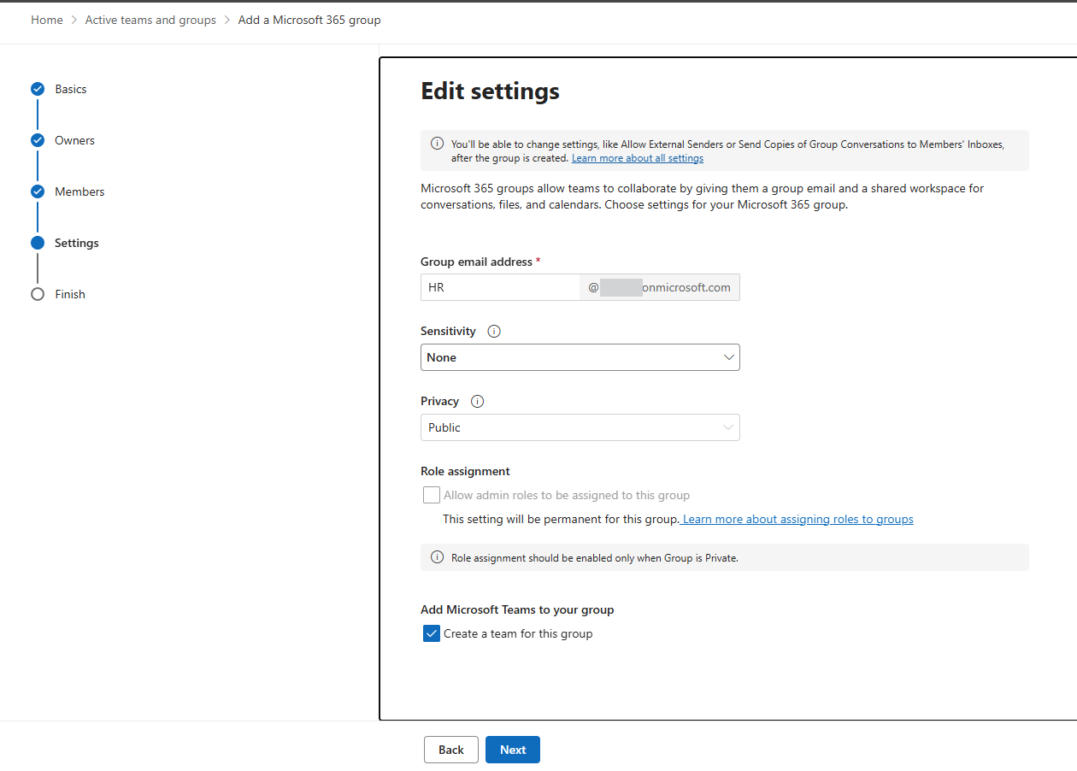
- Review the settings, then select Create group.
Verify: in Active teams & groups, the HR group appears with type Microsoft 365 group and privacy Private.

Edit M365 Group U.S. Sales
- Go to admin.microsoft.com and sign in with your Admin user.
- In the left navigation, select Teams & groups > Active teams & groups.
- Choose U.S. Sales, click on Membership and Members and select Nestor Wilke and “Remove as member”. Confirm Remove

Enable Audit & Sensitivity Labeling for Containers
The PowerShell toolkit in scripts/ configures every foundational Purview tenant setting in a single, idempotent run:
- Unified Audit Log ingestion (Exchange Online)
- SharePoint sensitivity-label support (EnableAIPIntegration)
- SharePoint PDF sensitivity labels
- Office label co-authoring (EnableLabelCoauth)
- Container labels for Microsoft 365 Groups, Teams, and SharePoint sites (Group.Unified EnableMIPLabels)
Recommended: use Option 2 (the PowerShell orchestrator). It is idempotent, prompts before applying changes, and supports -WhatIf for a dry run. Option 1 walks you through the underlying portal/cmdlet steps via Microsoft Learn — useful if you want to learn the manual flow.

Option 1 — Manual (portal + cmdlets)
References:
- Turn auditing on or off | Microsoft Learn
- Use sensitivity labels to protect collaborative workspaces (groups and sites) | Microsoft Learn
- Enable sensitivity labels for Office files in SharePoint and OneDrive | Microsoft Learn
- Enable Audit. In Microsoft Edge, navigate to https://purview.microsoft.com and sign in as the admin user. Select Solutions > Audit, then on the Search page select the Start recording user and admin activity bar. The blue bar should disappear once enabled.
- Note: Initial activation can take up to 24 hours before audit data is fully available.
- 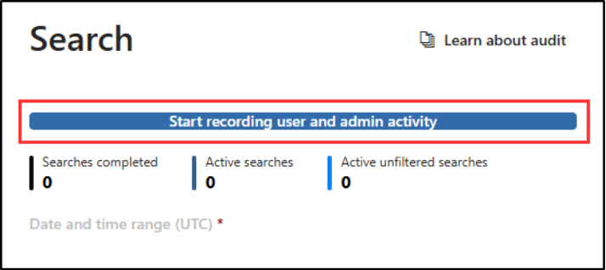
- Enable SharePoint sensitivity-label support. Connect to SharePoint Online PowerShell and run:
- Set-SPOTenant -EnableAIPIntegration $true
- Enable Office label co-authoring. Connect to Security & Compliance PowerShell and run:
- Set-PolicyConfig -EnableLabelCoauth:$true
- Enable container labels. Follow Assign sensitivity labels to Microsoft 365 groups in Microsoft Entra ID to set EnableMIPLabels = True on the Group.Unified directory setting via Microsoft Graph.
- If your tenant has no group settings created yet, start with Microsoft Entra cmdlets for configuring group settings.
- Synchronize sensitivity labels to Microsoft Entra ID. From a Security & Compliance PowerShell session, run:
- Execute-AzureAdLabelSync

Option 2 — PowerShell orchestrator (recommended)
The orchestrator at scripts/Deploy-PurviewBestPractice.ps1 signs in to Exchange Online, Security & Compliance, SharePoint Online, and Microsoft Graph (Beta), then applies every tenant setting listed above in one pass. All features run unconditionally — there are no opt-in switches.

Layout
scripts/
├── Deploy-PurviewBestPractice.ps1 ← entry point
├── Config/
│ └── PurviewConfig.psd1 ← four tenant-setting toggles (all $true by default)
└── Modules/
├── Connect-PurviewServices.ps1 ← EXO + IPPS + SPO + Graph (Beta) sign-in
├── Setup-TenantSettings.ps1 ← applies the settings
└── Invoke-WithTransientRetry.ps1 ← shared retry helper

Prerequisites
- PowerShell 7+ (pwsh.exe). Windows PowerShell 5.1 is not supported — the script hard-fails with an install hint. Install via:
- winget install --id Microsoft.PowerShell --source winget
- A tenant admin account (Global Administrator, or a combination of Compliance Administrator + SharePoint Administrator + Groups Administrator). The deploy admin you created earlier (e.g. admin@<yourtenant>.onmicrosoft.com) is fine.

Run a dry-run first (recommended)
Open a fresh pwsh window and preview the changes without touching the tenant:
cd <repo-root>\scripts
.\Deploy-PurviewBestPractice.ps1 `
-TenantAdminUpn admin@<yourtenant>.onmicrosoft.com `
-AutoInstallModules `
-WhatIf
You will see four browser sign-in prompts (EXO, IPPS, SPO, Graph). Choose No, this app only when prompted "Stay signed in to all your apps".
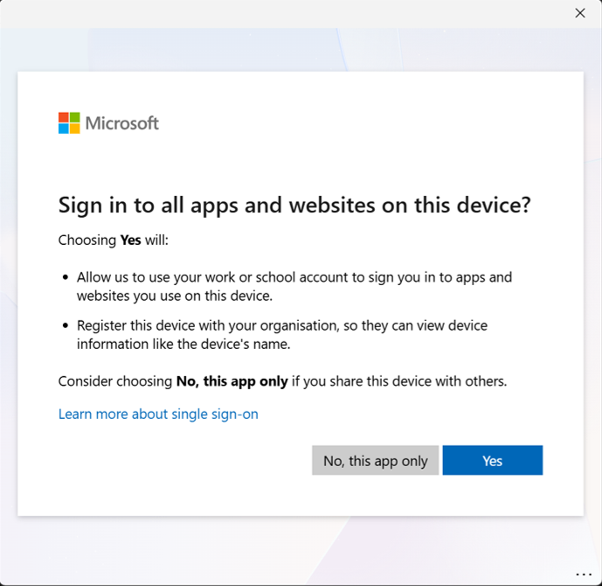
-WhatIf skips the y/N confirmation prompt and emits What if: Performing the operation ... lines for each setting that would change. Settings that are already in the desired state are reported as Already enabled. and not flagged.

Apply the changes
Re-run the same command without -WhatIf:
.\Deploy-PurviewBestPractice.ps1 `
-TenantAdminUpn admin@<yourtenant>.onmicrosoft.com `
-AutoInstallModules
You will be asked to confirm Proceed with deployment? [y/N] (suppress with -NonInteractive). The script then:
- Enables Unified Audit Log ingestion (idempotent — skipped if already on).
- Enables EnableAIPIntegration on SharePoint Online.
- Confirms PDF sensitivity-label support (built-in on current SPO; reported as already enabled).
- Enables EnableLabelCoauth in the IPPS policy config.
- Sets EnableMIPLabels = True on the Group.Unified directory setting via Microsoft Graph (Beta).
A summary block prints when the run completes, e.g.:
==============================================================================
Deployment summary (elapsed: 00:01:49)
==============================================================================
Tenant settings OK
==============================================================================
Verify: in Microsoft Purview > Information protection > Sensitivity labels, you can edit a label and the Groups & sites scope is selectable. (The first label is created in Phase 2.)

Optional parameters
Parameter | Purpose
-WhatIf | Preview every change without applying.
-NonInteractive | Skip the y/N confirmation prompt (CI / unattended runs).
-AutoInstallModules | Install ExchangeOnlineManagement, Microsoft.Online.SharePoint.PowerShell, and Microsoft.Graph.* modules to CurrentUser scope without prompting.
-SharePointAdminUrl <url> | Override the auto-derived SPO admin URL (rare — only needed for multi-geo / vanity domains).
-ConfigPath <path> | Use a custom PurviewConfig.psd1 (defaults to .\Config\PurviewConfig.psd1).

Synchronize labels to Microsoft Entra ID
The orchestrator does not run Execute-AzureAdLabelSync automatically because no labels exist yet at this point in the lab. After you create the first sensitivity label in Phase 2, run it once from a Security & Compliance PowerShell session:
Connect-IPPSSession -UserPrincipalName admin@<yourtenant>.onmicrosoft.com
Execute-AzureAdLabelSync

