(Step 1) Install AVRDUDESS.exe

* Run AVRDUDESS-2.17-setup.exe

(Step 2) Run AVRDUDESS

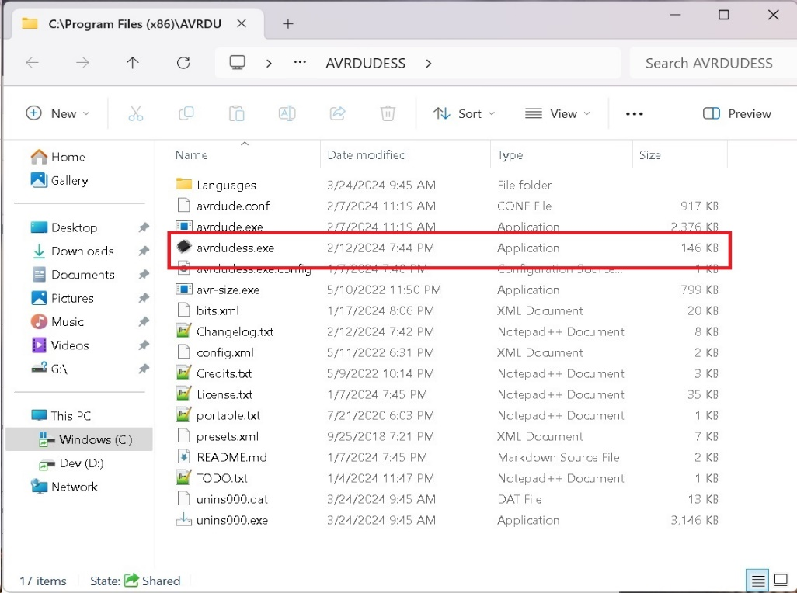

(Step 3) Configure AVRDUDESS with Anet A8 Parameters

1. Specify Programmer, (2.) Specify MCU, (3.) COM Port that connects to your 3D Printer, (4.) Baud Rate, (5.) Specify firmware.hex file to flash, (6.) Select “Go” to begin the process

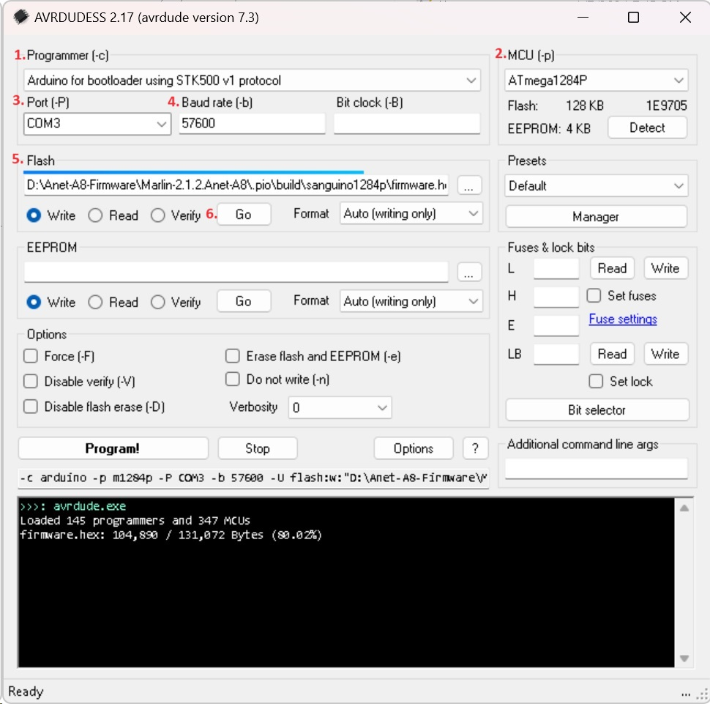

(Step 4) Verify flashing operation results in command window!