DVWA
Problem 1 : Brute Force
Step-1: Open dvwa brute force problem. 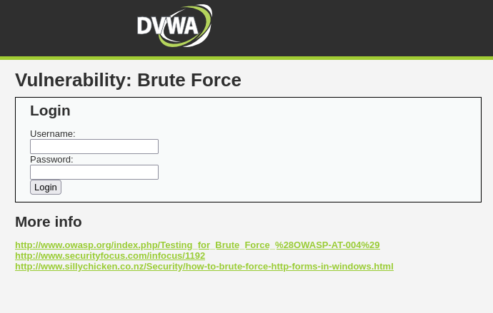
Step-2: Input a random username and password (try common credentials)
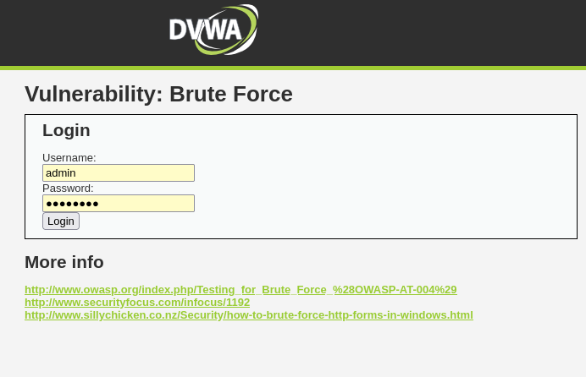
Step-3: Connect burp suite with browser for brute force attack. Open burp suite and configure the proxy as local host 127.0.0.1:8080 in the browser and burp both sides.
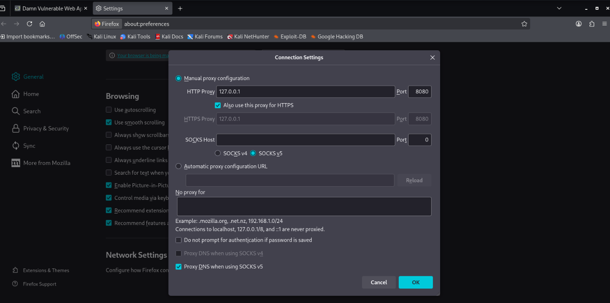
Step-4: Intercept burp request. ( on the proxy from burp and then load the target url in the browser).
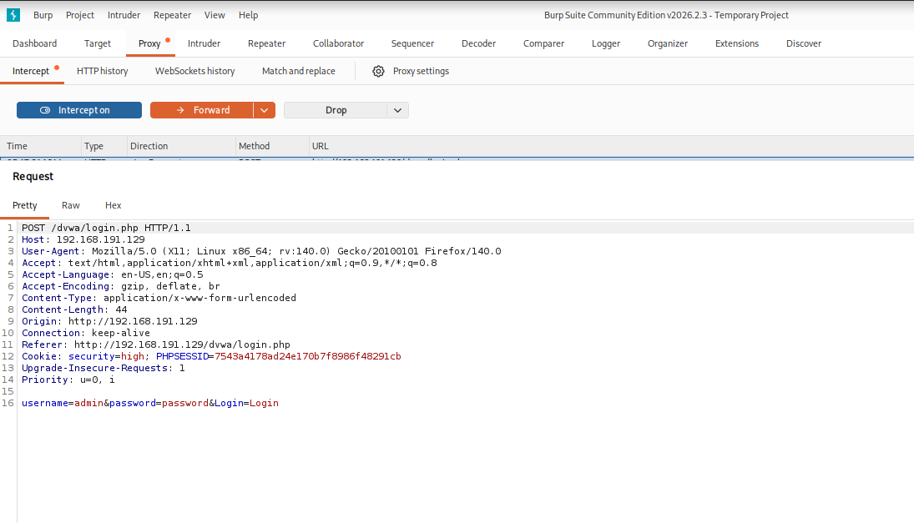

Step-5: Send to an intruder for brute force attack. (Right-click and select intruder.)
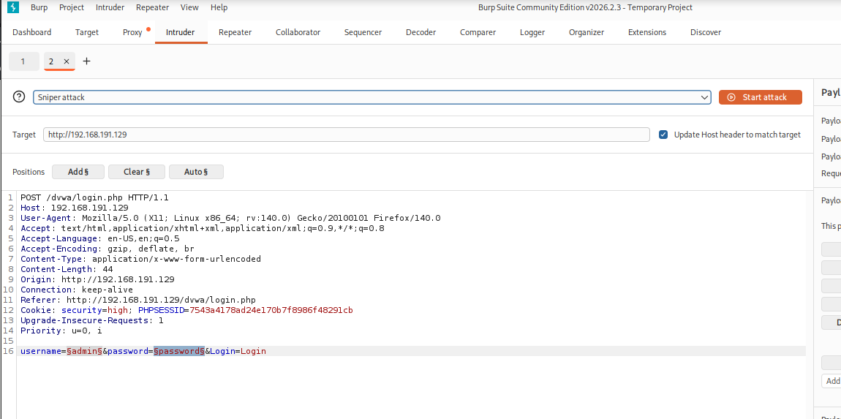
Step-6: Select the payload field. And use the cluster bomb attack method. Because I use 2 input fields. When using multiple payload fields, then you need to use cluster bomb attack methods.
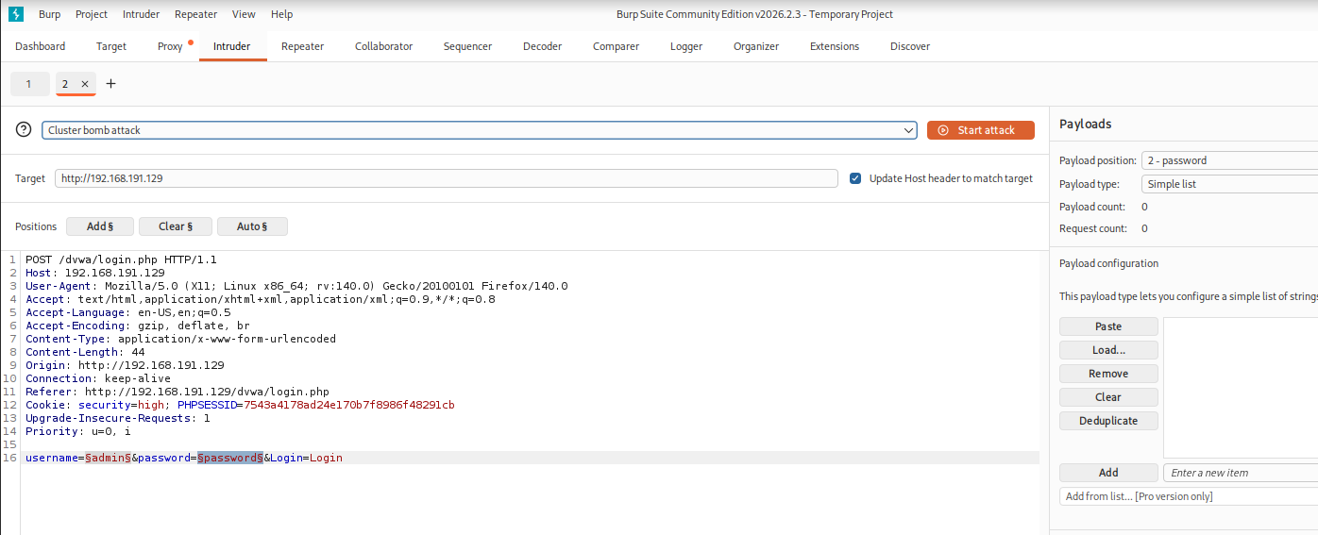
Step-7: Add payload for 2 parameters.
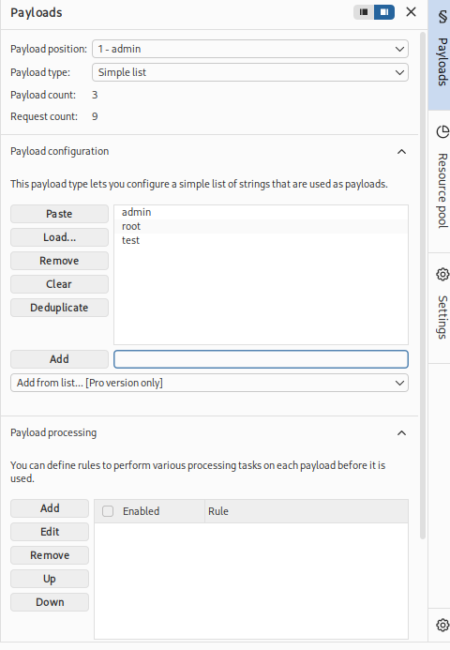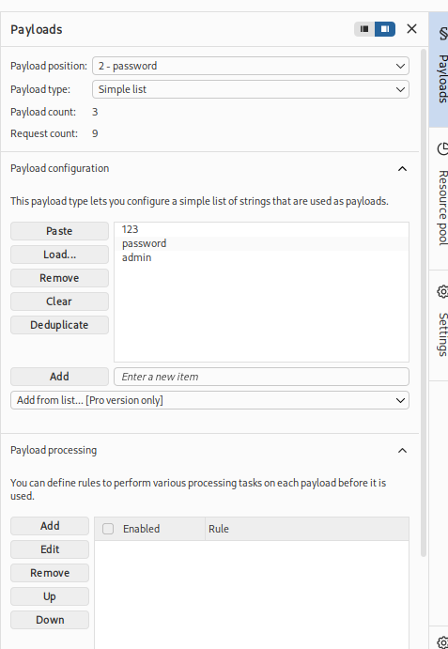
Step-8: Start attack and flow request length. If request lengths are fill abnormal, try to check login using this credential .
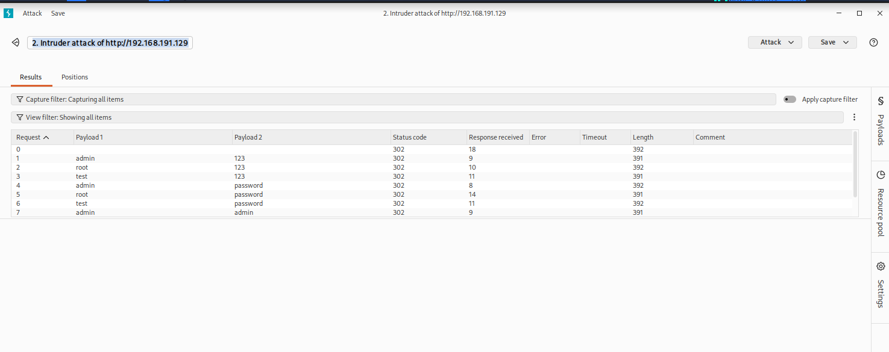

NB: High , medium, and low use the same solution. But maybe we need to change the payload.

Problem 2 : Command Execution
Step-1: Open problem in dvwa
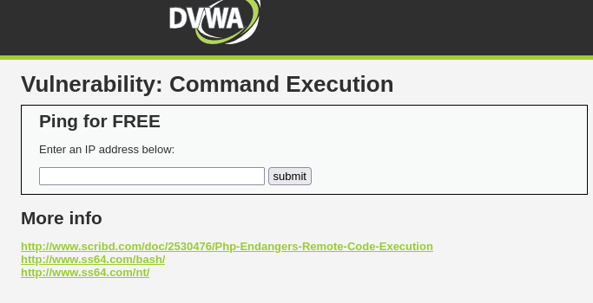
Step-2: Need to view the source code to get an idea about the server OS.
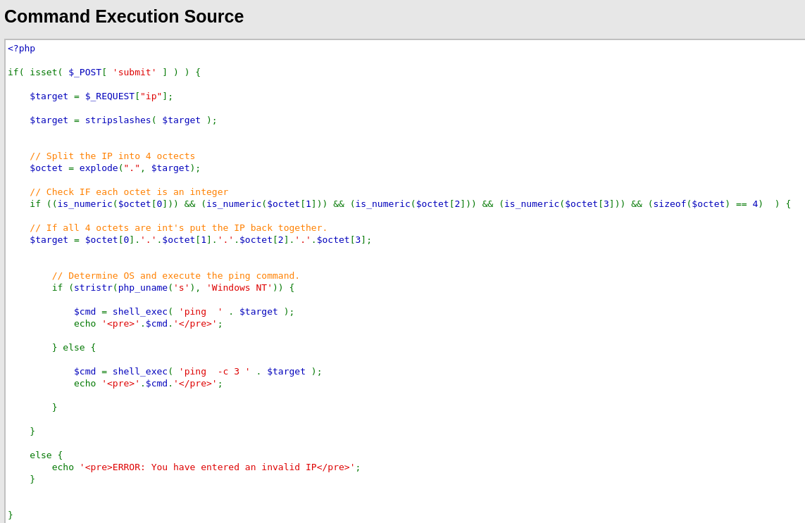
Here the server is Windows.
Step-3: So try to execute the Windows command.
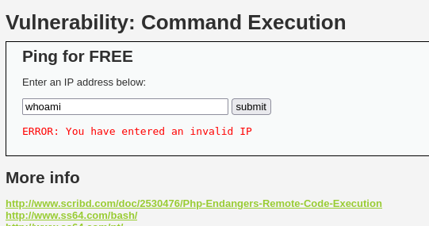
But not working. Because back-end queries do not match with this command. So to fix this problem, we need to show source code .

Here we see back-end query is localhost and localhost -c 4 so if we try execute any command first we need to use locahost command.

Step-4: Try to execute a command with localhost.
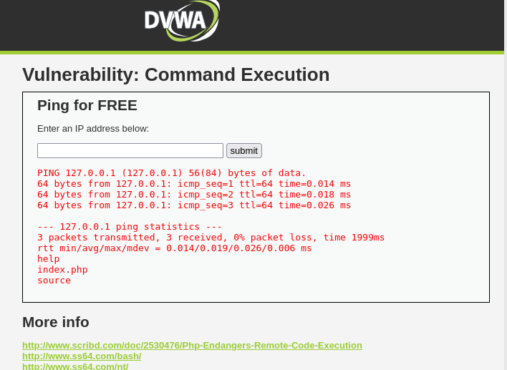
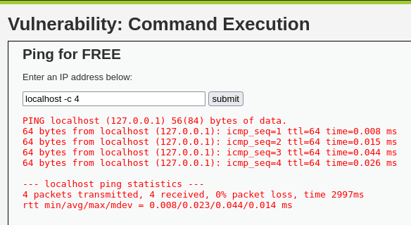
Step-5: Try to execute the command without localhost. I mean, comment out all previous queries and execute the command. This is our target.
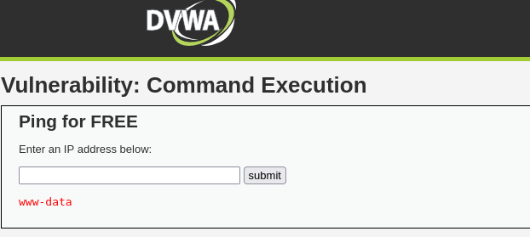
Yes, it is working ! Here I use ;whoami command and show the result. But why show result ? Because here use ; for comment out all previous commands. Now you can try another comment out way like &,|, || etc.
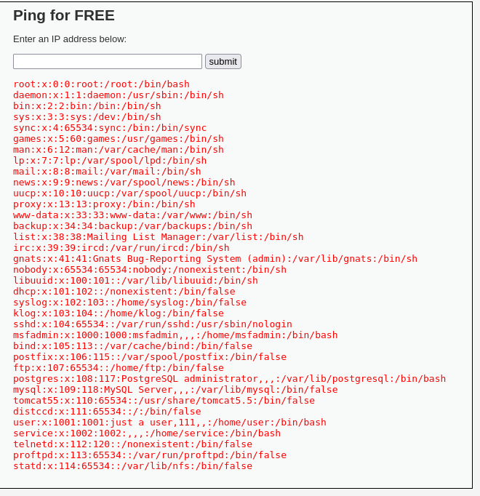
wow found all the directories. Here I use ; cat etc/passwd command .

NB: In high , medium level process are same but every category have whitelist some key . So every level you try to see source code and note down whitelist key and try to inject a command without that’s keys.
Problem 3: File Inclusion

Step-1: Open problem in DVWA.
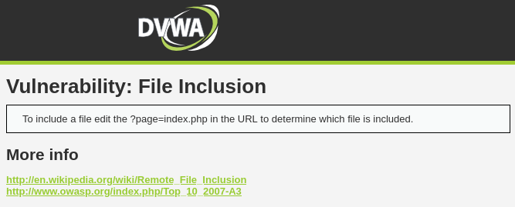
Step-2: Flow the url and find your input field. Here the problem url is
URL: http://192.168.209.131/dvwa/vulnerabilities/fi/?page=include.php
and input field, I mean parameter is (page=). So here we try to inject our command.

We need to file inclusion for this server . We know every sensitive file is included in the etc/passwd directory, so try it.
Yes, it's working. But for the advanced levels, it does not work to use this easy process. Ok, try to see a high-level problem.

I complete this section letter.

Problem 4: SQL injection
Step 1: Open problem in dvwa.
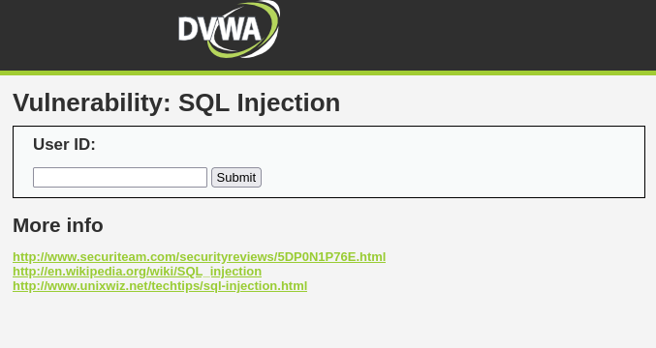
Step-2: Check this input field is vulnerable or not. So we use ‘ for show vulnerable message.
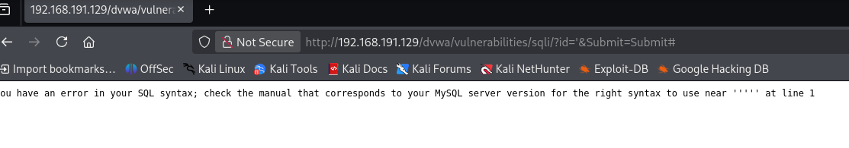
Step-3: Now fix this error message.
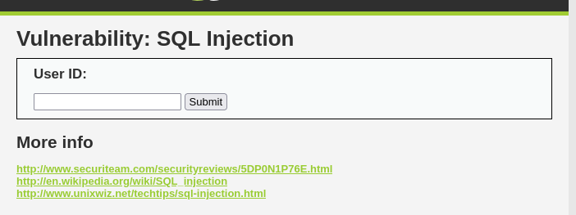
No vulnerable message because problem is fixed. Here I use – - for comment out all next query.

Step-4: Now find out how many column have this database.
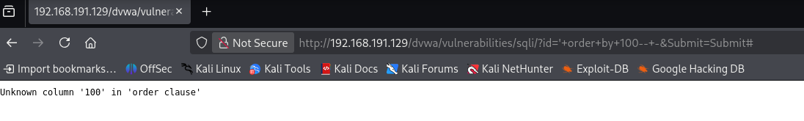
Use ‘ order by 100-- - and result is unknown column 100. That’s mean this database table have not exist 100 column. So minimize column number and find no error message.
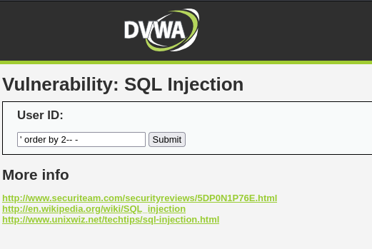
Here we see no error message. Now we know column number is 2

Step-5: Now find number of column. For finding vulnerable column use this command
‘ union select 1,2-- -
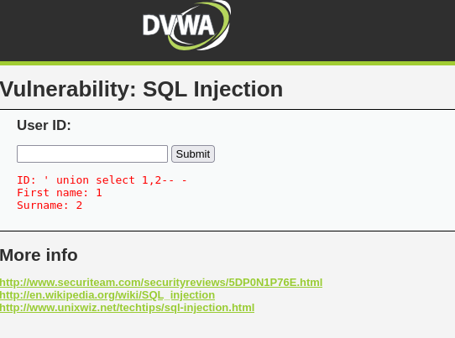
Here 1, 2 both column is vulnerable.

Step-6: Next step is retrieve table name from database.
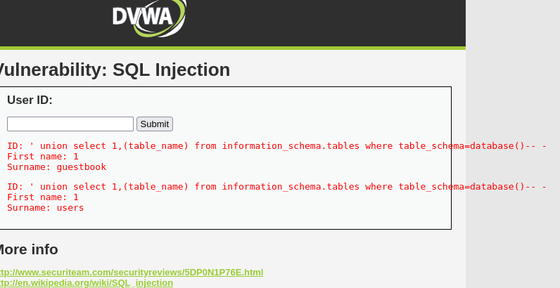
Command is : ' union select 1,(table_name) from information_schema.tables where table_schema=database()-- -
Here 2 table name found first is gestbook and second is users. Both table have information but users column have high possibility to have user login information.

Step-7: In this step we try to discover column name from users table.
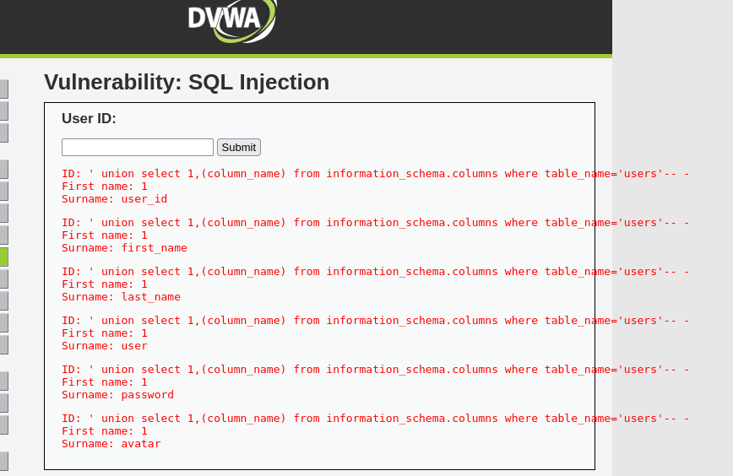
Here using command is : ' union select 1,(column_name) from information_schema.columns where table_name='users'-- -

This command retrieve all column name from users table. But I hope user and password column have login credential.

Step-8: Now try to retrieve data from user and password column .
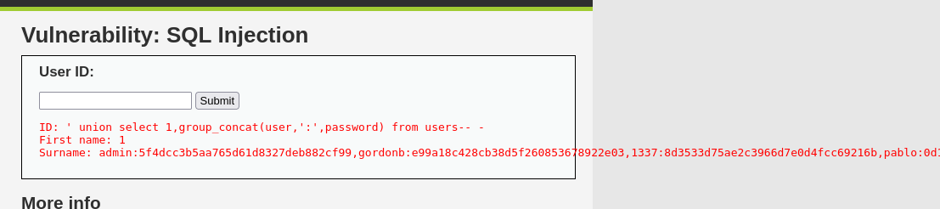
Using command is: ' union select 1,group_concat(user,'::',password) from users-- -

Here we see user login credential.
Username = admin
Password = 5f4dcc3b5aa765d61d8327deb882cf99

Problem 5: Blind SQL injection

Step-1: Start problem environment .
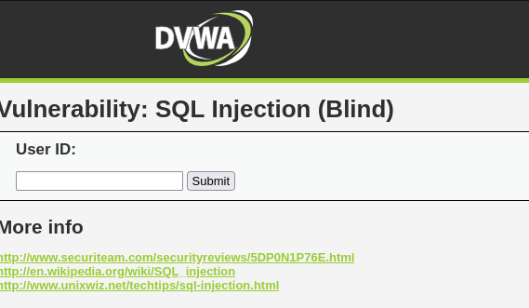
Step-2: Check this problem is sql vulnerable or not so use ‘
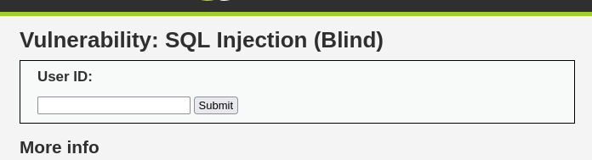
No error that means this site are not show error message. Because it have blind sql vulnerabilities.
How we can sure it lets see in next step.

Step-3: Now check this site is blind vulnerable or not.
So here method is when we put valid statement then site are show valid page but when we put invalid statement then this site are show invalid page. Lets see,,,,

First we put valid statement
1' and 1=1-- -
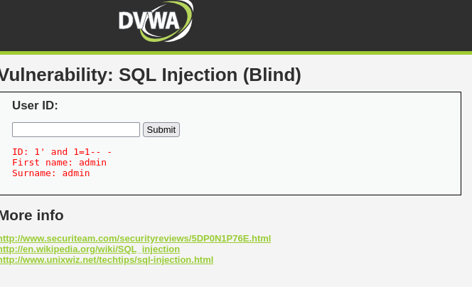
Show valid page !
But when use invalid statement
1' and 1=1-- -
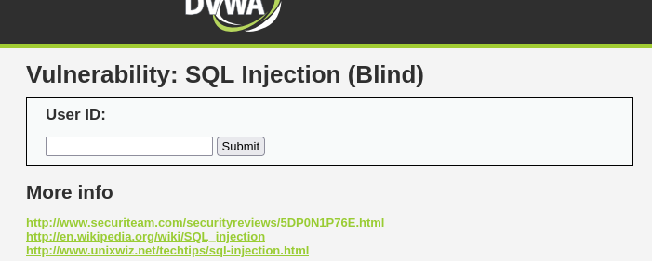
Not show valid page ! So we can say this site are blind sql vulnerable.

Step-4: Identify total column number from database.
Command is : 1' order by 2#
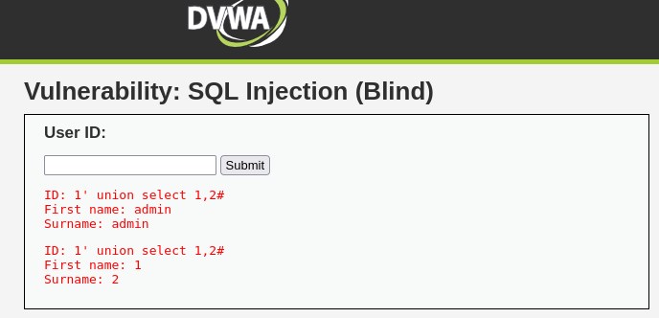
2 column found!
Here both column is vulnerable

Step-5: Try to retrieve table name.
Using command is : 1' union select 1,(table_name) from information_schema.tables where table_schema=database()#
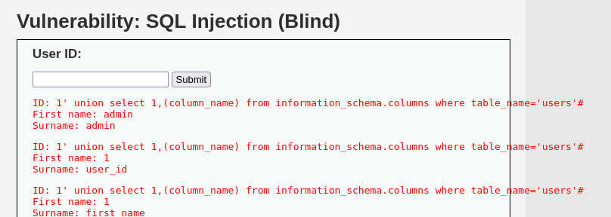
Step-7: Here table name is admin,guestbook and users. Now toy to retrieve column name from users table.
Command is : union select 1,(column_name) from information_schema.columns where table_name='users'
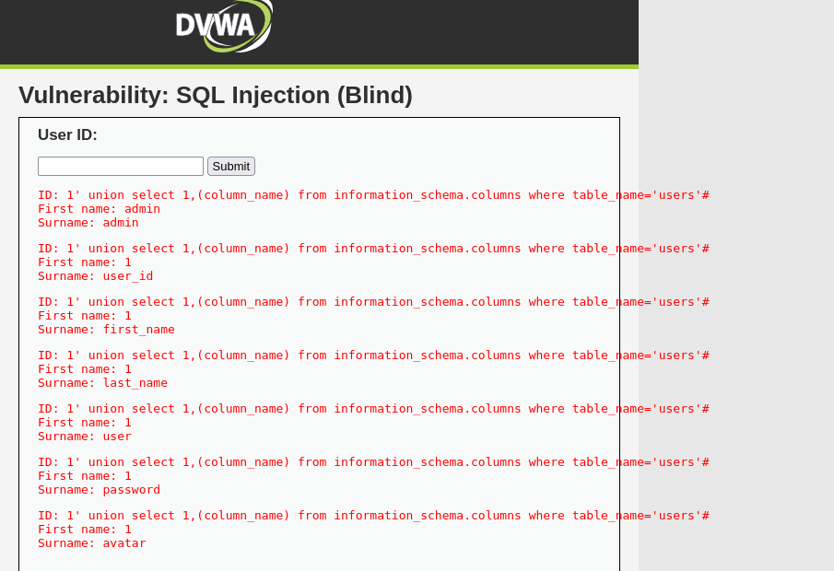
Step-8: last step try to retrieve user login credential.
Using command : union select 1,group_concat(user,'::',password) from users
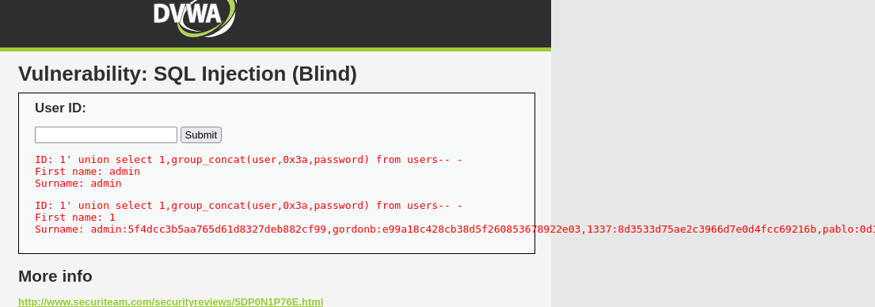
User name : admin
Password: 5f4dcc3b5aa765d61d8327deb882cf99

Problem 6: File upload

Step-1: Open problem in DVWA.
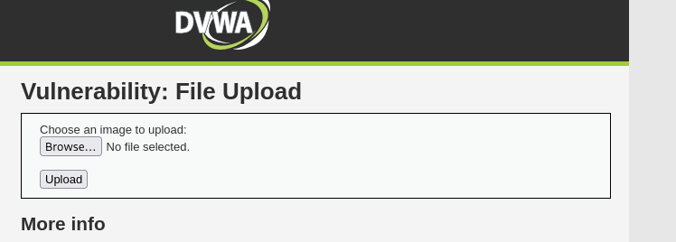
Step-2: Click browser button and select your file and click upload button. Now you can show a link bellow and copy it and pest url after 192.168.209.131/dvwa/herer,,,,,,
and hit enter,,,,,,,

In this problem I use a simple sell file and I inject my php code in a image file I will upload it.
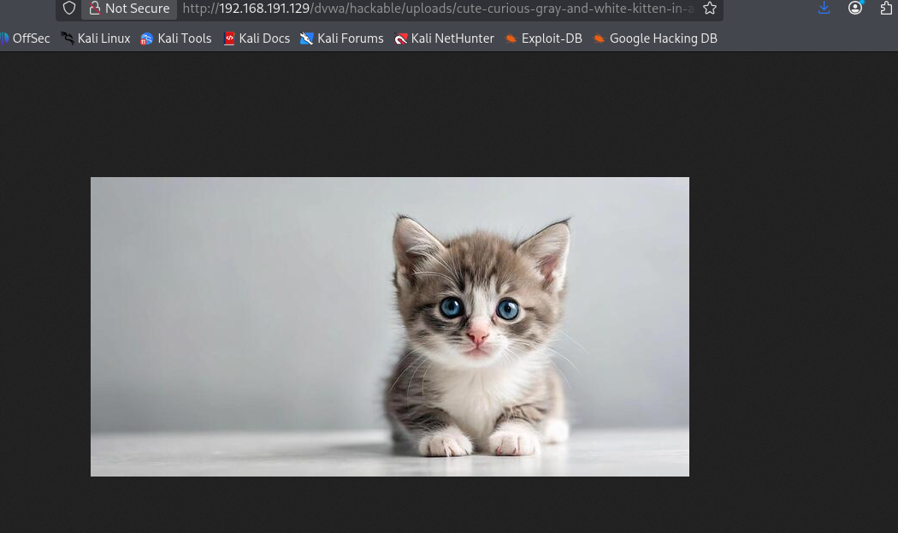

Boom ! My shell is working.

But when try to upload file in high or medium level vulnerabilities then you need to use some bypass technique. Ike you try to include shell code in image file and save this file name like file.php.jpg and try to upload this file. I hope it will work.

Problem 7: XSS reflected .

Step-1: Open problem in DVWA.
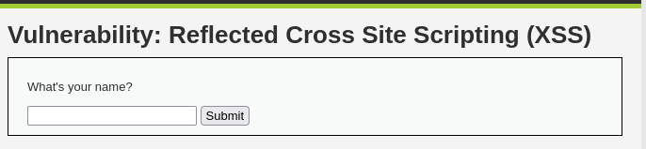
Step-2: Try to inject xss basic payload.
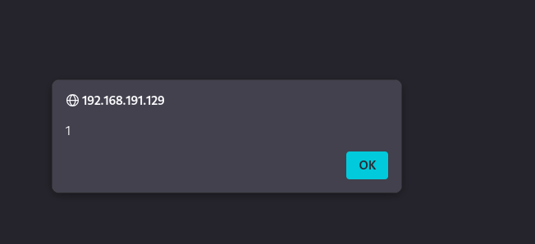
Yes it’s working. Here payload is ?><script>alert(1)</script>

ok lets go medium level !
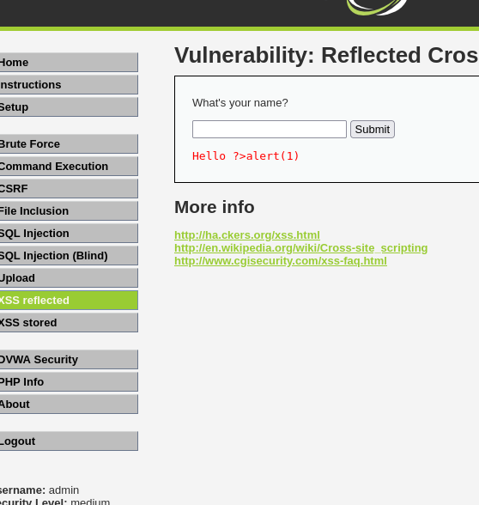
Same payload input here but not working.
But why ? Because this input field filter script tag. For check it you need to see source code.

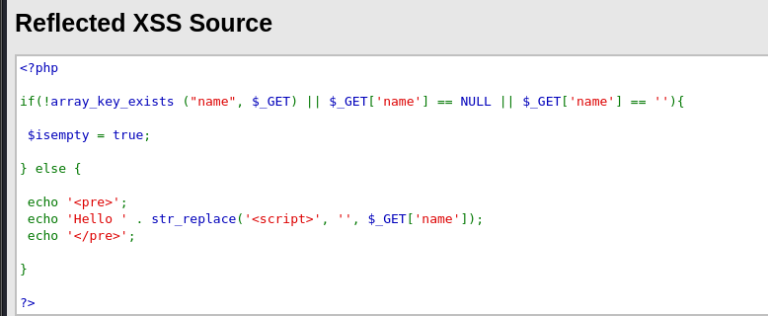
Here we can see script tag are replaced. So now we try to bypass script tag and inject.

