🧩 Self-Guided Lab Assignment (3 Hours)
Topic: Static and Dynamic Routing – Exploration & Verification

PART A – Conceptual Grounding
Static routing can be compared to a hand-drawn map in which you provide the router with precise, fixed instructions.
The Manual Definition: The router is told, "I don't care what you think; if you see traffic for Network A, you must send it out of Interface B," when a static route is defined. The router is merely the muscle; you are the brain. It just executes your hard-coded script; it makes no discoveries.
Fragile but Predictable: The path is always the same, making it predictable. Traffic will always stay on a particular high-speed link if you want it to. But it's brittle because static routes are "blind." The router will continue attempting to push data if the cable on the other end of that link is severed.
Where It Makes Sense: For "Stub Networks"—imagine a small branch office with just one entrance and one exit—static routing is ideal. If there is only one route to take, routers don't need to have a complicated conversation. Additionally, it works well for establishing a connection between a private network and an ISP (the Default Route).
2. The Living Network: Dynamic Routing
Your routers become a social network when you use dynamic routing. They speak with their neighbours instead of waiting for you to direct them.
Information Exchange: Routers are always chatting when they "speak" a protocol (such as OSPF or EIGRP). They exchange notes about which links are active, which are blocked, and which have vanished. Based on these discussions, the router's routing table becomes a dynamic document that is updated in real time.
The reason these protocols exist is because networks are untidy and dynamic. You don't want to have to manually update a route at three in the morning if a construction crew in a different city cuts a fibre line. There are protocols in place to automate the "pathfinding" procedure.

PART B – Static Routing Lab:
Topology 1 – Static Routing Between Two Networks
Topology Description
The topology consists of:
- Two routers (R1 and R2)
- Two LANs on different IP networks
- One PC connected to each router
Figure 1: Overall static routing topology in GNS3
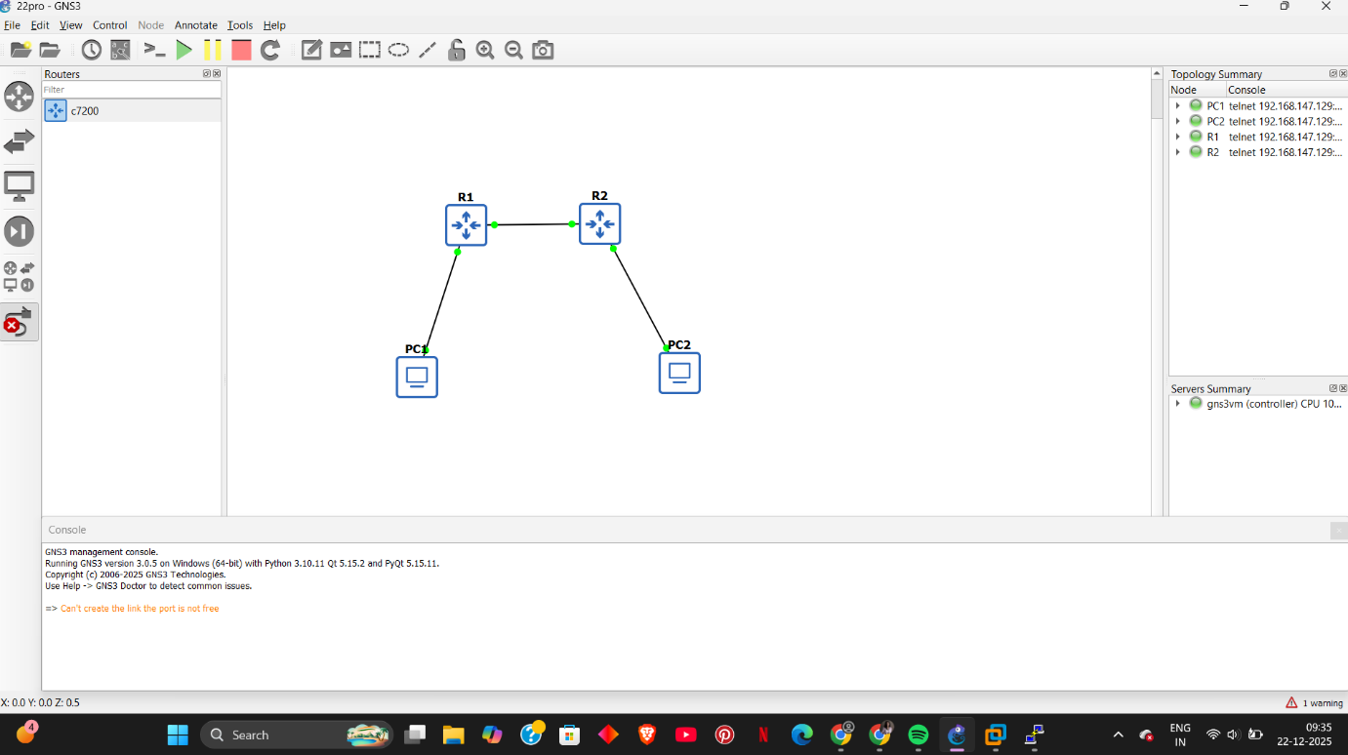

Topology Description
The topology consists of:
- Two routers (R1 and R2)
- Two LANs on different IP networks
- One PC connected to each router
Figure 1: Overall static routing topology in GNS3
Initial Verification (Before Static Routes)
- PCs can reach their own gateway
- PCs cannot reach the remote LAN
- Routers only know directly connected networks
Figure 2: PC1 failing to ping its default gateway initially
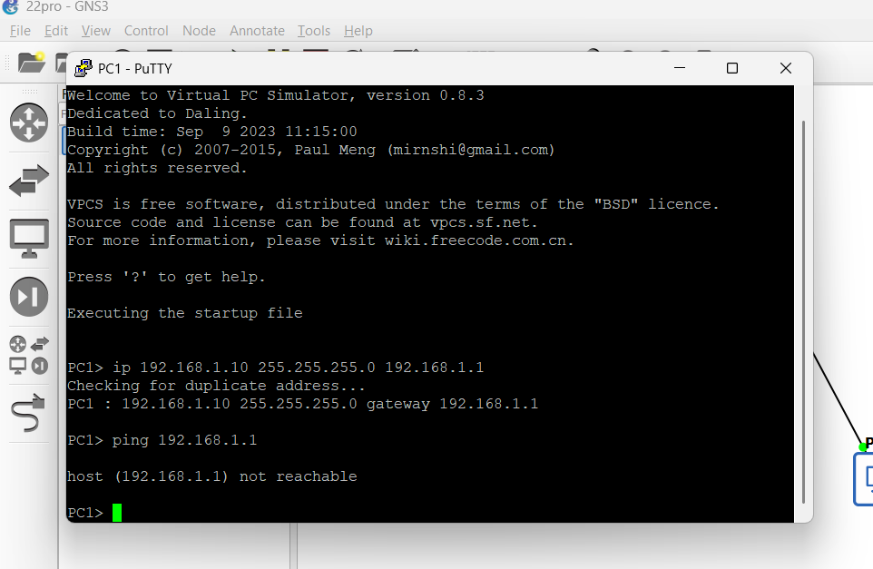
Figure 3: R1 routing table before static routes
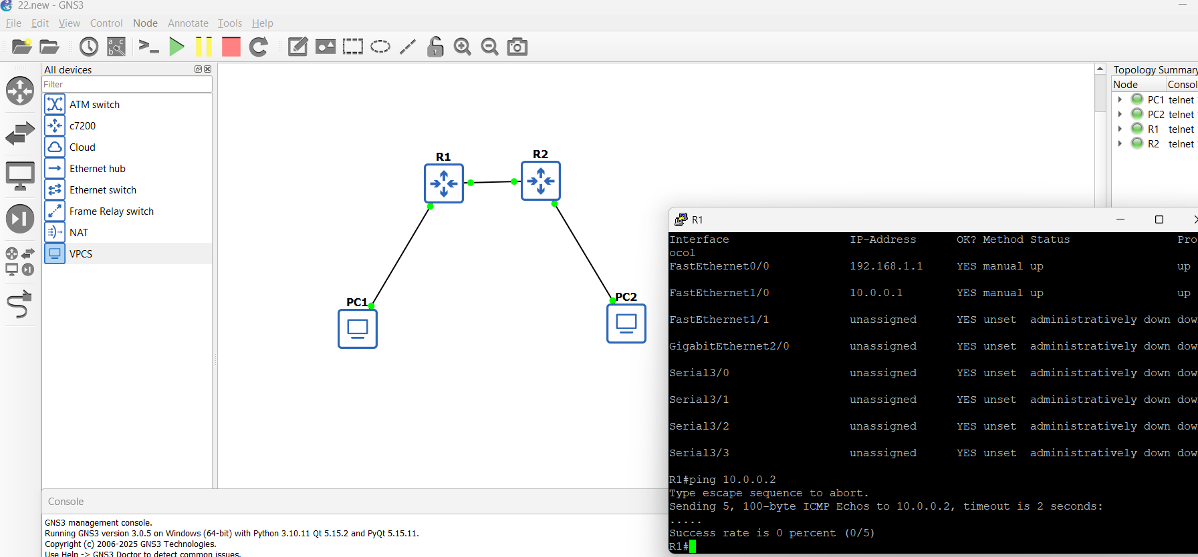
Static And Dynamic Routing – Lab Report

Static Route Configuration
Static routes were added:
- On R1: Route to 192.168.2.0 via 10.0.0.2
- On R2: Route to 192.168.1.0 via 10.0.0.1
After configuration:
- Routing tables updated
- End-to-end connectivity achieved
Figure 4: R2 routing table after static routing
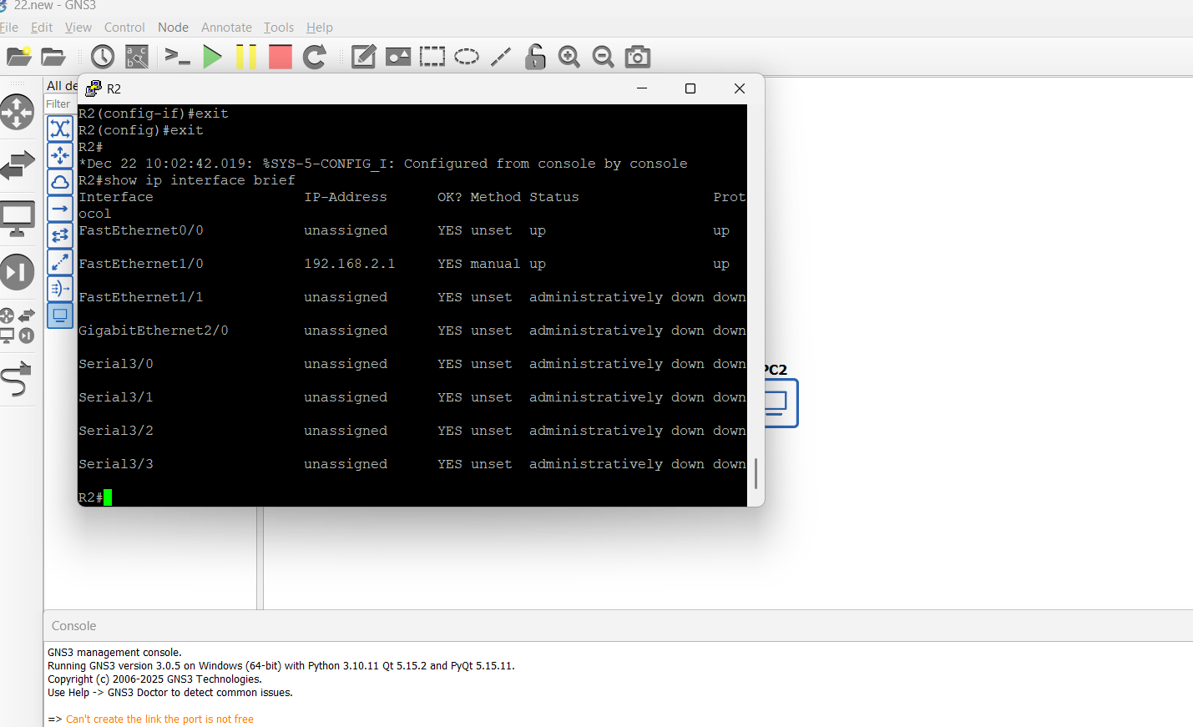
Verification
- PC1 can ping PC2
- Traffic successfully traverses both routers
Figure 5: Successful ping attempts after static routing
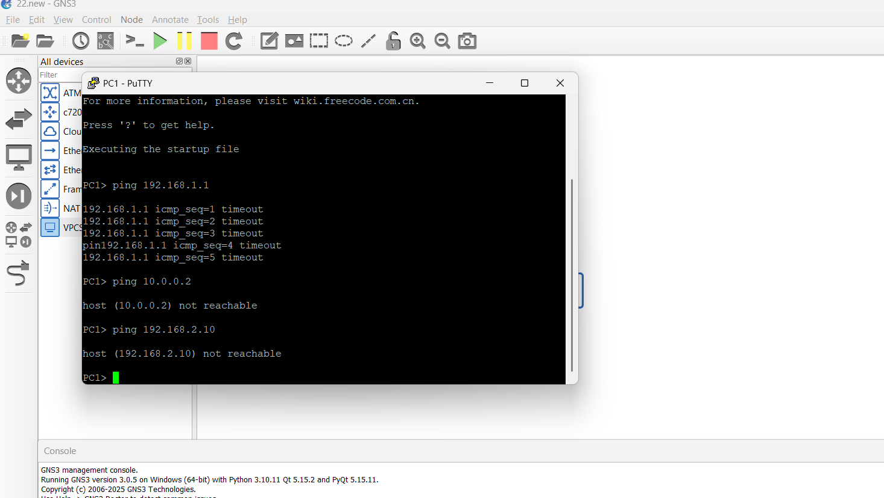
PART C – Dynamic Routing Lab (Approx. 1 hour)
Topology 2 – Dynamic Routing with Multiple Routers
Topology Description
This topology extends the earlier setup to include three routers (R1, R2, R3) connected in series, with end hosts on the edge routers. The middle router (R2) has no directly connected end device, making all edge-to-edge communication dependent entirely on routing.
- PC1 connected to R1 (192.168.1.0/24)
- PC2 connected to R3 (192.168.3.0/24)
- Inter-router links form transit networks reachable only through routing
Figure 6: Dynamic routing topology with three routers
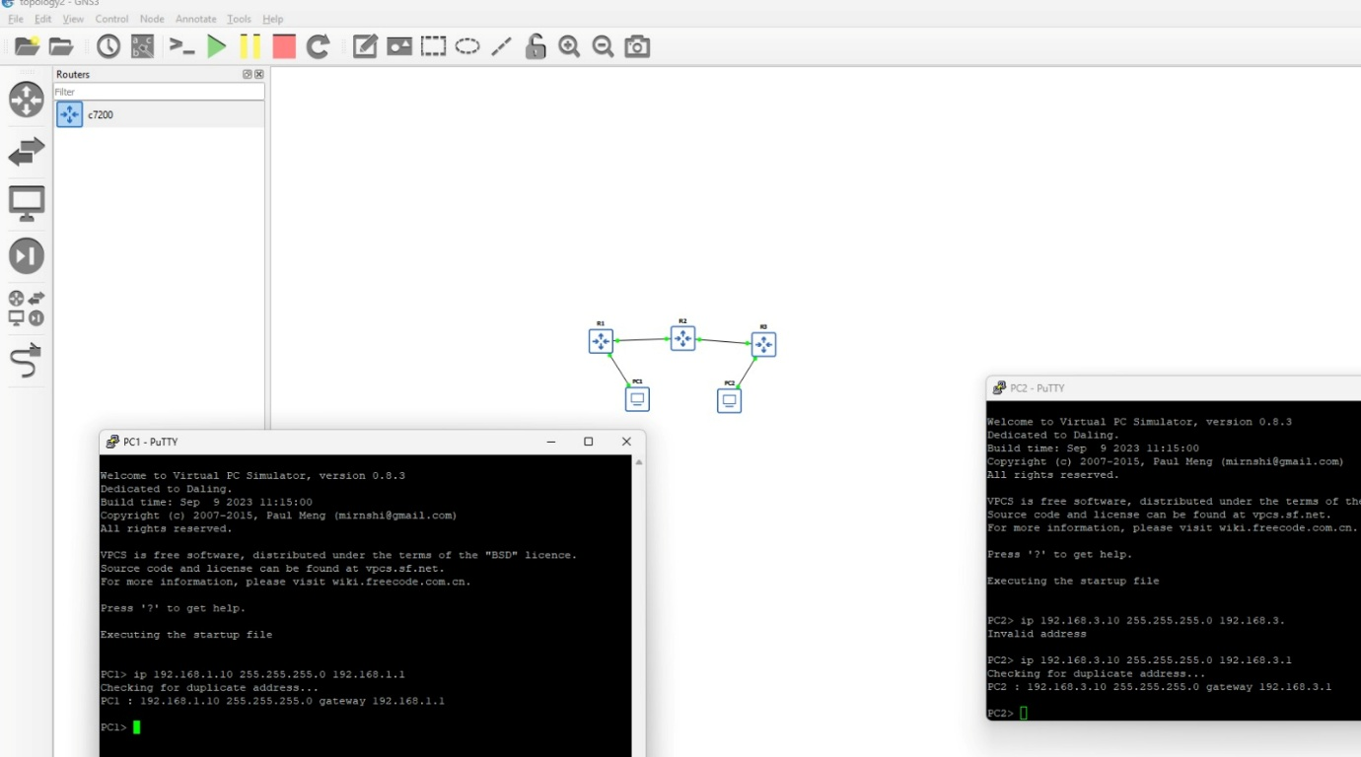
Static And Dynamic Routing – Lab Report
IP Configuration Summary
- PC1: 192.168.1.10/24, Gateway 192.168.1.1
- R1–R2 link: Transit network
- R2–R3 link: Transit network
- PC2: 192.168.3.10/24, Gateway 192.168.3.1
Initially, PCs were configured correctly but could not reach even their own gateway, confirming that routing information was missing.
Figure 7: PC1 unable to reach gateway before dynamic routing
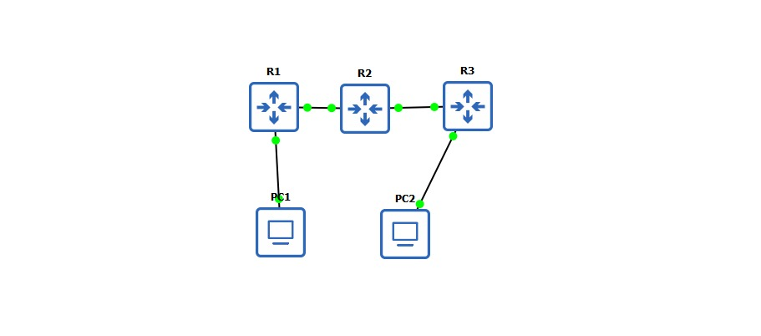
Dynamic Routing Configuration
A dynamic routing protocol supported by the router image was enabled on all three routers. Relevant networks were advertised so routers could exchange routing information automatically.
Once enabled:
- Routing tables populated without manual routes
- Each router learned about remote LANs
- Transit networks were correctly used for forwarding
Figure 8: End host IP configuration and readiness for dynamic routing
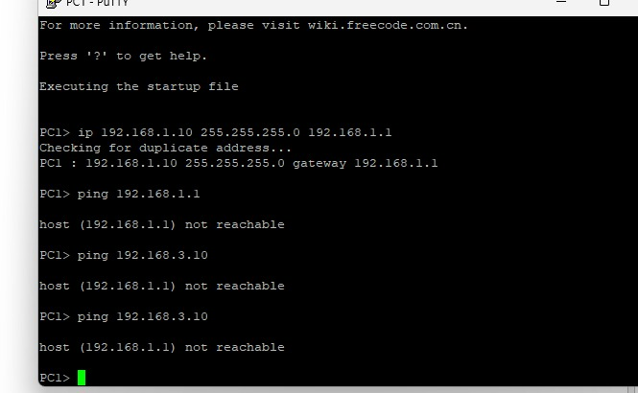
Verification After Dynamic Routing
After routing convergence:
- Routes to remote networks appeared automatically in routing tables
- PC1 successfully reached PC2
- Multi-hop packet flow worked without static routes
This confirmed that routers were making forwarding decisions based on learned information rather than manual configuration.
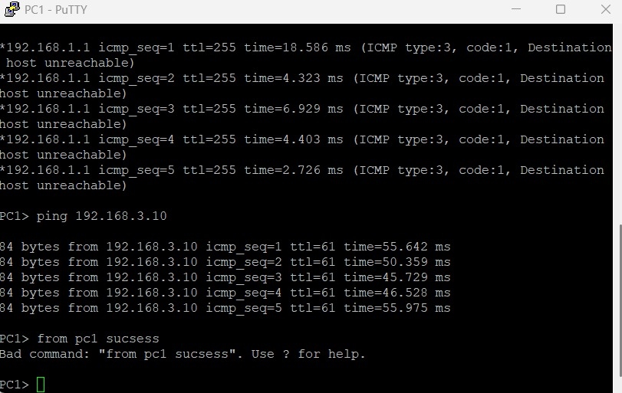
Failure Observation
A router interface or inter-router link was intentionally shut down to simulate failure.
Observed behavior:
- Affected routes were removed from routing tables
- Routers recalculated available paths
- Connectivity was either restored through alternate paths or failed gracefully
When the link was brought back up:
- Routes reappeared automatically
- End-to-end connectivity was restored without human intervention
This behavior clearly demonstrates why dynamic routing is essential in real networks.
PART D – Static vs Dynamic in Practice
Static routing produced small, rigid routing tables with no adaptation. Dynamic routing produced evolving routing tables that reflected the current network state.
When a link failed:
- Static routing collapsed and stayed broken
- Dynamic routing adapted and recovered
Dynamic routing felt more "alive" because routers responded to the network instead of ignoring it.
Static routing is better for:
- Small branch offices
- Single-exit networks
Dynamic routing is unavoidable for:
- Enterprise networks
- ISPs
- Any network where uptime matters

✨ Final Reflection – What Routing Really Means After This Lab
Routing is not just about forwarding packets. It is about decision-making, adaptability, and trust between network devices.
Static routing teaches control. Dynamic routing teaches resilience.
After this lab, routing stopped being a set of commands and started feeling like a living system that reacts to change.

