
NUTRILENS AI: AN INTELLIGENT FOOD LABEL ANALYSIS AND HEALTH ASSESSMENT SYSTEM
A MINI PROJECT REPORT
Submitted by

MARGERAT HELAN SAJI

MLM25MCA-2039
TO
the APJ Abdul Kalam Technological University in Partial fulfillment of the requirements for the award of the degree
of
MASTER OF COMPUTER APPLICATIONS
Under the Guidance of
Mr. ELDHOSE K PAUL
(Associate Professor, Department of Computer Applications)

DEPARTMENT OF COMPUTER APPLICATIONS
MANGALAM COLLEGE OF ENGINEERING, ETTUMANOOR
(Affiliated to APJ Abdul Kalam Technological University)
OCTOBER 2026

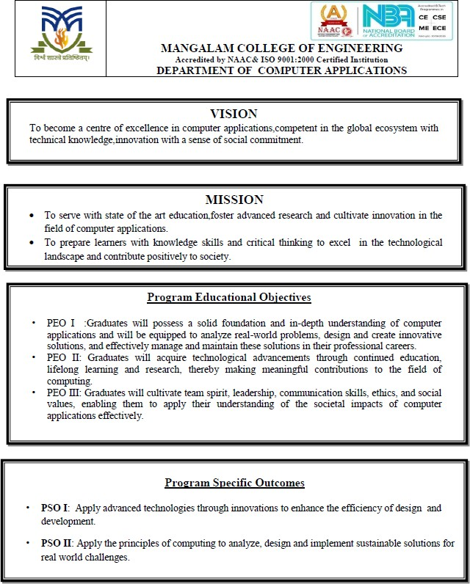

MAPPING OF PO-PSO-SDG
1. MAPPING WITH PROGRAM OUTCOMES (POs):
SL.NO | POs ADDRESSED | RELEVANCE TO PROJECT
1 | PO1 | Applies programming, computing and foundational knowledge to develop the food-label analysis system.
2 | PO2 | Applies problem analysis to identify the difficulties consumers face in understanding food labels, ingredients, allergens and misleading claims.
3 | PO3 | Designs and develops an OCR-based and rule-based solution for automated food-label analysis and health assessment.
4 | PO4 | Uses modern computational tools such as Python, Tesseract OCR, HTML, CSS, JavaScript and SQLite, while considering their limitations.
5 | PO7 | Considers professional ethics and responsible handling of food-related and user-profile information.
6 | PO8 | Requires continuous learning and application of OCR, AI and food-analysis technologies.

LIST OF PROGRAM OUTCOMES (POs):
PO1 (Foundation Knowledge): Apply knowledge of mathematics, programming logic and coding fundamentals for solution architecture and problem solving in developing the NutriLens AI food label analysis system.
PO2 (Problem Analysis): Identify, review, formulate and analyze the difficulties faced by consumers in understanding food labels, harmful ingredients, allergens and misleading claims using critical thinking frameworks.
PO3 (Development of Solutions): Design, develop and investigate an innovative solution that integrates OCR-based label extraction, ingredient analysis, deception detection, health-risk scoring and personalized recommendations.
PO4 (Modern Tool Usage): Select, adapt and apply modern computational tools such as Python, Tesseract OCR, HTML, CSS, JavaScript and SQLite for the development and implementation of the NutriLens AI system, considering their limitations.
PO5 (Individual and Teamwork): Function and communicate effectively during the planning, development, testing and documentation of the NutriLens AI project, while coordinating project activities and applying appropriate development methodologies.
PO6 (Project Management and Finance): Use the principles of project management such as scheduling, work breakdown structure and be conversant with the principles of Finance for profitable project management.
PO7: Apply knowledge of social, health and environmental considerations in developing a food-label analysis system that helps consumers understand packaged food information and make informed choices.
PO8: Apply ethical and professional principles in handling user health profiles, food-related information and personalized recommendations while developing and using the NutriLens AI system
2. MAPPING WITH PROGRAM SPECIFIC OUTCOMES (PSOs):
SL.NO | PSOs ADDRESSED | RELEVANCE TO PROJECT
1 | PSO 1 | Applies advanced technologies through innovations to enhance the efficiency of design development.
2 | PSO 2 | Applies the principles of computing to analyze, design and implement sustainable solutions for real world challenges.

LIST OF PROGRAM SPECIFIC OUTCOMES (PSOs):
PSO1 (Advanced Technologies and Innovation): Apply advanced computing technologies, programming concepts and innovative approaches to design and develop effective solutions for real-world problems.
PSO2 (Computing and Sustainable Solutions): Apply computing knowledge and modern computational tools to develop sustainable, user-oriented solutions addressing societal and technological needs
3. MAPPING WITH SUSTAINABLE DEVELOPMENT GOALS (SDGs):
SDG.NO | SDGs ADDRESSED | RELEVANCE TO PROJECT
SDG 3 | Good Health and Well-being | Helps users understand food ingredients and identify potentially concerning ingredients through automated analysis.
SDG 9 | Industry, Innovation and Infrastructure | Applies AI, OCR and computational technologies to develop an innovative food-analysis solution.
SDG 12 | Responsible Consumption and Production | Supports informed food choices by making product-label information easier to understand.
SDG 17 | Partnerships for the Goals | Promotes collaboration and knowledge sharing for developing digital health solutions.

SUSTAINABLE DEVELOPMENT GOALS (SDGs):
SDG 3 – Good Health and Well-Being-Ensure healthy lives and promote well-being for all at all
SDG 9 – Industry, Innovation, and Infrastructure-Build resilient infrastructure, promote inclusive and sustainable industrialization, and foster innovation.z
SDG 12 – Responsible Consumption and Production-Ensure sustainable consumption and production patterns.
SDG 17 – Partnerships for the Goals -Strengthen the means of implementation and revitalize the global partnership for sustainable development.
MANGALAM COLLEGE OF ENGINEERING, ETTUMANOOR
DEPARTMENT OF COMPUTER APPLICATIONS

OCTOBER 2026


DECLARATION
I hereby certify that the work which is being presented in the project entitled “NUTRILENS AN INTELLIGENT FOOD LABEL ANALYSIS AND HEALTH ASSESSMENT SYSTEM” submitted in the DEPARTMENT OF COMPUTER APPLICATIONS is an authentic record of my own work carried under the supervision of Mr. ELDHOSE K PAUL, ASSOCIATE PROFESSOR. This study has not been submitted to any other institution or university for the award of any other degree. This report has been checked for plagiarism by the college and the similarity index is within permissible limits set by the college.

Date: Name & Signature of Student
Place: MARGERAT HELEN SAJI
MANGALAM COLLEGE OF ENGINEERING, ETTUMANOOR
DEPARTMENT OF COMPUTER APPLICATIONS
OCTOBER 2026

CERTIFICATE
Certified that the report entitled “NUTRILENS AN INTELLIGENT FOOD LABEL ANALYSIS AND HEALTH ASSESSMENT SYSTEM” submitted by MARGERAT HELAN SAJI MLM25MCA-2039 to the APJ Abdul Kalam Technological University in partial fulfillment of the requirements for the award of the DEGREE OF MASTER OF COMPUTER APPLICATIONS by APJ ABDUL KALAM TECHNOLOGICAL UNIVERSITY is a bonafide record of the MINI PROJECT work carried out by her under our guidance and supervision during the academic year 2025-27.

PROJECT GUIDE  Mr. Eldhose K Paul  Associate Professor  Department Of Computer  Applications | PROJECT COORDINATOR  Ms.Athira R Kurup  Assistant Professor  Department of Computer Applications
HEAD OF THE DEPARTMENT  Ms. Divya S B  Assistant Professor  Department of Computer  Applications | INTERNAL EXAMINER

ACKNOWLEDGEMENT
I am greatly indebted to the authorities of Mangalam College of Engineering for providing the necessary facilities to successfully complete my Project on the topic “NutriLens AI: An Intelligent Food Label Analysis and Health Assessment System”.
I express my sincere thanks to Dr. Vinodh P Vijayan, Principal, Mangalam College of Engineering for providing the facilities to complete my Project successfully.
I thank and express my sincere gratitude to Ms. Divya S B, HOD, Department of Computer Applications, Mangalam College of Engineering, for her invaluable help and support which helped me a lot in successfully completing this Project work.
I express my gratitude to my Internal Guide, Mr.Eldhose K Paul, Associate professor, Department of Computer Applications for the suggestions and encouragement which helped in the successful completion of my Project.
Furthermore, I would like to acknowledge with much appreciation the crucial role of the faculties especially Project coordinator, Ms. Athira R Kurup, Department of Computer Applications, Mangalam College of Engineering, who gave the permission to use all the required equipment and the necessary resources to complete the presentation& report.
Finally, I would like to express my heartfelt thanks to my parents who were very supportive financially and mentally and for their encouragement to achieve my goal.

MARGERAT HELAN SAJI
MLM25MCA-2039
ABSTRACT
NutriLens is a web-based food label analysis system designed to help consumers understand packaged food labels and identify potentially misleading or harmful information. Food labels often contain complex ingredient names, nutritional information, health claims, allergens, and other details that may be difficult for users to interpret. NutriLens addresses this problem by providing a unified platform for analyzing food-label images and presenting the results in a simple and understandable form.
The system uses Tesseract Optical Character Recognition (OCR) to extract text from uploaded food-label images. The extracted ingredient and nutritional information is then analyzed using rule-based risk and ingredient analysis to identify potentially harmful ingredients, allergens, nutritional concerns, and misleading or deceptive claims. Based on the identified risks and nutritional information, the system generates a Health Score and provides warnings and personalized insights according to the user's selected health profile. The system also provides recommendations to help users better understand the analyzed product and its potential health implications.
NutriLens integrates image upload, OCR-based text extraction, ingredient and deception analysis, health-risk assessment, personalized recommendations, and result visualization within a single web application. The system is developed using Python, HTML, CSS, JavaScript, Tesseract OCR, and SQLite. By simplifying complex food-label information into understandable results, NutriLens aims to improve food-label awareness and support users in making more informed food choices.
Keywords: NutriLens, Food Label Analysis, Optical Character Recognition (OCR), Tesseract OCR, Deception Detection, Ingredient Analysis, Health Risk Assessment, Health Score, Personalized Recommendations, Food Safety.
Mapping with Sustainable Development Goals (Mention the Goals) | 3 – Good Health and Well-Being; 9 – Industry, Innovation and Infrastructure; 12 – Responsible Consumption and Production; 17 – Partnerships for the Goals
TABLE OF CONTENTS
Chapter No Title Page No.
Acknowledgement vii
Abstract viii
List of Tables xi
List of Figures xii
List of Abbreviations xiii
Chapter 1: INTRODUCTION 1
1.1 Background 1
1.2 Motivation 1
1.3 Scope and Objectives 2
1.4 problem sataement 2
Chapter 2: REQUIREMENTS AND ANALYSIS 4
2.1 Existing system and problem statement 4
2.2 Solution Overview 4
2.3 Feasibility Study 5
Chapter 3: LITERATURE REVIEW 7
3.1 Food Label Scanner & Personalized Supplement Recommendation System 7
3.2 DeepFood: Food Image Analysis and Dietary Assessment via Deep Model 8
3.3 FoodVisor: AI-Powered Food Label Analysis System 10
3.4 Package Food Health Analyzer using Ingredients Intelligence 11
3.5 A Framework to Identify Allergen and Nutrient Content in Fruits and Packaged Food Using Deep Learning and OCR 13
3.10 A Machine Learning-Based Approach for Personalized Nutrition Recommendation Based on Health Profile and Dietary Preferences 14
3.9 Food-101: Mining Discriminative Components with Random Forests 15
3.8 An Overview of the Tesseract OCR Engine 16
3.7 Nutrition5k: Towards Automatic Nutritional Understanding of Generic Food 16
3.6 NutriNet: A Deep Learning Food and Drink Image Recognition System for Dietary Assessment 17
Chapter 4: DIAGRAMS 18
4.1 Data Flow Diagrams 18
4.1.1 DFD LEVEL 0 19
4.1.2 DFD LEVEL 1 19
4.2 USE CASE DIAGRAM 20
4.3 CLASS DIAGRAM 21
4.4 STATE DIAGRAM 22
4.5 ACTIVITY DIAGRAM 23
4.6 SEQUENCE DIAGRAM 24
Chapter 5: METHODOLOGY 26
5.1 Module Descriptions 26
5.2 Algorithms 32
5.2.1 Food Label Text Extraction Algorithm 32
5.2.2 Food Ingredient and Risk Analysis Algorithm 33
5.2.3 Health Score and Personalized Analysis Algorithm 33
5.4 Case Study 35
5.3 Architecture 34
Chapter 6: IMPLEMENTATION DETAILS 36
6.1 IMPLEMENTATION PROCEDURES 36
6.1.1 User Authentication Implementation 36
6.1.2 Food Label Upload and OCR Implementation 37
6.1.3 Food Label Analysis Implementation 37
6.1.4 Health Score and Personalized Analysis Implementation 37
6.1.5 Dashboard and Result Presentation 37
6.2 TESTING METHODS AND RESULTS 38
6.2.2 Testing Strategy 38
6.2.1 Test Dataset and Test Inputs 38
6.2.3 Functional Testing 38
6.2.4 OCR Testing 39
6.2.5 Analysis Testing 39
6.2.6 Health Score and Recommendation Testing 39
6.2.7 Result Testing 39
6.2.8 Overall Testing Result 39
Chapter 7: ADVANTAGES AND DISADVANTAGES 41
7.1 ADVANTAGES 41
7.2 DISADVANTAGES 42
Chapter 8: RESULT AND DISCUSSION 43
8.1 RESULT 43
8.2 DISCUSSION 44
Chapter 9: CONCLUSION 45
9.1 Summary 45
9.2 LIMITATIONS 46
9.3 FUTURE SCOPE 47
9.4 APPLICATIONS 47
Chapter 10: APPENDICES 48
10.1 APPENDIX A – SAMPLE SOURCE CODE 48
Chapter 11: REFERENCES 58
LIST OF TABLES
TABLE NO. | TITLE | PAGE NO.
6.1 | Functional Test Cases | 35
LIST OF FIGURES
FIGURE NO. | TITLE | PAGE NO.
4.1 | DFD Level 0 | 16
4.2 | DFD Level 1 | 17
4.3 | Use Case Diagram | 18
4.4 | Class Diagram | 19
4.5 | State Diagram | 20
4.6 | Activity Diagram | 21
4.7 | Sequence Diagaram | 22
5.1 | Profile | 23
5.2 | Login | 24
5.3 | Upload | 25
5.4 | Analysis Result | 26
5.5 | System Architecture | 31
LIST OF ABBREVIATIONS
ABBREVIATION | FULL FORM
AI | Artificial Intelligence
OCR | Optical Character Recognition
ML | Machine Learning
NLP | Natural Language Processing
UI | User Interface
UX | User Experience
HTML | HyperText Markup Language
CSS | Cascading Style Sheets
JS | JavaScript
SQL | Structured Query Language
SQLite | Structured Query Language – Lite
TNR | Times New Roman
URL | Uniform Resource Locator
HTTP | HyperText Transfer Protocol
PDF | Portable Document Format
ID | Identification

CHAPTER 1

INTRODUCTION

1.1 Background
The increasing consumption of packaged and processed food has made food labels an important source of information for consumers. Food labels provide details such as ingredients, nutritional values, allergens, and health-related claims. However, these labels can be difficult to understand because they often contain technical ingredient names, complex nutritional information, and claims that may not clearly indicate the overall quality or potential risks of a product.
Consumers may overlook harmful ingredients, allergens, excessive amounts of sugar, salt, or other nutritional components while selecting food products. In addition, statements such as health or nutritional claims can sometimes create a positive impression without providing a complete understanding of the product's ingredients and nutritional characteristics. Manually examining every ingredient and comparing it with individual health requirements can also be time-consuming and difficult for ordinary users.
NutriLens is developed to address these challenges through a web-based food-label analysis system. The system allows users to upload an image of a food label, from which relevant text is extracted using Tesseract Optical Character Recognition (OCR). The extracted information is then analyzed to identify potentially harmful ingredients, allergens, nutritional concerns, and misleading claims using predefined analysis rules. Based on the identified factors and the user's selected health profile, the system provides a Health Score along with warnings and personalized insights.
The main purpose of NutriLens is to simplify complex food-label information and present the analysis in an understandable form. By combining OCR-based extraction, ingredient and risk analysis, health scoring, and personalized recommendations in a single web application, the system aims to help consumers better understand packaged food products and make more informed food choices.

1.2 Motivation
The motivation for developing NutriLens arises from the difficulty faced by consumers in understanding the information provided on packaged food labels. Food products contain detailed ingredient lists, nutritional values, allergen information, and various claims that may be difficult for ordinary consumers to interpret correctly. As a result, important information about the nutritional quality and potential risks of a product may be overlooked.
Another motivation is the need to make food-label analysis simple, quick, and personalized. Different users may have different health-related concerns, and the same food product may not be equally suitable for everyone. Manually checking ingredients and nutritional information against individual requirements can be time-consuming.
NutriLens is therefore motivated by the need for a system that can extract food-label information automatically, analyze ingredients and nutritional factors, identify potential risks and misleading claims, and present the results in an easy-to-understand form. The system also provides a Health Score and personalized insights based on the user's selected health profile.
The project aims to bridge the gap between the complex information presented on food labels and the practical understanding required by consumers, helping them make more informed decisions when selecting packaged food products.

1.3 Scope and Objectives
The scope of the NutriLens project is to develop a web-based food-label analysis system that helps consumers understand the information provided on packaged food products. The system focuses on analyzing food-label images containing ingredient lists and nutritional information. It uses Optical Character Recognition (OCR) to extract relevant information from the uploaded label and analyzes the extracted data to identify potentially harmful ingredients, allergens, nutritional concerns, and misleading claims. The system also generates a Health Score and provides personalized insights based on the user's selected health profile. NutriLens is intended for packaged and processed food products with printed labels and aims to present complex food-label information in a simple and understandable manner. The system does not cover fresh or loose food products without printed labels or real-time restaurant menu analysis.
The main objectives of NutriLens are to develop a unified web application for food-label analysis, extract food-label information using Tesseract OCR, analyze ingredients and nutritional information, identify potentially harmful ingredients and allergens, detect potentially misleading or deceptive claims, and assess the overall health-related quality of a food product. The system also aims to generate a Health Score based on the identified nutritional and risk factors and provide personalized insights according to the user's selected health profile. By combining these functions in a single platform, NutriLens aims to make food-label information easier to understand and support users in making more informed food choices.

1.4 problem sataement
Consumers often find it difficult to understand the information provided on packaged food labels because ingredient lists, nutritional values, allergens, and food-related claims can be complex and difficult to interpret. Important information about potentially harmful ingredients, nutritional concerns, or allergens may therefore be overlooked while selecting food products. In addition, manually checking each ingredient and nutritional value according to individual health requirements can be time-consuming and inconvenient.
Existing food-label analysis approaches may focus on individual aspects such as ingredient recognition, nutritional analysis, or food classification rather than providing these functions together with personalized health-related insights. Therefore, there is a need for a unified system that can extract information from food labels, analyze the ingredients and nutritional factors, identify potential risks and misleading claims, and present the results in an understandable manner.
NutriLens addresses this problem by providing a web-based platform that uses OCR to extract information from food-label images and performs ingredient and risk analysis. The system generates a Health Score and provides personalized insights based on the user's selected health profile, helping users understand the potential health-related concerns associated with packaged food products.

CHAPTER 2

REQUIREMENTS AND ANALYSIS

2.1 Existing system and problem statement
the existing food-label analysis approaches provide information about food ingredients, nutritional values, allergens, or food quality through different applications and online resources. Some systems focus on recognizing food items or extracting information from food images, while others provide nutritional analysis or recommendations based on food-related information. However, these approaches may not provide all the required functionalities together in a single platform.
Consumers generally need to manually read and interpret ingredient lists and nutritional information to understand the quality and potential risks of a packaged food product. Identifying harmful ingredients, allergens, excessive nutritional components, and misleading claims can be difficult, particularly for users who are not familiar with technical food-related terms. In addition, general food information may not consider the individual health requirements of different users.
Therefore, the existing approaches have limitations in providing a unified and personalized method for food-label analysis. There is a need for a system that can extract information directly from a food-label image, analyze the extracted information, identify potential risks and misleading claims, and present the results according to the user's health profile. NutriLens is proposed to address these requirements by integrating OCR-based extraction, ingredient and risk analysis, Health Score generation, and personalized health insights into a single web application.

2.2 Solution Overview
NutriLens is proposed as a web-based food-label analysis system that provides a simple and unified approach for understanding packaged food information. The system allows users to upload an image of a food label through the web application. The uploaded image is processed using Tesseract OCR to extract the available text, particularly ingredient and nutritional information.
The extracted information is then analyzed using predefined rules and risk criteria to identify potentially harmful ingredients, allergens, nutritional concerns, and potentially misleading claims. The identified factors are considered while assessing the overall quality of the product and generating a Health Score. The system also uses the health profile selected by the user to provide relevant personalized insights and warnings.
The complete process integrates image upload, OCR-based text extraction, ingredient analysis, risk detection, Health Score generation, and personalized recommendations within a single web application. The results are presented through an understandable interface so that users can easily identify important information about the analyzed food product. This approach reduces the need for users to manually examine and interpret complex food-label information and provides a convenient method for understanding potential health-related concerns.

2.3 Feasibility Study
A feasibility study is conducted to determine whether a proposed system can be developed and implemented successfully using the available resources, technology, and budget. It helps evaluate the practicality of the project before development begins. In the NutriLens AI project, the feasibility study considers the technical requirements, development costs, and ease of use. The system uses technologies such as Python, Flask, and Tesseract OCR to extract food label information, analyse ingredients and nutritional values, calculate the overall product risk score, and provide personalized health suggestions. The project is technically achievable, economically affordable, and operationally suitable for users because it relies on readily available software tools and provides a simple interface for food label analysis..
2.3.1 Technical Feasibility
Technical feasibility determines whether the required technologies, tools, and resources are available to develop and run the proposed system. NutriLens AI is technically feasible because it uses Python and Flask for application development, Tesseract OCR for extracting text from food label images, and database technologies for storing ingredient risk information. The system uses predefined rules and nutritional thresholds to analyse ingredients, calculate the overall product risk score, and classify products into different risk levels. It also considers the user's health profile to provide personalized suggestions. The application can run on a standard computer with the required software installed, making it practical to develop, test, and maintain without expensive hardware.
2.3.2 Economic Feasibility
Economic feasibility determines whether a project can be developed and maintained within an affordable budget. NutriLens AI is economically feasible because it uses open-source technologies such as Python, Flask, and Tesseract OCR, which are available free of cost. The project does not require expensive hardware or paid software licenses, as it can run on a standard computer. The use of existing libraries and database tools helps reduce development and maintenance expenses. Therefore, NutriLens AI can be developed at a low cost while providing useful features for food label analysis, nutritional risk assessment, and personalized health suggestions.

2.3.3 Operational Feasibility
Operational feasibility determines whether a system can be used effectively by its intended users in real-world situations. NutriLens AI is operationally feasible because it provides a simple and user-friendly interface that allows users to upload food label images and view the analysis results easily. The system extracts text, analyses ingredients and nutritional information, calculates the overall product risk score, and provides personalized health suggestions based on the user's health profile. It requires minimal technical knowledge to operate and helps users understand food labels more easily. Therefore, the system can support users in making informed food choices through accessible and understandable nutritional information.

CHAPTER 3

LITERATURE REVIEW

3.1 Food Label Scanner & Personalized Supplement Recommendation System
[Authors: Katankar et al. (2025)]
This research presents a Food Label Scanner and Personalized Supplement Recommendation System designed to help users obtain useful health-related information from food products. The study focuses on simplifying the process of examining packaged food by using food-label information to generate a health assessment and personalized recommendations. The system aims to assist users in understanding food products and making more informed choices based on the information available from the product label.
The proposed system uses a barcode scanning mechanism to identify food products. After scanning the barcode, the system retrieves relevant product information through external food databases, including OpenFoodFacts and USDA APIs. This approach reduces the need for users to manually enter product information and allows the system to obtain ingredient and nutritional details associated with the scanned product.
An important component of the research is the rule-based Health Score. The system analyses the available food information and applies predefined rules to assess the health characteristics of the product. This enables the system to convert detailed food information into a simpler health-related assessment that can be understood by users. The rule-based approach provides a structured method for evaluating food products based on their available information.
The study also focuses on personalized supplement recommendations. Based on the analysed food information and the user's requirements, the system generates recommendations intended to provide additional health-related guidance. This personalization makes the system different from a basic food-information retrieval application because the results can be adapted according to individual user needs.
The use of external food databases is another important aspect of the proposed system. By obtaining information from OpenFoodFacts and USDA APIs, the system can access structured food-product information rather than depending entirely on manual data entry. The integration of barcode scanning with external databases therefore provides a convenient approach for obtaining product information and performing subsequent analysis.
The research demonstrates how food-product identification, ingredient checking, health scoring, and personalized recommendations can be combined into a single application. However, the approach primarily depends on barcode-based product identification and external food databases. In comparison, NutriLens focuses on analysing an uploaded food-label image using OCR, making it possible to analyse a label without requiring barcode-based identification.
Key Aspects
- Use of barcode scanning for food-product identification.
- Integration with OpenFoodFacts and USDA APIs for obtaining food information.
- Analysis of available ingredient and food-product information.
- Implementation of a rule-based Health Score.
- Generation of personalized health-related recommendations.
- Reduction of manual food-information entry through barcode scanning.
- Use of external food databases to retrieve structured product information.
- Focus on helping users understand food products and their health-related characteristics.
- Combination of food analysis and personalized recommendation functionality.
- Demonstration of a structured approach to food-product health assessment.
The study demonstrates how barcode-based food identification, external food databases, rule-based health assessment, and personalized recommendations can be integrated into a food-analysis system. This research is relevant to NutriLens because it demonstrates the importance of combining food information analysis with health scoring and personalized guidance. NutriLens extends this concept through OCR-based food-label extraction and analysis of uploaded label images, allowing the system to work directly with information printed on food packaging.

3.2 DeepFood: Food Image Analysis and Dietary Assessment via Deep Model
[Authors: Jiang et al. (2020)]
This research presents DeepFood, a food image analysis system designed to support dietary assessment through automated food recognition and analysis. The study focuses on using deep learning techniques to identify food items from images and provide useful information related to food consumption and dietary assessment. The approach aims to reduce the need for manual identification and analysis of food items.
The proposed system uses a Faster R-CNN (Region-based Convolutional Neural Network) architecture with RPN (Region Proposal Network) and VGG-16 as part of its deep learning approach. The model is used for food-image analysis and region proposal, allowing the system to identify relevant food regions within an image. This provides a foundation for automated food recognition and subsequent nutritional or dietary analysis.
An important aspect of the research is region proposal and CNN-based classification. The system processes food images to identify different food regions and classify the recognized food items. By combining region-based detection with convolutional neural networks, the approach can handle food images containing different visual characteristics and multiple food regions.
The study also focuses on calorie and nutrient estimation. After identifying food items, the system can be used to support the assessment of nutritional characteristics associated with the recognized food. This makes the research relevant to applications where users need automated assistance in understanding food intake and dietary information.
The reported results demonstrate the effectiveness of the proposed deep learning approach. The study reports an mAP of up to 25.5%, with Top-1 accuracy of 71.7% and Top-5 accuracy of 93.1% for the reported FOOD2With-1bxx dataset. These results indicate the ability of the deep learning model to recognize and classify food-related content from images.
The research is relevant to NutriLens because it demonstrates how image-based analysis can be used to automatically obtain useful food-related information. However, DeepFood primarily focuses on food image analysis, food recognition, and dietary assessment, whereas NutriLens focuses specifically on food-label image analysis, including ingredient extraction, harmful-ingredient detection, allergen identification, deception detection, Health Score generation, and personalized health insights.
Key Aspects
- Use of deep learning for automated food image analysis.
- Application of Faster R-CNN for food-related image detection.
- Use of RPN and VGG-16 in the proposed deep learning architecture.
- Region proposal and CNN-based food classification.
- Automated identification of food items from images.
- Support for calorie and nutrient estimation.
- Reduction of manual food identification and dietary assessment.
- Application of image-based analysis to dietary assessment.
- Reported mAP of up to 25.5%.
- Reported Top-1 accuracy of 71.7% and Top-5 accuracy of 93.1% on the reported dataset.
The study demonstrates the potential of deep learning and image analysis for automated food recognition and dietary assessment. It is relevant to NutriLens because it establishes the importance of extracting food-related information from images automatically. While DeepFood concentrates on recognizing food items and supporting dietary assessment, NutriLens applies image processing specifically to packaged food labels, using OCR and rule-based analysis to examine ingredients, nutritional information, potential risks, and misleading claims.

3.3 FoodVisor: AI-Powered Food Label Analysis System
[Authors: Amoggha et al. (2025)]
This research presents FoodVisor, an AI-powered food label analysis system designed to analyze information obtained from food product labels. The study focuses on using artificial intelligence techniques to examine food-label information and provide users with useful insights regarding the safety and characteristics of food ingredients. The system combines image-based input and language-model-based analysis to support automated food-label interpretation.
The proposed system accepts OCR and barcode input for obtaining food-related information. OCR enables the system to extract textual information from food labels, while barcode-based input can be used to identify the corresponding food product. This provides two approaches for obtaining the information required for subsequent analysis.
An important component of FoodVisor is its Retrieval-Augmented Generation (RAG) approach combined with a Large Language Model (LLM). The system uses RAG together with LLM-based processing to perform ingredient safety analysis. This approach is intended to provide a more informed analysis of food ingredients by combining retrieved information with language-model processing.The reaserch also uses a fine-tuned LLaMA 2 model.The table provided for the study identifies QLoRA and PEET as the techniques associated with the model fine-tuning process.This indicates the use of parameter-efficent technique for adapting the language model to the food -label analysis task.The reported performance results demonstrate the effectiveness of the proposed approach. The study reports an accuracy of 98.99%, precision of 100%, recall of 95%, and an F1-score of 96.47%. These metrics indicate the reported performance of the system in its ingredient safety analysis task.
The study is closely related to NutriLens because both systems focus on extracting and analyzing information from food labels. However, FoodVisor uses a RAG and fine-tuned LLM-based approach, whereas the current NutriLens implementation uses Tesseract OCR followed by predefined rule-based ingredient and risk analysis. Therefore, the study provides a reference for how advanced AI and language-model techniques can be applied to automated food-label analysis.
Key Aspects
- Development of an AI-powered food-label analysis system.
- Use of OCR and barcode input for obtaining food information.
- Application of Retrieval-Augmented Generation (RAG).
- Use of a Large Language Model (LLM) for ingredient safety analysis.
- Fine-tuning of the LLaMA 2 model.
- Use of QLoRA and PEFT for model adaptation.
- Automated analysis of ingredient safety.
- Reported accuracy of 98.99%.
- Reported precision of 100% and recall of 95%.
- Reported F1-score of 96.47%.
The study demonstrates the potential of combining OCR, retrieval-based information processing, and fine-tuned language models for automated food-label analysis. It is particularly relevant to NutriLens because it addresses the same general problem of interpreting food-label information. NutriLens follows a comparatively simpler implementation using OCR and rule-based analysis, while the FoodVisor study demonstrates an alternative approach using advanced language-model techniques for ingredient safety analysis.

3.4 Package Food Health Analyzer using Ingredients Intelligence
[Authors: Gawade et al. (2026)]
This research presents a Package Food Health Analyzer using Ingredients Intelligence designed to help users understand the health-related characteristics of packaged food products. The study focuses on analyzing ingredients present in packaged food and providing information that can assist users in identifying potentially concerning ingredients and understanding their relationship with health conditions.
The proposed system uses OCR and machine learning classification as its main technical approaches. OCR is used to extract ingredient information from food-product images. This allows the system to obtain the ingredient details automatically instead of requiring the user to manually enter the information. The extracted ingredient information is then used for further analysis.
An important aspect of the research is ingredient extraction and disease-based recommendation. After extracting the ingredients, the system analyses them in relation to different health or disease conditions. Based on this analysis, the system provides recommendations that are intended to make users more aware of the suitability of a packaged food product for particular health conditions.
The study also focuses on providing a Health Score for the analyzed food product. The health score provides a simplified representation of the product's overall health-related characteristics, allowing users to understand the analysis without having to interpret every ingredient individually.
Another important feature is the connection between ingredient intelligence and personalized health advice. Instead of considering only the general quality of a food product, the system considers disease-related factors while providing its analysis. This approach demonstrates the importance of personalized food analysis, particularly for users who need to consider specific health conditions when selecting packaged foods.
According to the provided literature table, the research does not report specific performance metrics. However, the reported findings indicate improved ingredient awareness, disease-aware advice, and Health Score generation. These findings show the potential of combining automated ingredient extraction with health-oriented analysis for packaged food products.
The research is highly relevant to NutriLens because both systems focus on extracting and analyzing ingredients from packaged food labels and providing health-related information. NutriLens similarly uses OCR for label information extraction and provides a Health Score and personalized insights. However, NutriLens additionally focuses on potentially misleading claims, harmful ingredients, allergens, and nutritional risk assessment within a unified food-label analysis system.
Key Aspects
- Development of a packaged food health analysis system.
- Use of OCR for ingredient extraction.
- Application of machine learning classification.
- Analysis of ingredients present in packaged food products.
- Use of disease-based analysis for providing recommendations.
- Generation of a Health Score.
- Provision of health-related and disease-aware advice.
- Improvement of user awareness regarding food ingredients.
- Focus on connecting ingredient information with individual health concerns.
- Integration of ingredient analysis and personalized health guidance.
The study demonstrates the usefulness of combining OCR-based ingredient extraction, machine learning classification, and disease-aware recommendations for packaged food analysis. It is particularly relevant to NutriLens because it supports the concept of extracting ingredients automatically and using them to generate a Health Score and personalized health information. NutriLens builds on this type of approach by incorporating additional analysis of allergens, potentially harmful ingredients, nutritional concerns, and misleading food-label claims.

3.5 A Framework to Identify Allergen and Nutrient Content in Fruits and Packaged Food Using Deep Learning and OCR
[Authors: Rohini et al. (2021)]
This research presents a framework for identifying allergen and nutrient content in fruits and packaged food products by combining Optical Character Recognition (OCR) and deep learning techniques. The study focuses on extracting useful information from food-related images and analyzing the obtained information to help users understand the nutritional and allergen characteristics of food products.
The proposed framework uses OCR technology to extract textual information from images of packaged food labels. This enables the system to obtain ingredient and nutritional information from the text available on the product packaging. Automating the extraction process reduces the need for users to manually read and enter the information contained in food labels.An important aspect of the reaserch is the identification of allergen and nutrient-related information.After the relavent text is extr from the food image, the framework analyzes the available information to identify possible allergens and nutritional content. This can help users become more aware of ingredients that may be relevant to their dietary requirements.
The study also incorporates deep learning into the framework for food-related information analysis. The combination of OCR and deep learning provides an automated approach for processing food images and extracting meaningful information. This demonstrates how image-processing and intelligent analysis techniques can be integrated to support food-information interpretation.
Another important contribution of the research is its focus on both fruits and packaged food. By considering different types of food information, the framework demonstrates the possibility of applying automated analysis techniques across multiple food categories. The identification of allergens is particularly useful for consumers who need to avoid specific ingredients due to dietary restrictions or sensitivities.
The research is closely related to NutriLens because both systems use OCR to obtain information from food-related images and focus on identifying important food characteristics. However, NutriLens extends this concept by incorporating harmful-ingredient detection, potentially misleading claim detection, Health Score generation, nutritional risk assessment, and personalized health insights within a single web application.
Key Aspects
- Development of a framework for food information analysis.
- Use of Optical Character Recognition (OCR) for extracting text from food images.
- Application of deep learning for food-related information analysis.
- Identification of allergen content.
- Identification and analysis of nutrient information.
- Analysis of information from packaged food products.
- Consideration of fruits and packaged food.
- Automated extraction of information from food images.
- Support for improved awareness of allergens and nutritional content.
- Combination of OCR and intelligent analysis techniques for food information processing.
The study demonstrates the usefulness of combining OCR and deep learning for identifying allergen and nutrient information from food-related images. It is relevant to NutriLens because allergen and nutritional analysis are important components of food-label interpretation. NutriLens uses a similar OCR-based approach while extending the analysis to include ingredient risks, misleading claims, Health Score generation, and personalized recommendations, thereby providing a broader food-label analysis platform.

3.10 A Machine Learning-Based Approach for Personalized Nutrition Recommendation Based on Health Profile and Dietary Preferences
Puthran et al. (2025)
This research focuses on developing a personalized nutrition recommendation system that uses machine learning techniques to provide dietary suggestions based on individual health profiles and food preferences. Unlike traditional nutrition systems that offer general dietary advice, this approach considers differences in users' nutritional needs, health conditions, food habits, and personal preferences to generate more suitable recommendations.
The system can use user-related information, such as age, weight, activity level, dietary restrictions, and health goals, to identify appropriate food choices. Machine learning techniques can analyse patterns in the available data and help recommend foods that match the user's nutritional requirements. The approach aims to support healthier eating habits, improve dietary planning, and make nutrition guidance more relevant to each individual.
The paper proposes a hybrid recommendation method combining cosine similarity and Random Forest classification to match food options with users' health conditions, nutritional requirements, and dietary preferences. It discusses applications such as weight management, diabetes, and hypertension, demonstrating how personalized recommendations can support more suitable food choices. The study was presented at the 2025 Global Conference on Information Technology and Communication Networks (GITCON) and published in IEEE Xplore in February 2026
The main advantage of this approach is that it considers individual differences rather than recommending the same diet to everyone. However, the usefulness of the recommendations depends on the quality of the user information and nutritional data. While this research focuses on recommending suitable food options based on personal health profiles, NutriLens AI focuses on analysing uploaded food labels, identifying potentially concerning ingredients and nutritional values, calculating an overall product risk score, and providing personalized health suggestions.

3.9 Food-101: Mining Discriminative Components with Random Forests
Bossard, Guillaumin and Van Gool (2014)
This research presents the Food-101 dataset, a widely used benchmark for food image classification and recognition. The dataset contains 101,000 images belonging to 101 food categories, with 1,000 images for each category. It includes different food items with variations in appearance, presentation, lighting, and background, making food recognition a challenging task. The study introduces a classification approach that uses discriminative visual components and machine learning techniques to distinguish between different food categories.
The proposed method analyses visual features extracted from food images to identify characteristics that help differentiate one food item from another. Random Forests are used to classify food images based on these features. The dataset includes training and testing images, allowing researchers to evaluate the performance of their classification methods. Some images contain variations and noise, which makes the dataset useful for developing more robust food recognition systems. This research contributes to computer vision applications such as automated food identification, dietary monitoring, and food image classification.
However, the Food-101 dataset mainly focuses on identifying food categories from images and does not directly provide detailed ingredient analysis or product risk assessment. In comparison, NutriLens AI focuses on analysing food label images using OCR, identifying ingredients and nutritional information, calculating an overall product risk score, and providing personalized health suggestions based on the user's health profile.

3.8 An Overview of the Tesseract OCR Engine
Smith (2007)
This research provides an overview of the Tesseract Optical Character Recognition (OCR) engine, an open-source tool used to recognize and extract text from images and scanned documents. It explains how OCR converts printed text into machine-readable information that can be processed by computer applications. Tesseract supports multiple languages and is widely used in document digitization, text recognition, and automated information extraction. Its ability to extract text from images makes it useful for applications that require converting visual information into digital text. In the NutriLens AI project, Tesseract OCR is used to extract ingredient lists and nutritional information from uploaded food label images. The extracted text is then processed to analyse ingredients, assess nutritional risks, calculate the overall product risk score, and provide personalized health suggestions.

3.7 Nutrition5k: Towards Automatic Nutritional Understanding of Generic Food
Thames et al. (2021)
This research introduces Nutrition5K, a large-scale dataset developed to support automatic nutritional understanding of food using computer vision and deep learning techniques. The dataset contains thousands of food images captured from different angles, along with detailed nutritional information, ingredient composition, portion sizes, and measurements of calories and macronutrients such as protein, carbohydrates, and fat. It helps researchers develop models that can estimate the nutritional content of food based on visual information. The study explores how deep learning can be used to automate dietary assessment and reduce the need for manual food tracking. However, estimating nutritional values from images can be challenging because food appearance, portion size, and preparation methods may affect the results. Unlike Nutrition5K, which mainly focuses on estimating the nutritional content of prepared food from images, NutriLens AI analyses packaged food labels, evaluates ingredient and nutritional risks, calculates an overall product risk score, and provides personalized health suggestions based on the user's health profile.

3.6 NutriNet: A Deep Learning Food and Drink Image Recognition System for Dietary Assessment
Mezgec and Seljak (2017)
This research presents NUTRINET, a deep learning-based system designed to recognize food and drink items from images to support dietary assessment. The system uses image recognition techniques to identify different food categories automatically, reducing the need for manual food identification and recording. Deep learning models analyse visual features such as shape, colour, texture, and appearance to distinguish between food and drink items. The recognized food information can help users monitor their dietary habits and support applications related to nutrition tracking and dietary management.
The system demonstrates the potential of deep learning in automating food recognition and improving the convenience of dietary assessment. However, identifying food from an image alone may not provide accurate information about its ingredients, portion size, or complete nutritional composition. In comparison, NutriLens AI focuses on extracting text from food label images using OCR, analysing ingredients and nutritional values, calculating an overall product risk score, and providing personalized health suggestions based on the user's health profile.

CHAPTER 4

DIAGRAMS

4.1 Data Flow Diagrams

A Data Flow Diagram (DFD) is a graphical representation of the flow of data within a system. It explains how data enters the system, how it is processed, where it is stored, and how the final output is delivered to the user. A DFD helps to understand the working of a system clearly by representing its processes, external entities, data stores, and data flows using standard symbols. It focuses on the movement and processing of data rather than the internal programming details of the system.

In the NutriLens AI project, the DFD illustrates the complete flow of information from the user to the final result. First, the user uploads an image of a food label. The system extracts the text from the image using Optical Character Recognition (OCR) technology. The extracted text is then processed to identify the ingredients and available nutritional information. The system analyses the ingredients using stored risk information and evaluates nutritional values such as sugar, sodium, and fat based on predefined thresholds. Based on this analysis, an overall product risk score and risk level are calculated. The user's health profile is also considered to provide personalized health suggestions according to their needs. Finally, the system displays the extracted information, product risk assessment, and relevant recommendations to the user.

DFDs are commonly divided into different levels to represent the system at varying degrees of detail. Level 0, also called the context diagram, represents the entire system as a single process and shows its interaction with external entities. Level 1 divides the main system into major processes, such as text extraction, ingredient and risk analysis, and personalized health analysis. Level 2 provides a more detailed view of individual processes and explains their smaller steps. These diagrams help developers and users understand the system requirements, identify the flow of information, and communicate the overall system design effectively.

4.1.1 DFD LEVEL 0
The Data Flow Diagram (DFD) Level 0 of the NutriLens system represents the overall interaction between the user and the proposed food-label analysis system. At this level, NutriLens is represented as a single main process that receives food-label information and user-related information as input and provides the analyzed results as output.The user uploads a food-label image to the system for analysis. The system processes the uploaded image and extracts the available text using OCR. The extracted food-label information is then analyzed to identify ingredients, nutritional concerns, potentially harmful ingredients, allergens, and misleading claims. The system also considers the user's selected health profile while generating personalized insights.After processing the information, NutriLens provides the user with the food-label analysis results, Health Score, identified warnings, and personalized health-related information. Thus, the Level 0 DFD provides a high-level representation of how information flows between the user and the NutriLens system.
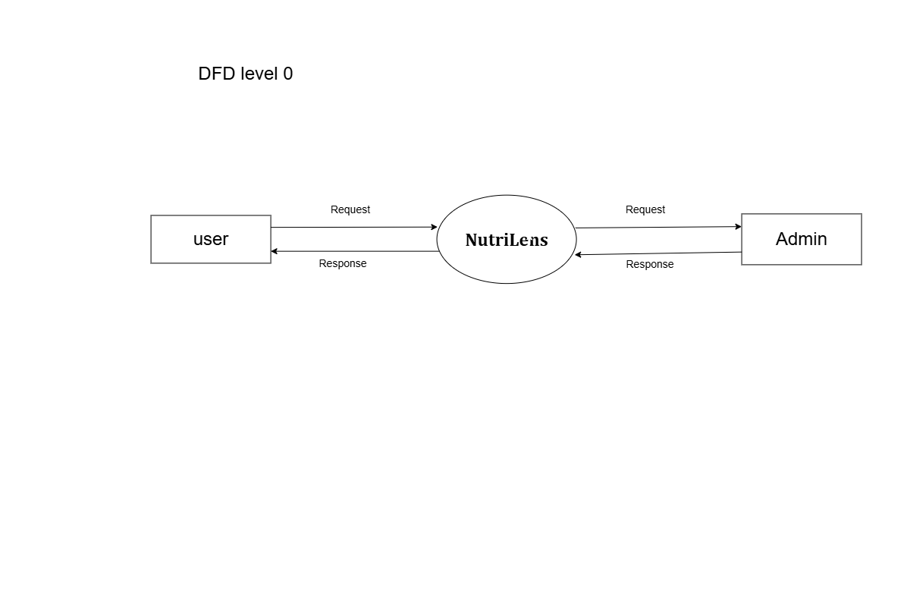
Figure 4.1: DFD Level 0

4.1.2 DFD LEVEL 1
The DFD Level 1 of the NutriLens system provides a more detailed representation of the internal processes involved in food-label analysis. The system is divided into several major processes through which the user's food-label image and health-profile information are processed.
First, the user uploads a food-label image to the system. The image is passed to the OCR Text Extraction process, where Tesseract OCR extracts the available text from the label. The extracted information is then passed to the Ingredient and Nutritional Analysis process, where the ingredients and nutritional information are examined.
The analyzed information is further processed by the Deception and Allergen Detection process to identify potentially misleading claims, harmful ingredients, and allergens. The system then performs Health Risk Scoring based on the identified nutritional and ingredient-related factors. A Health Score is generated from the analysis.
The user's selected health profile is also considered by the Personalized Recommendation process. Based on the analyzed food information and the user's health profile, the system generates relevant warnings and personalized insights. Finally, the processed results are displayed to the user through the User Dashboard.
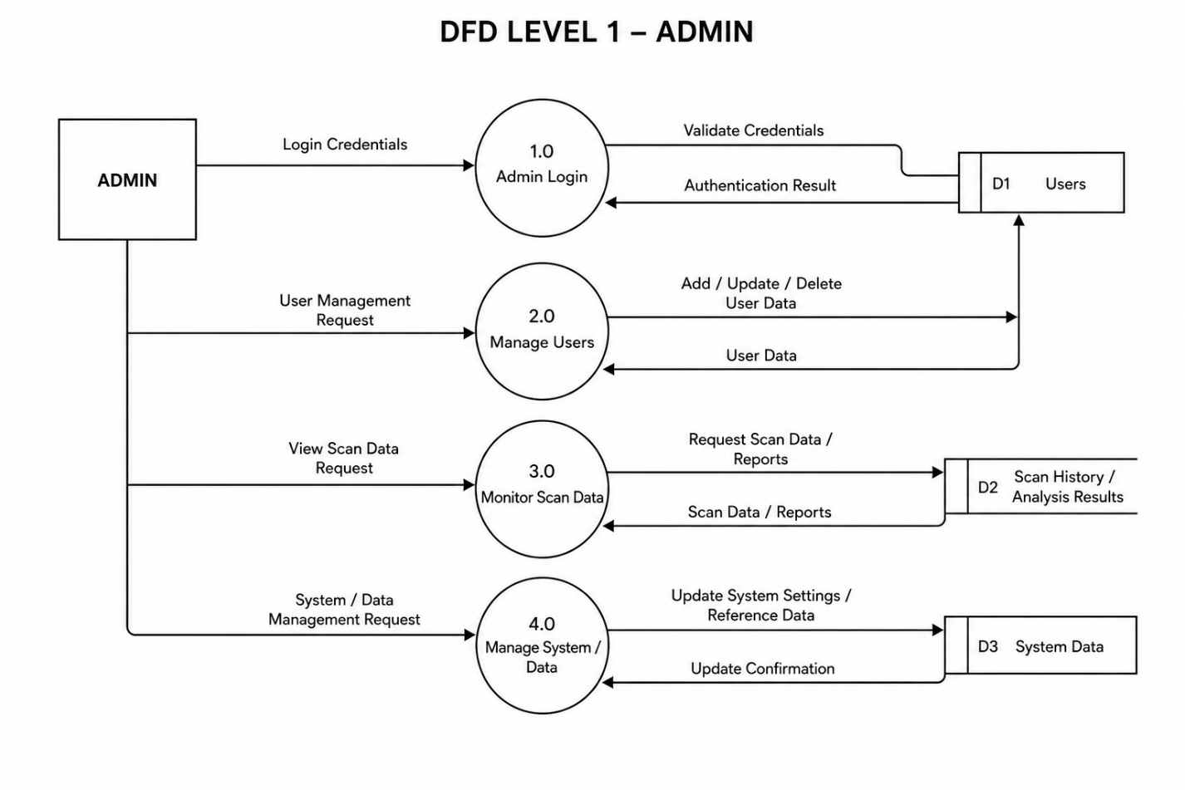
Figure 4.2: DFD Level 1

4.2 USE CASE DIAGRAM
The Use Case Diagram of the NutriLens system represents the interactions between the user and the major functions provided by the application. The primary actor of the system is the User, who interacts with NutriLens to analyze food-label information and obtain health-related results.
The user can register and log in to the system before accessing the available features. After logging in, the user can upload a food-label image for analysis. The system processes the uploaded image using OCR and extracts the available food-label information. The user can then view the analyzed ingredients and nutritional information along with detected risks and warnings.
The system also provides a Health Score based on the analyzed food information. The user can provide or select relevant health-profile information, which is considered while generating personalized insights. The user can view the final analysis and recommendations through the dashboard.
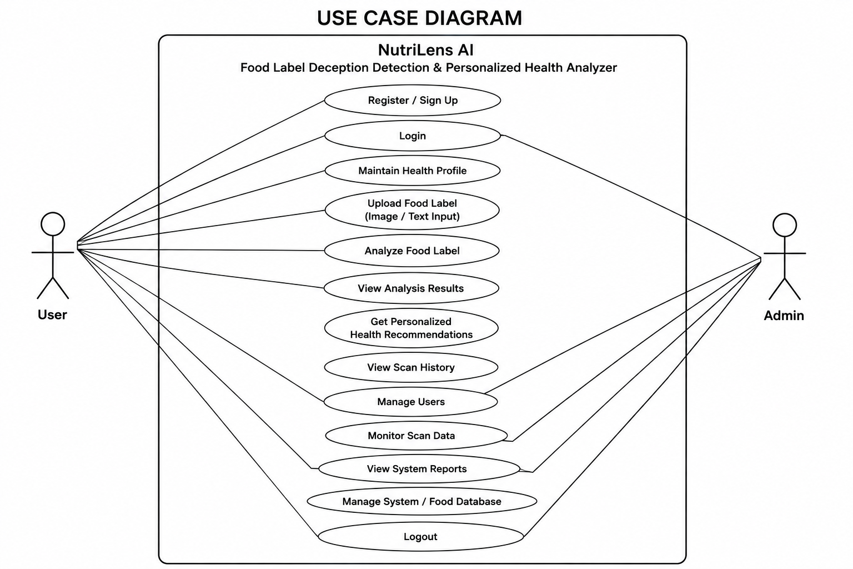
Figure 4.3: Use Case Diagram

4.3 CLASS DIAGRAM
The Class Diagram of the NutriLens system represents the main classes involved in the food-label analysis process and the relationships between them. It provides a structural view of the system by showing the important entities, their responsibilities, and how they interact with one another.
The User class represents the person using the NutriLens application. It manages user-related information and allows the user to upload a food-label image and provide the required health-profile information. The uploaded image is handled by the Image Upload functionality and is passed to the OCR processing component.
The OCR Processing component is responsible for extracting text from the uploaded food-label image. The extracted information is then processed by the Ingredient Analysis component, which examines the ingredients and available nutritional information.
The Risk Analysis component identifies potentially harmful ingredients, allergens, and other food-related concerns. The Deception Detection component examines the extracted label information for potentially misleading claims. The results from these analyses are used by the Health Score component to determine the overall health-related score of the analyzed product.
The Personalized Recommendation component uses the analysis results together with the user's selected health profile to generate relevant personalized insights. Finally, the Analysis Result represents the complete information presented to the user, including extracted information, identified risks, Health Score, and personalized recommendations.
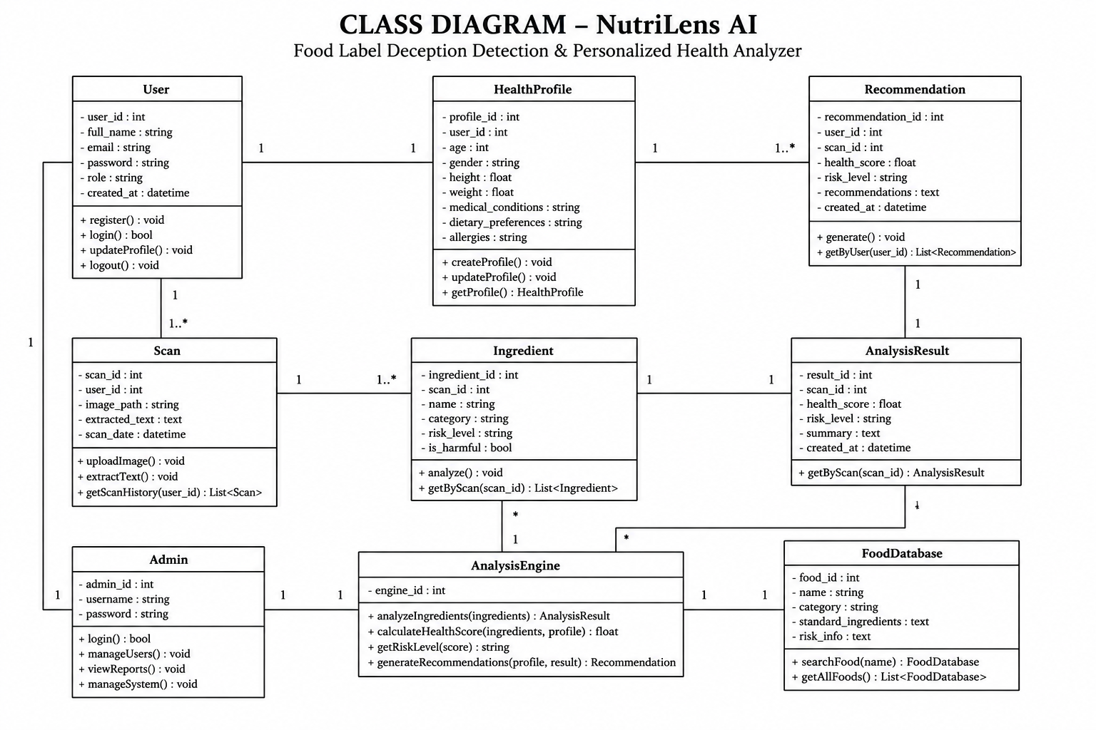
Figure 4.4: Class Diagram

4.4 STATE DIAGRAM
The State Diagram of the NutriLens system represents the different states through which the system passes during the food-label analysis process. It describes how the system changes from one state to another based on user actions and the completion of different processing stages.The process begins when the user opens the NutriLens application. The system enters the login or registration state, after which an authenticated user can access the main dashboard. The user then selects and uploads a food-label image, causing the system to move to the Image Upload state.After receiving the image, the system enters the OCR Processing state, where the text available on the food label is extracted. Once the text extraction is completed, the system moves to the Ingredient and Nutritional Analysis state. The extracted information is analyzed to identify relevant ingredients and nutritional factors.
The system then moves to the Risk and Deception Analysis state, where potentially harmful ingredients, allergens, nutritional concerns, and potentially misleading claims are examined. The identified factors are subsequently used for Health Score Generation.
After generating the Health Score, the system considers the user's selected health profile and enters the Personalized Insight state. The final analysis, warnings, Health Score, and personalized information are then displayed to the user through the dashboard.
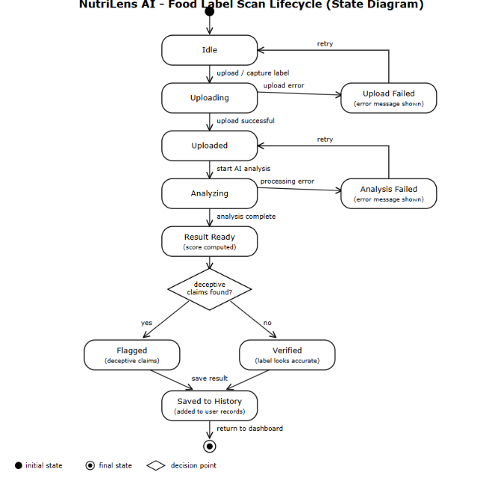
Figure 4.5: State Diagram

4.5 ACTIVITY DIAGRAM
The Activity Diagram of the NutriLens system represents the sequence of activities performed during the food-label analysis process. It shows how the system proceeds from user authentication and image upload to food-label processing, analysis, and presentation of the final results.
The process begins when the user opens the NutriLens application and logs in or registers. After successful authentication, the user accesses the dashboard and selects a food-label image for analysis. The system receives the uploaded image and begins the OCR process to extract the available text from the food label.
After text extraction, the system checks and processes the extracted ingredient and nutritional information. The ingredients are analyzed to identify potentially harmful ingredients and allergens, while the available label information is also examined for potentially misleading claims and nutritional concerns. The identified factors are then used to calculate the Health Score.The system subsequently considers the users selected health profile to generate relavent personalized insights.Finnally,the system the extracted information,health score,detected warnings,and personalize insights. Finally, the system displays the extracted information, Health Score, detected warnings, and personalized results on the dashboard. The activity ends after the user views the analysis
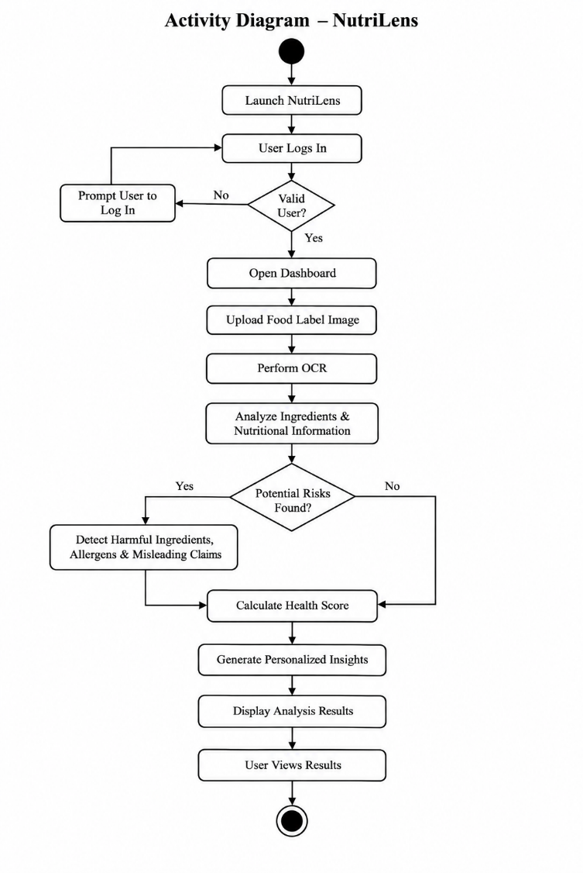
Figure 4.6: Activity Diagram

4.6 SEQUENCE DIAGRAM
The Sequence Diagram of the NutriLens system represents the sequence of interactions between the user and the different processes of the system during food-label analysis. It shows how the user's request is processed step by step and how the final analysis is returned.The sequence begins when the User logs into the NutriLens application and accesses the dashboard. The user then uploads a food-label image for analysis. The system receives the image and sends it to the OCR module, which extracts the text available on the food label. The extracted information is then passed to the Analysis module for ingredient and nutritional analysis.
The analysis module checks the extracted information for potentially harmful ingredients, allergens, nutritional concerns, and misleading claims. The identified factors are then used by the Health Score module to calculate the Health Score. The system also considers the user's selected health profile to generate personalized insights.
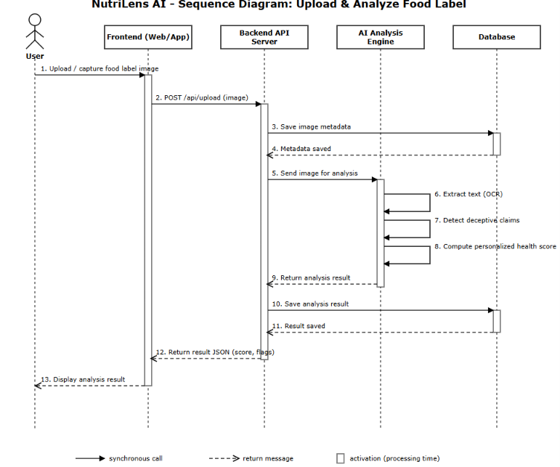
Finally, the system prepares the complete analysis and sends the results to the user's dashboard. The user can then view the extracted information, detected risks, Health Score, warnings, and personalized insights

Figure 4.7: Sequence Diagaram

CHAPTER 5

METHODOLOGY

5.1 Module Descriptions
Authentication and User Management Module
The Authentication and User Management Module manages user access to the NutriLens application. It provides registration and login functionality through which users can create an account and securely access the system. During registration, the user provides the required account information and creates login credentials. Registered users can log in to access the NutriLens dashboard and its food-label analysis features.
The module also manages the user's health-related profile information, which is used later for personalized food analysis and recommendations. After successful login, the user is directed to the dashboard where food-label analysis can be performed. User sessions are maintained to provide a continuous and personalized experience while using the application.

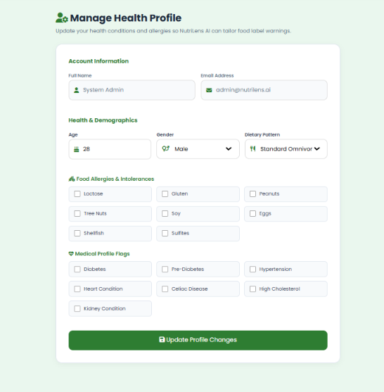

Figure 5.1: Profile
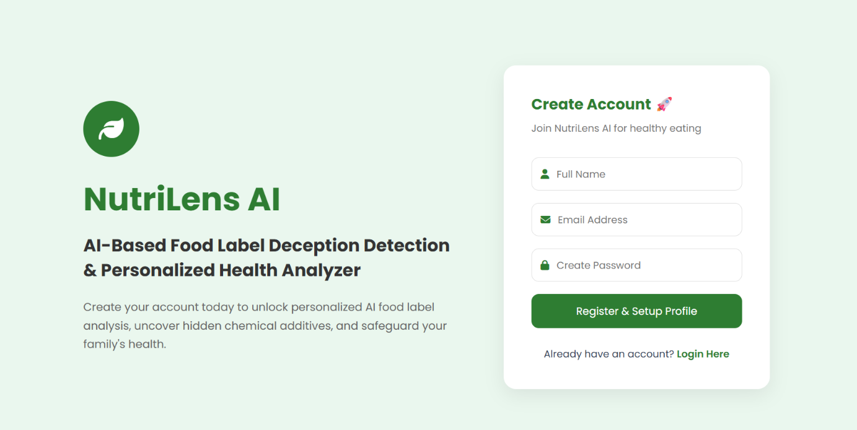
Figure 5.2: Login

Food Label Upload and OCR Module
The Food Label Upload and OCR Module is responsible for accepting food-label images from the user and extracting useful textual information from those images. It forms the initial stage of the NutriLens food-analysis process. Since food-label information is usually available in the form of printed text, the module converts the visual information present in the uploaded image into machine-readable text for further analysis.
The module provides an interface through which the user can select and upload a food-label image from their device. The uploaded image may contain the ingredient list, nutritional information, allergen information, product claims, and other relevant details printed on the package. Once the image is uploaded, it is passed to the OCR processing component.
NutriLens uses Tesseract Optical Character Recognition (OCR) to recognize and extract text from the uploaded food-label image. OCR technology enables the system to process information from an image without requiring the user to manually type the ingredient list. The extracted text is then made available to the subsequent analysis stage.
The OCR process generally involves receiving the uploaded image, preparing the image for text recognition, processing it through Tesseract OCR, and obtaining the extracted text. Image quality can influence the amount and accuracy of text that can be recognized. Clear and readable food-label images provide better input for the OCR process.
After extraction, the obtained text is passed to the Food Label Analysis and Risk Detection Module, where the ingredients and other food-related information are examined. Thus, this module acts as a bridge between the user's uploaded food-label image and the subsequent analysis processes.The module reduces the effort required from users when examining packaged food products. Instead of manually entering long ingredient lists or nutritional information, users can provide the available food-label image and allow the system to extract the relevant information automatically
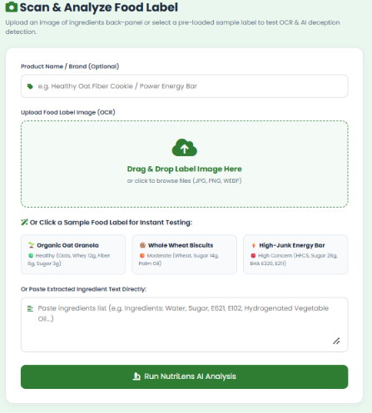
Figure 5.3: Upload

Food Label Analysis and Risk Detection Module
is the core analytical component of the NutriLens system. After the food-label image has been processed by the OCR module, the extracted text is passed to this module for detailed examination. The main purpose of this module is to identify important information from the food label and determine potential nutritional and health-related concerns.
The module analyzes the extracted ingredient information and nutritional details using predefined analysis rules and risk criteria. It examines the ingredients present in the product and identifies ingredients that may require attention. The system can also identify allergens and other potentially harmful ingredients based on the information available in its analysis criteria.
Another important function of this module is the identification of potentially misleading or deceptive food claims. Food labels may contain claims that give a positive impression about a product, while the ingredient information may indicate other characteristics that need to be considered. NutriLens compares the available label information with its predefined rules to identify such potentially misleading conditions.
The module also considers nutritional concerns present in the extracted food-label information. Factors such as sugar, salt, fats, and other relevant nutritional components can be examined according to the analysis criteria used by the system. The identified concerns are organized and presented to the user in a simple form rather than displaying only the raw OCR text.
All the analysis functions are grouped into this single module because they are part of the same food-label evaluation process. Ingredient analysis, nutritional analysis, harmful ingredient detection, allergen detection, and deception detection are not treated as separate modules. They collectively contribute to determining the potential risks associated with the analyzed food product.

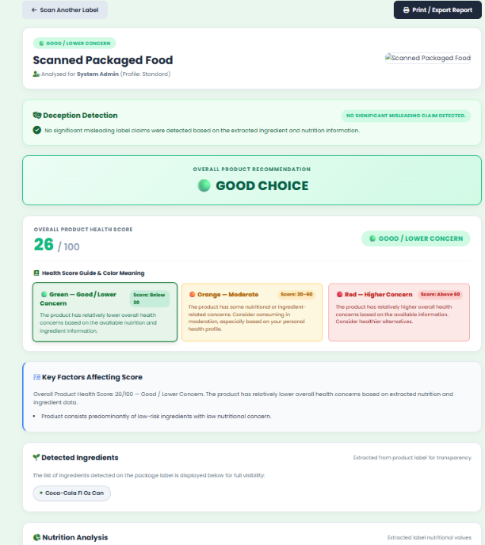
Figure 5.4: Analysis Result

Health Score and Personalized Recommendation Module
The Health Score and Personalized Recommendation Module is responsible for evaluating the overall health-related quality of the analyzed food product and presenting the result in a simple and understandable manner. The module uses the information obtained from the Food Label Analysis and Risk Detection Module to generate a Health Score and provide relevant health-related insights.
The Health Score is generated by considering the risks and nutritional concerns identified during food-label analysis. Instead of requiring the user to interpret every ingredient and warning individually, the system provides an overall score that gives a simplified indication of the product's health-related quality. The score is accompanied by the identified warnings so that users can understand the factors that contributed to the result.
The module also considers the health profile selected by the user. Different users may have different health-related concerns, and therefore the same food product may require different considerations for different users. NutriLens uses the available user profile information to provide more relevant warnings and personalized insights.
Based on the identified ingredients, nutritional concerns, risks, and user profile, the system generates appropriate recommendations and information. These recommendations are intended to help users understand the potential concerns associated with the analyzed product rather than simply presenting the raw analysis results.
Main Functions of the Module
- Health Risk Assessment – Evaluates the risks identified during food-label analysis.
- Health Score Generation – Generates an overall Health Score based on the analyzed factors.
- Health Profile Integration – Considers the user's selected health profile during the assessment.
- Personalized Warnings – Highlights concerns that may be relevant to the user's selected profile.
- Personalized Insights – Provides understandable information about the analyzed product.
- Recommendations – Provides relevant guidance based on the analysis results and user profile.

Figure 5.5: Score Result

Dashboard and Analysis History Module
The Dashboard and Analysis History Module provides the main interface through which users can view and access the information generated by the NutriLens system. After the food-label image is processed and analyzed, the results from the different stages of the system are presented to the user through the dashboard in an organized and understandable manner.
The dashboard brings together the important outputs of the food-label analysis process, including the extracted information, identified risks, warnings, Health Score, and personalized insights. This allows users to understand the analyzed food product without having to go through the individual processing stages performed by the system.
The module also provides access to the user's previous analysis results, where analysis history is implemented. The stored results allow users to review previously analyzed food products and refer to the information when required. This reduces the need to repeat an analysis when the user wants to check previously obtained results.
The dashboard is designed to provide a simple user interface where the user can navigate between the available functions of the application. It acts as the final presentation layer of the NutriLens system, converting the outputs generated by the backend analysis processes into information that can be easily viewed by the user.
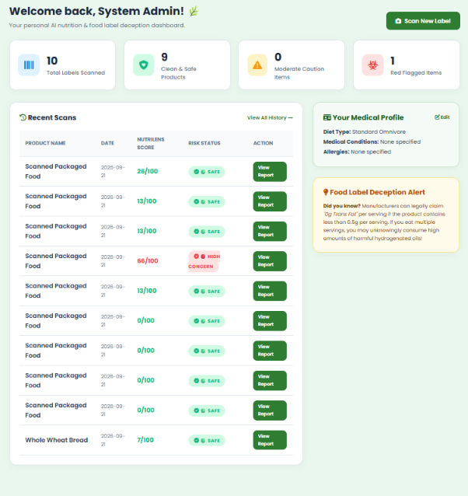

Figure 5.6: Dashoard

5.2 Algorithms

5.2.1 Food Label Text Extraction Algorithm
Describes the process of receiving the uploaded image, processing it through Tesseract OCR, and obtaining the extracted text.
Algorithm
Input: Food label image uploaded by the user.
Output: Extracted food label text or an unreadable image message.
Steps:
- Start.
- Accept the food label image uploaded by the user.
- Check whether the image is readable.
- Preprocess the image to improve text visibility.
- Apply Optical Character Recognition (OCR) using Tesseract OCR.
- Extract the text from the food label image.
- Check whether the extracted text contains readable food label information.
- If the text is unreadable, display “UNREADABLE / UPLOAD CLEARER IMAGE” and stop.
- If readable, identify the ingredient list and available nutritional information.
- Pass the extracted information to the food label analysis module.
- Display the extracted information.
- Stop.

5.2.2 Food Ingredient and Risk Analysis Algorithm
This algorithm represents the rule-based ingredient and nutritional risk analysis stage of NutriLens AI. The score is calculated for the overall product; individual ingredients are not displayed with separate risk levels.
Algorithm
Input: Extracted food ingredients and available nutritional information.
Output: Ingredient information and overall product risk score and risk level.
- Start.
- Receive the extracted food label text from the text extraction module.
- Identify the ingredient list and available nutritional values.
- Compare the identified ingredients with the stored ingredient risk database.
- Retrieve the available risk information for the identified ingredients.
- Analyze the nutritional values, including sugar, sodium, and fat, using predefined thresholds
- Calculate the overall product risk score based on the ingredient risk information and nutritional analysis rules.
- Classify the product based on its overall risk score:
  - 0–30: Safe
  - 31–60: Moderate
  - 61–100: Higher Risk
- Display the ingredient list, overall product risk score, and corresponding risk level.
- Stop.

5.2.3 Health Score and Personalized Analysis Algorithm
The Health Score and Personalized Analysis Algorithm describes how the identified risks and nutritional concerns are combined into an overall Health Score and how the selected health profile is used to generate personalized information.
Describes how the identified risks and nutritional factors are considered to generate the Health Score and how the user's selected health profile is used to provide personalized insights
Algorithm
Input: Food-label analysis findings and selected user health profile
Output: Health Score, warnings and personalized insights
1. Start
2. Receive the ingredient, nutritional, allergen, risk and deception analysis findings.
3. Determine the risk and nutritional factors covered by the implemented scoring rules.
4. Apply the predefined scoring logic to the identified factors.
5. Generate the overall Health Score for the analyzed product.
6. Receive the user-selected health profile.
7. Compare the identified concerns with the profile-related criteria implemented in NutriLens.
8. Generate relevant personalized warnings and insights.
9. Prepare the Health Score, warnings and personalized information for display.
10. Stop

5.3 Architecture
The architecture of NutriLens AI describes the overall structure of the system and explains how its different components interact to analyse food labels and provide personalized health suggestions. The system follows a modular architecture consisting of a user interface, food label text extraction, ingredient and nutritional risk analysis, personalized health analysis, and result presentation.
Users upload food label images through the interface, and the OCR module uses Tesseract to extract the text. The extracted information is processed by the analysis module, which identifies ingredients and evaluates nutritional values such as sugar, sodium, and fat using predefined rules and thresholds. The system then calculates the overall product risk score and assigns the appropriate risk category. The user's health profile is considered to generate personalized suggestions.
Finally, the dashboard displays the extracted information, risk assessment, and recommendations in a clear and understandable format. This modular architecture makes the system easier to develop, test, maintain, and improve..
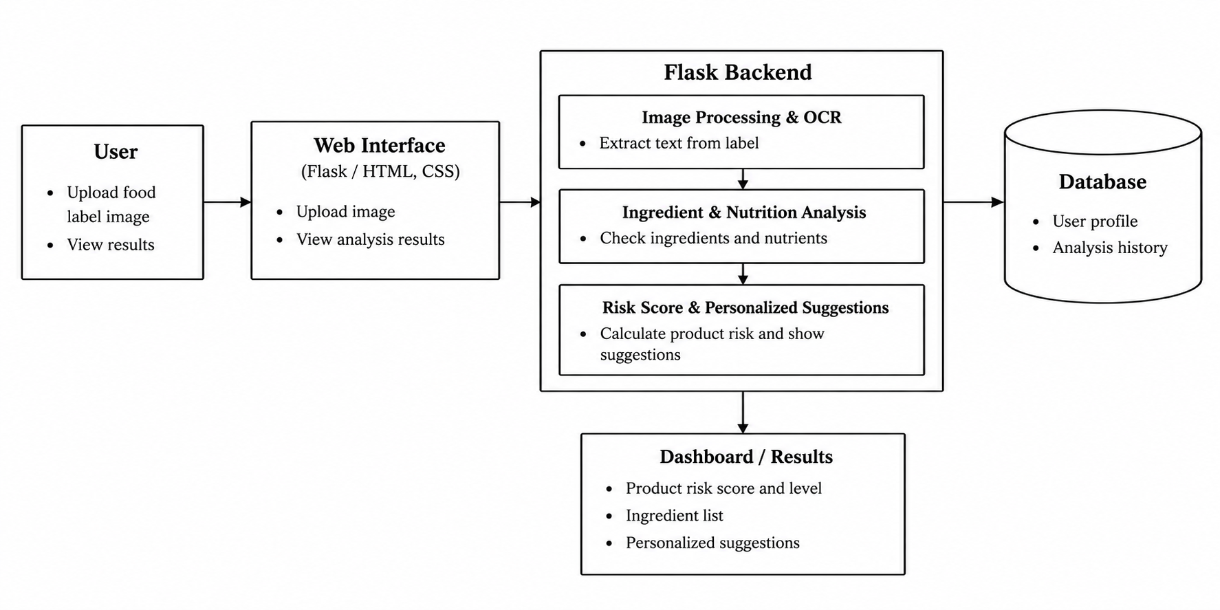
Figure 5.7: Architecture

5.4 Case Study
Illustrative Case Study: Packaged Food Label Analysis
Consider a packaged food product whose label contains an ingredient list, nutritional information, an allergen statement and a front-of-pack claim. A user selects the label image from the device and uploads it to NutriLens. The image is passed to the OCR component, which extracts the available text. The extracted information is then examined by the Food Label Analysis and Risk Detection Module. Ingredients are compared with the predefined risk and allergen criteria, nutritional concerns are considered, and relevant product claims are examined for potentially misleading conditions. The resulting factors are passed to the Health Score and Personalized Recommendation Module.
The user-selected health profile is then considered when presenting warnings and personalized insights. The dashboard presents the extracted information, identified concerns, Health Score and profile-related information in an organized form. This case study illustrates the complete flow of NutriLens from image input to final result presentation without requiring the user to manually type the ingredient list.

CHAPTER 6

IMPLEMENTATION DETAILS

6.1 IMPLEMENTATION PROCEDURES
The implementation of NutriLens involves the development and integration of different components required for food-label analysis. The system is implemented as a web application using Python, HTML, CSS, JavaScript, Tesseract OCR, and SQLite. The implementation follows a modular approach in which user management, image uploading, OCR-based text extraction, food-label analysis, health scoring, personalized recommendations, and dashboard presentation are integrated into a single application.
The implementation begins with the development of the user interface through which users can register, log in, upload food-label images, and view analysis results. The backend is responsible for processing user requests, handling uploaded images, performing OCR, analyzing extracted food-label information, generating the Health Score, and providing personalized results.

6.1.1 User Authentication Implementation
The User Authentication Implementation module provides secure access to the NutriLens AI application through user registration and login functionality. New users can create an account by providing the required details, while existing users can log in using their registered credentials. The system validates the entered information and allows access when the credentials are correct. This module helps manage user accounts and supports personalized features by associating each user's health profile and food analysis information with their account. It also helps prevent unauthorized access to user-specific data. Overall, the authentication module improves the security, organization, and usability of the application

6.1.2 Food Label Upload and OCR Implementation
The Food Label Upload and OCR Implementation module allows users to upload food label images for automatic text extraction. The system uses Optical Character Recognition (OCR) technology through the Tesseract OCR engine to extract text from the uploaded images. The extracted text includes ingredient lists and available nutritional information, which are passed to the subsequent analysis module. If the uploaded image contains unreadable text, the system displays an appropriate message asking the user to upload a clearer image. This module reduces the need for manual text entry and provides the necessary information for further ingredient analysis and nutritional risk assessment.

6.1.3 Food Label Analysis Implementation
Food Label Analysis Implementation is the process of analysing food label information to assess the nutritional risk of a product. In the NutriLens AI project, the uploaded food label image is processed using OCR to extract text and identify ingredients and nutritional values. The system compares the identified ingredients with stored risk information and evaluates sugar, sodium, and fat using predefined thresholds. Based on these rules, it calculates an overall product risk score and classifies the product as Safe, Moderate, or Higher Risk. The system also uses the user's health profile to provide personalized health suggestions. against the available risk criteria.The system identifies potentially harmful ingredients, specified allergens, nutritional concerns, and potentially misleading claims. The detected information is organized into analysis results that can be presented to the user.

6.1.4 Health Score and Personalized Analysis Implementation

Health Score and Personalized Analysis Implementation evaluates the overall nutritional risk of a food product and provides recommendations based on the user's health profile. In the NutriLens AI project, the system calculates an overall product risk score using ingredient risk information and nutritional values such as sugar, sodium, and fat. Based on the calculated score, the product is classified into three categories: Safe (0–30), Moderate (31–60), and Higher Risk (61–100).

The system also considers the user's health information, such as their dietary needs and health concerns, to provide personalized food suggestions. These suggestions help users understand whether a product is suitable for their needs and encourage healthier food choices. The implementation aims to make food label information easier to understand and support users in making informed dietary decisions.

6.1.5 Dashboard and Result Presentation
The Dashboard and Result Presentation module serves as the main interface for displaying the results generated by the NutriLens AI system. It presents the extracted food label text, identified ingredients, overall product risk score, and corresponding risk category in a clear and organized format. The risk category is displayed using colour indicators to help users easily distinguish between Safe (0–30), Moderate (31–60), and Higher Risk (61–100) products.
The dashboard also displays personalized health suggestions based on the user's health profile and the nutritional information obtained from the food label. These suggestions help users understand the potential nutritional concerns associated with a product and make better food choices according to their individual needs. If the uploaded image contains unreadable text, the system displays an appropriate message requesting a clearer image. By presenting the analysis results in a simple and understandable manner, this module improves user interaction, makes food label information easier to interpret, and supports informed dietary decisions.

6.2.2 Testing Strategy
Testing was carried out using food-label images representing the types of input the implemented system is designed to process. The test inputs included readable label images and images with varying text clarity so that the OCR stage and the downstream analysis flow could be observed under different input conditions. The testing also considered label content containing ingredients, nutritional information, allergen information and product claims relevant to the implemented analysis rules. No artificial accuracy value is reported here because the project does not use a statistically validated benchmark dataset for model training or classification.

6.2.1 Test Dataset and Test Inputs
Testing is an important stage in the development of NutriLens because the system needs to correctly process food-label images and generate meaningful analysis results. Testing was performed on the major functions of the application to identify errors and verify whether the implemented functions operate according to the intended requirements.
The testing process covers user authentication, image uploading, OCR text extraction, food-label analysis, risk detection, Health Score generation, personalized analysis, and result presentation.

6.2.3 Functional Testing

Functional Testing is a type of software testing used to verify whether an application works according to its specified requirements. It checks the functions of the system by providing inputs and comparing the actual results with the expected results.

In the NutriLens AI project, functional testing checks food label image uploads, text extraction using OCR, ingredient and nutritional risk analysis, overall product risk score calculation, risk classification, and personalized health suggestions. It also verifies whether appropriate error messages are displayed when an uploaded image is unreadable.

6.2.4 OCR Testing
OCR testing was performed to verify whether NutriLens could extract useful text from food-label images. Images containing ingredient lists and nutritional information were used as inputs. The extracted text was then examined to determine whether the important information required for further analysis was recognized.
OCR performance depends on factors such as image quality, text clarity, font size, orientation, and the visibility of the food-label information. Therefore, the extracted text may vary depending on the quality of the uploaded image.

6.2.5 Analysis Testing
Analysis testing was performed to verify whether the extracted information was correctly processed by the food-label analysis component. The system was tested using food-label information containing different ingredients and nutritional concerns.
The testing checked whether the system could identify relevant ingredients, harmful ingredients, allergens, nutritional concerns, and potentially misleading claims according to the predefined analysis criteria.

6.2.6 Health Score and Recommendation Testing
Health Score and Recommendation Testing is performed to verify whether the NutriLens AI system calculates the overall product risk score and displays the correct risk category according to the predefined thresholds. It checks whether scores from 0–30 are classified as Safe, 31–60 as Moderate, and 61–100 as Higher Risk. The testing also verifies whether personalized health suggestions are generated according to the user's health profile and the analysed food information. This ensures that the scoring rules and recommendation features work as intended.
6.2.7 Result Testing
Result Testing is performed to ensure that the NutriLens AI system displays the analysis results correctly and consistently. It verifies whether the extracted food label text, identified ingredients, overall product risk score, and corresponding risk category are presented clearly on the results page. The testing also checks whether the risk category matches the predefined score ranges: Safe (0–30), Moderate (31–60), and Higher Risk (61–100).
Additionally, it verifies whether personalized health suggestions are displayed according to the user's health profile and the analysed food information. When an uploaded image contains unreadable text, the system should display the appropriate message, “UNREADABLE / UPLOAD CLEARER IMAGE.” This testing helps ensure that users receive understandable results and that the application's output presentation functions as expected.

6.2.8 Overall Testing Result
The testing of the major NutriLens functions confirmed the intended workflow of the application. The system accepts food-label images, performs OCR-based text extraction, analyzes the extracted information, identifies relevant risks, generates a Health Score, and presents personalized information through the web interface.
However, OCR-based systems can be affected by the quality and readability of input images. Therefore, the accuracy of extracted information depends partly on the quality of the food-label image provided to the system.
Table 6.1: Functional Test Cases
Test Case | Input/Action | Expected Result
User Registration | Enter valid registration details | User account is created
User Login | Enter valid credentials | User is redirected to dashboard
Food Label Upload | Select a valid food-label image | Image is uploaded successfully
OCR Processing | Upload readable food-label image | Text is extracted from the image
Ingredient Analysis | Provide extracted ingredient text | Relevant ingredients are identified
Risk Detection | Analyze food-label information | Potential risks are identified
Allergen Detection | Provide label containing specified allergen | Allergen is identified
Deception Detection | Analyze relevant food claims | Potentially misleading claims are identified
Health Score | Complete food-label analysis | Health Score is generated
Personalized Analysis | Analyze using a selected health profile | Relevant personalized information is displayed
Result Display | Complete analysis | Results are displayed on the dashboard

CHAPTER 7

ADVANTAGES AND DISADVANTAGES

7.1 ADVANTAGES
NutriLens provides a convenient and simplified approach to understanding packaged food labels. Food labels usually contain a large amount of information, including ingredient names, nutritional values, allergens, and product claims, which may be difficult for ordinary users to interpret manually. NutriLens reduces this difficulty by allowing users to upload a food-label image and obtain an organized analysis of the available information. The use of OCR reduces manual data entry, while the integrated analysis process helps identify potentially harmful ingredients, allergens, nutritional concerns, and potentially misleading claims. The Health Score provides a simple overall indication of the analyzed product, while personalized insights allow the system to consider the user's selected health profile. By combining these functions in a single web application, NutriLens reduces the need to use multiple tools for examining food products and presents important information through an understandable interface.
Major advantages include:
- Easy Food Label Analysis: Simplifies the interpretation of complex food-label information.
- OCR-Based Extraction: Extracts text from uploaded food-label images using Tesseract OCR.
- Risk Detection: Identifies potentially harmful ingredients, allergens, and nutritional concerns.
- Deception Detection: Helps identify potentially misleading food-label claims according to predefined criteria.
- Health Score: Provides an overall score to make the analysis easier to understand.
- Personalized Insights: Uses the user's selected health profile to provide relevant information.
- Reduced Manual Effort: Reduces the need to manually read and enter lengthy ingredient lists.
- Unified Web Application: Combines image processing, analysis, scoring, and recommendations in one system.
- User-Friendly Results: Presents important findings through a simple dashboard.
- Support for Informed Choices: Helps users better understand packaged food products before making food choices.

7.2 DISADVANTAGES
Although NutriLens provides several useful features, the system also has certain limitations. The quality of the analysis depends partly on the quality and readability of the food-label image provided by the user because the system uses OCR to extract information from the image. Blurred, unclear, poorly positioned, or complex food-label images may affect text extraction. The analysis is also dependent on the predefined rules and criteria implemented in the system; therefore, an ingredient, risk, or claim that is not covered by the available criteria may not be identified. Similarly, the Health Score and personalized results depend on the information available from the food label and the health profile selected by the user. NutriLens is designed as an informational food-label analysis system and is not intended to replace professional medical or nutritional advice. The current system is also focused mainly on packaged food products containing readable printed labels and therefore has limitations when dealing with products without suitable labels.

CHAPTER 8

RESULT AND DISCUSSION

8.1 RESULT
NutriLens was implemented as a web-based food-label analysis application that integrates food-label image upload, OCR-based text extraction, ingredient and nutritional analysis, risk detection, Health Score generation, personalized insights, and result presentation. The developed system provides a unified interface through which users can submit a food-label image and obtain information about the analyzed product.
The implemented system successfully performs the major stages of the proposed workflow. The uploaded food-label image is processed using Tesseract OCR to extract available textual information. The extracted information is then analyzed using the predefined ingredient and risk criteria. Based on the analysis, the system identifies relevant concerns such as potentially harmful ingredients, allergens, nutritional concerns, and potentially misleading claims. The identified information is then used for Health Score generation and personalized analysis.
The results are presented through the NutriLens dashboard in a structured and understandable form. Users can view the Health Score together with the detected warnings and personalized information. This helps reduce the difficulty of interpreting lengthy ingredient lists and nutritional information manually.
The major results obtained from the implemented system are:
- Successful food-label image upload and processing.
- OCR-based extraction of food-label text using Tesseract.
- Identification of relevant ingredients and nutritional information.
- Detection of potentially harmful ingredients and allergens according to predefined criteria.
- Identification of potentially misleading claims according to implemented rules.
- Generation of a Health Score based on the analyzed information.
- Generation of personalized health-related insights.
- Presentation of analysis results through the web dashboard.
- Availability of analysis history where implemented.

8.2 DISCUSSION
The implementation of NutriLens demonstrates how OCR and rule-based food-label analysis can be combined to simplify the interpretation of packaged food information. The system provides a complete flow from food-label image input to the presentation of health-related analysis results. Instead of requiring users to manually examine every ingredient and nutritional value, the system extracts the available information and organizes the important findings.
One of the important outcomes of the project is the integration of multiple food-label analysis functions within a single application. Ingredient analysis, nutritional analysis, harmful ingredient detection, allergen detection, and deception detection are performed as part of the same analysis process. The Health Score and personalized analysis then convert these findings into information that can be more easily understood by the user.
The testing process also shows that the effectiveness of the system depends on the quality of the food-label image. Clear images provide more suitable input for OCR, while unclear or complex images can affect the extracted text and consequently influence the subsequent analysis. Similarly, the analysis results depend on the predefined criteria implemented within the system.
Overall, NutriLens achieves its primary objective of providing a unified web-based platform for simplifying food-label analysis. The system demonstrates the practical use of OCR, ingredient analysis, risk assessment, Health Score generation, and personalization in addressing the difficulties consumers may face while interpreting packaged food labels.
Overall, NutriLens achieves its primary objective of providing a unified web-based platform for simplifying food-label analysis and presenting complex food information in an understandable manner. The integration of OCR-based text extraction, ingredient and nutritional analysis, risk detection, Health Score generation, and personalized insights provides a complete workflow from image input to final result presentation. The system reduces the manual effort required to examine lengthy ingredient lists and helps users identify important information such as potentially harmful ingredients, allergens, nutritional concerns, and potentially misleading claims. The Health Score and personalized analysis further improve the readability of the results by presenting the identified information in a simplified form based on the user's selected health profile. The project also demonstrates the practical application of Python, Tesseract OCR, web technologies, and database management in developing a real-world food-label analysis solution. Although the performance of the system is influenced by factors such as image quality, OCR accuracy, and the predefined analysis criteria, the implemented application provides a useful foundation for automated food-label interpretation.

CHAPTER 9

CONCLUSION

9.1 Summary
NutriLens was developed as a web-based food-label analysis system to simplify the process of understanding information available on packaged food products. Food labels contain important details such as ingredients, nutritional information, allergens, and product claims, but this information can often be difficult for consumers to interpret. The proposed system addresses this difficulty by providing a unified platform for extracting and analyzing food-label information.
The system allows users to upload a food-label image, after which Tesseract OCR is used to extract the available textual information. The extracted information is then analyzed using predefined criteria to identify potentially harmful ingredients, allergens, nutritional concerns, and potentially misleading claims. The identified factors are used to generate a Health Score and provide relevant personalized insights based on the user's selected health profile.
NutriLens integrates authentication, food-label upload and OCR, food-label analysis and risk detection, Health Score and personalized recommendation, and dashboard and analysis history into a single application. This integration reduces the need for users to manually examine lengthy ingredient lists and helps present important food-related information in a simpler format.
The implementation demonstrates the practical use of Python, Tesseract OCR, HTML, CSS, JavaScript, and SQLite in developing a real-world food-label analysis application. Testing of the major system functions was carried out to verify the overall workflow, including image uploading, text extraction, food-label analysis, risk detection, Health Score generation, personalized analysis, and result presentation.
Overall, the developed NutriLens system provides a convenient approach for analyzing packaged food labels and presenting relevant information to users. Although the system has limitations related to OCR accuracy, image quality, predefined analysis criteria, and the availability of information on the food label, it provides a foundation that can be further improved and extended in future versions.

9.2 LIMITATIONS
The current implementation of NutriLens has certain limitations that may affect its performance and applicability. Since the system relies on OCR for extracting information from food-label images, the quality of the uploaded image can influence the accuracy of the extracted text. Labels that are blurred, unclear, poorly positioned, or contain complex layouts may not be recognized correctly.
The food-label analysis also depends on predefined ingredient and risk criteria implemented within the system. Therefore, ingredients, nutritional concerns, allergens, or claims that are not covered by the available criteria may not be identified. The Health Score is also based on the analysis rules implemented in the system and should be considered an informational assessment rather than professional medical or nutritional advice.
In addition, the current scope of the system is mainly focused on packaged food products that contain readable printed labels. The system cannot independently verify information that is not available or clearly visible on the provided label.

9.3 FUTURE SCOPE
The NutriLens system can be further enhanced by improving the accuracy and reliability of food-label analysis. Future versions can incorporate more advanced OCR techniques to improve text recognition from complex, low-quality, or differently oriented food-label images.
The ingredient and risk database can also be expanded to include a wider range of ingredients, allergens, nutritional factors, and food-related claims. More comprehensive nutritional analysis can be introduced to provide deeper information about the nutritional quality of a product.
Future development can also improve the personalization component by supporting a wider range of user health profiles and providing more detailed recommendations. Machine learning or other advanced AI techniques could be explored to improve ingredient classification, risk identification, and misleading-claim detection where appropriate.
The system can also be extended with additional food-product information sources and improved analysis history features. A mobile application could be developed in the future to make the system more convenient for users while purchasing packaged food products. These enhancements can improve the overall functionality, accuracy, and usability of NutriLens.

9.4 APPLICATIONS
NutriLens AI can be used to analyse food labels and help users understand the ingredients and nutritional information of packaged food products. It uses Optical Character Recognition (OCR) to extract text from uploaded food label images and analyses ingredients and nutritional values such as sugar, sodium, and fat to calculate an overall product risk score. The system helps identify potentially concerning ingredients and classifies products into different risk levels. It also provides personalized health suggestions based on the user's health profile and dietary needs. NutriLens AI can support healthier food selection, improve nutritional awareness, and help users make informed dietary decisions by presenting complex food label information in a simple and understandable format.
The major applications of NutriLens include:
- Consumer Food-Label Analysis: Helps users understand packaged food labels.
- Nutritional Awareness: Provides information about relevant nutritional concerns.
- Allergen Awareness: Helps identify specified allergens present in food-label information.
- Food Product Comparison: Can assist users in understanding differences between analyzed products.
- Health-Oriented Food Selection: Provides personalized information based on the selected health profile.
- Educational Use: Can be used to demonstrate the practical application of OCR and intelligent food-information analysis.
- Digital Food Information Services: Provides a foundation for developing more advanced food-analysis applications.

CHAPTER 10

APPENDICES

10.1 APPENDIX A – SAMPLE SOURCE CODE
The appendix contains selected portions of the source code used in the development of the NutriLens application. Only the important sections of the main modules are included to demonstrate the implementation of the system. The complete source code is maintained as part of the project files.
A.1
Login.html
{% extends "base.html" %}
{% block content %}
<div class="main-container">
<!-- Left Side -->
<div class="left-section">
<div class="logo-circle">
<i class="fa-solid fa-leaf"></i>
</div>
<h1>NutriLens AI</h1>
<h2>AI-Based Food Label Deception Detection & Personalized Health Analyzer</h2>
<p>
Scan food labels, detect misleading claims,
and receive personalized health recommendations
based on your medical profile.
</p>
</div>
<!-- Right Side -->
<div class="login-card">
<h2>Welcome Back 👋</h2>
<p>Please login to continue</p>
<form action="{{ url_for('login') }}" method="POST">
<div class="input-box">
<i class="fa-solid fa-envelope"></i>
<input type="email" name="email" placeholder="Email Address" required>
</div>
<div class="input-box">
<i class="fa-solid fa-lock"></i>
<input type="password" name="password" placeholder="Password" required>
</div>
<button type="submit" class="login-btn">
Login
</button>
</form>
<div class="bottom-text">
Don't have an account?
<a href="{{ url_for('signup') }}">Create Account</a>
</div>
</div>
</div>
{% endblock %}

base.html

<!DOCTYPE html>
<html lang="en">
<head>
<meta charset="UTF-8">
<meta name="viewport" content="width=device-width, initial-scale=1.0">
<title>NutriLens AI - Food Label Deception & Health Analyzer</title>

<link rel="stylesheet" href="{{ url_for('static', filename='css/style.css') }}">

<!-- Google Font -->
<link href="https://fonts.googleapis.com/css2?family=Poppins:wght@300;400;500;600;700;800&display=swap" rel="stylesheet">

<!-- Font Awesome -->
<link rel="stylesheet" href="https://cdnjs.cloudflare.com/ajax/libs/font-awesome/6.7.2/css/all.min.css">
</head>

<body>

{% if session.get('user_id') %}
<!-- Logged In Navbar -->
<nav class="navbar">
<a href="{{ url_for('dashboard') }}" class="nav-brand">
<div class="brand-icon">
<i class="fa-solid fa-leaf"></i>
</div>
<span class="brand-name">NutriLens AI</span>
</a>

<ul class="nav-links">
<li>
<a href="{{ url_for('dashboard') }}" class="{% if request.endpoint == 'dashboard' %}active{% endif %}">
<i class="fa-solid fa-chart-pie"></i> Dashboard
</a>
</li>
<li>
<a href="{{ url_for('upload_page') }}" class="{% if request.endpoint == 'upload_page' %}active{% endif %}">
<i class="fa-solid fa-expand"></i> Scan Label
</a>
</li>
<li>
<a href="{{ url_for('history_page') }}" class="{% if request.endpoint == 'history_page' %}active{% endif %}">
<i class="fa-solid fa-clock-rotate-left"></i> History
</a>
</li>
<li>
<a href="{{ url_for('profile_page') }}" class="{% if request.endpoint == 'profile_page' %}active{% endif %}">
<i class="fa-solid fa-user-gear"></i> Health Profile
</a>
</li>
{% if session.get('is_admin') %}
<li>
<a href="{{ url_for('admin_page') }}" class="{% if request.endpoint == 'admin_page' %}active{% endif %}">
<i class="fa-solid fa-shield-halved"></i> Admin
</a>
</li>
{% endif %}
<li class="user-badge">
<i class="fa-solid fa-circle-user"></i> {{ session.get('user_name') }}
</li>
<li>
<a href="{{ url_for('logout') }}" class="logout-btn">
<i class="fa-solid fa-right-from-bracket"></i> Logout
</a>
</li>
</ul>
</nav>
{% endif %}

<!-- Flash Messages -->
<div class="flash-messages">
{% with messages = get_flashed_messages(with_categories=true) %}
{% if messages %}
{% for category, message in messages %}
<div class="alert alert-{{ category }}">
<span><i class="fa-solid fa-circle-info"></i> {{ message }}</span>
</div>
{% endfor %}
{% endif %}
{% endwith %}
</div>

<!-- Main Content Block -->
{% block content %}
{% endblock %}

{% if session.get('user_id') %}
<footer class="footer">
<p>&copy; 2026 NutriLens AI – Food Label Deception Detection and Personalized Health Analyzer. All Rights Reserved.</p>
</footer>
{% endif %}

<script src="{{ url_for('static', filename='js/script.js') }}"></script>
</body>
</html>

Signup.html
{% extends "base.html" %}
{% block content %}
<div class="main-container">
<!-- Left Side -->
<div class="left-section">
<div class="logo-circle">
<i class="fa-solid fa-leaf"></i>
</div>
<h1>NutriLens AI</h1>
<h2>AI-Based Food Label Deception Detection & Personalized Health Analyzer</h2>
<p>
Create your account today to unlock personalized AI food label analysis,
uncover hidden chemical additives, and safeguard your family's health.
</p>
</div>
<!-- Right Side -->
<div class="login-card">
<h2>Create Account 🚀</h2>
<p>Join NutriLens AI for healthy eating</p>
<form action="{{ url_for('signup') }}" method="POST">
<div class="input-box">
<i class="fa-solid fa-user"></i>
<input type="text" name="name" placeholder="Full Name" required>
</div>
<div class="input-box">
<i class="fa-solid fa-envelope"></i>
<input type="email" name="email" placeholder="Email Address" required>
</div>
<div class="input-box">
<i class="fa-solid fa-lock"></i>
<input type="password" name="password" placeholder="Create Password" required>
</div>
<button type="submit" class="login-btn">
Register & Setup Profile
</button>
</form>
<div class="bottom-text">
Already have an account?
<a href="{{ url_for('login') }}">Login Here</a>
</div>
</div>
</div>
{% endblock %}

Upload.html

{% extends "base.html" %}

{% block content %}

<div class="app-container" style="max-width: 900px;">

<div class="page-header">
<h1 class="page-title"><i class="fa-solid fa-camera" style="color: #2E7D32;"></i> Scan & Analyze Food Label</h1>
<p class="page-subtitle">Upload an image of ingredients back-panel or select a pre-loaded sample label to test OCR & AI deception detection.</p>
</div>

<div class="card" style="padding: 35px;">

<form action="{{ url_for('analyze_upload') }}" method="POST" enctype="multipart/form-data">

<!-- Product Name Input -->
<div style="margin-bottom: 25px;">
<label style="font-weight: 600; font-size: 14px; margin-bottom: 8px; display: block;">Product Name / Brand (Optional)</label>
<div class="input-box">
<i class="fa-solid fa-tag"></i>
<input type="text" name="product_name" id="productNameInput" placeholder="e.g. Healthy Oat Fiber Cookie / Power Energy Bar">
</div>
</div>

<!-- Image Dropzone -->
<div style="margin-bottom: 25px;">
<label style="font-weight: 600; font-size: 14px; margin-bottom: 8px; display: block;">Upload Food Label Image (OCR)</label>

<div class="upload-dropzone" id="dropzone">
<i class="fa-solid fa-cloud-arrow-up upload-icon"></i>
<h3 style="color: #2E7D32; font-size: 18px; margin-bottom: 5px;">Drag & Drop Label Image Here</h3>
<p style="color: #64748B; font-size: 14px;">or click to browse files (JPG, PNG, WEBP)</p>
<p id="fileNameDisplay" style="margin-top: 10px; font-size: 14px; color: #2E7D32;"></p>
<input type="file" name="label_image" id="fileInput" accept="image/*" style="display: none;">
</div>
</div>

<!-- Sample Pre-loaded Labels Grid -->
<div style="margin-bottom: 25px;">
<div class="sample-labels-title"><i class="fa-solid fa-wand-magic-sparkles" style="color: #2E7D32;"></i> Or Click a Sample Food Label for Instant Testing:</div>
<div class="sample-grid">
<div class="sample-card" data-pname="Organic Oat Granola" data-text="Ingredients: Whole Grain Oats, Whey Protein 12g, Fiber 6g, Water, Honey 3g, Salt 50mg, Almonds, Natural Vanilla.">
<h4>🌱 Organic Oat Granola</h4>
<p>🟢 Healthy (Oats, Whey 12g, Fiber 6g, Sugar 3g)</p>
</div>

<div class="sample-card" data-pname="Whole Wheat Milk Biscuits" data-text="Ingredients: Whole Wheat Flour, Refined Wheat Flour, Sugar 14g, Palm Oil, Salt 220mg, Saturated Fat 3g, Milk Solids, Soy Lecithin.">
<h4>🍪 Whole Wheat Biscuits</h4>
<p>🟠 Moderate (Wheat, Sugar 14g, Palm Oil)</p>
</div>

<div class="sample-card" data-pname="High-Junk Energy Bar" data-text="Ingredients: High Fructose Corn Syrup, Sugar 28g, Palm Oil, Maltodextrin, Hydrogenated Oil, Sodium Benzoate E211, BHA E320, Tartrazine E102, Sodium 480mg.">
<h4>⚡ High-Junk Energy Bar</h4>
<p>🔴 High Concern (HFCS, Sugar 28g, BHA E320, E211)</p>
</div>
</div>
</div>

<!-- Fallback Text Input Area -->
<div style="margin-bottom: 30px;">
<label style="font-weight: 600; font-size: 14px; margin-bottom: 8px; display: block;">Or Paste Extracted Ingredient Text Directly:</label>
<div class="input-box" style="align-items: flex-start;">
<i class="fa-solid fa-align-left" style="margin-top: 5px;"></i>
<textarea name="manual_text" id="ingredientTextArea" rows="4" placeholder="Paste ingredients list (e.g. Ingredients: Water, Sugar, E621, E102, Hydrogenated Vegetable Oil...)"></textarea>
</div>
</div>

<button type="submit" class="login-btn" style="display: flex; align-items: center; justify-content: center; gap: 10px; font-size: 18px;">
<i class="fa-solid fa-microscope"></i> Run NutriLens AI Analysis
</button>

</form>

</div>

</div>

{% endblock %}

Profile.html

{% extends "base.html" %}

{% block content %}

<div class="app-container" style="max-width: 850px;">

<div class="page-header">
<h1 class="page-title"><i class="fa-solid fa-user-gear" style="color: #2E7D32;"></i> Manage Health Profile</h1>
<p class="page-subtitle">Update your health conditions and allergies so NutriLens AI can tailor food label warnings.</p>
</div>

<div class="card" style="padding: 35px;">
<form action="{{ url_for('profile_page') }}" method="POST">

<div style="margin-bottom: 25px;">
<h3 style="color: #2E7D32; font-size: 16px; margin-bottom: 15px;">Account Information</h3>
<div style="display: grid; grid-template-columns: 1fr 1fr; gap: 15px;">
<div>
<label style="font-weight: 600; font-size: 13px; color: #64748B;">Full Name</label>
<div class="input-box" style="background: #F8FAFC;">
<i class="fa-solid fa-user"></i>
<input type="text" value="{{ user.name }}" readonly style="color: #64748B;">
</div>
</div>
<div>
<label style="font-weight: 600; font-size: 13px; color: #64748B;">Email Address</label>
<div class="input-box" style="background: #F8FAFC;">
<i class="fa-solid fa-envelope"></i>
<input type="email" value="{{ user.email }}" readonly style="color: #64748B;">
</div>
</div>
</div>
</div>

<div style="margin-bottom: 25px;">
<h3 style="color: #2E7D32; font-size: 16px; margin-bottom: 15px;">Health & Demographics</h3>
<div style="display: grid; grid-template-columns: 1fr 1fr 1fr; gap: 15px;">
<div>
<label style="font-weight: 600; font-size: 13px;">Age</label>
<div class="input-box">
<i class="fa-solid fa-cake-candles"></i>
<input type="number" name="age" value="{{ profile.age if profile else 28 }}" required>
</div>
</div>
<div>
<label style="font-weight: 600; font-size: 13px;">Gender</label>
<div class="input-box">
<i class="fa-solid fa-venus-mars"></i>
<select name="gender">
<option value="Male" {% if profile and profile.gender == 'Male' %}selected{% endif %}>Male</option>
<option value="Female" {% if profile and profile.gender == 'Female' %}selected{% endif %}>Female</option>
<option value="Other" {% if profile and profile.gender == 'Other' %}selected{% endif %}>Other</option>
</select>
</div>
</div>
<div>
<label style="font-weight: 600; font-size: 13px;">Dietary Pattern</label>
<div class="input-box">
<i class="fa-solid fa-utensils"></i>
<select name="diet_type">
<option value="Standard Omnivore" {% if profile and profile.diet_type == 'Standard Omnivore' %}selected{% endif %}>Standard Omnivore</option>
<option value="Vegetarian" {% if profile and profile.diet_type == 'Vegetarian' %}selected{% endif %}>Vegetarian</option>
<option value="Vegan" {% if profile and profile.diet_type == 'Vegan' %}selected{% endif %}>Vegan</option>
<option value="Keto / Low-Carb" {% if profile and profile.diet_type == 'Keto / Low-Carb' %}selected{% endif %}>Keto / Low-Carb</option>
<option value="Halal" {% if profile and profile.diet_type == 'Halal' %}selected{% endif %}>Halal</option>
</select>
</div>
</div>
</div>
</div>

<!-- Food Allergies Checkboxes -->
<div style="margin-bottom: 25px;">
<label style="font-weight: 600; font-size: 15px; color: #2E7D32; display: block; margin-bottom: 10px;">
<i class="fa-solid fa-wheat-awn-circle-exclamation"></i> Food Allergies & Intolerances
</label>
<div class="checkbox-group">
{% set user_alg = (profile.allergies.split(',') if profile and profile.allergies else []) %}
{% for item in ['Lactose', 'Gluten', 'Peanuts', 'Tree Nuts', 'Soy', 'Eggs', 'Shellfish', 'Sulfites'] %}
<label class="custom-checkbox">
<input type="checkbox" name="allergies" value="{{ item }}" {% if item in user_alg %}checked{% endif %}>
<span>{{ item }}</span>
</label>
{% endfor %}
</div>
</div>

<!-- Medical Conditions Checkboxes -->
<div style="margin-bottom: 25px;">
<label style="font-weight: 600; font-size: 15px; color: #2E7D32; display: block; margin-bottom: 10px;">
<i class="fa-solid fa-heart-pulse"></i> Medical Profile Flags
</label>
<div class="checkbox-group">
{% set user_med = (profile.medical_conditions.split(',') if profile and profile.medical_conditions else []) %}
{% for cond in ['Diabetes', 'Pre-Diabetes', 'Hypertension', 'Heart Condition', 'Celiac Disease', 'High Cholesterol', 'Kidney Condition'] %}
<label class="custom-checkbox">
<input type="checkbox" name="medical_conditions" value="{{ cond }}" {% if cond in user_med %}checked{% endif %}>
<span>{{ cond }}</span>
</label>
{% endfor %}
</div>
</div>

<button type="submit" class="login-btn" style="margin-top: 15px;">
<i class="fa-solid fa-floppy-disk"></i> Update Profile Changes
</button>

</form>
</div>

</div>

{% endblock %}

CHAPTER 11

REFERENCES
1. Abdelmageed, L. N., Fathy, B. E., Ali, R. E., and Borham, M. L. (2024). Enhancing Dietary Guidance with Machine Learning: A Stacking Classifier Approach to Personalized Nutrition. Proceedings of the 2024 International Mobile, Intelligent, and Ubiquitous Computing Conference (MIUCC), pp. 164–170.
2. Amoggha, C. H., Padmapriya, R., and Ajina, A. (2025). FoodVisor: An AI-powered food label analysis system for ingredient interpretation and personalized dietary recommendations. Research Square preprint.
3. An, R., Shi, Y., Shen, J., Bullard, T., Liu, G., Yang, Q., Chen, N., and Cao, L. (2021). Effect of front-of-package nutrition labeling on food purchases: A systematic review. Public Health, 191, 59–67.
4. Anitha, E., and Banu, A. B. (2026). Biometrically anchored and psychological states aware deep learning for enhanced personalized food recommendation systems. Scientific Reports.
5. Bossard, L., Guillaumin, M., and Van Gool, L. (2014). Food-101 – Mining discriminative components with random forests. In Computer Vision – ECCV 2014, Lecture Notes in Computer Science, pp. 446–461.
6. Cunha, C., Rebelo, J., and Duarte, R. (2024). Unveiling neural networks for personalized diet recommendations. Procedia Computer Science, 241, 606–611.
7. Ganderats-Fuentes, M., and Morgan, S. (2023). Front-of-package nutrition labeling and its impact on food industry practices: A systematic review of the evidence. Nutrients, 15(11), 2630.
8. Gawade, J. S., Patale, S., Sakhare, O., Shaikh, R., and Bhivare, S. (2026). Package Food Health Analyzer using Ingredients Intelligence. Journal of Integrated Science and Technology, 13(1), Article 1008.
9. Harrington, R. A., Adhikari, V., Rayner, M., and Scarborough, P. (2019). Nutrient composition databases in the age of big data: foodDB, a comprehensive, real-time database infrastructure. BMJ Open, 9(6), e026652.
10. Jiang, L., Qiu, B., Liu, X., Huang, C., and Lin, K. (2020). DeepFood: Food image analysis and dietary assessment via deep model. IEEE Access, 8, 47477–47489.
11. Karamanlı Aydın, S., Ali, R. H., Faiz, S., and Khan, T. A. (2025). An integrated AI framework for personalized nutrition using machine learning and natural language processing for dietary recommendations. Applied Sciences, 15(17), 9283.
12. Katankar, V., Patle, L., Deshmukh, H., and Sonone, A. (2025). Food Label Scanner & Personalized Supplement Recommendation System. International Journal on Advanced Electrical and Computer Engineering, 14(1), 200–207.
13. Lei, Z., Yang, S., Liu, H., Aslam, S., Liu, J., Tekle, H., Bugingo, E., and Zhang, D. (2018). Mining of nutritional ingredients in food for disease analysis. IEEE Access, 6, 52766–52778.
14. Mezgec, S., and Seljak, B. K. (2017). NutriNet: A deep learning food and drink image recognition system for dietary assessment. Nutrients, 9(7), 657.
15. Puthran, R., Bhandary, J., Shetty, A. P., Sujith, S., and Shetty, S. V. (2025). A Machine Learning-Based Approach for Personalized Nutrition Recommendation Based on Health Profile and Dietary Preferences. 2025 Global Conference on Information Technology and Communication Networks (GITCON).
16. Qiao, G., Zhang, D., Zhang, N., Shen, X., Jiao, X., Lu, W., Fan, D., Zhao, J., Zhang, H., Chen, W., and Zhu, J. (2025). Food recommendation towards personalized wellbeing. Trends in Food Science & Technology, 156, 104877.
17. Rohini, B., Pavuluri, D. M., Kumar, L. N., Soorya, V., and Aravinth, J. (2021). A framework to identify allergen and nutrient content in fruits and packaged food using deep learning and OCR. 2021 7th International Conference on Advanced Computing and Communication Systems (ICACCS), pp. 72–77.
18. Sharma, J., Aher, J., Kalsariya, T., Nyaykare, K., Darwade, A., and Makwana, F. (2024). SafeBite Fruit Scanner: A New Era in Fruit Quality and Safety Analysis. International Journal of Innovative Research in Technology, 10(12), 1206–1214.
19. Smith, R. (2007). An overview of the Tesseract OCR engine. Proceedings of the Ninth International Conference on Document Analysis and Recognition (ICDAR), pp. 629–633.
20. Sweidan, S., Askar, S. S., Abouhawwash, M., and Badr, E. (2025). A hybrid healthy diet recommender system based on machine learning techniques. Computers in Biology and Medicine, 184, 109389.
21. Tarannum, S., Jalal, M. S., and Huda, M. N. (2024). HALALCheck: A multi-faceted approach for intelligent Halal packaged food recognition and analysis. IEEE Access, 12, 28462–28474.
22. Thames, Q., Karpur, A., Norris, W., Xia, F., Panait, L., Weyand, T., and Sim, J. (2021). Nutrition5k: Towards automatic nutritional understanding of generic food. Proceedings of the IEEE/CVF Conference on Computer Vision and Pattern Recognition (CVPR), pp. 8903–8911.
23. Toledo, R. Y., Alzahrani, A. A., and Martínez, L. (2019). A food recommender system considering nutritional information and user preferences. IEEE Access, 7, 96695–96711.
24. Tsolakidis, D., Gymnopoulos, L. P., and Dimitropoulos, K. (2024). Artificial intelligence and machine learning technologies for personalized nutrition: A review. Informatics, 11(3), 62.
25. Yera Toledo, R., Alzahrani, A. A., and Martínez, L. (2019). A food recommender system considering nutritional information and user preferences. IEEE Access, 7, 96695–96711.

