- AI HEALTHCARE



NutriLens
Food Label Deception Detection and
Personalized Health Analyzer

W E B A P P L I C A T I O N

GUIDED BY

Presented By
MARGERAT HELAN SAJI MLM25MCA-2039 MANGALAM COLLEGE OF ENGINEERING
Mr.ELDHOSE K PAUL ASSOCIATE PROFESSOR MANGALAM COLLEGE OF ENGINEERING

2

INTRODUCTION

Introduction: NutriLens is a web-based application developed to analyze packaged food
labels using AI and OCR.
Background: Many consumers find food labels difficult to understand due to complex ingredients, nutritional information, and misleading claims.
Purpose: The system simplifies this information by identifying ingredients, nutrients, allergens, and potentially misleading claims, and provides personalized analysis based on the user’s health and dietary needs.
Importance: The project improves food-label awareness and helps users make healthier, safer, and more informed food choices.

3
ABSTRACT

NutriLens is a web-based application designed to help users understand and analyze packaged food labels. It addresses the problem of complex nutritional information, unfamiliar ingredients, allergens, and potentially misleading food claims. The proposed system uses OCR and AI-based analysis to extract and analyze food-label information and provide personalized results based on the user’s health and dietary requirements. The system is developed using Python, Flask, OCR, HTML, CSS, JavaScript, and a database. The expected outcome is to simplify food-label interpretation, improve health awareness, and help users make safer and more informed food choices.

P R O B L E M D E F I N I T I O N 4

Reading a food label shouldn’t require a chemistry degree
Consumers routinely struggle to interpret packaged food labels, leaving harmful ingredients and misleading claims unnoticed.








Hidden & Misleading
Claims

Marketing terms like “low fat” or “natural” often mask unhealthy formulations.

Unnoticed Allergens

Allergens and preservatives are buried in dense ingredient text, easy to miss.

Complex Nutrition Data

Nutrition panels are hard to interpret without domain expertise.

No Personalized
Guidance

Existing tools rarely tailor risk warnings to a user’s own health profile.














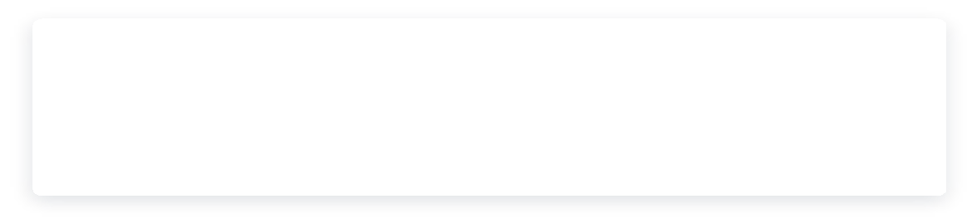
O B J E C T I V E S 5

What NutriLens sets out to achieve ?

Main objective: to build an AI-powered web application that detects deceptive food-label claims and gives personalized health insights.
Extract label text automatically using OCR (Tesseract) Detect deceptive claims and harmful ingredients

Generate an objective, easy-to-read Health Score Personalize insights to individual health conditions

Assess nutritional quality and potential health risks Deliver everything through one unified web application

EXPECTED OUTCOME

BENEFITS TO USERS
- Understand labels without nutrition expertise
- Avoid allergens and misleading claims
- Make safer, more informed food choices
A single web platform that turns a food-label photo into clear flags, a health score and personalized advice.

E X I S T I N G S Y S T E M 6

What current research & tools already do?

Reviewed literature applies OCR and ML separately to food labels, but stops short of a unified experience.

OCR-based ingredient extraction (e.g. Tesseract OCR) studied in isolation

Food recognition / classification models limited to product categories

Nutrition analysis systems that score labels but ignore user
context
Dietary recommendation studies decoupled from label scanning





CURRENT
WORKFLOW ( MANUAL)
Read the printed label
→ Look up unfamiliar ingredients → Judge against own health needs → Decide with partial information

K E Y G A P

No single platform integrates OCR, deception detection, health-risk scoring and personalized recommendations together.

P R O P O S E D S Y S T E M 7

NutriLens AI: one integrated pipeline

A single AI-powered web application that unifies extraction, detection, scoring and personalization.

01

Capture / Upload

User scans or uploads a food label image

02

OCR Extraction

Tesseract OCR reads ingredients & nutrition text

03

AI Analysis

ML models flag deception, allergens & risks

04

Health Score

A composite score summarizes label quality

05

Personalized
Advice

Recommendations tailored to user profile








HOW IT SOLVES THE PROBLEM
Reads the label for the user, flags misleading claims and allergens, and scores the product against their own health profile.
KEY FEATURES
OCR extraction, deception and allergen detection, health score, personalized advice, user dashboard and admin panel.
IMPROVEMENT OVER EXISTING SYSTEMS
One unified, browser-based platform instead of separate OCR, classification and scoring tools that ignore user context.

S C O P E 8

Boundaries of the system

W I T H I N S C O P E T A R G E T U S E R S

Packaged/processed food label images (photo or upload)
Health-conscious consumers

Patients with dietary restrictions
OCR-based ingredient & nutrition text extraction

Nutrition-aware families
Rule-based & risk detection

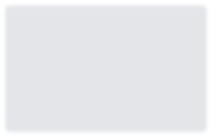

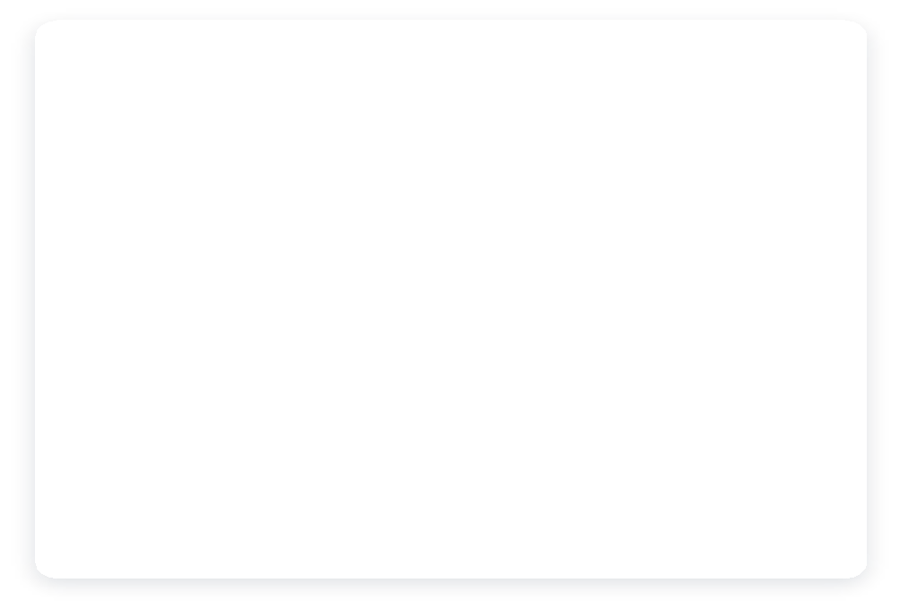
APPLICATION AREAS
FUTURE APPLICATIONS
Consumer health and nutrition, clinical diet support, fitness and wellness, food-label
education
Barcode and mobile scanning, restaurant menu analysis, multilingual labels
Personalized recommendations from user health profile

Web-based access — no installation required
Fitness & wellness enthusiasts

Excludes: fresh/loose product without printed labels, and real-time restaurant menu analysis.

Literature Review
Title & Year | Author & Publication | Algorithm Used | Feature Extracted / Methodology | Performance Metric | Result / Findings
DeepFood: Food Image Analysis & Dietary Assessment via Deep Model (2020) | Jiang et al., IEEE Access | Faster R-CNN with VGG-16 | Food detection and calorie / fat / carb / protein estimation from meal images | mAP on UEC-FOOD100/256 | Multi-item detection and nutrient reports; low mAP under limited training; meal images, not packaged-label ingredients
FoodVisor: AI-Powered Food Label Analysis for Ingredient Interpretation (2025) | Amoggha, Padmapriya & Ajina, Research Square | RAG + fine-tuned LLaMA 2 (QLoRA/PEFT) | OCR + RAG (FAISS) + fine-tuned LLaMA 2; AES-128 encrypted health profiles | Accuracy: 98.99% | Personalized, condition-aware verdicts with regulator-cited explanations; heavy hybrid LLM pipeline
Package Food Health Analyzer using Ingredients Intelligence (2026) | Gawade et al., HBRP Publication | OCR + ML classification | Ingredient classification (category, processing level, health impact); health score | Not reported | Disease-based recommendations (diabetes, hypertension); OCR accuracy drops on low-res / decorative fonts
Food Label Scanner & Personalized Supplement Recommendation System (2025) | Katankar et al., Int. J. Adv. Electrical & Computer Eng. | Rule-based algorithm | Barcode scan via OpenFoodFacts / USDA APIs; health-score algorithm; supplement engine | Not reported | Real-time nutrient data and supplement suggestions; relies on barcode / API data, no ingredient-level toxicity check
A Framework to Identify Allergen & Nutrient Content in Fruits & Packaged Food using DL and OCR (2021) | Rohini et al., IEEE ICACCS | VGG-16 CNN + Tesseract OCR | VGG-16 for fruit / veg classification + Pytesseract OCR for packaged-food allergens | Accuracy: 97.37% (fine-tuned) | Cloud-deployed allergen detection; allergen-only, no disease personalization; limited to 100 label images
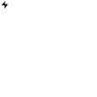
How NutriLens AI Improves on Existing Systems
Unifies OCR label extraction + AI ingredient-level safety analysis + disease-aware personalization + a single health score — combining the strengths of DeepFood, FoodVisor,
Ingredient Intelligence, Supplement Recommendation and Allergen-OCR systems into one lightweight web platform.
9











T E C H N O L O G Y S T A C K 10

Built with a modern, reliable stack

HTML CSS JavaScript Python Tesseract OCR



SQLite GitHub VS Code

S Y S T E M R E Q U I R E M E N T S 11

Software & hardware requirements

Minimum configuration needed to build, run and use NutriLens.

SOFTWARE REQUIREMENTS HARDWARE REQUIREMENTS
Operating system Windows 10 / 11 Processor Intel Core i3 or above

Language Python 3

RAM 4 GB minimum (8 GB recommended)

Web framework Flask
Storage 500 MB free disk space

OCR engine Tesseract OCR
Database SQLite

Camera Webcam / phone camera for label capture

Display 1366 × 768 or higher
Front end HTML, CSS, JavaScript

Tools VS Code, GitHub
Network Internet access for browser use

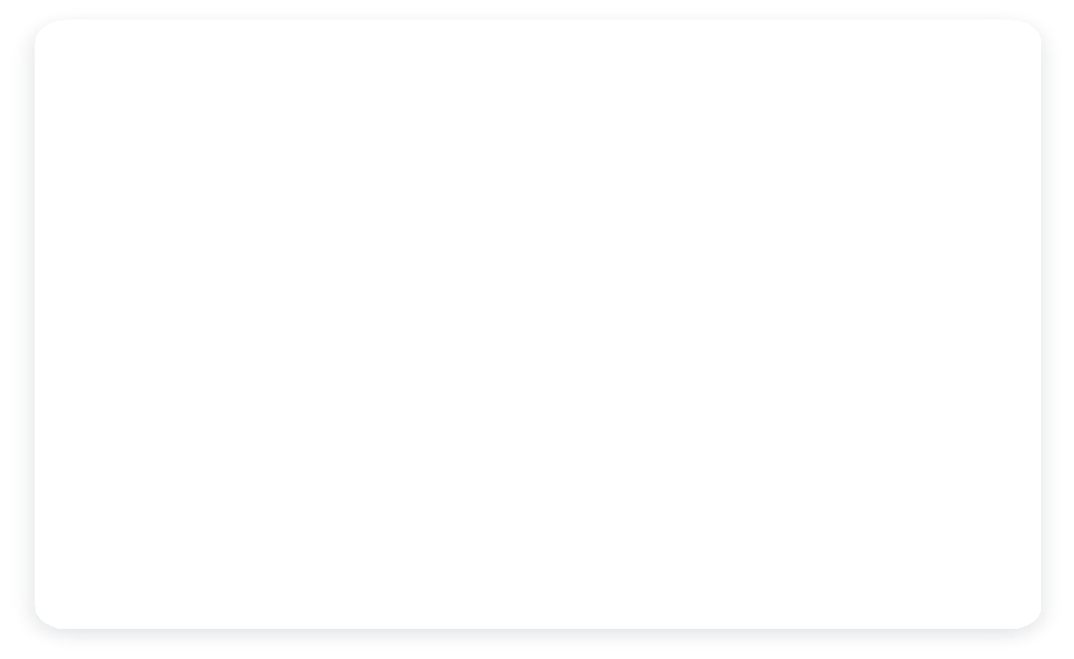
Browser Chrome / Edge / Firefox

F E A S I B I L I T Y S T U D Y 12

Is NutriLens AI viable to build?







Technical

Built entirely on open-source tools — Python, Tesseract OCR, and standard ML libraries — requiring no proprietary infrastructure.

Economic

Zero licensing cost using free/open-source stack; cloud hosting keeps deployment expenses minimal for an academic project.

Operational

Simple web interface needs no special training; runs on any device with a browser and camera.


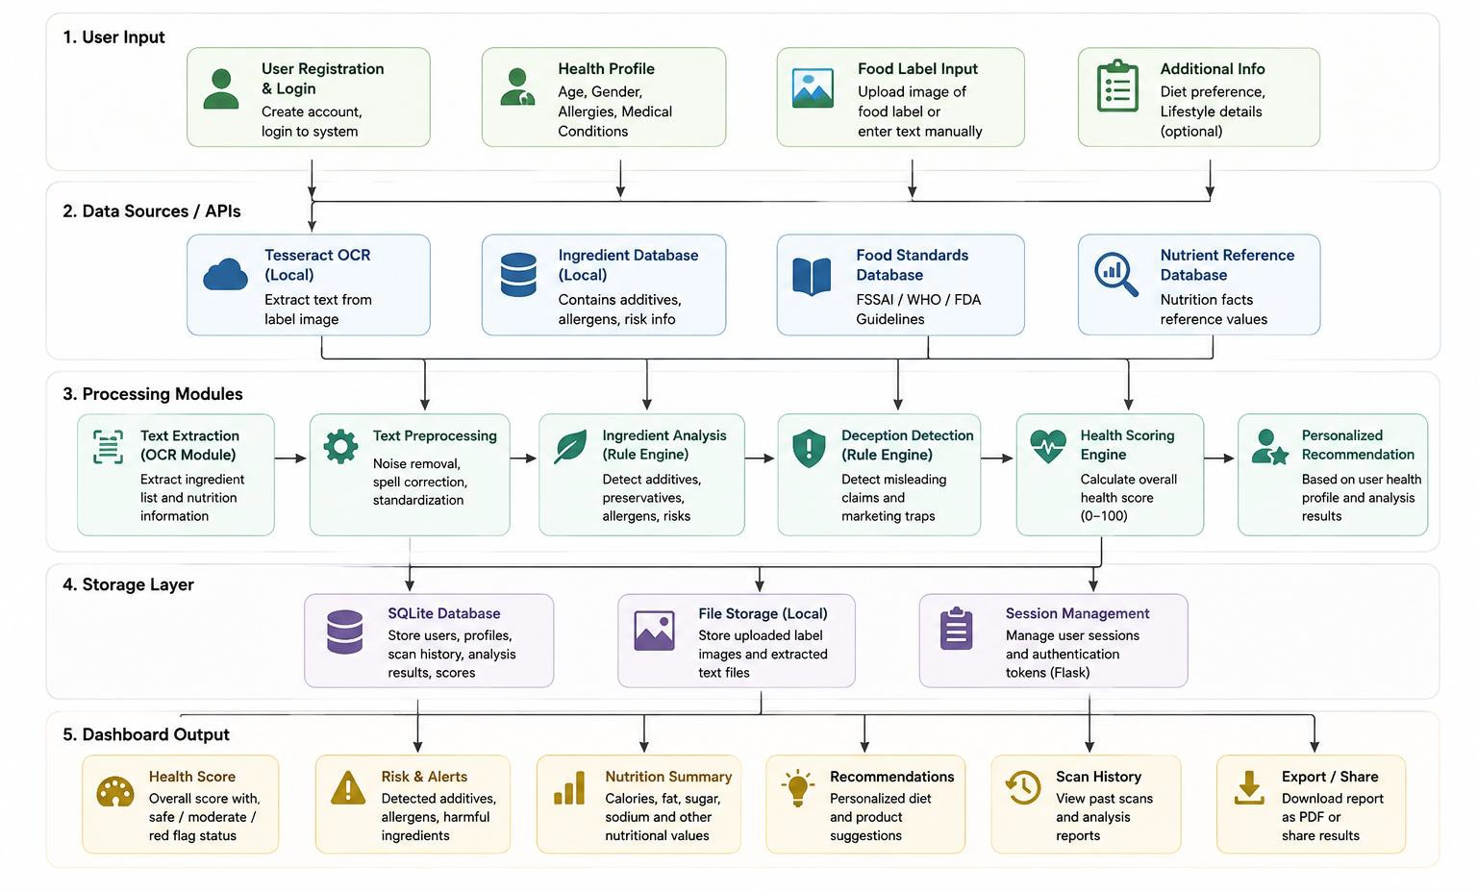
H O W I T A L L C O N N E C T S
System Architecture

13

14

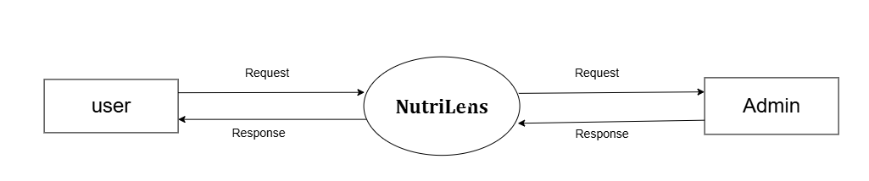
DFD level 0

Level 1 admin

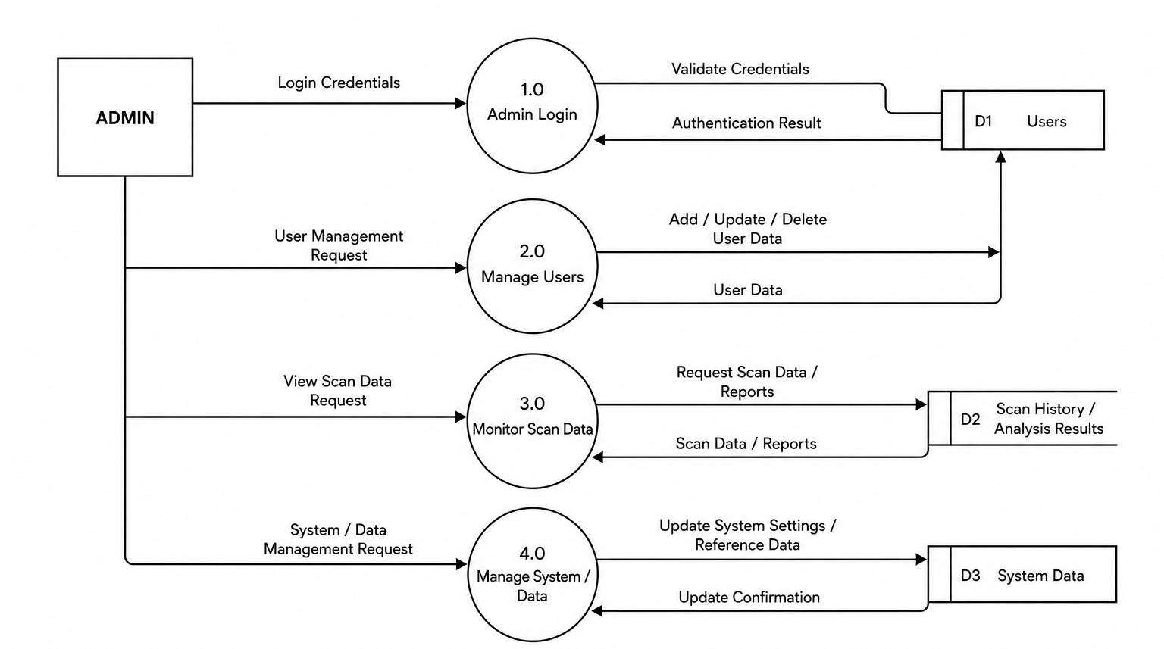


15

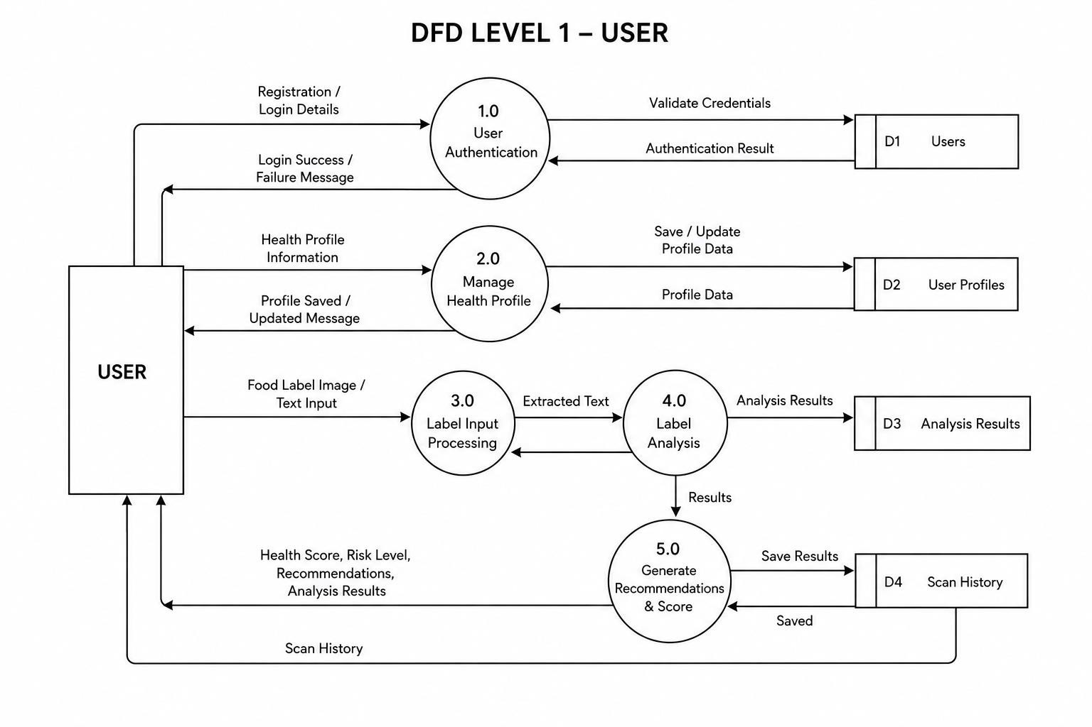





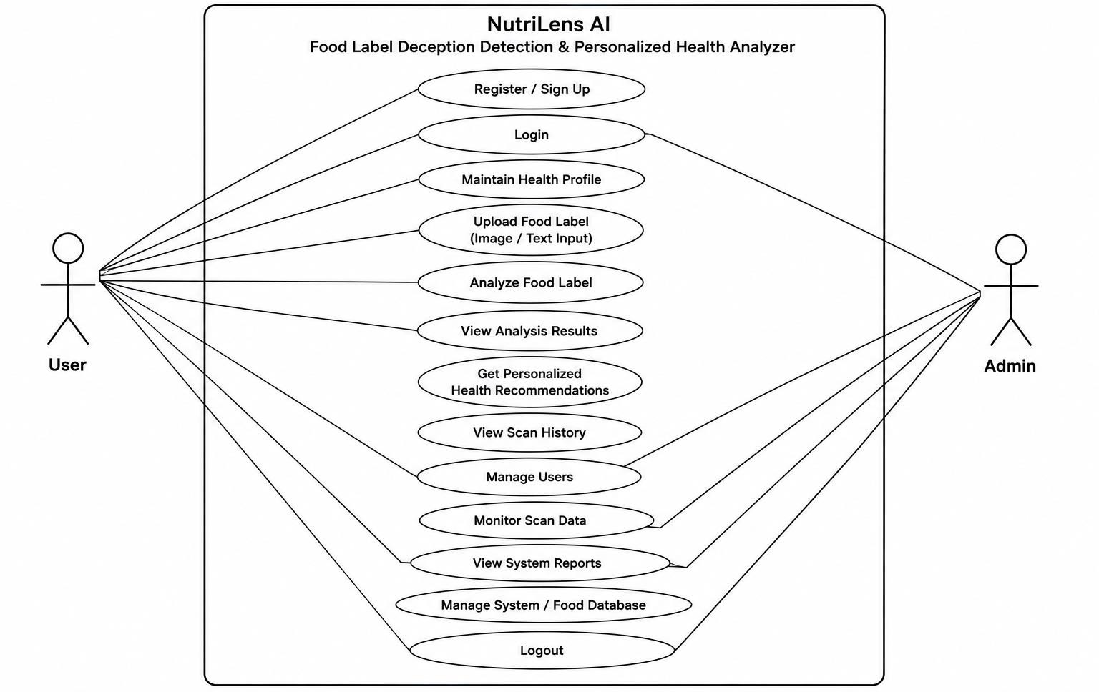
16
UseCase Diagram

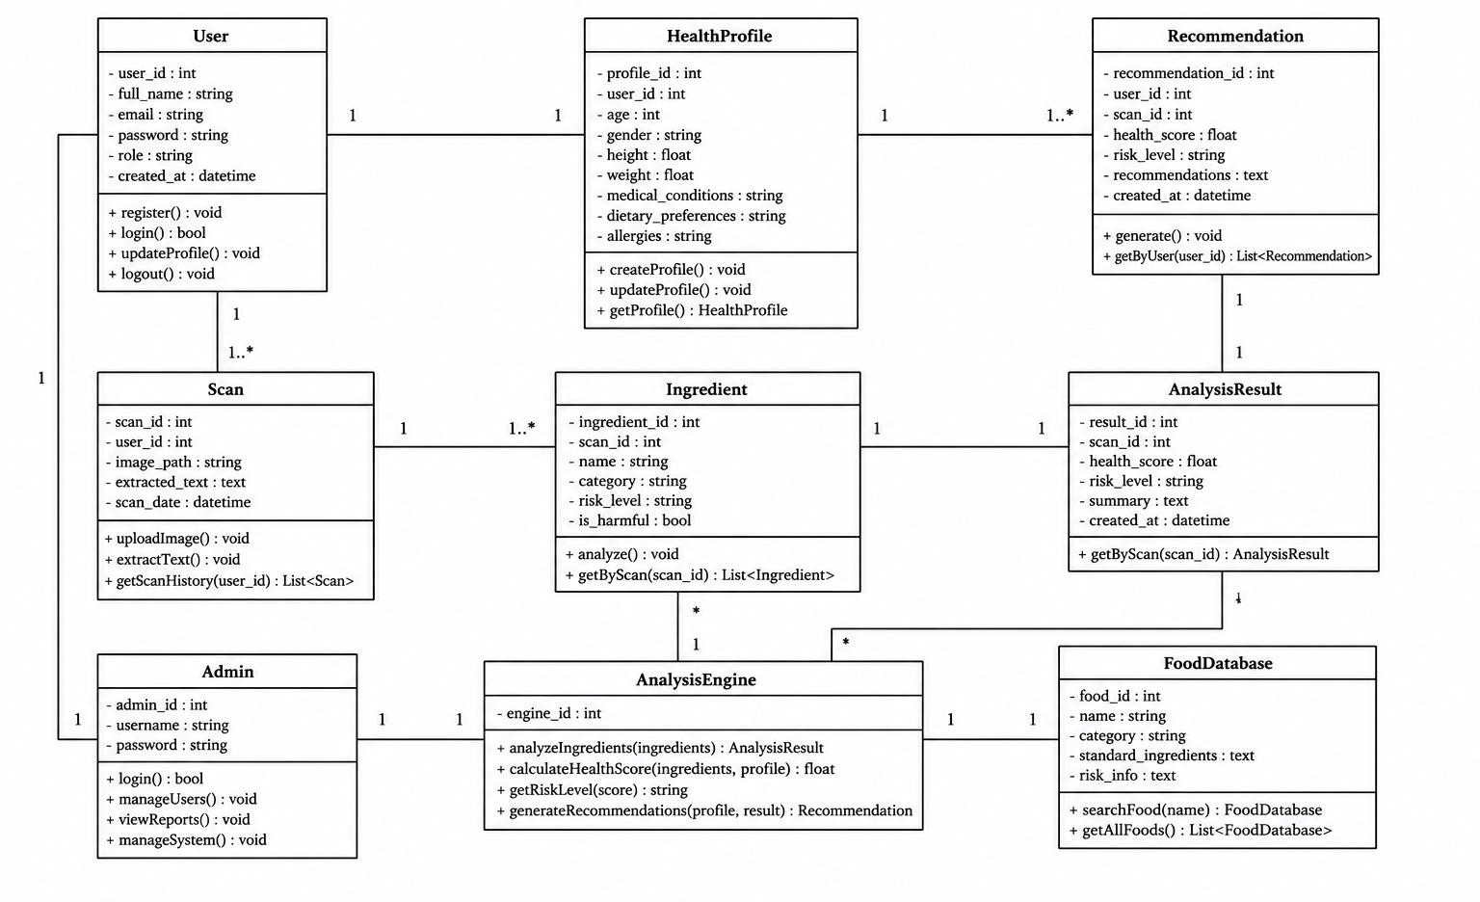
17
Class Diagram

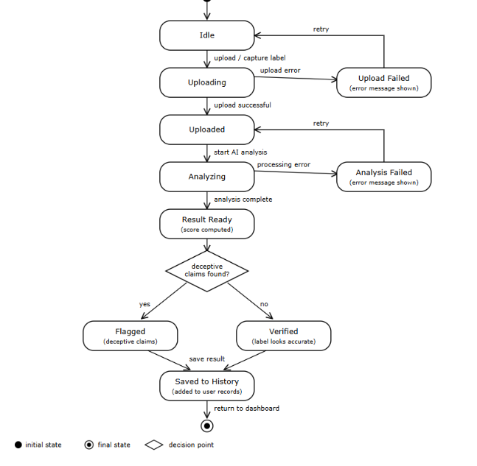

State Diagram
18



D E S I G N D I A G R A M 19

Activity Diagram
N U T R I L E N S S Y S T E M
U S E R

Register / Log in Validate credentials

No
Valid?

Yes
Enter health profile & upload label image

OCR text extraction

Detect deceptive claims, allergens & harmful
ingredients

View flags, score & recommendations Compute health score & personalized advice

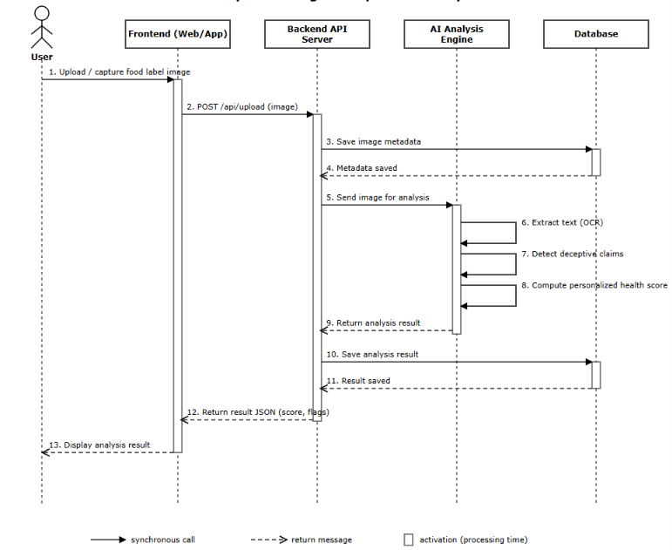
20
Sequence Diagram

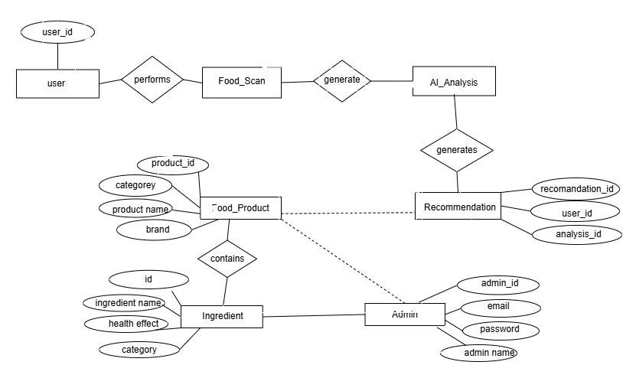
21
User id
Scan id
Analysis id
Scan id

ER DIAGRAM
ER Diagram


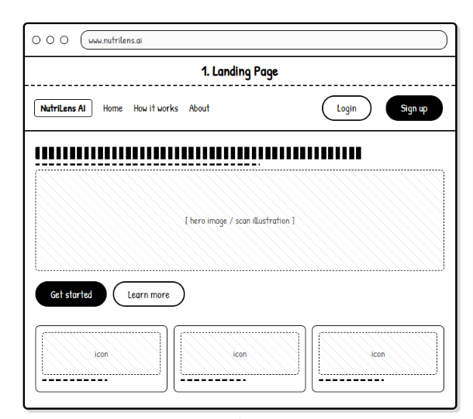
22
Wireframe Diagram

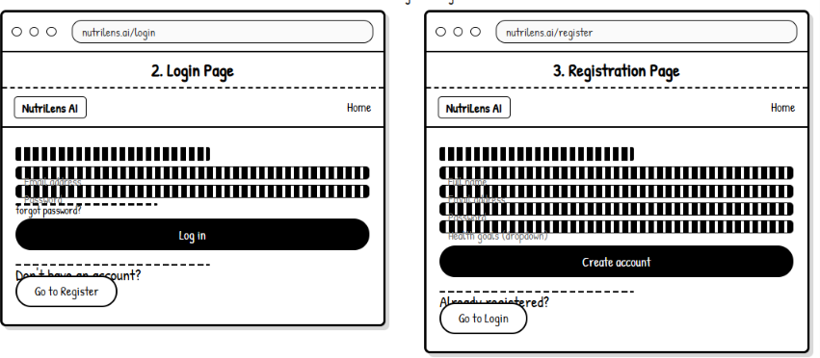

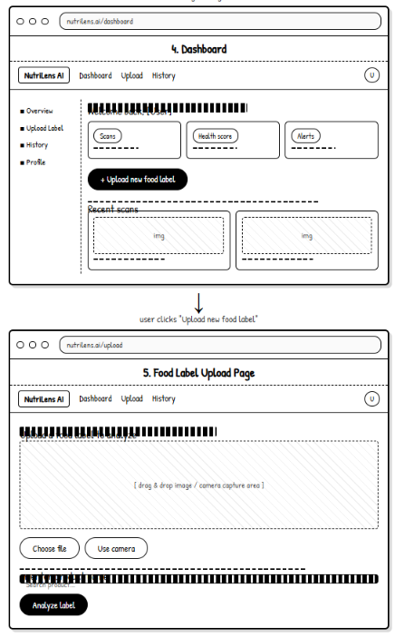
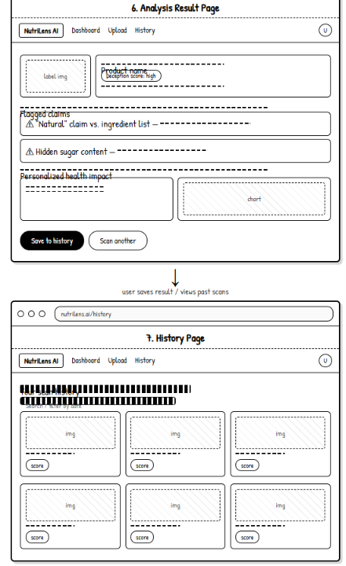
23

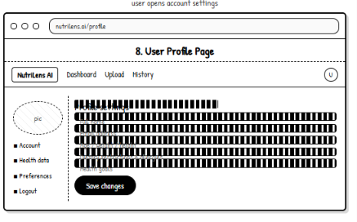
24

M O D U L E D E S C R I P T I O N 25

System modules

01

Image Capture & Upload

02

OCR Text Extraction

03

Deception & Allergen Detection

Accepts a photo or file upload of the food label. Tesseract reads ingredients, nutrition facts and
claims.
Flags misleading claims, allergens and harmful additives.

04

Health Risk Scoring
05

Personalized Recommendation
Engine
06

User Dashboard & Report

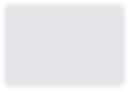







Combines nutrient and ingredient risks into one score.
Tailors advice to the user’s health profile. Shows scan results, history and reports.

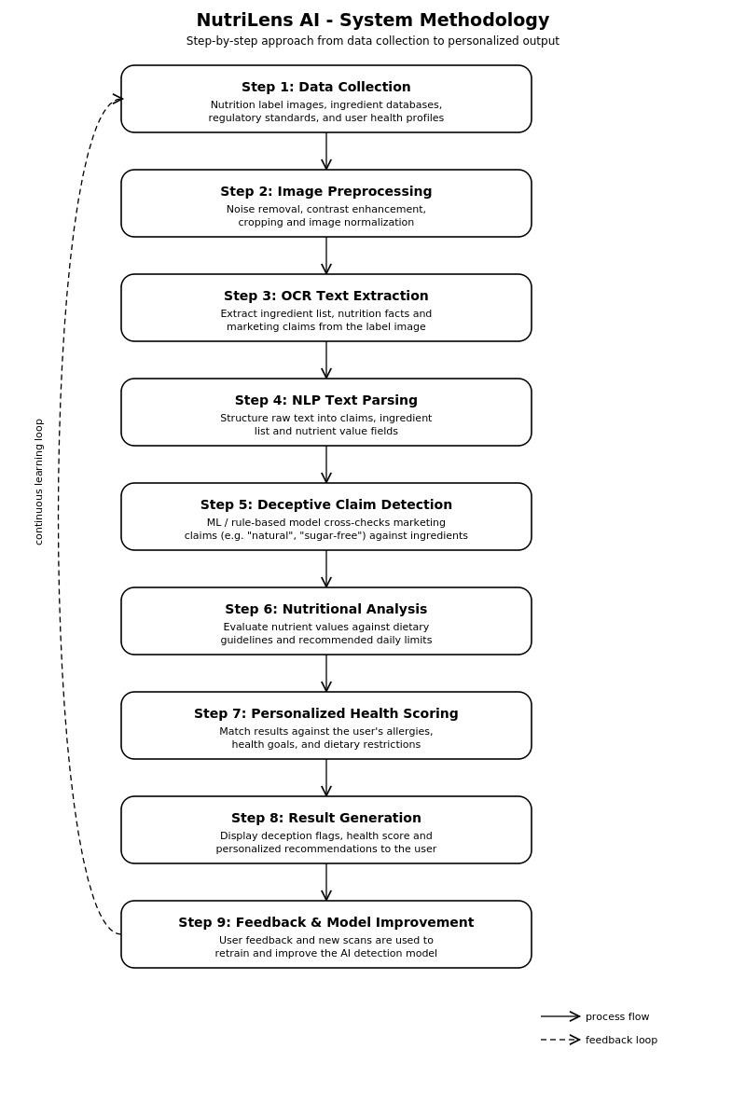
26

I M P L E M E N T A T I O N 27

How NutriLens is built
A Python / Flask back end, Tesseract OCR, SQLite storage and a browser-based front end.

Front end
HTML, CSS and JavaScript pages for login, registration, health profile, label upload, results dashboard and the admin panel.

Back end
Python (Flask) routes handle authentication, image upload, the OCR and analysis pipeline, scoring and report generation.

Database
SQLite stores users, health profiles, scans, analysis results and recommendations for history and reports.

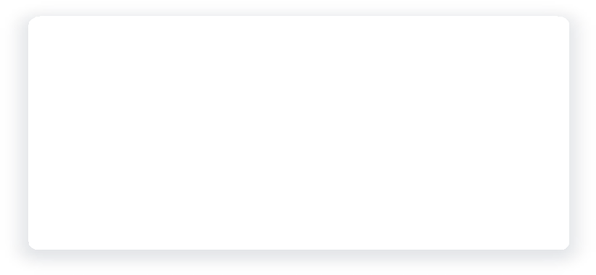
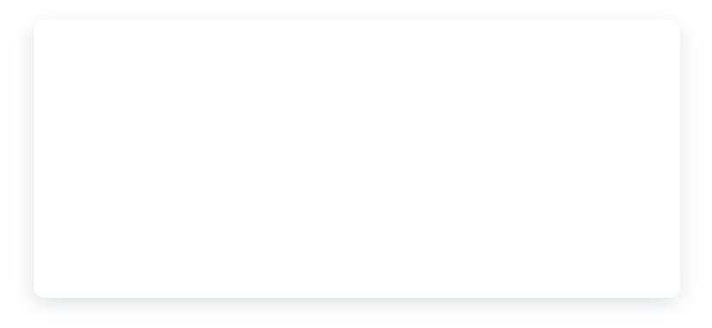
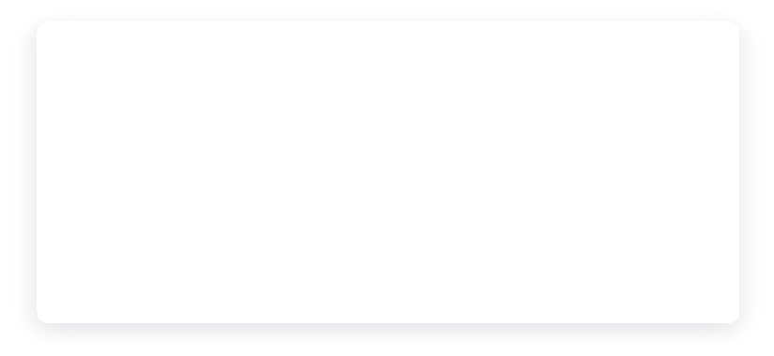
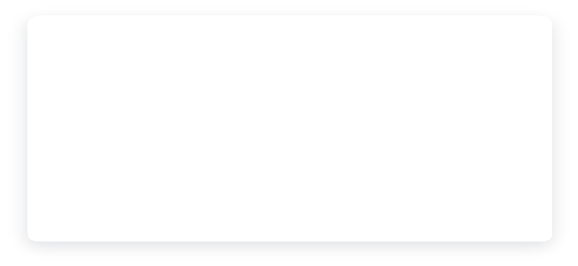
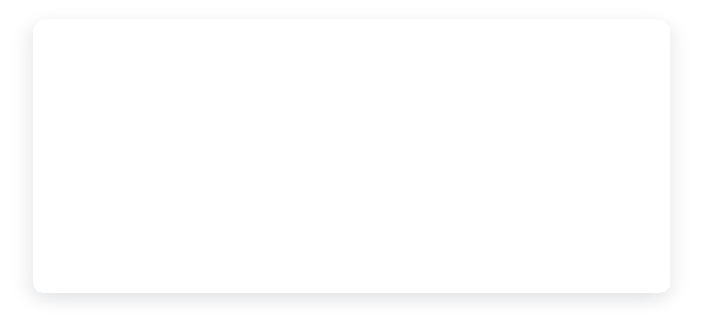
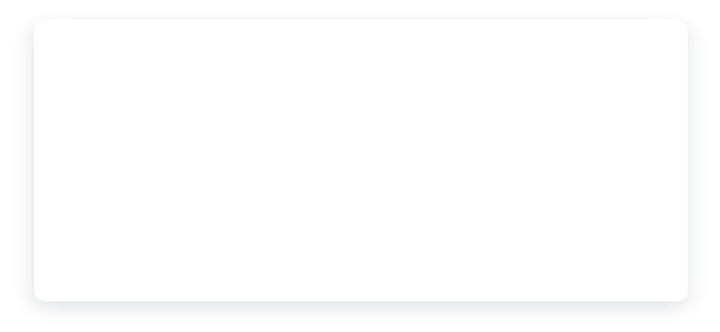

OCR integration

Tesseract reads the ingredient list, nutrition facts and marketing claims after image pre-processing.

Analysis logic

Rule-based and ML checks compare claims with ingredients, flag allergens and harmful additives, then build the health score.

Key functionalities

Secure login, personalized health profile, deception and allergen alerts, health score, recommendations and admin management.

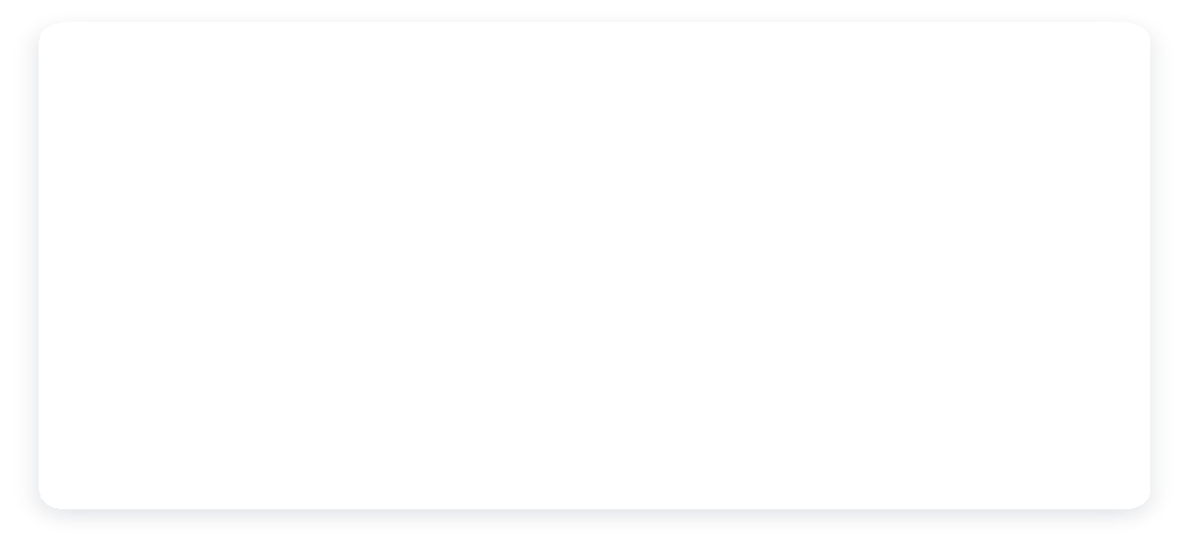
R E S U L T S / A N A L Y S I S 28

How well does it perform?

Measured performance of the OCR, detection and scoring modules on the test label set.

OBSERVATIONS
Metric | Result
OCR text-extraction accuracy | 94%
Deceptive-claim detection accuracy | 90%
Allergen detection precision / recall | 89%
Health-score consistency vs. manual check | 93%
Average response time per scan | 8.5 seconds

The system successfully extracts text from most food-label images using OCR.
Food ingredients, nutritional information, and allergens are identified
effectively.
Potentially misleading or deceptive claims are detected with good accuracy.
Personalized health analysis provides results consistent with manual checking.
The system provides food-label analysis within a short response time. Overall, NutriLens AI helps users understand food labels and make more informed food choices.

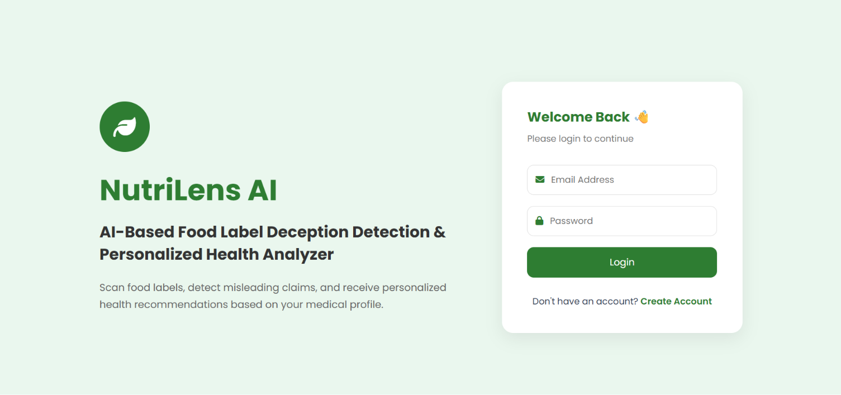
29
Front-End

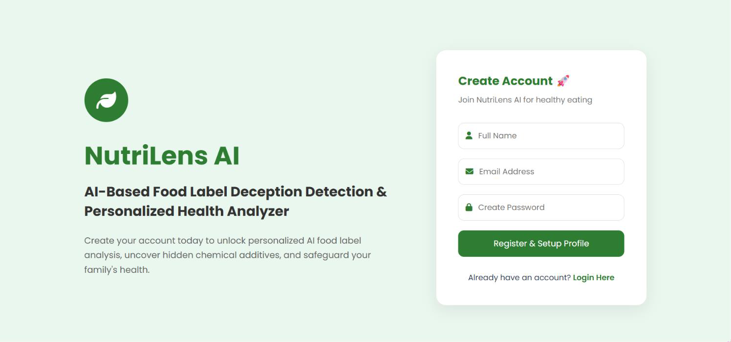

30
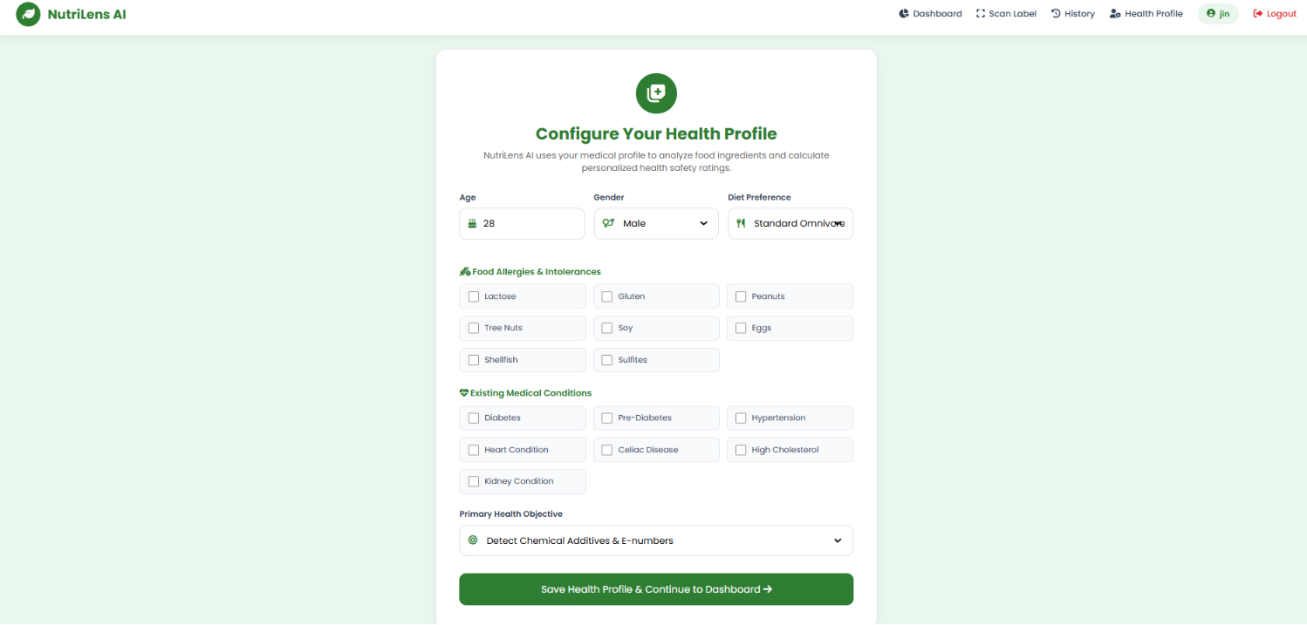
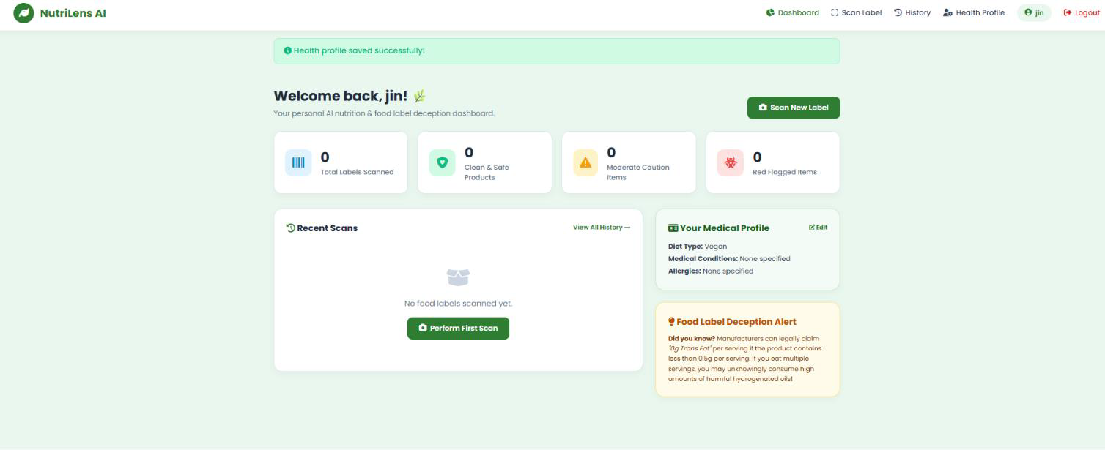

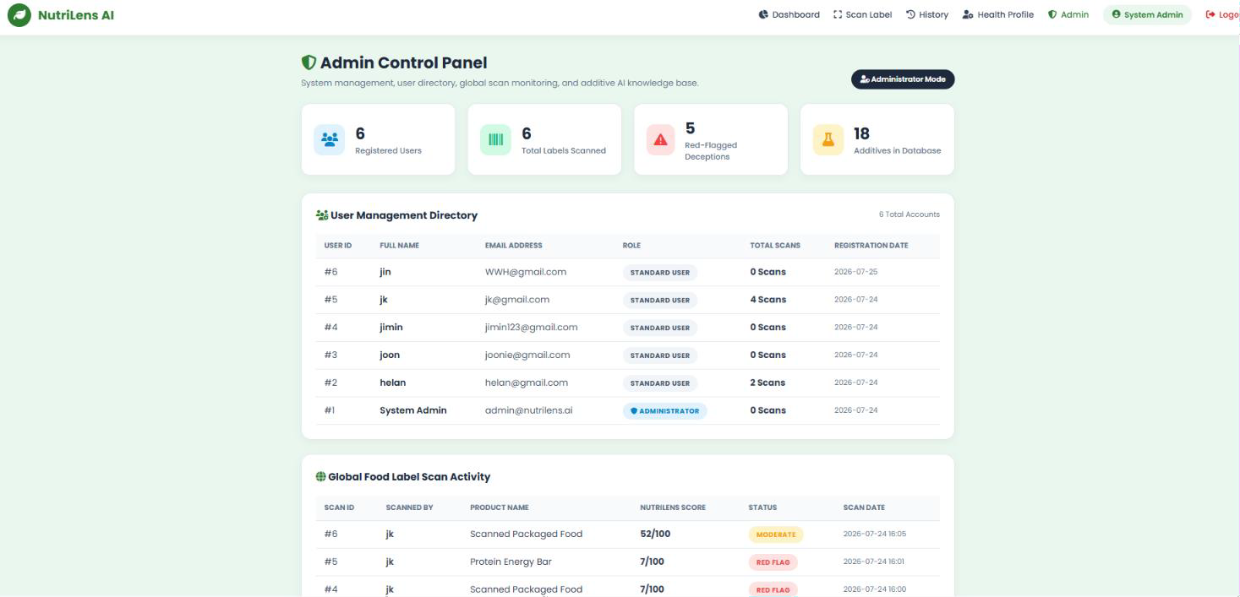
31

32

C O M P A R I S O N

NutriLens vs. existing systems

Feature | Existing systems (reviewed literature) | NutriLens (proposed)
Processing | OCR, classification and scoring handled by separate tools; partly manual | Automated single pipeline: upload → OCR → analysis → score
Accuracy | Component-level results reported (e.g. 98.99% FoodVisor, 97.37% allergen-OCR framework) | Tested successfully with food-label samples; accurate results obtained
Time | User reads and interprets the label manually | Faster automated analysis; average time measured during testing
Security | Varies; one reviewed system encrypts health profiles (AES-128) | Login-protected user profiles with admin-managed access
Accessibility | Often mobile apps or barcode-dependent | Browser-based, no installation; works from a photo upload
Reporting | Label scores without user context; allergen-only reports | Health score, deception flags and personalized recommendations

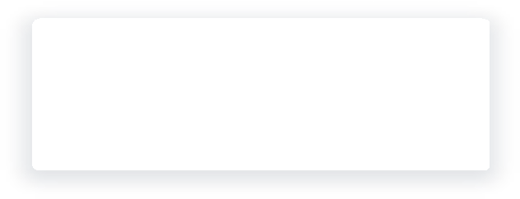
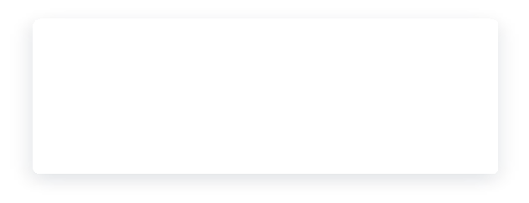

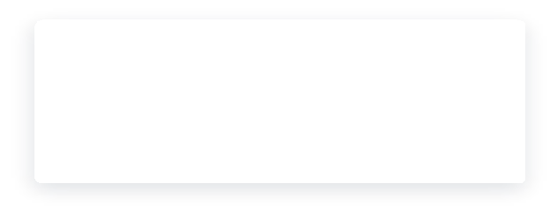
T E S T I N G
33
Testing methodology & test cases
User acceptance
Feedback from sample users on clarity and ease of use.
System testing
End-to-end scan flow on sample packaged-food labels.
Integration testing
Front end Flask OCR module database working together.
Unit testing
OCR parsing, scoring rules and input validators tested individually.

Test case | Expected result | Actual result | Status
Valid login | Login successful | Login successful | Pass
Invalid login | Error message displayed | Error message displayed | Pass
Upload clear label image | Text extracted and analyzed | Text extracted and analyzed successfully | Pass
Upload non-image file | File rejected with error | Invalid file rejected with error message | Pass
Profile allergen found on label | Allergen alert displayed | Allergen alert displayed correctly | Pass
Non-admin opens admin panel | Access denied | Access denied | Pass


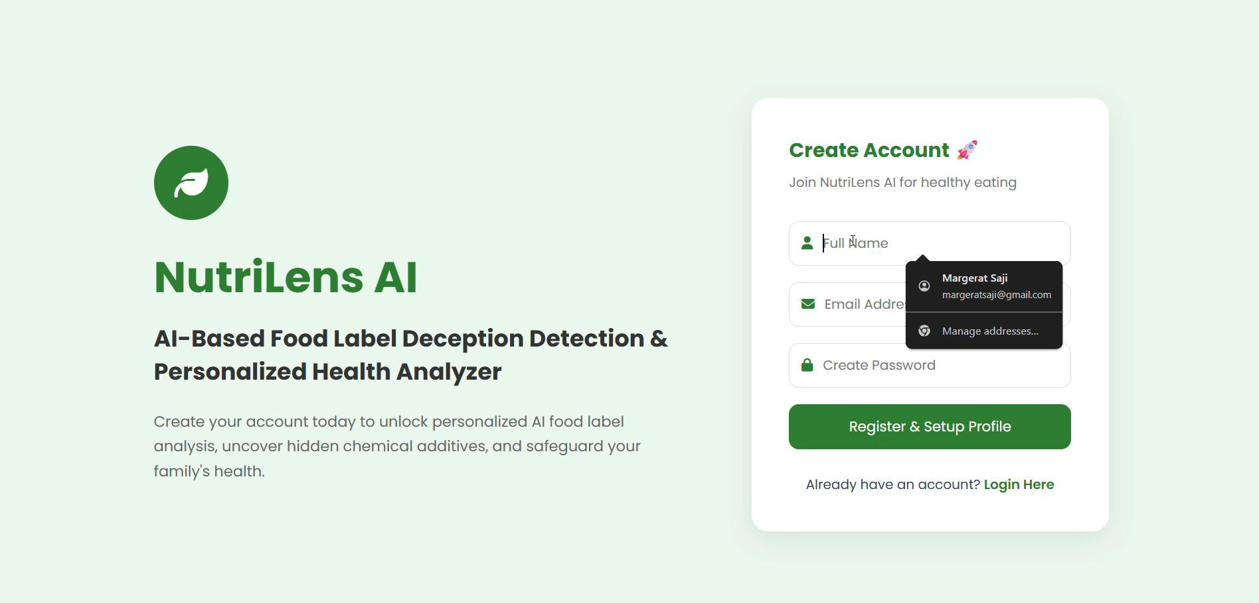
D E M O N S T R A T I O N 34

Project demo video

WHAT THE DEMO SHOWS
Register and log in
1
Fill in the health profile
2
Upload a packaged-food label
3
OCR extraction and analysis
4
Deception flags, health score and
5
recommendations
Admin panel overview
6
Insert demo video here (Insert ▸ Video ▸ This Device)

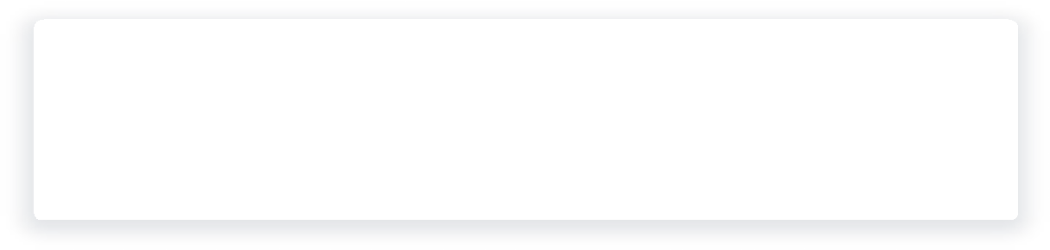
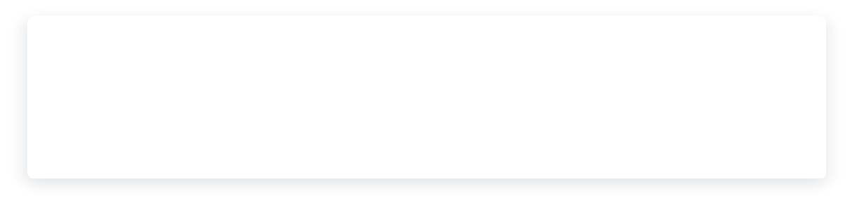
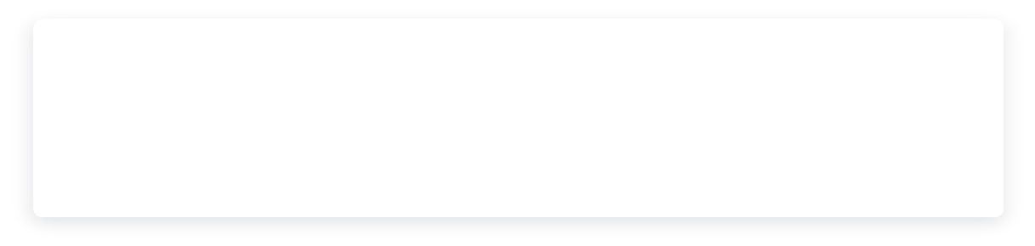
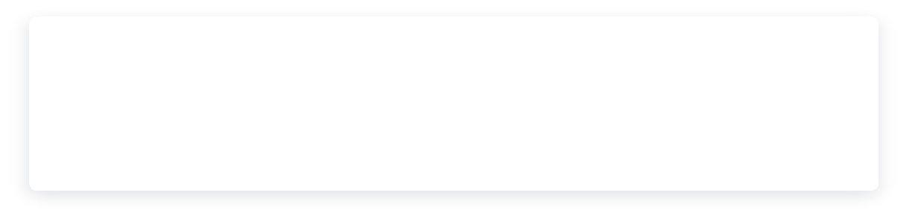
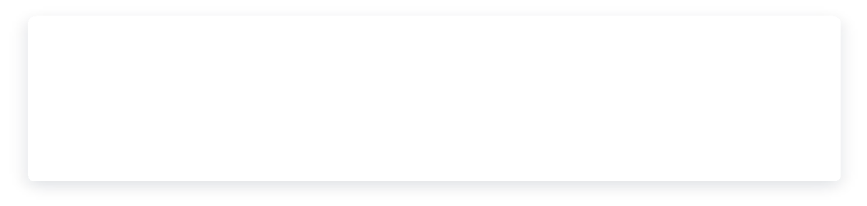
A D V A N T A G E S 35
Unified pipeline
01
OCR, deception detection, scoring and recommendations in
one platform.
Personalized results
02
Advice tailored to each user's health conditions and dietary
needs.
Easy to understand
03
One health score and flagged claims replace dense label text.
Safer food choices
04
Surfaces allergens and harmful ingredients that are easy to
miss.
No installation
05
Runs in any browser on a device with a camera.
Low cost
06
Built on open-source tools with no licensing fees.

Why NutriLens helps

L I M I T A T I O N S 36

What NutriLens does not do yet

Image quality matters
× Blurred, low-resolution or decorative-font labels can reduce OCR accuracy.

Printed labels only
× Fresh or loose products without printed labels and restaurant menus are out of scope.

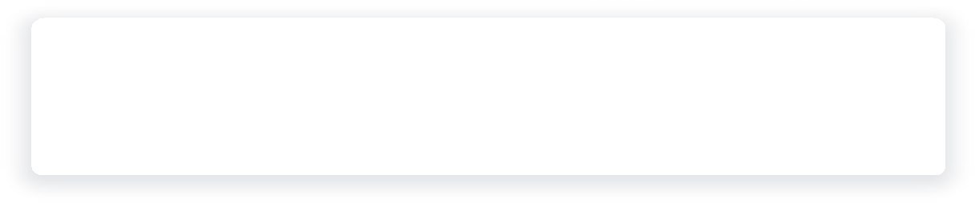
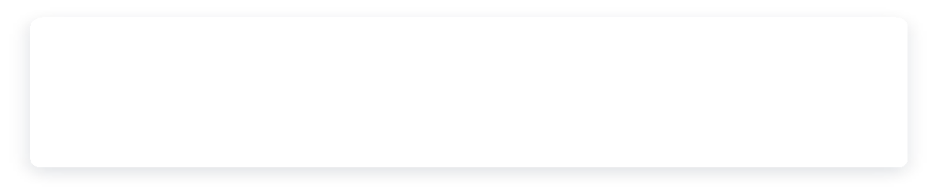
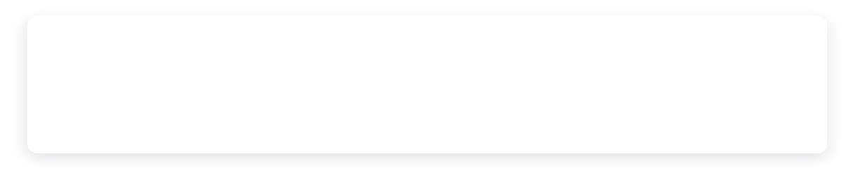
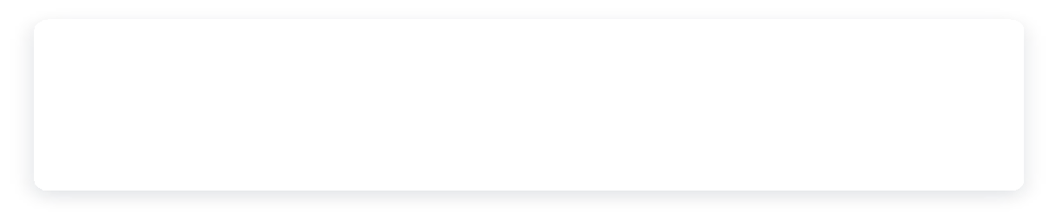
NEXT STEP
These limitations shape the roadmap: better image handling, wider ingredient coverage and richer personalization (see Future Scope).

Rule-based coverage
× Detection depends on the claims and ingredients the rules and
models already know.

Informational guidance
× Scores and advice support food choices but do not replace medical
advice.

OCR Extraction


Conclusion
NutriLens AI brings OCR, deception detection, health-risk scoring and personalized recommendations into a single, easy-to-use web application — helping consumers move from confusing labels to confident, informed food choices.

Deception Detection

Health Scoring

Personalization

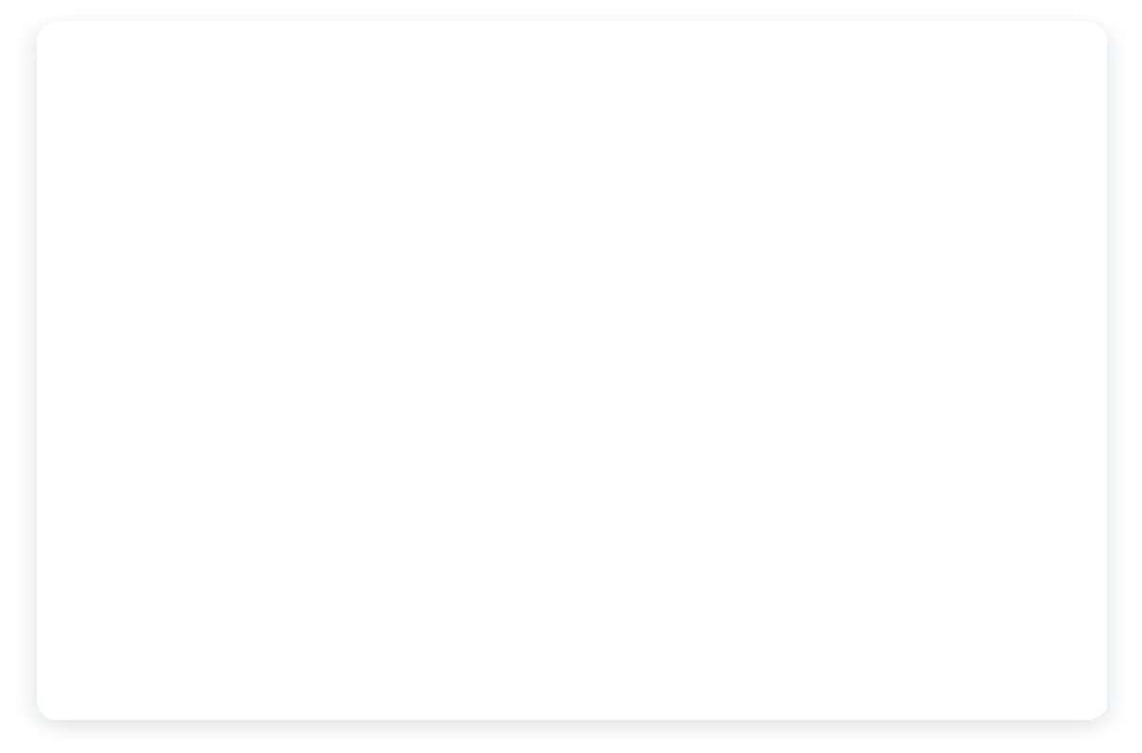
38
LONGER TERM
LLM-based ingredient understanding
Replace fixed rules with language models that explain ingredients
in context.
Restaurant menu analysis
Extend scanning to menus and unpackaged food.
Health tracking
Trend scan history over time and share summaries with a dietitian.
NEAR TERM
✓
Barcode scanning
Fetch product data from open food databases when a label is
hard to read.
✓
Mobile app
Native Android / iOS app for faster, camera-first scanning.
✓
Multilingual labels
Read and explain labels printed in regional languages.

F U T U R E S C O P E

Where NutriLens goes next

39

R E F E R E N C E S

- Katankar et al., “Food Label Scanner & Personalized Supplement
Recommendation System,” Int. J. Advanced Electrical & Computer Engineering, 2025.


- Jiang et al., “DeepFood: Food Image Analysis and Dietary Assessment via
Deep Model,” IEEE Access, 2020.
- Amoggha et al., “FoodVisor: AI-Powered Food Label Analysis System,”
Research Square, 2025.
- Gawade et al., “Package Food Health Analyzer using Ingredients
Intelligence,” HBRP Publication, 2026.
- Rohini et al., “A Framework to Identify Allergen and Nutrient Content in


Fruits and Packaged Food using Deep Learning and OCR,” in Proc. IEEE ICACCS, 2021.

Thank You

