# 🛡️ My Security

**My Security** is a web platform that helps users check the security status of their region in the Greater Tunis area using an interactive map. The application visualizes security levels by area and provides tailored safety recommendations.

## 🌍 Project Overview

The project uses **OpenStreetMap** to display markers indicating the safety level of different regions. Users can search by **postal code** or click directly on the map to view the status of their neighborhood.

Each marker on the map reflects a security level with a specific color:

- 🟢 Green – Safe

- 🟡 Yellow – Moderate Risk

- 🔴 Red – High Risk

Based on the current level, the platform suggests suitable **security tools** and **prevention measures**.

## 🛠️ Technologies Used

- **HTML** & **CSS** – Structure and styling

- **JavaScript** – Map interaction and logic

- **PHP** – Backend logic and data processing

- **OpenStreetMap** (via Leaflet.js) – Interactive map

## 📌 Features

- 🔍 Search by region or postal code

- 📍 Interactive map with color-coded markers

- 🧰 Security recommendations based on risk level

- 🗺️ Focus on Greater Tunis region

- 🕵️ Real-time feedback on regional safety

## 🖼️ Screenshots

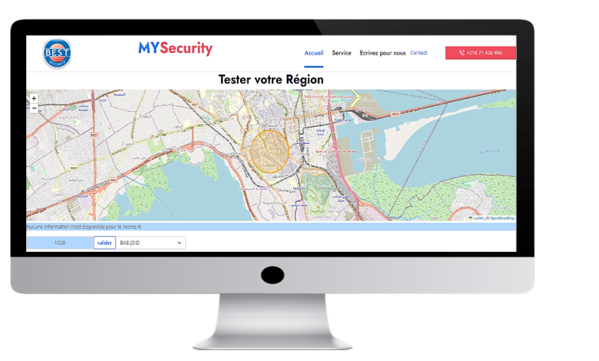

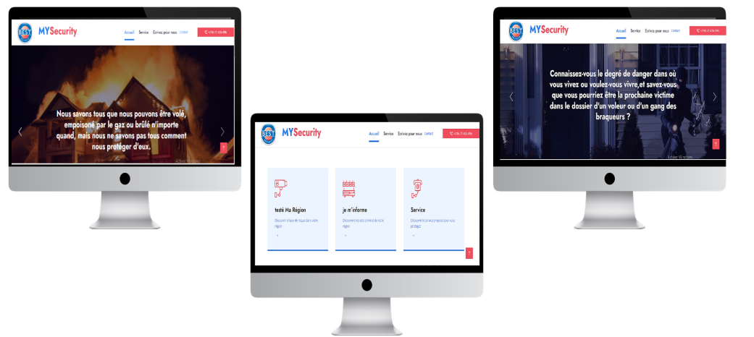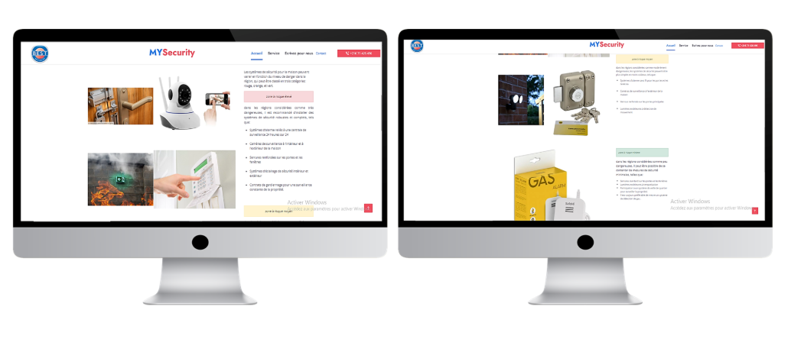

## 🚀 How to Run

Follow these steps to set up and run the project locally:

🚀 Quick Installation

1. Clone the project

bash

git clone https://github.com/helasaoudi/my_security.git

1. Install a local server  
   Use [XAMPP](https://www.apachefriends.org/), WAMP, or MAMP, and make sure Apache and MySQL are running.
2. Import the database
   * Go to [phpMyAdmin](http://localhost/phpmyadmin)
   * Create a database named my_security
   * Import the file: statistique (1).sql
3. Move the project folder
   * For XAMPP → htdocs/my_security
   * For WAMP → www/my_security
4. Run the project in your browser