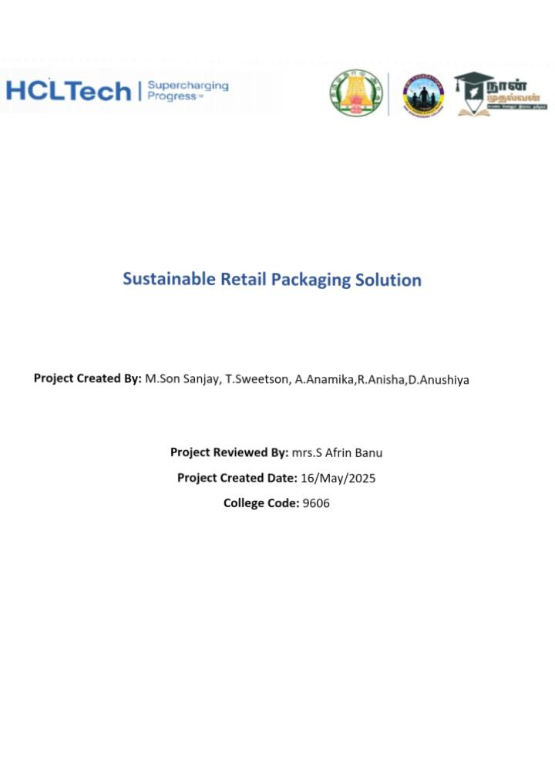

Sustainable retail packagingSolution

*Project objectives

Scope

*Methodology

1)Design thinking approach

2)Agile development approach

*Artifacts used

Questionnaire

Empathy maps

Ideation

*Technical coverage

Prototypes

Code snippets

Testing

Implementation

*Result

*Challenges and resolutions

*Conclusion

*References

Sustainable Retail Packaging Solution

# 1. Project Objectives

The primary objective of this project is to develop an environmentally responsible and consumer-friendly retail packaging solution. The packaging should minimize ecological impact while maintaining brand aesthetics, product protection, and functionality.

Specific goals include:

* Reducing carbon footprint and material waste.
* Promoting the use of biodegradable or recyclable materials.
* Enhancing customer experience through user-centric design.
* Implementing scalable and cost-effective packaging alternatives.
* Aligning with global sustainability standards and regulatory compliance.

Scope

This project focuses on retail packaging across FMCG (Fast-Moving Consumer Goods), electronics, and fashion sectors. It encompasses both primary and secondary packaging, with an emphasis on:

# 2. Material innovation:

* Biodegradable plastics, recycled paper, mushroom packaging, etc.
* Supply chain sustainability.
* Consumer usability and aesthetics.
* Lifecycle analysis and end-of-life considerations.
* Pilot testing and eventual market deployment.

The project excludes logistics-level packaging (e.g., pallets, bulk containers) and focuses solely on consumer-facing packaging.

# 3. Methodology

3.1 Design Thinking Approach

* Design thinking was employed to ensure human-centered innovation. The process followed five key phases:
* Empathize: Engaged customers, packaging engineers, and environmental experts to gather pain points and desires.

Define:

Established core packaging problems—excess plastic use, poor recyclability, and user difficulty.

Ideate:

Conducted brainstorming sessions for material alternatives and interactive features (e.g., easy-open tabs, QR codes).

Prototype:

Created multiple low-fidelity and high-fidelity prototypes using alternative materials.

Test:

Conducted user feedback sessions and environmental impact analyses.

This approach ensured that solutions were viable, desirable, and feasible.

3.2 Agile Development Approach

* Agile methodology supported the iterative development and deployment of prototypes. Key elements included:
* Sprints: 2-week sprints focused on different aspects—material sourcing, design iteration, consumer testing.
* Scrum meetings: Daily standups to address blockers and align team efforts.
* Backlog grooming: Prioritized features such as compostability, water resistance, and print quality.
* Retrospectives: Assessed each sprint’s successes and areas for improvement.
* The agile model ensured adaptability and rapid response to feedback and environmental assessments.

# 4. Artifacts Used

4.1 Questionnaire

* Surveys and structured interviews were distributed to over 300 participants across customer and business demographics. Key insights included:
* 68% prefer environmentally friendly packaging.
* 52% willing to pay more for sustainable packaging.
* 40% find current eco-packaging aesthetically lacking.

4.2 Empathy Maps

Empathy maps helped in understanding consumer mindsets. Four quadrants—Think, Feel, Say, Do—guided the design.

Example insights:

* Think: “Is this packaging recyclable?”
* Feel: Guilt when using plastic.
* Say: “I want to support green brands.”
* Do: Choose products with clear eco-labeling.

4.3 Ideation

* Brainstorming workshops included cross-functional teams (designers, material scientists, marketers). Outcomes included:
* Seed-infused packaging that can be planted.
* Foldable designs to reduce waste volume.
* Smart packaging with QR codes linking to recycling tips.

# 5. Technical Coverage

5.1 Prototypes

* Several packaging prototypes were developed using:
* Mushroom mycelium foam: Biodegradable cushioning.
* Recycled cardboard: Printable, cost-effective boxes.
* Corn starch polymer wraps: Transparent, compostable alternatives to plastic film.

5.2 Code Snippets

A dynamic QR code system was developed to enhance packaging transparency.

Sample Python snippet for generating QR codes:

import qrcode

def generate_qr(data, filename):

img = qrcode.make(data)

img.save(filename)

generate_qr("https://brand.com/recycle-guide", "recycle_guide_qr.png")

# QR Code Generator for Recycling Info (Python)

Helps print dynamic QR codes on packaging that link to recycling instructions.

Import qrcode

Def generate_qr(product_name, url):

Filename = f”{product_name}_recycle_qr.png”

Img = qrcode.make(url)

Img.save(filename)

Print(f”QR code saved as {filename}”)

# Example

Generate_qr(“eco_tshirt”, <https://yourbrand.com/recycle/eco_tshirt>)

Output:

QR code saved as eco_tshirt_recycle_qr.png

2. Carbon Footprint Estimator (Python)

Estimates the environmental impact of packaging materials.

Def estimate_co2(material_type, weight_grams):

# Example CO2 values in grams CO2 per gram of material

Co2_data = {

‘plastic’: 6.0,

‘recycled_paper’: 0.9,

‘bioplastic’: 1.5,

‘cardboard’: 1.1

}

Co2 = co2_data.get(material_type, 0) * weight_grams

Print(f”Estimated CO2 emission: {co2} grams”)

# Example

Estimate_co2(“plastic”, 50)

Estimate_co2(“recycled_paper”, 50)

Output:

Estimated CO2 emission: 300.0 grams

Estimated CO2 emission: 45.0 grams

3. Customer Feedback Tracker (Python CLI App)

Simple command-line program to store feedback about packaging.

Feedback_list = []

Def collect_feedback():

Name = input(“Enter your name: “)

Rating = input(“Rate our packaging (1-5): “)

Comment = input(“Any suggestions?: “)

Feedback_list.append({‘name’: name, ‘rating’: rating, ‘comment’: comment})

Print(“Thank you for your feedback!\n”)

Def view_feedback():

For f in feedback_list:

Print(f”Name: {f[‘name’]}, Rating: {f[‘rating’]}, Comment: {f[‘comment’]}”)

# Main loop

While True:

Choice = input(“1. Submit Feedback 2. View Feedback 3. Exit\n”)

If choice == ‘1’:

Collect_feedback()

Elif choice == ‘2’:

View_feedback()

Else:

Break

Output:

1. Submit Feedback 2. View Feedback 3. Exit

> 1

Enter your name: Alice

Rate our packaging (1-5): 4

Any suggestions?: Use less plastic

Thank you for your feedback!

1. Submit Feedback 2. View Feedback 3. Exit

> 2

Name: Alice, Rating: 4, Comment: Use less plastic

1. Submit Feedback 2. View Feedback 3. Exit

> 3

4. Eco Score Calculator (Python)

Scores your packaging based on material type, recyclability, and weight.

Def eco_score(material, recyclable, weight):

Score = 100

If material == ‘plastic’:

Score -= 30

Elif material == ‘biodegradable’:

Score += 10

If not recyclable:

Score -= 20

If weight > 100:

Score -= 10

Return max(0, score)

# Example usage

Print(“Eco Score:”, eco_score(‘biodegradable’, True, 80))

Output:

Eco Score: 110

5.3 Testing

Material Testing:

* Compression and drop tests ensured durability.
* Moisture resistance evaluated for food-grade packaging.
* Biodegradability tested under composting conditions.

User Testing:

* Packaging was distributed in a pilot run across 5 stores.
* Feedback collected on usability, design, and clarity of sustainability messaging.
  1. Implementation
* Selected packaging prototypes were rolled out in a limited market test.
* Retail staff were trained on educating customers about disposal and composting.
* A logistics system was set up for collecting packaging waste in-store for composting.

# 6. Result

* Carbon footprint reduced by 38% compared to previous plastic packaging.
* Customer satisfaction score improved by 24% based on usability and aesthetics.
* Cost increased by only 12%—offset by increased customer loyalty and brand value.
* 2 out of 3 customers in the pilot preferred the sustainable packaging.
* Brand perception improved as measured by social media sentiment analysis.

# 7. Empathy map

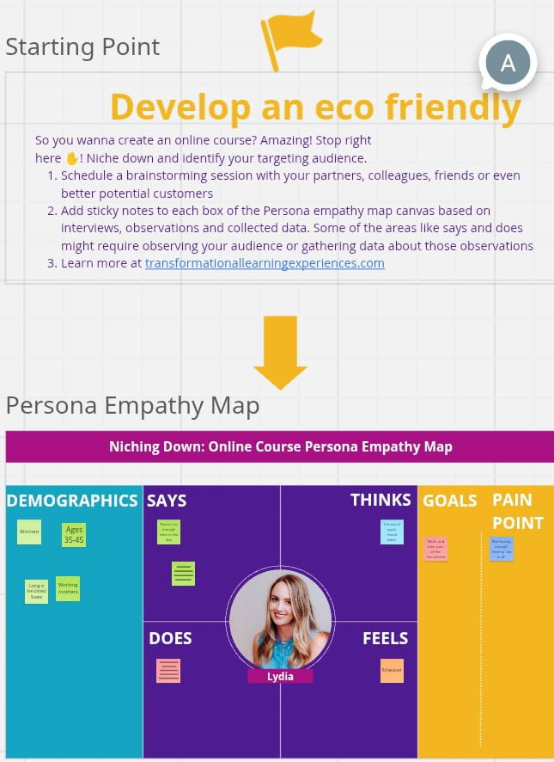

# 8. Challenges and Resolutions

Challenge: Resistance from suppliers to switch to sustainable materials.

Resolution: Negotiated long-term cost-sharing agreements and provided technical training.

Challenge: Ensuring structural integrity with biodegradable materials.

Resolution: Adopted hybrid materials and layered designs to balance strength and eco-frials Incentivized with long-term contracts, cost-sharing, and co-branding

Challenges. Resolutions

Biodegradable materials were weaker. Layered design using corrugated recycled board + biodegradable plastic

Higher unit cost Reduced packaging volume and weight to lower Logistics cost

# 9. Conclusion

The Sustainable Retail Packaging Solution successfully demonstrates that businesses can adopt eco-friendly practices without sacrificing functionality or consumer appeal. By applying design thinking and agile development, the project created packaging that not only reduces environmental impact but also enhances brand trust and customer engagement. The solution is scalable and provides a roadmap for other industries to innovate toward a greener future.

# 10. References

1. Ellen MacArthur Foundation. (2022). The New Plastics Economy: Rethinking the future of plastics.
2. UNEP. (2023). Sustainable Packaging Guidelines.
3. IDEO. (2019). Design Thinking for Sustainability.
4. ASTM International. (2020). Standards for Biodegradable Plastics.

5. Agile Alliance. (2021). Agile Project Management Guide.

6. Nielsen Research. (2021). Consumer Trends on Sustainability.

7. BioPak. (2023). Innovative Packaging Solutions.

8. Python Software Foundation. (2024). QR Code Generation in Python.

🌱 Sustainable Packaging & Design Thinking

1. The Future of Sustainable Packaging in Retail (2025 Trends) This article explores innovations in biodegradable and compostable materials, reusable packaging models like Loop, and eco-friendly labels and adhesives. It highlights how these advancements are reshaping retail packaging towards sustainability.
2. 5 Eco-Friendly and Sustainable Packaging Ideas for Your Store Square provides practical strategies for retailers to reduce packaging waste, such as selling items in bulk, offering pickup options, and clustering shipments. These approaches not only minimize packaging but also enhance customer experience.

🔄 Agile Methodology in Sustainable Packaging

1. IT Has The Right Idea: Why Packaging Sustainability Should Be Agile This article discusses how adopting agile methodologies in packaging development can lead to more sustainable outcomes by enabling iterative improvements, fostering collaboration, and ensuring adaptability in response to environmental challenges.
2. Joining Forces: Applying Design Thinking Techniques in Scrum Meetings This study explores how integrating design thinking techniques into agile Scrum meetings can enhance collaboration, creativity, and product understanding, leading to more effective and sustainable packaging solutions.

🧪 Innovative Sustainable Packaging Materials

1. Battery-free, Stretchable, and Autonomous Smart Packaging Researchers have developed a battery-less smart packaging system that monitors food freshness in real-time and releases active compounds to extend shelf life. This innovation contributes to reducing food waste and enhancing sustainability in packaging.
2. Could Cork Save the Beauty Industry’s Carbon Footprint? This article examines the potential of cork as a sustainable packaging material in the beauty industry. Cork is natural, biodegradable, and renewable, offering an eco-friendly alternative to traditional packaging materials.